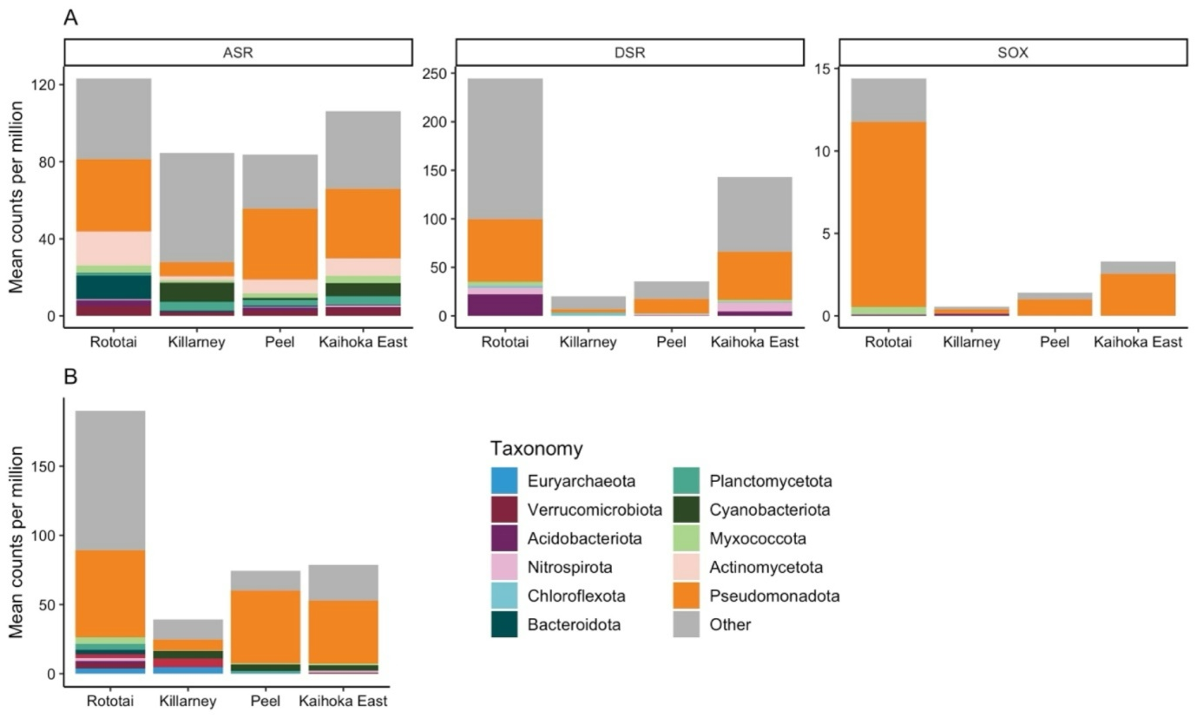
Supplementary Fig. 1. Taxonomic composition of microbial communities associated with genes related to; A) sulfur metabolism, and B) nitrogen fixation. ASR – assimilatory sulfur reduction; DSR – dissimilatory sulfur reduction; SOX – sulfur oxidation.

