Interfacial interaction driven rheological properties of quartz nanofluids from molecular dynamics simulations and density functional theory calculations
Zhaoyang Lou^{a,c*}, Chen Cheng^{b}, Yingqi Cui^{c}, Hao Tian^{c}
ª Department of Radiation Oncology, Affiliated Cancer Hospital of Zhengzhou University, Henan Cancer Hospital, Zhengzhou, China; ^{b} Department of Strategy and Healthcare Development, Affiliated Cancer Hospital of Zhengzhou University, Henan Cancer Hospital, Zhengzhou, China; ^{c} Institute of Atomic and Molecular Physics, Sichuan University, Chengdu, China

*corresponding author:
Zhaoyang Lou
louslove@163.com

Supporting Information

Table S1 Simulated viscosities of quartz nanofluids with different volume concentration and temperature.
Temp/K | Viscosity/mPa·s (D=11.2 Å) |  |  |  |  | Viscosity/mPa·s (D=18.4 Å)
Temp/K | 0.00% | 1.20% | 2.40% | 3.60% | 4.80% | 4.80%
280 | 1.357±0.032 | 1.557±0.043 | 1.764±0.048 | 2.226±0.051 | 3.051±0.053 | 2.022±0.057
290 | 1.031±0.041 | 1.198±0.027 | 1.365±0.044 | 1.748±0.050 | 2.357±0.048 | 1.478±0.043
300 | 0.846±0.016 | 0.895±0.036 | 1.023±0.037 | 1.302±0.044 | 1.819±0.045 | 1.181±0.046
310 | 0.667±0.009 | 0.720±0.022 | 0.831±0.031 | 1.062±0.033 | 1.472±0.035 | 1.023±0.037
320 | 0.538±0.029 | 0.608±0.032 | 0.688±0.026 | 0.887±0.028 | 1.194±0.033 | 0.828±0.031
330 | 0.486±0.025 | 0.505±0.029 | 0.576±0.032 | 0.712±0.024 | 0.979±0.024 | 0.752±0.028
340 | 0.438±0.023 | 0.417±0.025 | 0.489±0.024 | 0.616±0.016 | 0.771±0.022 | 0.625±0.027

Table S2 Calculated viscosities of quartz nanofluids through formular (2).
Temp/K | Viscosity/mPa·s (D=11.2 Å)
Temp/K | 0.00% | 1.20% | 2.40% | 3.60% | 4.80%
280 | 1.385 | 1.452 | 1.736 | 2.241 | 2.968
290 | 1.081 | 1.133 | 1.356 | 1.749 | 2.316
300 | 0.858 | 0.900 | 1.076 | 1.388 | 1.838
310 | 0.692 | 0.725 | 0.867 | 1.118 | 1.480
320 | 0.565 | 0.592 | 0.708 | 0.913 | 1.208
330 | 0.467 | 0.489 | 0.585 | 0.754 | 0.999
340 | 0.390 | 0.409 | 0.489 | 0.631 | 0.835

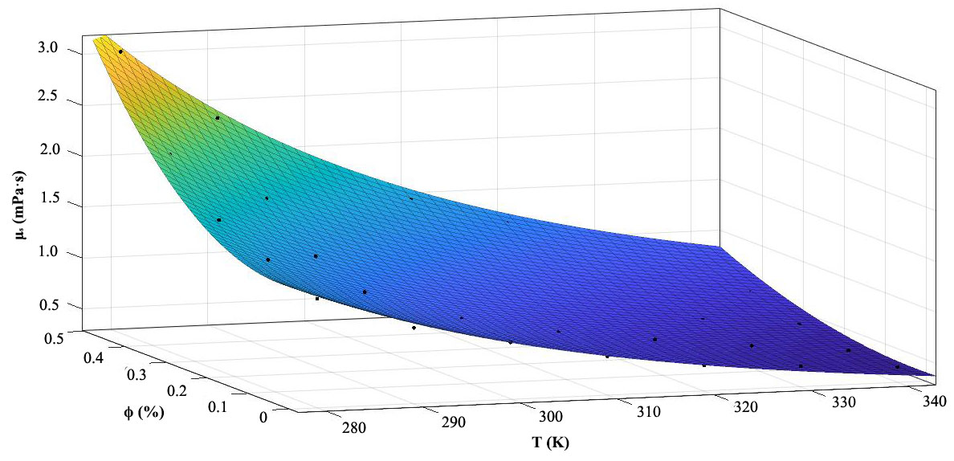
Fig S1 Comparison of viscosities metrics between calculated values through formular 2 (colored surface) and simulated values (black dots) through molecular dynamics modeling, with R² = 0.996.

