SUPPLEMENTARY INFORMATION
Intercalation of the anticancer drug lenalidomide into montmorillonite for bioavailability control. A computational study.
Yumeida V. Meruvia-Rojas^{a,b}, Esther Molina-Montes^{b,c} Alfonso Hernández-Lagunaª, C. Ignacio Sainz-Díazª
ª Instituto Andaluz de Ciencias de la Tierra, CSIC-UGR, Av. de las Palmeras, 4, 18100-Armilla, Granada, Spain.^{b} Pharmacy Faculty, University of Granada, Granada, Spain.
^{C} Instituto de Investigación Biosanitaria ibs. GRANADA, Granada, Spain.

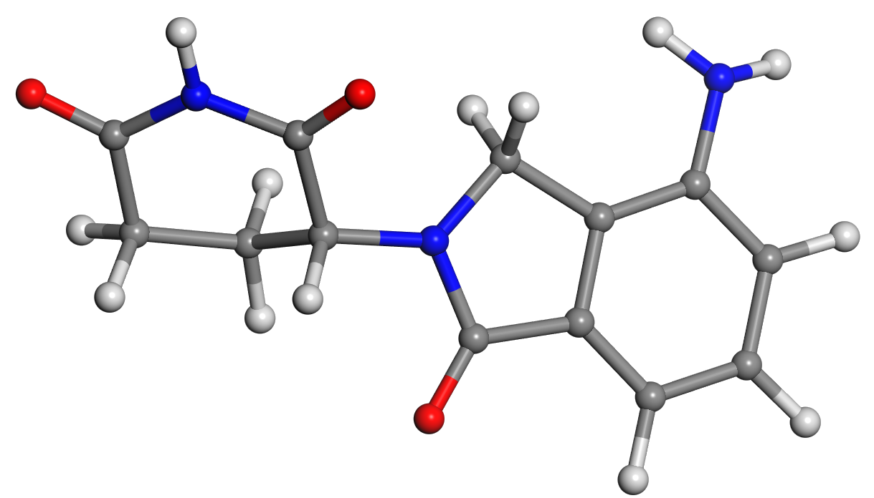a
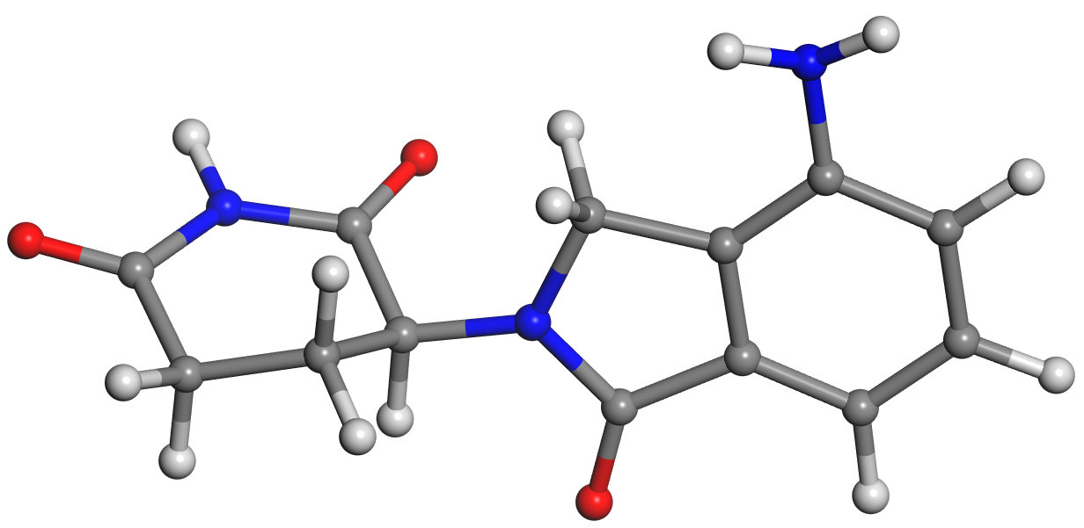b
Figure S1. Molecular structure of LEN optimized in 3-D PBC with INTERFACE (a) and Dmol³ (b).

Movie S1: Molecular dynamics simulations of MNT-LEN complex with INTERFACE (MNT_Len_DMmovie file)
Table S1 IR frequencies (in cm⁻¹) calculated for the optimized (INTERFACE FF) structures comparing with experimental values
Modeª | exp | molecule | LEN-1 | LEN-4 | MNT-LEN
ν(OH)_{w} |  |  |  |  | 3630-3416
ν(OH)_{oct} |  |  |  |  | 3517-3511
ν(NH₂)_{as} | 3475-3310^{b}, 3407^{k}, 3455^{m} | 3529 | 3437-3435 | 3461-3458 | 3377
ν(NH₂)_{s} | 3342^{k}, 3362^{m} | 3420 | 3337-3330 | 3341 | 3288
ν(NH) | 3250-3140^{b}, 3080^{k} | 3497 | 3420-3415 | 3380 | 3454
ν(CH) | 3080-3050^{b,c-d}, 3185-3148^{k}, 3080-3153^{m} | 3048^{c}, 3075^{d}, 3066e, | 3096-3092e, 3080^{d}, 3063^{c} | 3082^{c}, 3064^{d}, 3096e | 3053^{c}, 3075e, 3066^{d}
ν(CH₂) | 2975-2840^{b}, 2964^{k}, 3057^{m} | 2984^{h}, 2943^{f},  2938^{g}, | 3007^{f}, 2992^{h}, 2940^{g}, 2951^{f}, 2941^{h} | 2955^{f}, 2965^{h}, 3050^{h}, 2970^{g} | 3012^{h}, 3005^{g}, 2982^{f},
ν(CH₂)_{s} | 2964-2910^{k} | 2899^{f}, 2927^{h}, 2885^{g} | 2939^{h}, 2893^{g} | 2916^{g}, 2913^{f} | 2918^{f}, 2904^{g},  2960^{h}
ν(CH) | 2910-2879^{k}, 2841^{m} | 2924 | 2981 | 2949 | 2910
ν(C=O) | 1740-1620^{b}, 1700-1640^{k}, 1702-1675^{m} | 1801^{i}, 1766^{f}, 1790^{g} | 1800^{i}, 1772^{f}, 1787^{g} | 1797^{i}, 1762^{f}, 1792^{g} | 1791^{g}, 1785^{i}, 1768^{f}
δ(OH₂)_{s} |  |  |  |  | 1730-1673
δ(NH₂)_{s} | 1630-1603^{k}, 1633-1607^{m} | 1698-1648 | 1698-1648 | 1720, 1709 | 1652
ν(C=C)_{rn} | 1610-1400^{b} | 1757, 1693 | 1761, 1695 | 1765, 1698 | 1759
δ(CH) | 1486^{k}, 1493^{m} | 1542-1519^{c-d} | 1571-1526^{c-d} | 1545^{c-d}
δ(CH₂)_{s} | 1480^{k}, 1445^{m} | 1481^{g}, 1477^{f}, 1464^{h} | 1496^{f}, 1506^{g}, 1474^{h}, 1495^{g}, 1489^{f} | 1486^{f}, 1526^{g}, 1467^{h} | 1488-1443^{g}, 1479^{f}, 1463^{h}
δ(NH) | 1460-1411^{k}, 1445^{m} | 1381 | 1441, 1407 | 1429-1425
δ(CH) | 1341-1241^{k}, 1350-1169^{m} | 1352-1153 |  |  | 1534, 1476
γ(CH) | 880^{k}, 879^{m} | 923 | 942-879 | 960-900
ª Notation: s = symmetrical; as = asymmetrical; ν = stretching vibration; δ = bending in-plane vibration; γ = bending-out-of-plane vibration; w = water; oct = MOHM’ of octahedral sheet; rn = ring. ^{b} Interpreted by Chennuru et al. [14]. ^{c} Aromatic in meta position with respect to the amine group. ^{d} Aromatic in ortho position with respect to amine. ^{e} Aromatic in para position with respect to amine. ^{f} Piperidine ring in position α with the aromatic moiety. ^{g} In the heterocyclic ring. ^{h} Piperidine ring in position β with the aromatic moiety. ^{i} Piperidine ring in position γ with the aromatic moiety. ^{j} O=C-N-C=O. ^{k} Extracted from the spectra of LEN-1 [15]. ^{m} Extracted from the spectra of LEN-4 [14]

Table S2 IR frequencies (in cm⁻¹) calculated from the optimized (CASTEP) structures comparing with experimental values
Modeª | exp | molecule | LEN-1 | LEN-4
ν(NH₂)_{as} | 3475-3310^{b}, 3407^{k}, 3455^{m} | 3554 | 3455 | 3493-1490
ν(NH₂)_{s} | 3342^{k}, 3362^{m} | 3445 | 3361 | 3363-3362
ν(NH) | 3250-3140^{b}, 3080^{k} | 3425 | 3005 | 3052-3047
ν(CH) | 3080-3050^{b,c-d}, 3185-3148^{k}, 3153^{m} | 3115e, 3094^{c}, 3074^{d}, | 3114e, 3100^{c}, 3088^{d}, | 3117e, 3106^{c}, 3092^{d},
ν(CH₂) | 2975-2840^{b}, 2964^{k}, 3057^{m} | 3026^{h}, 3012^{f},  2919^{g}, | 3048^{f}, 3021^{h}, 2940^{g} | 3034^{h}, 3026^{f}, 2952^{g}, 2946^{f}ax, 2905^{h}ax
ν(CH₂)_{s} | 2964^{k} | 2949^{f}, 2937^{h}, 2877^{g} | 2991^{f}, 2942^{h}, 2902^{g} | 2915^{g},
ν(CH) | 2910-2879^{k}, 2841^{m} | 2909 | 2941-2939 | 2918
ν(C=O) | 1740-1620^{b}, 1700-1640^{k}, 1702-1633^{m} | 1721^{i}, 1710^{f}, 1697^{g} | 1686_{s}^{f,i}, 1667_{as}^{f,i}, 1639^{g} | 1692^{i}, 1685_{s}^{f,i}, 1684^{f}, 1650-1646^{g}
δ(NH₂)_{s} | 1630-1603^{k}, 1633-1607^{m} | 1614, 1591 | 1630 | 1625-1595
ν(C=C)_{rn} | 1610-1400^{b} | 1598 | 1595-1587 | 1585
δ(CH) | 1486^{k}, 1493^{m} | 1477-1443^{c-d}, 1384^{c-d} | (1475, 1307)^{c-d} | 1485^{c-d}
δ(CH₂)_{s} | 1460^{k}, 1445-1418^{m} | 1428^{g}, 1439^{f}, 1402^{h} | 1452^{f}, 1429^{g}, 1383^{h} | 1448-1435^{f}, 1427-1425^{g}, 1414^{h}, 1393^{g}
δ(NH) | 1460-1411^{k}, 1675-1445^{m} | 1366 | 1467 | 1675-1663
δ(CH) | 1341-1241^{k}, 1350-1169^{m} | 1369, 1324-1143 | 1442, 1378, 1348-1154 | 1382-1275
γ(NH) |  | 736 | 942 | 921
γ(CH) | 880^{k}, 983-879^{m} | 790-736 | 947 | 982
ª Notation: s = symmetrical; as = asymmetrical; ν = stretching vibration; δ = bending in-plane vibration; γ = bending-out-of-plane vibration; rn = ring. ^{b} Interpreted by Chennuru et al. [14]. ^{c} Aromatic in meta position with respect to the amine group. ^{d} Aromatic in ortho position with respect to amine. ^{e} Aromatic in para position with respect to amine. ^{f} Piperidine ring in position α with the aromatic moiety. ^{g} In the heterocyclic ring. ^{h} Piperidine ring in position β with the aromatic moiety. ^{i} Piperidine ring in position γ with the aromatic moiety. ^{j} O=C-N-C=O. ^{k} Extracted from the spectra of LEN-1 [15]. ^{m} Extracted from the spectra of LEN-4 [14].

