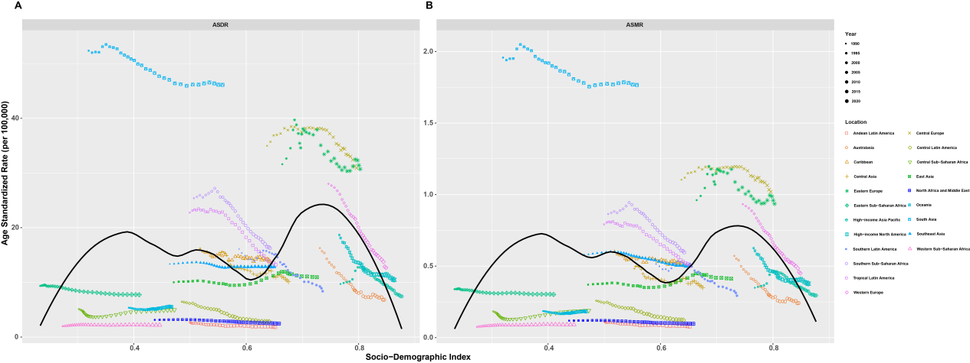
Supplementary Figure 1 Correlation analysis of ASDR, ASMR, and SDI in 21 GBD regions in 2021.
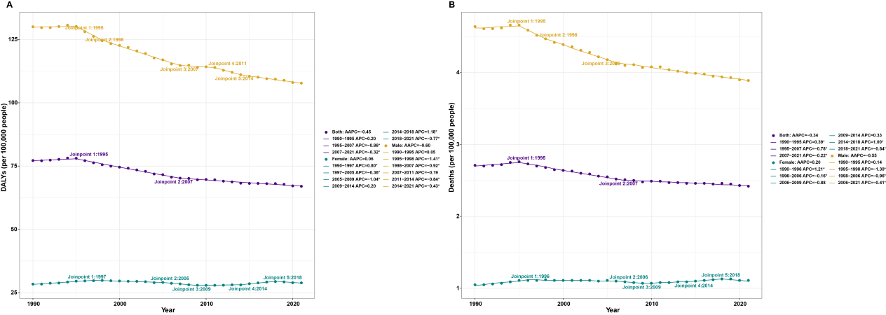
Supplementary Figure 2 Joinpoint regression analysis of global lip and oral cavity cancer attributable to behavioral risk factors, 1990–2021. (A) ASDR; (B) ASMR.
Supplementary Figure 3 Age-specific burden of lip and oral cavity cancer attributable to behavioral risk factors in 2021. (A) Mortality rate; (B) DALYs rate.
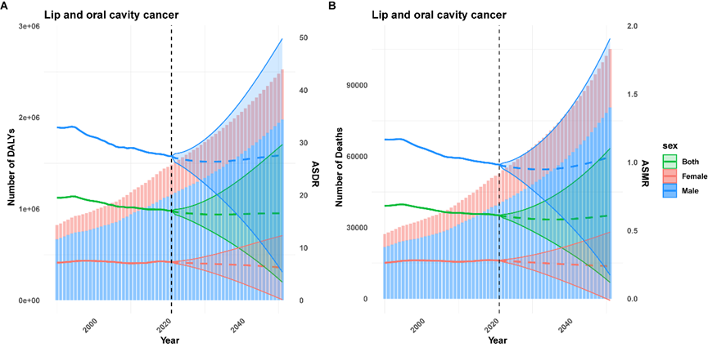
Supplementary Figure 4 Projected global burden of LOC attributable to behavioral risk factors for the next 30 years. (A) ASDR; (B) ASMR.

