Electrochemical properties of positive electrode in lead-acid battery modified by ammonium-based ionic liquids
Journal of Solid State Electrochemistry
Agnieszka Gabryelczyk¹, Kacper Kopczyński¹, Marek Baraniak¹, Bartosz Łęgosz¹, Filip Walkiewicz¹, Juliusz Pernak¹, Ewa Jankowska², Włodzimierz Majchrzycki², Paweł Kędzior³, Grzegorz Lota^{1,2,a,*}
¹Faculty of Chemical Technology, Poznan University of Technology, Berdychowo 4, 60-965 Poznan, Poland
²Institute of Non-Ferrous Metals Division in Poznan Central Laboratory of Batteries and Cells, Forteczna 12, 61-362 Poznan, Poland
³PPUH AUTOPART Jacek Bąk Sp. z o.o., Kwiatkowskiego 2a, 39-300 Mielec, Poland
ªISE member
*Corresponding author:
Tel. +48 61 665 2159 Fax +48 61 665 2571
E-mail address: grzegorz.lota@put.poznan.pl

Thermogravimetric curves of 3 samples of PQA have been shown (Fig. OR_1) in order to confirm the reproducibility of the synthesis. The samples were retrieved from different synthesis batches of the same ionic liquid.
Fig. OR_1 Thermogravimetric curves of three samples of PQA.

Corrosion current densities i_{corr} and corrosion potentials E_{corr} have been evaluated using Tafel extrapolation, where a tangent was drawn alongside cathodic and anodic branches of Tafel plot. The coordinates (x,y) of the crossover point of the two tangents represent the corrosion parameters (E_{corr}, i_{corr}).
Fig. OR_2 Potentiodynamic polarization curve of Pb-Ca-Sn alloy in electrolyte with PQA.

Fig. OR_3-OR_5 present pictures of positive electrode grids, before and after galvanostatic cycling. It can be observed that the corrosion effect on the reference grid (Fig. OR_4) is stronger in comparison to the grid coated with the mass which contained the ionic liquid (Fig. OR_5).

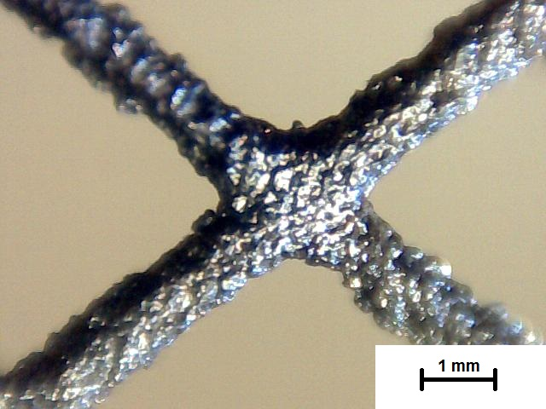
Fig. OR_3 Positive electrode grid before twenty galvanostatic cycles.
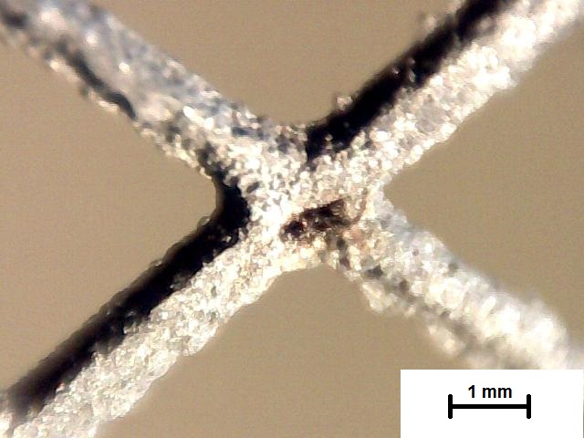
Fig. OR_4 Reference positive electrode grid after twenty galvanostatic cycles.

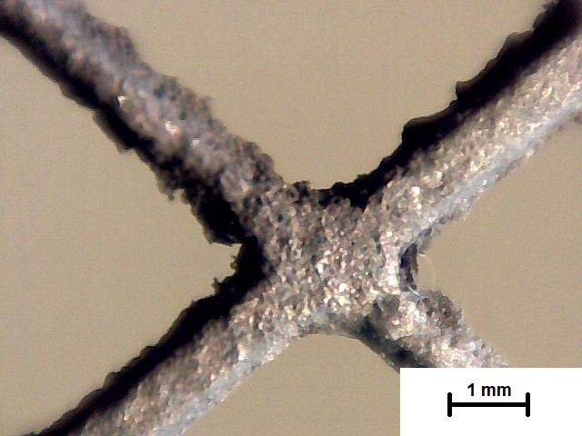
Fig.OR_5 Positive grid based on the modified positive electrode after twenty galvanostatic cycles.

