Supporting Information

Importance of catalyst-photoabsorber interface design configuration on the performance of Mo-doped BiVO₄ water splitting photoanodes
Olga A. Krysiak^{1,2}, João R.C. Junqueira¹, Felipe Conzuelo¹, Tim Bobrowski¹, Justus Masa³, Andrzej Wysmolek⁴, Wolfgang Schuhmann^{1,}*

¹Analytical Chemistry – Center for Electrochemical Sciences (CES), Faculty of Chemistry and Biochemistry, Ruhr University Bochum, Universitätsst. 150, D-44780 Bochum, Germany
²College of Inter-Faculty Individual Studies in Mathematics and Natural Sciences, University of Warsaw, Banacha 2c, 02-097 Warsaw, Poland
³Max Planck Institute for Chemical Energy Conversion, Stiftstraße 34-36, 45470 Mülheim an der Ruhr, Germany
⁴Institute of Experimental Physics, Faculty of Physics, University of Warsaw, Pasteura 5, 02-093, Warsaw, Poland

Linear sweep voltammetry
All measurements were conducted under chopped light, front-side irradiation (5 s light/5 s dark) with a scan rate of 1 mV s⁻¹. The photocurrent depicted in the manuscript are the result of subtracting the current measured in the dark from the current measured under illumination (calculated from chopped light measurements, grey line in Fig. S1b.
Fig. S1 Representation of LSV curves obtained. a) calculated dark, light and photocurrent, b) extended area of graph in panel a) for a potential range from 0.6 to 0.9 V with overlapped chopped light measurement plot.

Powder X-ray diffraction patterns
XRD-patterns for prepared BiVO₄ and Mo-doped BiVO₄ samples were compared with reference patterns. The obtained results proved that the prepared material corresponds with BiVO₄ (with small impurities) in a monoclinic Scheelite structure (space group: I2/b). After Mo-doping, BiVO₄ formed a tetragonal Scheelite structure (space group: I41/a), which is normally unstable without Mo. The calculated stoichiometric ratio of elements was: Bi_{0.94}Mo_{0.17}V_{0.83}O₄.
Fig. S2 Diffraction patterns for BiVO₄ and Mo:BiVO₄ samples in comparison with reference patterns from literature.[1, 2]
XRD-patterns for prepared NiFeCrO₄ catalyst powder shows the presence of a uniform phase of mixed Ni,Fe,Cr-oxides, with a NiFeCrO₄ stoichiometry. The obtained substance crystallises in the cubic crystal system, corresponding to the space group Fd3m (lattice constant, a = 8.311 Å). The shape of the reflections indicates small size crystallites.
Fig. S3 Diffraction pattern for a NiFeCrO₄ catalyst powder
Raman spectra of Mo-doped BiVO₄
Molybdenum doping leads to substitution of some vanadium atoms in the BiVO₄ crystal lattice by Mo atoms. As a result, several characteristic features appear in the recorded Raman spectra: the stretching mode [ν_{s}(V-O)] appearing at 826 cm⁻¹ shifts to lower wavenumbers, a shoulder assigned to the stretching mode of Mo-O-Mo [ν_{s}(Mo-O-Mo)] bonds appears at 877 cm⁻¹, and finally, the asymmetric and symmetric deformation modes of the VO₄ tetrahedra [δ_{as}(VO₄)³⁻ and δ_{s}(VO₄)³⁻, respectively] merge into a broader peak[3].
Mo:BiVO₄ samples are characterised by an increased separation of photogenerated charges[4].
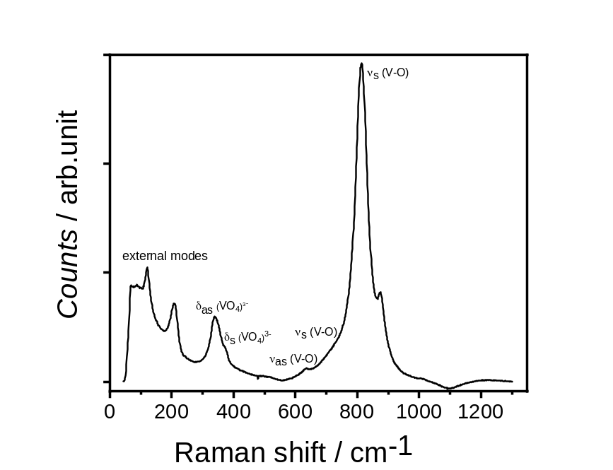
Fig. S4 Raman spectrum of prepared Mo:BiVO₄
UV-Vis spectroscopy
Fig. S5 Optical absorption of Mo:BiVO₄ and Mo:BiVO₄-catalyst modified photoanodes
Linear sweep voltammetry in the dark
Linear sweep voltammetry measurements conducted under dark conditions (without light illumination) show the appearance of a small electrocatalytic current after incorporation of the different catalysts. As can be seen in Fig. S5, only a few of the catalysts incorporated with Mo:BiVO₄ led to increased current in the absence of illumination. Notably, the observed increase appeared mostly at high anodic overpotentials and was not substantial, which proved that the detected photoactivity of the samples was not a result of background electrocatalytic activity.
Fig. S6 Linear sweep voltammetry recorded in dark in the absence (black line) and presence (other colours) of different catalysts, scan rate 1 mV s⁻¹ in 0.1 mol dm⁻³ sodium tetraborate, pH 9.3

Mo:BiVO₄ photoanode modified with layered-double hydroxide
The photograph in Fig. S7a presents a Mo:BiVO₄ sample (9 cm × 2 cm) with a NiFe-LDH embedded into the semiconductor film. The sample presents an increasing loading of catalyst along the substrate’s longer dimension. The transparency of the sample changes accordingly, following the changes in the amount of catalyst. For a high loading of catalyst, the sample becomes more transparent, suggesting hampering effect for Mo:BiVO₄ formation.
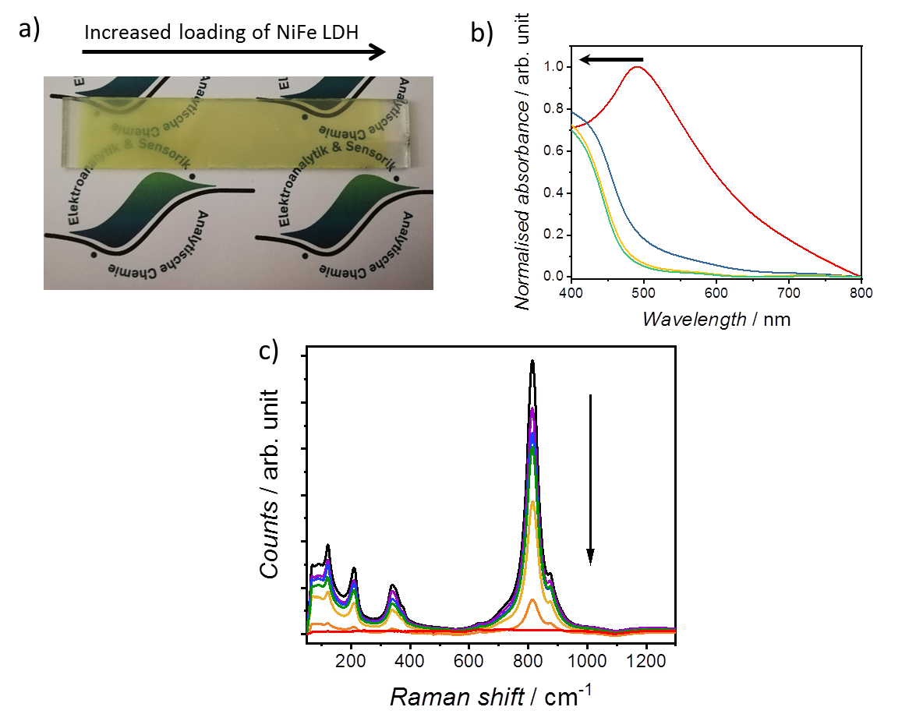
Fig. S7 a) Image of a Mo:BiVO₄ sample modified with a gradient loading of NiFe LDH embedded into the semiconductor film. b) Corresponding optical absorbance spectra, the arrow shows the direction of optical absorption change with an increased catalyst loading. c) Comparison of Raman spectra collected alongside the sample, the arrow shows the direction of an increased catalyst loading.

Tauc plots
Tauc plots obtained from optical absorbance measurements show significant narrowing of the sample bandgap after doping with Mo (from ca. 2.5 eV to 2.2 eV). The transitions visible at both plots, a) and b), and for both samples at ca. 3.0 eV and ca. 3.5 eV are the transitions from different states in the BiVO₄ valance band, composed mainly of O 2p and Bi 6s orbitals.[5] The presence of those transitions in both types of samples also indicates the absence of alterations in this part of the electronic structure.
Fig. S8 Tauc plots for a) indirect allowed and b) direct allowed transitions for BiVO₄ and Mo:BiVO₄ photoanodes

Calculation of light absorption and charge separation yields
Light absorption by the photoanodes was estimated from the AM1.5G radiation spectrum and the UV–vis absorbance data as reported in Ref.[6]
The water splitting photocurrent ($J_{H_{2}O}$) was defined by the rate of photon absorption expressed as a current density ($J_{abs}$), the charge separation yield of the photogenerated carriers in the bulk ($η_{bulk}$), and the charge separation yield at the surface ($η_{surf}$):
$$J_{H_{2}O}=J_{abs}×η_{bulk}×η_{surf}$$
The photocurrent measured with sulfites in the electrolyte ($J_{SO_{3}}$) was the product of $J_{abs}$ and $η_{bulk}$ only:
$$J_{SO_{3}}=J_{abs}×η_{bulk}$$
because in the presence of hole scavenger in the electrolyte the charge injection yield becomes 100%.
The charge injection yield into water was then defined as:
$$η_{surf}= \frac{J_{H_{2}O}}{J_{{SO}_{3}}}$$
Charge separation can be calculated by:
$$η_{bulk}= \frac{J_{SO_{3}}}{J_{abs}}$$
$J_{abs}$ can be obtained by measuring the light absorption of the sample and integrating it with respect to the AM1.5G solar spectrum:
$J_{abs}(\frac{mA}{{cm}^{2}})=\int_{λ_{1}}^{λ_{2}}{\frac{λ}{1240}P_{abs}}\left(λ\right)dλ(\frac{mW}{{cm}^{2}})$,
where:
$$P_{d}=P_{0} {10}^{-A}$$
$$P_{abs}=P_{0}(1-{10}^{-A})$$
$P_{0}$ (mW cm⁻² nm⁻¹): power provided by the solar simulator
A: absorbance
$P_{abs}$: power of light absorbed by the photocatalyst
$P_{d}$: power of dissipated light (reflection and penetration)

(Photo)electrochemical impedance measurements (PEIS)
Impedance spectra are presented only for the pristine Mo:BiVO₄ electrode and for Mo:BiVO₄ electrodes modified with catalysts in their optimal film configuration (where an increase in the measured photocurrent has been observed). All the samples measured exhibited the same general trends: for measurements conducted in the dark, a capacitive contribution is observed that is more predominant for increasing applied potentials. For measurements conducted under irradiation, characteristic semicircles are observed with decreasing resistivity as the applied potential is increased.

Fig. S9. Nyquist plots recorded in the dark and under illumination on a Mo:BiVO₄ ﬁlm. The measurements were performed in 0.1 mol dm⁻³ sodium tetraborate, pH 9.3 under simulated AM 1.5G illumination

Fig. S10. Nyquist plots recorded in dark and under illumination on the electrodes with different oxygen evolution catalysts incorporated into the Mo:BiVO₄ film. The measurements were performed in 0.1 mol dm⁻³ sodium tetraborate, pH 9.3 under simulated AM 1.5G illumination.
Fig. S11 Nyquist plots recorded in dark and under illumination on the electrodes with different oxygen evolution catalysts deposited on top of the Mo:BiVO₄ film. The measurements were performed in 0.1 mol dm⁻³ sodium tetraborate, pH 9.3 under simulated AM 1.5G illumination.

Table S1. Resistance and capacitance values obtained from the Nyquist plots presented in Figs. S9-11 measured under illumination.
 | U / V vs. RHE | R_{u} / kΩ | R_{ct} / kΩ | C_{d} / µF
Mo:BiVO₄ | 0.4 | 0.164 | 11.091 | 143
Mo:BiVO₄ | 0.6 | 0.154 | 0.994 | 86.1
Mo:BiVO₄ | 0.8 | 0.150 | 0.41 | 24.7
Mo:BiVO₄ | 1.0 | 0.145 | 0.327 | 13.7
Mo:BiVO₄ | 1.2 | 0.144 | 0.345 | 6.6
Mo:BiVO₄ | 1.4 | 0.142 | 0.296 | 6.3
Mo:BiVO₄ + Co₃O₄ inside | 0.4 | 0.325 | 9.132 | 77.6
Mo:BiVO₄ + Co₃O₄ inside | 0.6 | 0.228 | 3.007 | 69.3
Mo:BiVO₄ + Co₃O₄ inside | 0.8 | 0.208 | 1.146 | 46.7
Mo:BiVO₄ + Co₃O₄ inside | 1.0 | 0.178 | 0.777 | 20.7
Mo:BiVO₄ + Co₃O₄ inside | 1.2 | 0.190 | 0.544 | 13.0
Mo:BiVO₄ + Co₃O₄ inside | 1.4 | 0.192 | 0.489 | 11.6
Mo:BiVO₄ + NiFeCrO₄ inside | 0.4 | 0.238 | 7.903 | 77.1
Mo:BiVO₄ + NiFeCrO₄ inside | 0.6 | 0.256 | 0.250 | 59.7
Mo:BiVO₄ + NiFeCrO₄ inside | 0.8 | 0.209 | 0.181 | 11.6
Mo:BiVO₄ + NiFeCrO₄ inside | 1.0 | 0.205 | 0.206 | 10.6
Mo:BiVO₄ + NiFeCrO₄ inside | 1.2 | 0.192 | 0.250 | 7.7
Mo:BiVO₄ + NiFeCrO₄ inside | 1.4 | 0.187 | 0.249 | 6.4
Mo:BiVO₄ + NiFeO_{x} inside | 0.4 | 0.307 | 0.478 | 46.8
Mo:BiVO₄ + NiFeO_{x} inside | 0.6 | 0.386 | 0.061 | 11.5
Mo:BiVO₄ + NiFeO_{x} inside | 0.8 | 0.245 | 0.213 | 17.1
Mo:BiVO₄ + NiFeO_{x} inside | 1.0 | 0.417 | 0.267 | 2.4
Mo:BiVO₄ + NiFeO_{x} inside | 1.2 | 0.310 | 0.174 | 16.3
Mo:BiVO₄ + NiFeO_{x} inside | 1.4 | 0.229 | 0.026 | 20.5
Mo:BiVO₄ + CoFe LDH on top | 0.4 | 0.164 | 8.062 | 88.7
Mo:BiVO₄ + CoFe LDH on top | 0.6 | 0.172 | 0.342 | 50.1
Mo:BiVO₄ + CoFe LDH on top | 0.8 | 0.150 | 0.215 | 13.2
Mo:BiVO₄ + CoFe LDH on top | 1.0 | 0.147 | 0.221 | 11.1
Mo:BiVO₄ + CoFe LDH on top | 1.2 | 0.148 | 0.232 | 8.9
Mo:BiVO₄ + CoFe LDH on top | 1.4 | 0.147 | 0.251 | 7.3
Mo:BiVO₄ + NiFe LDH on top | 0.4 | 0.214 | 10.854 | 59.4
Mo:BiVO₄ + NiFe LDH on top | 0.6 | 0.222 | 6.923 | 32.5
Mo:BiVO₄ + NiFe LDH on top | 0.8 | 0.201 | 4.403 | 33.8
Mo:BiVO₄ + NiFe LDH on top | 1.0 | 0.200 | 3.299 | 29.1
Mo:BiVO₄ + NiFe LDH on top | 1.2 | 0.180 | 2.917 | 27.7
Mo:BiVO₄ + NiFe LDH on top | 1.4 | 0.136 | 2.620 | 29.3
Table S1. (Continued).

 | U / V vs. RHE | R_{u} / kΩ | R_{ct} / kΩ | C_{d} / µF
Mo:BiVO₄ + NiFeCrO₄ on top | 0.4 | 0.188 | 9.387 | 71.3
Mo:BiVO₄ + NiFeCrO₄ on top | 0.6 | 0.170 | 0.338 | 41.4
Mo:BiVO₄ + NiFeCrO₄ on top | 0.8 | 0.169 | 0.189 | 11.2
Mo:BiVO₄ + NiFeCrO₄ on top | 1.0 | 0.168 | 0.203 | 9.6
Mo:BiVO₄ + NiFeCrO₄ on top | 1.2 | 0.163 | 0.228 | 7.0
Mo:BiVO₄ + NiFeCrO₄ on top | 1.4 | 0.161 | 0.252 | 5.6
Mo:BiVO₄ + NiFeO_{x} on top | 0.4 | 0.385 | 5.882 | 65.4
Mo:BiVO₄ + NiFeO_{x} on top | 0.6 | 0.314 | 0.543 | 27.4
Mo:BiVO₄ + NiFeO_{x} on top | 0.8 | 0.327 | 0.300 | 10.3
Mo:BiVO₄ + NiFeO_{x} on top | 1.0 | 0.333 | 0.231 | 9.1
Mo:BiVO₄ + NiFeO_{x} on top | 1.2 | 0.322 | 0.216 | 7.5
Mo:BiVO₄ + NiFeO_{x} on top | 1.4 | 0.302 | 0.216 | 6.2
Mo:BiVO₄ + Ni_{x}B on top | 0.4 | 0.194 | 10.261 | 91.8
Mo:BiVO₄ + Ni_{x}B on top | 0.6 | 0.166 | 1.524 | 78.1
Mo:BiVO₄ + Ni_{x}B on top | 0.8 | 0.163 | 0.444 | 38.4
Mo:BiVO₄ + Ni_{x}B on top | 1.0 | 0.162 | 0.273 | 19.7
Mo:BiVO₄ + Ni_{x}B on top | 1.2 | 0.160 | 0.223 | 12.1
Mo:BiVO₄ + Ni_{x}B on top | 1.4 | 0.158 | 0.208 | 9.8

References
1. Cesari M, Perego G, Zazzetta A et al. (1971) The crystalstructures of the bismuth molybdovanadates and of the a-phase bismuth molybdate. Polyhedron 33: 3395–3397
2. Sleight AW, Chen H-y, Ferretti A (1979) Crystalgrowth and structure of BiVO4. Mater. Res. Bull. 14: 1571–1581
3. Merupo VI, Velumani S, Oza G et al. (2015) Structural, electronic and optical features of molybdenum-doped bismuth vanadium oxide. Mater. Sci. Semicond. Process. 31: 618–623. doi: 10.1016/j.mssp.2014.12.057
4. Yao W, Iwai H, Ye J (2008) Effects of molybdenum substitution on the photocatalytic behavior of BiVO₄. Dalton Trans.(11): 1426–1430. doi: 10.1039/b713338c
5. Zhao Z, Li Z, Zou Z (2011) Electronic structure and optical properties of monoclinic clinobisvanite BiVO₄. Phys. Chem. Chem. Phys. 13(10): 4746–4753. doi: 10.1039/c0cp01871f
6. Dotan H, Sivula K, Grätzel M et al. (2011) Probing the photoelectrochemical properties of hematite (α-Fe₂O₃) electrodes using hydrogen peroxide as a hole scavenger. Energy Environ. Sci. 4(3): 958–964. doi: 10.1039/C0EE00570C

