Supplementary information
This supplement provides information about commercial instrumentation for measurements of capacitor and supercapacitor data, in particular capacity and electric series resistance ESR.
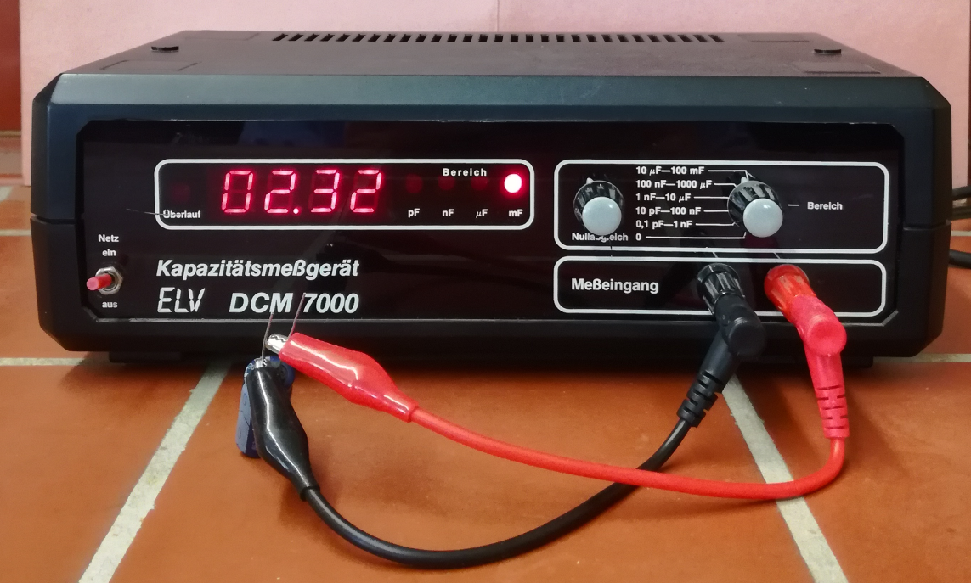
Fig. S1: Instrument ELV DCM 7000 for capacity measurements.
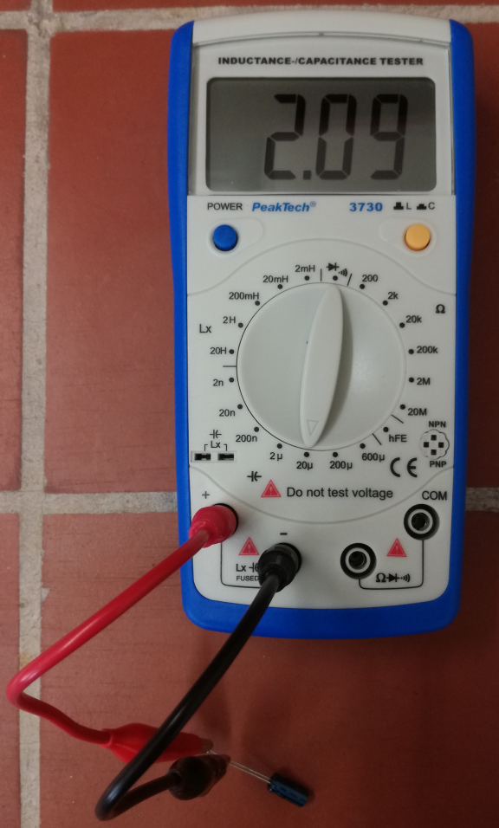
Fig. S2: Instrument Peaktech 3730 for capacity measurements.
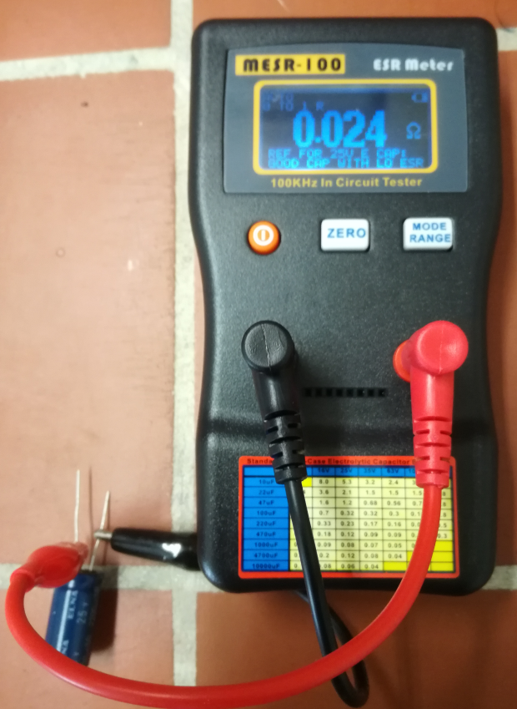
Fig. S3: Instrument Jingyan MESR100 V2 for ESR measurements.
Table S1: ESR values of the tested supercaps obtained with the instrument MESR100 V2 and from impedance measurements
nominal capacitance | 1 F | 10 F | 100 F | 500 F
ESR with MESR100 V2 | 4.84 Ω | 0.019 Ω | 0.007 Ω | 0.004 Ω
ESR from impedance measurements | 8.7 Ω | 0.08 Ω | 0.08 Ω | 0.009 Ω
The differences are mostly due to experimental differences. With the instrument MESR100 V2 an explicit zeroing of wire and contact resistances is performed before the actual measurement. The rather large value of ESR for the 1 F supercap may be due to its mechanical construction (button type) different from the construction of the other samples.

