Supporting information
Structure and Particle Surface Analysis of Li₇P₂S₈I Solid Electrolytes Synthesized by Liquid-Phase Shaking
Kazuhiro Hikima ^{1z}, Kaito Ogawa ¹, Radian Febi Indrawan ¹, Hirofumi Tsukasaki ², Satoshi Hiroi ³, Koji Ohara ³, Kazutaka Ikeda ⁴, Toshiki Watanabe ⁵, Toshiyuki Matsunaga ⁵, Kentaro Yamamoto ⁶, Shigeo Mori ², Yoshiharu Uchimoto ⁵ and Atsunori Matsuda ¹

¹ Department of Electrical and Electronic Information Engineering, Toyohashi University of Technology, 1-1 Hibarigaoka, Tempaku, Toyohashi, Aichi 441-8580, Japan
² Department of Materials Science, Graduate School of Engineering, Osaka Metropolitan University, 1-1, Gakuen-cho, Naka-ku, Sakai, Osaka 599-8531, Japan
³ Faculty of Materials for Energy, Shimane University, 1060 Nishi-Kawatsu-cho, Matsue, Shimane 690-8504, Japan
⁴ Neutron Industrial Application Promotion Center, Comprehensive Research Organization for Science and Society (CROSS), Tokai, Ibaraki 319-1106, Japan
⁵ Graduate School of Human and Environmental Studies, Kyoto University, Sakyo-ku, Kyoto 606-8501, Japan
⁶ Faculty of Engineering, Nara Women’s University, Kitauoya-nishimachi, Nara 630-8263, Japan
^{z} Corresponding author: E-mail: hikima@ee.tut.ac.jp

Figure S1. Synchrotron XRD patterns of Li₇P₂S₈I solid electrolytes synthesized by liquid phase shaking method.

Figure S2. XRD patterns of Li₇P₂S₈I solid electrolytes synthesized by mechanical milling method.

Figure S3. TEM observation results of Li₇P₂S₈I solid electrolytes synthesized by mechanical milling method. (a) BF images and ED patterns, and (b) ED intensity profiles and the corresponding HCDF images. ED patterns in (a) were taken from the observed areas, as indicated by the circles in BF images.

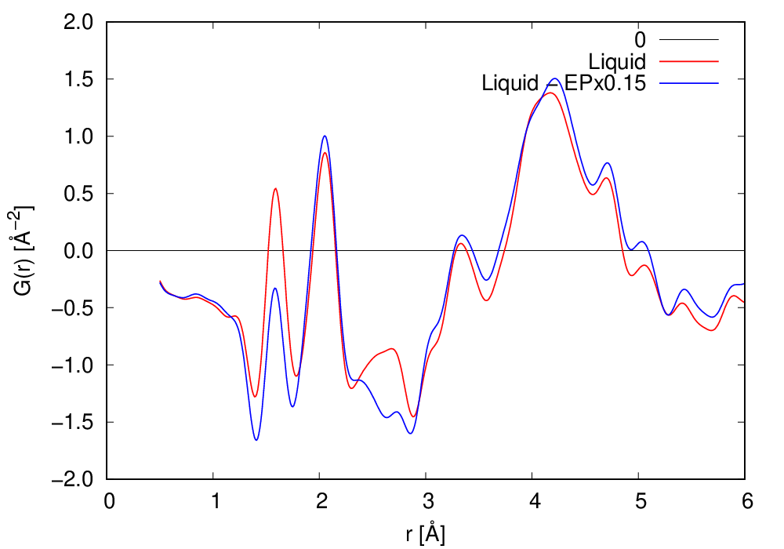
Figure S4. Pair Distribution Function (PDF) analysis results of Li₇P₂S₈I solid electrolytes synthesized by liquid phase shaking method and the difference from ethyl propionate solvent was calculated.

