Comparative Life Cycle Assessment of Sequential Chemical and Electrochemical Processes for the Treatment of Industrial Textile Wastewater

Luis Miguel Salazar Sogamoso¹, Miguel-Ángel Gómez-García¹, Izabela Dobrosz-Gómez^{2*}

¹Universidad Nacional de Colombia - Sede Manizales; Departamento de Ingeniería Química; Facultad de Ingeniería y Arquitectura; GI-PRISMA: Grupo de Investigación en Procesos Reactivos Intensificados y Materiales Avanzados; LM&PR: Laboratorio de Materiales y Procesos Reactivos; Campus La Nubia, Manizales, 170003, Colombia. lumsalazarso@unal.edu.co, magomez@unal.edu.co
²Universidad Nacional de Colombia - Sede Manizales; Departamento de Física y Química; Facultad de Ciencias Exactas y Naturales; GI-PRISMA: Grupo de Investigación en Procesos Reactivos Intensificados y Materiales Avanzados; LM&PR: Laboratorio de Materiales y Procesos Reactivos; Campus La Nubia, Manizales, 170003, Colombia. idobrosz-gomez@unal.edu.co
*Corresponding author: (57) 606 8879300, idobrosz-gomez@unal.edu.co, Universidad Nacional de Colombia, Campus La Nubia, Bloque L, 226, Manizales, 170003, Colombia.

Supplementary Material

Table S1. Physicochemical (following standard methods [73]) and biological (following ISO procedures) parameters of the ITWW and the supernatant from the Coagulation-Flocculation treatment (ITWW-CF), objects of this study. The values ​​reported for ITWW are average values ​​of 3 samplings carried out monthly. The values ​​reported for ITWW-CF are average values ​​of the supernatant of the CF process and correspond to approx. 36 L of treated ITWW, specifically 18 jars of 2 liters each. The maximum permissible discharge limits (*) ​​for textile industry effluents are also included according to current environmental regulations [30].

Table S2. The main characteristics of the CF, CF-F-N and CF-EF-N processes implemented in the treatment of textile effluent

Figure S1. Relative impact of the most harmful reagents in (a) F-N and (b) EF-N during their life cycle assessment according to the ReCiPe-2016 method at the midpoint level

Figure S2. Relative impact of electricity in sequential processes, EF-N and F-N, estimated using ReCiPe-2016 method at the midpoint level

Note: The numbering of bibliographic references coincides with that of the main text for the reader's convenience.

Table S1. Physicochemical (following standard methods [73]) and biological (following ISO procedures) parameters of the ITWW and the supernatant from the Coagulation-Flocculation treatment (ITWW-CF), objects of this study. The values ​​reported for ITWW are average values ​​of 3 samplings carried out monthly. The values ​​reported for ITWW-CF are average values ​​of the supernatant of the CF process and correspond to approx. 36 L of treated ITWW, specifically 18 jars of 2 liters each. The maximum permissible discharge limits (*) ​​for textile industry effluents are also included according to current environmental regulations [30].
Parameter | Unit | Standard method [73] /  ISO procedure | Discharge limit* [30] | Average values
 |  |  |  | ITWW | ITWW-CF
General
pH | - | 4500-H⁺ B | 6.00 a 9.00 | 7.76 ± 0.39 | 7.24 ± 0.91
Chemical Oxygen Demand (COD) | mg/L O₂ | 5220 D | 400.00 | 3375 ± 300.3 | 1282 ± 111
Biochemical Oxygen Demand (BOD₅) | mg/L O₂ | 5210 B | 200.00 | 686.6 ± 46.3 | 310.3 ± 104
Total Suspended Solids (TSS) | mg/L | 2540 D | 50.00 | 90.2 ± 40.5 | 10.88 ± 1.30
Oil and Grease | mg/L | 5520 D | 20.00 | 9.82 ± 1.3 | 3.5 ± 0.3
Phenols | mg/L | 5530 B,C | 0.20 | 0.61 ± 0.07 | N. D.
Hydrocarbons
Hydrocarbons | mg/L | 5520 F | 10.00 | 1.27 ± 0.09 | 0.24 ± 0.06
Nitrogen Compounds
Nitrogen (N) | mg/L | 4500-N | A&R | 705.2 ± 697.7 | 367 ± 256.3
Ions
Chloride (Cl⁻) | mg/L | 4500-Cl⁻ B | 1200.00 | 192.0 ± 95.8 | 123.3 ± 19.43
Sulfate (SO₄²⁻) | mg/L | 4500-SO₄²⁻ E | A&R | 1480 ± 156.6 | 1526 ± 451
Metals and Metalloids
Aluminum (Al) | mg/L | 3111 B | N.A. | 0.58 ± 0.28 | 0.73 ± 0.12
Cadmium (Cd) | mg/L | 3111 B | 0.02 | < LDM | < LDM
Cobalt (Co) | mg/L | 3111 B | 0.50 | < LDI | < LDI
Cupper (Cu) | mg/L | 3111 B | 1.00 | < LDM | < LDM
Chromium (Cr) | mg/L | 3111 B | 0.50 | 23.18 ± 6.09 | 1.55 ± 0.81
Iron (Fe) | mg/L | 3111 B | N.A. | 1.46 | < LCM
Nickel (Ni) | mg/L | 3111 B | 0.50 | < LCM | < LCM
Zinc (Zn) | mg/L | 3111 B | 3.00 | 0.20 | < LCM
Other Parameters for Analysis and Report
True color (Absorbance measurements  at different wavelengths: 436, 525 and 620 nm) | m⁻¹ | ISO 7887: 2012-04 B,  2120-D | A&R | ª147.1 ± 37.1  ª149.2 ± 36.8  ª140.8 ± 31.9 | 104.5 ± 51.7  66.5 ± 41.6  53.8 ± 33.7
Additional parameters of interest (not included in current environmental regulation)
Total Organic Carbon (TOC) | mg/L C | 5310 B | N.A. | 1330 ± 55 | 530 ± 70
Conductivity | mS/cm | 2510 B | N.A. | 2.27 ± 0.43 | 4.07 ± 0.69
Hexavalent Chromium | mg/L | 3500-Cr B | N.A. | 21.39 ± 2.51 | 0.34 ± 0.02
Dissolved Oxygen | mg/L | 4500-O B | N.A. | 0.9 ± 0.7 | 1.69 ± 0.25
Turbidity | NTU | 2130 B | N.A. | 261.6 ± 92.4 | 86.5 ± 0.85
Color | mg/L | 2120 C | N.A. | 1048 ± 85 | 35.31 ± 23.10
Color | U. Pt-Co | 2120 B | N.A. | 44232 ± 2187 | 2522 ± 1447
Color | RGB Scale | 2120 E | N.A. | [7; 0; 0] | [153; 122; 94]
Color | Tone | N.A. | N.A.
Median lethal concentration  (LC₅₀ Artemia salina) | mg/L | ISO 6341:2012  ISO 5667-16:2000 | N.A. | 15.1 ± 2.0 | 51.1 ± 3.3
N.A.: Does not apply; A & R: Analysis and Report; Dilution factor used for measurement: ª = 1:6.67; LDI (Instrument Detection Limits): Cd = 0.003 mg/L; Co = 0.01 mg/L; Cu=0.005 mg/L; LCM (Limit of quantification): Al = 1.86 mg/L; Cr = 0.75 mg/L; Ni = 0.61 mg/L; Zn = 0.13 mg/L.

Table S2. The main characteristics of the CF, CF-F-N and CF-EF-N processes implemented in the treatment of textile effluent.
Experimental setup configuration |  |  | Primary treatment | Sequential AOP
 |  |  | Coagulation-Flocculation | Fenton | Electro-Fenton
Reactor type |  |  | Rectangular jar with paddle stirrer (ASTM D2035) | Batch, under continuous stirring, jacketed bath (F-12-CM, Julabo GmbH) with temperature control (PT-100, ±0.01 K) | Electrochemical cell, under continuous stirring, single compartment, monopolar configuration of electrodes arranged in parallel, galvanostatic mode of operation, jacketed bath (F-12-CM, Julabo GmbH) with temperature control (PT-100, ±0.01 K)
Reactor material |  |  | Polycarbonate | Borosilicate glass | Borosilicate glass
Reactor volume (L) |  |  | 2.0 | 0.2 | 0.2
Electrode material |  |  | N.A. | N.A. | Boron-doped diamond anode  (BDD/Si ​​NeoCoat®-Electrodes, Switzerland; submerged area of 20 cm²);  Commercial activated carbon felt cathode (ACF1600, 1500 m²/g, Ceramaterials LLC, USA; submerged area of 30 cm²)
Distance between electrodes (cm) |  |  | N.A. | N.A. | 1
Reactor inputs |  |  | ITWW  Al₂(SO₄)₃·14H₂O (98% p/p, Protokimica, Colombia)  Ca(OH)₂ (99% p/p, BDH La, Colombia) | ITWW-CF  FeSO₄.7H₂O (Extra Pure Grade, Duksan, Korea);  H₂O₂ (30% p/p, Biopharchem, Sigma Aldrich, USA)  H₂SO₄ (95-97%, 1.84 g/cm³, Merck KGaA, Germany)  Ca(OH)₂ (g/L)  (97% m/m, BDH La, Colombia) | ITWW-CF  External DC power supply 0-30V, 0-6A (OWON® ODP3063, China);  FeSO₄.7H₂O (Extra Pure Grade, Duksan, Korea);  NaCl (ACS, para análisis, Merck, Germany);  H₂SO₄ (95-97%, 1.84 g/cm³, Merck KGaA, Germany)  NaOH (g/L)  (≥97% m/m, Carlo Erba, France)
Reactor outputs |  |  | ITWW-CF  Sludge (12.4 g/L) | ITWW-CF-F-N  Sludge (7.65 g/L) | ITWW-CF-EF-N  Sludge (0.21 g/L)
Aeration flow (L/min) |  |  | N.A. | N.A. | 1.6
Stirring velocity (rpm) |  |  | Alkalinization (Ca(OH)₂):  150 rpm – 5 min  Fast mixing stage (Al₂(SO₄)₃·14H₂O):  150 rpm – 1 min  Slow mixing stage:  40 rpm – 20 min  Settling – 15 min | 190 | 500
Optimization of operating conditions
Independent variables |  |  | [Al₂(SO₄)₃·14H₂O] = 7-22 g/L  Ca(OH)₂ = 3-9 g/L | pH = 2.82–5,  [Fe²⁺] = 564–2000 mg/L,  [H₂O₂] = 3153–8000 mg/L | j = 3.33–13.33 mA/cm²,  [Fe²⁺] = 0.1–3 mM,  [NaCl] = 0–2000 mg/L
Dependent variables |  |  | %R_{COD}  %R_{Color}  TOpC  GS  pH_{final} | %R_{COD}  TOpC | COD/COD₀  TOC/TOC₀  TOpC
Optimization methodology |  |  | CCD (two levels and two factors), RSM | CCD (two levels and three factors), RSM | CCD (two levels and three factors), RSM
Optimization conditions |  |  | Multivariable, restricted:  maximize: R_{COD} + R_{Color,} + minimize: (TOpC) + pH_{final} ≥ 6 | Multivariable, restricted:  maximize: R_{COD} subject to R_{COD} ≥ 71% [30] + minimize: TOpC | Multivariable, restricted  Minimize: COD/COD₀ subject to COD/COD₀ ≤ 0.36 [30] + minimize: TOC/TOC₀ + minimize: TOpC)
Optimization tool |  |  | Design Expert®  $$D={(d_{1}^{w1}d_{2}^{w2})}^{1/\sum{w_{i}}}$$  MatLab® (functions: patternsearch (which determines the highest “desirability” optimization parameter) and fmincon (optimization) | Design Expert®  $$D={(d_{1}^{w1}d_{2}^{w2})}^{1/\sum{w_{i}}}$$  MatLab® (functions: patternsearch (which determines the highest “desirability” optimization parameter) and fmincon (optimization) | Design Expert®  $$D={(d_{1}^{w1}d_{2}^{w2}d_{3}^{w3})}^{1/\sum{w_{i}}}$$  MatLab® (functions: patternsearch (which determines the highest “desirability” optimization parameter) and fmincon (optimization)
Optimal operating conditions
Al₂(SO₄)₃·14H₂O (g/L) |  |  | 16.09 | N.A. | N.A.
Ca(OH)₂ (g/L) |  |  | 5.16 | N.A. | N.A.
[H₂O₂] (mg/L) |  |  | N.A. | 3679 | N.A.
[Fe²⁺] (mg/L) |  |  | N.A. | 1977 | 104.77
[NaCl] (mg/L) |  |  | N.A. | N.A. | 107.43
pH |  |  | > 12.1 | 2.31 | 3.0
Current density (j) (mA/cm²) |  |  | N.A. | N.A. | 5.1
Treatment time (min) |  |  | 41 | 180 | 120
Temperature (ºC) |  |  | 20 | 20 | 20
NaOH (g/L)  (≥97% m/m, Carlo Erba, France) |  | Neutralization | N.A. | N.A. | 0.40
Ca(OH)₂ (g/L)  (97% m/m, BDH La, Colombia) |  | Neutralization | N.A. | 4.63 | N.A.
Organic compound removal performance
%R_{COD} | 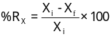 |  | 61.01 ± 3.32 | 71.25 ± 0.31 | 66.86 ± 2.81
%R_{TOC} |  |  | 60.15 ± 4.10 | 66.09 ± 0.48 | 61.84 ± 1.74
%R_{Color} |  |  | 97.14 ± 1.18 | 99.58 ± 0.05 | 96.25 ± 1.86
Operating costs (TOpC) (USD/m³) |  |  | 5.99 ± 0.11  $$\text{TOp}{\text{C}}_{\text{C-F}}\left[\frac{\text{USD}}{m^{3}}\right]=\frac{P_{alum}[alum]}{Purity_{alum}} \\ +\frac{P_{\text{Ca}(\text{OH})_{2}}[Ca(OH)_{2}]}{Purity_{Ca(OH)_{2}}} \\ +P_{sludge}×C_{\text{sludge }}$$ | 7.67 ± 0.02  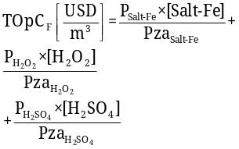 | 5.92 ± 0.10  $$TOpC_{EF}\left[\frac{USD}{m^{3}}\right]=\frac{P_{Salt-Fe}×[Salt-Fe]}{{Pza}_{Salt-Fe}}+\frac{P_{H_{2}{SO}_{4}}×[H_{2}{SO}_{4}]}{{Pza}_{H_{2}{SO}_{4}}}+P_{electricity}×E_{c}$$
%R_{COD-}sequential |  |  | N.A. | 88.28 ± 0.27 | 89.34 ± 1.68
%R_{TOC-} sequential |  |  | N.A. | 86.39 ± 0.62 | 86.92 ± 0.75
%R_{Color-} sequential |  |  | N.A. | 99.99 ± 0.01 | 99.76 ± 0.07
pH_{final} |  |  | 7.24 ± 0.96 | 6.1 ± 0.10 | 7.9 ± 0.20
Total operational costs (TOpC_{total}) (USD/m³) |  |  | 5.99 ± 0.11  N.A. | 13.66 ± 0.12  $$TOpC_{F-N}\left[\frac{USD}{m^{3}}\right]=TOpC_{F} \\ +\frac{P_{Ca(OH)_{2}}×[Ca(OH)_{2}]}{Purity_{Ca(OH)_{2}}}+ \\ P_{sludge}×C_{\text{sludge }}$$ | 11.91 ± 0.21  $$TOpC_{EF-N}\left[\frac{USD}{m^{3}}\right]=TOpC_{EF} \\ +\frac{P_{NaOH}×[NaOH]}{Purity_{NaOH}}+ \\ P_{sludge}×C_{sludge}$$
Medium Lethal Concentration  (LC₅₀ Artemia salina) (mg/L) |  |  | 51.1 ± 3.3 | Non-toxic | Non-toxic
Reference |  |  | [67] | [65] | [66]
N.A.: Does not apply; CCD - Central Composite experimental Design; RSM - Response Surface Methodology; 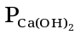, 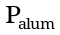 , 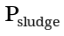,
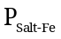, 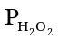, 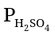, 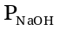represented the costs (USD/kg) of: slaked lime, alum, sludge disposal, iron sulfate heptahydrate, hydrogen peroxide, sulfuric acid and sodium hydroxide, respectively; P_{electricity} represented the costs (USD/kWh) of electricity consumption; E_{c} correspond to electricity consumption (kWh/m³), Purity_{i} accounted for the purity of different reagents; [Ca(OH)₂], [alum], [H₂SO₄], [NaOH], [Salt-Fe] and [H₂O₂] corresponded to concentrations of slaked lime, alum, sulfuric acid, sodium hydroxide, iron sulfate heptahydrate and hydrogen peroxide, respectively; C_{sludge} (kg/m³) was the concentration of the sludge generated (mass of sludge/total volume of effluent treated in the jar)

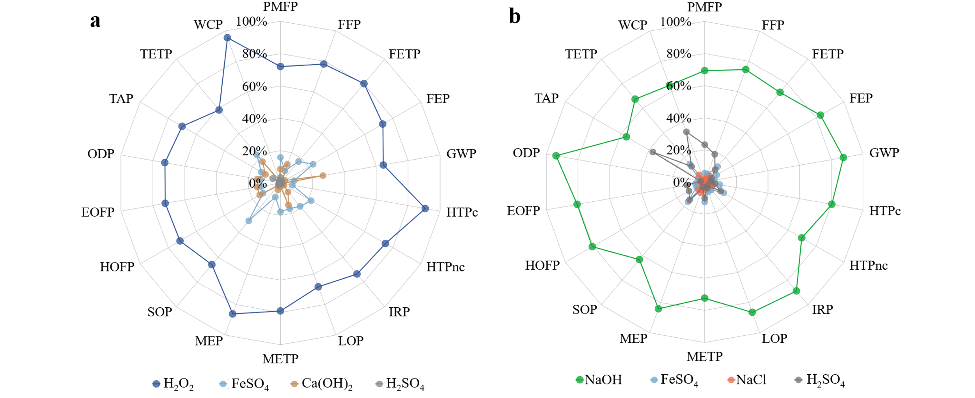
Figure S1. Relative impact of the most harmful reagents in (a) F-N and (b) EF-N during their life cycle assessment according to the ReCiPe-2016 method at the midpoint level

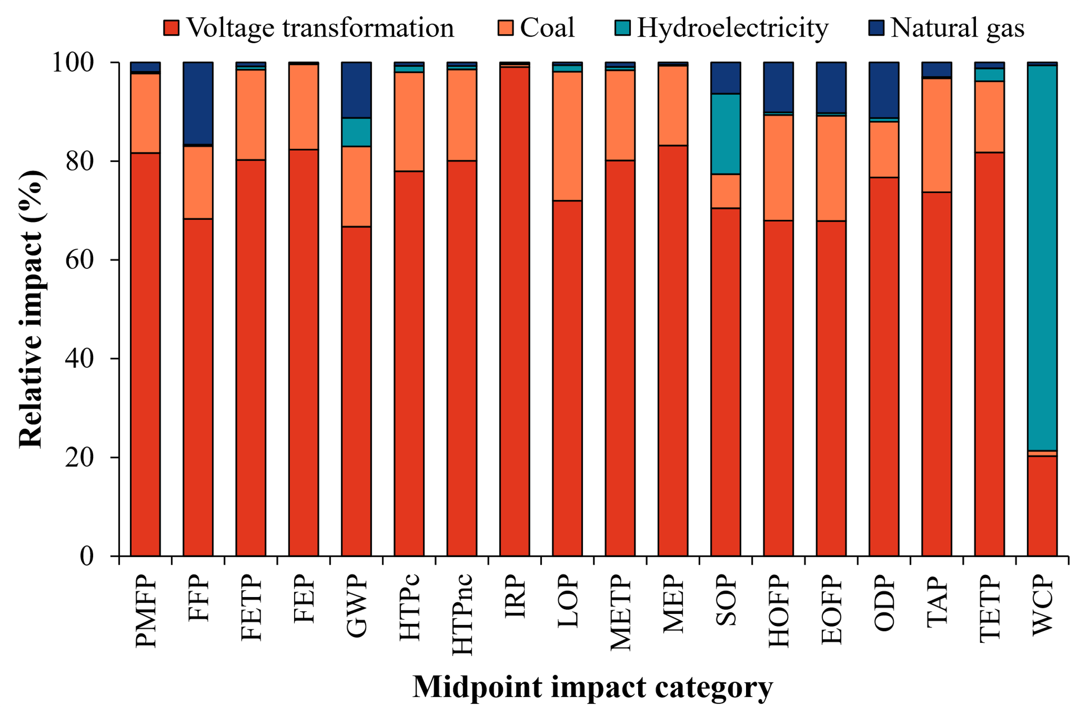
Figure S2. Relative impact of electricity in sequential processes, EF-N and F-N, estimated using ReCiPe-2016 method at the midpoint level

