SUPPLEMENTARY INFORMATION

Electronic modulation of palladium nanocatalysts supported on high-entropy spinel oxides for enhanced ethanol oxidation reaction

Colani T Fakudeª , Aderemi B Harunaª, Patrick V. Mwongaª, Thapelo P Mofokengª, and Kenneth I. Ozoemena^{a,}*

ªMolecular Sciences Institute, School of Chemistry, University of the Witwatersrand, Johannesburg 2050, South Africa

Fig. S1: a)HR-TEM image of HESOx/C(crystalline region) and b) HESOx/C(amorphous region) and corresponding inverse FFT with lattice fringes (insert, FFT transform).

Fig. S2: HR-TEM images of Pd-HESOx/C at a) 5nm and b) 50 nm,.

Fig. S3: SEM-EDS elemental analysis for a) HESO_{x}, b) HESO_{x}/C, and c) Pd-HESOx/C materials and d) EDX maps of Pd-HESOx/C and the constituent elements

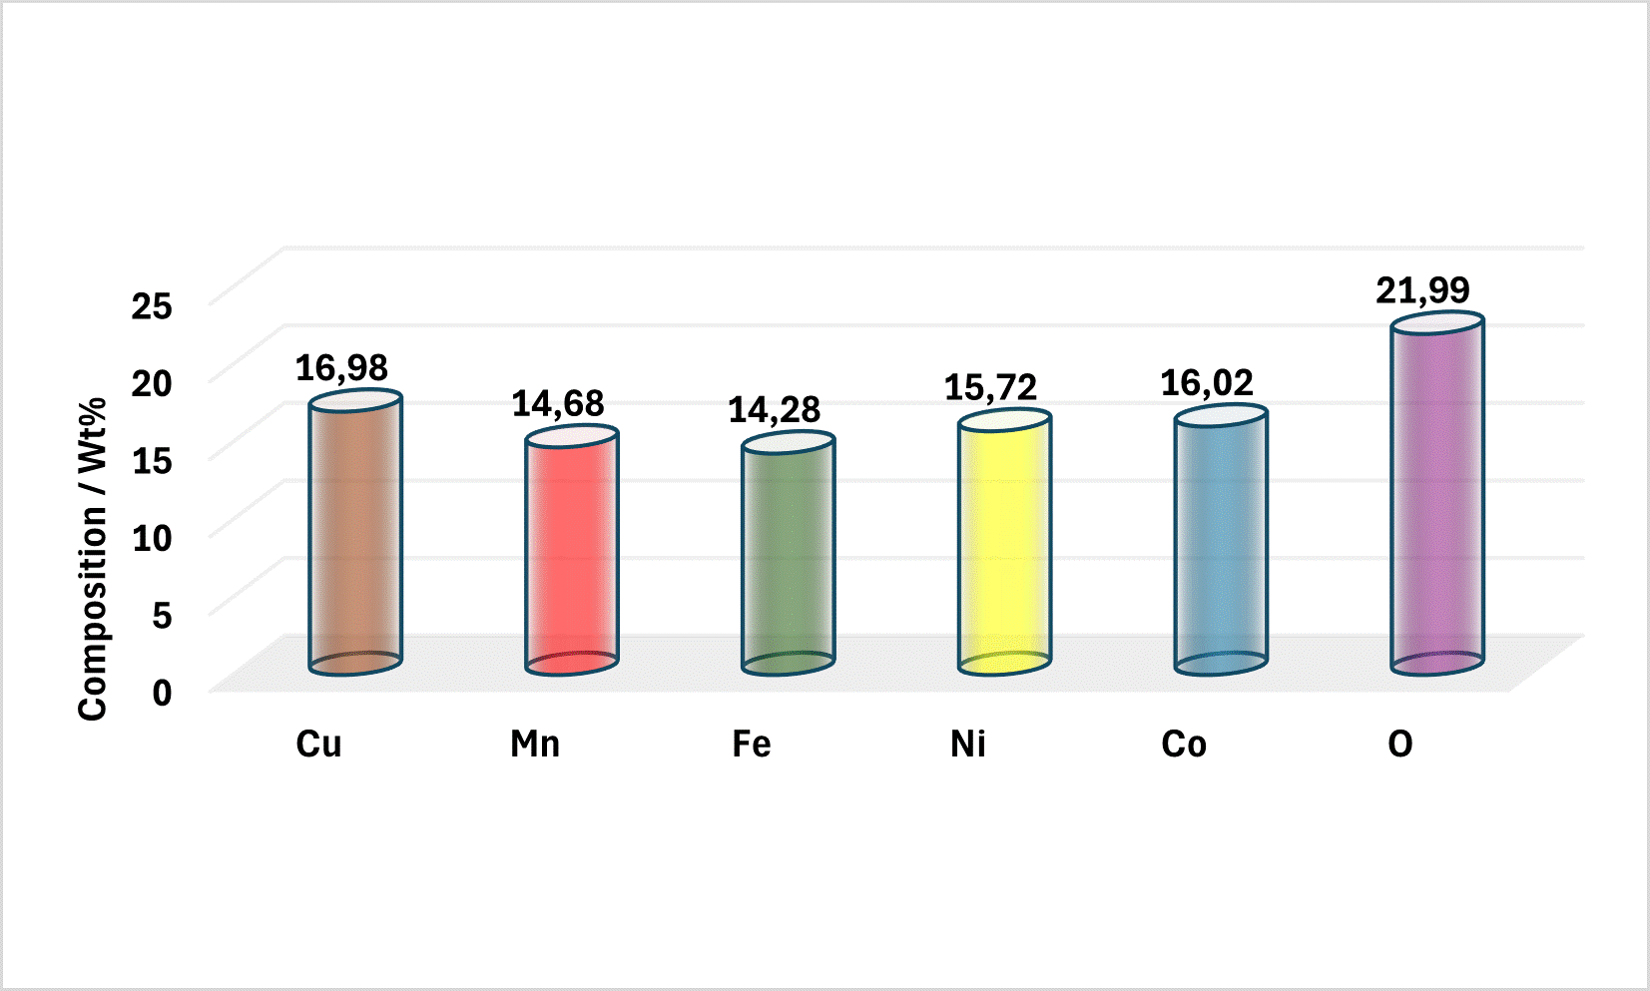
Fig. S4: SEM-EDS elemental analysis of the HESOx material.

Fig. S5: XPS-wide surveys for HESOx/C, HESOx/C and Pd-HESOx/C materials

Fig. S6: XPS spectra of HESOx. a) Cu 2p, b) Fe 2p, c) Mn 2p, d) Ni 2p and Co 2p

Fig. S7: Scan rate studies for the commercial a) Pd/C and b)CV stability study for comparing the 10th and 500th cycles.

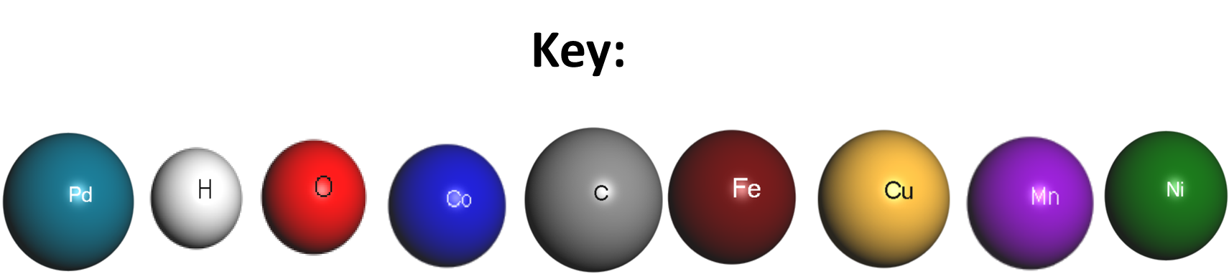
Fig. S8: A model representation of the adsorption of CHCH and the possible adsorption sites on Pd/C and Pd-HESOx/C electrocatalysts (Key: shows colored balls representing the different elements making up the electrocatalysts).

Fig. S9: (a, c) Band structure and (b, d) partial density of states (PDOS) of (a, b) Pd/C and (c, d) Pd-HESOx/C. The dotted lines represent the Fermi energy level.

*Authors to whom correspondence should be addressed: K.I. Ozoemena (e-mail: Kenneth.ozoemena@wits.ac.za).

