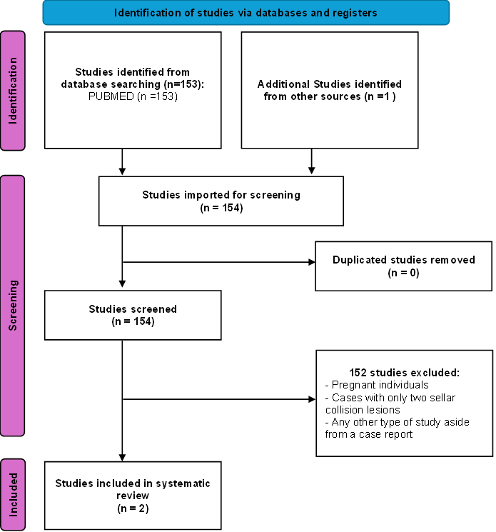

Online resource 1. Algorithm for database search and article selection

