Vegetation type dominates the spatial variability in CH₄ emissions across multiple Arctic tundra landscapes
Scott J. Davidson, Victoria L. Sloan, Gareth K. Phoenix, Robert Wagner, James P. Fisher, Walter C. Oechel, Donatella Zona

Supplementary Information
This file provides specific details on methods and results referred to in the main text of the above article, including diurnal CH₄ measurements. Figure S1 provides an illustration of the chamber flux set up, S2 and S3 depict the gross primary productivity (GPP) values for each microtopographic positon/vegetation type and the relationship between GPP and CH₄ at all four field sites. Table S1 provides information on the Ordination biplot vectors for NMDS axes 1 and 2.
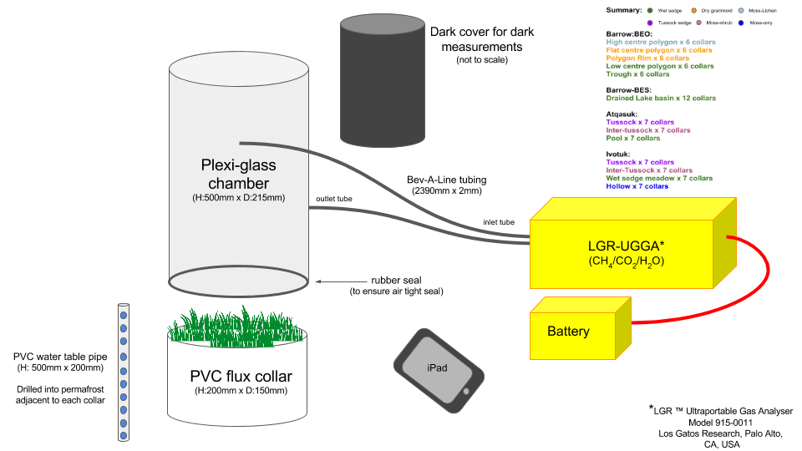
Figure S1: Illustration of the chamber flux measurement set-up including details on chamber and collar dimensions and equipment used.
Spatial variability in CO₂ fluxes
The average GPP values across all four sites were higher for tussock sedge (0.11 ± 0.05 gC – CO₂ m⁻² h⁻¹) , moss shrub (0.07 ± 0.05 gC – CO₂ m⁻² h⁻¹) and wet sedge (0.06 ± 0.08 gC – CO₂ m⁻² h⁻¹) and lower for dry graminoid (0.03 ± 0.02 gC – CO₂ m⁻² h⁻¹), moss lichen (0.04 ± 0.06 gC – CO₂ m⁻² h⁻¹) and moss only (0.01 ± 0.01 gC – CO₂ m⁻² h⁻¹) vegetation communities (Fig. S3).
Overall, the highest GPP was found at Atqasuk and Ivotuk, both with comparable flux rates, while Barrow-BEO/Barrow-BES had lower GPP (Fig. S3).

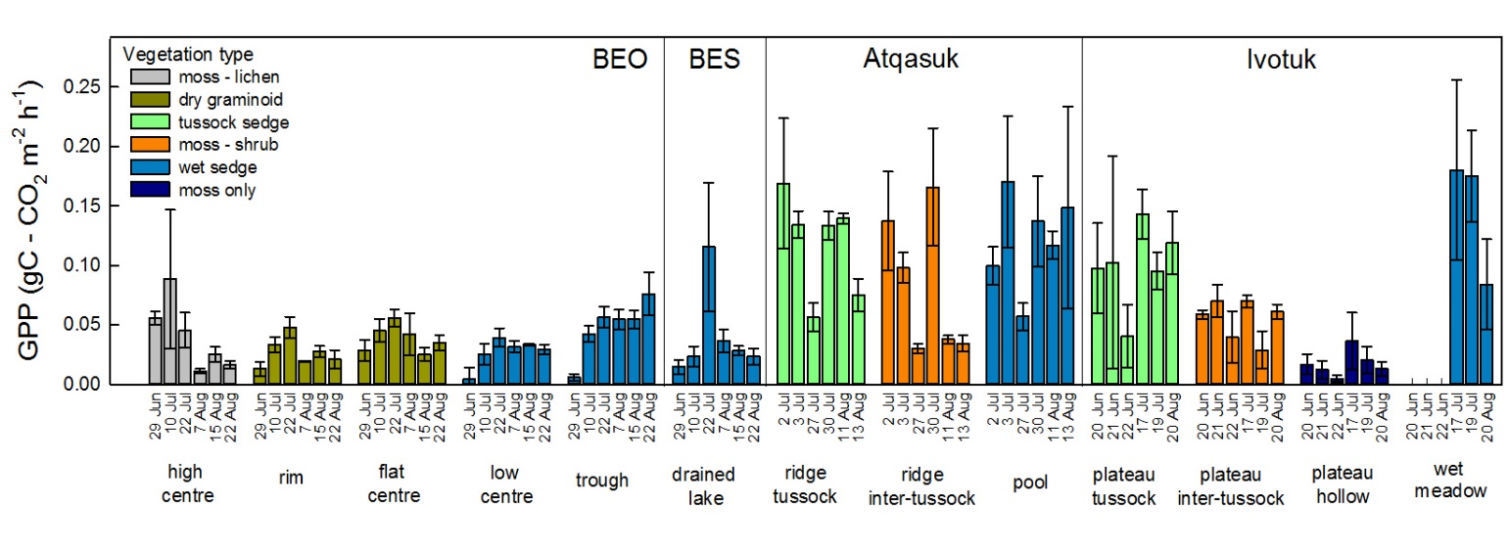
Figure S2. Gross Primary Productivity (GPP) fluxes measured at four Alaskan arctic field sites during summer 2014. Micro-topographic position in the landscape is indicated by text labels beneath x-axis. Bars are mean ± standard error for each date (n = 6 or 7)
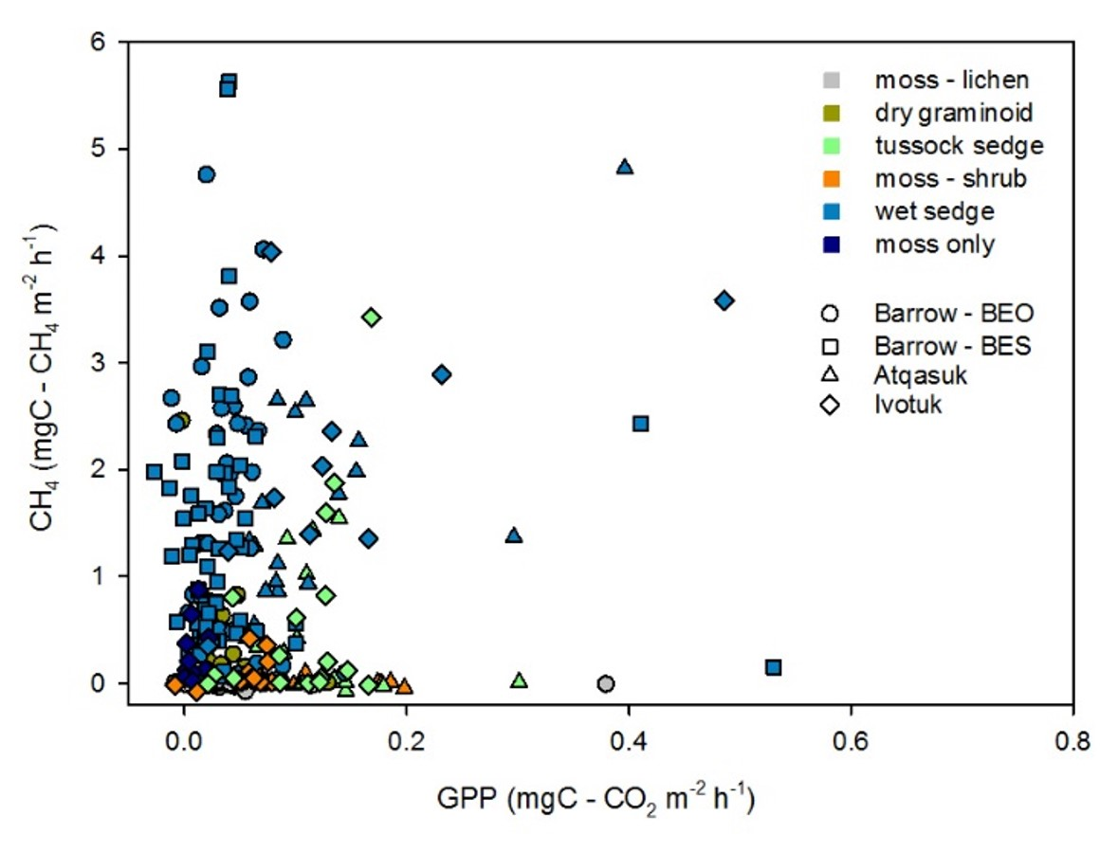
Figure S3: Relationship between Gross Primary Productivity (GPP) and CH₄ emissions across all four sites
Table S1: Ordination biplot vectors for NMDS axes 1 and 2
Variable | r² | Pr(>r)
Soil moisture | 0.640 | 0.001 | ***
Water table | 0.548 | 0.001 | ***
pH | 0.346 | 0.001 | ***
Maximum thaw depth | 0.016 | 0.625 | ns
Vegetation height | 0.344 | 0.001 | ***
Vascular plant cover | 0.336 | 0.001 | ***
Moss cover | 0.089 | 0.018 | *
Moss layer thickness | 0.039 | 0.176 | ns
CH₄ flux | 0.231 | 0.001 | ***

Significance codes: 0 ‘***’ 0.001 ‘**’ 0.01 ‘*’ 0.05 ‘.’ 0.1 ‘ns’ 1
P values based on 999 permutations

