Electronic Supporting information

Table S1. List of plant species identified during sampling in January 2015 and January 2016. Each species functional group and photosynthetic pathway is indicated.
Species | Functional group | Photosynthetic pathway
Chenopodium murale | Forb | C₃
Desmodium spp. | Legume | C₃
Hypochaeris radicata L. | Forb | C₃
Lepidium spp. | Forb | C₃
Medicago polymorpha | Legume | C₃
Medicago sativa | Legume | C₃
Modiola carolinensis | Forb | C₃
Bryophyta | Forb | C₃
Plantago lanceolata | Forb | C₃
Portulaca oleracea L. | Forb | C₃
Rumex brownii | Forb | C₃
Senecio madagascariensis | Forb | C₃
Trifolium spp. | Legume | C₃
Bromus spp. | Grass | C₃
Ehrharta erecta | Grass | C₃
Lolium rigidum | Grass | C₃
Microlaena stipoides | Grass | C₃
Bothriochloa macra | Grass | C₄
Chloris gayana | Grass | C₄
Cynodon dactylon | Grass | C₄
Cyperus brevifolius | Grass | C₄
Eragrostis brownii | Grass | C₄
Paspalum spp. | Grass | C₄
Setaria incrassata | Grass | C₄
Sporobolus africanus | Grass | C₄
Themeda triandra | Grass | C₄

Figure S1. Structural equation model containing all a priori hypothetical pathways. Abbreviations: MBC (microbial biomass carbon); MBN (microbial biomass nitrogen); Omin-C (organo-mineral carbon); Pom-C (particulate organic carbon); Pom-N (particulate organic nitrogen). The numbers in the arrows denote references used to support our predictions (see below). Boxes represent changes in pools between 2015 and 2016.
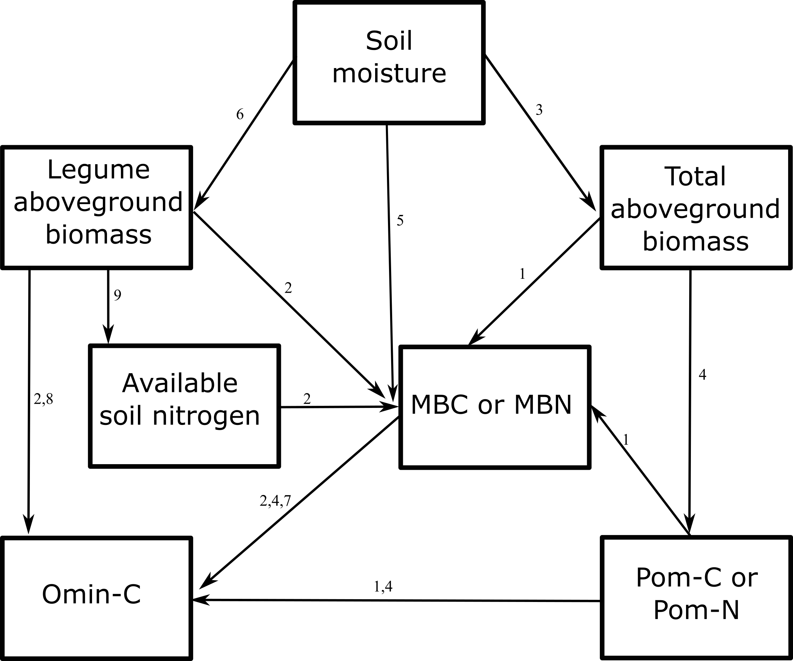
References:
- Cotrufo, M. F., J. L. Soong, A. J. Horton, E. E. Campbell, M. L. Haddix, D. H. Wall and W. J. Parton (2015). "Formation of soil organic matter via biochemical and physical pathways of litter mass loss." Nature Geoscience 8(10): 776-779.
- Cotrufo, M. F., M. D. Wallenstein, C. M. Boot, K. Denef and E. Paul (2013). "The Microbial Efficiency-Matrix Stabilization (MEMS) framework integrates plant litter decomposition with soil organic matter stabilization: do labile plant inputs form stable soil organic matter?" Global Change Biology 19(4): 988-995.
- Hoover, D. L. and B. M. Rogers (2016). "Not all droughts are created equal: the impacts of interannual drought pattern and magnitude on grassland carbon cycling." Global Change Biology 22(5): 1809-1820.
- Kögel-Knabner, I. (2017). "The macromolecular organic composition of plant and microbial residues as inputs to soil organic matter: Fourteen years on." Soil Biology and Biochemistry 105: A3-A8.
- Schimel, J., T. C. Balser and M. Wallenstein (2007). "Microbial stress-response physiology and its implications for ecosystem function." Ecology 88(6): 1386-1394.
- Signarbieux, C. and U. Feller (2012). "Effects of an extended drought period on physiological properties of grassland species in the field." Journal of Plant Research 125(2): 251-261.
- Solomon, D., J. Lehmann, J. Harden, J. Wang, J. Kinyangi, K. Heymann, C. Karunakaran, Y. Lu, S. Wirick and C. Jacobsen (2012). "Micro- and nano-environments of carbon sequestration: Multi-element STXM–NEXAFS spectromicroscopy assessment of microbial carbon and mineral associations." Chemical Geology 329(0): 53-73.
- De Deyn, G. B., R. S. Shiel, N. J. Ostle, N. P. McNamara, S. Oakley, I. Young, C. Freeman, N. Fenner, H. Quirk and R. D. Bardgett (2011). "Additional carbon sequestration benefits of grassland diversity restoration." Journal of Applied Ecology 48(3): 600-608.
- Creme, A., A. Chabbi, F. Gastal and C. Rumpel (2016). "Biogeochemical nature of grassland soil organic matter under plant communities with two nitrogen sources." Plant and Soil: 1-13.

