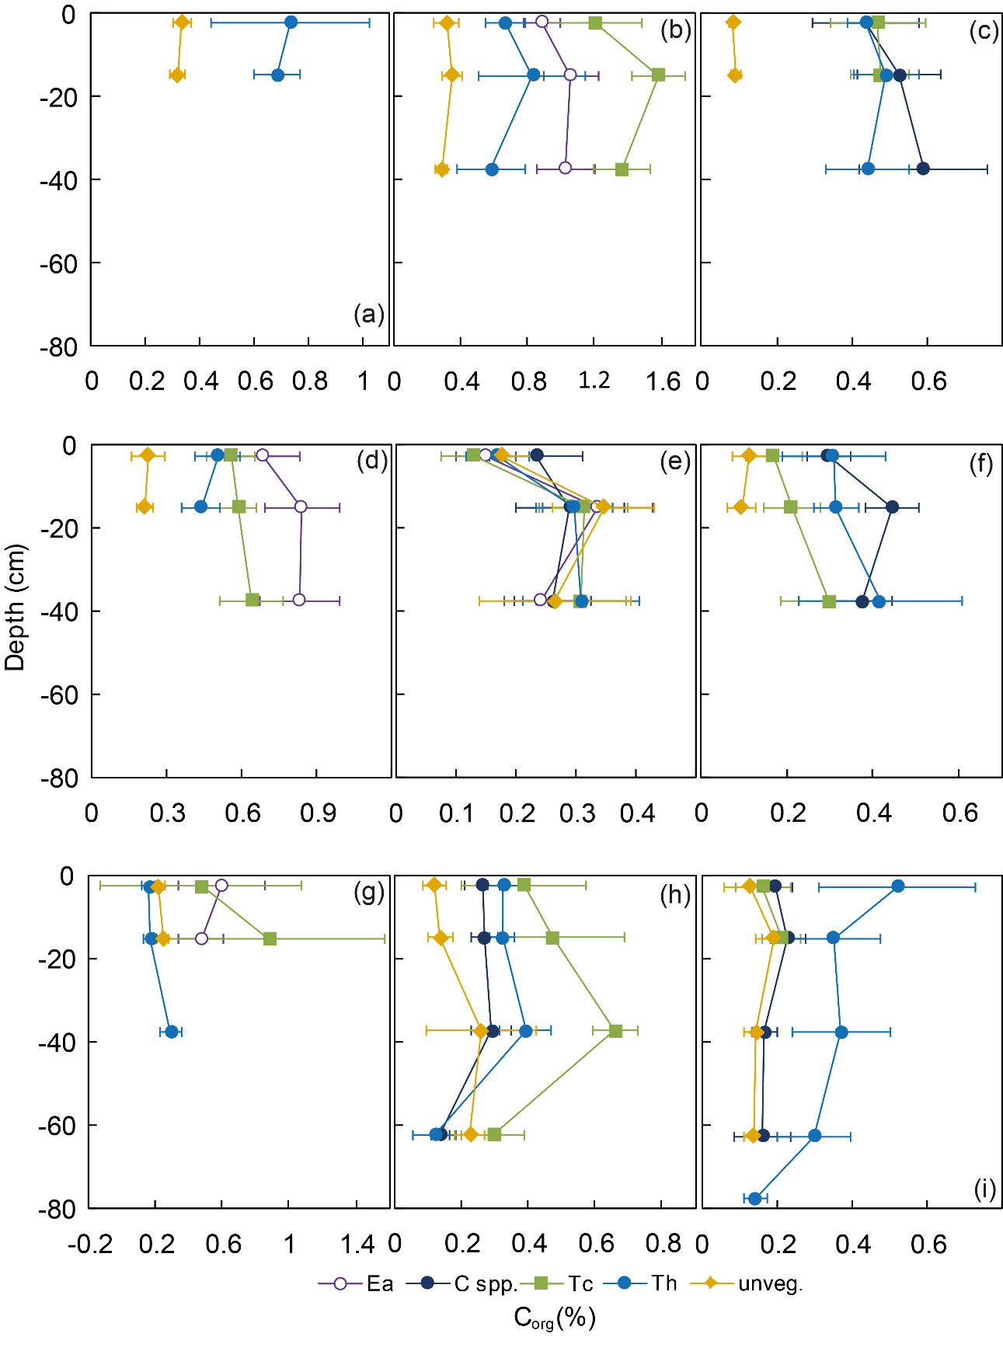
Supplementary Figure 1. Mean proportion (%) of organic carbon (C_{org}) in sediment in different depth segments from seagrass meadows and unvegetated areas in the different study sites (see Fig. 1 for locations of sites and Fig. 2 for full names of seagrass species). Note that the x-axis scales are different.
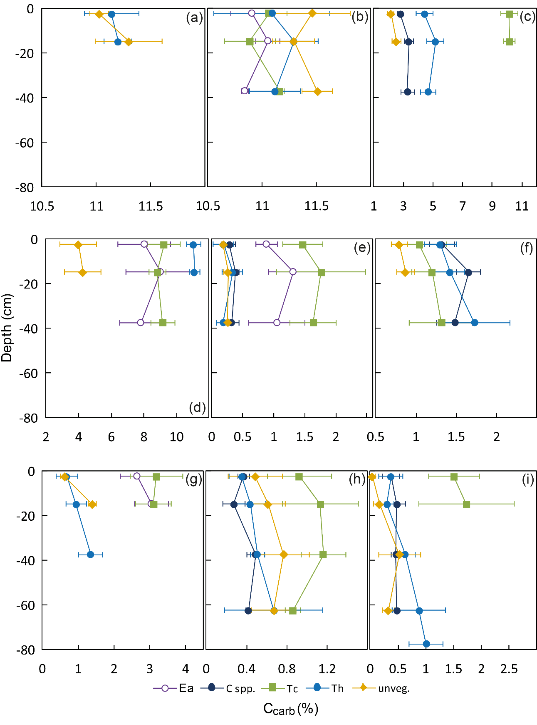
Supplementary Figure 2. Mean proportion (%) of inorganic carbon (C_{carb}) in sediment in different depth segments from seagrass meadows and unvegetated areas in the different study sites (see Fig. 1 for locations of sites and Fig. 2 for full names of seagrass species). Note that the x-axis scales are different.
Supplementary Table 1. Data (mean ± SD) of sediment-related variables in different habitats and across sites.

Supplementary Table 2. Data (mean ± SD) of seagrass-related variables in different habitats and across sites. Shoot dens = Shoot density, Canopy = Canopy height, Seag cov = Seagrass coverage, Ag biom = Above-ground seagrass biomass, Bg biom = Beloew-ground seagrass biomass, Ag C = Above-ground seagrass carbon, Bg C = Below-ground seagrass carbon, Ag N = Above-ground seagrass nitrogen, Bg N = Below-ground seagrass nitrogen

