SUPPLMENTARY MATERIAL

TITLE: The role of forest elephants in shaping tropical forest-savanna co-existence

RUNNING HEADER: Forest elephants stabilise forest-savanna mosaics

AUTHORS: Anabelle W. Cardoso^{*1,2}, Yadvinder Malhi¹, Imma Oliveras¹, David Lehmann^{3,4}, Josué Edzang Ndong⁴, Edmond Dimoto⁴, Emma Bush³, Kathryn Jeffery^{3,4,5}, Nicolas Labriere⁶, Simon L. Lewis^{7,8}, Lee T. J. White⁴, William Bond⁹, Katharine Abernethy^{3,5}

Affiliations: *Corresponding author, anabellecardoso@gmail.com, +44 (0)1865 285070
¹School of Geography and the Environment, U.Oxford, Oxford, OX1 3QY, UK.
²Department of Ecology and Evolutionary Biology, Yale U., New Haven, 06511, CT, USA.
³Biological and Environmental Sciences, Faculty of Natural Sciences, U.Stirling, Stirling, FK9LA, UK.
⁴Agence Nationale des Parcs Nationaux, BP20379, Libreville, Gabon.
⁵Institut de Recherche en Ecologie Tropicale, CENAREST, BP843, Libreville, Gabon.
⁶Laboratoire Évolution et Diversité Biologique, UMR 5174 (CNRS/IRD/UPS), 31062 Toulouse Cedex 9, France.
⁷Department of Geography, University College London, London, WC1E 6BT, UK.
⁸School of Geography, University of Leeds, Leeds, LS2 9JT, UK.
⁹Biological Sciences Department, U. Cape Town, Cape Town, 7700, South Africa.

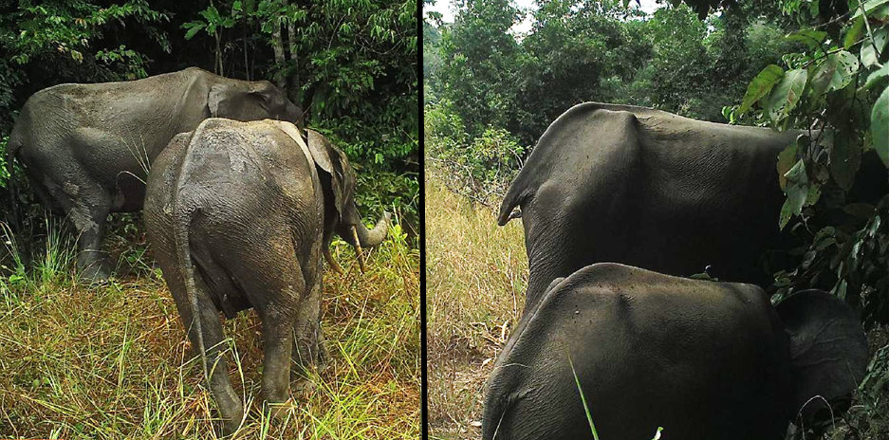
Figure S1: Camera trap images of emaciated forest elephants, captured during this study at the end of the dry season (August/September 2017).
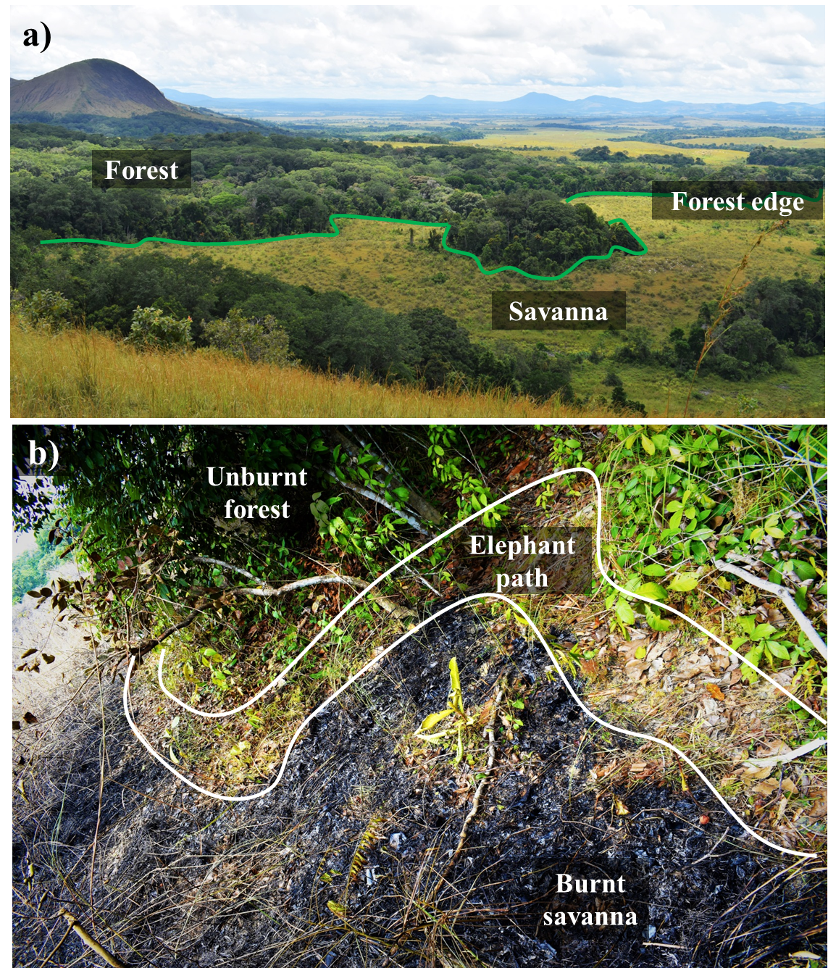
Figure S2: Photographs of the study site showing a) the sharp transitions between forest and savanna and the location of the forest edge; and b) an example of the elephant path that runs along the forest edge and how it acts as a fire break during burning.

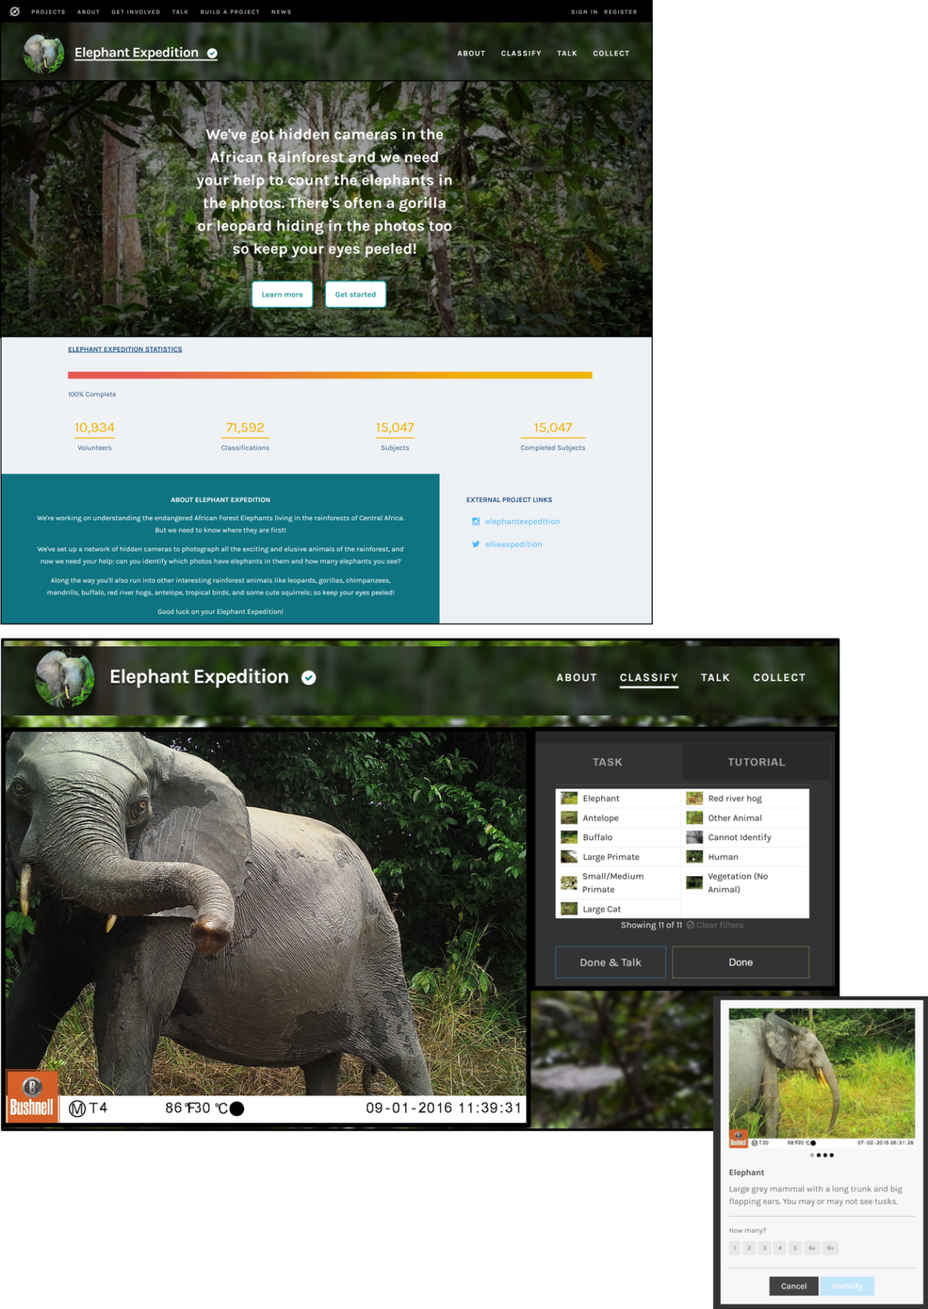
Figure S3a: Example of the citizen science web interface, “Elephant Expedition” (https://www.zooniverse.org/projects/anabellecardoso/elephant-expedition)
showing the landing screen (top), classification window (bottom) and elephant
count window (inset).
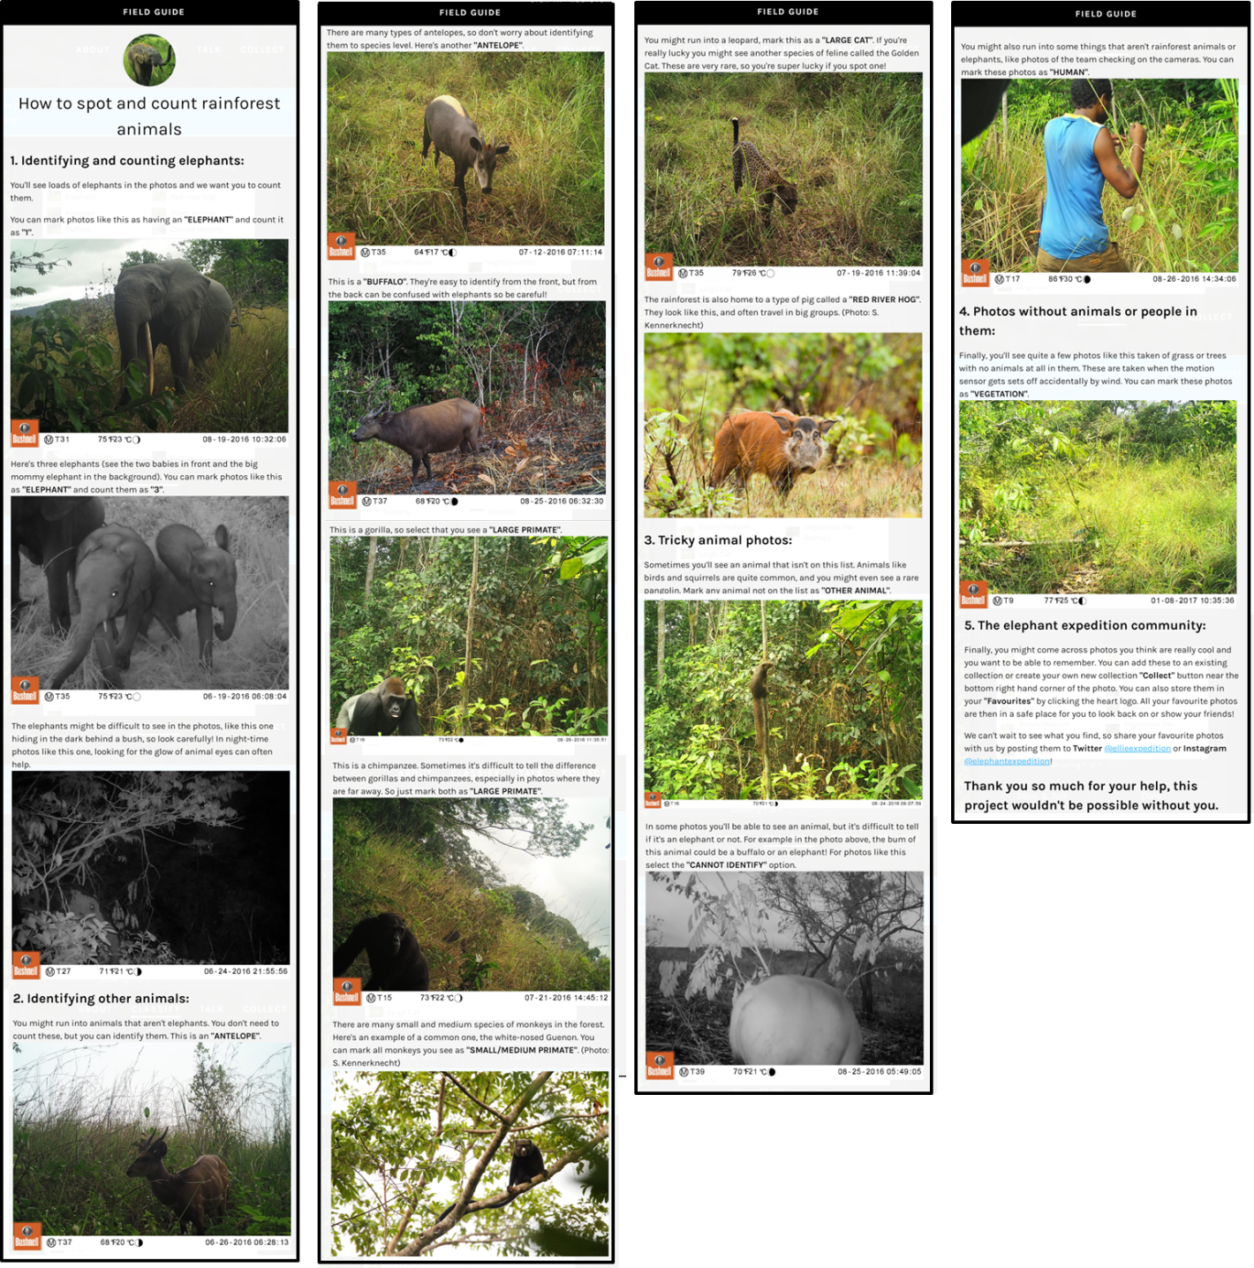
Figure S3b: Example of the citizen science web interface, “Elephant Expedition” (https://www.zooniverse.org/projects/anabellecardoso/elephant-expedition) showing the pre-classification tutorial.

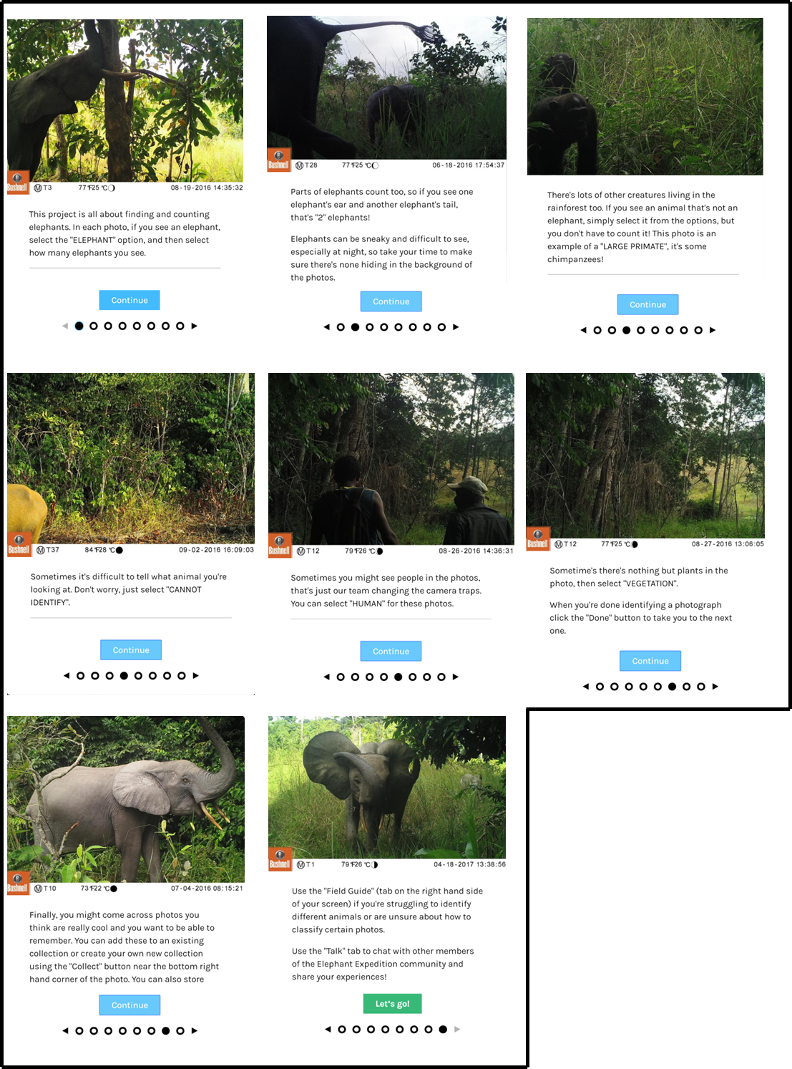
Figure S3c: Example of the citizen science web interface, “Elephant Expedition” (https://www.zooniverse.org/projects/anabellecardoso/elephant-expedition) showing the field guide that citizen scientists can consult during classification.
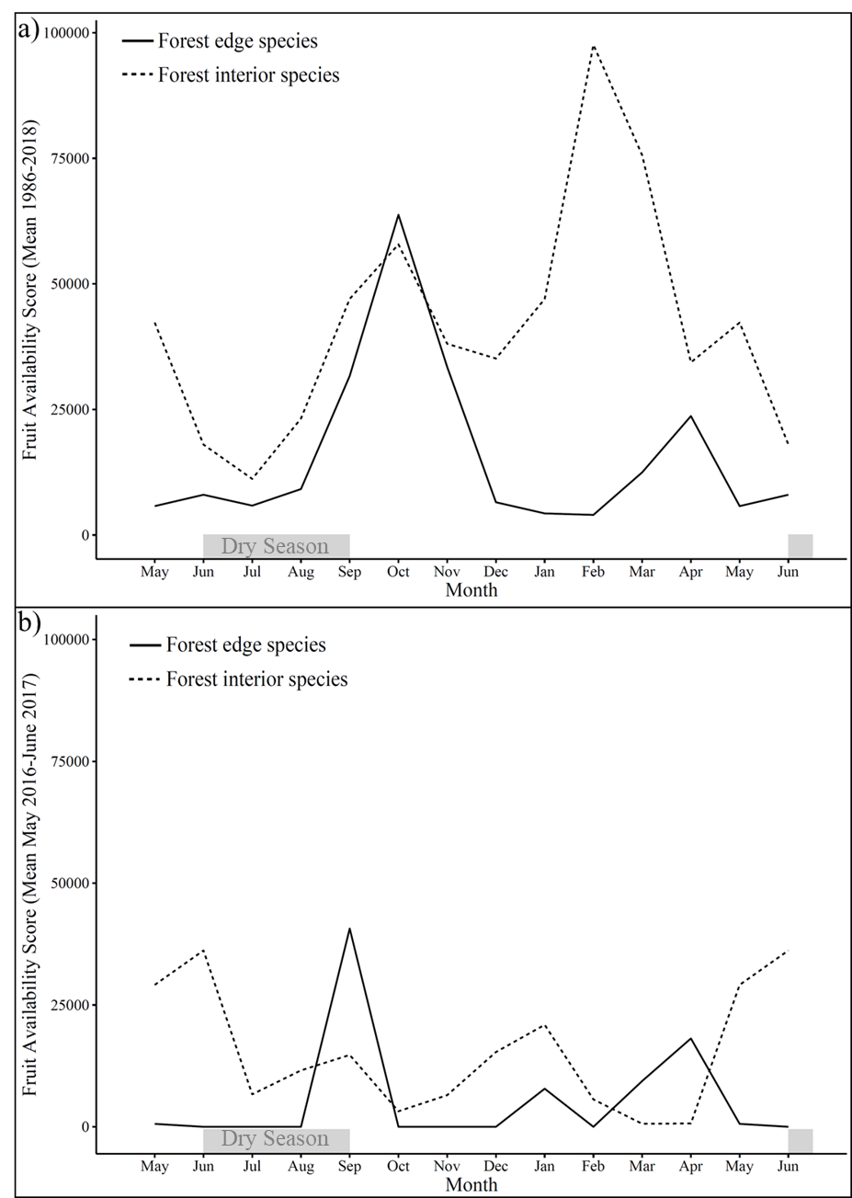
Figure S4: A comparison of fruit availability scores at the forest edge and in the forest interior calculated using a) long-term phenology data (mean 1986 – 2018) and b) phenology data from the study period only (May 2016 – June 2017).

Figure S6: A heavily used forest elephant path in the savanna interior that shows no ability to act as a fire-break.
Figure S5: Fruit availability score (mean monthly 1986-2018) for each species in the phenology dataset.
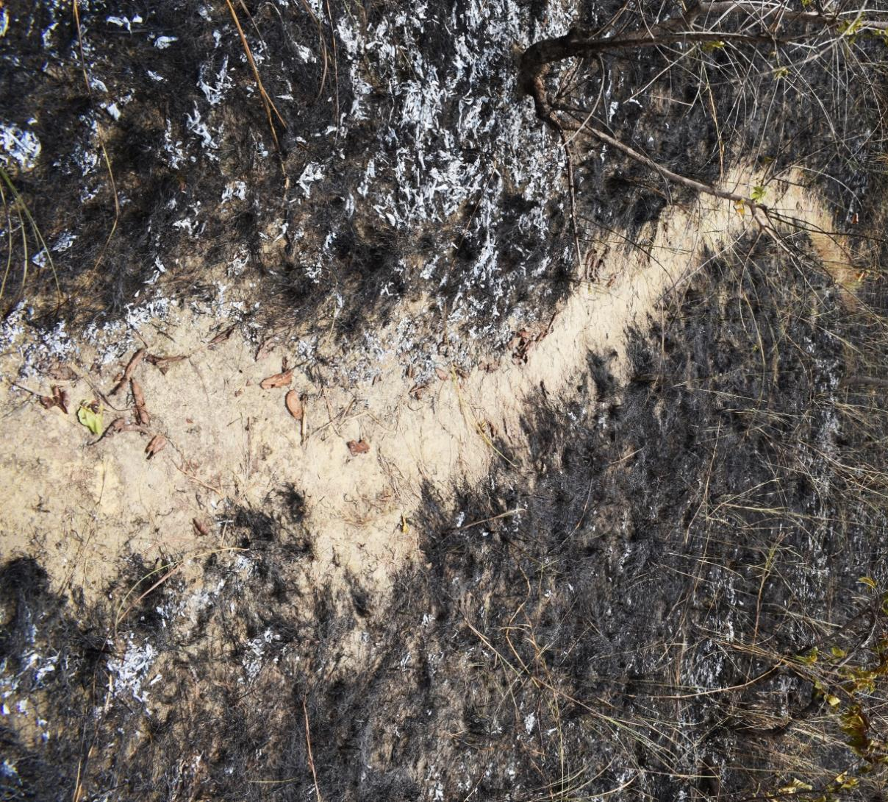

Table S1: All data sets used in calculation of the “fruit availability score”.

Data set name | Specific vegetation type | Total plot size (ha) | Data owner
CAYETTE1 | Bosquet/Forest patch | 0.08 | Lee J. T. White
CAYETTE2 | Bosquet/Forest patch | 0.08 | Lee J. T. White
CENTROPLACUS | Bosquet/Forest patch | 0.08 | Lee J. T. White
CHATEAUDEAU | Bosquet/Forest patch | 0.08 | Lee J. T. White
COUPONS | Bosquet/Forest patch | 0.08 | Lee J. T. White
DGG1 | Bosquet/Forest patch | 0.08 | Lee J. T. White
DGG2 | Bosquet/Forest patch | 0.08 | Lee J. T. White
FdAEROPORT1 | Bosquet/Forest patch | 0.08 | Lee J. T. White
FdAEROPORT2 | Bosquet/Forest patch | 0.08 | Lee J. T. White
KLAINEDOXA1 | Bosquet/Forest patch | 0.08 | Lee J. T. White
KLAINEDOXA2 | Bosquet/Forest patch | 0.08 | Lee J. T. White
KLAINEDOXA3 | Bosquet/Forest patch | 0.08 | Lee J. T. White
KOUROU1 | Bosquet/Forest patch | 0.08 | Lee J. T. White
KOUROU2 | Bosquet/Forest patch | 0.08 | Lee J. T. White
LACINFERIEUR | Bosquet/Forest patch | 0.08 | Lee J. T. White
LACSUPERIEUR1 | Bosquet/Forest patch | 0.08 | Lee J. T. White
LACSUPERIEUR2 | Bosquet/Forest patch | 0.08 | Lee J. T. White
MANDRILL1 | Bosquet/Forest patch | 0.08 | Lee J. T. White
MANDRILL2 | Bosquet/Forest patch | 0.08 | Lee J. T. White
MANDRILL3 | Bosquet/Forest patch | 0.08 | Lee J. T. White
LNL04 | Colonising forest | 0.5 | Nicolas Labriere and Simon Lewis
LNL05 | Colonising forest | 0.5 | Nicolas Labriere and Simon Lewis
LNL06 | Colonising forest | 0.5 | Nicolas Labriere and Simon Lewis
VEGCAT2.1 | Colonising forest | 0.08 | Lee J. T. White
VEGCAT2.2 | Colonising forest | 0.08 | Lee J. T. White
VEGCAT2.3 | Colonising forest | 0.08 | Lee J. T. White
VEGCAT2.4 | Colonising forest | 0.08 | Lee J. T. White
VEGCAT2.5 | Colonising forest | 0.08 | Lee J. T. White
CARDOSO | Forest-savanna transition | 12.95 | Anabelle W. Cardoso
LOPEL9 | Gallery forest | 0.08 | Lee J. T. White
MBAYEGALLERY | Gallery forest | 0.08 | Lee J. T. White
MBAYEN5 | Gallery forest | 0.08 | Lee J. T. White
LNL10 | Marantaceae forest | 1 | Nicolas Labriere and Simon Lewis
LNL11 | Marantaceae forest | 1 | Nicolas Labriere and Simon Lewis
LPG02 | Marantaceae forest | 1 | Lee J. T. White
MPAM | Marantaceae forest | 2.5 | Lee J. T. White
VEGCAT4.1 | Marantaceae forest | 0.08 | Lee J. T. White
VEGCAT4.2 | Marantaceae forest | 0.08 | Lee J. T. White
Table S1 cont:

Data set name | Specific vegetation type | Total plot size (ha) | Data owner
VEGCAT4.4 | Marantaceae forest | 0.08 | Lee J. T. White
WW94 | Marantaceae forest | 2.5 | Lee J. T. White
LNL12 | Mature forest | 1 | Nicolas Labriere and Simon Lewis
LPG01 | Mature forest | 1 | Lee J. T. White
VEGCAT5.1 | Mature forest | 0.08 | Lee J. T. White
VEGCAT5.2 | Mature forest | 0.08 | Lee J. T. White
VEGCAT5.3 | Mature forest | 0.08 | Lee J. T. White
VEGCAT5.4 | Mature forest | 0.08 | Lee J. T. White
VEGCAT5.5 | Mature forest | 0.08 | Lee J. T. White
LNL08 | Mix: Monodominant Okoume, Sacoglottis forest | 1 | Nicolas Labriere and Simon Lewis
LTJWsite1 | Mix: Rocky forest, Marantaceae forest and Monodominant Okoume/Azobe | 0.5 | Lee J. T. White
LTJWsite2 | Mix: Rocky forest, Marantaceae forest and Monodominant Okoume/Azobe | 0.5 | Lee J. T. White
LTJWsite3 | Mix: Rocky forest, Marantaceae forest and Monodominant Okoume/Azobe | 0.5 | Lee J. T. White
LTJWsite4 | Mix: Rocky forest, Marantaceae forest and Monodominant Okoume/Azobe | 0.5 | Lee J. T. White
LTJWsite5 | Mix: Rocky forest, Marantaceae forest and Monodominant Okoume/Azobe | 0.5 | Lee J. T. White
SEGC94 | Mix: Rocky forest, Marantaceae forest and Monodominant Okoume/Azobe | 2.5 | Lee J. T. White
LNL07 | Monodominant Okoume | 1 | Nicolas Labriere and Simon Lewis
LNL09 | Monodominant Okoume | 1 | Nicolas Labriere and Simon Lewis
VEGCAT3.1 | Monodominant Okoume | 0.08 | Lee J. T. White
VEGCAT3.2 | Monodominant Okoume | 0.08 | Lee J. T. White
VEGCAT3.5 | Monodominant Okoume/Azobe | 0.08 | Lee J. T. White
VEGCAT1.1 | Savanna | 0.08 | Lee J. T. White

