Appendix
Varying vegetation composition, respiration and photosynthesis decrease temporal variability of the CO₂ sink in a boreal bog
Korrensalo Aino^{*a}, Mehtätalo Lauri^{b}, Alekseychik Pavel^{c,d}, Uljas Salliª, Mammarella Ivan^{c}, Vesala Timo^{c,e}, Tuittila Eeva-Stiinaª
ª School of Forest Sciences, University of Eastern Finland, Joensuu, Finland
^{b} School of Computing, University of Eastern Finland, Joensuu, Finland
^{c} Institute for Atmospheric and Earth System Research/Physics, Faculty of Science, University of Helsinki, Finland
^{d} Natural Resources Institute Finland, Helsinki, Finland
^{e} Dept. of Forest Sciences, University of Helsinki, Finland
*Corresponding author: aino.korrensalo@uef.fi tel. +358 (0)44 319 0460

Appendix 1. Sampling grid of the vegetation inventory in 2013. 14 inventory plots are not visible in the figure due to missing coordinates, but the information from the plots was used in the analysis. The abbreviations of the plant community types are HHU=high hummock, HU=hummock, HL=high lawn, L=lawn, HO=hollow, MB=bare peat, W=open water. (Photograph: Ilkka Korpela)
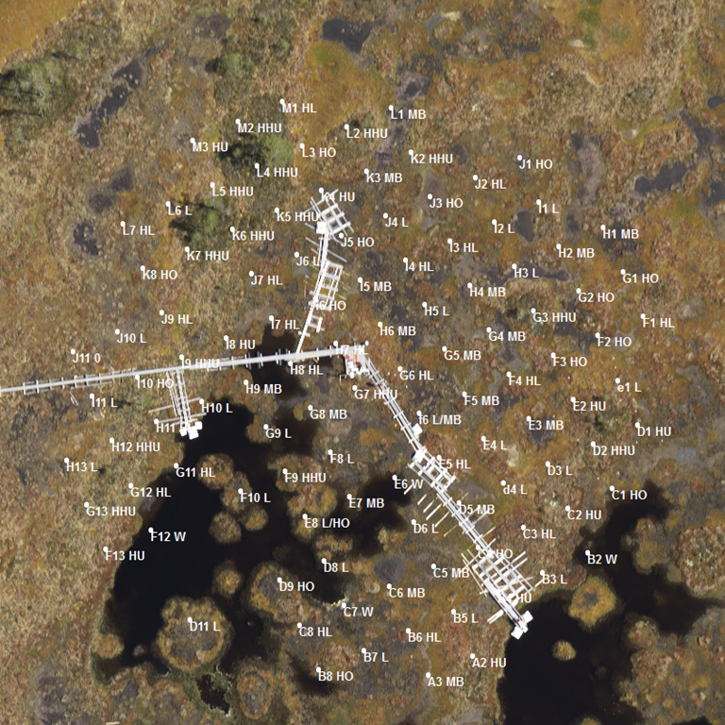
Appendix 2. Detailed description of the response modeling procedure
To reconstruct the NEE flux of the six measured vegetation community types over the growing seasons 2012−2014 and to compare their responses to environmental variables, we used a non-linear mixed-effects model with the hyperbolic light saturation curve:
${NEE}_{trsij}=\frac{{Pmax}_{trsi}{PPFD}_{trsij}}{k_{trsi}+{PPFD}_{trsij}}-R_{trsi}+e_{trsi}$ (1)
where NEE_{trsij} is the observed net CO₂ exchange per square meter and the predictor PPFD_{trsij} is the photosynthetic photon flux density (µmol m⁻² s⁻¹) for measurement j on plot i on plot group s on Julian day r in year t. The parameters to be estimated are respiration (R_{trsi}), maximum rate of light saturated photosynthesis (Pmax_{trsi}) and the level of PPFD were half of Pmax was reached (k_{trsi}). The residual error (e_{trsi}) is normally distributed with mean zero and constant variance.
In the full model, the parameters R_{trsi}, Pmax_{trsi} and k_{trsi} were written as linear functions of fixed predictors and random effects. Possible fixed predictors were VGA, air temperature, WT depth and plant community type. Model fitting was started by assuming constant mean for all of the parameters, and the fixed predictors were then added one by one after plotting the random effects of the simpler model parameters against the potential fixed predictors.
P_{G} and R are known to have nonlinear responses to temperature and VGA. To account for self-shading at high levels of VGA (Riutta and others 2007), VGA was used as a fixed predictor of Pmax_{trsi} transformed as VGA_{B}=1-exp(-VGA). A linear response of R_{trsi} to VGA could be assumed, but as such a model formulation led to estimation problems we used VGA_{B} also as a fixed predictor of R_{trsi}.
To find a suitable response shape for air temperature, we considered first and second order polynomials of transformation T[max(T, v)]. The formulation assumes polynomial response for temperatures above v and no effect for temperatures below v; the value of v was found using a grid search. Plant community type explained the variation in both Pmax_{trsi} and R_{trsi} better than WT, and after inclusion of plant community type, WT no longer explained neither of them. Since none of the possible fixed predictors seemed to explain the variation in k_{trsi}, we assumed it to be constant with the appropriate combination of random effects. To select the random effect structure of the model, we examined the random variation of alternative models with normally distributed nested random effects of year, plot group, measurement plot and measurement day included in different combinations of parameters R, Pmax and k.
The final submodels for the parameters of NEE were:
${Pmax}_{trsi}=$ f (C_{krsi}, VGA_{B}, (max(T, v))², m_{t}, m_{kr}, m_{trs}, m_{trsi}) (2)
$R_{trsi}=$ g (C_{krsi}, VGA_{B}, (max(T, v))², n_{t}, n_{tr}, n_{trs}, n_{trsi}) (3)
$k_{trsi}=$ h (1 + a_{k} + a_{tr} + a_{trs} + a_{trsi}) (4)
where C_{krsi} is the categorical predictor of plant community type (6 levels) and VGA_{B} is the transformed VGA. T is the air temperature (°C) using a transformation max(T, 17) for R_{trsi} and max(T, 12) for Pmax_{trsi}. The four last terms represent the random effects of year, plot group, measurement plot and measurement day. The model parameter estimates, including those of the random part, are presented in Appendix 1. The model was fitted using the function nlme of the R program package nlme (Pinheiro and Bates 2000).
Using the fixed part of the nonlinear mixed-effects model (Eq. (1)−(4)), we reconstructed daily (g CO₂ m⁻² d⁻¹) and annual (g CO₂ m⁻² growing season⁻¹) cumulative P_{G}, R and NEE fluxes at each of the 18 measurement plots during growing seasons 2012−2014 from the beginning of May until the end of September (Julian days 121-273), hereafter referred to as growing season. P_{G} was reconstructed by setting the parameter R_{krsi} to zero and R by setting the parameter Pmax_{krsi} to zero. For the reconstruction, we used continuous PPFD and air temperature data recorded at 30 min intervals at SMEAR II measurement station at 10 km distance from the site and daily VGA of each measurement plot calculated using the log-linear VGA development model (Wilson and others 2007).

Appendix 3. Table of parameter estimates and random effects of the nonlinear mixed-effects model based on chamber measurements of net ecosystem exchange (NEE) (Eq. 1-4).
Fixed part | Value | Std. error | t-value | p-value
Pmax (mg CO₂ m^{–2} h^{–1})
Constant (HHU) | 293.9 | 35.7 | 8.2 | <0.001
HU | -52.1 | 18.2 | -2.9 | 0.004
HL | 25.3 | 18.0 | 1.4 | 0.160
L | -106.8 | 22.4 | -4.8 | <0.001
HO | -217.7 | 19.8 | -11.0 | <0.001
BP | -317.1 | 25.3 | -12.5 | <0.001
VGA_{B} | 1054.6 | 64.6 | 16.3 | <0.001
(max(T,12))² | 0.7 | 0.1 | 7.9 | <0.001
R (mg CO₂ m^{–2} h^{–1})
Constant (HHU) | 174.8 | 17.1 | 10.2 | <0.001
HU | -39.6 | 11.1 | -3.6 | <0.001
HL | -23.4 | 11.1 | -2.1 | 0.035
L | -130.7 | 13.2 | -9.9 | <0.001
HO | -140.8 | 11.9 | -11.8 | <0.001
BP | -139.9 | 14.4 | -9.7 | <0.001
VGA_{B} | 194.7 | 34.8 | 5.6 | <0.001
(max(T,17))² | 0.9 | 0.09 | 10.2 | 0.329
k (µmol m^{–2} s^{–1})
Constant | 198.1 | 7.9 | 25.0 | <0.001

Random part | Level | SD | Corr (Pmax, R) | Corr (Pmax, k) | Corr (R, k)
Pmax | Year | 23.6 | - | - | -
R |  | 0.15
k |  | 0.20
Pmax | JD | 99.3 | 0.88 | 0.07 | 0.40
R |  | 46.2
k |  | 27.1
Pmax | Plot group | 17.9 | - | - | -
R |  | 12.2
k |  | 31.0
Pmax | Plot | 131.1 | 0.42 | 0.64 | 0.11
R |  | 72.5
k |  | 77.8
Residual error |  | 44.4

Appendix 4. Validation of the fixed part of the net ecosystem exchange (NEE) model by comparing measured fluxes of 2015 with the corresponding modeled fluxes of all plant community types. Data of year 2015 was not used for the model construction. The black line represents the 1:1 fit between the modeled and measured values. The goodness of fit is expressed in the graph as r² value as well as slope and intercept of the linear equation between measured and modeled values. 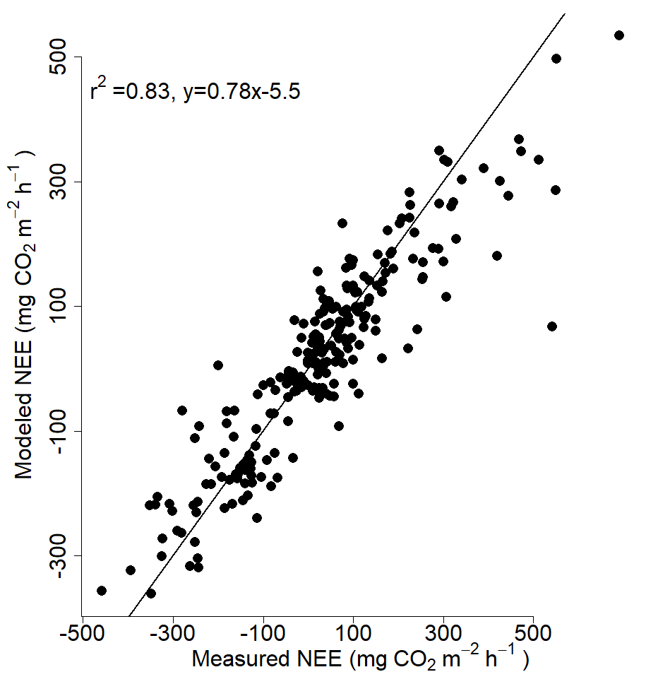

Appendix 5. Full names of the plant species in Figure 2b.
AndrPol = Andromeda polifolia L.
BetuNan = Betula nana L.
CallVul = Calluna vulgaris (L.) Hull
CareLim = Carex limosa L.
DrosLon = Drosera longifolia L.
DrosRot = Drosera rotundifolia L.
EmpeNig = Empetrum nigrum L.
ErioVag = Eriophorum vaginatum L.
RubuCha = Rubus chamaemorus L.
SchePal = Scheuchzeria palustris L.
TricCes = Trichophorum cespitosum (L.) Hartm.
SphaAng = Sphagnum angustifolium (Warnst.) C.E.O. Jensen
SphaBal = Sphagnum balticum (Russow) C.E.O. Jensen
SphaCus = Sphagnum cuspidatum Ehrh. ex Hoffm.
SphaFus = Sphagnum fuscum (Schimp.) H. Klinggr.
SphaMage = Sphagnum magellanicum Brid.
SphaMaj = Sphagnum majus (Russow) C.E.O. Jensen
SphaPap = Sphagnum papillosum Lindb.
SphaRub = Sphagnum rubellum Wilson

Appendix 6. Figure of reconstructed daily ecosystem respiration (R), gross photosynthesis (P_{G}) and net ecosystem exchange (NEE) at the six studied plant community types over the growing seasons 2012−2014.
