Contrasting impacts of cultivated exotics on the functional diversity of domestic gardens in three regions with different aridity

Contents:

Appendix S1: Characterization of studied regions
Appendix S2: References retrieved from TRY database
Appendix S3: Details on missing trait data imputation and validation
Appendix S4: Sensitivity analyses considering different maximum plant height
Appendix S5: Complementary analyses

Appendix S1: Characterization of studied regions

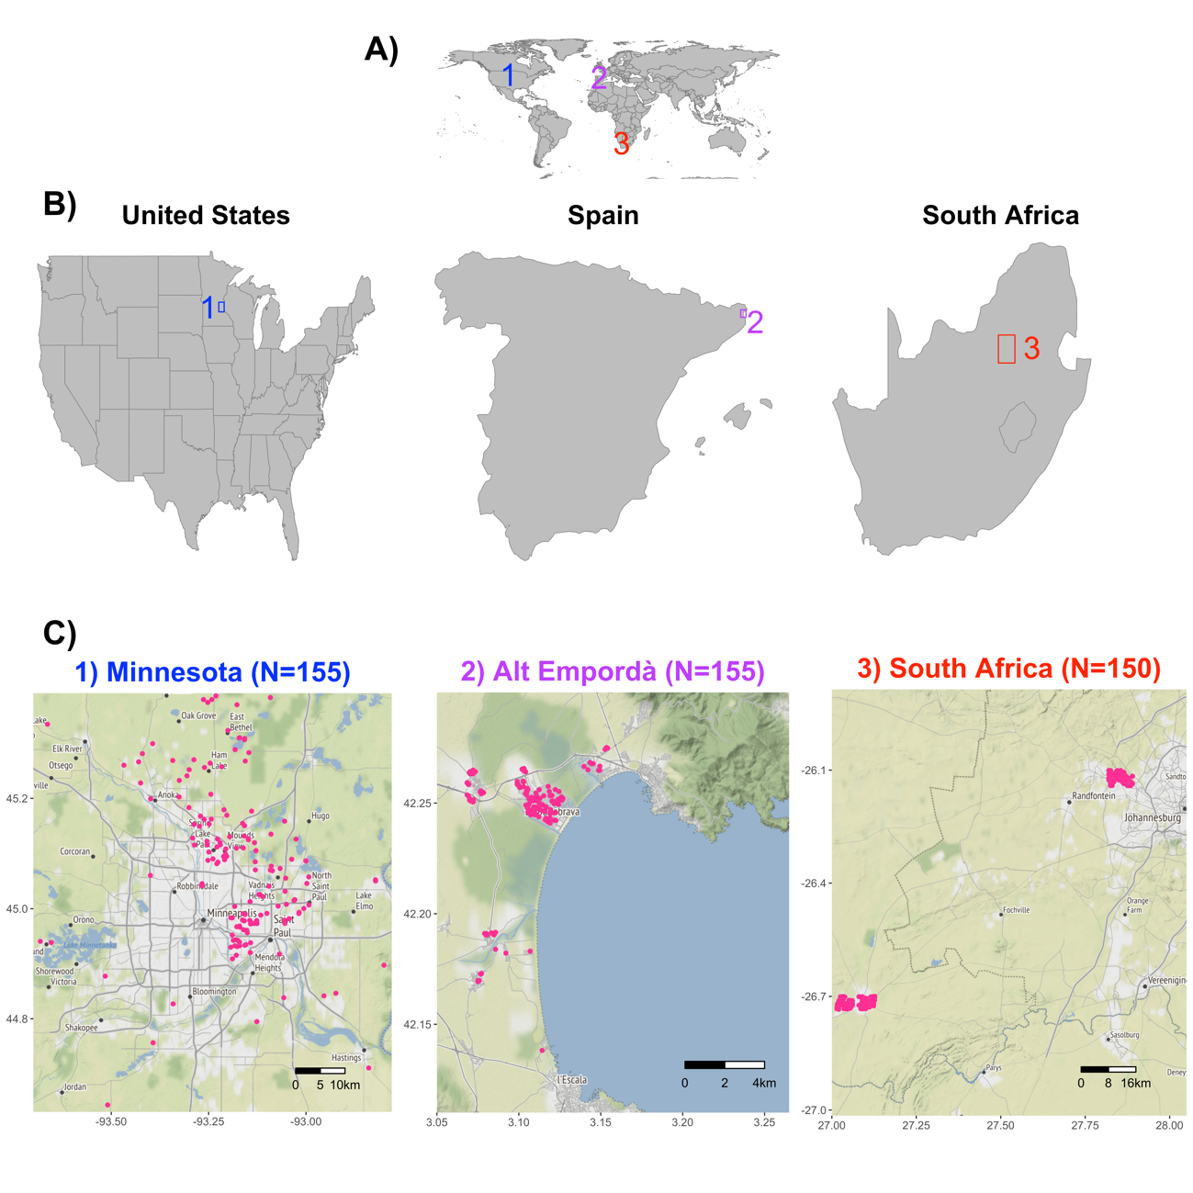
Figure S1: Locations of the three studied regions (i.e., Minneosta, Alt Empordà, and central South Africa) in the global context (A) and within countries (B). For each region, we also show the location of individual domestic gardens (C; pink dots).

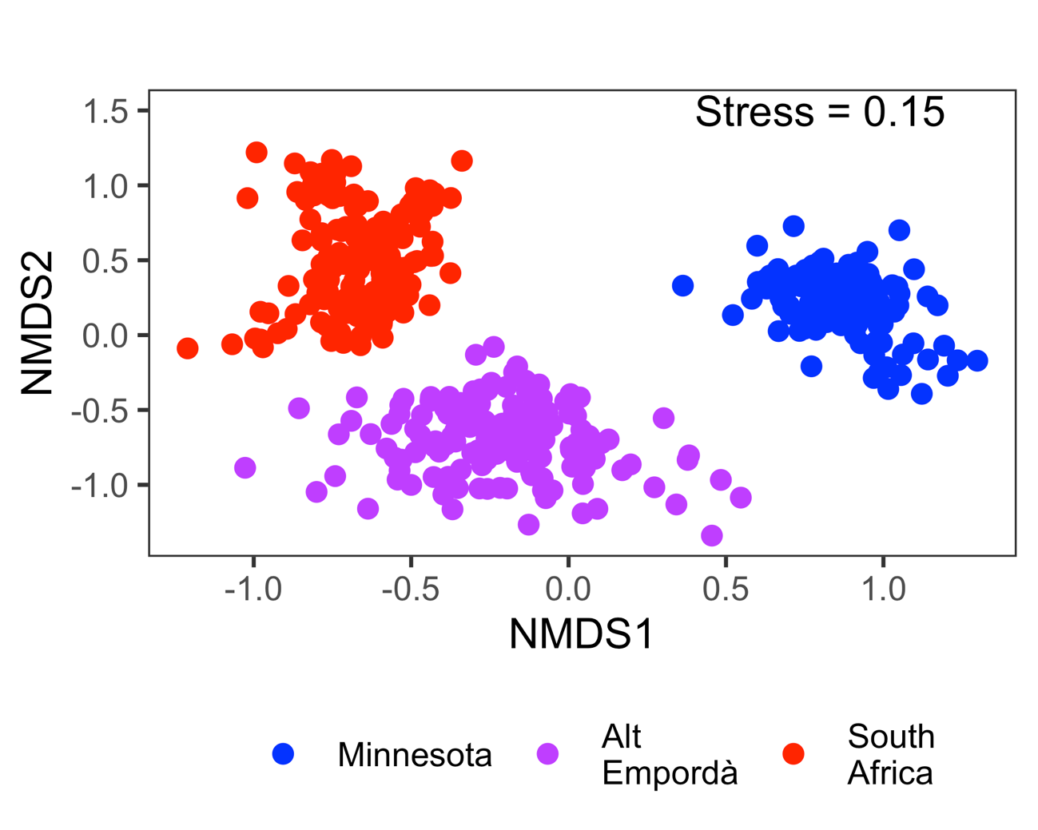
Figure S2: Result of the non-metric multidimensional scaling (NMDS) based on Sørensen dissimilarity index of the flora of 460 domestic gardens in Minnesota (US), Alt Empordà (Spain) and central South Africa. We performed NMDS with R package vegan (Oksanen and others, 2017).

References:

Oksanen, J., Blanchet, F. G., Kindt, R., Legendre, P., Minchin, P. R., O’hara, R. B., … others. (2017). vegan: Community Ecology Package. R Package Version 2.4-4. Retrieved from https://CRAN.R-project.org/package=vegan.

Table S1: Locations with datasets included in the study. A complete list of original references using that particular dataset is also provided. References for datasets can be found in the main text.
Location | Dataset | References
Minnesota (United States) | Cavender-Bares and others (2019) | Cavender-Bares, J.; Padullés Cubino, J.; Pearse, W.; Hobbie, S.; Lange, A.J.; Knapp, S.; Nelson, K. C. (2020). Horticultural availability and homeowner preferences drive plant diversity and composition in urban yards. Ecological Applications, e02082.  Knapp, S., Dinsmore, L., Fissore, C., Hobbie, S.E., Jakobsdottir, I., Kattge, J., King, J.Y., Klotz, S., McFadden, J.P. & Cavender-Bares, J. (2012) Phylogenetic and functional characteristics of household yard floras and their changes along an urbanization gradient. Ecology, 93, S83–S98.
Minnesota (United States) | Padullés Cubino and Narango (2019a) | Padullés Cubino, J., Avolio, M.L., Wheeler, M., Larson, K., Hobbie, S.E., Cavender-Bares, J., Hall, S.J., Nelson K.C., Trammell, T.L.E., Neill, C., Pataki, D.E., Grove, J.M., Groffman, P.M. (2020). Linking yard plant diversity to homeowners’ landscaping priorities across the U.S. Landscape & Urban Planning, 196, 103730.  Padullés Cubino, J., Cavender-Bares, J., Hobbie, S.E., Pataki, D.E., Avolio, M.L., Darling, L.E., Larson, K.L., Hall, S.J., Groffman, P.M., Trammell, T.L.E., Steele, M.K., Grove, J.M. & Neill, C. (2019) Drivers of plant species richness and phylogenetic composition in urban yards at the continental scale. Landscape Ecology, 34, 63-77.  Padullés Cubino, J., Cavender-Bares, J., Hobbie, S.E., Hall, S.J., Trammell, T.L.E., Neill, C., Avolio, M.L., Darling, L.E., Groffman, P.M. (2019). Contribution of non-native plants to the phylogenetic homogenization of US yard floras. Ecosphere, 10, e02638.  Pearse, W.D., Cavender-Bares, J., Hobbie, S.E., Avolio, M.L., Bettez, N., Roy Chowdhury, R., Darling, L.E., Groffman, P.M., Grove, J.M., Hall, S.J., Heffernan, J.B., Learned, J., Neill, C., Nelson, K.C., Pataki, D.E., Ruddell, B.L., Steele, M.K. & Trammell, T.L.E. (2018). Homogenization of plant diversity, composition, and structure in North American urban yards. Ecosphere, 9, e02105.  Locke, D.H., Avolio, M., Trammel, T., Chowdhury, R.R., Grove, J.M., Rogan, J., Martin, D.G., Bettez, N., Cavender-Bares, J., Groffman, P.M. and Hall, S.J. (2018). A multi-city comparison of front and backyard differences in plant species diversity and nitrogen cycling in residential landscapes. Landscape and Urban Planning, 178, 102-111.  Wheeler, M. M., C. Neill, P. M. Groffman, M. Avolio, N. Bettez, J. Cavender-Bares, R. Roy Chowdhury, L. Darling, J. M. Grove, S. J. Hall, J. B. Heffernan, S. E. Hobbie, K. L. Larson, J. L. Morse, K. C. Nelson, L. A. Ogden, J. O’Neil-Dunne, D. E. Pataki, C. Polsky, M. Steele, and T. L. E. Trammell. (2017). Continental-scale homogenization of residential lawn plant communities. Landscape and Urban Planning, 165, 54–63.
Alt Empordà (Spain) | Padullés Cubino (2019) | Padullés Cubino, J.; Kirkpatrick, J.B.; Vila, J. (2017). Do water requirements from Mediterranean gardens relate to socio-economic or demographic factors? Urban Water Journal, 14, 401-408.  Padullés Cubino, J.; Vila, J.; Barriocanal, C. (2016). Floristic and structural differentiation between gardens of primary and secondary residences in the Costa Brava (Catalonia, Spain). Urban Ecosystems, 19, 505-521.  Padullés Cubino, J., Vila Subirós, J. & Barriocanal Lozano, C. (2015). Propagule pressure from invasive plant species in gardens in low-density suburban areas of the Costa Brava (Spain). Urban Forestry & Urban Greening, 14, 941–951.  Padullés Cubino, J.; Vila, J.; Barriocanal, C. (2014). Maintenance, modifications, and water use in private gardens of Alt Empordà, Spain. Horttechnology, 24, 374-383.
South Africa | Dataset will be made publicly available upon manuscript acceptance | Davoren, E., Siebert, S., Cilliers, S. & du Toit, M.J. (2016). Influence of socioeconomic status on design of Batswana home gardens and associated plant diversity patterns in northern South Africa. Landscape and Ecological Engineering, 12, 129–139.  Lubbe C.S., Siebert S.J., Cilliers S.S. (2011). A floristic analysis of domestic gardens in the Tlokwe Municipal area, South Africa. Bothalia, 41, 351–361.  Lubbe, C.S., Siebert, S.J. & Cilliers, S.S. (2010) Political legacy of South Africa affects the plant diversity patterns of urban domestic gardens along a socio-economic gradient. Scientific Research and Essays, 5, 2900–2910.  Molebatsi L.Y., Siebert S.J., Cilliers S.S. (2013). Alien and indigenous plant species diversity of homegardens of a rural settlement in the eastern Kalahari, South Africa. Scripta Botanica Belgica, 50, 294–303.

Table S2: Climatic data for the three regions included in our study. For each climatic variable and urban area, we provide the raw value and the standardized value in brackets. Standardized values were used to assess what climatic variable maximized climatic variation among regions (i.e., a middle-standardized value closer to 0.5). The variable that maximized climatic variation among regions was the Aridity index, and its middle-standardized value (0.47) is shown in bold.

Regions | Mean Annual Temperature (ºC)¹ | Maximum temperature of the warmest month (ºC)¹ | Minimum temperature of the coldest month (ºC)¹ | Annual precipitation (mm)¹ | Aridity index  (*10,000)²
Minnesota | 7.02 (0.00) | 26.67 (0.00) | -17.40 (0.00) | 754 (1.00) | 8291 (1.00)
Alt Empordà | 15.24 (0.85) | 27.86 (0.36) | 3.70 (1.00) | 531 (0.00) | 6118 (0.47)
South Africa | 16.73 (1.00) | 30.00 (1.00) | 1.39 (0.89) | 720 (0.84) | 4217 (0.00)
¹Climatic data represent average values across all households in each region. They were obtained from the WorldClim database v.2 (www.worldclim.org/version2).
²Details on the calculation of the Aridity index can be found in the Methods.

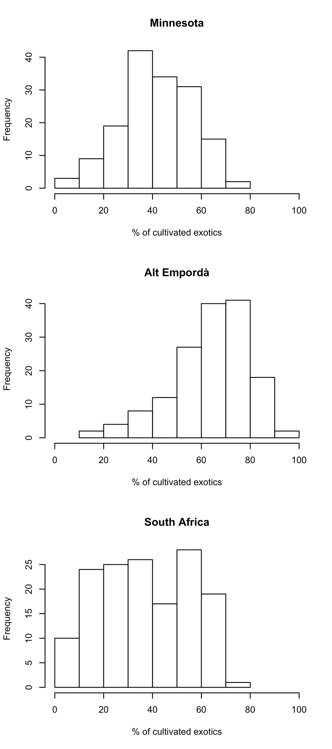
Figure S3: Histogram of the proportion (%) of cultivated exotic plants in domestic gardens in the threes sampled regions.

Appendix S2: References retrieved from TRY database

Adler, P. B., D. G. Milchunas, W. K. Lauenroth, O. E. Sala & Burke I. C. (2004). Functional traits of graminoids in semi-arid steppes: a test of grazing histories. Journal of Applied Ecology 41, 653–663.
Adler P. B., R. Salguero-Gómez, A. Compagnoni, J. S. Hsu, J. Ray-Mukherjee, C. Mbeau-Ache & Franco M. (2014). Functional traits explain variation in plant life history strategies. PNAS 111(2), 740-745. doi: 10.1073/pnas.1315179111
Auger, S. & B. Shipley (2012). Interspecific and intraspecific trait variation along short environmental gradients in an old-growth temperate forest. Journal of Vegetation Science. DOI: 1111/j.1654-1103.2012.01473.x
Baraloto, C., C. E. T. Paine, L. Poorter, J. Beauchene, D. Bonal, A.-M. Domenach, B. Herault, S. Patino, J.-C. Roggy & Chave J. (2010). Decoupled leaf and stem economics in rainforest trees. Ecology Letters 13, 1338-1347.
Berner, L. T., H. D. Alexander, M. M. Loranty, P. Ganzlin, M. C. Mack, S. P. Davydov & S. J. Goetz S. J. (2015). Biomass allometry for alder, dwarf birch, and willow in boreal forest and tundra ecosystems of far northeastern Siberia and north-central Alaska, Forest Ecology and Management 337, 110-118.
Blonder, B., B. Buzzard, L. Sloat, I. Simova, R. Lipson, B. Boyle & Enquist B. (2012). The shrinkage effect biases estimates of paleoclimate. American Journal of Botany 99(11), 1756-1763.
Blonder, B., C. Violle & B. J. Enquist (2013). Assessing the causes and scales of the leaf economics spectrum using venation networks in Populus tremuloides. Journal of Ecology 101, 981–989. doi:10.1111/1365-2745.12102
Blonder, B., C. Violle, L. Patrick & Enquist B. (2011). Venation networks and the origin of the leaf economics spectrum. Ecology Letters 14, 91-100.
Bocanegra-Gonzalez K. T., F. Fermandez-Mendez & Galvis-Jimenez J. F. (in press) Determinación de la resiliencia en bosques secundarios húmedos tropicales a través de la diversidad funcional de árboles en la región del Bajo Calima, Buenaventura, Colombia.
Bond-Lamberty, B., C. Wang & Gower S. T. (2002). Above- and belowground biomass and sapwood area allometric equations for six boreal tree species of northern Manitoba, Can. J. For. Res. 32(8), 1441-1450.
Bond-Lamberty, B., C. Wang & Gower S. T. (2002). Leaf area dynamics of a boreal black spruce fire chronosequence, Tree Physiol. 22(14), 993-1001.
Boucher, F. C., W. Thuiller, C. Arnoldi, C. H. Albert, & S. Lavergne S. (2013). Unravelling the architecture of functional variability in wild populations of Polygonum viviparum L. Functional Ecology 27, 382–391.
Bragazza L. (2009). Conservation priority of Italian alpine habitats: a floristic approach based on potential distribution of vascular plant species. Biodiversity and Conservation 18, 2823–2835.
Brown et al. (2011). Assessing Natural Resource Use by Forest-Reliant Communities in Madagascar Using Functional Diversity and Functional Redundancy Metrics. PLoS ONE 6(9): e24107. doi:10.1371/journal.pone.0024107
Burrascano S., R. Copiz, E. Del Vico, S. Fagiani, E. Giarrizzo, M. Mei, A. Mortelliti, F. M. Sabatini & Blasi C. (2015). Wild boar rooting intensity determines shifts in understorey composition and functional traits. Community Ecology 16(2), 244-253. DOI: 10.1556/168.2015.16.2.12
Butterfield, B. J. & Briggs J. M. (2011). Regeneration niche differentiates functional strategies of desert woody plant species. Oecologia 165, 477-487.
Campetella, G., Z. Botta-Dukát, C. Wellstein, R. Canullo, S. Gatto, S. Chelli, L. Mucina & Bartha S. (2011). Patterns of plant trait-environment relationships along a forest succession chronosequence. Agriculture, Ecosystems & Environment 145(1), 38-48. doi:10.1016/j.agee.2011.06.025
Cavender-Bares, J., A. Keen & Miles B. (2006). Phylogenetic structure of floridian plant communities depends on taxonomic and spatial scale. Ecology 87, S109-S122.
Cerabolini B., S. Pierce, A. Luzzaro & Ossola A.(2010). Species evenness affects ecosystem processes in situ via diversity in the adaptive strategies of dominant species. Plant Ecology 207(2), 333-345.
Cerabolini B. E. L., G. Brusa, R. M. Ceriani, R. De Andreis, A. Luzzaro & Pierce S. (2010). Can CSR classification be generally applied outside Britain? Plant Ecology 210, 253-261.
Ciccarelli D. (2015). Mediterranean coastal dune vegetation: Are disturbance and stress the key selective forces that drive the psammophilous succession? Estuarine, Coastal and Shelf Science 165(5), 247–253. doi: 10.1016/j.ecss.2015.05.023
Ciocarlan V. (2009). The illustrated Flora of Romania. Pteridophyta et Spermatopyta. Editura Ceres, 1141 p (in Romanian).
Coomes, D. A., S. Heathcote, E. R. Godfrey, J. J. Shepherd & Sack L. (2008). Scaling of xylem vessels and veins within the leaves of oak species. Biology Letters 4, 302-306.
Cornelissen, J. H. C., B. Cerabolini, P. Castro-Diez, P. Villar-Salvador, G. Montserrat-Marti, J. P. Puyravaud, M. Maestro, M. J. A. Werger & Aerts R. (2003). Functional traits of woody plants: correspondence of species rankings between field adults and laboratory-grown seedlings? Journal of Vegetation Science 14, 311-322.
Domingues T. F., P. Meir, T. R. Feldpausch, et al. (2010). Co-limitation of photosynthetic capacity by nitrogen and phosphorus in West Africa woodlands. Plant, Cell & Environment 33(6), 959-980.
Dwyer, J. M., R. J. Hobbs & Mayfield M. M. (2014). Specific leaf area responses to environmental gradients through space and time. Ecology 95, 399-410.
Everwand G., E. L. Fry, T. Eggers & Manning P. (2014). Seasonal variation in the relationship between plant traits and grassland carbon and water fluxes. Ecosystems 17, 1095-1108.
Fagúndez, J. & J. Izco J. (2008). Seed morphology of two distinct species of Erica L. (Ericaceae). Acta Botanica Malacitana 33, 1-9.
Fitter, A. H. & Peat H. J. (1994). The Ecological Flora Database. Journal of Ecology 82, 415-425.
Fonseca, C. R., J. M. Overton, B. Collins & Westoby M. (2000). Shifts in trait-combinations along rainfall and phosphorus gradients. Journal of Ecology 88, 964-977.
Forgiarini, C., A. F. Souza, S. J. Longhi & Oliveira J. M. (2015). In the lack of extreme pioneers: trait relationships and ecological strategies of 66 subtropical tree species. J. Plant Ecology 8, 359–367. doi:10.1093/jpe/rtu028
Frenette-Dussault, C., B. Shipley, J. F. Léger, D. Meziane & Hingrat Y. (2012). Functional structure of an arid steppe plant community reveals similarities with Grime's C-S-R theory. Journal of Vegetation Science 23, 208-222.
Freschet, G. T., J. H. C. Cornelissen, R. S. P. van Logtestijn & Aerts R. (2010). Evidence of the ‘plant economics spectrum’ in a subarctic flora. Journal of Ecology 98, 362-373.
Fry, E. L., S. A. Power & Manning P. (2014). Trait based classification and manipulation of functional groups in biodiversity-ecosystem function experiments. Journal of Vegetation Science 25, 248-261.
Fyllas, N. M., S. Patino, T. R. Baker, G. Bielefeld Nardoto, L. A. Martinelli, C. A. Quesada, R. Paiva, M. Schwarz, V. Horna, L. M. Mercado, A. Santos, L. Arroyo, E. M. Jimenez, F. J. Luizao, D. A. Neill, N. Silva, A. Prieto, A. Rudas, M. Silviera, I. C. G. Vieira, G. Lopez-Gonzale & J. Lloyd J. (2009). Basin-wide variations in foliar properties of Amazonian forest: phylogeny, soils and climate Biogeosciences 6, 2677-2708.
Gachet, S., E. Véla & Tatoni T. (2005). BASECO: a floristic and ecological database of Mediterranean French flora. Biodiversity and Conservation 14(4), 1023-1034.
Gallagher, R. V. & Leishman M. R. (2012). A global analysis of trait variation and evolution in climbing plants. Journal of Biogeography 39, 1757-1771. DOI: 10.1111/j.1365-2699.2012.02773.x
Garnier, E., S. Lavorel, P. Ansquer, H. Castro, P. Cruz, J. Dolezal, O. Eriksson, C. Fortunel, H. Freitas, C. Golodets, K. Grigulis, C. Jouany, E. Kazakou, J. Kigel, M. Kleyer, V. Lehsten, J. Leps, T. Meier, R. Pakeman, M. Papadimitriou, V. P. Papanastasis, H. Quested, F. Quetier, M. Robson, C. Roumet, G. Rusch, C. Skarpe, M. Sternberg, J.-P. Theau, A. Thebault, D. Vile & Zarovali M. P. (2007). Assessing the effects of land-use change on plant traits, communities and ecosystem functioning in grasslands: A standardized methodology and lessons from an application to 11 European sites. Annals of Botany 99, 967-985.
Gonzalez-Akre, E., W. McShea, N. Bourg & Anderson-Teixeira K. (2015). Leaf traits data (SLA) for 56 woody species at the Smithsonian Conservation Biology Institute-ForestGEO Forest Dynamic Plot. Front Royal, Virginia. USA. [Data set]. Version 1.0.(www.try-db.org)
Green, W. (2009). USDA PLANTS Compilation, version 1, 09-02-02. (http://bricol.net/downloads/data/PLANTSdatabase/) NRCS: The PLANTS Database (http://plants.usda.gov, 1 Feb 2009). National Plant Data Center: Baton Rouge, LA 70874-74490 USA.
Guerin, G. R., H. Wen & Lowe A. J. (2012). Leaf morphology shift linked to climate change. Biology Letters 8, 882-886.
Guy, A. L., J. M. Mischkolz & Lamb E. G. (2013). Limited effects of simulated acidic deposition on seedling survivorship and root morphology of endemic plant taxa of the Athabasca Sand Dunes in well watered greenhouse trials. Botany 91, 176-181. http://dx.doi.org/10.1139/cjb-2012-0162
Hao, G. Y., L. Sack, A. Y. Wang, K. F. Cao & Goldstein G. (2010). Differentiation of leaf water flux and drought tolerance traits in hemiepiphytic and non-hemiepiphytic Ficus tree species. Functional Ecology 24, 731-740.
Hattermann, D., C. Elstner, M. Bernhardt-Römermann & Eckstein L. Measurements from the project “Relative effects of local and regional factors as drivers for plant community diversity, functional trait diversity and genetic structure of species on Baltic uplift islands” funded by the German Research Foundation - DFG: BE 4143/5-1 and EC 209/12-1
Hickler, T. (1999). Plant functional types and community characteristics along environmental gradients on Öland's Great Alvar (Sweden) Masters Thesis, University of Lund, Sweden.
Hill, M. O., C. D. Preston & Roy D. B. (2004). PLANTATT - attributes of British and Irish Plants: status, size, life history, geography and habitats. Huntingdon: Centre for Ecology and Hydrology.
Joseph, G. S., C. L. Seymour, G. S. Cumming, D. H. M. Cumming & Mahlangu Z. (2014). Termite mounds increase functional diversity of woody plants in African savannas. Ecosystems 17, 808–819.
Kattge, J., W. Knorr, T. Raddatz & Wirth C. (2009). Quantifying photosynthetic capacity and its relationship to leaf nitrogen content for global-scale terrestrial biosphere models. Global Change Biology 15, 976-991.
Kichenin, E., et al. (2013). Contrasting effects of plant inter- and intraspecific variation on community-level trait measures along an environmental gradient. Functional Ecology 27(5), 1254-1261.
Kirkup, D., P. Malcolm, G. Christian & Paton A. (2005). Towards a digital African Flora. Taxon 54, 457-466.
Kleyer, M., R. M. Bekker, I. C. Knevel, J. P. Bakker, K. Thompson, M. Sonnenschein, P. Poschlod, J. M. van Groenendael, L. Klimes, J. Klimesova, S. Klotz, G. M. Rusch, Hermy, M., D. Adriaens, G. Boedeltje, B. Bossuyt, A. Dannemann, P. Endels, L. Götzenberger, J. G. Hodgson, A.-K. Jackel, I. Kühn, D. Kunzmann, W. A. Ozinga, C. Römermann, M. Stadler, J. Schlegelmilch, H. J. Steendam, O. Tackenberg, B. Wilmann, J. H. C. Cornelissen, O. Eriksson, E. Garnier & Peco B. (2008). The LEDA Traitbase: a database of life-history traits of the Northwest European flora. Journal of Ecology 96, 1266-1274.
Koike, F. (2001). Plant traits as predictors of woody species dominance in climax forest communities. Journal of Vegetation Science 12, 327-336.
Komac B., C. Pladevall, M. Domenech & Fanlo R. (2014). Functional diversity and grazing intensity in sub-alpine and alpine grasslands in Andorra. Applied Vegetation Science 18(1), 75-85
Kühn, I., W. Durka & Klotz S. (2004). BiolFlor - a new plant-trait database as a tool for plant invasion ecology. Diversity and Distribution 10, 363-365.
Kurokawa, H. & Nakashizuka T. (2008). Leaf herbivory and decomposability in a Malaysian tropical rain forest. Ecology 89, 2645-2656.
La Pierre, K. J. & Smith M. D. (2015). Functional trait expression of grassland species shift with short- and long-term nutrient additions. Plant Ecology 216, 307 doi:10.1007/s11258-014-0438-4
Laughlin, D. C., J. J. Leppert, M. M. Moore & Sieg C. H. (2010). A multi-trait test of the leaf-height-seed plant strategy scheme with 133 species from a pine forest flora. Functional Ecology 24, 493-501.
Laughlin, D. C., P. Z. Fulé, D. W. Huffman, J. Crouse & Laliberte E. (2011). Climatic constraints on trait-based forest assembly. Journal of Ecology 99, 1489-1499.
Lhotsky, B., A. Csecserits, B. Kovács & Botta-Dukát Z. 2016. New plant trait records of the Hungarian flora 58(3-4), 397-400.
Malhado, A. C. M., Y. Malhi, R.J. Whittaker, R.J. Ladle, H. ter Steege, O. L. Phillips, N. Butt, L. E. O. C. Aragão, C. A. Quesada, A. Araujo-Mutakami, L. Arroyo, J. Peacock, G. López-González, T. R. Baker, L. O. Anderson, S. Almeida, N. Higuchi, T. J . Killeen, A. Monteagudo, D. A. Neill, N. C. A. Pitman, A. Prieto, R. P. Salomão, R. M. Vásquez & Laurance W. F. (2009). Spatial trends in leaf size of Amazonian rainforest trees. Biogeoscience 6, 1563-1576. DOI:10.5194/bg-6-1563-2009
Manning, P., K. Houston & Evans T. (2009). Shifts in seed size across experimental nitrogen enrichment and plant density gradients. Basic and Applied Ecology 10, 300-308.
Moretti, M. & Legg C. (2009). Combining plant and animal traits to assess community functional responses to disturbance. Ecography 32, 299-309. doi: 10.1111/j.1600-0587.2008.05524.x
Martinez-Garza, C., F. Bongers & Poorter L. (2013). Are functional traits good predictors of species performance in restoration plantings in tropical abandoned pastures? Forest Ecology and Management 303, 35-45.
Medlyn, B. E., F.-W. Badeck, D. G. G. De Pury, C. V. M. Barton, M. Broadmeadow, R. Ceulemans, P. De Angelis, M. Forstreuter, M. E. Jach, S. Kellomäki, E. Laitat, M. Marek, S. Philippot, A. Rey, J. Strassemeyer, K. Laitinen, R. Liozon, B. Portier, P. Roberntz, K. Wang & Jarvis P. G. (1999). Effects of elevated CO2 on photosynthesis in European forest species: a meta-analysis of model parameters. Plant, Cell and Environment 22, 1475-1495.
Mencuccini, M. (2003). The ecological significance of long distance water transport: short-term regulation and long-term acclimation across plant growth forms. Plant, Cell and Environment, 26, 163-182.
Messier, J., B. J. McGill & Lechowicz M. J. (2010). How do traits vary across ecological scales? A case for trait-based ecology. Ecology Letters 13, 838-848.
Milla, R. & Reich P. (2011). Multi-trait interactions, not phylogeny, fine-tune leaf size reduction with increasing altitude. Annals of Botany 107, 455–465.
Ogaya, R. & J. Penuelas (2003). Comparative field study of Quercus ilex and Phillyrea latifolia: photosynthetic response to experimental drought conditions. Environmental and Experimental Botany 50, 137-148.
Ordonez, J. C., P. M. van Bodegom, J. P. M. Witte, R. P. Bartholomeus, J. R. van Hal & Aerts R. (2010). Plant Strategies in Relation to Resource Supply in Mesic to Wet Environments: Does Theory Mirror Nature? American Naturalist 175, 225-239.
Pahl, A. T., J. Kollmann, A. Mayer & Haider S. (2013). No evidence for local adaptation in an invasive alien plant: field and greenhouse experiments tracing a colonization sequence. Annals of Botany 112(9), 1921-1930. DOI: 10.1093/aob/mct246
Paula, S., M. Arianoutsou, D. Kazanis, Ç. Tavsanoglu, F. Lloret, C. Buhk, F. Ojeda, B. Luna, J. M. Moreno, A. Rodrigo, J. M. Espelta, S. Palacio, B. Fernández-Santos, P. M. Fernandes & Pausas J. G. (2009). Fire-related traits for plant species of the Mediterranean Basin. Ecology 90, 1420.
Peco, B., I. de Pablos, J. Traba &Levassor C. (2005). The effect of grazing abandonment on species composition and functional traits: the case of dehesa. Basic and Applied Ecology, 6(2), 175-183.
Pierce, S., G. Brusa, M. Sartori & Cerabolini B. E. L. (2012). Combined use of leaf size and economics traits allows direct comparison of hydrophyte and terrestrial herbaceous adaptive strategies. Annals of Botany 109(5), 1047-1053
Pierce, S., G. Brusa, M. Sartori & Cerabolini B. E. L. (2013) Allocating CSR plant functional types: the use of leaf economics and size traits to classify woody and herbaceous vascular plants. Functional Ecology 27(4), 1002-1010
Pierce, S., R. M. Ceriani, R. De Andreis, A. Luzzaro & Cerabolini B. (2007). The leaf economics spectrum of Poaceae reflects variation in survival strategies. Plant Biosystems 141(3), 337-343.
Pierce, S., A. Luzzaro, M. Caccianiga, R. M. Ceriani & Cerabolini B. (2007). Disturbance is the principal ?-scale filter determining niche differentiation, coexistence and biodiversity in an alpine community. Journal of Ecology 95, 698-706.
Pierce, S., I. Vagge, G. Brusa & Cerabolini B. E. L. (2014). The intimacy between sexual traits and Grime’s CSR strategies for orchids coexisting in semi-natural calcareous grassland at the Olive Lawn. Plant Ecology 215(5), 495-505.
Prentice, I. C., T. Meng, H. Wang, S. P. Harrison, J. Ni & Wang G. (2011). Evidence for a universal scaling relationship of leaf CO2 drawdown along a moisture gradient. New Phytologist 190, 169–180.
Preston, K. A., W. K. Cornwell & DeNoyer J. L. (2006). Wood density and vessel traits as distinct correlates of ecological strategy in 51 California coast range angiosperms. New Phytologist 170, 807-818.
Price, C. A. & Enquist B. J. (2007). Scaling of mass and morphology in Dicotyledonous leaves: an extension of the WBE model. Ecology 88(5), 1132–1141.
Pyankov, V. I., A. V. Kondratchuk & Shipley B. (1999). Leaf structure and specific leaf mass: the alpine desert plants of the Eastern Pamirs, Tadjikistan. New Phytologist 143, 131-142.
Quero, J. L., R. Villar, T. Maranon, R. Zamora, D. Vega & Sack L. (2008). Relating leaf photosynthetic rate to whole-plant growth: drought and shade effects on seedlings of four Quercus species. Functional Plant Biology 35, 725-737.
Reich, P. B., M. G. Tjoelker, K. S. Pregitzer, I. J. Wright, J. Oleksyn & Machado J. L. (2008). Scaling of respiration to nitrogen in leaves, stems and roots of higher land plants. Ecology Letters 11, 793-801.
Royal Botanical Gardens KEW. Seed Information Database (SID), http://data.kew.org/sid/ accessed May 2014
Sack, L. (2004). Responses of temperate woody seedlings to shade and drought: do trade-offs limit potential niche differentiation? Oikos 107, 110-127.
Sack, L. & K. Frole (2006). Leaf structural diversity is related to hydraulic capacity in tropical rain forest trees. Ecology 87, 483-491.
Sack, L., P. D. Cowan, N. Jaikumar & Holbrook N. M. (2003). The 'hydrology' of leaves: co-ordination of structure and function in temperate woody species. Plant Cell and Environment 26, 1343-1356.
Sack, L., P. J. Melcher, W. H. Liu, E. Middleton & Pardee T. (2006). How strong is intracanopy leaf plasticity in temperate deciduous trees? American Journal of Botany 93, 829-839.
Sandel, B., J. D. Corbin & Krupa M. (2011). Using plant functional traits to guide restoration: A case study in California coastal grassland. Ecosphere 2(2), 1-6.
Schall, P., C. Lödige, M. Beck & Ammer C. (2012). Biomass allocation to roots and shoots is more sensitive to shade and drought in European beech than in Norway spruce seedlings. Forest Ecology and Management 266, 246-253
Scherer-Lorenzen, M., E.-D. Schulze, A. Don, J. Schumacher & Weller E. (2007). Exploring the functional significance of forest diversity: A new long-term experiment with temperate tree species (BIOTREE). Perspectives in Plant Ecology, Evolution and Systematics 9, 53-70.
Schroeder-Georgi, T., C. Wirth, K. Nadrowski, S. T. Meyer, L. Mommer & Weigelt A. (2016). From pots to plots: hierarchical trait-based prediction of plant performance in a mesic grassland. Journal of Ecology, 104, 206–218. doi:10.1111/1365-2745.12489
Schurr, F. M., G. F. Midgley, A. G. Rebelo, G. Reeves, P. Poschlod & Higgins S. I. (2007). Colonization and persistence ability explain the extent to which plant species fill their potential range. Global Ecology and Biogeography, 16, 449-459.
Schweingruber, F. H. & Landolt W. (2005). The Xylem Database. Swiss Federal Research Institute WSL.
Scoffoni, C., A. Pou, K. Aasamaa & Sack L. (2008). The rapid light response of leaf hydraulic conductance: new evidence from two experimental methods. Plant Cell and Environment 31, 1803-1812.
Shiodera, S., J. S. Rahajoe & Kohyama T. (2008). Variation in longevity and traits of leaves among co-occurring understorey plants in a tropical montane forest. Journal of Tropical Ecology 24, 121-133.
Shipley, B. (1995). Structured Interspecific Determinants of Specific Leaf-Area in 34 Species of Herbaceous Angiosperms. Functional Ecology 9, 312-319.
Shipley, B. & Parent M. (1991). Germination Responses of 64 Wetland Species in Relation to Seed Size, Minimum Time to Reproduction and Seedling Relative Growth-Rate. Functional Ecology 5, 111-118.
Shipley, B. & Vu T. T. (2002). Dry matter content as a measure of dry matter concentration in plants and their parts. New Phytologist 153, 359-364.
Siefert, A. (2012). Spatial patterns of functional divergence in old-field plant communities. Oikos 121, 907-914.
Siefert, A., J. D. Fridley & Ritchie M. E. (2014). Community functional responses to soil and climate at multiple spatial scales: when does intraspecific variation matter? PLoS ONE 9: e111189
Spasojevic, M. J. & Suding K. N. (2012). Inferring community assembly mechanisms from functional diversity patterns: the importance of multiple assembly processes. Journal of Ecology 100, 652-661.
Swaine, E. K. (2007). Ecological and evolutionary drivers of plant community assembly in a Bornean rain forest. PhD Thesis, University of Aberdeen, Aberdeen.
Takkis, K. 2014. Changes in plant species richness and population performance in response to habitat loss and fragmentation. DISSERTATIONES BIOLOGICAE UNIVERSITATIS TARTUENSIS 255, 2014-04-07. Available from: http://hdl.handle.net/10062/39546
Vergutz, L., S. Manzoni, A. Porporato, R.F. Novais & Jackson R.B. (2012). A Global Database of Carbon and Nutrient Concentrations of Green and Senesced Leaves. Data set. Available on-line [http://daac.ornl.gov] from Oak Ridge National Laboratory Distributed Active Archive Center, Oak Ridge, Tennessee, U.S.A. http://dx.doi.org/10.3334/ORNLDAAC/1106
Vile, D. (2005). Significations fonctionnelle et ecologique des traits des especes vegetales: exemple dans une succession post-cultural mediterraneenne et generalisations, PHD Thesis.
Von Holle, B. & Simberloff D. (2004). Testing Fox's assembly rule: Does plant invasion depend on recipient community structure? Oikos 105, 551-563.
Williams, M., Y.E. Shimabokuro & Rastetter E.B. (2012). LBA-ECO CD-09 Soil and Vegetation Characteristics, Tapajos National Forest, Brazil. Data set. Available on-line [http://daac.ornl.gov] from Oak Ridge National Laboratory Distributed Active Archive Center, Oak Ridge, Tennessee, U.S.A. http://dx.doi.org/10.3334/ORNLDAAC/1104
Willis, C. G., M. Halina, C. Lehman, P. B. Reich, A. Keen, S. McCarthy & Cavender-Bares J. (2010). Phylogenetic community structure in Minnesota oak savanna is influenced by spatial extent and environmental variation. Ecography 33, 565-577.
Wilson, K., D. Baldocchi & Hanson P. (2000). Spatial and seasonal variability of photosynthetic parameters and their relationship to leaf nitrogen in a deciduous forest. Tree Physiology 20, 565–578.
Wirth, C. & Lichstein J. W. (2009). The Imprint of Species Turnover on Old-Growth Forest Carbon Balances - Insights From a Trait-Based Model of Forest Dynamics. Pages 81-113 in C. Wirth, G. Gleixner, and M. Heimann, editors. Old-Growth Forests: Function, Fate and Value. Springer, New York, Berlin, Heidelberg.
Wright, J. P. &Sutton-Grier A. (2012). Does the leaf economic spectrum hold within local species pools across varying environmental conditions? Functional Ecology 26(6), 1390-1398. doi: 10.1111/1365-2435.12001
Wright, I. J., D. D. Ackerly, F. Bongers, K. E. Harms, G. Ibarra-Manriquez, M. Martinez-Ramos, S. J. Mazer, H. C. Muller-Landau, H. Paz, N. C. A. Pitman, L. Poorter, M. R. Silman, C. F. Vriesendorp, C. O. Webb, M. Westoby & Wright S. J. (2007). Relationships among ecologically important dimensions of plant trait variation in seven Neotropical forests. Annals of Botany 99, 1003-1015.
Wright, I. J., P. B. Reich, M. Westoby, D. D. Ackerly, Z. Baruch, F. Bongers, J. Cavender-Bares, T. Chapin, J. H. C. Cornelissen, M. Diemer, J. Flexas, E. Garnier, P. K. Groom, J. Gulias, K. Hikosaka, B. B. Lamont, T. Lee, W. Lee, C. Lusk, J. J. Midgley, M. L. Navas, U. Niinemets, J. Oleksyn, N. Osada, H. Poorter, P. Poot, L. Prior, V. I. Pyankov, C. Roumet, S. C. Thomas, M. G. Tjoelker, E. J. Veneklaas & Villar R. (2004). The worldwide leaf economics spectrum. Nature 428, 821-827.
Wright, S. J., K. Kitajima, N. J. B. Kraft, P. B. Reich, I. J. Wright, D. E. Bunker, R. Condit, J. W. Dalling, S. J. Davies, S. Díaz, B. M. J. Engelbrecht, K. E. Harms, S. P. Hubbell, C. O. Marks, M. C. Ruiz-Jaen, C. M. Salvador & Zanne (2011). Functional traits and the growth-mortality tradeoff in tropical trees. Ecology 91, 3664-3674.
Appendix S3: Details on missing trait data imputation and performance assessment

Data for plant height and leaf area were not available for some species (Table S3). Deleting species with missing data from the analysis would reduce the number of data points substantially, and probably bias the results because of the selective removal of species that were less well known (Swenson, 2014). These cases were accommodated by estimating the missing values using phylogenetic information from species with available data. Some characteristics inherent to functional traits such as a strong phylogenetic trait signal and structural trade-offs between traits support statistical gap-filling of sparse trait matrices using this approach (Swenson 2014).

Table S3: Proportion of plant species with available trait data within and across sampled regions. Note that a same species can be classified as either cultivated or spontaneous in different regions and/or gardens.

Location and species pool |  | Total number of species | % of species with trait values
 |  | Total number of species | Plant Showiness | Plant height (m) | Leaf area (mm²)
Across all regions (all species) |  | 1,863 | 100 | 87 | 58
Cultivated |  | 1,388 | 100 | 84 | 53
Spontaneous |  | 656 | 100 | 95 | 76
Within each region
 | Minnesota (all species) | 956 | 100 | 83 | 64
 | Cultivated | 684 | 100 | 80 | 59
 | Spontaneous | 417 | 100 | 92 | 80
 | Alt Empordà (all species) | 549 | 100 | 83 | 57
 | Cultivated | 461 | 100 | 80 | 51
 | Spontaneous | 88 | 100 | 99 | 86
 | South Africa (all species) | 760 | 100 | 100 | 56
 | Cultivated | 550 | 100 | 100 | 51
 | Spontaneous | 210 | 100 | 100 | 70

Detailed studies of contemporary evolution have revealed that a rich variety of processes influence how traits evolve through time. These studies have documented the action of natural selection on traits from one generation to the next. For example, changes in environmental conditions affect which individuals survive within the population. When natural selection acts on traits that can be inherited from parents to offspring, those traits evolve. Therefore, functional traits have a strong phylogenetic signal and structural trade-offs between traits and trait-environment relationships.

In our study we followed this assumption to estimate missing traits using phylogenetic information from species with available data. Particularly, we used the function ‘phylopars’ in the R package Rphylopars (Goolsby and others, 2017). This function provides an efficient and statistically consistent method of combining any number of empirical observations with the phylogenetic tree to arrive at a complete set of estimates for missing parameter values. Furthermore, the function can be used to fit alternative evolutionary models. We constructed a phylogenetic tree using an updated version of the Zanne and others (2014) phylogeny constructed by Qian and Jin (2016). In our case, four alternative evolutionary models with implicit assumptions were initially considered:

- Brownian motion (BM): The BM is the simplest model and assumes that, through time, traits evolve via a random walk process. In this model there is no optimum value for the trait, and there are no processes (e.g., selection) that influence the trait value. Variation is unbounded and accumulates linearly as a function of time, and the expected difference in trait value (i.e., the mean value) is zero.
- Ornstein-Uhlenbeck (OU): The OU model is derived from the Brownian motion model, but has an additional “constraint parameter”, which pulls the trait value towards the long term mean. This mean can be conceptualized as the optimum value for a particular trait. The result of this model is a much more bounded set of trait values, but again, the mean trait value is zero. When the parameter is 0, the model is equivalent to the BM model.
- Multivariate Ornstein-Uhlenbeck (MOU): The MOU model is equivalent to the OU process assuming that trait values across species can covary because of phylogenetic relationships. In this case, scalars are replaced by vectors, or matrices, as appropriate.
- Early Burst (EB): The EB model is also derived from the Brownian motion model. Like the OU model, this model includes an extra parameter (r) that describes how the rate of evolution changes exponentially through time. The result is that, when r is negative, the evolution of a continuous trait takes place rapidly at first, and decelerates with time (conversely, when r is positive, rates accelerate). When r is 0, the model is equivalent to the BM model.

The four models were compared using the available trait data from our data set and the best-fitting model (OU) extracted on the basis of the lowest AIC value (AIC_{BM} = 83183; AIC_{OU} = 82994; AIC_{MOU} =83182; AIC_{EB} = 83184). Under the OU model, the effect of branch length on variance dies out after a short time, and so the traits can be quite similar to each other, even after a long divergence time.

To asses the performance of trait imputation in our data, we initially reduced our species × trait matrix to a new matrix retaining only those species with complete trait data for each plant trait. From this new matrix, we randomly removed values so that the percent of missing values ranged from 10% to 20% in plant height and from 10% to 50% in leaf area, thus including the range of observed data gaps in our original dataset (Table S3). We then imputed the missing trait values using the approach described above. We repeated this process 100 times for each trait and each proportion of missing values, and calculated the mean Normalized Root Mean Squared Error (NRMSE; Oba and others 2003), which is the mean of squared imputation errors divided by the total range for each trait, across the 100 imputations. NRMSE ranges between 0 an 1, and a value of 0 would indicate a perfect fit to the data. In addition, we also calculated the coefficient of determination (R²) that gives the proportion of the variance of the the real data tha is predictable from the the imputed data. R² also ranges between 0 a 1, and a value of 1 would indicate a perfect fit of the data. We calculated both measures with the function ‘gof’ in R package hydroGOF (Zambrano-Bigiarini 2020).

Table S4: Mean error (NRMSE) and R² derived from trait imputation on different proportions of data removal for plant height and leaf area.

Plant trait | Proportion (%) of missing values | NRMSE | R²
Plant height | 10 | 0.17 | 0.97
Plant height | 20 | 0.25 | 0.93
Leaf area | 10 | 0.05 | 1.00
Leaf area | 20 | 0.18 | 0.97
Leaf area | 30 | 0.24 | 0.94
Leaf area | 40 | 0.37 | 0.74
Leaf area | 50 | 0.51 | 0.66

In general, our results showed that imputations were consistently more accurate at lower missigness rates for both plant height and leaf area (Table S4). Species with missing trait values in our dataset represented the 13% and 42% of all species for plant height and leaf area, respectively (Table S3). Therefore, the performance of our imputations was moderate to high.

References:

Goolsby EW, Bruggeman J, Ané C. 2017. Rphylopars : fast multivariate phylogenetic comparative methods for missing data and within-species variation. Fitzjohn R, editor. Methods in Ecology and Evolution 8:22–7.
Qian H, Jin Y. 2016. An updated megaphylogeny of plants, a tool for generating plant phylogenies and an analysis of phylogenetic community structure. Journal of Plant Ecology 9:233–9.
Oba S, Sato M, Takemasa I,Monden M, Matsubara K & Ishii S. 2003. A Bayesian missing value estimation method for gene expression profile data. Bioinformatics 19:2088–2096.
Zambrano-Bigiarini M. 2020. hydroGOF: Goodness-of-fit functions for comparison of simulated and observed hydrological time series. R package version 0.4-0. URL https://github.com/hzambran/hydroGOF. DOI:10.5281/zenodo.839854.
Swenson, N. G. 2014. Phylogenetic imputation of plant functional trait databases. Ecography 37:105–110.
Zanne AE, Tank DC, Cornwell WK, Eastman JM, Smith SA, FitzJohn RG, McGlinn DJ, O’Meara BC, Moles AT, Reich PB, Royer DL, Soltis DE, Stevens PF, Westoby M, Wright IJ, Aarssen L, Bertin RI, Calaminus A, Govaerts R, Hemmings F, Leishman MR, Oleksyn J, Soltis PS, Swenson NG, Warman L, Beaulieu JM. 2014. Three keys to the radiation of angiosperms into freezing environments. Nature 506:89–92.
Appendix S4: Sensitivity analyses considering different maximum plant height

Some cultivated species in domestic gardens rarely achieve their maximum plant height because human management imposes strong constrains on this plant trait. For this reason, and based on the authors’ personal observations and knowledge on the vegetation of analyzed domestic gardens, we established a maximum plant height of 25 m, and assigned this value to all species taller than that. Nonetheless, we repeated analyses with different maximum plant heights to test for their effect on the results, but they all showed similar patterns (compare Table S5 vs. Table 2, and Figure S4 vs. Figure 2).

Table S5: Results from candidate linear mixed-effects models predicting the mean and variance of plant height considering different maximum plant heights (i.e., 15m, 35m, and 45m) across all domestic gardens. For each model, the number of parameters (K), the change in small-sample-size-corrected Akaike’s information relative to the best model (ΔAIC_{c}), the model weight (w_{i}), the log-likelihood (Log(L)), the marginal and conditional R-squared are given. Models within two ΔAIC_{c} points of the top model are shown in bold. We also present model-averaged estimates and unconditional SE for each explanatory variable of interest incorporated into the whole set of models. Unconditional confidence intervals that do not overlap zero are shown in bold. All models include ‘city’ nested within ‘region’ as random effect and ‘garden area’ (log-transformed) as fixed effect (not shown). n.a.= not applicable.

Response variable | Model | K | ΔAIC_{c} | w_{i} | Log(L) | Marginal R² | Conditional R² |  | Model-averaged estimate | Unconditional SE
Plant height_{CM} (max. 15m) | M5 Cul. Exotics*Aridity | 7 | 0 | 1 | -579.68 | 0.23 | 0.23 |  | -0.40 | 0.05
Plant height_{CM} (max. 15m) | M4 Cul. Exotics + Aridity | 6 | 56 | 0 | -608.72 | 0.13 | 0.13 |  | n.a. | n.a.
Plant height_{CM} (max. 15m) | M3 Log(Cul. Exotics) | 5 | 56.02 | 0 | -609.75 | 0.13 | 0.13 |  | 0.31 | 0.04
Plant height_{CM} (max. 15m) | M2 Cul. Exotics | 5 | 56.28 | 0 | -609.88 | 0.13 | 0.13 |  | 0.24 | 0.05
Plant height_{CM} (max. 15m) | M1 Aridity | 5 | 88.95 | 0 | -626.22 | 0.36 | 0.62 |  | -0.28 | 0.07
Plant height_{CM} (max. 15m) | M0 Null | 4 | 97.98 | 0 | -631.75 | 0.06 | 0.08 |  | n.a. | n.a.
Plant height_{CM} (max. 35m) | M5 Cul. Exotics*Aridity | 7 | 0 | 1 | -703.61 | 0.26 | 0.29 |  | -0.54 | 0.07
Plant height_{CM} (max. 35m) | M3 Log(Cul. Exotics) | 5 | 55.31 | 0 | -733.33 | 0.16 | 0.16 |  | 0.29 | 0.06
Plant height_{CM} (max. 35m) | M2 Cul. Exotics | 5 | 56.58 | 0 | -733.96 | 0.16 | 0.16 |  | 0.20 | 0.07
Plant height_{CM} (max. 35m) | M4 Cul. Exotics + Aridity | 6 | 58.23 | 0 | -733.76 | 0.17 | 0.18 |  | n.a. | n.a.
Plant height_{CM} (max. 35m) | M1 Aridity | 5 | 71.72 | 0 | -741.53 | 0.13 | 0.13 |  | -0.17 | 0.13
Plant height_{CM} (max. 35m) | M0 Null | 4 | 74.64 | 0 | -744.01 | 0.12 | 0.12 |  | n.a. | n.a.
Plant height_{CM} (max. 45m) | M5 Cul. Exotics*Aridity | 7 | 0 | 1 | -717.98 | 0.25 | 0.28 |  | -0.56 | 0.07
Plant height_{CM} (max. 45m) | M3 Log(Cul. Exotics) | 5 | 56.25 | 0 | -748.16 | 0.15 | 0.16 |  | 0.31 | 0.07
Plant height_{CM} (max. 45m) | M2 Cul. Exotics | 5 | 57.65 | 0 | -748.86 | 0.15 | 0.16 |  | 0.20 | 0.07
Plant height_{CM} (max. 45m) | M4 Cul. Exotics + Aridity | 6 | 59.51 | 0 | -748.76 | 0.16 | 0.17 |  | n.a. | n.a.
Plant height_{CM} (max. 45m) | M1 Aridity | 5 | 72.49 | 0 | -756.29 | 0.11 | 0.11 |  | -0.22 | 0.14
Plant height_{CM} (max. 45m) | M0 Null | 4 | 73.42 | 0 | -757.77 | 0.10 | 0.10 |  | n.a. | n.a.
Plant height_{VAR} (max. 15m) | M5 Cul. Exotics*Aridity | 7 | 0 | 1 | -1516.9 | 0.13 | 0.33 |  | -2.80 | 0.40
Plant height_{VAR} (max. 15m) | M0 Null | 4 | 37 | 0 | -1538.5 | 0.09 | 0.10 |  | n.a. | n.a.
Plant height_{VAR} (max. 15m) | M1 Aridity | 5 | 38.53 | 0 | -1538.3 | 0.08 | 0.09 |  | -4.20 | 1.21
Plant height_{VAR} (max. 15m) | M2 Cul. Exotics | 5 | 38.98 | 0 | -1538.5 | 0.09 | 0.10 |  | -0.09 | 0.41
Plant height_{VAR} (max. 15m) | M3 Log(Cul. Exotics) | 5 | 39.04 | 0 | -1538.5 | 0.09 | 0.10 |  | -0.03 | 0.37
Plant height_{VAR} (max. 15m) | M4 Cul. Exotics + Aridity | 6 | 40.58 | 0 | -1538.3 | 0.08 | 0.09 |  | n.a. | n.a.
Plant height_{VAR} (max. 35m) | M5 Cul. Exotics*Aridity | 7 | 0 | 1 | -2011.2 | 0.08 | 0.46 |  | -8.42 | 1.17
Plant height_{VAR} (max. 35m) | M0 Null | 4 | 41.45 | 0 | -2035 | 0.06 | 0.23 |  | n.a. | n.a.
Plant height_{VAR} (max. 35m) | M1 Aridity | 5 | 43 | 0 | -2034.7 | 0.11 | 0.24 |  | -9.06 | 3.85
Plant height_{VAR} (max. 35m) | M3 Log(Cul. Exotics) | 5 | 43.42 | 0 | -2034.9 | 0.06 | 0.24 |  | 0.31 | 1.15
Plant height_{VAR} (max. 35m) | M2 Cul. Exotics | 5 | 43.49 | 0 | -2035 | 0.06 | 0.23 |  | -1.12 | 1.20
Plant height_{VAR} (max. 35m) | M4 Cul. Exotics + Aridity | 6 | 44.94 | 0 | -2034.7 | 0.12 | 0.24 |  | n.a. | n.a.
Plant height_{VAR} (max. 45m) | M5 Cul. Exotics*Aridity | 7 | 0 | 1 | -2114.3 | 0.08 | 0.46 |  | -10.00 | 1.47
Plant height_{VAR} (max. 45m) | M0 Null | 4 | 36.59 | 0 | -2135.7 | 0.06 | 0.23 |  | n.a. | n.a.
Plant height_{VAR} (max. 45m) | M3 Log(Cul. Exotics) | 5 | 38.39 | 0 | -2135.6 | 0.06 | 0.24 |  | 0.71 | 1.42
Plant height_{VAR} (max. 45m) | M1 Aridity | 5 | 38.57 | 0 | -2135.7 | 0.11 | 0.24 |  | -12.46 | 4.71
Plant height_{VAR} (max. 45m) | M2 Cul. Exotics | 5 | 38.6 | 0 | -2135.7 | 0.06 | 0.23 |  | -0.75 | 1.50
Plant height_{VAR} (max. 45m) | M4 Cul. Exotics + Aridity | 6 | 40.61 | 0 | -2135.7 | 0.12 | 0.24 |  | n.a. | n.a.

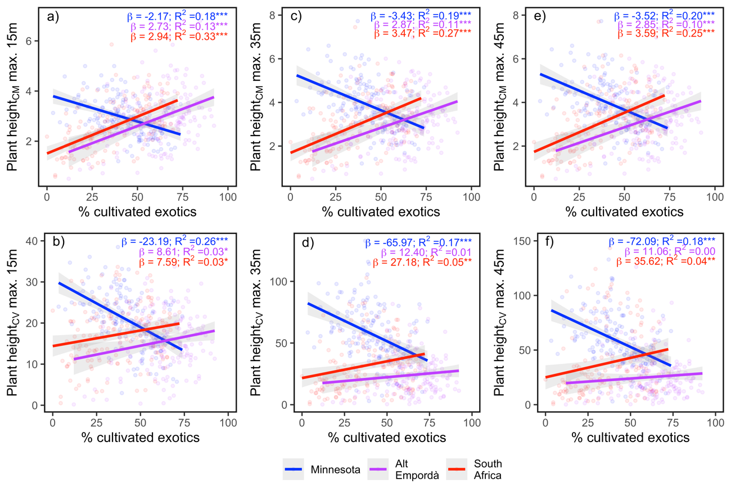
Figure S4: Relationship between the mean (top row) and variance (bottom row) of plant height considering three different maximum plant heights (i.e., 15m, 35m, and 45m) and the proportion (%) of cultivated exotics in domestic gardens. In each plot, points and linear regressions are colored according to ‘region’. Blue colors represent cooler and wetter conditions (i.e., Minnesota), red colors represent warmer and drier conditions (i.e., central South Africa), and violet colors intermediate conditions between the two (i.e., Alt Empordà). Shaded areas indicate 95% confidence intervals. Standardized regression coefficients (β), and adjusted R² are also provided. *, ** and *** indicate significant interactions at P < 0.05, 0.01, and 0.001, respectively.

Appendix S5: Complementary analyses

Table S6: Results of Moran’s I test for each response variable and derived model residuals. SD = standard deviation.

Response variable | Observed | Expected | SD | P-value
Plant showiness_{CM} | 0.47 | 0.00 | 0.01 | <0.01
Plant showiness_{CM} (residuals) | 0.01 | 0.00 | 0.01 | 0.15
Plant height_{CM} | 0.17 | 0.00 | 0.01 | <0.01
Plant height_{CM} (residuals) | 0.02 | 0.00 | 0.01 | 0.05
log(Leaf area_{CM}) | 0.13 | 0.00 | 0.01 | <0.01
log(Leaf area_{CM}) (residuals) | 0.00 | 0.00 | 0.01 | 0.90
Plant showiness_{CV} | 0.03 | 0.00 | 0.01 | 0.01
Plant showiness_{CV} (residuals) | 0.01 | 0.00 | 0.01 | 0.37
Plant height_{CV} | 0.32 | 0.00 | 0.01 | <0.01
Plant height_{CV} (residuals) | 0.03 | 0.00 | 0.01 | 0.04
log(Leaf area_{CV}) | 0.11 | 0.00 | 0.01 | <0.01
log(Leaf area_{CV}) (residuals) | 0.00 | 0.00 | 0.01 | 0.90

Table S7: Results for Mann-Whitney U test and F-tests comparing the mean and variances, respectively, for each plant trait (i.e., plant showiness, plant height, and leaf area) in each particular location. CM = community mean; CV = community variance.

Region | Variable | Tests results
Minnesota | Plant showiness_{CM} | W = 1264, p-value < 2.2e-16
Minnesota | Plant showiness_{VAR} | F = 1.051, num df = 154, denom df = 154, p-value = 0.7581
Minnesota | Plant height_{CM} | W = 21386, p-value < 2.2e-16
Minnesota | Plant height_{VAR} | F = 1.5734, num df = 154, denom df = 154, p-value = 0.005177
Minnesota | Leaf area_{CM} | W = 9831, p-value = 0.00571
Minnesota | Leaf area_{VAR} | F = 0.065738, num df = 154, denom df = 154, p-value < 2.2e-16
Alt Empordà | Plant showiness_{CM} | W = 2263.5, p-value < 2.2e-16
Alt Empordà | Plant showiness_{VAR} | F = 2.0696, num df = 153, denom df = 153, p-value = 8.863e-06
Alt Empordà | Plant height_{CM} | W = 8179, p-value = 2.512e-06
Alt Empordà | Plant height_{VAR} | F = 1.3326, num df = 153, denom df = 153, p-value = 0.07677
Alt Empordà | Leaf area_{CM} | W = 4594, p-value < 2.2e-16
Alt Empordà | Leaf area_{VAR} | F = 0.023914, num df = 153, denom df = 153, p-value < 2.2e-16
South Africa | Plant showiness_{CM} | W = 2062.5, p-value < 2.2e-16
South Africa | Plant showiness_{VAR} | F = 0.96377, num df = 145, denom df = 145, p-value = 0.8245
South Africa | Plant height_{CM} | W = 1718, p-value < 2.2e-16
South Africa | Plant height_{VAR} | F = 0.24182, num df = 145, denom df = 145, p-value < 2.2e-16
South Africa | Leaf area_{CM} | W = 6652, p-value = 2.822e-08
South Africa | Leaf area_{VAR} | F = 0.028048, num df = 145, denom df = 145, p-value < 2.2e-16

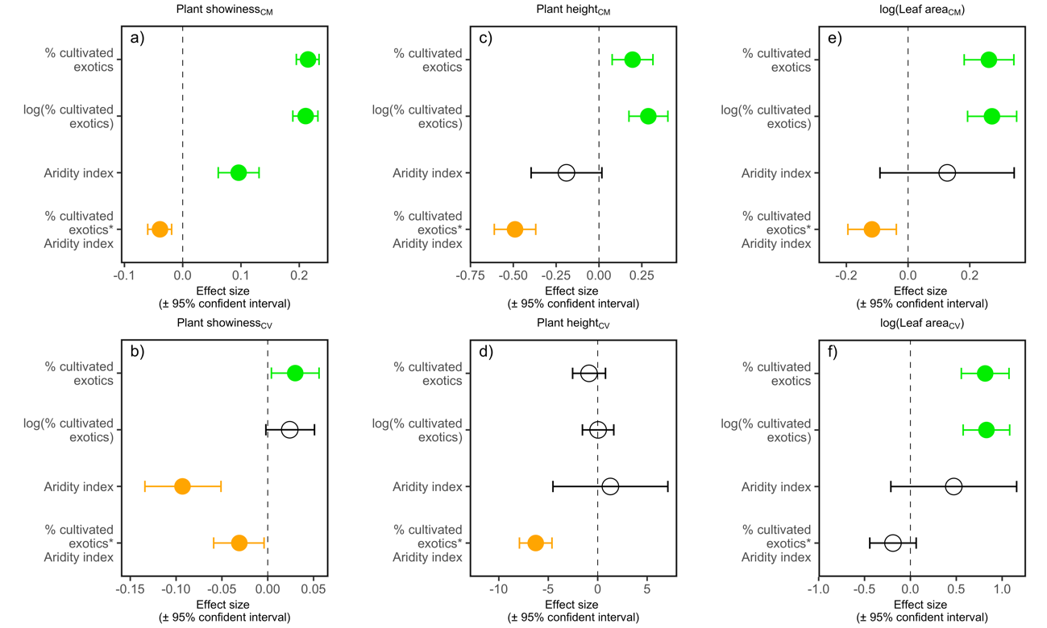
Figure S5: Relative influence of predictor variables on the mean and variance of plant showiness (a-b), plant height (c-d) and leaf area (e-f) in domestic gardens. Effect sizes are standardized coefficients from linear mixed-effects models estimated separately for each predictor variable of interest. The lines indicate 95% confidence interval. Solid green circles indicate significant positive effects, solid orange circles indicate significant negative effects, and open circles indicate non-significant effects. CM = community mean; CV = community variance.

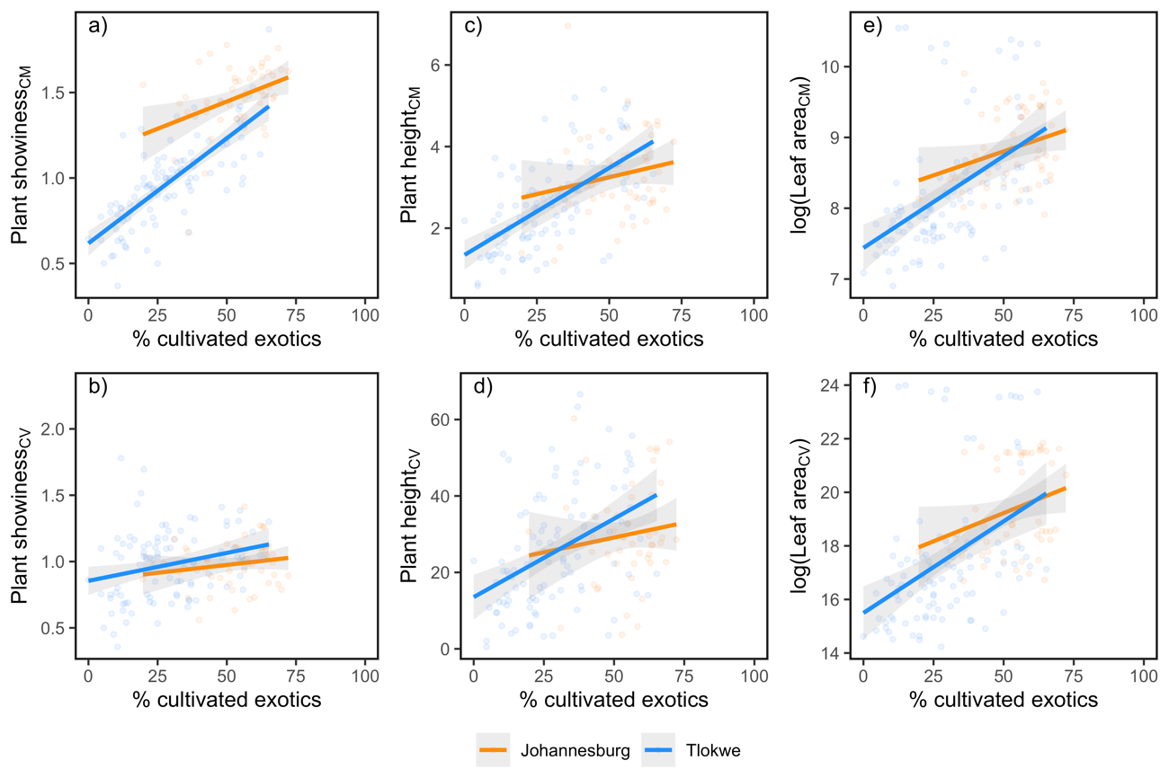
Figure S6: Relationship between the mean (top row) and variance (bottom row) of the three plant traits (i.e., plant showiness, plant height, and leaf area) and the proportion (%) of cultivated exotics in domestic gardens in the two municipalities of South Africa: Johannesburg (orange), and Tlokwe (blue). Shaded areas indicate 95% confidence intervals. We found consistent patterns between the two municipalities for all traits, thus supporting the inclusion of the two municipalities under the same region in our analyses.

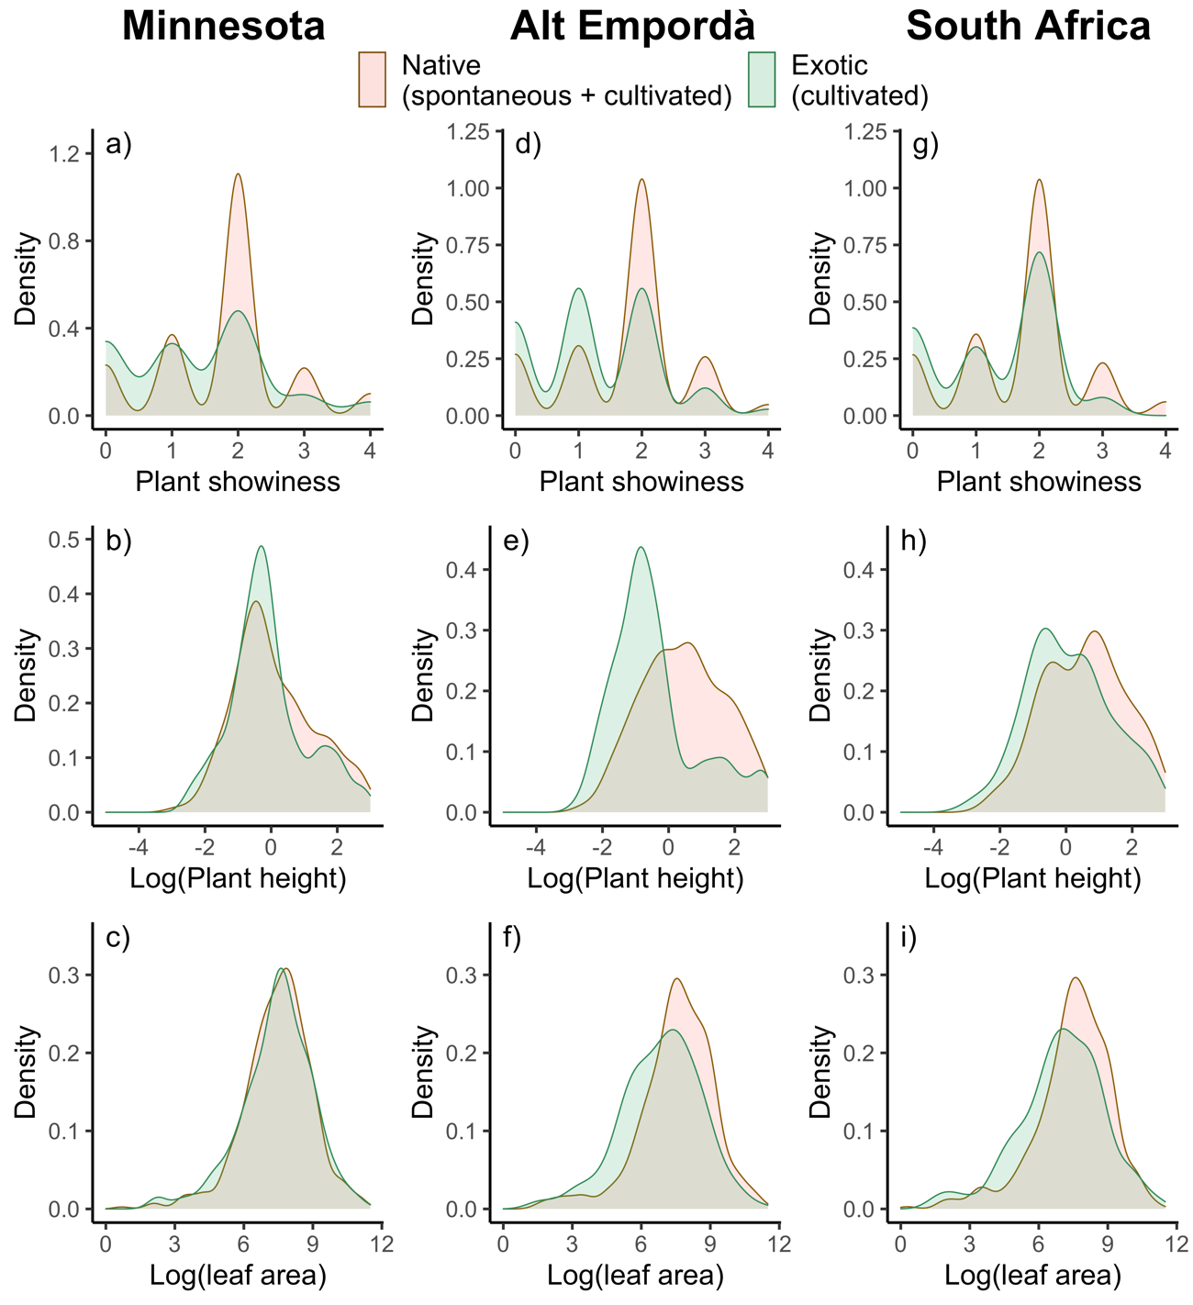
Figure S7: Density curves for plant showiness, plant height, and leaf area of cultivated exotic and native species in gardens in Minnesota (a-c), Alt Empordà (d-f), and central South Africa (g-i).

