Supplementary material 1
Soil temperature corrections
We corrected for the possible effects of the measurement timing using data from miniature temperature loggers with a temperature range between -40°C to 85°C, a resolution of 0.5°C, and an accuracy ±0.5°C (ThermoChron iButtons DS1921G and DS1922L, San Jose, CA, USA). The loggers were located within the same study area and largely in the same plots as the remainder of the measurements. The loggers were buried 7.5 cm below the soil surface. We recorded data from 168 loggers during the first four campaigns. During the last campaign, we recorded data from 98 loggers. We corrected the temperature measurements separately for each campaign as follows. First, we used noon of the first day of each campaign as the reference moment, to which we corrected the temperature measurements. That is, we calculated the difference between each measurement compared to the reference moment. Second, we fitted generalised additive models for the campaign periods using the mgcv package in R (Wood, 2017). Finally, we used the models based on the logger data to predict correction factors for the actual temperature measurements used in the remainder of the analyses. The mean absolute correction for these measurements was 0.86°C.
When fitting the models, we used the temperature differences between the logger temperatures and the reference moments as the response variables. As predictors, we used 1) minutes to the reference moment (cubic regression splines), 2) time of day (cyclic cubic regression splines), and 3) the raw temperature data (cubic regression splines). The first predictor represents the effects of the weather patterns and seasonality, the second represents the effects of the diurnal temperature cycle, and the third represents the absolute temperature level. In the model, we included both the individual predictors and their tensor product interactions. We set the basis dimension for all smoothers to four. All predictors and their interactions were statistically significant (P < 0.05) in all of the models and the explained deviance varied from between 37% and 82%.

Wood, S. N. (2017). Generalized additive models: an introduction with R: Chapman and Hall/CRC.
Supplementary material 2
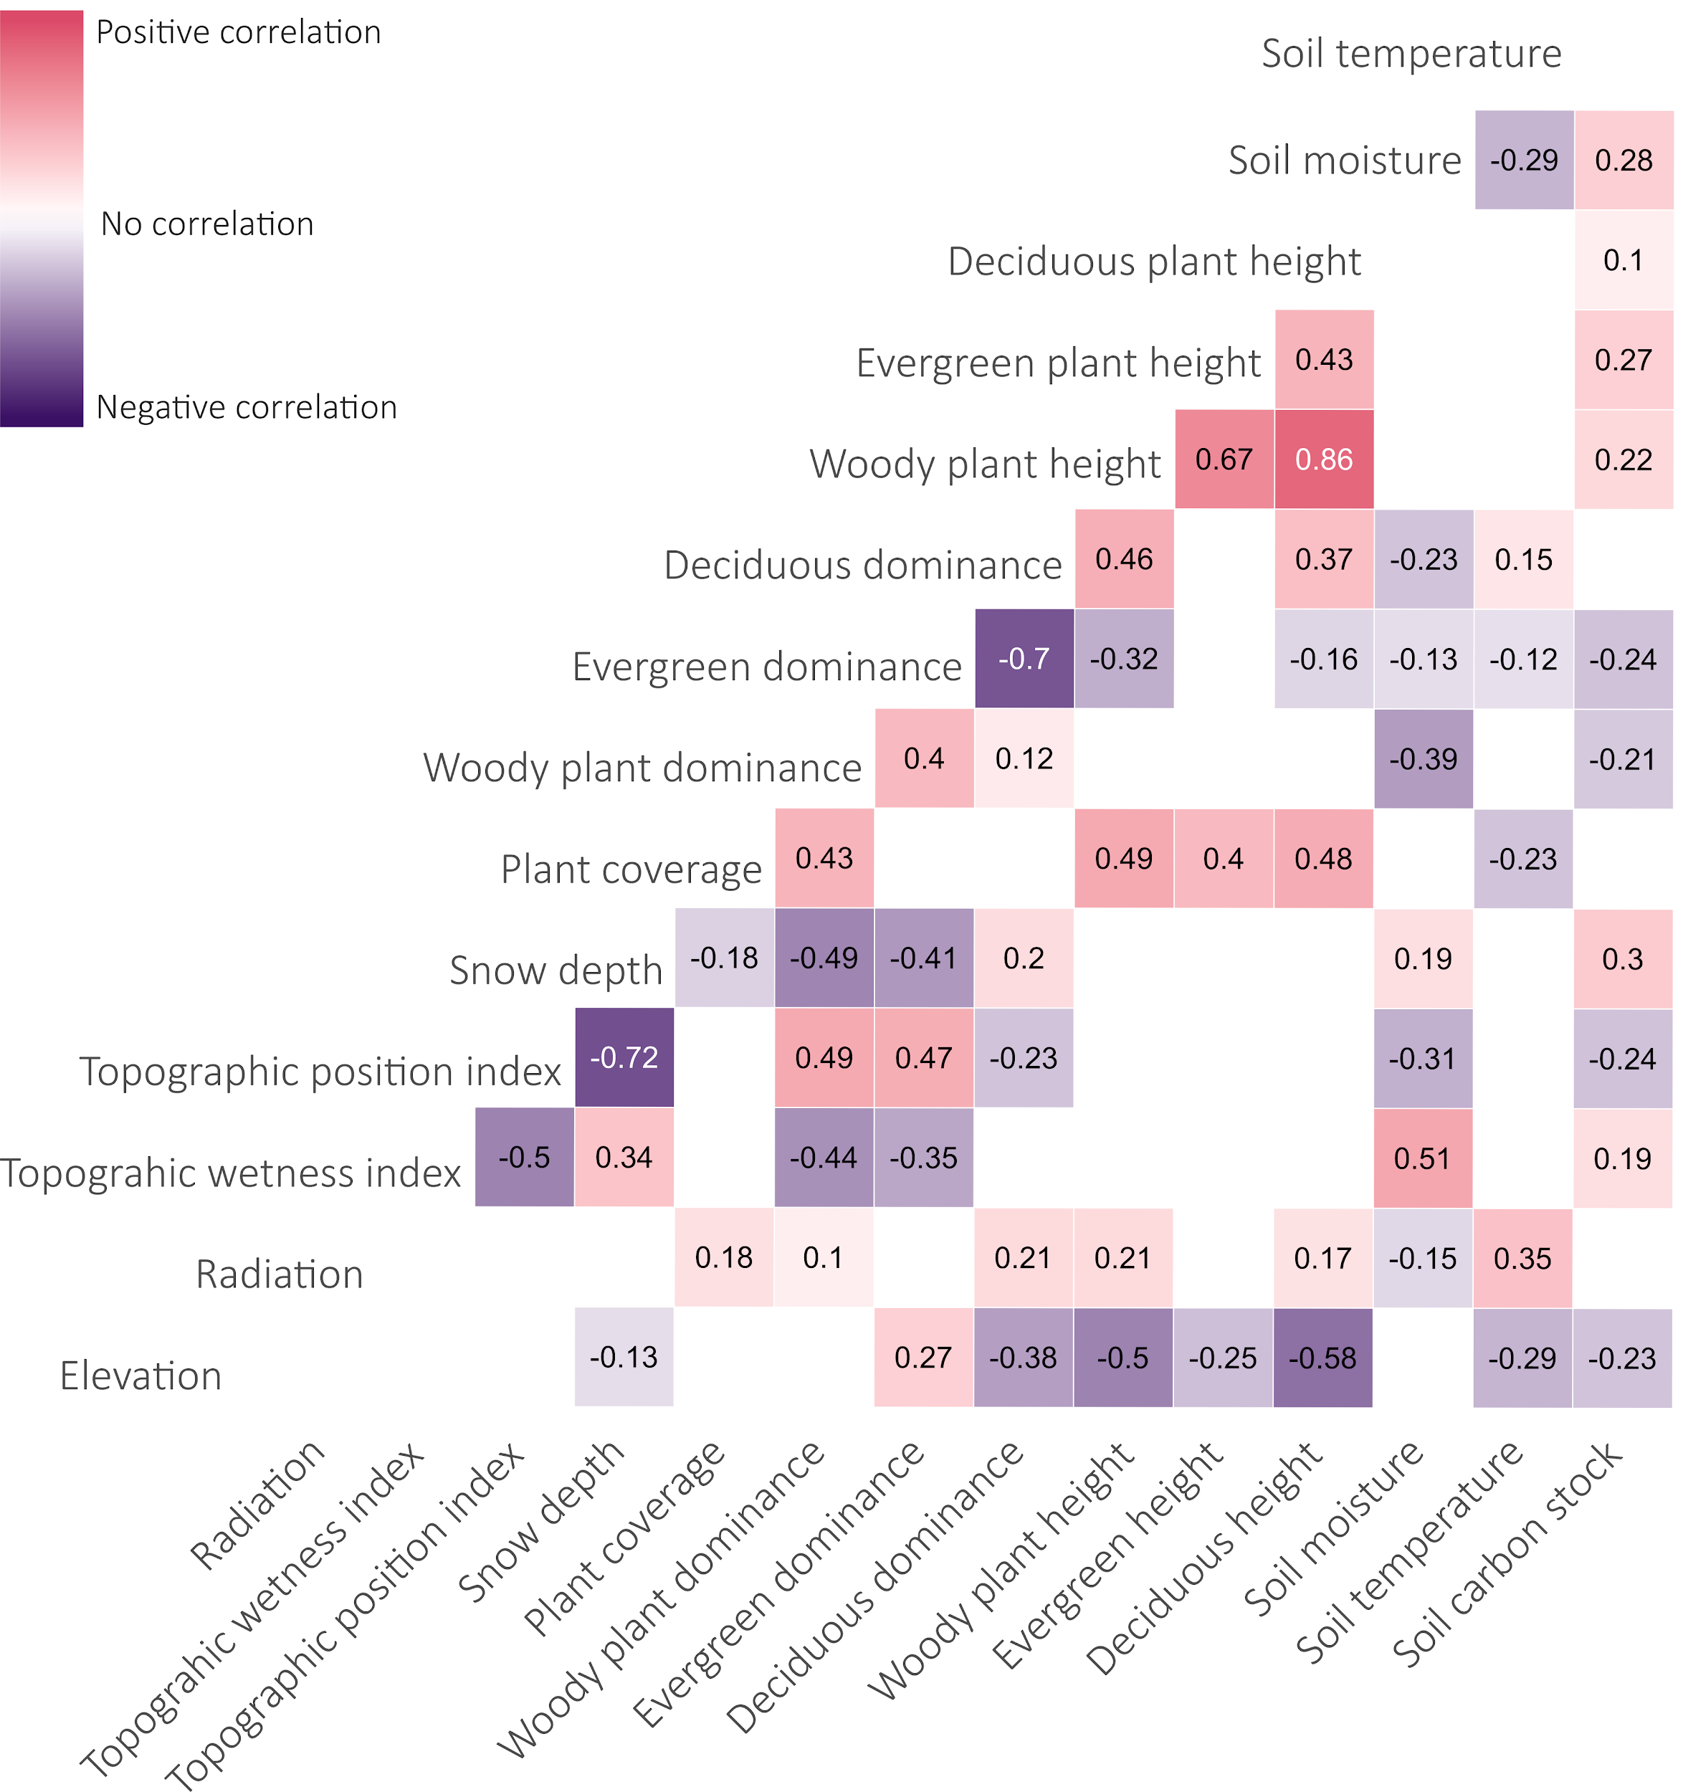
Bivariate correlations. The correlation matrix shows the Spearman’s correlations between variables (n = 171). Relationships ≤ -0.70 or ≥ 0.70 are presented in white numbers. Statistically significant (P ≤ 0.05) correlations are shown as squares, whereas non-significant correlations (P ≥ 0.05) remain blank.
Supplementary material 3
Model structure and results.
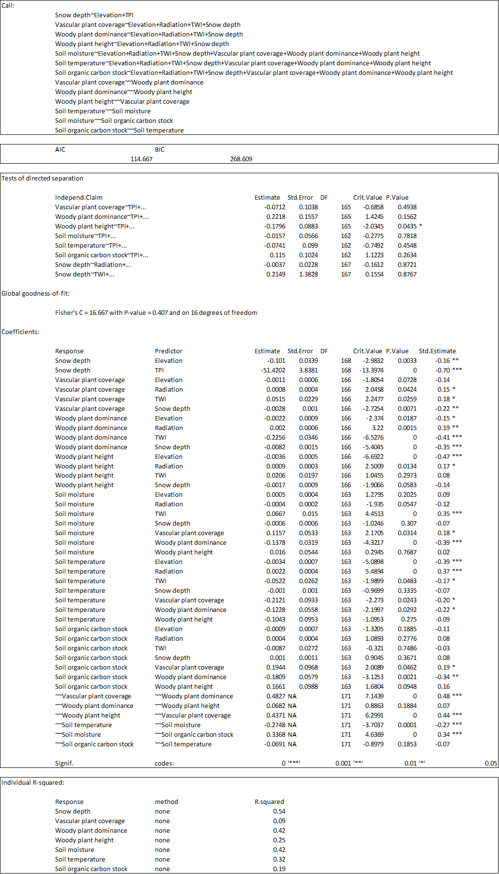
Supplementary material 4
Model structure and results of the evergreen and deciduous woody plant SEMs.
