Supplementary Table 1. Database used for vote counting and meta-analysis.
Doi is the doi identification code of the paper. Author is the first author of the paper. Pub_year is the publication year. Case is the case within the study. id_site is the site (location) of the case. Country is the country of the site. Lat and Long are latitude and longitude of the site. Temp is the site mean annual temperature. Prec is the site mean annual precipitation. Species is the investigated tree species. Mix_pure distinguishes between mixed and pure stands. Broad_conif distinguishes between broadleaf and conifer stands. Un_evenaged distinguishes between even and unevenaged stands. Age is the mean age of stand trees. BA is the stand basal area. Number is the number of trees sampled for the case. Last_cut is the number of years from the last thinning before drought. Observ_treat distinguishes between “observ”, for comparisons between non-manipulated stands with different basal areas, or “treat”, which involved comparisons between different thinning intensities. MS is the qualitative assessment of competition effects on the mean sensitivity of tree-ring chronology. Clim_assoc is the qualitative assessment of competition effects on the association between climate and annual growth. Year is the year when drought occurred. Resist_qual is the qualitative assessment of competition effects on resistance. Resil_qual is the qualitative assessment of competition effects on resilience. Recov_qual is the qualitative assessment of competition effects on recovery. Resist_quant is the quantitative assessment of resistance. Resil_quant is the quantitative assessment of resilience. Recov_quant is the quantitative assessment of recovery.
For MS, Clim_assoc, Resist_qual, Resil_qual and Recov_qual, the label “neg” is for the cases where competition exacerbates the negative effects of drought, the label “positive” is for the opposite cases, and “neutral” for cases where no differences is detected.
(See .csv file)

Supplementary Table 2. Estimates of moderators for the meta-regression models.
 | Resistance |  | Recovery |  | Resilience
moderator | estim. | p | estim. | p | estim. | p
Mix/pure | -0.016 | 0.889 | 0.592 | 0.026 | 0.324 | 0.345
Broad/conif | -0.129 | 0.179 | 0.281 | 0.096 | 0.236 | 0.058
Un/evenaged | -0.077 | 0.402 | 0.321 | 0.038 | 0.031 | 0.778
Species | -0.175 | 0.651 | 0.314 | 0.511 | 0.669 | 0.143
Observ/treat | -0.316 | 0.003 | 0.248 | 0.261 | -0.194 | 0.175
Thin. year | 0.002 | 0.674 | 0.022 | 0.007 | 0.008 | 0.234
Temper. | 0.003 | 0.665 | -0.011 | 0.405 | 0.010 | 0.283
Precip. | 0.000 | 0.876 | 0.000 | 0.250 | 0.000 | 0.779
Age | 0.000 | 0.850 | 0.001 | 0.550 | 0.000 | 0.883
Shade tol. | 0.054 | 0.201 | -0.052 | 0.516 | -0.090 | 0.109
Drought tol. | -0.023 | 0.578 | 0.028 | 0.711 | 0.104 | 0.048
Study area | 0.296 | 0.350 | 0.456 | 0.386 | -0.400 | 0.289

Models are calculated for resistance, recovery and resilience. Mix/pure is mixed and pure stands; Broad/conif is broadleaf and conifer species; Un/evenaged is uneven- and even-aged stands; Species is the tree species; Observ/treat is the study design, i.e., “observational”, for comparisons between non-manipulated stands with different basal areas, or “treatment”, which involved comparisons between different thinning intensities; Thin. year is the number of years from the last thinning before drought; Temp is mean annual temperature of the site; Prec is mean annual precipitation; Age is the mean tree age; Shade tol is the shade tolerance, and Drought tol is the drought tolerance of the species on a 1 to 5 scale according to Niinemets and Valladares, 2006; Study area is the area where the case is located, considered as random factor. estim. is the estimate of the factor effect; p indicates the estimate significance.

Supplementary Table 3. Estimates of SPEI moderators for the meta-regression models.
 | Resistance |  | Recovery |  | Resilience
 | estim. | p | estim. | p | estim. | p
SPEI_3_1 | -0.010 | 0.771 | -0.081 | 0.137 | -0.094 | 0.014
SPEI_3_2 | 0.006 | 0.890 | -0.059 | 0.439 | -0.035 | 0.542
SPEI_3_3 | -0.035 | 0.507 | 0.016 | 0.860 | -0.050 | 0.450
SPEI_3_4 | -0.048 | 0.332 | 0.070 | 0.426 | 0.000 | 0.998
SPEI_3_5 | -0.050 | 0.256 | 0.161 | 0.022 | 0.003 | 0.956
SPEI_3_6 | -0.042 | 0.289 | 0.129 | 0.036 | 0.025 | 0.583
SPEI_3_7 | -0.027 | 0.509 | 0.180 | 0.005 | 0.050 | 0.306
SPEI_3_8 | -0.046 | 0.199 | 0.123 | 0.037 | 0.073 | 0.085
SPEI_3_9 | -0.087 | 0.024 | 0.157 | 0.014 | 0.083 | 0.088
SPEI_3_10 | -0.029 | 0.508 | 0.033 | 0.648 | 0.020 | 0.703
SPEI_3_11 | 0.033 | 0.474 | 0.016 | 0.830 | 0.004 | 0.937
SPEI_3_12 | 0.082 | 0.043 | -0.070 | 0.356 | -0.007 | 0.911
SPEI_6_1 | -0.012 | 0.683 | -0.078 | 0.118 | -0.096 | 0.008
SPEI_6_2 | -0.016 | 0.613 | -0.082 | 0.124 | -0.095 | 0.013
SPEI_6_3 | -0.017 | 0.655 | -0.091 | 0.130 | -0.112 | 0.009
SPEI_6_4 | -0.042 | 0.390 | -0.089 | 0.284 | -0.139 | 0.010
SPEI_6_5 | -0.063 | 0.209 | 0.146 | 0.084 | -0.035 | 0.578
SPEI_6_6 | -0.071 | 0.094 | 0.166 | 0.013 | 0.006 | 0.904
SPEI_6_7 | -0.051 | 0.224 | 0.185 | 0.006 | 0.045 | 0.376
SPEI_6_8 | -0.046 | 0.216 | 0.153 | 0.011 | 0.050 | 0.264
SPEI_6_9 | -0.076 | 0.037 | 0.167 | 0.004 | 0.051 | 0.247
SPEI_6_10 | -0.051 | 0.245 | 0.146 | 0.032 | 0.050 | 0.324
SPEI_6_11 | -0.004 | 0.930 | 0.069 | 0.257 | 0.070 | 0.142
SPEI_6_12 | 0.003 | 0.947 | 0.073 | 0.272 | 0.068 | 0.178
SPEI_9_1 | -0.006 | 0.837 | -0.105 | 0.046 | -0.104 | 0.005
SPEI_9_2 | -0.018 | 0.548 | -0.088 | 0.097 | -0.097 | 0.011
SPEI_9_3 | -0.018 | 0.592 | -0.092 | 0.111 | -0.102 | 0.014
SPEI_9_4 | -0.029 | 0.433 | -0.093 | 0.131 | -0.124 | 0.003
SPEI_9_5 | -0.045 | 0.224 | -0.023 | 0.718 | -0.103 | 0.018
SPEI_9_6 | -0.047 | 0.243 | 0.023 | 0.734 | -0.072 | 0.127
SPEI_9_7 | -0.054 | 0.240 | 0.108 | 0.153 | -0.041 | 0.446
SPEI_9_8 | -0.046 | 0.255 | 0.148 | 0.026 | 0.034 | 0.485
SPEI_9_9 | -0.076 | 0.032 | 0.163 | 0.003 | 0.033 | 0.448
SPEI_9_10 | -0.046 | 0.250 | 0.157 | 0.017 | 0.040 | 0.406
SPEI_9_11 | -0.019 | 0.619 | 0.120 | 0.048 | 0.050 | 0.272
SPEI_9_12 | -0.022 | 0.569 | 0.114 | 0.061 | 0.057 | 0.213
SPEI_12_1 | 0.018 | 0.589 | -0.110 | 0.066 | -0.075 | 0.082
SPEI_12_2 | 0.016 | 0.642 | -0.107 | 0.078 | -0.079 | 0.066
SPEI_12_3 | -0.005 | 0.880 | -0.108 | 0.074 | -0.102 | 0.018
SPEI_12_4 | -0.017 | 0.629 | -0.125 | 0.049 | -0.123 | 0.004
SPEI_12_5 | -0.035 | 0.349 | -0.068 | 0.311 | -0.114 | 0.013
SPEI_12_6 | -0.039 | 0.309 | -0.017 | 0.797 | -0.083 | 0.085
SPEI_12_7 | -0.043 | 0.286 | 0.017 | 0.806 | -0.079 | 0.105
SPEI_12_8 | -0.055 | 0.163 | 0.069 | 0.323 | -0.036 | 0.461
SPEI_12_9 | -0.078 | 0.043 | 0.104 | 0.107 | -0.016 | 0.740
SPEI_12_10 | -0.067 | 0.146 | 0.134 | 0.084 | -0.019 | 0.717
SPEI_12_11 | -0.020 | 0.639 | 0.144 | 0.040 | 0.037 | 0.455
SPEI_12_12 | -0.032 | 0.411 | 0.136 | 0.028 | 0.040 | 0.379
SPEI_15_1 | 0.037 | 0.318 | -0.122 | 0.062 | -0.059 | 0.210
SPEI_15_2 | 0.030 | 0.434 | -0.149 | 0.029 | -0.077 | 0.101
SPEI_15_3 | 0.021 | 0.577 | -0.120 | 0.080 | -0.090 | 0.070
SPEI_15_4 | 0.009 | 0.830 | -0.127 | 0.078 | -0.095 | 0.054
SPEI_15_5 | -0.007 | 0.869 | -0.074 | 0.321 | -0.100 | 0.047
SPEI_15_6 | -0.030 | 0.454 | -0.043 | 0.541 | -0.093 | 0.056
SPEI_15_7 | -0.034 | 0.395 | -0.034 | 0.633 | -0.098 | 0.046
SPEI_15_8 | -0.050 | 0.221 | 0.010 | 0.895 | -0.058 | 0.251
SPEI_15_9 | -0.073 | 0.066 | 0.068 | 0.347 | -0.040 | 0.435
SPEI_15_10 | -0.054 | 0.214 | 0.042 | 0.583 | -0.065 | 0.214
SPEI_15_11 | -0.036 | 0.378 | 0.063 | 0.382 | -0.031 | 0.532
SPEI_15_12 | -0.035 | 0.413 | 0.082 | 0.245 | -0.012 | 0.817

Models are calculated for resistance, recovery and resilience. SPEI was calculated for integration periods of 3, 6, 9, 12, and 15 months, from month 1 (January the northern hemisphere; previous year July for the southern hemisphere) to month 12 (December for the northern hemisphere; June for the southern hemisphere). estim. is the estimate of the factor effect; p indicates the estimate significance.

Supplementary Table 4. Statistics for the random-effect models calculated using species-specific relative basal area.
 | df | τ² | τ | I²(%) | H² | estim. | s.e. | p | AICc
Random-eff. model
Resis_B | 78 | 0.145 | 0.380 | 96.4 | 27.8 | -0.164 | 0.045 | <0.001 | 79.1
Recov_B | 55 | 0.301 | 0.549 | 98.3 | 57.4 | 0.116 | 0.075 | 0.122 | 97.0
Resil_B | 57 | 0.167 | 0.408 | 96.5 | 28.5 | -0.046 | 0.056 | 0.403 | 69.2

df are the degrees of freedom, τ² is the estimate of total amount of heterogeneity in the size effect, i.e., the slope of the linear relationship between each resilience component (resistance for Resis, recovery for Recov, and resilience for Resil) and the stand relative basal area calculated on the absolute maximum value for the species (species-specific); τ is the square root of the estimate of total heterogeneity; I²(%) is the percentage of total variability due to heterogeneity; H² is the ratio between total variability and within-study variance; estim. is the estimate of the mean size effect; s.e. is the estimate standard error; p indicates the estimate significance; AICc is the corrected Akaike's Information Criterion of the model.

Supplementary Table 5. Minimum and maximum values of the mean effect size in random-effect models, calculating from leave-one out validation.
Random-eff. model | min estim. | p | max estim. | p
Resis_A | -0.147 | <0.001 | -0.121 | <0.001
Resis_B | -0.181 | <0.001 | -0.153 | <0.001
Recov_A | 0.116 | 0.014 | 0.151 | 0.063
Recov_B | 0.100 | 0.063 | 0.137 | 0.182
Resil_A | -0.052 | 0.246 | -0.023 | 0.589
Resil_B | -0.062 | 0.253 | -0.030 | 0.578

Models are calculated for resistance, recovery and resilience, and for site-specific, models “A”, and species-specific, models “B”, relative basal area. min estim. is the lowest mean effect estimate, and max estim. is the highest mean effect estimate of model removing one case; p indicates the estimate significance.

Supplementary Table 6. Statistics for the random-effect models including the outliers.
Random-eff. model | df | τ² | τ | I²(%) | H² | estim. | s.e. | p | AICc
Resis_A | 81 | 0.104 | 0.322 | 95.0 | 19.9 | -0.159 | 0.038 | <0.001 | 58.5
Resis_B | 81 | 0.161 | 0.401 | 96.7 | 30.4 | -0.194 | 0.046 | <0.001 | 91.0
Recov_A | 62 | 0.262 | 0.511 | 98.0 | 50.0 | 0.182 | 0.066 | 0.006 | 100.5
Recov_B | 62 | 0.344 | 0.586 | 98.5 | 65.4 | 0.170 | 0.076 | 0.024 | 116.6
Resil_A | 63 | 0.191 | 0.437 | 97.4 | 38.0 | -0.059 | 0.057 | 0.298 | 82.7
Resil_B | 63 | 0.246 | 0.496 | 98.0 | 48.7 | -0.071 | 0.064 | 0.263 | 97.9

Models are calculated for resistance, recovery and resilience, and for site-specific, models “A”, and species-specific, models “B”, relative basal area. df are the degrees of freedom, τ² is the estimate of total amount of heterogeneity in the size effect; τ is the square root of the estimate of total heterogeneity; I²(%) is the percentage of total variability due to heterogeneity; H² is the ratio between total variability and within-study variance; estim. is the estimate of the mean size effect; s.e. is the estimate standard error; p indicates the estimate significance; AICc is the corrected Akaike's Information Criterion of the model.

Supplementary Table 7. Kendall's τ correlation between sample size and size effect, and publication year and size effect, for the random-effect models.
 | Sample size |  | Public. year
Random-eff. model | τ | p | τ | p
Resis_A | -0.218 | 0.005 | -0.145 | 0.071
Resis_B | -0.235 | 0.003 | -0.131 | 0.105
Recov_A | -0.188 | 0.045 | -0.076 | 0.427
Recov_B | -0.192 | 0.041 | -0.086 | 0.375
Resil_A | -0.296 | 0.001 | -0.167 | 0.077
Resil_B | -0.314 | 0.001 | -0.137 | 0.146

Models are calculated for resistance, recovery and resilience, and for site-specific, models “A”, and species-specific, models “B”, relative basal area. τ is τ Kendall's correlation, p indicates the correlation significance.

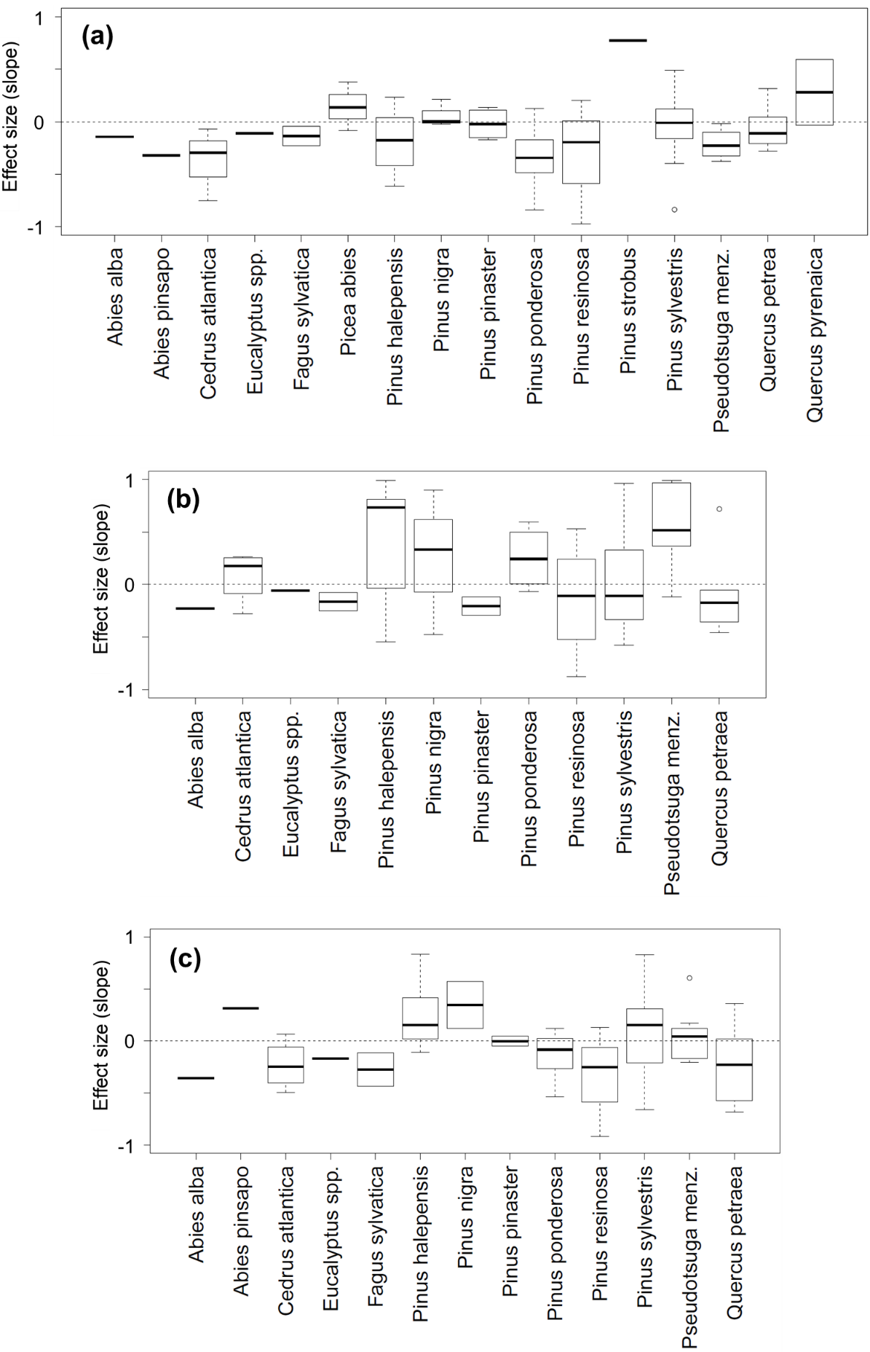
Supplementary Figure 1. Resistance (a), recovery (b) and resilience (c) effect size across tree species.
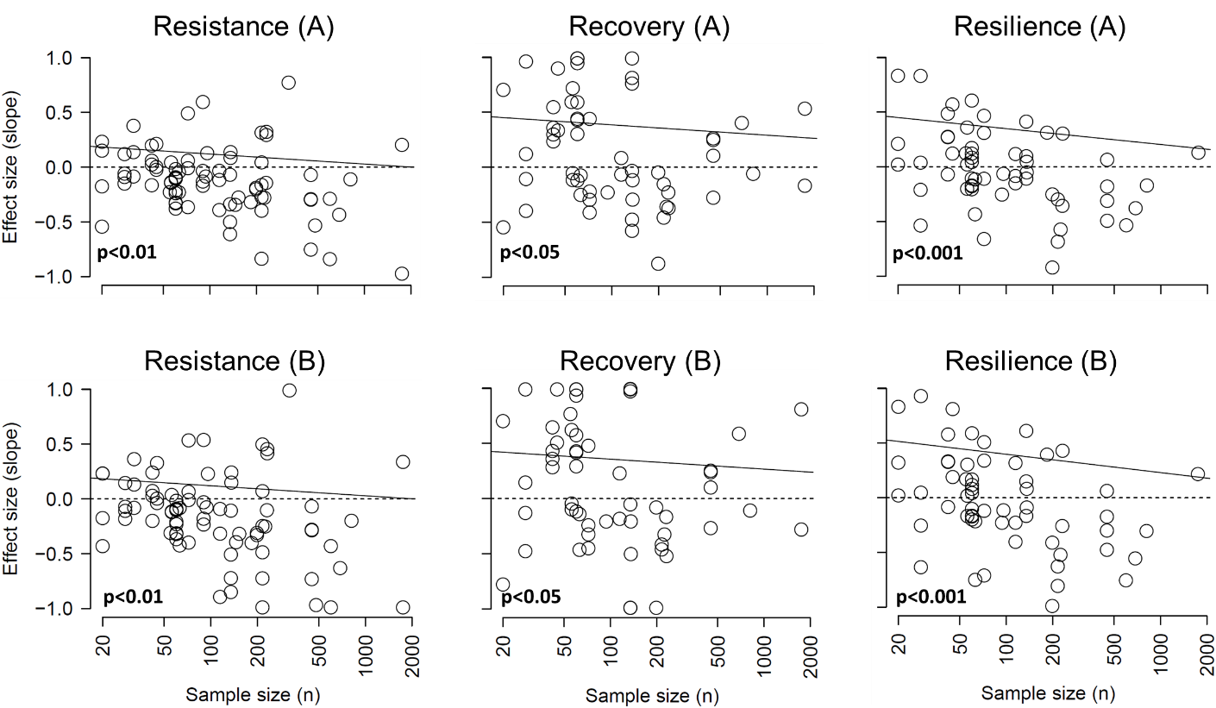
Supplementary Figure 2. Relationship between sample size and effect size. Sample size is the number of trees in the case. Effect size is the slope of the linear relationship between resistance, recovery and resilience and the relative basal area (site-specific: models “A”, top panels; species-specific: models “B”, bottom panels). Dotted lines separate positive and negative slopes. Regression line (solid line) is presented for significant relationships (p < 0.05).

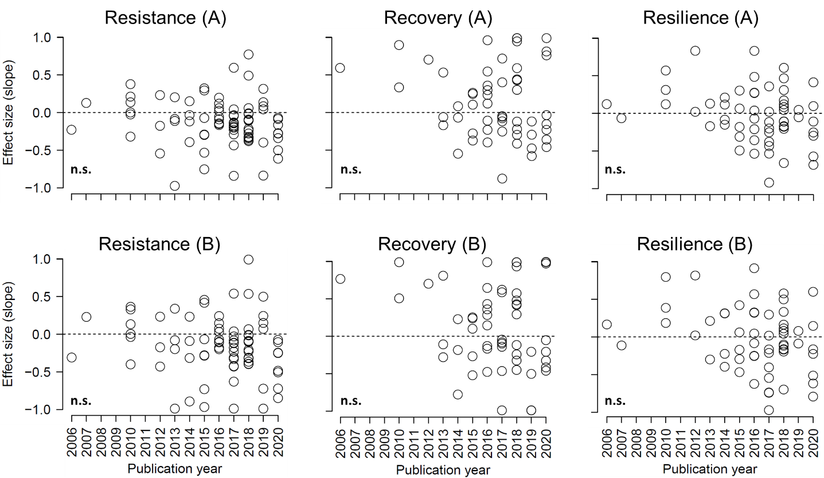
Supplementary Figure 3. Relationship between publication year and effect sizes. Effect size is the slope of the linear relationship between resistance, recovery and resilience and the relative basal area (site-specific: models “A”, top panels; species-specific: models “B”, bottom panels). Dotted lines separate positive and negative slopes.

