Supplementary Material

Fig. S1. Number of successful territories (i.e., with observed well-grown young in the nest at some point prior to fledging) across time in each mountain system.

Fig. S2. ﻿Heatmap depicting pair-wise correlations among the 21 candidate remotely sensed metrics derived for each MODIS product to describe the surface energy balance. Values represent the Pearson correlation coefficient multiplied by 100. See variable acronyms in Table 1.

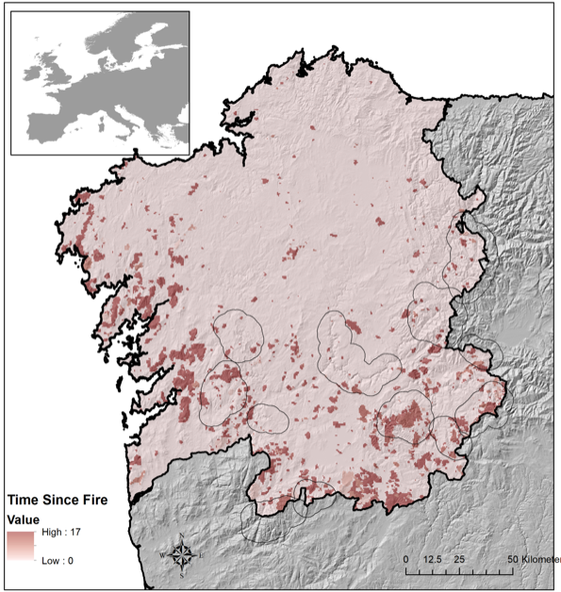
Fig. S3. Time since last fire (expressed in years) that have taken place in the study area between 2001 and 2017. Polygons represent the mountain areas wherein historical and current breeding territories are located.

Table S1. Model selection table for nest survival models fitted with ecosystem functioning attributes derived from EVI time series.
EVI_DMi | EVI_DMx | EVI_Mean | EVI_Min | AIC | delta | weight
 |  | -0.3005 |  | 464.8 | 0 | 0.290
-0.09018 |  | -0.3045 |  | 465.6 | 0.76 | 0.198
 |  | -0.2803 | -0.07077 | 466.1 | 1.31 | 0.150
 | 0.002088 | -0.3001 |  | 466.8 | 2.00 | 0.107
-0.07495 |  | -0.2897 | -0.04742 | 467.3 | 2.49 | 0.084
-0.10160 | -0.032370 | -0.3109 |  | 467.4 | 2.62 | 0.078
 | -0.016640 | -0.2818 | -0.07589 | 468.1 | 3.27 | 0.057

Table S2. Model selection table for nest survival models fitted with ecosystem functioning attributes derived from LST time series.
LST_DMx | LST_Mean | LST_Min | LST_sSD | AIC | delta | weight
-0.11720 | -0.148100 |  | 0.4041 | 457.7 | 0.00 | 0.123
-0.11060 | -0.156500 |  | 0.4014 | 457.8 | 0.11 | 0.116
 | -0.148900 |  | 0.3801 | 458.1 | 0.43 | 0.099
 | -0.231300 | 0.144200 | 0.4463 | 458.2 | 0.53 | 0.095
 | -0.140400 |  | 0.3818 | 458.3 | 0.55 | 0.094
-0.10270 | -0.224700 | 0.120600 | 0.4535 | 458.4 | 0.67 | 0.088
 | -0.218600 | 0.136500 | 0.4450 | 458.6 | 0.91 | 0.078
-0.11220 |  |  | 0.3920 | 459.6 | 1.93 | 0.047
 |  |  | 0.3689 | 460.1 | 2.36 | 0.038
 |  | -0.004579 | 0.3719 | 461.6 | 3.92 | 0.017

Table S3. Model selection table for nest survival models fitted with ecosystem functioning attributes derived from ALB time series.
ALB_DMi | ALB_DMx | ALB_Max | ALB_Min | AIC | delta | weight
-0.1260 |  | 0.11430 |  | 477.7 | 0.00 | 0.148
-0.1207 |  |  |  | 478.0 | 0.30 | 0.127
 |  | 0.10460 |  | 478.3 | 0.62 | 0.108
-0.1678 | -0.09662 |  |  | 478.8 | 1.13 | 0.084
-0.1466 | -0.04417 | 0.09752 |  | 479.5 | 1.79 | 0.060
-0.1322 |  | 0.12180 | 0.028560 | 479.5 | 1.82 | 0.059
-0.1214 |  |  | -0.003500 | 480.0 | 2.30 | 0.047
 | 0.03500 | 0.11930 |  | 480.1 | 2.43 | 0.044
 | -0.01509 |  |  | 480.2 | 2.52 | 0.042
 |  |  | 0.011730 | 480.2 | 2.52 | 0.042
 |  | 0.11250 | -0.011240 | 480.3 | 2.60 | 0.040
-0.1690 | -0.09687 |  | -0.005543 | 480.8 | 3.13 | 0.031
-0.1507 | -0.04089 | 0.10550 | -0.025930 | 481.4 | 3.64 | 0.024

Table S4. Model selection table for nest survival models fitted with the four most important variables of the three ecosystem functioning components.
ALB_DMi | EVI_Mean | LST_Mean | LST_sSD | AIC | delta | weight
-0.1335 | -0.1901 | -0.14890 | 0.2904 | 454.2 | 0.00 | 0.395
 | -0.1686 | -0.15470 | 0.2943 | 455.6 | 1.41 | 0.195
-0.1535 | -0.1985 |  | 0.2745 | 456.1 | 1.85 | 0.156
-0.1130 |  | -0.14390 | 0.3861 | 457.7 | 3.49 | 0.069
 | -0.1745 |  | 0.2780 | 457.8 | 3.63 | 0.064
 |  | -0.14890 | 0.3801 | 458.1 | 3.92 | 0.056

Table S5. Model selection table (only those with delta > 2) for nest survival models fitted with the four most important variables of the three ecosystem functioning components plus the lagged variable of burnt area created by shifting three years in which the fire event took place.
ALB_DMi | TLagFi3 | EVI_Mean | LST_Mean | LST_sSD | AIC | delta | weight
 | -0.25740 |  |  |  | 298.1 | 0.00 | 0.140
 | 0.25880 |  |  | 0.1307 | 298.8 | 0.75 | 0.096
-0.12850 |  | -0.3295 | -0.173400 | 0.1976 | 299.5 | 1.44 | 0.068
-0.05961 | -0.25030 |  |  |  | 299.7 | 1.63 | 0.062
 |  | -0.3064 | -0.177200 | 0.210 | 299.9 | 1.80 | 0.057
 | -0.25730 |  | -0.011570 |  | 300.1 | 1.98 | 0.052

