Supplement 2

Ongoing fen-bog transition in a boreal aapa mire inferred from repeated field sampling, aerial images, and Landsat data. Ecosystems.
Tiina H. M. Kolari^{1,4}, Antti Sallinen^{2,3,4}, Franziska Wolff³, Timo Kumpula³, Kimmo Tolonen¹ & Teemu Tahvanainen¹
¹Department of Environmental and Biological Sciences, University of Eastern Finland, P.O. Box 111, FI-80101, Joensuu, Finland

²Biodiversity Centre, Finnish Environment Institute, Lentiirantie 342 B, FI-88900 Kuhmo, Finland
³Department of Geographical and Historical Studies, University of Eastern Finland, P.O. Box 111, FI-80101, Joensuu, Finland

⁴These two authors contributed equally to this article.

Correspondence:
Tiina H. M. Kolari, tiina.kolari@uef.fi, tel. +358405439545
Antti Sallinen, antti.sallinen@syke.fi, tel. +358407514466

Additional information on Landsat analysis
  - Landsat images used in the study (product identifiers)
  - Landsat blue, green, SWIR1, and SWIR2 reflectance in the study mire in 1985, 2002 and 2020

2.1 Landsat images used in the study (product identifiers*)
- Correlation analysis
- LT05_L1TP_190016_19880512_20170208_01_T1
- LT05_L1TP_191016_19970613_20180225_01_T1
- LC08_L1TP_190016_20190619_20190703_01_T1
- Time series
- LT05_L1TP_191016_19850815_20170219_01_T1
- LT05_L1TP_191016_19860717_20170217_01_T1
- LT05_L1TP_191016_19870720_20170211_01_T1
- LT05_L1TP_191016_19900813_20170130_01_T1
- LT05_L1TP_191016_19940808_20170113_01_T1
- LT05_L1TP_191016_19980702_20161223_01_T1
- LE07_L1TP_190016_20020730_20170128_01_T1
- LT05_L1TP_190016_20060717_20161120_01_T1
- LE07_L1TP_190016_20090802_20161218_01_T1
- LE07_L1TP_191016_20090825_20161218_01_T1
- LT05_L1TP_190016_20100712_20161014_01_T1
- LC08_L1TP_191016_20130727_20170503_01_T1
- LC08_L1TP_190016_20140723_20170421_01_T1
- LC08_L1TP_191016_20150818_20170406_01_T1
- LC08_L1TP_192016_20160726_20170322_01_T1
- LC08_L1TP_190016_20170715_20170727_01_T1
- LC08_L1TP_191016_20180725_20180731_01_T1
- LC08_L1TP_190016_20190822_20190903_01_T1
- LC08_L1TP_192016_20200705_20200708_01_T1

*The Landsat Collection 1 Level-1 product identifiers follow the format
LXSS_LLLL_PPPRRR_YYYYMMDD_yyyymmdd_CC_TX, where:
- L = Landsat
- X = Sensor (“C” = OLI/TIRS combined, “O” = OLI-only, “T” = TIRS-only, “E” = ETM+, “T” = “TM, “M” = MSS)
- SS = Satellite (”07”=Landsat 7, “08”=Landsat 8)
- LLL = Processing correction level (L1TP/L1GT/L1GS)
- PPP = WRS path
- RRR = WRS row
- YYYYMMDD = Acquisition year, month, day
- yyyymmdd = Processing year, month, day
- CC = Collection number (01, 02, …)
- TX = Collection category (“RT” = Real-Time, “T1” = Tier 1, “T2” = Tier 2)

  - Landsat blue, green, SWIR1, and SWIR2 in the study mire in 1985, 2002, and 2020

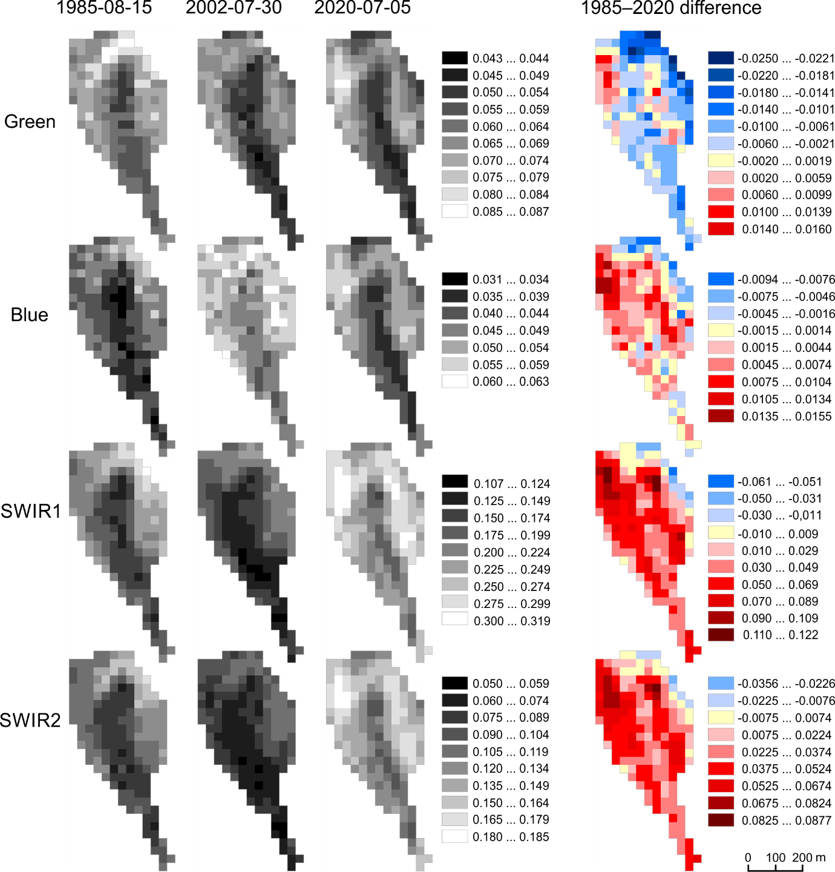

Figure 1. Landsat blue, green, SWIR1, and SWIR2 reflectance in the undrained parts of Mahlaneva mire in 1985, 2002 and 2020. Green = reflectance in Landsat green band (λ ≈ 0.56 μm), Blue = reflectance in Landsat blue band (λ ≈ 0.48 μm), SWIR1 = reflectance in Landsat short-wave infrared 1 band (λ ≈ 1.61 μm), SWIR2 = reflectance in Landsat short-wave infrared 2 band (λ ≈ 2.21 μm). A transformation enhancing the continuity between the TM and OLI sensors (Roy et al. 2016) has been applied to the 2020 values.

