Supplementary material
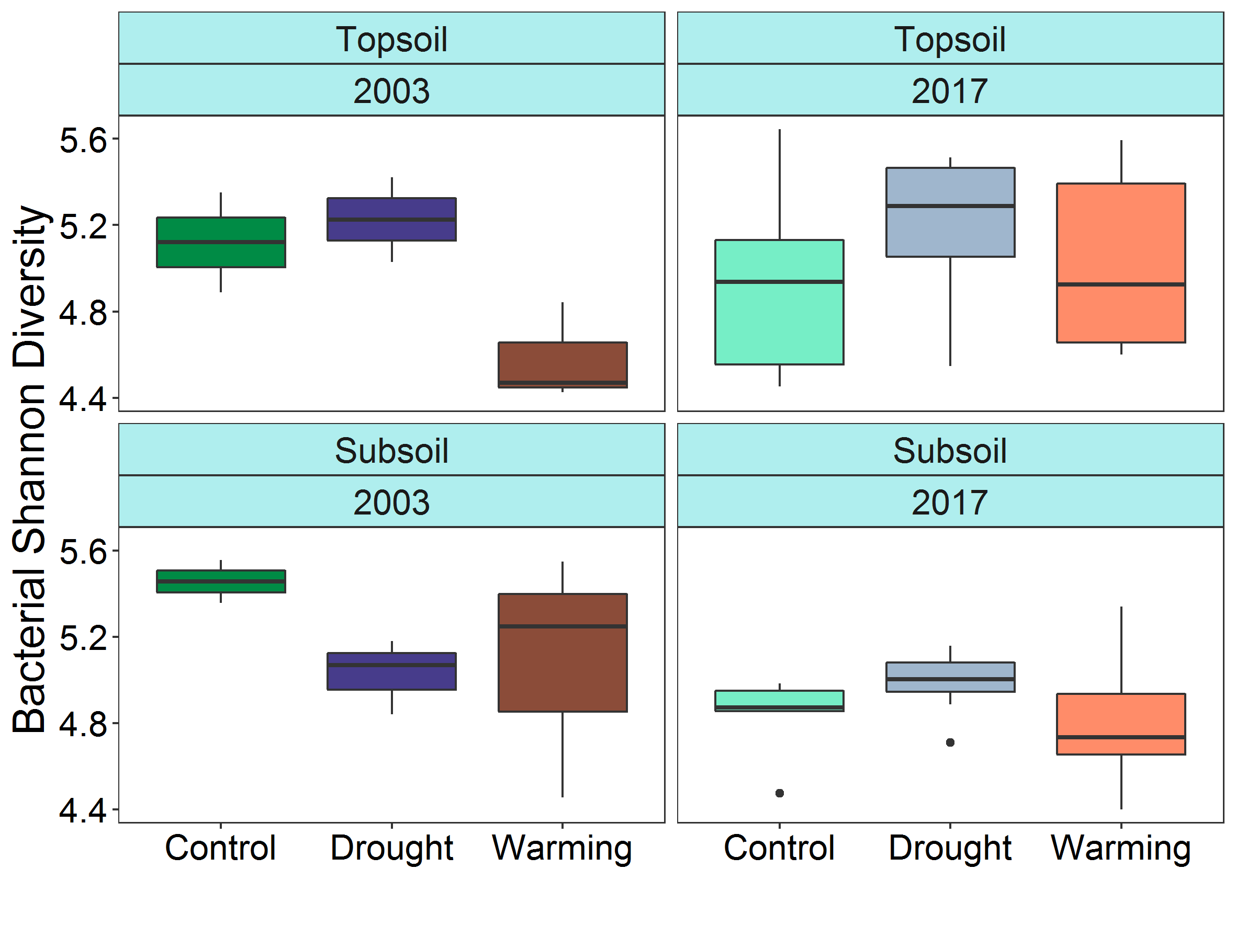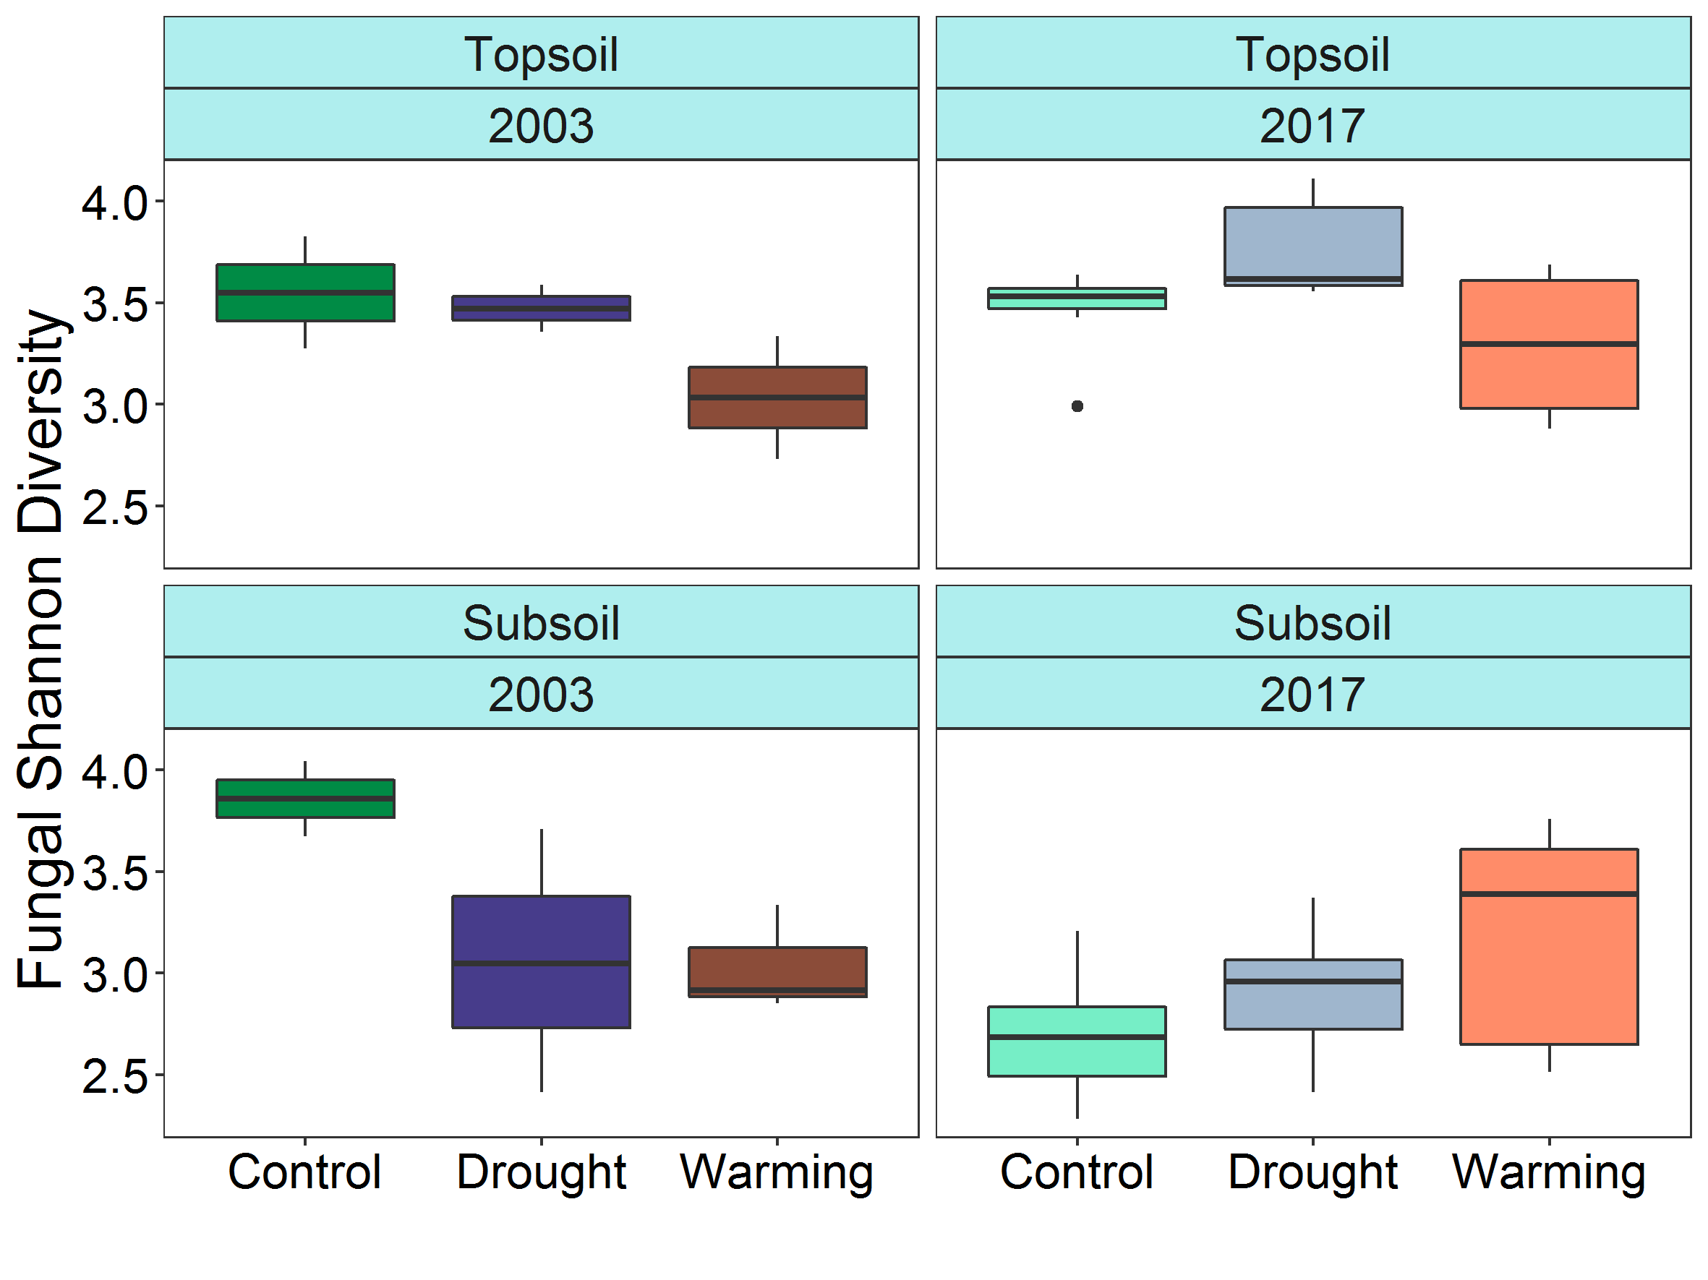
Figure 1: Bacterial (left) and fungal (right) Shannon diversity by year, treatment and depth
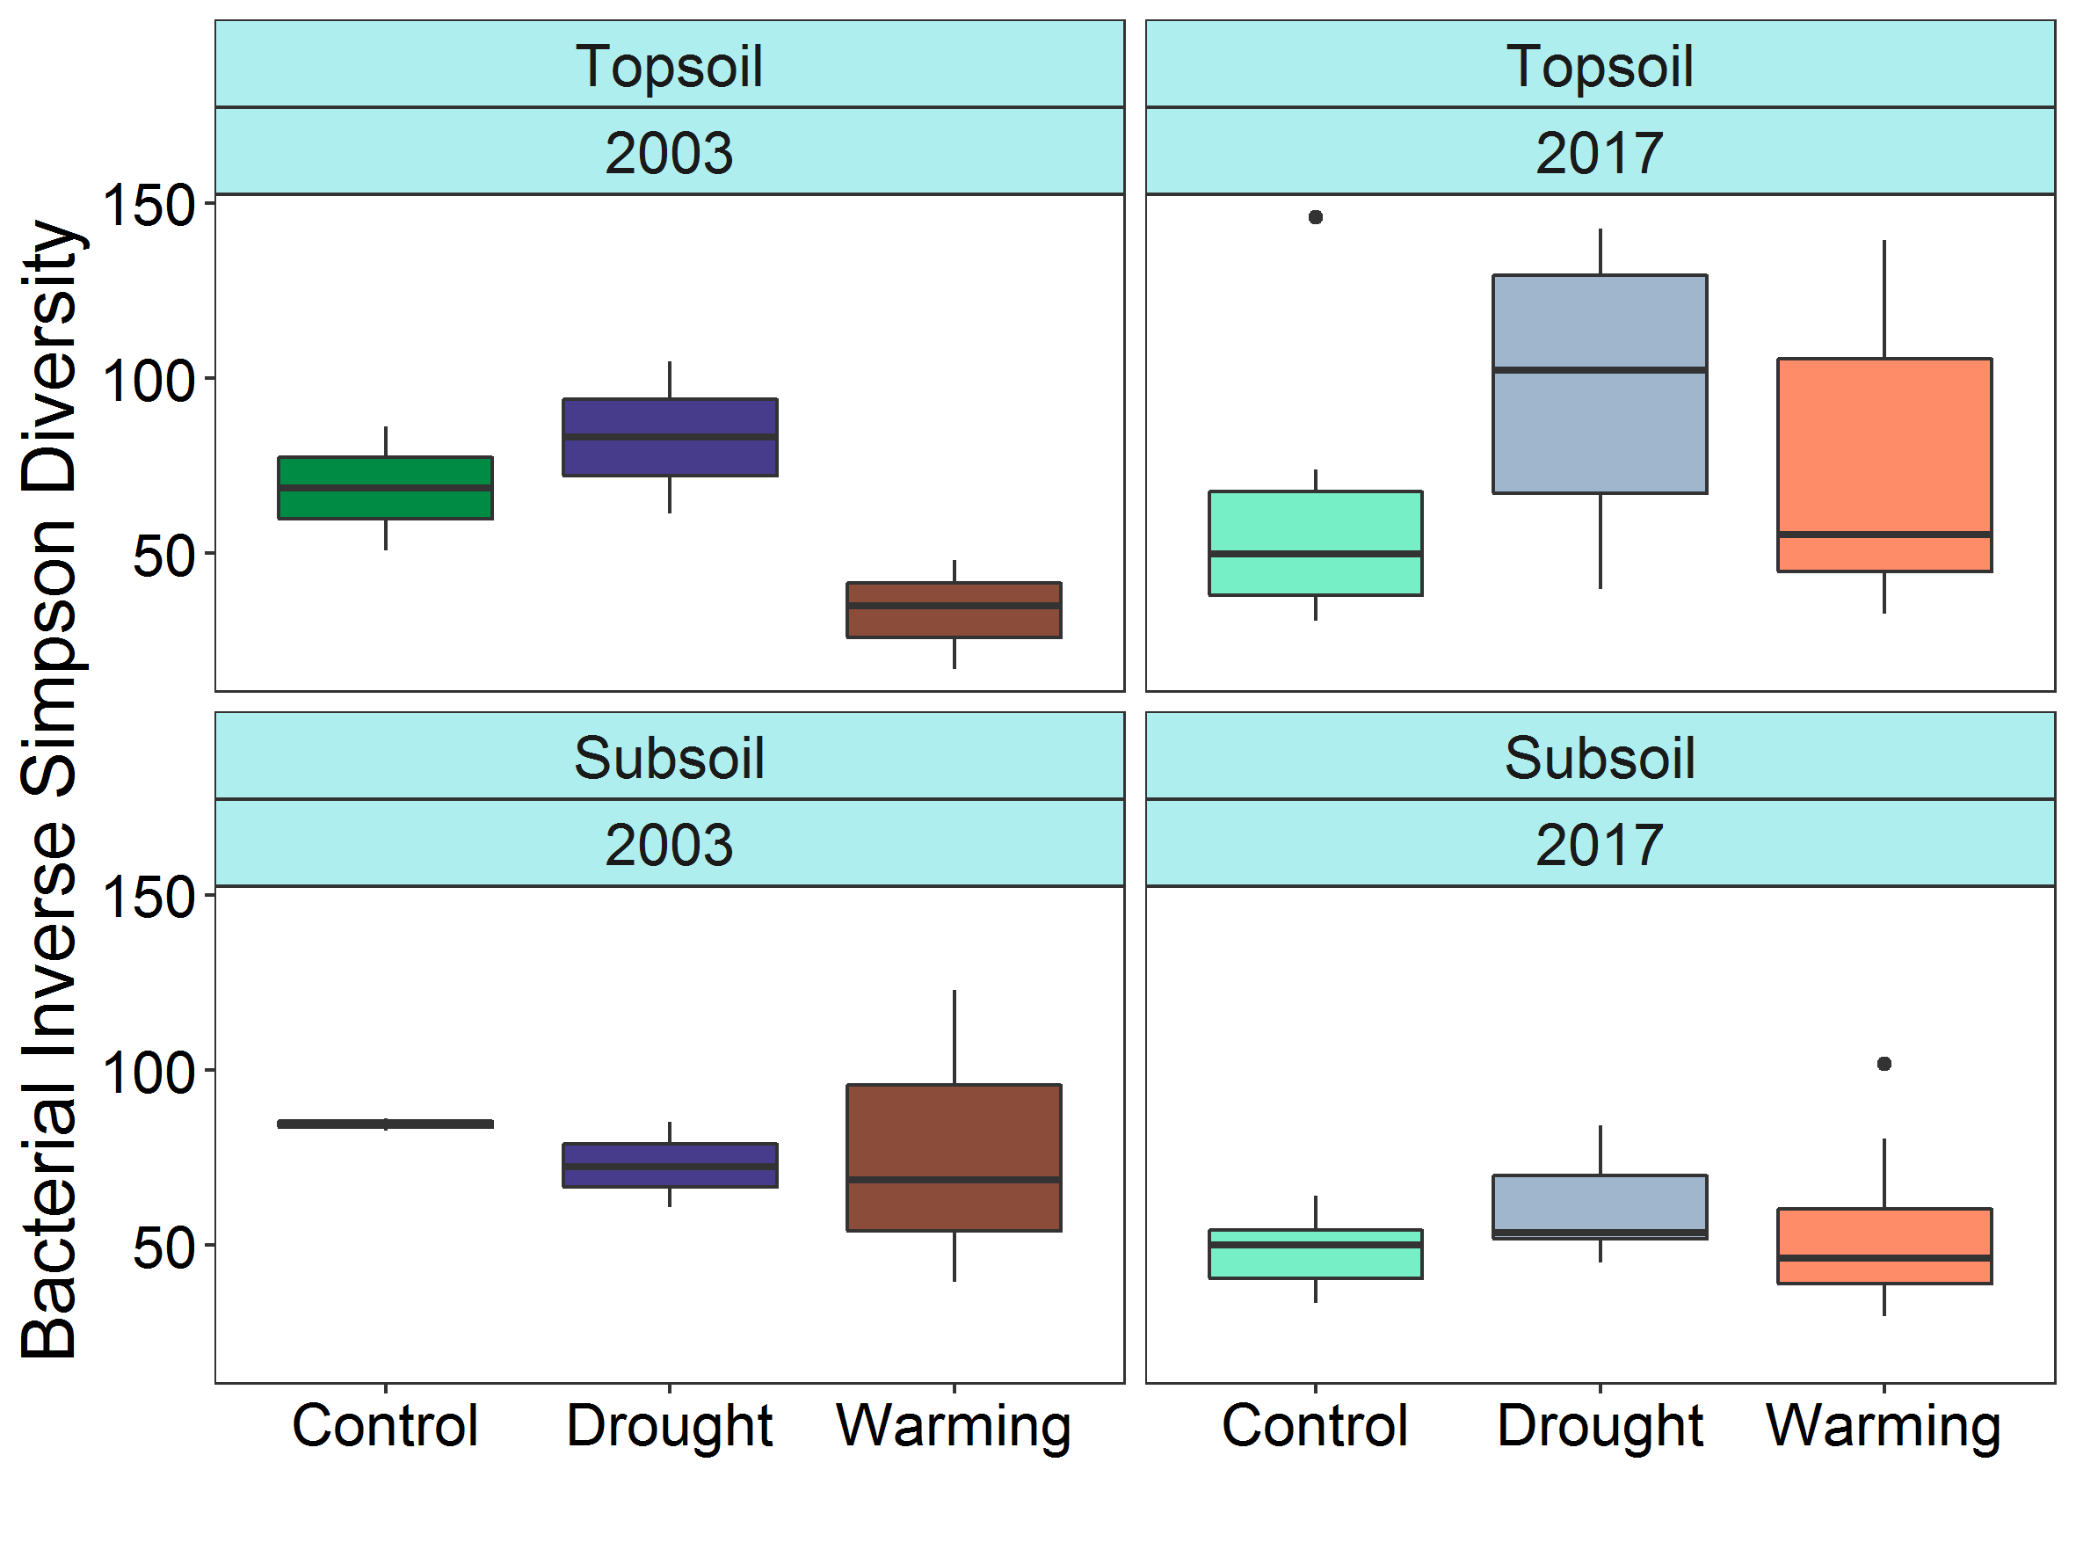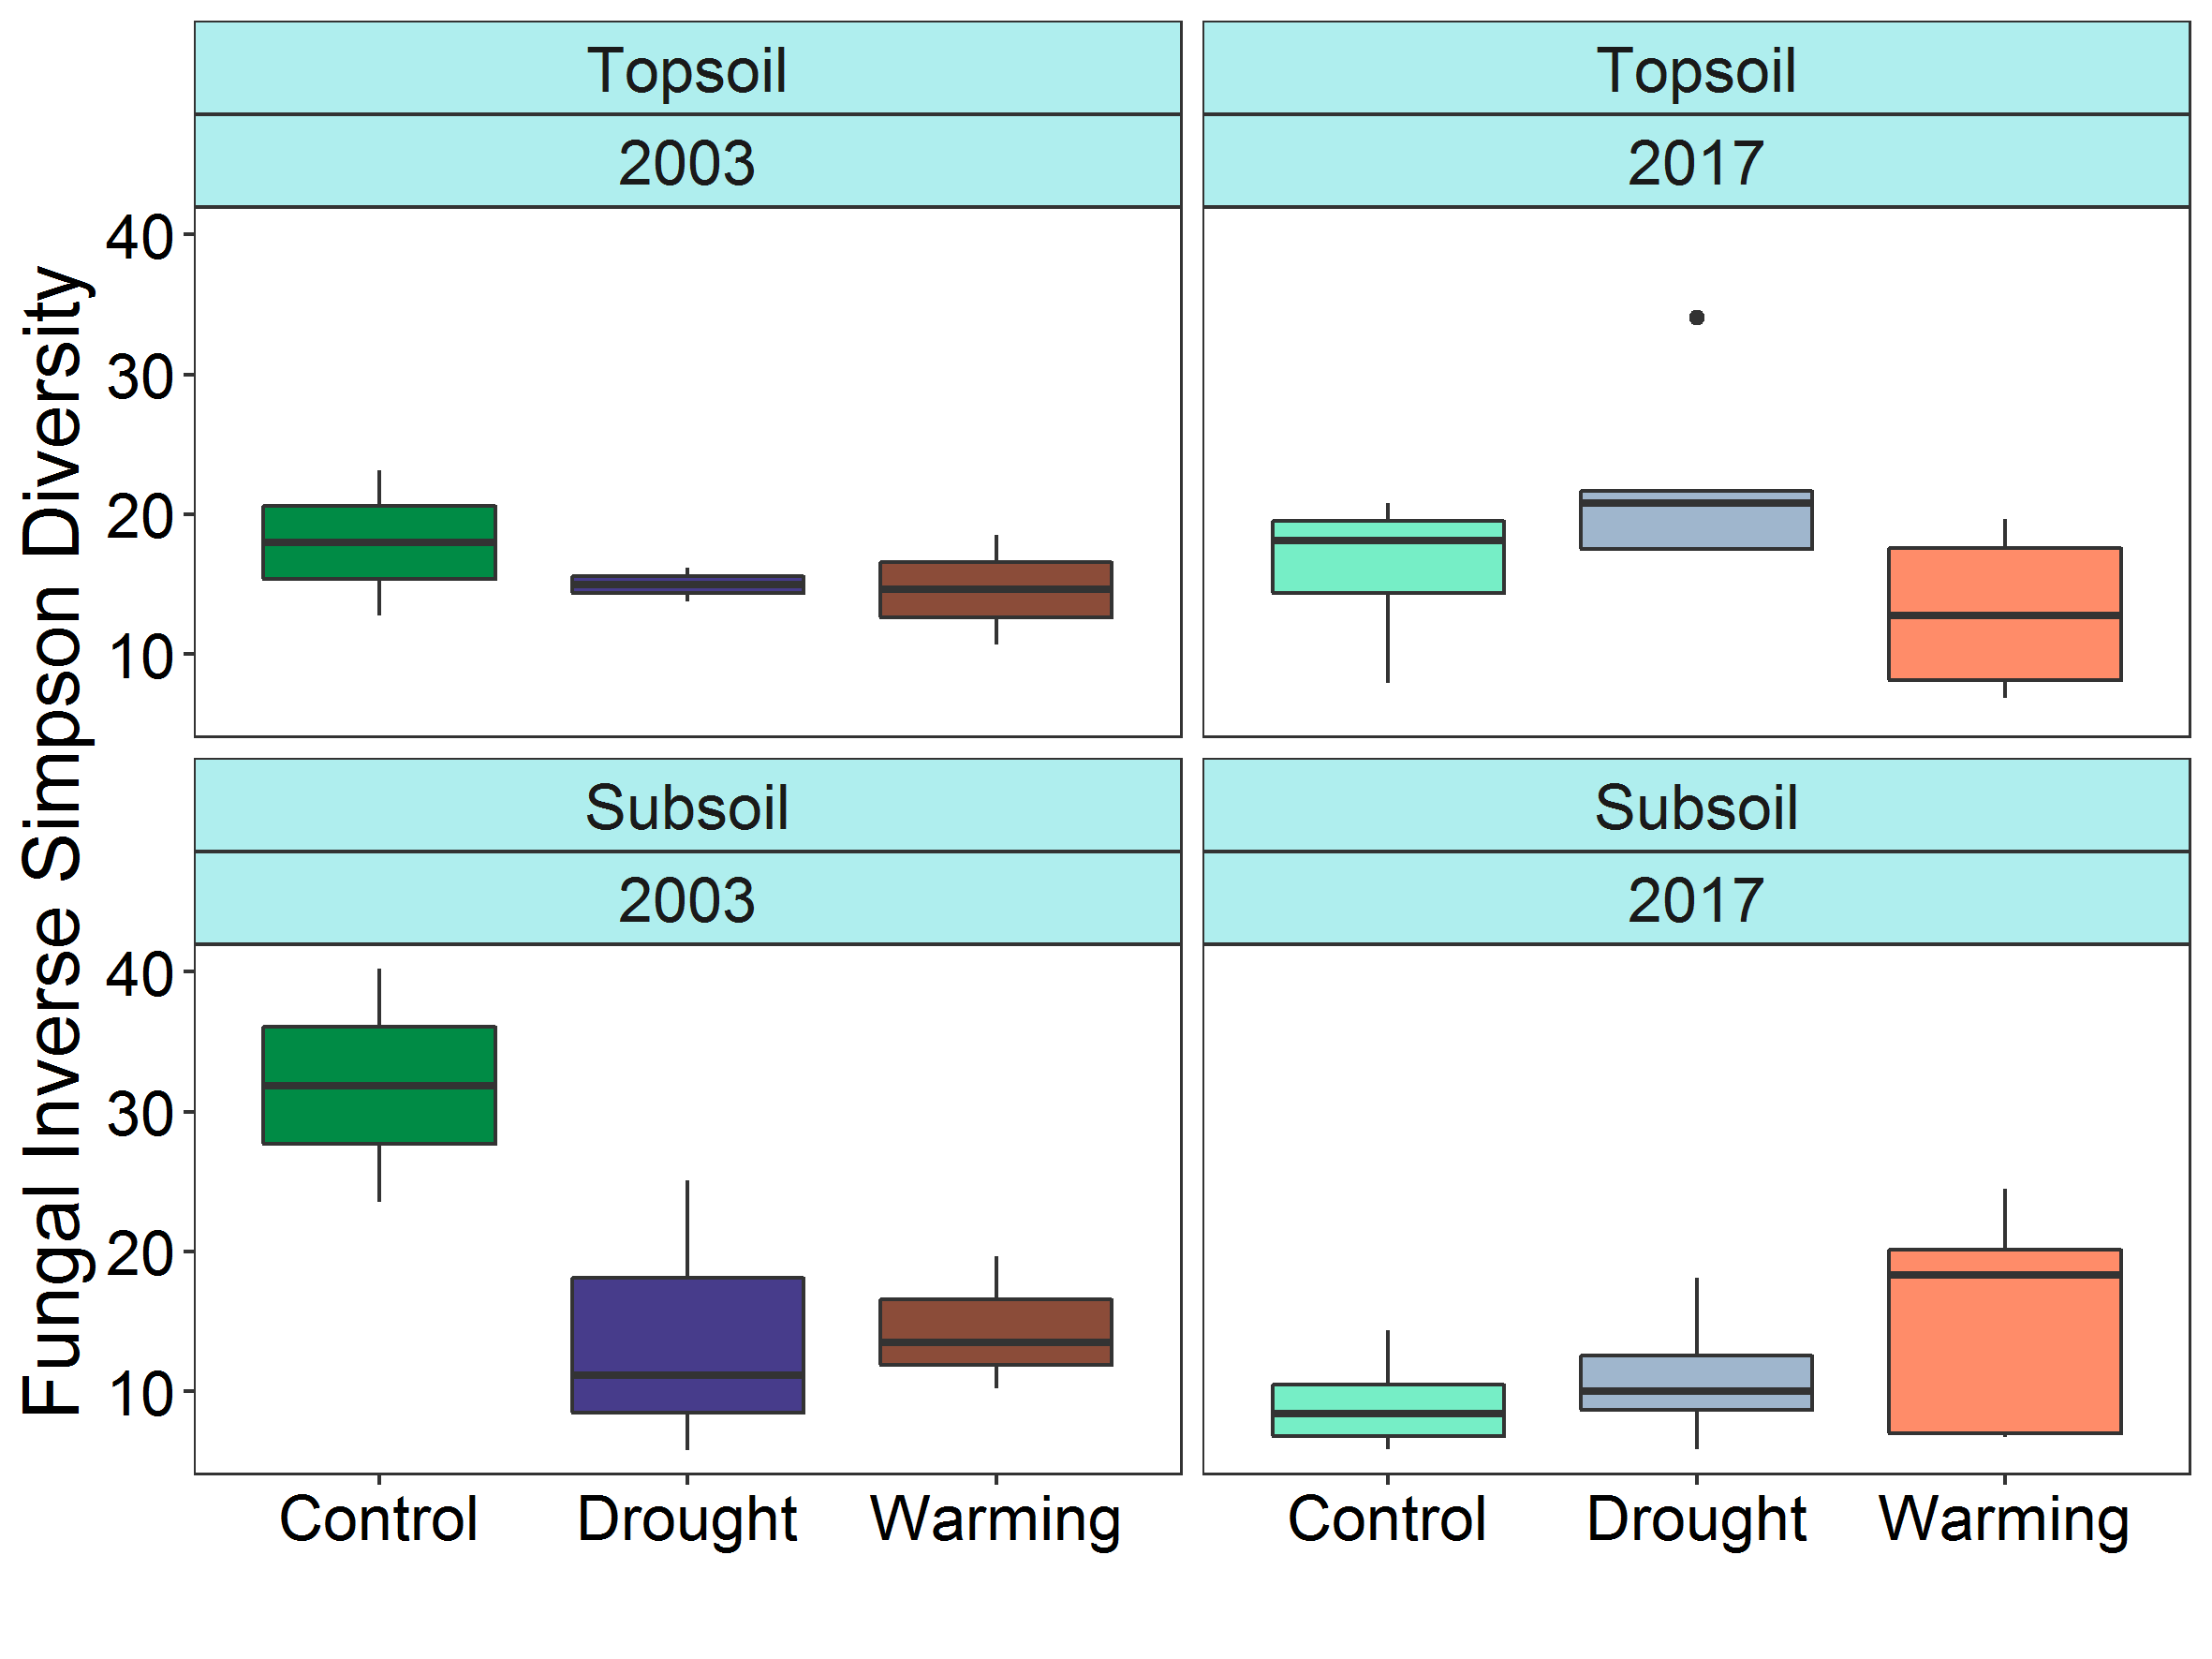
Figure 2: Bacterial (left) and fungal (right) inverse Simpson diversity by year, treatment and depth
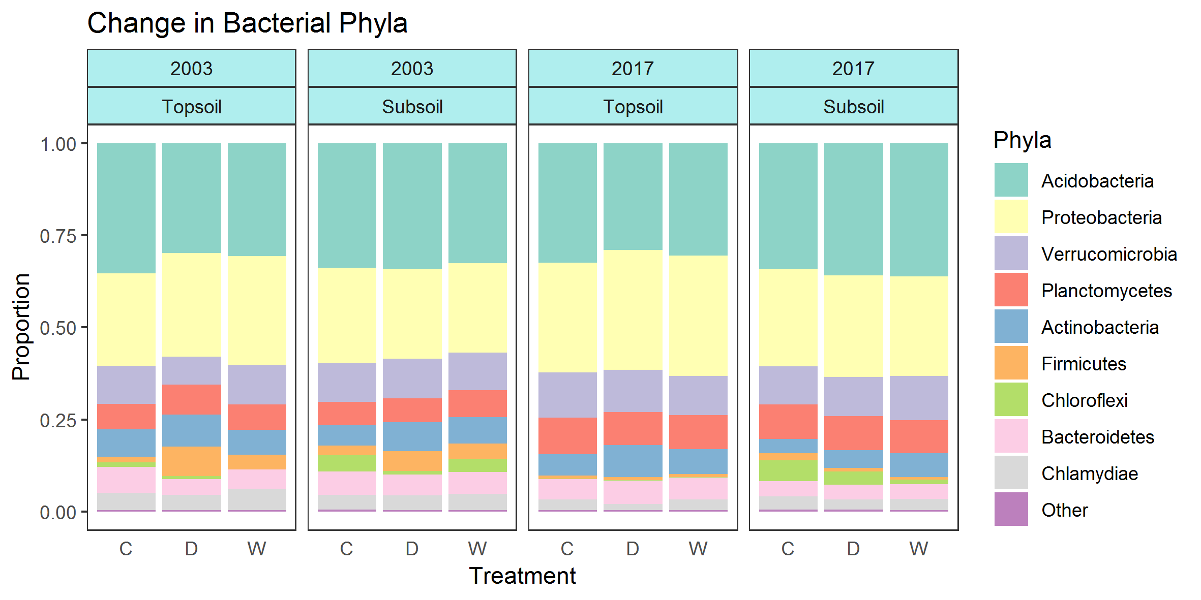
Figure 3: Limited change in bacterial phyla composition with treatment in the different years and depths.
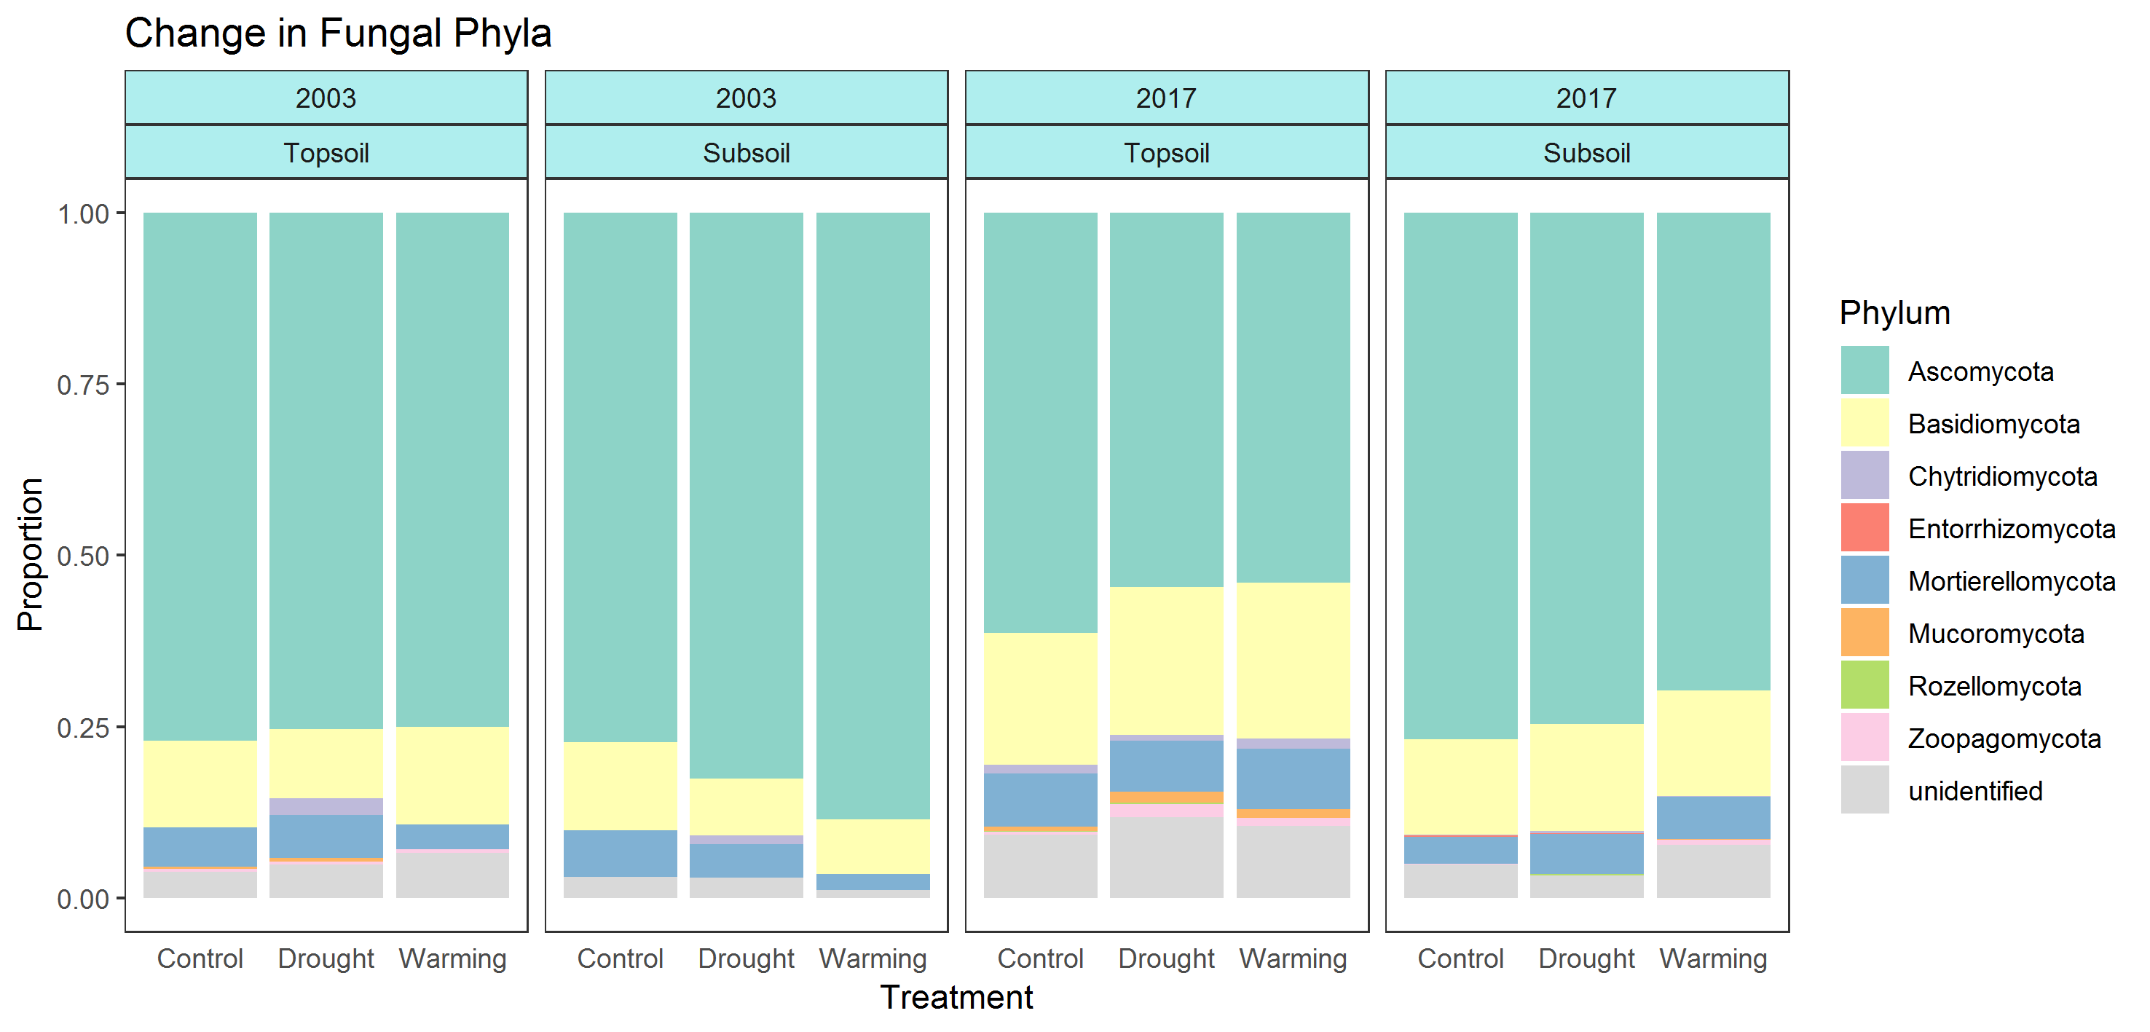
Figure 4: Limited change in fungal phyla composition with treatment in the different years and depths.
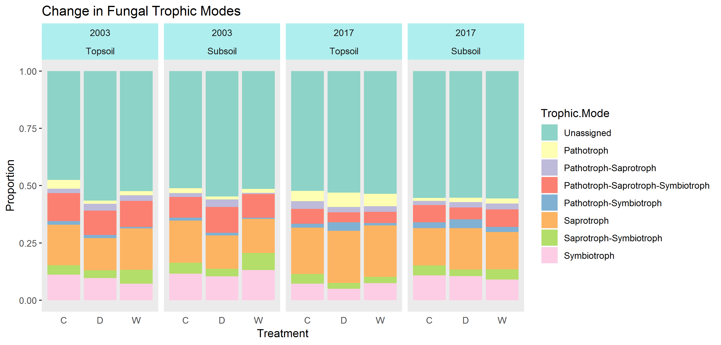
Figure 5: The majority of fungal taxa were unassigned to trophic modes, with limited changes in the relative frequency of the trophic modes by treatment, year and depth.

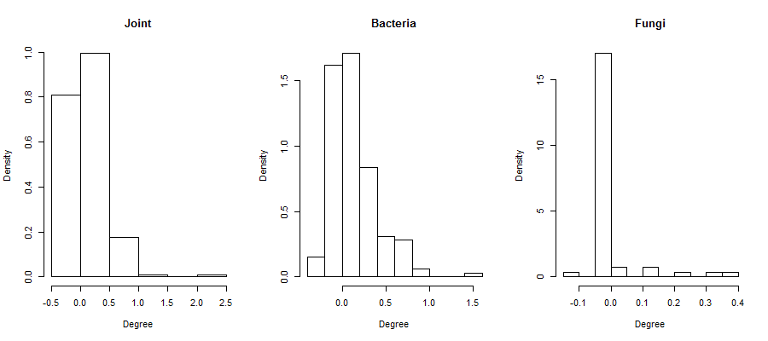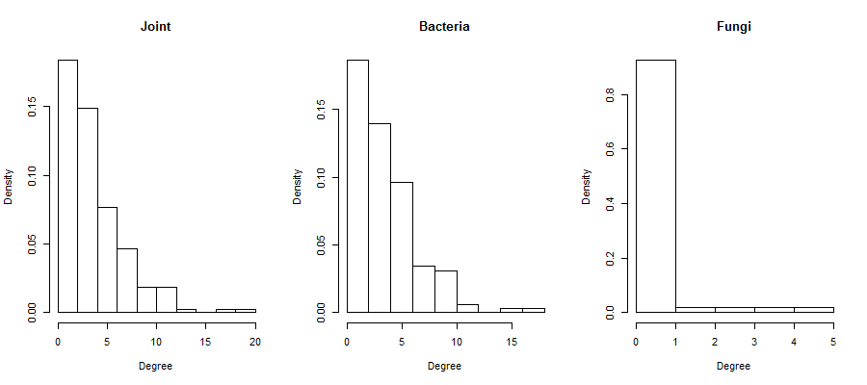
Figure 6: Strength (top row) and degree distribution (bottom row) of the three networks: joint (both bacteria and fungi), bacteria only and fungi only. The transitivity of the networks, or clustering coefficients, were 0.106 for the joint network, 0.131 for the bacteria network and 0.150 for the fungi network.

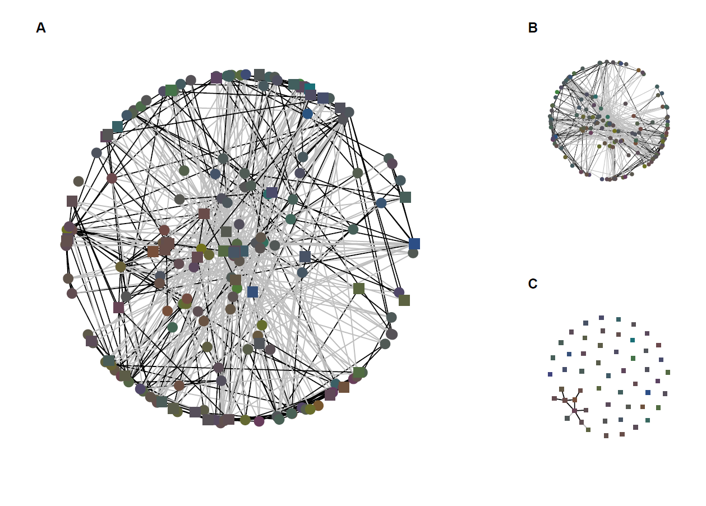
Figure 7: Microbial co-occurrence networks for bacteria and fungi together (A), bacteria only (B) and fungi only (C). Black links are positive, grey negative. The nodes are clustered together according to the Fruchterman Reingold algorithm (for graphical simplicity the fungal layout is based on the unweighted edges). Nodes are coloured by their preference for different treatments: green are control specialists, red warming specialists and blue drought specialists. A brown colour indicates no specialism. Data from 2017 only.

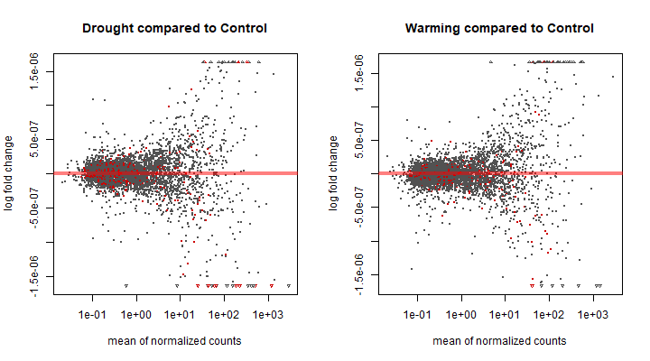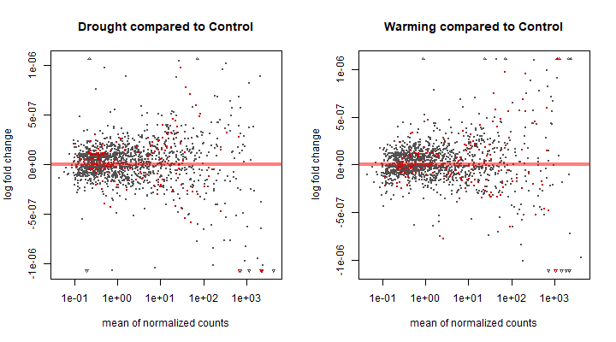
Figure 8: The change in bacterial (top row) and fungal (bottom row) taxa with the treatments compared to control. Taxa that had an adjusted p-value of less than 0.1 are marked in red, all others are marked in black.

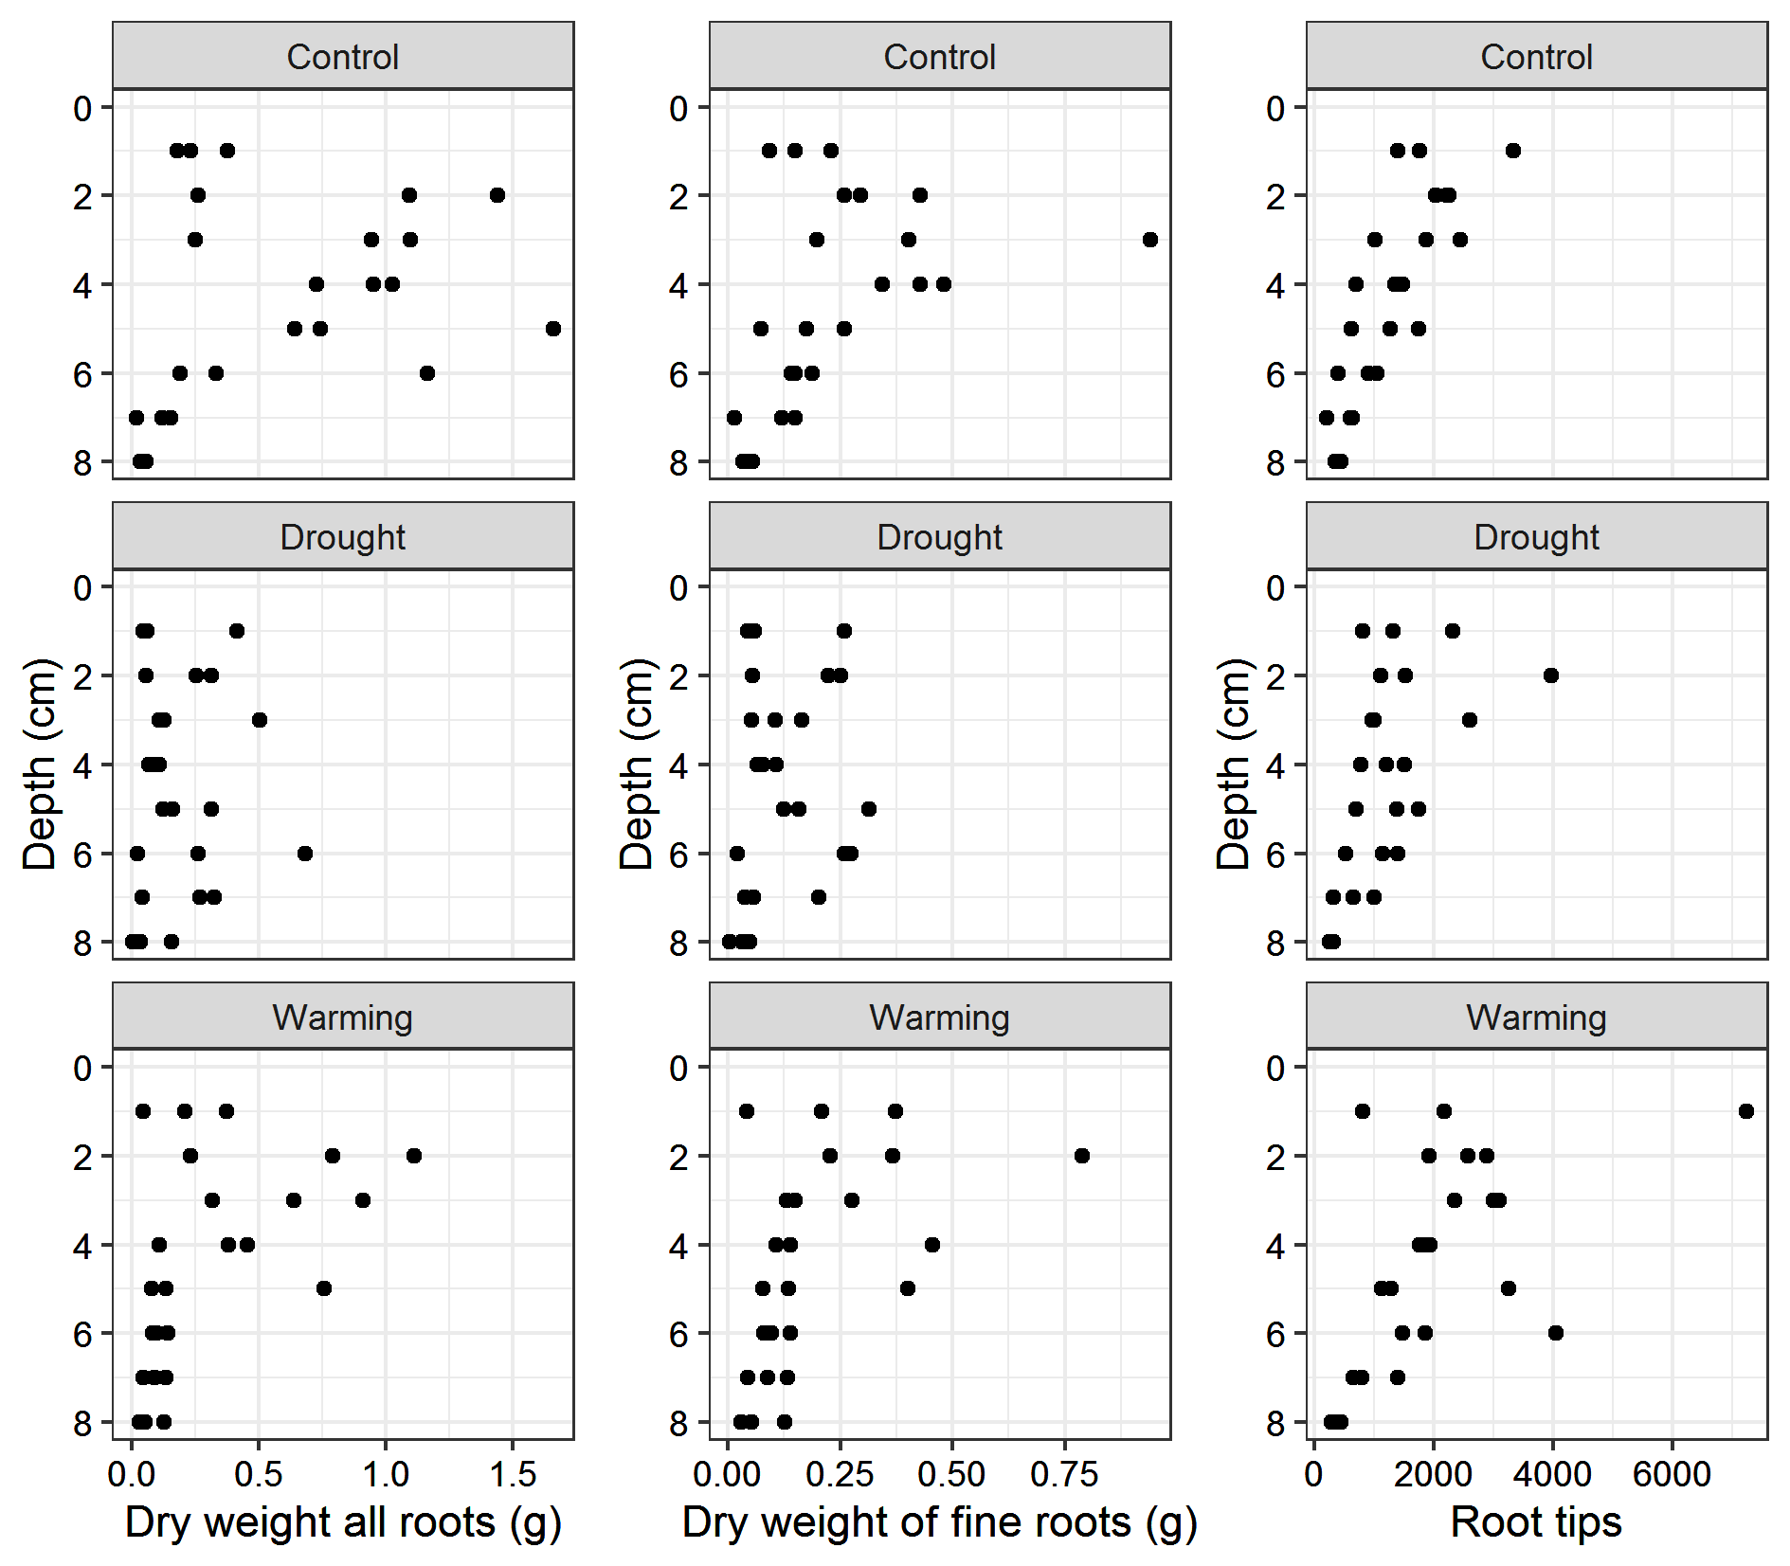
Figure 9: The change in root distribution with depth across the treatments. The left shows the dry weight of all roots, the centre the dry weight of roots under 2 mm in diameter and the right the number of root tips.

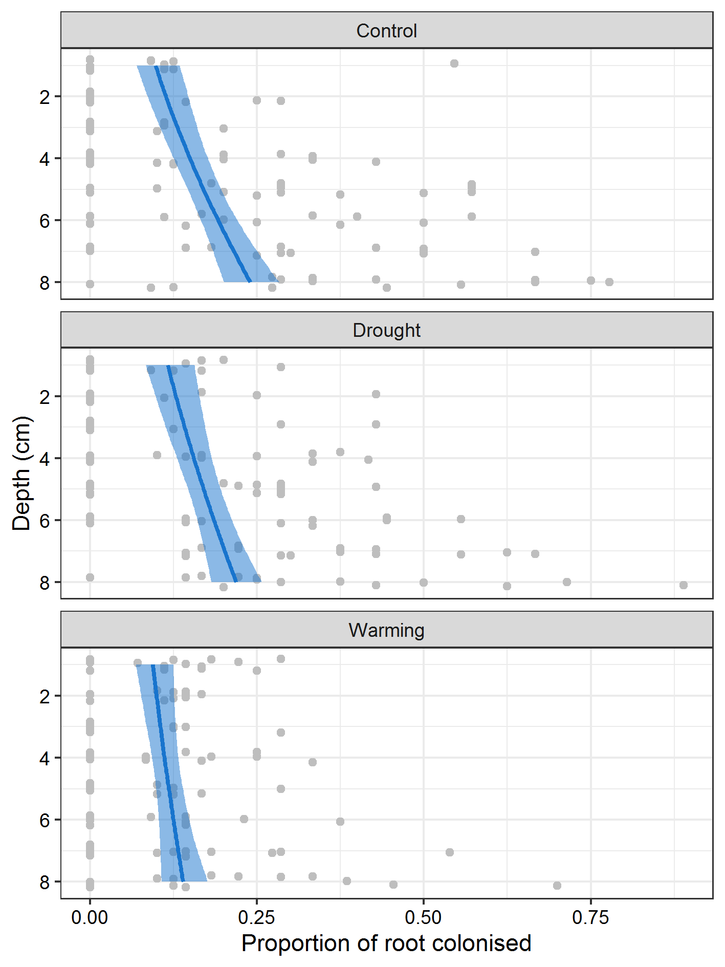
Figure 10: The proportion of root that is colonised by DSE increases with depth in the control and drought treatments but not in the warming treatments. The blue lines represent the model estimated effects plus their error as a blue band.

Table 1: The number of samples per year and treatment, with total number of samples sequenced and the number of samples that obtained enough DNA to be included in the analysis.
 |  | Control |  |  | Drought |  |  | Warming
 | Year | Topsoil | Transition zone | Subsoil | Topsoil | Transition zone | Subsoil | Topsoil | Transition zone | Subsoil
Sent for sequencing | 2003 | 2 |  | 2 | 2 |  | 3 | 3 |  | 3
Sent for sequencing | 2017 | 9 | 9 | 8 | 9 | 9 | 8 | 9 | 9 | 8
Successfully amplified (bacteria) | 2003 | 2 |  | 2 | 2 |  | 3 | 3 |  | 3
Successfully amplified (bacteria) | 2017 | 9 | 9 | 5 | 8 | 9 | 8 | 9 | 9 | 8
Successfully amplified (fungi) | 2003 | 2 |  | 2 | 2 |  | 3 | 2 |  | 3
Successfully amplified (fungi) | 2017 | 7 | 6 | 8 | 5 | 6 | 7 | 4 | 3 | 5

Table 2: The most connected taxa within the networks and their taxonomic identification. Degree is the number of other taxa they are connected to, strength is the sum of all of the weights of the links connected to the taxa. The taxa with the top 10 degree, top 20 strength and top 10 negative strength are included here.
Taxonomy | Degree | Strength | Notes
k_Bacteria;p_Proteobacteria;c_Alphaproteobacteria;o_Rhodospirillales;f_ ;g_;s_ | 19 | 2.397
k_Bacteria;p_Proteobacteria;c_Gammaproteobacteria;o_Xanthomonadales;f_Sinobacteraceae;g_;s_ | 9 | 1.039
k_Bacteria;p_Acidobacteria;c_Acidobacteriia;o_Acidobacteriales;f_Koribacteraceae;g_;s_ | 6 | 0.966
k_Bacteria;p_Acidobacteria;c_Solibacteres;o_Solibacterales;f_Solibacteraceae;g_Candidatus Solibacter;s_ | 11 | 0.859
k_Bacteria;p_Verrucomicrobia;c_[Pedosphaerae];o_[Pedosphaerales];f_auto67_4W;g_;s_ | 18 | 0.802
k_Fungi;p_Mortierellomycota;c_Mortierellomycetes;o_Mortierellales;f_Mortierellaceae;g_Mortierella;s_humilis | 7 | 0.777 | Undefined saprotroph
k_Bacteria;p_Acidobacteria;c_Acidobacteriia;o_Acidobacteriales;f_Koribacteraceae;g_;s_ | 11 | 0.681
k_Fungi;p_Ascomycota;c_Leotiomycetes;o_Helotiales;f_Hyaloscyphaceae;g_Hyaloscypha;s_fuckelii | 5 | 0.642 | Undefined saprotroph
k_Bacteria;p_Proteobacteria;c_Alphaproteobacteria;o_Rhizobiales;f_Methylocystaceae;g_;s_ | 11 | 0.639
k_Fungi;p_Ascomycota;c_Eurotiomycetes;o_Chaetothyriales;f_unidentified;g_unidentified;s_unidentified | 8 | 0.625
k_Bacteria;p_Acidobacteria;c_DA052;o_Ellin6513;f_;g_;s_ | 9 | 0.614
k_Bacteria;p_Proteobacteria;c_Gammaproteobacteria;o_Xanthomonadales;f_Sinobacteraceae;g_;s_ | 5 | 0.609
k_Bacteria;p_Proteobacteria;c_Alphaproteobacteria;o_Rhizobiales;f_Methylocystaceae;g_;s_ | 11 | 0.595
k_Bacteria;p_Acidobacteria;c_Acidobacteriia;o_Acidobacteriales;f_Koribacteraceae;g_;s_ | 8 | 0.587
k_Bacteria;p_Acidobacteria;c_Acidobacteriia;o_Acidobacteriales;f_Acidobacteriaceae;g_;s_ | 4 | 0.584
k_Bacteria;p_Proteobacteria;c_Deltaproteobacteria;o_Syntrophobacterales;f_Syntrophobacteraceae;g_;s_ | 5 | 0.574
k_Bacteria;p_Acidobacteria;c_TM1;o_;f_;g_;s_ | 10 | 0.561
k_Bacteria;p_Acidobacteria;c_Solibacteres;o_Solibacterales;f_;g_;s_ | 7 | 0.554
k_Bacteria;p_Acidobacteria;c_Acidobacteriia;o_Acidobacteriales;f_Koribacteraceae;g_;s_ | 5 | 0.552
k_Bacteria;p_Acidobacteria;c_DA052;o_Ellin6513;f_;g_;s_ | 6 | 0.550
k_Bacteria;p_Acidobacteria;c_Acidobacteriia;o_Acidobacteriales;f_Acidobacteriaceae;g_;s_ | 9 | 0.516
k_Bacteria;p_Proteobacteria;c_Alphaproteobacteria;o_Rhizobiales;f_Methylocystaceae;g_;s_ | 11 | 0.457
k_Bacteria;p_Proteobacteria;c_Alphaproteobacteria;o_Rhizobiales;f_Bradyrhizobiaceae;g_Bradyrhizobium;s_ | 11 | 0.340 | Nitrogen fixing
k_Bacteria;p_Acidobacteria;c_Acidobacteriia;o_Acidobacteriales;f_Koribacteraceae;g_Candidatus Koribacter;s_ | 10 | 0.323
k_Bacteria;p_Verrucomicrobia;c_[Pedosphaerae];o_[Pedosphaerales];f_[Pedosphaeraceae];g_Pedosphaera;s_ | 13 | 0.159
k_Bacteria;p_Proteobacteria;c_Deltaproteobacteria;o_Syntrophobacterales;f_Syntrophobacteraceae;g_;s_ | 10 | 0.158
k_Bacteria;p_Actinobacteria;c_Actinobacteria;o_Actinomycetales;f_;g_;s_ | 12 | 0.015
k_Bacteria;p_Proteobacteria;c_Gammaproteobacteria;o_Enterobacteriales;f_Enterobacteriaceae;g_Escherichia;s_coli | 12 | -0.032
k_Fungi;p_Mortierellomycota;c_Mortierellomycetes;o_Mortierellales;f_Mortierellaceae;g_Mortierella;s_humilis | 9 | -0.145 | Saprotroph
k_Bacteria;p_Acidobacteria;c_Solibacteres;o_Solibacterales;f_;g_;s_ | 4 | -0.188
k_Fungi;p_Ascomycota;c_Leotiomycetes;o_Helotiales;f_Helotiaceae;g_Meliniomyces;s_unidentified | 3 | -0.201 | Saprotroph-Symbiotroph
k_Bacteria;p_Acidobacteria;c_DA052;o_Ellin6513;f_;g_;s_ | 6 | -0.216
k_Fungi;p_Ascomycota;c_Lecanoromycetes;o_Lecanorales;f_Ramalinaceae;g_Toninia;s_physaroides | 3 | -0.221 | Symbiotroph (lichenised)
k_Bacteria;p_Proteobacteria;c_Deltaproteobacteria;o_Syntrophobacterales;f_Syntrophobacteraceae;g_;s_ | 4 | -0.226
k_Bacteria;p_Acidobacteria;c_Acidobacteriia;o_Acidobacteriales;f_Acidobacteriaceae;g_;s_ | 4 | -0.244
k_Bacteria;p_Verrucomicrobia;c_[Methylacidiphilae];o_S-BQ2-57;f_;g_;s_ | 3 | -0.258
k_Fungi;p_Ascomycota;c_unidentified;o_unidentified;f_unidentified;g_unidentified;s_unidentified | 4 | -0.279
k_Bacteria;p_Verrucomicrobia;c_[Pedosphaerae];o_[Pedosphaerales];f_auto67_4W;g_;s_ | 6 | -0.284
k_Bacteria;p_Acidobacteria;c_Acidobacteriia;o_Acidobacteriales;f_Acidobacteriaceae;g_;s_ | 10 | -0.462
Table 3: The microbial diversity and NMDS scores for the different samples. Columns are: Plot (plot number); Quad. (quadrat of plot that was sampled); Depth (T = topsoil, M = middle, S = subsoil); Year (2003 or 2017 sampling); Treatment (Control, drought or warming plot); BACT RICH (bacterial richness); BACT SHAN (bacterial Shannon diversity); BACT SIMP (bacterial Simpson diversity); BACT NMDS1 (score of first axis in bacterial NMDS ordination); BACT NMDS2 (score of second axis in bacterial NMDS ordination); FUNG RICH (fungal richness); FUNG SHAN (fungal Shannon diversity); FUNG SIMP (fungal Simpson diversity); FUNG NMDS1 (score of first axis in fungal NMDS ordination); FUNG NMDS2 (score of second axis in fungal NMDS ordination).
Plot | Quad. | Depth | Year | Treatment | BACT RICH | BACT SHAN | BACT SIMP | BACT NMDS1 | BACT NMDS2 | FUNG RICH | FUNG SHAN | FUNG SIMP | FUNG NMDS1 | FUNG NMDS2
9 | G9 | T | 2017 | Control | 536 | 5.64 | 0.007 | -0.762 | -0.877 | 224 | 3.51 | 0.07 | -0.921 | -0.014
6 | E7 | S | 2017 | Control | 512 | 4.95 | 0.018 | 1.148 | -0.855 | 38 | 2.28 | 0.152 | 1.037 | -0.219
3 | G9 | T | 2017 | Control | 296 | 4.48 | 0.033 | -0.419 | 0.263 | NA | NA | NA | NA | NA
3 | G2 | T | 2017 | Control | 481 | 4.94 | 0.02 | -0.193 | 0.076 | 167 | 3.58 | 0.048 | -0.336 | -0.07
3 | B3 | T | 2017 | Control | 372 | 4.77 | 0.024 | -0.542 | 0.025 | 170 | 3.56 | 0.054 | -0.396 | -0.076
5 | G2 | M | 2017 | Drought | 256 | 4.35 | 0.036 | -0.136 | 0.647 | NA | NA | NA | NA | NA
1 | F8 | M | 2017 | Warming | 301 | 4.56 | 0.024 | 0.283 | 0.439 | NA | NA | NA | NA | NA
3 | G2 | S | 2017 | Control | 340 | 4.47 | 0.03 | 1.288 | -0.083 | 42 | 2.44 | 0.126 | 0.931 | 0.229
4 | E4 | T | 2017 | Drought | 414 | 5.39 | 0.008 | -0.809 | -0.638 | 269 | 4.11 | 0.029 | -0.828 | -0.301
7 | B7 | S | 2017 | Warming | 439 | 5.34 | 0.01 | -0.494 | -0.366 | 175 | 3.61 | 0.049 | -0.507 | 0.131
1 | NA | T | 2003 | Warming | 469 | 4.84 | 0.021 | -0.565 | 0.058 | NA | NA | NA | NA | NA
2 | D8 | T | 2017 | Warming | 426 | 5.43 | 0.008 | -1.056 | -1.053 | 158 | 2.88 | 0.145 | -1.09 | 0.158
7 | C4 | M | 2017 | Warming | 341 | 4.6 | 0.022 | 0.014 | 0.598 | NA | NA | NA | NA | NA
2 | G5 | S | 2017 | Warming | 296 | 4.4 | 0.034 | 0.085 | 0.739 | NA | NA | NA | NA | NA
4 | E4 | M | 2017 | Drought | 482 | 5.08 | 0.015 | 0.442 | -0.05 | 136 | 3.43 | 0.053 | 0.069 | -0.281
7 | F5 | M | 2017 | Warming | 426 | 5.13 | 0.013 | 0.01 | 0.207 | NA | NA | NA | NA | NA
5 | B6 | M | 2017 | Drought | 359 | 4.68 | 0.024 | 0.463 | 0.464 | 97 | 3.38 | 0.054 | 0.321 | 0.15
7 | C4 | S | 2017 | Warming | 408 | 5.09 | 0.012 | -0.146 | 0.19 | 153 | 3.76 | 0.041 | -0.109 | 0.037
2 | C2 | T | 2017 | Warming | 299 | 4.66 | 0.022 | -0.569 | 0.136 | NA | NA | NA | NA | NA
8 | C8 | M | 2017 | Drought | 526 | 5.55 | 0.007 | -0.754 | -0.663 | 253 | 3.87 | 0.043 | -0.877 | -0.138
9 | NA | T | 2003 | Control | 577 | 5.35 | 0.012 | 0.03 | -0.05 | 132 | 3.83 | 0.043 | 0.034 | 0.015
8 | F5 | T | 2017 | Drought | 415 | 5.19 | 0.012 | -0.279 | -0.202 | NA | NA | NA | NA | NA
9 | NA | S | 2003 | Control | 776 | 5.56 | 0.012 | 0.722 | -0.335 | 116 | 3.68 | 0.043 | 0.27 | -0.065
2 | C2 | M | 2017 | Warming | 303 | 4.69 | 0.019 | 0.066 | 0.246 | NA | NA | NA | NA | NA
8 | B7 | M | 2017 | Drought | 354 | 4.69 | 0.023 | 0.327 | 0.296 | 91 | 3.07 | 0.076 | 0.333 | -0.008
4 | F8 | T | 2017 | Drought | 430 | 5.14 | 0.014 | -0.536 | -0.153 | NA | NA | NA | NA | NA
6 | D5 | M | 2017 | Control | 381 | 5.14 | 0.011 | 0.012 | 0.09 | 157 | 3.5 | 0.054 | -0.283 | 0.028
1 | F8 | T | 2017 | Warming | 350 | 4.92 | 0.018 | -0.756 | -0.213 | 108 | 3.01 | 0.116 | -0.47 | 0.264
8 | C8 | T | 2017 | Drought | 302 | 4.55 | 0.025 | -0.337 | 0.287 | NA | NA | NA | NA | NA
6 | E7 | T | 2017 | Control | 377 | 4.94 | 0.018 | -0.01 | 0.136 | 166 | 3.64 | 0.049 | -0.34 | 0.137
5 | B6 | S | 2017 | Drought | 405 | 5.01 | 0.015 | 0.899 | -0.015 | 64 | 3.03 | 0.074 | 0.598 | 0.052
2 | NA | S | 2003 | Warming | 647 | 5.55 | 0.008 | 1.017 | -0.463 | 61 | 2.85 | 0.098 | 0.6 | -0.132
7 | B7 | M | 2017 | Warming | 402 | 5 | 0.017 | -0.124 | 0.076 | NA | NA | NA | NA | NA
7 | NA | T | 2003 | Warming | 318 | 4.47 | 0.029 | -0.256 | 0.894 | 48 | 2.73 | 0.094 | 0.461 | 0.529
6 | C2 | T | 2017 | Control | 281 | 4.45 | 0.031 | -0.385 | 0.341 | 114 | 3.43 | 0.055 | -0.087 | -0.066
9 | D6 | M | 2017 | Control | 360 | 4.9 | 0.018 | -0.226 | 0.352 | 147 | 3.8 | 0.034 | -0.165 | 0.066
3 | G2 | M | 2017 | Control | 242 | 4.49 | 0.023 | 0.226 | 0.833 | NA | NA | NA | NA | NA
7 | F5 | T | 2017 | Warming | 397 | 4.97 | 0.018 | -0.221 | 0.067 | NA | NA | NA | NA | NA
4 | D2 | M | 2017 | Drought | 423 | 5.2 | 0.013 | -0.686 | -0.286 | 184 | 3.88 | 0.036 | -0.514 | -0.158
7 | C4 | T | 2017 | Warming | 287 | 4.64 | 0.023 | -0.305 | 0.333 | NA | NA | NA | NA | NA
5 | F8 | S | 2017 | Drought | 390 | 5.14 | 0.012 | 0.384 | -0.106 | 113 | 3.37 | 0.055 | 0.174 | -0.193
2 | D8 | M | 2017 | Warming | 398 | 5.23 | 0.009 | -0.98 | -0.413 | 139 | 3.06 | 0.089 | -0.793 | 0.25
4 | NA | S | 2003 | Drought | 419 | 4.84 | 0.016 | 0.243 | 0.389 | 50 | 2.41 | 0.172 | 0.563 | 0.169
7 | NA | S | 2003 | Warming | 335 | 4.45 | 0.025 | 0.183 | 0.739 | 45 | 2.92 | 0.074 | 0.579 | 0.393
8 | C8 | S | 2017 | Drought | 425 | 4.89 | 0.022 | 0.404 | -0.143 | 95 | 2.96 | 0.119 | 0.245 | -0.261
4 | E4 | S | 2017 | Drought | 519 | 5 | 0.019 | 0.74 | -0.482 | 56 | 2.75 | 0.099 | 0.563 | -0.207
9 | G9 | S | 2017 | Control | 423 | 4.98 | 0.016 | 1.174 | -0.309 | 64 | 2.67 | 0.112 | 0.495 | -0.479
2 | G5 | M | 2017 | Warming | 385 | 4.1 | 0.065 | -0.429 | 0.31 | NA | NA | NA | NA | NA
9 | D6 | T | 2017 | Control | 325 | 4.55 | 0.026 | -0.147 | 0.477 | NA | NA | NA | NA | NA
5 | B6 | T | 2017 | Drought | 509 | 5.46 | 0.008 | -0.691 | -0.633 | 182 | 3.58 | 0.057 | -0.76 | -0.084
5 | F8 | M | 2017 | Drought | 318 | 4.56 | 0.023 | -0.15 | 0.119 | NA | NA | NA | NA | NA
1 | B4 | S | 2017 | Warming | 359 | 4.74 | 0.022 | 0.942 | 0.164 | 47 | 2.52 | 0.143 | 0.647 | 0.301
4 | F8 | M | 2017 | Drought | 396 | 4.73 | 0.031 | -0.245 | -0.117 | NA | NA | NA | NA | NA
8 | F5 | M | 2017 | Drought | 403 | 4.87 | 0.022 | 0.161 | -0.056 | 139 | 3.66 | 0.043 | 0.011 | -0.313
5 | NA | T | 2003 | Drought | 507 | 5.03 | 0.016 | -0.044 | 0.274 | 70 | 3.36 | 0.062 | 0.235 | 0.373
2 | NA | T | 2003 | Warming | 437 | 4.42 | 0.059 | -0.818 | 0.055 | 113 | 3.34 | 0.054 | -0.19 | 0.253
2 | C2 | S | 2017 | Warming | 395 | 4.88 | 0.019 | 0.219 | 0.131 | NA | NA | NA | NA | NA
9 | E2 | T | 2017 | Control | 536 | 5.28 | 0.013 | -0.176 | -0.265 | 170 | 3.53 | 0.07 | -0.385 | 0.314
9 | E2 | M | 2017 | Control | 411 | 5.03 | 0.016 | -0.13 | 0.382 | NA | NA | NA | NA | NA
1 | B4 | T | 2017 | Warming | 471 | 5.59 | 0.007 | -1.041 | -0.761 | 198 | 3.58 | 0.059 | -0.958 | 0.131
3 | B3 | M | 2017 | Control | 348 | 4.74 | 0.024 | -0.605 | 0.122 | 159 | 3.14 | 0.112 | -0.341 | -0.281
6 | D5 | T | 2017 | Control | 451 | 5.13 | 0.015 | -0.587 | -0.157 | 149 | 2.99 | 0.126 | -0.461 | -0.231
3 | G9 | M | 2017 | Control | 268 | 4.39 | 0.025 | 0.033 | 0.771 | 83 | 2.74 | 0.151 | 0.261 | 0.101
5 | F8 | T | 2017 | Drought | 427 | 5.47 | 0.008 | -0.943 | -0.652 | 265 | 3.97 | 0.046 | -0.903 | -0.097
2 | D8 | S | 2017 | Warming | 329 | 4.69 | 0.025 | 0.196 | 0.525 | 79 | 2.64 | 0.15 | 0.324 | 0.222
5 | NA | S | 2003 | Drought | 497 | 5.18 | 0.012 | 0.382 | 0.421 | 74 | 3.05 | 0.089 | 0.455 | 0.196
1 | NA | S | 2003 | Warming | 621 | 5.25 | 0.015 | 0.65 | -0.014 | 69 | 3.34 | 0.051 | 0.467 | 0.06
8 | B7 | T | 2017 | Drought | 343 | 4.8 | 0.018 | -0.28 | 0.224 | NA | NA | NA | NA | NA
8 | B7 | S | 2017 | Drought | 531 | 5.16 | 0.012 | 0.991 | -0.566 | 120 | 3.1 | 0.086 | 0.152 | -0.298
4 | D2 | S | 2017 | Drought | 457 | 5.06 | 0.019 | 0.918 | -0.603 | 58 | 2.7 | 0.113 | 0.626 | -0.382
3 | B3 | S | 2017 | Control | 488 | 4.87 | 0.025 | 0.866 | -0.636 | 46 | 2.94 | 0.07 | 0.707 | -0.309
1 | D7 | T | 2017 | Warming | 488 | 5.39 | 0.009 | -0.609 | -0.277 | 184 | 3.69 | 0.051 | -0.553 | -0.031
1 | D7 | M | 2017 | Warming | 275 | 4.48 | 0.03 | -0.003 | 0.576 | 107 | 3.06 | 0.091 | 0.083 | 0.168
5 | G2 | T | 2017 | Drought | 493 | 5.51 | 0.007 | -0.949 | -0.74 | 214 | 3.62 | 0.048 | -0.92 | 0.045
6 | C2 | M | 2017 | Control | 286 | 4.41 | 0.042 | -0.179 | 0.507 | 68 | 3.02 | 0.076 | 0.26 | 0.312
6 | E7 | M | 2017 | Control | 358 | 4.61 | 0.029 | 0.295 | 0.301 | 77 | 3.1 | 0.077 | 0.405 | 0.019
7 | B7 | T | 2017 | Warming | 447 | 4.92 | 0.022 | -0.3 | -0.024 | NA | NA | NA | NA | NA
6 | NA | T | 2003 | Control | 451 | 4.89 | 0.02 | -0.026 | 0.456 | 126 | 3.27 | 0.078 | -0.096 | 0.294
8 | NA | T | 2003 | Drought | 632 | 5.42 | 0.01 | -0.164 | -0.4 | 136 | 3.58 | 0.073 | -0.075 | 0.209
1 | D7 | S | 2017 | Warming | 295 | 4.55 | 0.028 | 0.123 | 0.465 | 94 | 3.39 | 0.054 | 0.238 | 0.181
2 | G5 | T | 2017 | Warming | 378 | 4.6 | 0.031 | -0.586 | -0.054 | NA | NA | NA | NA | NA
9 | D6 | S | 2017 | Control | 380 | 4.85 | 0.02 | 1.264 | -0.39 | 77 | 2.51 | 0.171 | 0.491 | -0.375
1 | F8 | S | 2017 | Warming | 369 | 4.73 | 0.021 | 1.321 | -0.493 | NA | NA | NA | NA | NA
4 | F8 | S | 2017 | Drought | 530 | 4.97 | 0.019 | 0.24 | -0.351 | NA | NA | NA | NA | NA
1 | B4 | M | 2017 | Warming | 319 | 4.73 | 0.024 | -0.107 | 0.347 | 191 | 3.56 | 0.051 | -0.482 | 0.041
9 | G9 | M | 2017 | Control | 424 | 4.93 | 0.017 | 0.175 | 0.084 | NA | NA | NA | NA | NA
8 | F5 | S | 2017 | Drought | 310 | 4.71 | 0.02 | 1.113 | -1.101 | 99 | 2.42 | 0.171 | 0.086 | -0.604
6 | NA | S | 2003 | Control | 570 | 5.36 | 0.012 | 0.606 | -0.116 | 116 | 4.04 | 0.025 | 0.256 | 0.008
8 | NA | S | 2003 | Drought | 494 | 5.07 | 0.014 | 0.099 | 0.529 | 115 | 3.71 | 0.04 | 0.175 | 0.158
3 | G9 | S | 2017 | Control | NA | NA | NA | NA | NA | 92 | 2.8 | 0.103 | 0.363 | -0.255
4 | D2 | T | 2017 | Drought | NA | NA | NA | NA | NA | 166 | 3.56 | 0.057 | -0.568 | -0.242
6 | C2 | S | 2017 | Control | NA | NA | NA | NA | NA | 106 | 3.21 | 0.078 | 0.21 | 0.047
9 | E2 | S | 2017 | Control | NA | NA | NA | NA | NA | 55 | 2.69 | 0.145 | 0.682 | 0.13

