Resolving the drivers of algal nutrient limitation from boreal to Arctic lakes and streams

Maria Myrstener* and Megan L. Fork*, Ann-Kristin Bergström, Isolde Callisto Puts, Demian Hauptmann, Peter D. F. Isles, Ryan M. Burrows, and Ryan A. Sponseller
*Corresponding authors: Maria Myrstener (mariamyrstener@gmail.com), Megan Fork (megan.fork@gmail.com)

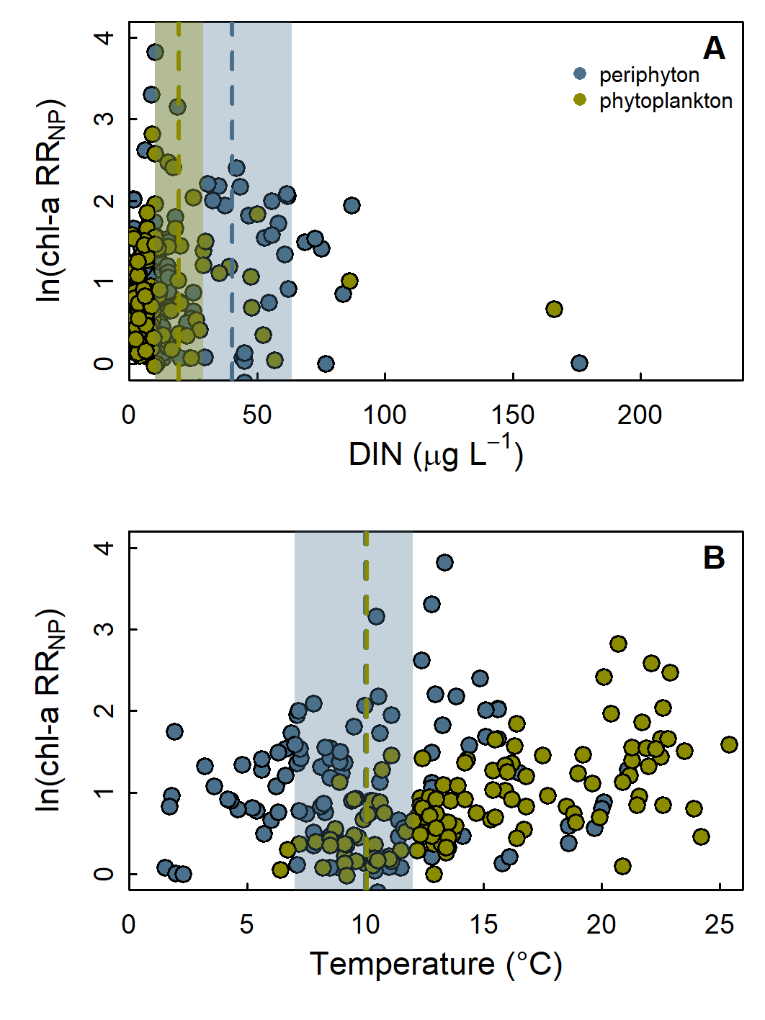
Figure S1. Relationship between Chl-a response to N+P addition (lnRR_{NP}) and ambient DIN concentration (A) or temperature (B) in periphyton and phytoplankton bioassays. We identified thresholds in RR_{NP} at 40.2 µg L⁻¹ DIN (95% CI = [10, 63.7]) for periphyton and 19.3 µg L⁻¹ DIN (95% CI = [10, 28.8]) for phytoplankton. Temperature thresholds were at 10°C for periphyton (95% CI = [7, 12]) and for phytoplankton (95% CI = [10, 10]), though at any given temperature, periphyton tended to respond more strongly to added nutrients.
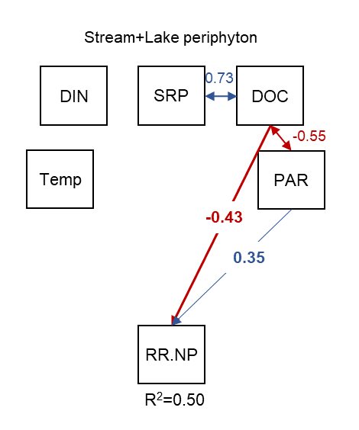
Figure S2. Path analysis results of stream+lake periphyton responses to NP addition. Arrows between predictors (temperature, DIN, SRP, DOC and PAR) represent Pearson correlations at p≤0.01. Arrows from predictors to response variables (RR_{NP} and RR_{N}) represent path coefficients at p≤0.01.

Table S1. Results of Tukey multiple comparison of means with 95% family-wise confidence level and t-tests of RR_{N} and RR_{P} compared to 0. Note negative means for multiple RR_{P}.
Test | Contrasts | mean | diff | lwr | upr | p
Tukey | BorealLakePeriphyton:N-BorealLakePeriphyton:P |  | 1.09 | 0.16 | 2.03 | 0.01
Tukey | BorealLakePeriphyton:NP-BorealLakePeriphyton:P |  | 1.24 | 0.30 | 2.17 | 0.00
Tukey | BorealLakePeriphyton:NP-BorealLakePeriphyton:N |  | 0.14 | -0.79 | 1.08 | 1.00
t-test | BorealLakePeriphyton:N - 0 | 0.55 |  |  |  | 0.01
t-test | BorealLakePeriphyton:P - 0 | -0.69 |  |  |  | <0.01
Tukey | BorealStream:NP-BorealStream:P |  | 0.55 | 0.06 | 1.05 | 0.01
Tukey | BorealStream:N-BorealStream:P |  | 0.82 | 0.32 | 1.31 | 0.00
Tukey | BorealStream:N-BorealStream:NP |  | 0.26 | -0.23 | 0.76 | 0.93
t-test | BorealStream:N - 0 | 0.42 |  |  |  | <0.01
t-test | BorealStream:P - 0 | -0.31 |  |  |  | <0.01
Tukey | SubArcticLakePeriphyton:N-SubArcticLakePeriphyton:P |  | 1.30 | 0.37 | 2.23 | 0.00
Tukey | SubArcticLakePeriphyton:NP-SubArcticLakePeriphyton:P |  | 1.58 | 0.64 | 2.51 | 0.00
Tukey | SubArcticLakePeriphyton:NP-SubArcticLakePeriphyton:N |  | 0.28 | -0.66 | 1.21 | 1.00
t-test | SubArcticLakePeriphyton:N - 0 | 0.63 |  |  |  | <0.01
t-test | SubArcticLakePeriphyton:P - 0 | 0.31 |  |  |  | <0.01
Tukey | SubArcticLakePhytoplankton:N-SubArcticLakePhytoplankton:P |  | 0.18 | -0.13 | 0.50 | 0.85
Tukey | SubArcticLakePhytoplankton:NP-SubArcticLakePhytoplankton:P |  | 0.60 | 0.28 | 0.92 | 0.00
Tukey | SubArcticLakePhytoplankton:NP-SubArcticLakePhytoplankton:N |  | 0.42 | 0.10 | 0.73 | 0.00
t-test | SubArcticLakePhytoplankton:N - 0 | 0.23 |  |  |  | <0.01
t-test | SubArcticLakePhytoplankton:P - 0 | 0.04 |  |  |  | 0.09
Tukey | BorealLakePhytoplankton:N-BorealLakePhytoplankton:P |  | 0.36 | -0.02 | 0.75 | 0.09
Tukey | BorealLakePhytoplankton:NP-BorealLakePhytoplankton:P |  | 0.97 | 0.58 | 1.35 | 0.00
Tukey | BorealLakePhytoplankton:NP-BorealLakePhytoplankton:N |  | 0.60 | 0.22 | 0.99 | 0.00
t-test | BorealLakePhytoplankton:N - 0 | 0.44 |  |  |  | <0.01
t-test | BorealLakePhytoplankton:P - 0 | 0.06 |  |  |  | 0.45
Tukey | SubArcticStream:N-SubArcticStream:P |  | 0.40 | 0.04 | 0.75 | 0.01
Tukey | SubArcticStream:NP-SubArcticStream:P |  | 1.13 | 0.77 | 1.49 | 0.00
Tukey | SubArcticStream:NP-SubArcticStream:N |  | 0.73 | 0.38 | 1.09 | 0.00
t-test | SubArcticStream:N - 0 | 1.33 |  |  |  | <0.01
t-test | SubArcticStream:P - 0 | 0.02 |  |  |  | 0.85

Table S2. Numbers of site and individual bioassay experiments included in analyses, sorted by water body type, habitat and region. Path analysis for high and low DOC used data only from pelagic lake bioassays.
 | Lakes |  |  | Streams |  | TOTAL
Individual experiment sites | 57 |  |  | 32 |  | 89
 | Subarctic (pelagic) | Boreal (pelagic) | Periphyton  (subarctic+boreal) | Subarctic  (periphyton) | Boreal (periphyton)
Total bioassay experiments | 79 | 53 | 18 | 62 | 32 | 244
Used in path analyses (Fig. 4) | 79 | 53 | excluded | 62 | 32 | N = 205
 | High DOC | Low DOC | DOC=9.6 mg L⁻¹
Used in DOC path analyses (Fig. 5) | 36 | 94 | 2 |  |  | N = 132

PAR modeling for lake benthic periphyton experiments
Daily light data for in situ benthic lake incubations were estimated by modeling hourly incident PAR and subtracting the proportion attenuated by the water column above the deployment. Based on deployment dates and geographic coordinates of the lakes, we used the STRÅNG model from the Swedish Meteorological and Hydrological Institute (strang.smhi.se/extraction/index.php) to estimate hourly incident PAR during deployments. We calculated the proportion of incident light transmitted through the water column to the deployment depth using extinction coefficients (k_{d}, estimated from measured absorbance as described in Fork et al. 2020) and reported depth of deployment (Arst, Mäekivi, Lukk, & Herlevi, 1997). We applied this extinction coefficient to the incident light time series and calculated mean PAR at the deployment over the course of the incubation.

