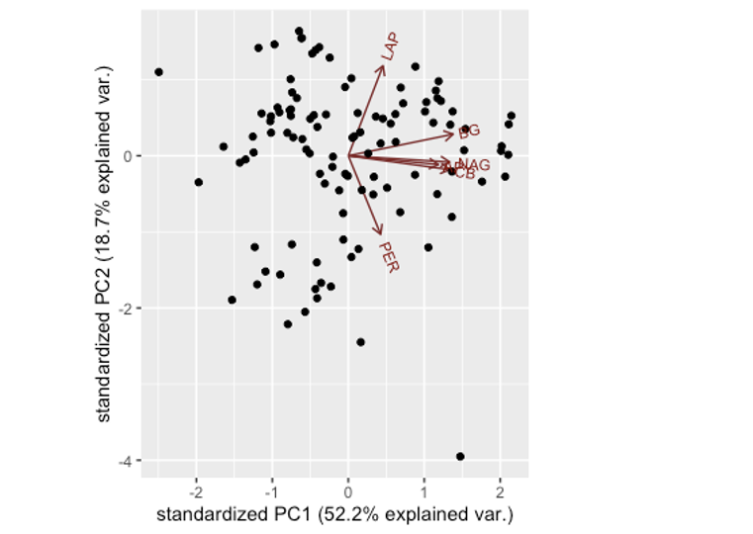
Figure S2. Principal components analysis of potential extracellular enzyme activities. Arrows represent directions for each enzymes included: Leucine aminopeptidase (LAP), B glucosidase (BG), cellobiosidase (CB), N acetylglucosaminidase (NAG), acid phosphatase (AP), and summed oxidases - peroxidase and phenol oxidase (PER). Points represent individual plots for all enzyme activities.
Figure S2. Soil pH between tree mycorrhizal types, arbuscular (AM) and ectomycorrhizal (EcM). Points represent raw data and horizontal black lines represent the mean from the model output.

Figure S3. Non-metric multidimensional scaled representation of fungal community composition with all ASVs. Each point represents one sample, is shaded by soil pH, and labeled by site (see table S1 for site information).

Figure S4. Summed relative abundance of the top 30 most abundant genera of all fungal ASVs (a), and EcM fungal ASVs within the top 30 most abundant genera (b) across tree species: Hemlock (EcM evergreen), Birch (EcM deciduous), Ash (AM deciduous), and Cedar (AM evergreen).

Table S1. Site information for location, species sampled, organic horizon depth (listed in order of species sampled), elevation, annual cumulative precipitation, average annual temperature, soil series, parent material, slope range, and average percent clay content or upper 10cm of mineral soil (mean +- standard error).
 | Avery Brook (AB) | Clement Brook (CB) | Hubbard Brook (HB) | Long Pond (LP) | Roaring Ridge (RR)
Lat, Long | 43.78332, -72.28776 | 44.06643, -72.31306 | 43.94463, -71.71660 | 44.62112, -72.26415 | 44.27549, -72.13417
Tree Species (# of plots / site) | Birch (3)  Hemlock (3) | Ash (3) | Ash (3)  Hemlock(3)  Birch (3) | Cedar (3) | Cedar (3)
Mean O horizon depth (cm) | 6.3 $\frac{+}{-}$ 0.4 | 5.7$\frac{+}{-}$0.4 | 8.8 $\frac{ +}{-}$ 0.7 | 21.6 $\frac{+}{-}$ 1.1 | 10 $\frac{+}{-}$0.4
pH (mean $\frac{+}{-}$ SE) | 4.6 $\frac{+}{-}$ 0.1 | 5.5 $\frac{+}{-}$0.1 | 4.3 $\frac{+}{-}$0.1 | 5.4 $\frac{+}{-}$0.1 | 6.4 $\frac{+}{-}$0.03
Elevation (m) | 277 | 409 | 350 | 496 | 479
Annual precipitation (mm) | 1100 | 1200 | 1400 | 1300 | 1200
Average annual temperature (C) | 6.5 | 5.6 | 6.2 | 4.9 | 5.4
Soil series | Monadnock and Berkshire sandy loams | Tunbridge -Woodstock very rocky fine sandy loams | Colton gravely to sandy loam | Buckland loam | Monadnock fine sandy loam
Soil order | Spodosol | Spodosol/ Inceptisol | Spodosol | Inceptisol | Spodosol
Slope range % | 3 to 8 | 8 to 25 | 8 to 15 | 8 to 15 | 0 to 15
Average % clay ($\frac{+}{-}$SE) | 9.6 $\frac{+}{-}$ 1.6 | 13.9 $\frac{+}{-}$ 4.5 | 13.8 $\frac{+}{-}$ 2.9 | 17.0 $\frac{+}{-}$ 2.0 | 11.1 $\frac{+}{-}$ 1.1

Table S2. Soil carbon to nitrogen ratios (C:N), pH, and potential enzyme activities summarized by tree species and soil horizon (mean $\frac{+}{-}$ standard error). Enzyme abbreviations are as follows: G
(-glucosidase), CB (cellbiohydrolase), NAG (N-acetyl glucosamidase), LAP (leucine aminopeptidase). Oxidase activity represents the combined activities of peroxidase and phenoloxidase. Organic horizon label includes depth (mean $\frac{+}{-}$ SE).

Tree species | Horizon | Soil C:N | Soil pH | Oxidase (ng g soil⁻¹ hr⁻¹) | G (g g soil⁻¹ hr⁻¹) | CB (g g soil⁻¹ hr⁻¹) | NAG (g g soil⁻¹ hr⁻¹) | LAP (g g soil⁻¹ hr⁻¹)
Ash | Organic (6.3 $\frac{+}{-}$ 0.8) | 18.0 $\frac{+}{-}$ 1.3 | 5.12 $\frac{+}{-}$ 0.08 | 0.019 $\frac{+}{-}$ 0.008 | 22700 $\frac{+}{-}$ 4600 | 3940 $\frac{+}{-}$ 1000 | 97200 $\frac{+}{-}$ 33000 | 14200 $\frac{+}{-}$ 2400
Ash | Mineral | 15.4 +- 0.9 | 5.16 $\frac{+}{-}$ 0.07 | 0.019 $\frac{+}{-}$ 0.006 | 5580 $\frac{+}{-}$ 2200 | 1040 $\frac{+}{-}$ 200 | 4600 $\frac{+}{-}$ 1400 | 23000 $\frac{+}{-}$ 11000
Birch | Organic (8.2 $\frac{+}{-}$ 0.6) | 20.2 $\frac{+}{-}$ 0.6 | 4.42 $\frac{+}{-}$ 0.06 | 0.031 $\frac{+}{-}$ 0.009 | 11400 $\frac{+}{-}$ 2200 | 1230 $\frac{+}{-}$ 310 | 94100 $\frac{+}{-}$ 18000 | 5930 $\frac{+}{-}$810
Birch | Mineral | 20.8 $\frac{+}{-}$ 0.8 | 4.49 $\frac{+}{-}$ 0.06 | 0.035 $\frac{+}{-}$ 0.005 | 4660 $\frac{+}{-}$ 410 | 1240 $\frac{+}{-}$ 440 | 3920 $\frac{+}{-}$ 620 | 8550 $\frac{+}{-}$ 2000
Cedar | Organic (15.8 $\frac{+}{-}$ 1.5) | 21.9 $\frac{+}{-}$ 1.6 | 5.77 $\frac{+}{-}$ 0.11 | 0.063 $\frac{+}{-}$ 0.03 | 36900 $\frac{+}{-}$ 8800 | 6510 $\frac{+}{-}$ 1700 | 135000 $\frac{+}{-}$ 25000 | 13100 $\frac{+}{-}$2000
Cedar | Mineral | 19.2 $\frac{+}{-}$ 1.7 | 6.03 $\frac{+}{-}$ 0.09 | 0.025 $\frac{+}{-}$ 0.006 | 2900 $\frac{+}{-}$ 380 | 509 $\frac{+}{-}$ 74 | 3010 $\frac{+}{-}$570 | 18500 $\frac{+}{-}$ 5400
Hemlock | Organic (7.8 $\frac{+}{-}$ 0.4) | 23.9 $\frac{+}{-}$ 1.3 | 3.69 $\frac{+}{-}$ 0.05 | 0.065 $\frac{+}{-}$ 0.014 | 58300 $\frac{+}{-}$ 12000 | 8000 $\frac{+}{-}$ 1400 | 173000 $\frac{+}{-}$ 26000 | 14600 $\frac{+}{-}$ 2900
Hemlock | Mineral | 23.2 $\frac{+}{-}$ 0.6 | 4.57 $\frac{+}{-}$ 0.06 | 0.021 $\frac{+}{-}$ 0.005 | 5160 $\frac{+}{-}$ 1100 | 694 $\frac{+}{-}$ 230 | 5260 $\frac{+}{-}$ 1600 | 16000 $\frac{+}{-}$ 5200

