Supplementary material for:
Glacial meltwater increases the dependence on marine subsidies of fish in freshwater ecosystems
Short: Proglacial streams depend more on subsidies
G. Saboret^{1,3}, C. Moccetti^{2,4}, K. Takatsu⁵, D.J. Janssen¹, B. Matthews^{2,4}, J. Brodersen^{2,4} and C.J. Schubert^{1,3}
¹ Dept. of Surface Waters-Research and Management, EAWAG, Swiss Federal Institute of Aquatic Science and Technology, Kastanienbaum, Switzerland
² Dept. of Fish Ecology and Evolution, EAWAG, Swiss Federal Institute of Aquatic Science and Technology, Kastanienbaum, Switzerland
³ Institute of Biogeochemistry and Pollutant Dynamics, ETH Zürich, Universitätstrasse 16, 8092 Zürich, Switzerland
⁴ Institute of Ecology and Evolution, Aquatic Ecology, University of Bern, Bern, Switzerland
⁵ Sado Island Center for Ecological Sustainability, Niigata University, Niibo-Katagami 1101-1, Sado, Niigata 952-0103, Japan

Tables

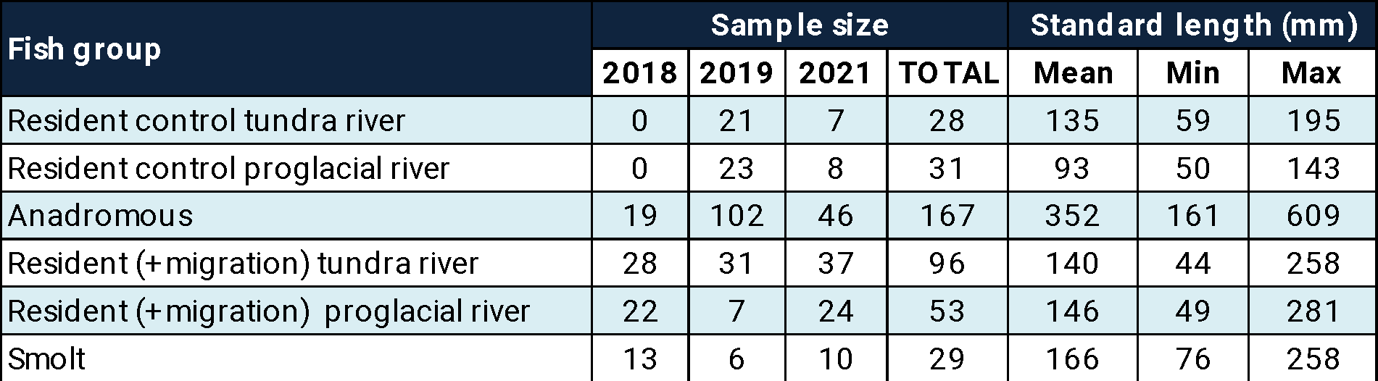

Table S1-Summary of char collection
The table reports the sample size and fish size (standard length, in mm) for the three field campaigns.
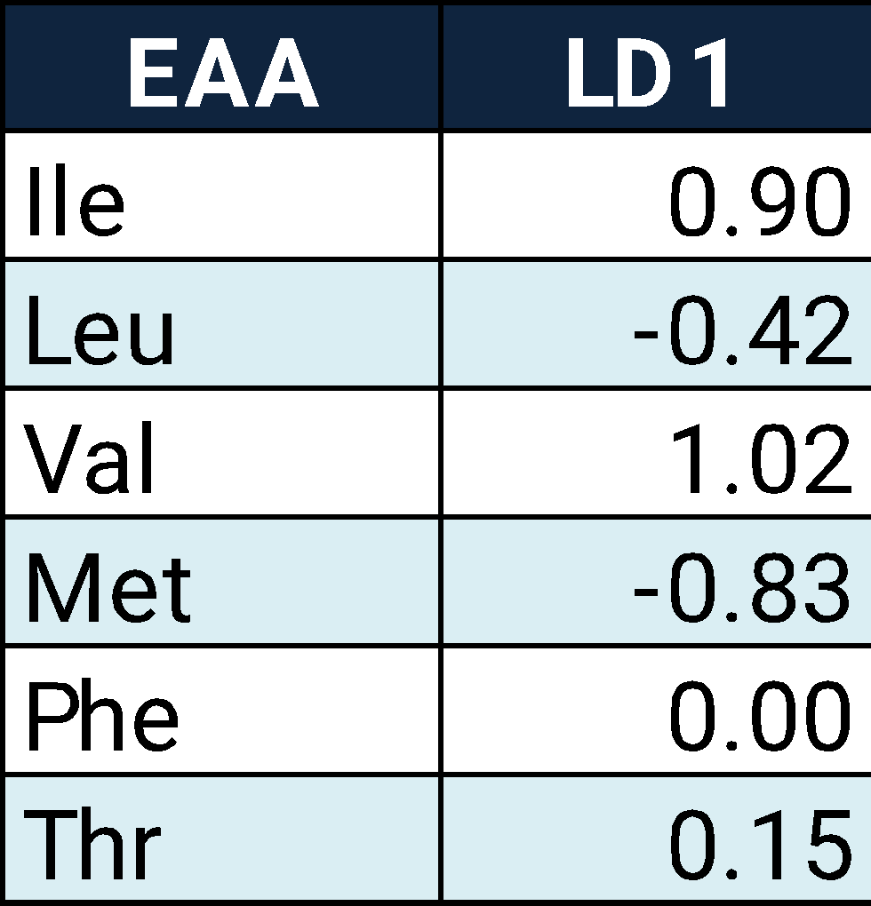
Table S2-Linear discriminant analysis loading
Loadings of the linear component analysis (LDA) based on the δ¹³C values of six essential amino acids (EAAs), which values are mean-normalized, of freshwater resident char and marine feeding char. The table reports the contribution of the six EAAs to the LD axis: Isoleucine (Ile), Leucine (Leu), Valine (Val), Phenylalanine (Phe), Threonine (Thr), and Methionine (Met).
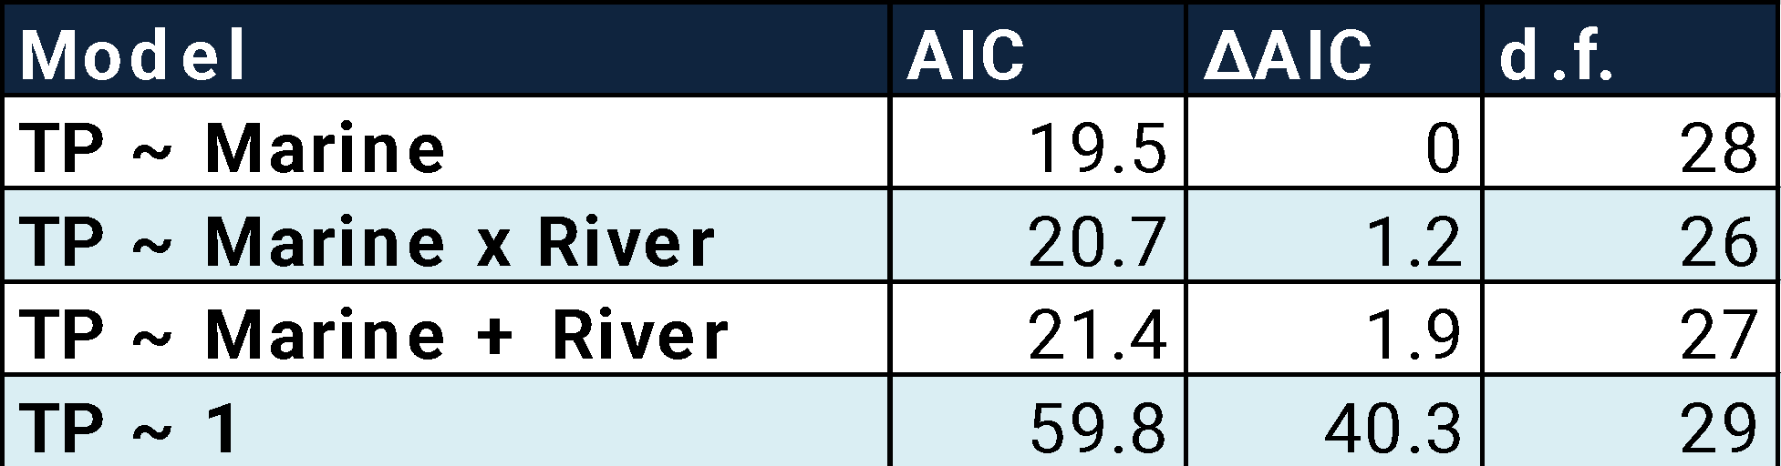

Table S3-Generalized model summary of trophic position
Glm fitting trophic position (TP) in resident char in subsidized streams. TP was inferred by the amino acid method. For each model we report the best fit (first row, lowest AIC) and other considered models. Models are described by Aikake information criteria (AIC), ΔAIC (the difference between the model and the lowest AIC), degree of freedom (d.f.). Variables include the river type (River), i.e., proglacial or tundra river, and one continuous factor, the marine resource use (Marine), as inferred by mixing model of the essential amino acid carbon fingerprinting.

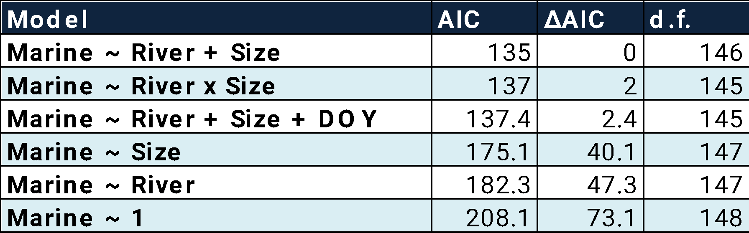

Table S4-Generalized model summary of marine subsidy use
Glm fitting marine subsidy use (Marine) in resident char in subsidized streams. Marine subsidy use was inferred using mixing models of bulk carbon isotopes. For each model we report the best fit (first row, lowest AIC) and other considered models. Models are described by Aikake information criteria (AIC), ΔAIC (the difference between the model and the lowest AIC), degree of freedom (d.f.). Variables include the river type (River), i.e., proglacial or tundra river, and two continuous factors, standard body size in mm (Size), and day of the year at capture (DOY).

Figures

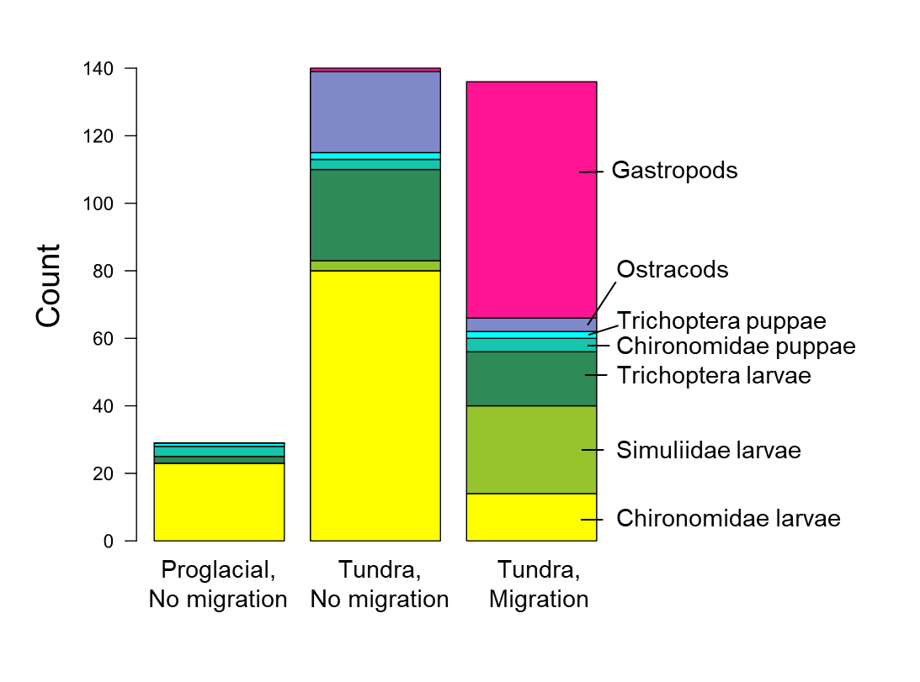

Figure S1. Counts of invertebrates of three standardized kick samples in three rivers. The bar plots show the cumulative counts of seven invertebrate categories. Proglacial river with migration was not sampled.

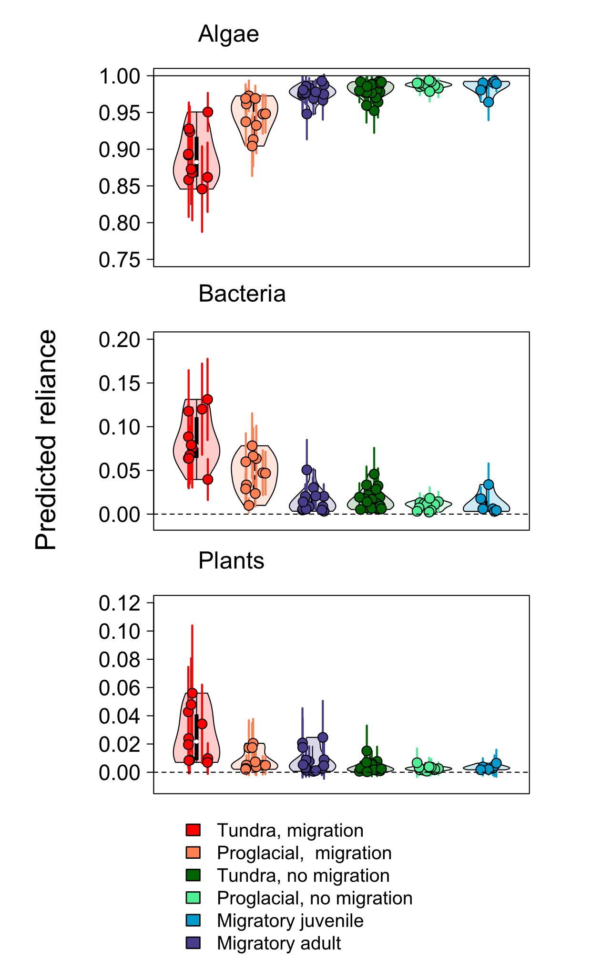

Figure S2. Predicted reliance on three clades of primary producers: algae (top), bacteria (middle), and plants (bottom). Predictions are made from bootstrapped LDA, see methods and (Saboret and others 2023). The plots show the distribution of reliance for the six different char cohorts (see legend). Dots show individual char, while segments around dots show one standard deviation of model prediction.

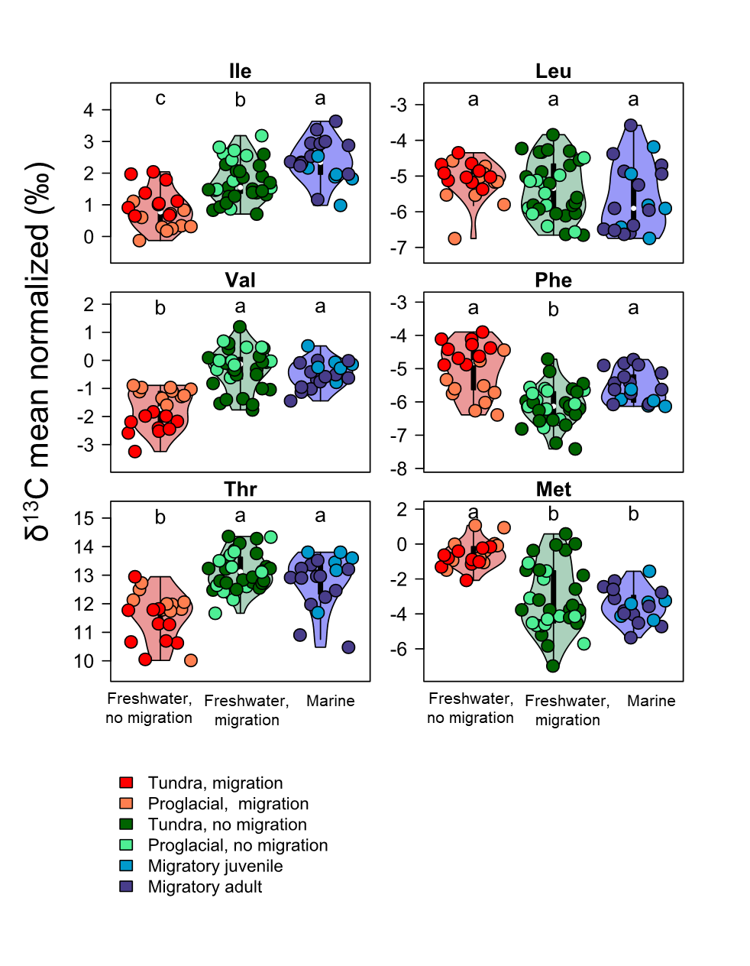
Figure S3. δ¹³C mean-centered values in six essential amino acids (from left to right and top to bottom: Isoleucine, Leucine, Valine, Phenylalaine, Threonine, and Methionine) for three groups of char. Letters show significant differences based on Kruskal-Wallis test, with post-hoc comparison using the criterion Fisher’s least significant difference.

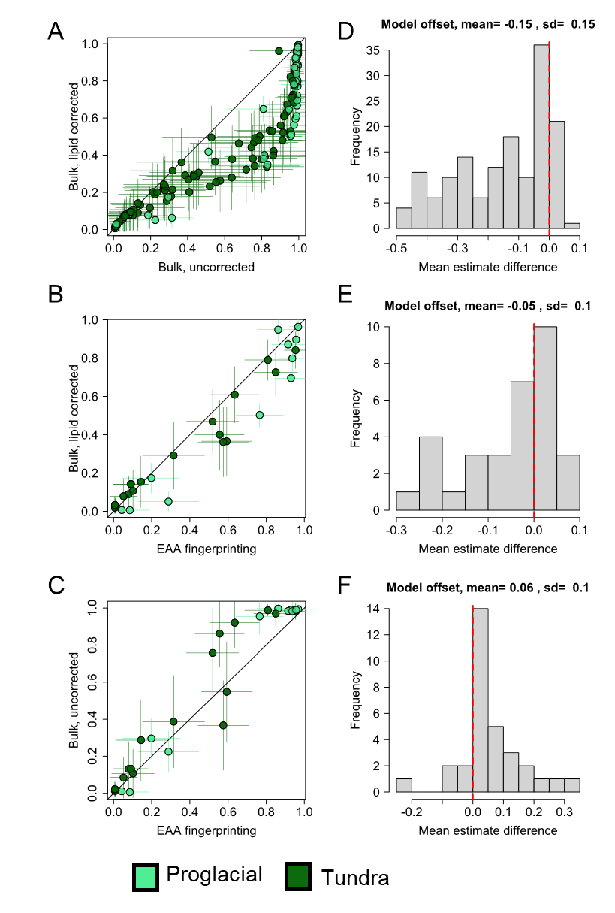
Figure S4. Comparison between marine reliance of three mixing models: bulk raw δ¹³C, bulk lipid-corrected δ¹³C, and essential amino acid (EAA) fingerprinting. Panels (A), (B), and (C) show the relationship between the pairs of model estimates. Black lines depict the one-to-one lines. Dots represent individual fish, while segments around dots show one standard deviation around mean estimates. Panels (D), (E), and (F) display the distribution of mean differences between model estimates. Red dotted lines indicate zero.

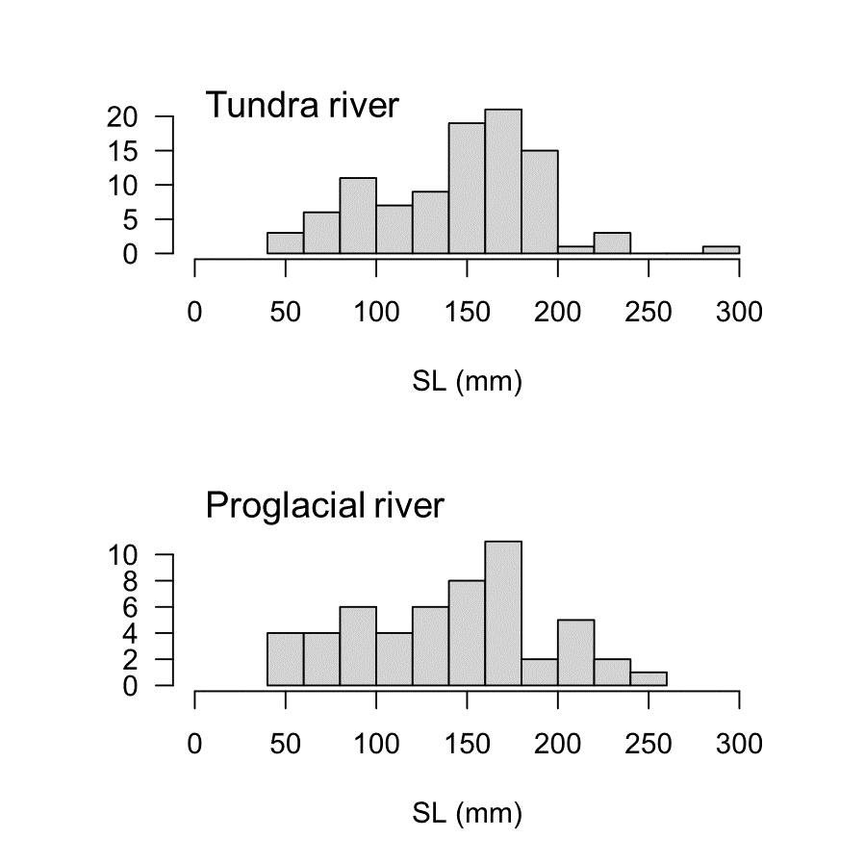
Figure S5. Char size distribution (standard length, in mm) in the two tributaries, with migration.
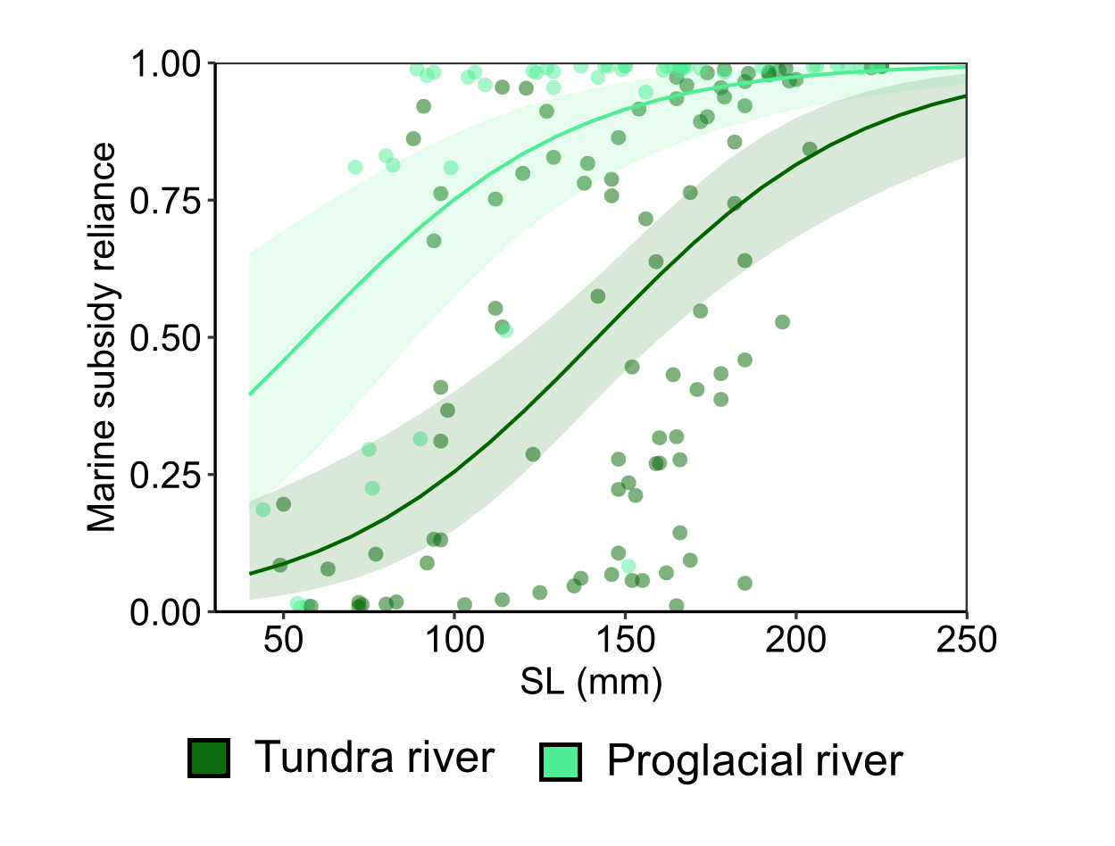
Figure S6. Relationship between marine subsidy reliance (y-axis) and char body size (x-axis), in tundra (dark green) or proglacial (light green) streams. Here, marine reliance is derived from the raw δ¹³C (i.e., no lipid correction) bulk mixing model. Dots show individual estimates from bulk mixing model. Lines with shaded area show the mean estimates and associated 95% confidence intervals from logistic regression.

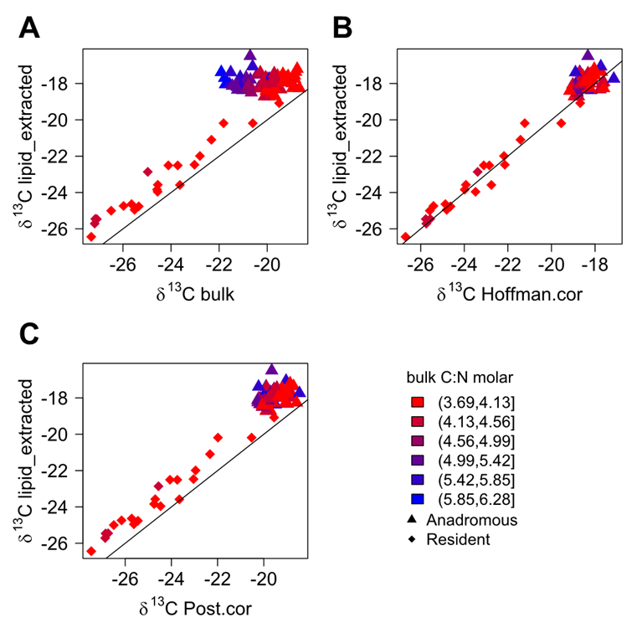
Figure S7. Comparison of δ¹³C in char muscle tissue after lipid extraction (y-axis), and values without lipid extraction (A), corrected with Hoffman mass balance approach (B), and corrected with global Post aquatic animal equation (C). Dot shapes and colors show char migratory strategy, and C:N molar ratio in muscle biopsy, before lipid extraction.

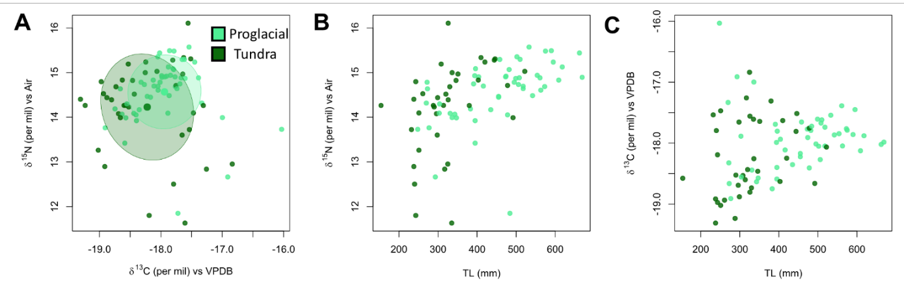

Figure S8. Comparison between isotopic ratio of carbon and nitrogen between anadromous mature char caught in proglacial (orange) or tundra (green) river. (A) Bulk stable isotope of carbon (x-axis) and nitrogen (y-axis). (B) and (C) show the relationship between char body length (x-axis) and bulk stable isotopes of nitrogen and carbon, respectively.

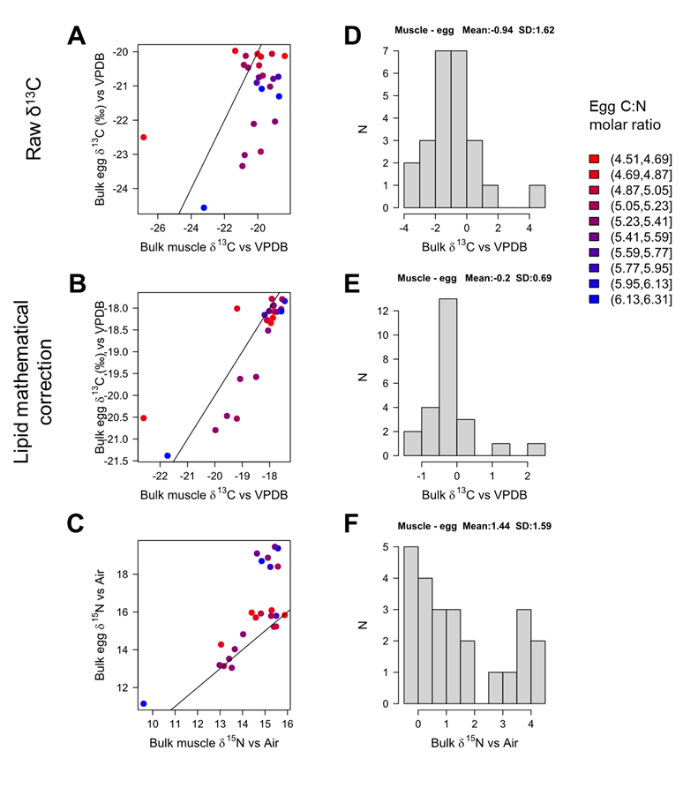

Figure S9. Comparison between maternal muscle and egg bulk isotopic composition. (A) (B), and (C) show relationship between egg (y-axis) and muscle (x-axis) isotopic ratios of carbon, carbon corrected for lipid depletion, and nitrogen, respectively. Lines show linear regressions. Dot colors show the carbon-to-nitrogen (C:N) molar ratio in eggs, see legend. (D), (E) and (F) show the distribution of the relative difference between egg and muscle isotopic ratios of carbon, carbon corrected for lipid depletion, and nitrogen, respectively.

Appendix
Appendix 1. River physical and chemical data
River temperature and conductivity were determined with a RBR Concerto CTD in 2022. Total dissolved phosphorus concentrations were determined by ICP-MS/MS (Agilent 8900) with In as an internal standard. Accuracy was confirmed with the standard reference material SRLS-6 (determined value = 172 ± 9 nmol/L, literature value = 167 ± 33 nmol/L, (Yeghicheyan and others 2019) and the detection limit, defined as three times the standard deviation of the blank, was 4 nmol/L.
Appendix 2. Bulk stable isotope analysis and lipid correction
We dried the samples at 60°C for at least two days. We homogenized the samples by grinding them using tungsten beads (3 min at 30 hertz). For bulk stable isotope analysis, we measured δ¹³C and δ¹⁵N using a Vario PYRO CUBE CN elemental analyser (Elementar, Langenselbold, Germany) connected to an isotope ratio mass spectrometer (IRMS, Elementar, Langenselbold, Germany). We weighed ~0.5 mg of the dorsal muscle. Every tenth sample we ran Urea and acetanilide standards with certified values (Schimmelmann, Indiana University). We corrected the measured stable isotope ratios for sample weight (i.e. considering peak intensity), and drift in the sequence, when we observed a significant drift (linear regression). The δ¹³C and δ¹⁵N values of all samples were normalized to the Vienna Pee Dee Belemnite (VPDB) and atmospheric air, respectively. The standard deviation of the acetanilide standard in one batch was at maximum 0.15‰ for both δ¹³C and δ¹⁵N.
Biopsies were preserved in ethanol, which is well known to affect the isotopic composition of carbon, but has little effect on nitrogen (Arrington and Winemiller 2002). However, this effect is mainly driven by ethanol-extraction of lipids (Vizza and others 2013; Durante and others 2020); which we corrected for.
We corrected fish δ¹³C for lipid depletion in ¹³C (Δδ¹³C_{lipid}), using a mass balance approach (Hoffman and others 2015):
δ¹³C_{lipid free} = δ¹³C_{bulk} – f_{lipid} . Δδ¹³C_{lipid}, with f_{lipid} the fraction of lipids, given by:
f_{lipid} = 1 - C:N_{lipid free}/C:N_{bulk ,} with C:N the molar C:N ratio.
We used Δδ¹³C_{lipid} = 7 ‰, which is a common value reported on fish and salmonid (Post and others 2007; Hoffman and others 2015; Mumby and others 2018). We measured C:N_{lipid free} using anadromous and resident char of another study in a similar system in Southern Greenland. For this study, we had frozen-preserved muscle samples and we run elemental and bulk stable isotope analysis with and without lipid extraction by three extraction Methanol:Dichloromethane 1:1 (unpublished data). We found C:N_{lipid free}= 3.4, which was also the value that maximized the fit between lipid extracted and normalized δ¹³C.
We compared this approach to the commonly used approach following (Post and others 2007), based on the global formula for aquatic animals:
δ¹³C_{lipid free} = δ¹³C_{bulk} –3.32 + 0.99 * C:N_{bulk}
In this equation, C:N_{bulk} is the mass ratio (instead of molar ratio, which we converted for this calculation).
We observed a global increase in δ¹³C following lipid extraction (Fig. S7A, min: 0.1, max: 4.5, mean: 1.9), aligning with the removal of δ¹³C-depleted lipids. The mathematical mass balance approach yielded close estimates between mathematically corrected δ¹³C lipid-free values and actual δ¹³C lipid-free values (Fig. S7B, min: -0.8, max: 1.8, mean: 0.4). Additionally, correction using the global Post equation resulted in a closer fit compared to uncorrected δ¹³C values, albeit much less adequately than the former approach (Fig. S7C, min: 0.1, max: 3.2, mean: 1.5). Thus, we were confident that the mass balance approach was adequate to mathematically correct for lipid δ¹³C depletion.
Appendix 3. Mixing models of marine reliance
We used Bayesian mixing models in MixSIAR (Stock and others 2018) to estimate marine reliance, one based on the EAA δ¹³C fingerprinting, and two based on bulk δ¹³C, raw and lipid-normalized, to extrapolate the results to more fish.
Source end-members
Setting baselines for mixing models is often a challenge; and primary consumers are often used instead (Post 2002). Here, we used as end-members the resident control for freshwater production (proglacial and tundra rivers), and the anadromous for marine production. This choice was driven by preliminary stomach content analysis that showed high diversity and seasonality in freshwater preys, making the freshwater baseline difficult to estimate. Likewise, the marine baseline was best described by anadromous char as we hypothesized that residents would feed on their eggs.
To address if anadromous char returning to proglacial or tundra rivers differ in diet (and so in isotopic baselines that could affect the models), we compared bulk isotopes of mature individuals caught in the two streams (Fig. S8). We found that they did not differ in bulk δ¹⁵N (t.test, P=0.11), but differed in bulk δ¹³C (t.test, P=0.03, mean difference 0.21 ‰). However, this difference was driven by the interactive effect of body size on bulk δ¹³C in the proglacial stream (P=0.03), which alleviated the effect of tributary origin (P=0.11, generalized linear model, see Fig. S4B for illustration). Therefore, we considered that anadromous char returning to the two different type of rivers had similar isotopic ratios because the difference was small, and driven by small individuals in the tundra river that anyways produce much fewer eggs.
Fingerprinting model
The model based on the EAA δ¹³C fingerprinting offered the advantage to directly estimate the contribution of proteins from primary producers, independent of δ¹³C baseline variation and trophic transfer uncertainty. The fingerprinting relies on the premise that different phyla of primary producers leave distinct δ¹³C offsets between EAA (Larsen and others 2009, 2013), which fingerprinting is transferred up the food chains through consumers (Manlick and Newsome 2022). The fingerprinting has proven as a powerful tool to estimate the relative reliance on primary production, disentangling green and brown food webs (Pollierer and others 2019; Manlick and others 2023), or allochthonous and autochthonous organic matter in freshwater food webs (Liew and others 2019; Besser and others 2022), or even different phyla of algae (Larsen and others 2013; Elliott Smith and Fox 2021; Stahl and others 2023).
To distinguish marine and freshwater production, we used 6 EAA: Ile, Leu, Thr, Val, Phe and Met (Whiteman and others 2019). First, we maximized the fingerprinting difference between freshwater and marine end-members using a linear discriminant analysis (LDA). They showed a significantly different LD score (LD₁), (Fig. 3B-C). The fact that resident fish had overlapping fingerprinting supported the assumption that they had a mixed reliance on the two productions. On the other hand, all freshwater control chars clustered together, supporting a similar freshwater fingerprinting in stream production.
However, going from fingerprinting measurements to mixing model estimates remains challenging. Here, we used a combination of Bayesian mixing model and linear discriminant analysis (LDA). In a two-dimension model, LD₁ is a good proxy for source reliance (Fox and others 2019; Elliott Smith and Fox 2021), given that LD₁ is a linear combination of the EAA normalized δ¹³C, which also scale linearly between the two end-members values. It is unclear how error measurement and small fractionation of EAA δ¹³C (Manlick and others 2023; Robinson and others 2023) could affect the model prediction. To address this question, we used the LD₁ in a Bayesian mixing model, as recommended in (Manlick and Newsome 2022), in which we could account for measure uncertainty (set discrimination factor as mean=0; sd=0.5) and model the distribution of end-members setting process error in MixSIAR (Stock et al. 2018).
Bulk isotope models
For bulk stable isotope mixing model, we considered δ¹³C as a marker of marine reliance, given the clear separation between the two end-members (Fig. 2B). However, there is debate about whether or not to correct δ¹³C for lipid depletion in mixing model. This is especially relevant as eggs are rich in fat, and some fats can be routed to synthesis of non-essential amino acids (Newsome and others 2014), therefore contributing to the “lipid-corrected” pool (Arostegui and others 2019).
We were mainly interested in modelling the transfer and assimilation of proteins, as they are the most abundant macromolecules and we wanted to address the transfer of carbon flows between ecosystems. Thus, we implemented one model based on the lipid-corrected values. To ensure our findings were not biased due to routing of marine lipids in amino acid synthesis, we also implemented one bulk model based on the δ¹³C raw values.
To address the maternal isotopic fractionation in eggs that we used as end-members, we analyzed bulk stable isotopes of 5-to-10 pooled eggs for 24 ripe anadromous individuals, collected in different streams of the area (see (Takatsu and others 2022) for data collection). We found no significant discrimination in δ¹³C (t.test, P>0.1) and high variability in δ¹⁵N (Fig. S9). For the raw δ¹³C model, we found a significant offset of 0.94‰ (t.test, P<0.02, Fig. S9), which we accounted for in the model.
We did not consider δ¹⁵N in the bulk model because of high propagated uncertainty considering freshwater baseline, maternal egg δ¹⁵N discrimination and fish TP in freshwater.
We considered small trophic fractionation of ¹³C between fish and their prey of 0.50 ± 0.13‰ (mean ± SD) (McCutchan and others 2003), and corrected the freshwater endmember by correcting by one trophic level discrimination (-0.5 ‰). We run two different models for tundra and proglacial tributaries, using resident controls of both tributaries as baselines.
MixSIAR
For the three mixing models, we did not consider continuous or fixed effects because we suspected that char show high individual variability in their feeding behavior. Rather, we considered individuals as “random” factors because we hypothesized that individuals randomly deviate from mean (Semmens and others 2009).
We input sources as means and standard deviations. We set the models using “long” run, meaning 300 000 iterations (burn-in = 200 000) on three parallel Monte Carlo Markov chains with a thinning interval of 300 using non-informative priors. We used “uninformative” priors (α=1). We reported for mixing models the mean, standard deviation and 95% confidence interval. We assessed model convergence using Gelman–Rubin (Gelman and others 2014) and Geweke diagnostics (Geweke 1991).

References
Arostegui MC, Schindler DE, Holtgrieve GW. 2019. Does lipid-correction introduce biases into isotopic mixing models? Implications for diet reconstruction studies. Oecologia 191:745–55.
Arrington DA, Winemiller KO. 2002. Preservation Effects on Stable Isotope Analysis of Fish Muscle. :6.
Besser AC, Elliott Smith EA, Newsome SD. 2022. Assessing the Potential of Amino Acid δ ¹³ C and δ ¹⁵ N Analysis in Terrestrial and Freshwater Ecosystems. J Ecol:1365-2745.13853.
Durante LM, Sabadel AJM, Frew RD, Ingram T, Wing SR. 2020. Effects of fixatives on stable isotopes of fish muscle tissue: implications for trophic studies on preserved specimens. Ecol Appl 30. https://onlinelibrary.wiley.com/doi/abs/10.1002/eap.2080. Last accessed 08/07/2020
Elliott Smith EA, Fox MD. 2021. Characterizing energy flow in kelp forest food webs: a geochemical review and call for additional research. Ecography:ecog.05566.
Fox MD, Elliott Smith EA, Smith JE, Newsome SD. 2019. Trophic plasticity in a common reef‐building coral: Insights from δ ¹³ C analysis of essential amino acids. Briones M, editor. Funct Ecol 33:2203–14.
Gelman A, Carlin JB, Stern HS, Rubin DB. 2014. Bayesian data analysis taylor & francis. Boca Raton FL USAGoogle Sch.
Geweke J. 1991. Evaluating the accuracy of sampling-based approaches to the calculation of posterior moments. Federal Reserve Bank of Minneapolis
Hoffman JC, Sierszen ME, Cotter AM. 2015. Fish tissue lipid-C:N relationships for correcting δ ¹³ C values and estimating lipid content in aquatic food-web studies: Fish tissue lipid-C:N relationships. Rapid Commun Mass Spectrom 29:2069–77.
Larsen T, Taylor DL, Leigh MB, O’Brien DM. 2009. Stable isotope fingerprinting: a novel method for identifying plant, fungal, or bacterial origins of amino acids. Ecology 90:3526–35.
Larsen T, Ventura M, Andersen N, O’Brien DM, Piatkowski U, McCarthy MD. 2013. Tracing Carbon Sources through Aquatic and Terrestrial Food Webs Using Amino Acid Stable Isotope Fingerprinting. Savage C, editor. PLoS ONE 8:e73441.
Liew JH, Chua KWJ, Arsenault ER, Thorp JH, Suvarnaraksha A, Amirrudin A, Yeo DCJ. 2019. Quantifying terrestrial carbon in freshwater food webs using amino acid isotope analysis: Case study with an endemic cavefish. Soto D, editor. Methods Ecol Evol 10:1594–605.
Manlick PJ, Cook JA, Newsome SD. 2023. The coupling of green and brown food webs regulates trophic position in a montane mammal guild. Ecology 104. https://onlinelibrary.wiley.com/doi/10.1002/ecy.3949. Last accessed 17/04/2023
Manlick PJ, Newsome SD. 2022. Stable isotope fingerprinting traces essential amino acid assimilation and multichannel feeding in a vertebrate consumer. Methods Ecol Evol:2041-210X.13903.
McCutchan JH, Lewis WM, Kendall C, McGrath CC. 2003. Variation in trophic shift for stable isotope ratios of carbon, nitrogen, and sulfur. Oikos 102:378–90.
Mumby JA, Larocque SM, Johnson TB, Stewart TJ, Fitzsimons JD, Weidel BC, Walsh MG, Lantry JR, Yuille MJ, Fisk AT. 2018. Diet and trophic niche space and overlap of Lake Ontario salmonid species using stable isotopes and stomach contents. J Gt Lakes Res 44:1383–92.
Newsome SD, Wolf N, Peters J, Fogel ML. 2014. Amino Acid 13C Analysis Shows Flexibility in the Routing of Dietary Protein and Lipids to the Tissue of an Omnivore. Integr Comp Biol 54:890–902.
Pollierer MM, Larsen T, Potapov A, Brückner A, Heethoff M, Dyckmans J, Scheu S. 2019. Compound‐specific isotope analysis of amino acids as a new tool to uncover trophic chains in soil food webs. Ecol Monogr 89. https://onlinelibrary.wiley.com/doi/abs/10.1002/ecm.1384. Last accessed 28/02/2020
Post DM. 2002. USING STABLE ISOTOPES TO ESTIMATE TROPHIC POSITION: MODELS, METHODS, AND ASSUMPTIONS. Ecology 83:703–18.
Post DM, Layman CA, Arrington DA, Takimoto G, Quattrochi J, Montaña CG. 2007. Getting to the fat of the matter: models, methods and assumptions for dealing with lipids in stable isotope analyses. Oecologia 152:179–89.
Robinson AL, Smith EAE, Besser AC, Newsome SD. 2023. Tissue-Specific Carbon Isotope Patterns of Amino Acids in Southern Sea Otters. In Review https://www.researchsquare.com/article/rs-2648511/v1. Last accessed 13/04/2023
Saboret G, Stalder D, Matthews B, Brodersen J, Schubert CJ. 2023. Autochthonous production sustains food webs in large perialpine lakes, independent of trophic status: Evidence from amino acid stable isotopes. Freshw Biol 68:870–87.
Semmens BX, Ward EJ, Moore JW, Darimont CT. 2009. Quantifying Inter- and Intra-Population Niche Variability Using Hierarchical Bayesian Stable Isotope Mixing Models. Getz WM, editor. PLoS ONE 4:e6187.
Stahl AR, Rynearson TA, McMahon KW. 2023. Amino acid carbon isotope fingerprints are unique among eukaryotic microalgal taxonomic groups. Limnol Oceanogr:lno.12350.
Stock B, Semmens B, Ward E, Parnell A, Jackson A, Phillips D. 2018. Package ‘MixSIAR’. Bayesian Mix Model R Version 3.
Takatsu K, Delarue C, Heller N, Saboret G, Brodersen J. 2022. Relationships between egg size and maternal size, life history forms, and habitats of Greenlandic Arctic charr (Salvelinus alpinus). Environ Biol Fishes. https://link.springer.com/10.1007/s10641-022-01374-x. Last accessed 09/01/2023
Vizza C, Sanderson BL, Burrows DG, Coe HJ. 2013. The Effects of Ethanol Preservation on Fish Fin Stable Isotopes: Does Variation in C:N Ratio and Body Size Matter? Trans Am Fish Soc 142:1469–76.
Whiteman J, Elliott Smith E, Besser A, Newsome S. 2019. A Guide to Using Compound-Specific Stable Isotope Analysis to Study the Fates of Molecules in Organisms and Ecosystems. Diversity 11:8.
Yeghicheyan D, Aubert D, Bouhnik‐le Coz M, Chmeleff J, Delpoux S, Djouraev I, Granier G, Lacan F, Piro J-L, Rousseau T. 2019. A new interlaboratory characterisation of silicon, rare earth elements and twenty‐two other trace element concentrations in the natural river water certified reference material SLRS‐6 (NRC‐CNRC). Geostand Geoanalytical Res 43:475–96.

