Supplementary Materials

Ecosystem change caused by hydrological change is associated with population decline in a formerly-common grazing herbivore
Blaser-Hart, W.J., G.K. Shanungu, P.J. Edwards, J. Harms, S.P.H Hart, G.A. Ellenbroek, H. A. M. J. van Gils, C. Simukonda, and H. Olde Venterink

Supplementary methods
A description of the main habitat types in the Kafue Flats
The vegetation of the Kafue Flats is closely adjusted to the seasonal pattern of flooding and shows a clear zonation (Douthwaite and van Lavieren, 1977; Rees, 1978b; Ellenbroek, 1987). For our study, we recognised six main vegetation types:

- Permanent open water.
- Deep-flooded grassland occurs where the maximum depth of seasonal flooding exceeds 70 cm, but flooding is not permanent. This habitat is dominated by tall floating grasses, including Vossia cuspidata, Oryza longistaminata, Echinochloa scabra and Brachiaria rugulosa.
- Shallow-flooded grassland (also referred to as water-meadow) covers extensive areas that are seasonally flooded up to a depth of 70 cm. This habitat is dominated by short grasses including Panicum repens, Leersia denudata and Acroceras macrum.
- Open termitaria grassland occur in the seasonally waterlogged zone above the high flood line marked by the abundance of termite mounds (Cubitermes spp., Odontotermes spp.). The termitaria zone is mainly open grassland dominated by Digitaria milanjiana, Setaria sphacelata, Brachiaria regulosa, Panicum maximum, Sporobolus sp. and Eulalia geniculata. Several woody species occur at low abundance in this zone (Piliostigma thonningii, Lonchocarpus capassa, Combretum ghasalense, Albizzia anthelmintica, Dichrostachys cinerea, Vachellia seyal, V. sieberana and V. gerardii), though historically woody cover is mainly low.
- Shrub-encroached termitaria grassland. This is the same type of grassland as type 4, except that it has been encroached in recent decades by woody species, particularly Dichrostachys cinerea and Vachellia species. The woody species had a minimal cover of 30% to separate this vegetation type from type 4.
- Munga woodland is an open, thorny savanna woodland occurring at poorly drained soils on the Kafue Flats and elsewhere in Zambia e.g. along the Zambesi. The woody cover is dominated by the tree species in the genera Vachellia, Combretum and Terminalia - and thickets of shrubby species such as Markhamia obtusifolia, Combretum fragrans, Dichrostachys cinerea and Vachellia nilotica are frequent. The understorey is composed mainly of tall savanna grasses, including species of Hyparrhenia, Setaria, Brachiaria, Echinochloa and Panicum. Termite mounds are quite common, but less abundant than in the termitaria zone (Fig. 2b, Sheppe and Osborne, 1971; Rees, 1978a; Ellenbroek, 1987).
Supplementary Tables
Table S1. Accuracy assessment for the 2013 map. The table incudes confusion matrix for different land cover classes (DFG= Deep-flooded grassland, MI=Mimosa pigra, SFG= Shallow-flooded grassland, WO=Woodland, OT= Open termitaria grassland, WA=Water, ST= Shrub-encroached termitaria grassland). Values represent the number of ground truth points in each class (horizontally) and the corresponding map class (vertically). From these, overall user’s (U_Accuracy) and producers’ accuracy (P_Accuracy) are calculated per class. The overall map accuracy 0.82 is the average of users’ and producers’ accuracy. The Kappa statistic (κ) 0.78 measures classification performance; 1 indicates perfect agreement with ground truth, 0 indicates agreement as expected per random chance.
ClassValue | DFG | MI | SFG | WO | OT | WA | ST | Total | U_Accuracy | Kappa
DFG | 117 | 24 | 1 | 0 | 1 | 0 | 6 | 149 | 0.79
MI | 8 | 43 | 0 | 0 | 0 | 2 | 2 | 55 | 0.78
SFG | 0 | 0 | 36 | 0 | 3 | 0 | 1 | 40 | 0.90
WO | 0 | 0 | 0 | 42 | 5 | 0 | 12 | 59 | 0.71
OT | 0 | 0 | 1 | 5 | 124 | 0 | 32 | 162 | 0.77
WA | 4 | 4 | 1 | 0 | 0 | 138 | 0 | 147 | 0.94
ST | 1 | 4 | 0 | 6 | 13 | 0 | 123 | 147 | 0.84
Total | 130 | 75 | 39 | 53 | 146 | 140 | 176 | 759 | 0.00
P_Accuracy | 0.90 | 0.57 | 0.92 | 0.79 | 0.85 | 0.99 | 0.70 | 0.00 | 0.82
Kappa |  |  |  |  |  |  |  |  |  | 0.78

Table S2 First day after the flooding period that the floodplain grassland could be accessed by Kafue lechwe under the assumption that lechwe can access key floodplain areas when the water levels at Nyimba hydrological gauging station are below 980.6 m asl. This value is based on observations of the of the first lechwe movement into the floodplain grassland in 2010 and the water levels at Nyimba observed on the same dates. 2010 (shaded in green) was used as a reference year because we only observed very few deaths in lechwe during out study period. Shaded grey years mark years in which the accessibility to the floodplain was delayed by 1-2 months. We lack complete hydrological data for the years between 1986 and 1995.

Period | Year | accessibility at 980.7 m | accessibility at 980.6 m | accessibility at 980.5 m
Before both dams | 1963 | 15. Sep | 21. Sep | 25. Sep
 | 1964 | 10. Jul | 15. Jul | 18. Jul
 | 1965 | 16. Jun | 20. Jun | 23. Jun
 | 1966 | all year | all year | 13. May
 | 1967 | all year | all year | all year
 | 1968 | all year | all year | all year
 | 1969 | 1. Aug | 7. Aug | 14. Aug
 | 1970 | 19. May | 6. Jun | 9. Jul
After first dam | 1971 | 25. Jun | 4. Jul | 8. Jul
 | 1972 | all year | all year | 23. May
 | 1973 | all year | all year | all year
 | 1974 | before 13. Jun | before 13. Jun | 13. Jun
 | 1975 | 27. Jun | 2. Jul | 7. Jul
 | 1976 | 30. Jul | 3. Aug | 8. Aug
After second dam | 1977 | 17. May | 23. May | 1. Jun
 | 1978 | 31. Aug | 6. Sep | 10. Sep
 | 1979 | 2. Aug | 9. Aug | 13. Aug
 | 1980 | 19. Jun | 26. Jun | 2. Jul
 | 1981 | 8. Jul | 13. Jul | 18. Jul
 | 1982 | all year | all year | all year
 | 1983 | all year | all year | all year
 | 1984 | all year | all year | all year
 | 1985 | before 14. Jul | before 14. Jul | 14. Jul
 | 1996 | all year | all year | all year
 | 1997 | all year | all year | all year
 | 1998 | all year | all year | all year
 | 1999 | all year | all year | 9. Jun
 | 2000 | all year | all year | all year
 | 2001 | 18. Jun | 25. Jun | 2. Jul
 | 2002 | all year | all year | all year
 | 2003 | all year | all year | all year
 | 2004 | all year | all year | all year
 | 2005 | all year | all year | all year
 | 2006 | all year | all year | 25. May
 | 2007 | 24. Apr | 23. May | 31. May
 | 2008 | 11. May | 16. May | 22. May
 | 2009 | 22. Jun | 1. Jul | 5. Jul
Reference year | 2010 | 6. Jul | 11. Jul | 12 .Jul

Supplementary Figures

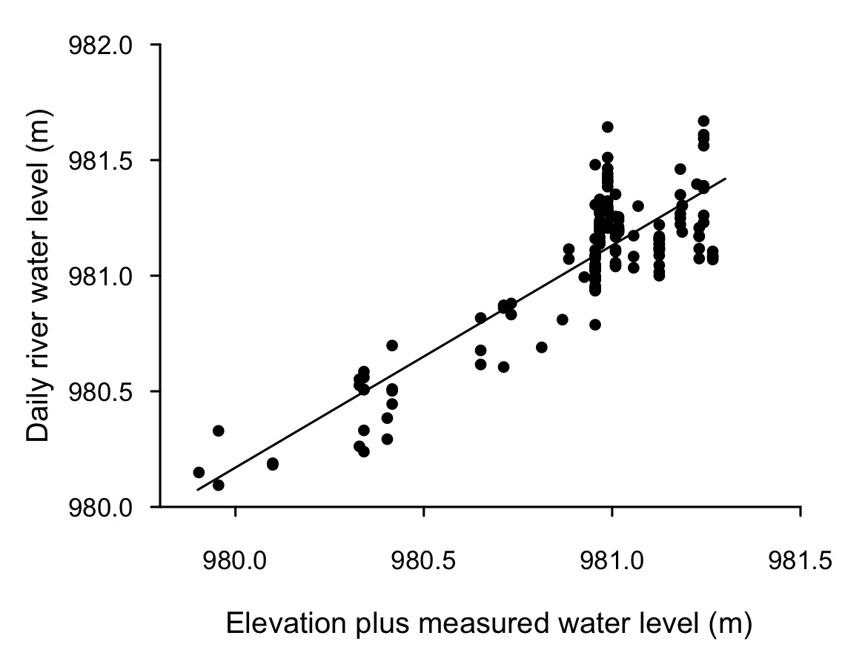
Figure S1 Water level measurements at sites of known elevation revealed that the flood levels in the seasonally-flooded grasslands are highly correlated to the river water levels at Nyimba (Pearson correlation coefficient = 0.86, N= 162, period: 31.12.2009-12.03.2011). Elevation can hence be a good proxy for the expected flooding in a given site in the Kafue Flats. Elevation of selected sites that we re-visited throughout the study was determined by means of land surveying with a level instrument (differential levelling) in October 2010.
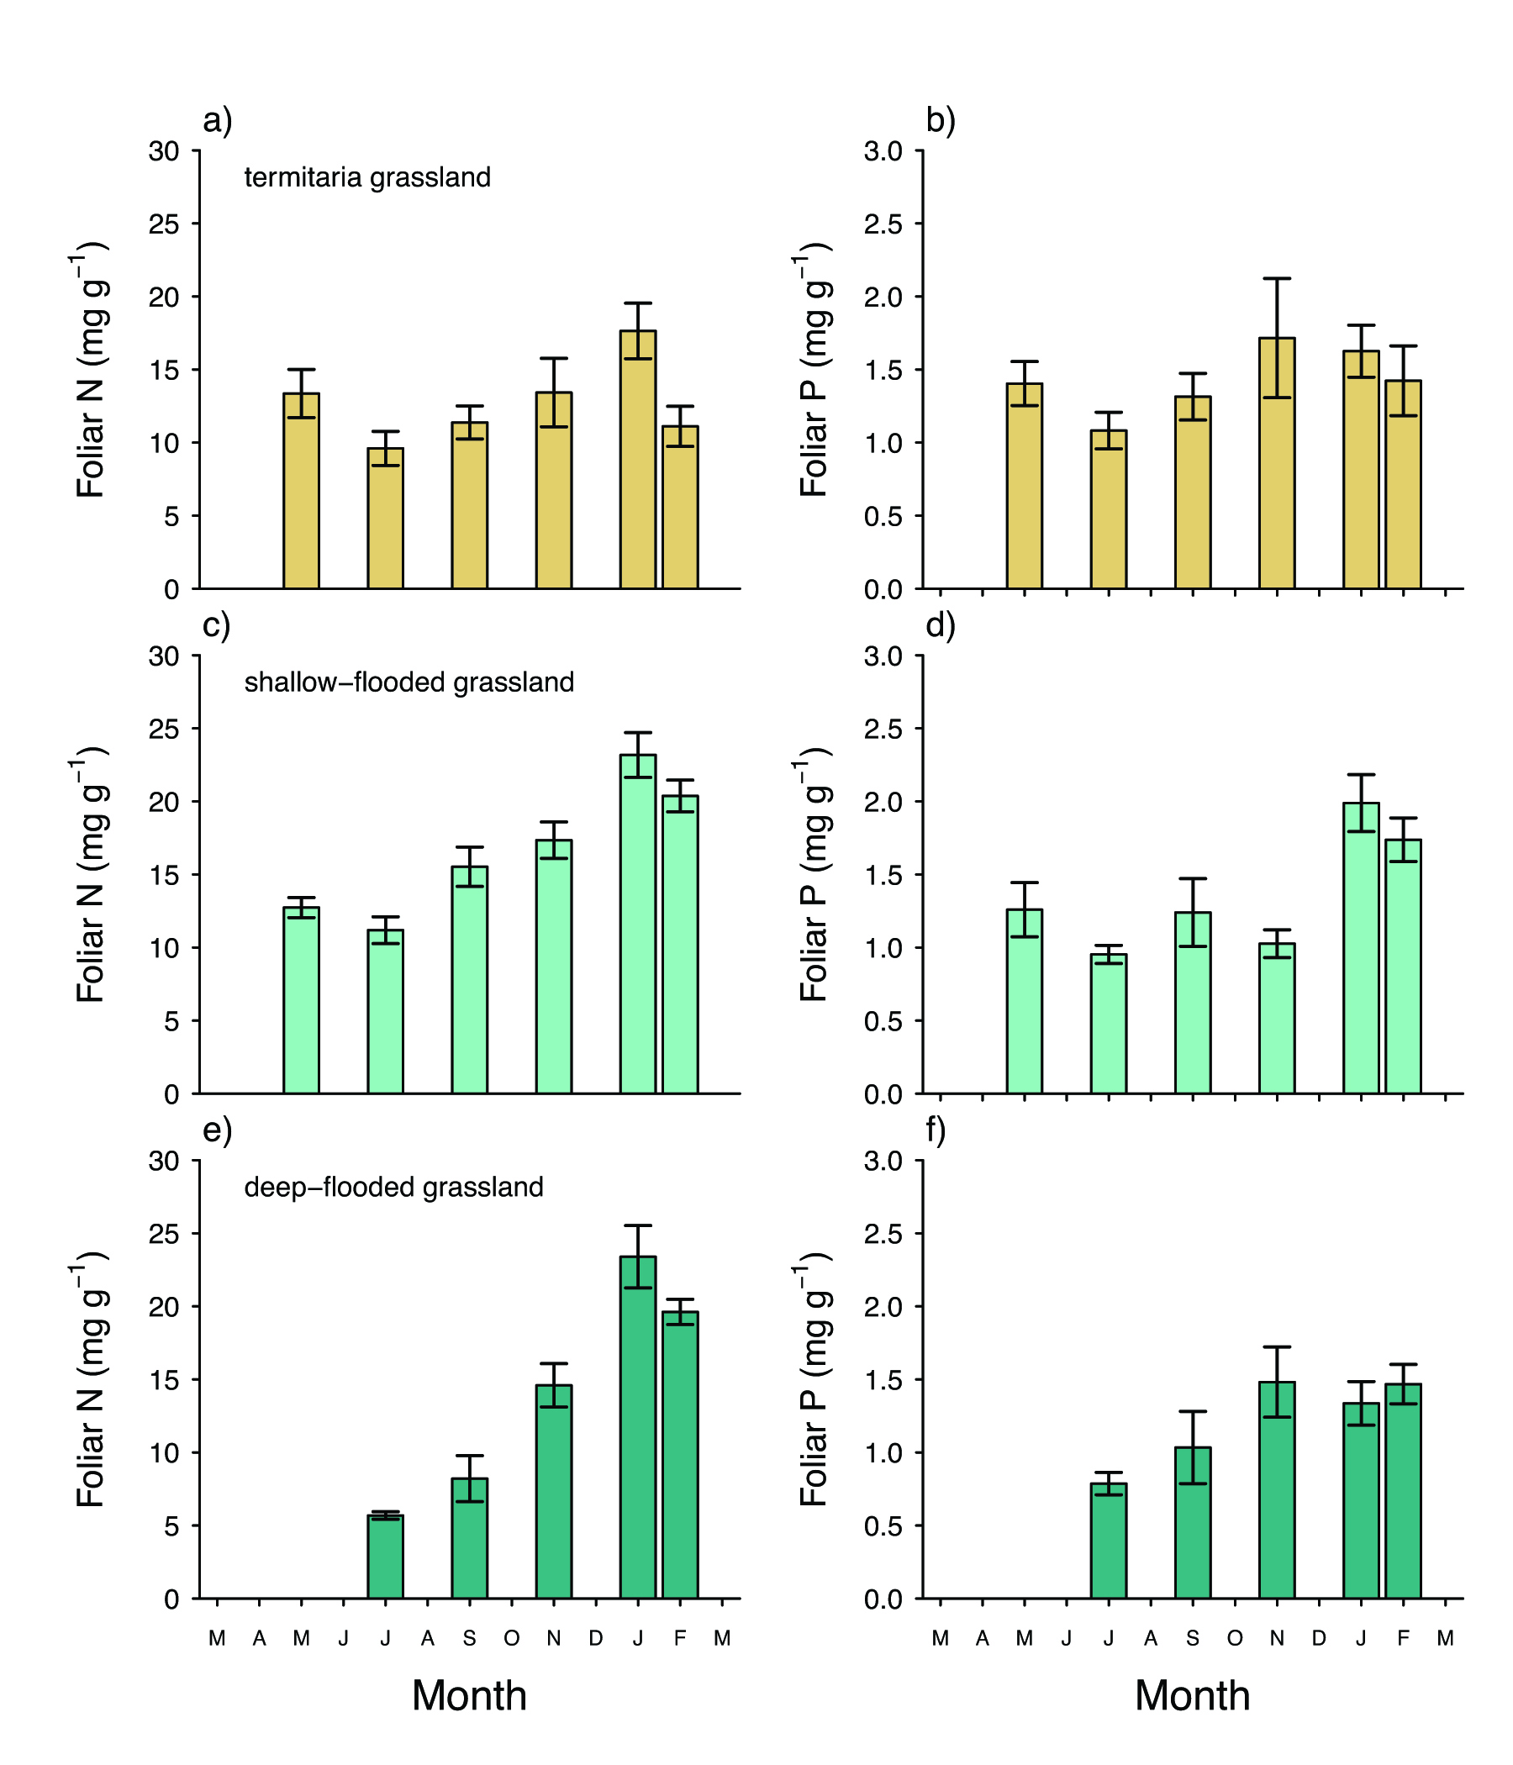
Figure S2: Foliar nitrogen (N) and phosphorus (P) concentrations in living grass biomass across three main lechwe habitat types: a,b) termitaria grassland, c,d) shallow-flooded grassland, and e,f) deep-flooded grassland from May 2010 to February 2011. Bars represent means ± standard errors.
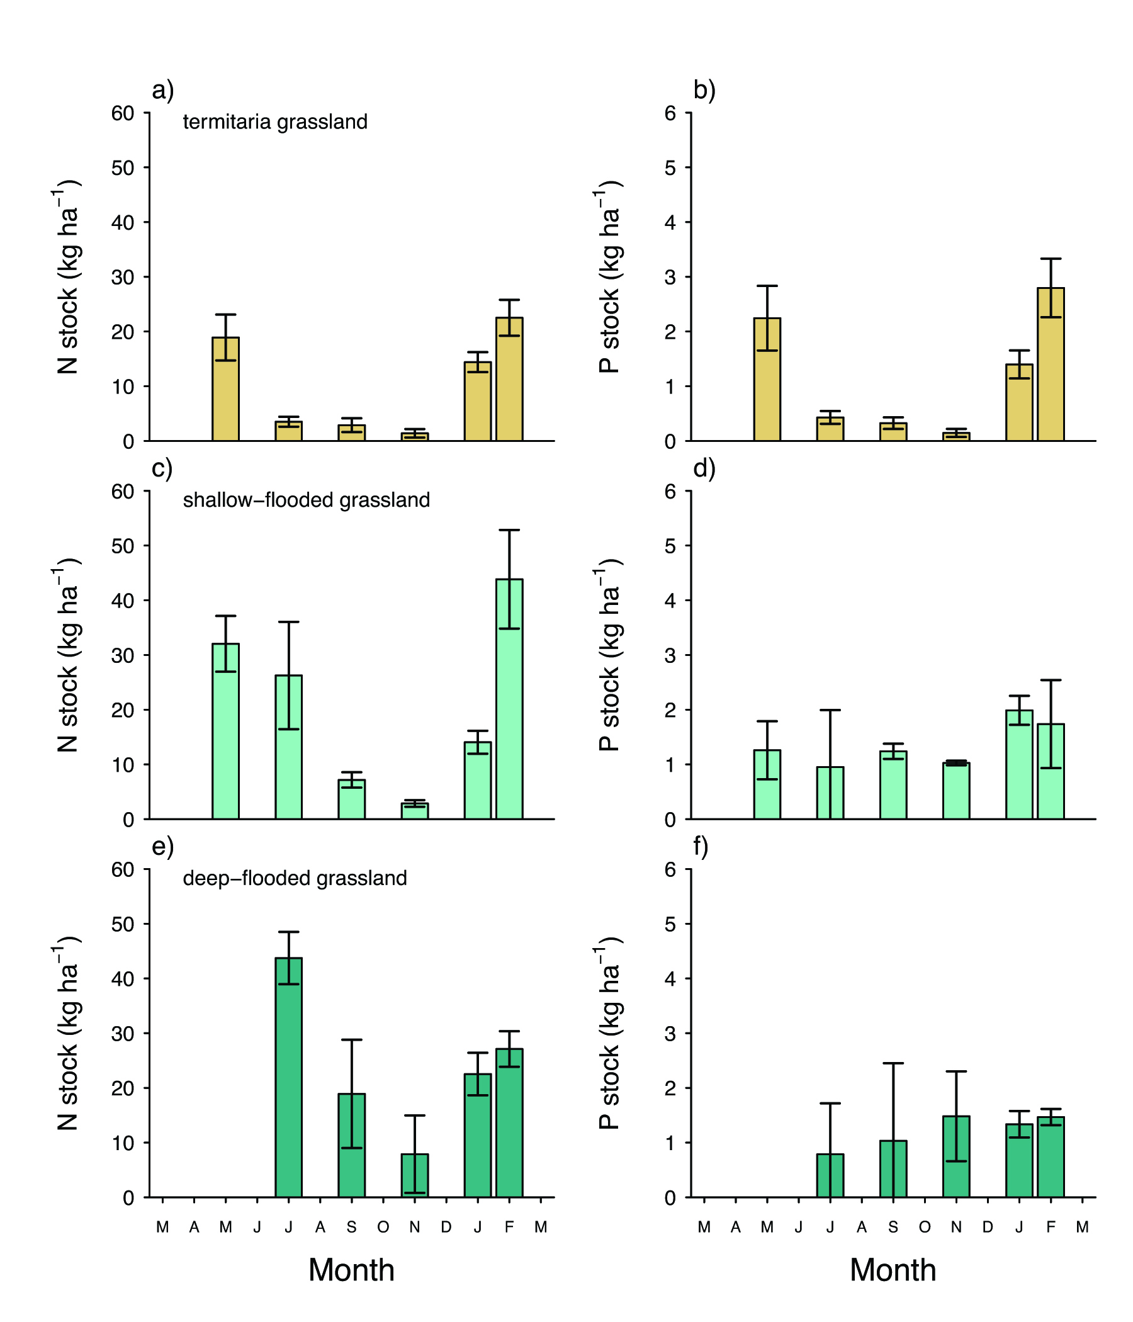
Figure S3: Nitrogen (N) and phosphorus (P) stocks in living grass biomass across three main lechwe habitat types: a,b) termitaria grassland, c,d) shallow-flooded grassland, and e,f) deep-flooded grassland from May 2010 to February 2011. Bars represent means ± standard errors.

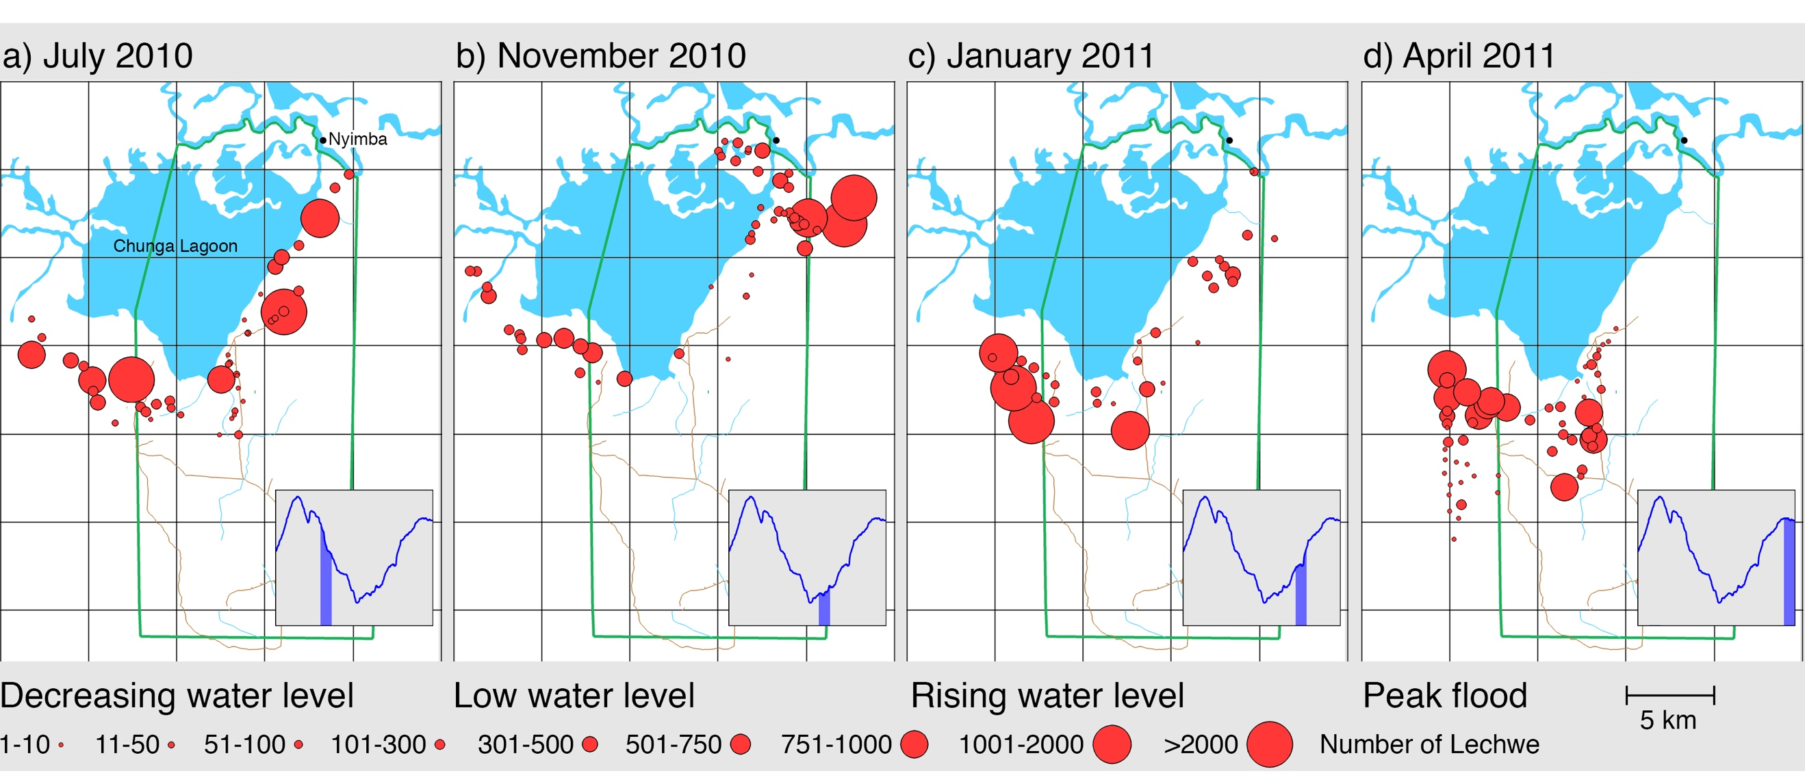
Figure S4 Number of Kafue lechwe on the South Bank of the Kafue River and Lochinvar National Park (green line) in a) July 2010, b) November 2010, c) January 2011 and d) April 2011. The lechwe population was monitored by ground (in a-c) and aerial surveys (in d). The grey insets show the prevailing water levels of the Kafue River at the time of the survey.
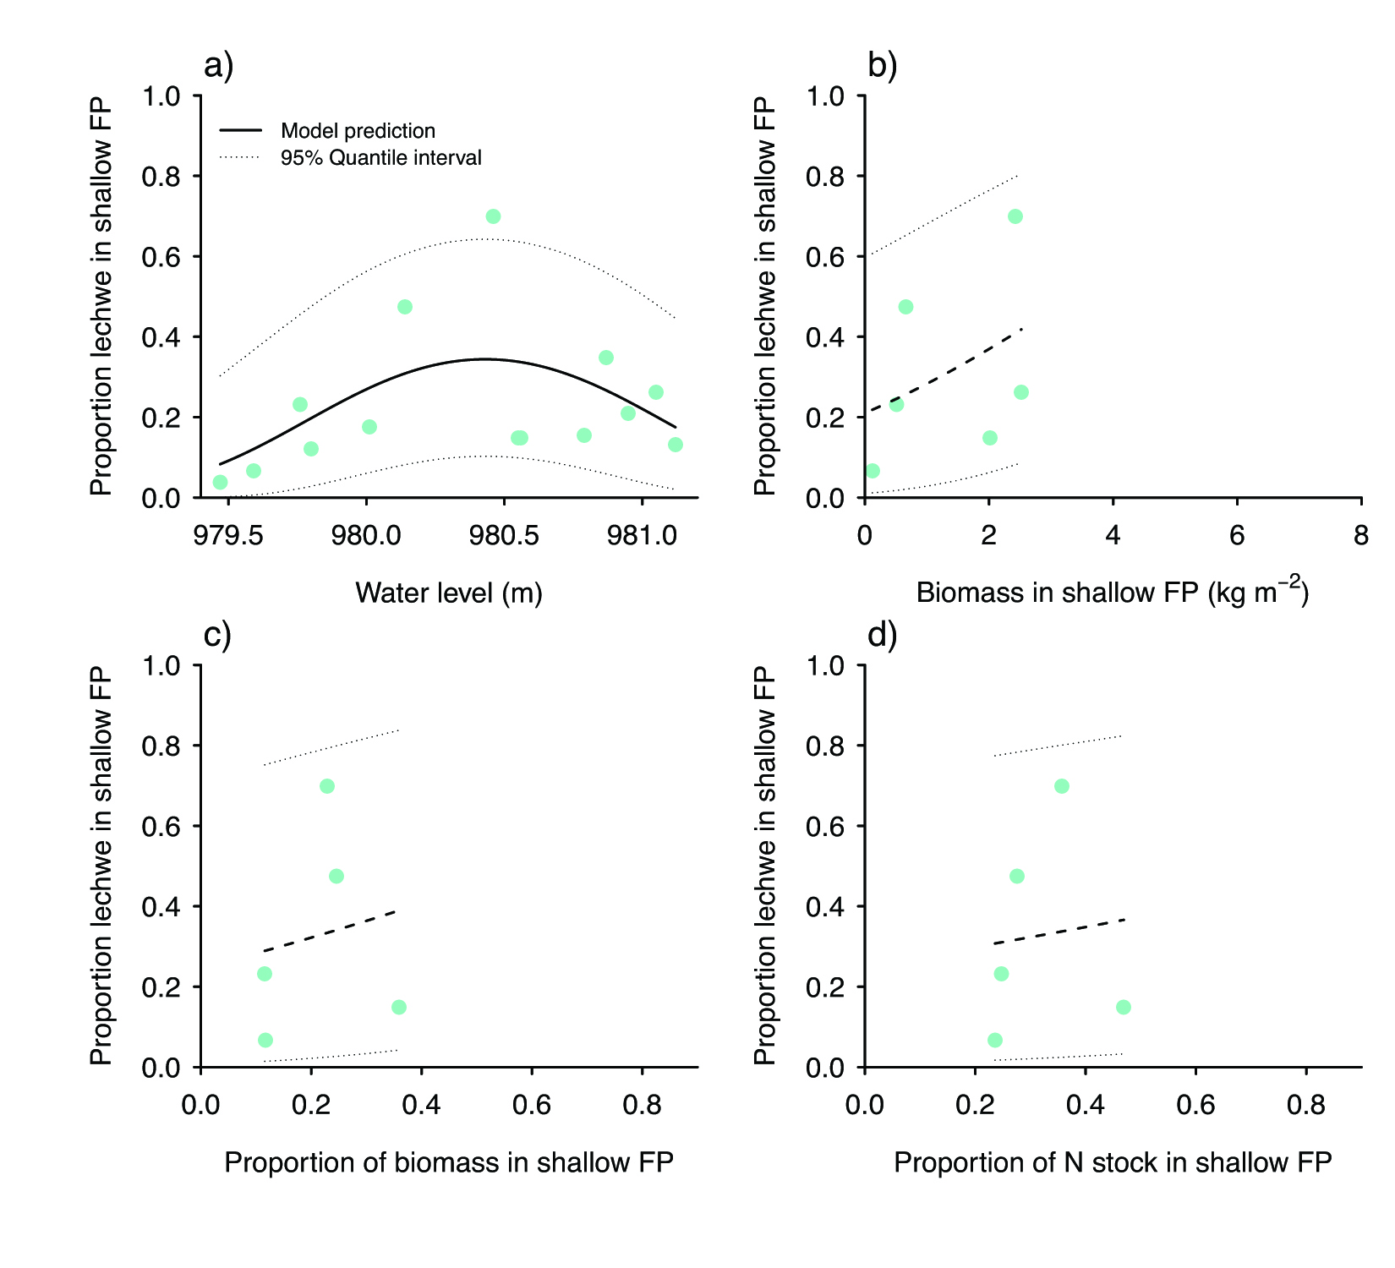
Figure S5 Relationship between the proportion of the lechwe population in shallow-flooded grassland habitats (shallow FP) and various ecosystem factors: a) mean monthly water level, b) mean monthly living grass biomass in the shallow-flooded grassland, c) the mean biomass in shallow-flooded grassland relative to the total biomass across all habitats (termitaria, shallow, and deep-flooded grassland), and d) the mean nitrogen stocks in shallow-flooded grassland relative to the total nitrogen stocks across all habitats (proportion of N stock). Axes are scaled to represent the same range across habitats shown in Fig. 4 and 5. Solid lines indicate that the slope coefficient was significant at p < 0.05 based on a partial Wald test. Non-significant relationships are shown with dashed lines. Dotted lines show the 95% quantile interval around the fitted model.

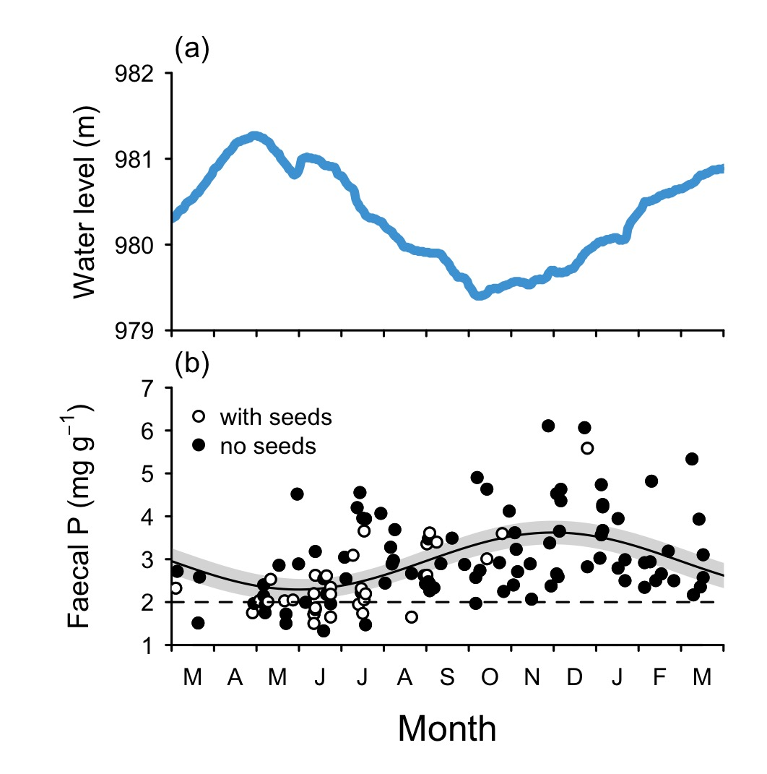
Figure S6 Seasonal changes in water level (a) and phosphorus concentration in fresh lechwe dung (b). Open and solid data points are for samples with and without D. cinerea seeds, respectively. Solid line is fitted sinusoid model, dashed horizontal line shows critical nutritional threshold for ungulates of 2 mg P g⁻¹ (Wrench et al., 1997).
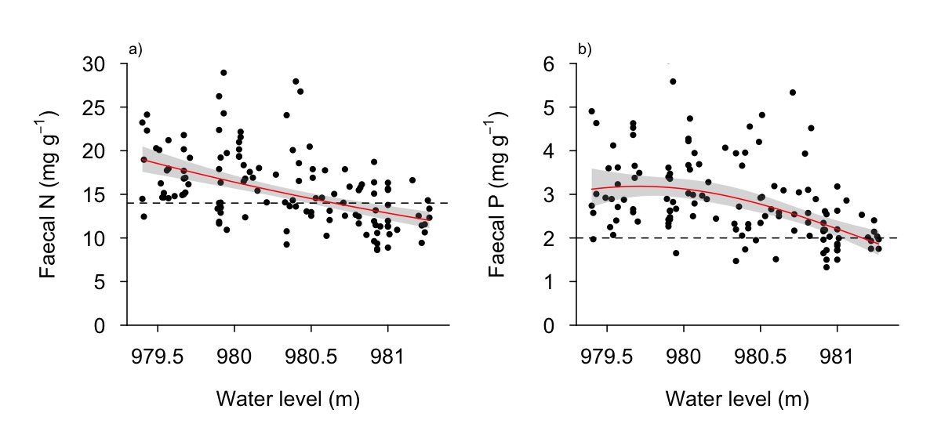
Figure S7 Nitrogen and phosphorus concentrations in lechwe dung with increasing water levels in the Kafue River. Significant relationships from linear regression models are shown as solid red lines. Shaded grey areas represent 95% confidence intervals around model predictions. Dashed horizontal lines shows critical nutritional threshold for ungulates of 14 mg N g⁻¹ and 2 mg P g⁻¹, respectively (Wrench et al., 1997).

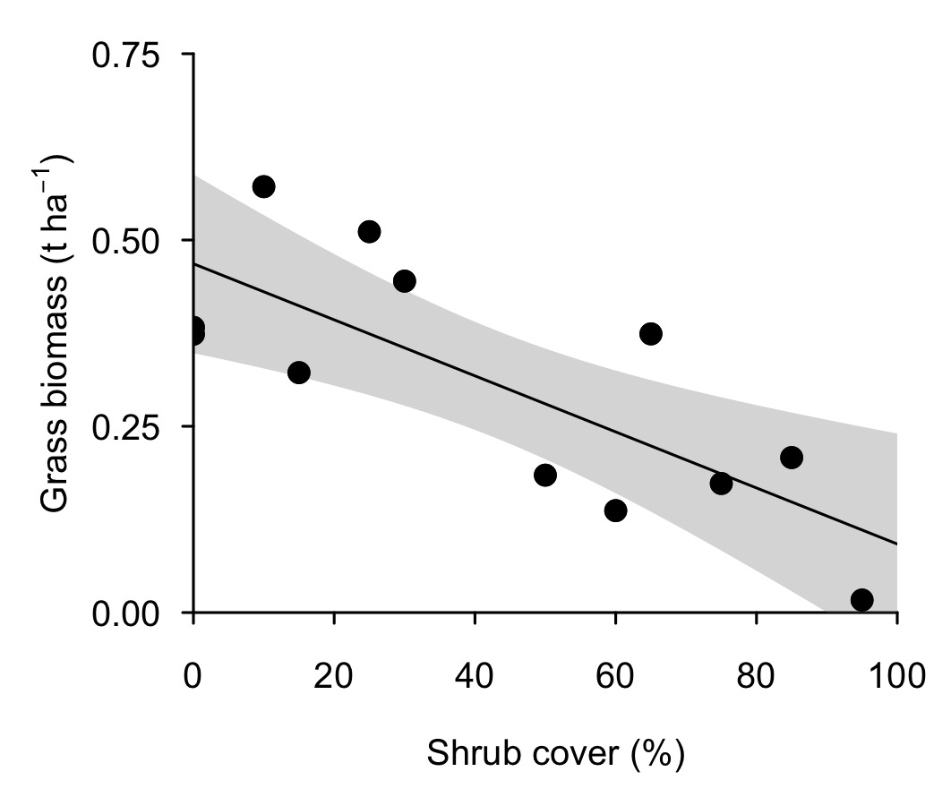
Figure S8 Increasing canopy cover of D. cinerea reduces the total grass biomass in its understory. Canopy cover was visually estimated in 10×10 m plots within pure D. cinerea stands. Standing grass biomass was clipped to ground level in a 0.5×0.5 m quadrat in the center of each plot at the beginning of the wet season (December 2010). The cut material was separated into grasses, forbs, and shrub seedlings, then dried and weighed separately. Only the grass biomass is presented here. The solid black line represents a significant linear relationship (F1,10 = 13.8, R2 = 0.58. p = 0.004) based on a linear regression model. The shaded grey area represents the 95% confidence intervals around the model prediction.

Cited References

Douthwaite, R.J., van Lavieren, L.P., 1977. A Description of the vegetation of Lochinvar National Park, Zambia. Technical Report 34. National Council for Scientific Research, Lusaka, Zambia.
Ellenbroek, G.A., 1987. Ecology and productivity of an African wetland system: The Kafue Flats, Zambia. PhD Thesis. Junk Publisher.
Rees, W.A., 1978a. The ecology of Kafue Lechwe - as affected by Kafue Gorge hydroelectric scheme. J. Appl. Ecol. 15, 205-217.
Rees, W.A., 1978b. Ecology of Kafue Lechwe - Soils, Water Levels and Vegetation. J. Appl. Ecol. 15, 163-176.
Sheppe, W., Osborne, T., 1971. Patterns of Use of a Flood Plain by Zambian Mammals. Ecol. Monogr. 41, 179-205.
Wrench, J.M., Meissner, H.H., Grant, C.C., 1997. Assessing diet quality of African ungulates from faecal analyses: The effect of forage quality, intake and herbivore species. Koedoe 40, 125-136.

