Supplementary Information for

This PDF file includes:
Additional Material and Methods.
Figures S1-4.
Tables S1-5.
Additional Bibliography

Additional Material and Methods

Field survey. Soil sampling was conducted during the same days within each soil chronosequence. The short-term climatic influences (e.g., seasonality) on the structure and composition of soil and community composition are much lower than that from spatial variability associated with soil properties and perennial vegetation (Delgado-Baquerizo and others 2019), whose effects should be particularly appreciable in our chronosequences. Therefore, we do not expect any influence of climatic seasonality within our results.

Shapes of the relationships between soil total P and soil development stage. We selected the best model using the next set of three hierarchical rules:

- Models need to be significant (P ≤ 0.05). If only one (out of three) model is significant, the significant model is selected by default. P-values from robust regressions (Andersen 2008; Yegorov 2016) were used to avoid misinterpretation of our data resulting from outliers. We conducted these analyses using the R package rlm (Andersen 2008; Yegorov 2016).

- Akaike information criterion. When more than one model is significant, we used Akaike Information Criteria (AICc) (Burnham and Anderson 2003; Burnham and others 2011) to select the best model fits. A model with a better fit corresponds to a lower AICc value. AICc is a corrected version of AIC, which is recommended when dealing with small sample sizes, as in our case (Burnham and Anderson 2003; Burnham and others 2011). According to ref. 28-29, a difference in AICc values of 2 (ΔAICc > 2) was used to determine substantial differences between models. If a single model had a ΔAICc > 2 compared with the rest of the models, that model was selected as our best model. We conducted these analyses using the R package MuMIn (Barton 2020).

- Parsimony criterion. When two or more models had a difference in AICc values lower than 2 (ΔAICc < 2), we then selected the simplest model (linear > quadratic > cubic) as the best model.
Table S1. Main characteristics of nine soil chronosequences included in this global study. See Fig. 1 for the location for geographical distribution. Chronosequence origin describes the major causal agent of each chronosequence. Aridity classification followed the Aridity Index (AI) classification: arid (0.05 > AI < 0.20), semiarid (0.20 > AI < 0.50), dry-subhumid (0.50 > AI < 0.65) and mesic (AI > 0.65).
FAO soil classification was obtained by Digital Soil Map of the World: https://data.apps.fao.org/map/catalog/srv/eng/
MAT, mean annual temperature; MAP, mean annual precipitation.

Chronosequence origin | Label | Country | Name | Age | Aridity classification | FAO  Soil classification | MAT (ºC) | MAP (mm)
Volcanic | AZ | USA | SAGA | 0.9-3000ky | Semiarid | Regosols | 9.68 | 427
Volcanic | CH | Chile | Conguillio | 0.06-5000ky | Mesic | Andosols | 8.95 | 1917
Volcanic | CI | Spain | La Palma | 0.5-1700ky | Dry-subhumid | Andosols | 13.27 | 507
Volcanic | HA | USA | Hawaii | 0.3-4100ky | Mesic | Andosols | 16.03 | 1885
Volcanic | MEX | Mexico | Chichinautzin | 1-100ky | Mesic | Regosols | 11.06 | 1235
Sedimentary | CAL | USA | Merced | 0.1-3000ky | Semiarid | Luvisols | 16.32 | 360
Sedimentary | CO | USA | Coal creek | 5-2000ky | Semiarid | Fluvisols | 8.95 | 431
Sand dune | QL | Australia | Cooloola | 3.6-716ky | Mesic | Arenosols | 20.77 | 1516
Sand dune | WA | Australia | Jurien Bay | 0.1-2000ky | Semiarid | Arenosols | 18.97 | 557

Table S2. Dominant vegetation community composition in each soil development stage ordered by its chronosequence origin.

Chronosequence origin | Name | Stage | Age (years) | Dominant vegetation
Volcanic | AZ | 1 | 900 | Juniperus monosperma, Pinus edulis, Bouteloua gracilis
Volcanic | AZ | 2 | 55000 | Juniperus monosperma, Pinus edulis, Bouteloua gracilis
Volcanic | AZ | 3 | 750000 | Juniperus monosperma, Pinus edulis, Bouteloua gracilis
Volcanic | AZ | 4 | 3000000 | Juniperus monosperma, Pinus edulis, Bouteloua gracilis
Volcanic | CH | 1 | 60 | Gaultheria pumila, Racomitrium lanuginosum
Volcanic | CH | 2 | 266 | Lomatia hirsuta, Austrocedrus chilensis
Volcanic | CH | 3 | 776 | Araucaria araucana, Nothofagus antarctica
Volcanic | CH | 4 | 3470 | Nothofagus dombeyi, Araucaria araucana
Volcanic | CH | 5 | 60000 | Nothofagus dombeyi, N. obliqua, N. alpina
Volcanic | CH | 6 | 5000000 | Nothofagus dombeyi, N. alpina
Volcanic | CI | 2 | 525 | Pinus canariensis
Volcanic | CI | 3 | 6000 | Pinus canariensis, Erica arborea, Pterocephalus porphyranthus
Volcanic | CI | 4 | 40000 | Pinus canariensis, Adenocarpus viscosus, Chamaecytisus proliferus, Erica arborea
Volcanic | CI | 5 | 600000 | Pinus canariensis, Adenocarpus viscosus
Volcanic | CI | 6 | 1100000 | Pinus canariensis, Cistus symphytifolius
Volcanic | CI | 7 | 1700000 | Pinus canariensis, Cistus symphytifolius
Volcanic | HA | 1 | 300 | Metrosideros polymorpha, Morella faya, Vaccinium calycinum, Ilex anomala, Cheirodendron trigynum, Cibotium glaucom, Hedychium gardnerianum, Isoetes sp. (grass), Coprosma sp., Myrsine lessertiana, Dicranopteris linearis, Machaerina angustifolia, Anemone hupehensis, ,
Volcanic | HA | 2 | 20000 | Metrosideros polymorpha, Cheirodendron trigynum, Cibotium glaucom, Cibotium menziesii, Ilex anomala, Freycinetia arborea, Astelia menziesii, Melicope clusiifolia, Vaccinium calycinum, Nephrolepis sp., Asplenium spp. (multi), Athyrium microphyllum, Ilex myrtifolia, Peperomia sp., Polypodium sp.,

Volcanic | HA | 3 | 150000 | Metrosideros polymorpha, Cibotium glaucom, Cibotium menziesii, Hedychium gardnerianum, Vaccinium calycinum, Cheirodendron trigynum, Psidium cattleianum, Dicranopteris linearis, Asplenium sp., Melicope clusiifolia, Myrsine sandwicensis, Elaphoglossum sp, Polygonum punctatum (sic?) (water smartweed), Tibouchina herbacea, Peperomia sp., Psilotum nudum
Volcanic | HA | 4 | 4100000 | Metrosideros polymorpha, Hedychium gardnerianum, Dicranopteris linearis, Pittosporum gayanum, Psidium cattleianum, Astelia menziesiana, Morella faya, Vaccinium meyenianum, Smilax hawaiensis, Elaphoglossum spp, Elaeocarpus bifidus, Clerodendrum sp, Alyxia oliviformis,
Volcanic | MEX | 1 | 1000 | Pinus montezumae, Bacharis conferta, Alnus firmifolia, Penstemon sp.
Volcanic | MEX | 2 | 1835 | Abies religiosa, Arbutus xalapensis, Pinus herrerae, Bacharis conferta, Pinus montezumae, Penstemon sp., Bacharis conferta, Buddleja sp.,
Volcanic | MEX | 3 | 3800 | Alnus firmifolia, Quercus laurina, Pinus montezumae, Pinus pseudostrobus
Volcanic | MEX | 4 | 6200 | Pinus montezumae, Alnus firmifolia
Volcanic | MEX | 5 | 8000 | Pinus montezumae, Bacharis conferta, Buddleja parviflora
Volcanic | MEX | 6 | 10000 | Pinus patula, Alnus firmifolia, Pinus montezumae, Senecio sp
Volcanic | MEX | 7 | 30500 | Pinus ayacahuite, Pinus pseudostrobus, Pinus montezumae
Volcanic | MEX | 8 | 100000 | Pinus montezumae, Abies religiosa, Quercus laurina, Penstemos sp., Bacharis conferta
Sedimentary | CAL | 1 | 100 | Populus fremontii, Helianthus annuus, Amaranthus albus
Sedimentary | CAL | 2 | 3000 | Quercus lobata, Silybum marianum, Hordeum murinum L
Sedimentary | CAL | 3 | 30000 | Festuca californica
Sedimentary | CAL | 5 | 600000 | Rytidosperma penicillatum
Sedimentary | CAL | 6 | 3000000 | Festuca bromoides, F. myuros, Bromus hordaceous, B. diandrus
Sedimentary | CO | 1 | 5000 | Juncus arcticus, Andropogon gerardii, Panicum virgatum
Sedimentary | CO | 2 | 140000 | Andropogon gerardii, Panicum virgatum
Sedimentary | CO | 3 | 240000 | Panicum virgatum, Poa compresa, Andropogon gerardii
Sedimentary | CO | 4 | 640000 | Chrysopsis sp, Andropogon gerardii, L. cinquefoil
Sedimentary | CO | 5 | 1000000 | Andropogon gerardii, M. Burgia, Poa compresa,
Sedimentary | CO | 6 | 2000000 | Andropogon gerardii, Poa compresa, M. Burgia

Sand dune | QL | 1 | 3600 | Eucalyptus tessellaris, Angophora costata, Eucalyptus intermedia, Casuarina littoralis, Melaleuca quinquenerva, Banksia integrifolia, Banksia serrata, Macrozamia spp., Acacia aulacocarpa, Acacia flavescens, Groundstorey, Cassytha paniculata, Gahnia sieberiana, Hardenbergia violacea
Sand dune | QL | 2 | 6700 | Eucalyptus tessellaris, Angophora costata, Eucalyptus intermedia, Casuarina littoralis, Melaleuca quinquenerva, Banksia integrifolia, Banksia serrata, Macrozamia spp., Acacia aulacocarpa, Acacia flavescens, Groundstorey, Cassytha paniculata, Gahnia sieberiana, Hardenbergia violacea
Sand dune | QL | 3 | 134000 | Eucalyptus tessellaris, Angophora costata, Eucalyptus intermedia, Casuarina littoralis, Melaleuca quinquenerva, Banksia integrifolia, Banksia serrata, Macrozamia spp., Acacia aulacocarpa, Acacia flavescens, Groundstorey, Cassytha paniculata, Gahnia sieberiana, Hardenbergia violacea
Sand dune | QL | 4 | 176000 | Eucalyptus tessellaris, Angophora costata, Eucalyptus intermedia, Casuarina littoralis, Melaleuca quinquenerva, Banksia integrifolia, Banksia serrata, Macrozamia spp., Acacia aulacocarpa, Acacia flavescens, Groundstorey, Cassytha paniculata, Gahnia sieberiana, Hardenbergia violacea
Sand dune | QL | 5 | 324000 | Eucalyptus tessellaris, Angophora costata, Eucalyptus intermedia, Casuarina littoralis, Melaleuca quinquenerva, Banksia integrifolia, Banksia serrata, Macrozamia spp., Acacia aulacocarpa, Acacia flavescens, Groundstorey, Cassytha paniculata, Gahnia sieberiana, Hardenbergia violacea
Sand dune | QL | 6 | 716000 | Eucalyptus tessellaris, Angophora costata, Eucalyptus intermedia, Casuarina littoralis, Melaleuca quinquenerva, Banksia integrifolia, Banksia serrata, Macrozamia spp., Acacia aulacocarpa, Acacia flavescens, Groundstorey, Cassytha paniculata, Gahnia sieberiana, Hardenbergia violacea
Sand dune | WA | 1 | 100 | Acacia cyclops, Acacia rostellifera, Scaevola crassifolia, Olearia axillaris, Spyridium globulosum
Sand dune | WA | 2 | 1000 | Melaleuca systena, Acacia lasiocarpa, Acacia rostellifera
Sand dune | WA | 3 | 6500 | Melaleuca systena, Acacia lasiocarpa, Acacia rostellifera
Sand dune | WA | 4 | 120000 | Melaleuca systena, Banksia leptophylla, Calothamnus quadrifidus
Sand dune | WA | 5 | 480000 | Banksia menziesii, Banksia attenuata, Mesomelaena pseudostygia, Hibbertia hypericoides
Sand dune | WA | 6 | 2000000 | Banksia menziesii, Jacksonia floribunda, Banksia leptophylla

Table S3. All relationships stablished of our full a-priori conceptual model (i.e., with non-significant paths included) based on previous knowledge.

Number | Associations | Rationale | Ref.
3 | Chronosequence age → Substrate origin | For example, the accumulation of wind-blown quartz sand forms dune systems. This siliceous parent material is transported by sand-moving winds from the inner continental shelf during pedogenesis. | (Chen and others 2015)
1 | Chronosequence age → Plant cover | Plant attributes related to ecosystem retrogression. | (Peltzer and others 2010)
2 | Chronosequence age → P fraction | Pedogenesis involves a decline in total soil P over millions of years of soil development. | (Walker and Syers 1976; Turner and Condron 2013)
4 | Chronosequence age → Soil | For example, soil acidification is known with increasing age. | (Delgado-Baquerizo and others 2019)
6 | Climate ↔ Substrate origin | Climatic events can affect to active marine transgression or dune development | (Lees 2006)
5 | Climate → Plant cover | Climate affects plant attributes (e. g., MAT could be positively associated with plant cover). | (Maestre and others 2012)
7 | Climate → P fraction | For instance, MAT could increase occluded P by geochemical processes such as P sorption on secondary minerals. | (Hou and others 2018)
8 | Climate → Soil | For instance, MAT can regulate soil pH via promoting soil  weathering. | (Delgado-Baquerizo and others 2020b)
14 | Substrate origin → P fraction | For example, small amounts of P in the parent sand can be associated with sesquioxide coatings (silica, Al, Fe and potassium) of siliceous sands. | (Thompson 1992)
9 | Substrate origin → Plant cover | Foliar nutrient concentrations and resorption efficiency occurring in plants are associated with substrate origin. | (Turner and Laliberté 2015)
10 | Substrate origin →Soil | Differences in soil chemistry associated with the geological origin of rocks. | (Huggett 1998)
11 | Plant cover →Soil | For example, promote soil C via litter production. | (Delgado-Baquerizo and others 2016)
12 | Plant cover → P fraction | Plant cover can directly influence (litterfall) soil P. | (Belnap 2011)
13 | Soil → P fraction | P forms are predominantly controlled by geochemical processes. | (Walker and Syers 1976; Turner and Condron 2013)

Table S4. The overall SEM goodness of fit for each model.

 | Chi-square | df | Probability level | RMSEA | PCLOSE | R²
Non-occluded | 0.107 | 1 | 0.743 | 0 | 0.786 | 0.55
Occluded | 0.107 | 1 | 0.743 | 0 | 0.786 | 0.52
Organic | 0.107 | 1 | 0.743 | 0 | 0.786 | 0.22
Primary | 0.107 | 1 | 0.743 | 0 | 0.786 | 0.7
Total | 0.107 | 1 | 0.743 | 0 | 0.786 | 0.72

Table S5. Summary for the best models predicting the relationship between soil total P and soil development stage for 9 studied chronosequences. Models are ranked by significance, AICc and parsimony. AICc measures the relative goodness of fit of a given model; the lower its value, the more likely the model is correct. ✔ P ≤ 0.05

Table S5. Basic soil data employed in SEM models.

Variable | Mean ± SD | Units
MAT | 13.92 ± 4.25 | ºC
MAP | 968.31 ± 594.10 | mm
Plant cover | 74.03 ± 23.92 | %
Soil pH | 5.96 ± 1.10 | Unitless
TRB | 382.13 ± 468.86 | cmolc kg⁻¹
CIA | 40.78 ± 22.99 | Unitless
Soil carbon | 5.38 ± 6.48 | %
Non occluded P | 21.38 ± 28.44 | g m⁻²
Occluded P | 8.43 ± 8.92 | g m⁻²
Primary P | 19.27 ± 31.06 | g m⁻²
Organic P | 3.05 ± 5.45 | g m⁻²
Total P | 52.12 ± 55.92 | g m⁻²

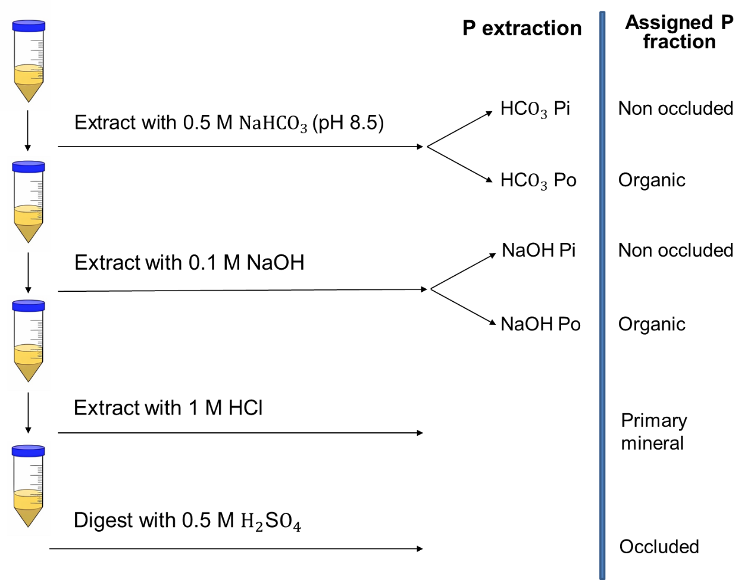
Figure S1. Flow chart of soil P fractionation. The flow chart follows the procedures outlined by Hedley et al. (1982) and Tiessen and Moir (1993). Phosphorus is grouped into primary mineral (extracted in HCl acid), occluded phosphorus (extracted in H₂S₄0 acid after heating), non-occluded phosphorus (inorganic phosphate extracted in NaHCO₃ and NaOH) and organic phosphorus (after alkaline and acid digestion in NaHCO₃ and NaOH, respectively).

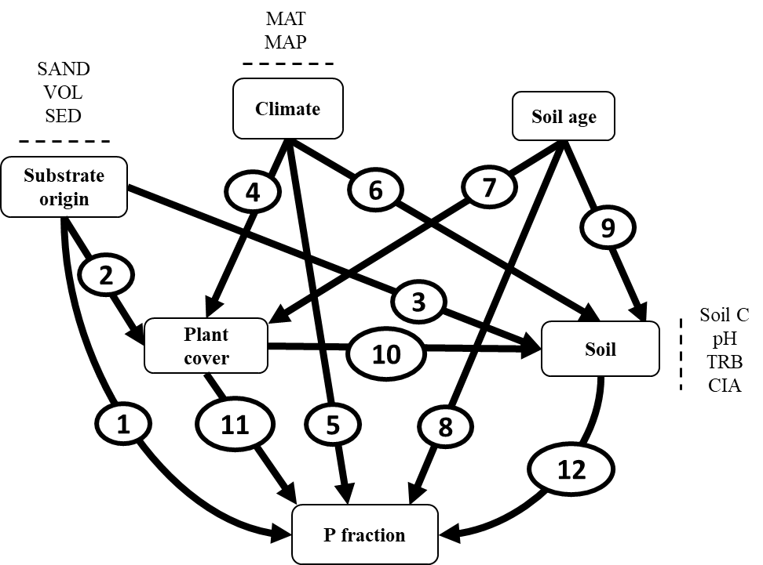

Figure S2. A priori structural equation model assessing the effects of soil age, climate (mean annual precipitation [MAP] and mean annual temperature [MAT]), aboveground (plant cover), soil attributes (belowground [soil C] resource availability, soil abiotic factors [pH], chemical index of alteration [CIA] and total base cation reserves [TRB]), substrate origin (e.g., volcanic [VOLC] and sand dune [SAND]) on different P fractions. Rectangles represent the response variables and circles represent the hypothesized pathways.
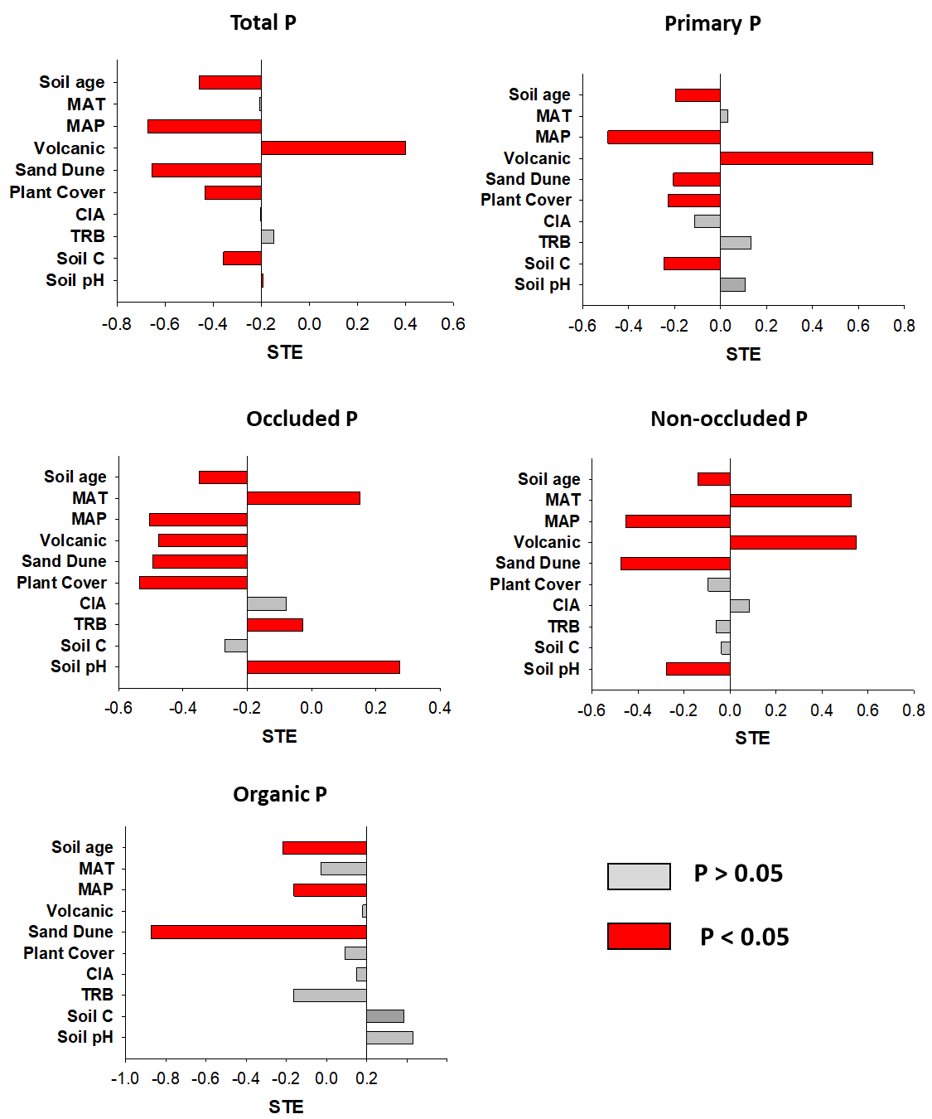

Figure S3. Total standardized effects (STE) from environmental factors on total primary, non-occluded, occluded and organic P fractions. MAT: mean annual temperature; MAP: mean annual precipitation; CIA: chemical index of alteration; TRB: total base cation reserves.

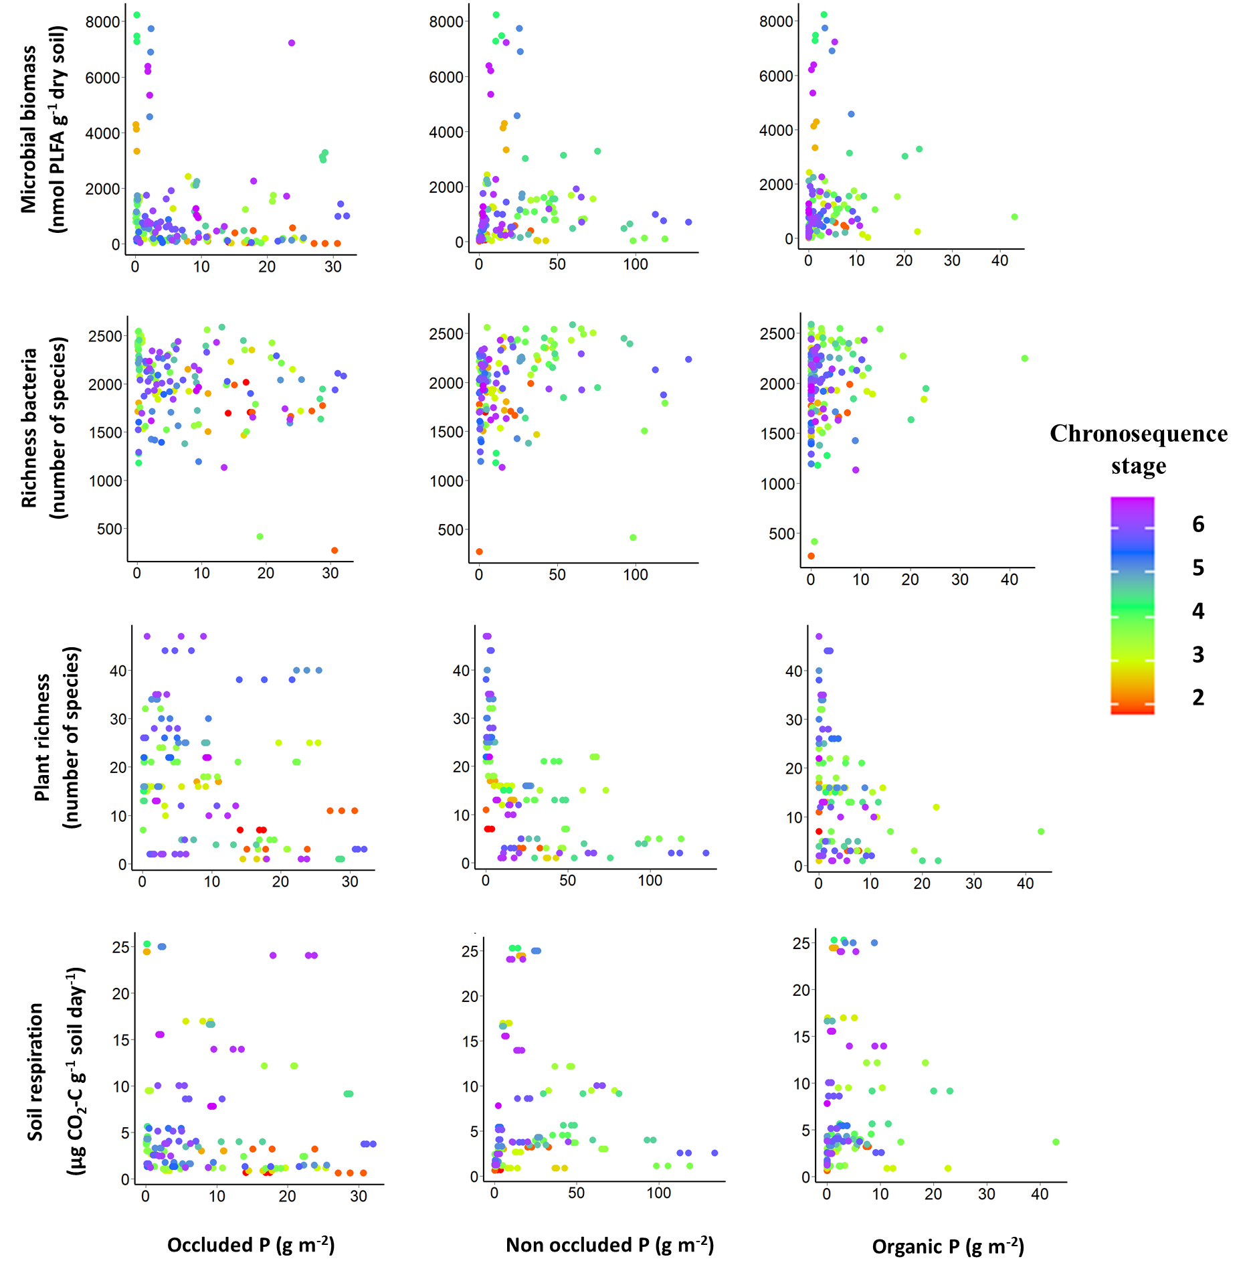

Figure S4. Relationships between some P fractions and multiple soil functions during soil development.

Additional Bibliography
Andersen R. 2008. Modern Methods for Robust Regression. SAGE Publications, Inc. http://methods.sagepub.com/book/modern-methods-for-robust-regression
Barton K. 2020. MuMIn: multi-model inference. R package version 1.43. https://cran.r-project.org/web/packages/MuMIn/MuMIn.pdf. Last accessed 30/03/2022
Belnap J. 2011. Biological Phosphorus Cycling in Dryland Regions. In: Bünemann E, Oberson A, Frossard E, editors. Vol. 26. Springer, Berlin, Heidelberg. pp 371–406.
Burnham KP, Anderson DR. 2003. Model Selection and Multimodel Inference: A Practical Information-Theoretic Approach. Burnham KP, Anderson DR, editors. J Wildl Manage 67:655. https://www.jstor.org/stable/3802723?origin=crossref
Burnham KP, Anderson DR, Huyvaert KP. 2011. Erratum to: AIC model selection and multimodel inference in behavioral ecology: some background, observations, and comparisons. Behav Ecol Sociobiol 65:415–415. http://link.springer.com/10.1007/s00265-010-1084-z
Chen CR, Hou EQ, Condron LM, Bacon G, Esfandbod M, Olley J, Turner BL. 2015. Soil phosphorus fractionation and nutrient dynamics along the Cooloola coastal dune chronosequence, southern Queensland, Australia. Geoderma 257–258:4–13. https://linkinghub.elsevier.com/retrieve/pii/S001670611500141X
Delgado-Baquerizo M, Bardgett RD, Vitousek PM, Maestre FT, Williams MA, Eldridge DJ, Lambers H, Neuhauser S, Gallardo A, García-Velázquez L, Sala OE, Abades SR, Alfaro FD, Berhe AA, Bowker MA, Currier CM, Cutler NA, Hart SC, Hayes PE, Hseu Z-Y, Kirchmair M, Peña-Ramírez VM, Pérez CA, Reed SC, Santos F, Siebe C, Sullivan BW, Weber-Grullon L, Fierer N. 2019. Changes in belowground biodiversity during ecosystem development. Proceedings of the National Academy of Sciences 116:6891–6. https://pnas.org/doi/full/10.1073/pnas.1818400116
Delgado-Baquerizo M, Maestre FT, Reich PB, Jeffries TC, Gaitan JJ, Encinar D, Berdugo M, Campbell CD, Singh BK. 2016. Microbial diversity drives multifunctionality in terrestrial ecosystems. Nat Commun 7.
Delgado-Baquerizo M, Reich PB, Bardgett RD, Eldridge DJ, Lambers H, Wardle DA, Reed SC, Plaza C, Png GK, Neuhauser S, Berhe AA, Hart SC, Hu H-W, He J-Z, Bastida F, Abades S, Alfaro FD, Cutler NA, Gallardo A, García-Velázquez L, Hayes PE, Hseu Z-Y, Pérez CA, Santos F, Siebe C, Trivedi P, Sullivan BW, Weber-Grullon L, Williams MA, Fierer N. 2020a. The influence of soil age on ecosystem structure and function across biomes. Nat Commun 11:4721. https://www.nature.com/articles/s41467-020-18451-3
Delgado-Baquerizo M, Reich PB, Trivedi C, Eldridge DJ, Abades S, Alfaro FD, Bastida F, Berhe AA, Cutler NA, Gallardo A, García-Velázquez L, Hart SC, Hayes PE, He JZ, Hseu ZY, Hu HW, Kirchmair M, Neuhauser S, Pérez CA, Reed SC, Santos F, Sullivan BW, Trivedi P, Wang JT, Weber-Grullon L, Williams MA, Singh BK. 2020b. Multiple elements of soil biodiversity drive ecosystem functions across biomes. Nat Ecol Evol 4:210–20.
Hou E, Chen C, Luo Y, Zhou G, Kuang Y, Zhang Y, Heenan M, Lu X, Wen D. 2018. Effects of climate on soil phosphorus cycle and availability in natural terrestrial ecosystems. Glob Chang Biol 24:3344–56. http://www.ncbi.nlm.nih.gov/pubmed/29450947
Huggett RJ. 1998. Soil chronosequences, soil development, and soil evolution: a critical review. Catena (Amst) 32:155–72.
Lees B. 2006. Timing and Formation of Coastal Dunes in Northern and Eastern Australia. J Coast Res 221:78–89. http://www.bioone.org/doi/abs/10.2112/05A-0007.1
Maestre FT, Quero JL, Gotelli NJ, Escudero A, Ochoa V, Delgado-Baquerizo M, García-Gómez M, Bowker MA, Soliveres S, Escolar C, García-Palacios P, Berdugo M, Valencia E, Gozalo B, Gallardo A, Aguilera L, Arredondo T, Blones J, Boeken B, Bran D, Conceição AA, Cabrera O, Chaieb M, Derak M, Eldridge DJ, Espinosa CI, Florentino A, Gaitán J, Gatica MG, Ghiloufi W, Gómez-González S, Gutiérrez JR, Hernández RM, Huang X, Huber-Sannwald E, Jankju M, Miriti M, Monerris J, Mau RL, Morici E, Naseri K, Ospina A, Polo V, Prina A, Pucheta E, Ramírez-Collantes DA, Romão R, Tighe M, Torres-Díaz C, Val J, Veiga JP, Wang D, Zaady E. 2012. Plant Species Richness and Ecosystem Multifunctionality in Global Drylands. Science (1979) 335:214–8. https://www.science.org/doi/10.1126/science.1215442
Peltzer DA, Wardle DA, Allison VJ, Troy Baisden W, Bardgett RD, Chadwick OA, Condron LM, Parfitt RL, Porder S, Richardson SJ, Turner BL, Vitousek PM, Walker J, Walker LR. 2010. Understanding ecosystem retrogression. Ecol Monogr 80:509–29.
Thompson C. 1992. Genesis of podzols on coastal dunes in southern Queensland .I. Field relationships and profile morphology. Soil Research 30:593. http://www.publish.csiro.au/?paper=SR9920593
Turner BL, Condron LM. 2013. Pedogenesis, nutrient dynamics, and ecosystem development: the legacy of T.W. Walker and J.K. Syers. Plant Soil 367:1–10. http://link.springer.com/10.1007/s11104-013-1750-9
Turner BL, Laliberté E. 2015. Soil Development and Nutrient Availability Along a 2 Million-Year Coastal Dune Chronosequence Under Species-Rich Mediterranean Shrubland in Southwestern Australia. Ecosystems 18:287–309. http://link.springer.com/10.1007/s10021-014-9830-0
Walker TW, Syers JK. 1976. The fate of phosphorus during pedogenesis. Geoderma 15:1–19. https://linkinghub.elsevier.com/retrieve/pii/0016706176900665
Yegorov O. 2016. Robust Fitting of Linear Model. R package version 1.2. https://mran.microsoft.com/snapshot/2016-05-22/web/packages/rlm/rlm.pdf

