Supplemental Information
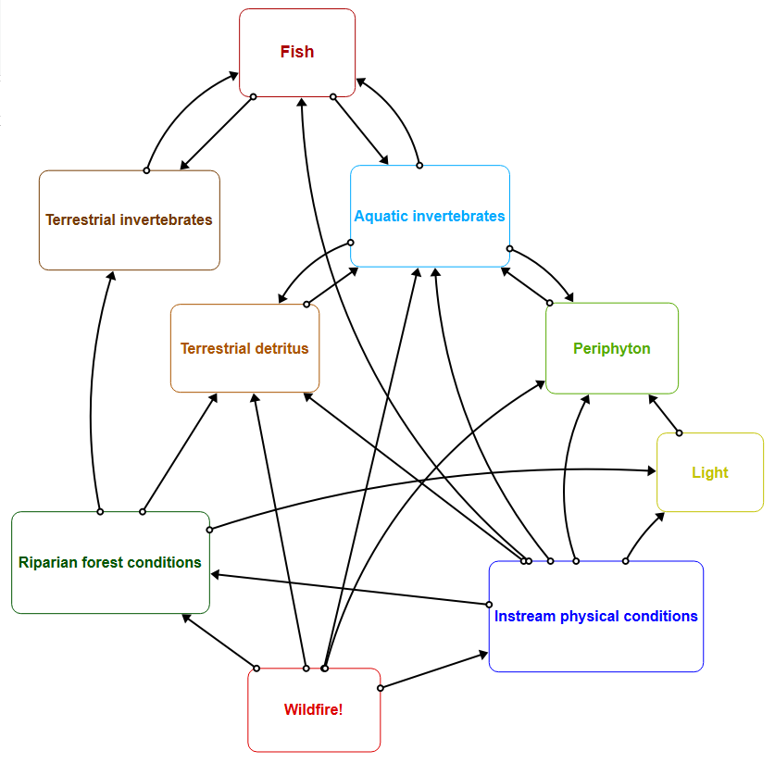
Figure S1. Structure of the Aquatic Trophic Productivity (ATP) model. In this version of the ATP, fire affects riparian forest and instream physical conditions. Changes in riparian forest and instream physical conditions associated with fire then are linked to the model food web structure to ultimately affect fish. As a result, fire can affect fish both through changes in their physical habitat as well as through changes in their trophic resources.

