Supplemental Material

to

The structural and functional impacts of invasive Psidium cattleianum in forests on the Island of Hawai’i

Tara Seely, corresponding author; tara_seely@berkeley.edu;
Department of Environmental Science, Policy, and Management
University of California, Berkeley, 130 Mulford Hall #3114 Berkeley, CA 94720-3114, USA

Lucas Berio Fortini; U.S. Geological Survey, Pacific Island Ecosystems Research Center
P.O. Box 44, Hawaii National Park, HI 96718, USA

Yutong Liang; Sustainable Energy and Environment Thrust
The Hong Kong University of Science and Technology (Guangzhou), Guangzhou, Guangdong, 511453, China

John Battles; Department of Environmental Science, Policy, and Management
University of California, Berkeley, 130 Mulford Hall #3114 Berkeley, CA 94720-3114, USA

Table of Contents
Introduction 3
S1. Site description 3
S2. Field sampling design 3
S3. Terrestrial laser scanning (TLS) 4
S4. Tree density and basal area calculation 5
S5. TLS Point cloud processing 6
S5.1 Scan registration 6
S5.2 Point thinning and filtration 7
S5.3 Georeferencing 8
S5.4 Point classification 8
S5.5 Point cloud normalization 8
S5.6 Inferring structure from TLS point cloud 8
S6. Measurement of vegetation density and forest structure 9
S6.1 Spatial autcorrelation assessment 9
S7. Statistics 11
S8. Biophysical model 13
S8.1 Model parameterization 14
S9. R packages 17
S10. Disclaimer 17
References 18

Figures
Figure S1. Schematic of field sampling 4
Figure S2. Variograms of density and structural metrics 10
Figure S3. Schematic of point cloud sampling 11
Figure S4. Surface temperature and soil temperature calibration 16

Tables
Table S1. Registration root mean square error (RMSE) 6
Table S2. Statistical models compared 13
Table S3. Statistical results of vegetation density and structural metrics as a function of invasion 13
Table S4. R packages used in analysis 17

Introduction
This document expands upon the methods used for the manuscript, ‘The structural and functional impacts of invasive Psidium cattleianum in forests on the Island of Hawai’i.’ The information herein is intended to supplement descriptions provided in the main journal article. At times, the supplemental text references elements (i.e., figures, tables, or equations) within the main text using the journal article’s original labels. Elements included in the supplement are prefaced with an ‘S’.

S1. Site description
Among all sites, forest inventory data broadly characterize the forest types with an average tree basal area of 44.3 m²/ha (se = 1.9) and an average tree density of 3,784 trees/ha (se = 23) (USDA 2024).
There were slight variations in species composition between sites, but native transects typically had a Metrosideros polymorpha-dominant canopy and a Cibotium glaucum-dominant (i.e., tree fern-dominant) midstory (Table 1). The “mixed” and “invasive” transects had an intermediate mix of native species and invasive P. cattleianum.

S2. Field sampling design
Canopy species point intercept and basal area measurements were taken at 13 points within the 40 m transect X 10 m width area shown in Figure S1. The canopy species point intercept method records the canopy species directly above the sample point and was used for site characterization (Bonham 2013). Basal area measurements are discussed in S4. Terrestrial laser scanning (TLS) locations were clustered around the 40 m centerline of the sampling area (Fig. S1).

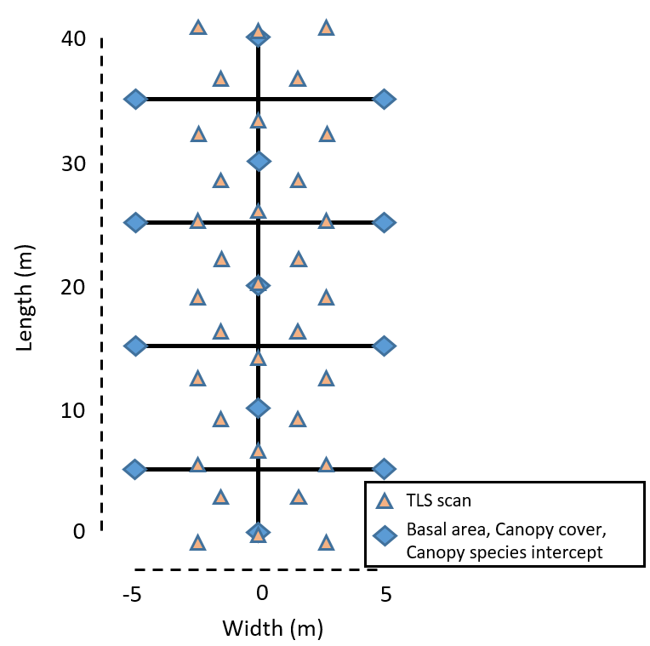
Figure S 1
Figure S1. Schematic of field sampling design

S3. Terrestrial laser scanning (TLS)
The terrestrial laser scanning (TLS) locations were spaced ~2.5 m apart (Fig. S1). The arrangement of TLS locations varied for each transect depending on forest density and tree locations. The density of TLS locations helped minimize occlusion, or incomplete point cloud sampling due to physical features obscuring the light detection and ranging (LiDAR) beam. Increased TLS locations within an area increases the likelihood that LiDAR beams will reach features at risk of being occluded by understory vegetation, such as the top of the canopy. TLS produces a three-dimensional (3D) point cloud of the sampled area, which consists of clusters of points representing physical features. The point cloud models the structural arrangement of features only. Thus, the inventory measurements of canopy species intercept and basal area with the point cloud data must be coupled to characterize the species composition and relative species abundance of the sampled area. TLS data collection was performed with a Leica BLK360 instrument (Leica Geosystems, Heerbrugg, Switzerland) with point density set to standard, or 10 mm at 10 m. The Leica BLK360 also collected photographs at each scan location which was used to assist point cloud registration, as well as tree density calculation. The High Dynamic Range (HDR) photograph setting was used if the instrument was photographing in direct sunlight.

S4. Tree density and basal area calculation
We used the Leica BLK360’s photographs to calculate tree density. Within the photographs, we selected 15 equally spaced points along the center line of the transect (Fig. S1). At each point, we extracted the distance to the two nearest trees in each sector (i.e., north, south, east, west) from the spatially registered photographs and then calculated the stem density of the site using the Morisita m̂₂ estimator equation (Morisita 1957; Cogbill and others 2018):

 | 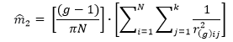 | (Eq. S1)
where m̂₂ is the density in trees m⁻², N is the total number of points, g is the rank order of distances in a sector, i is the point, j is the sector, k is the number of equiangular sectors, and r_{(g)ij} is the distance from point i to the g^{th} nearest tree in sector j (Eq. 2).
Our method for estimating tree basal area relied on point sampling using wedge prisms (Fig. S1). This technique samples forest composition with a variable-radius plot. The probability of intersecting the wedge is a function of the diameter of the tree and the distance from the point (Wensel and others 1980). Although effective sample area is dependent on tree basal area, basal area prisms are a reliable, widely used forest inventory method because of proportional sampling; the proportion of trees measured to those not measured in a given size class is consistent and representative of the distribution of tree basal area within the forest (Becker and Nichols 2011).
For each transect, the average tree density was combined with average basal area to calculate the P. cattleianum invasion importance value (IV_{inv}) (Eq. 1). For Kalōpā, the basal area prism data were lost, so basal area was calculated using the site’s photographs and point clouds. This approach was feasible because P. cattleianum has distinct bark easily distinguishable from other forest species. Diameter at breast height (dbh) was estimated for the trees included in point-estimates of tree density (8 trees per point). Basal area (m² ha⁻¹) was calculated from these measurements as the mean basal area per tree (m² tree ⁻¹).

S5. TLS point cloud processing

S5.1 Scan registration
Scans were registered in ReCap Pro (Version 7.0.1.22; Anon 2021). Registration root mean square error (RMSE) measurements are documented in Table S1. Shorthand for site names includes ‘Havo’ for Hawaiʻi Volcanoes National Park (Hawaiʻi Volcanoes NP hereafter) and ‘Lau’ for Laupāhoehoe.

Table S1. Registration RMSE (m).
Table S 1
Point cloud | Registration RMSE (m)
ʻŌlaʻa native 40 | 0.004835
ʻŌlaʻa mixed 0 to 20 | 0.004097
ʻŌlaʻa mixed 20 to 40 | 0.004082
ʻŌlaʻa invasive 40 | 0.003942
Lau native 0 22 | 0.004202
Lau native 22 40 | 0.003223
Lau mixed | 0.003305
Lau invasive 0 20 | 0.005065
Lau invasive 20 40 | 0.003284
Havo native | 0.004846
Havo mixed | 0.002882
Havo invasive | 0.004058
Cooper center native | 0.003235
Cooper center mixed | 0.004211
Cooper center invasive | 0.006751
Kalōpā native | 0.002879
Kalōpā mixed | 0.002893
Kalōpā invasive | 0.003747

S5.2 Point thinning and filtration
The density of LiDAR returns is nonuniform for three reasons. First, the LiDAR is emitted radially from the instrument. Structural features close to the instrument will be measured at a higher point density than features located further from the instrument. With TLS, the forest understory has denser point coverage than the top of the canopy. Second, LiDAR works as a “line-of-sight” measurement, such that objects closer to the instrument will occlude, or block objects in the same radial trajectory further from the instrument. Occlusion typically increases with forest density. Third, multi-scan LiDAR, which is used to resolve issues of occlusion by increasing the amount of “viewsheds” of data collection, introduces uneven point density throughout the point cloud. To correct the nonuniformity of point density, the point cloud is thinned using the R package LidR to a maximum point density of one point per 0.1 m³ (Roussel and others 2020; Roussel and Auty 2023). If needed, point clouds were also manually filtered for erroneous points occurring below the surface, of an unknown source, using Global Mapper geospatial software (Version 20.0.0; Anon 2018). Erroneous points were identified using either 1) an elevation threshold set with the ground point classification tool or 2) visual observations of a cross-section of point cloud data using the perpendicular path profile tool.

S5.3 Georeferencing
Point cloud datasets were shifted to their origin coordinate that was recorded by GPS in the field.

S5.4 Point classification
Ground points were classified using an automatic classification algorithm in Global Mapper. The algorithm was parameterized with a base bin size of 0.1 m, minimum height departure of 0.2 m, maximum height delta of 1 m, expected terrain slope of 4%, and maximum building width of 5 m.

S5.5 Point cloud normalization
Point clouds were normalized by subtracting a digital elevation model (DEM) representing the ground surface from the point cloud. DEMs were created in Global Mapper Geospatial software at 1-m resolution using the minimum binning interpolation approach. The normalization was done using functions within the LidR R package.

S5.6 Inferring structure from TLS point cloud
The thinned, normalized point cloud was then voxelized, or divided into 1 m³ volumetric pixels (voxels). Within each voxel, the normalized density of points (points/m³) was used to calculate the vegetation area index, or VAI (Atkins and others 2018). The normalized VAI per m³ could range from 0, indicating an empty m³ voxel, up to 10, indicating a voxel containing the maximum (thinned) point density of 100 points/m³. The structural arrangement and heterogeneity metrics (leaf height, vertical vegetation distribution, rugosity, and gini coefficient) were calculated from the distribution of VAI through the point cloud, using the R package forestR (Atkins and others 2018).

S6. Measurement of vegetation density and forest structure

S6.1 Spatial autocorrelation assessment
Each transect point cloud was divided into 40 1 m X 6 m slices. The slices are centered on the transect midline, such that scan density (i.e., number of scans per area) is uniform between slices. Canopy metrics such as height, total vegetation area index (VAI), and rugosity were summarized for each slice using R package forestR (Atkins and others 2018). We evaluated the spatial autocorrelation between slices using variograms that plot the semivariance of each canopy metric by the space between samples (Fig. S2). Autocorrelation is defined as a trend of increasing semivariance with increasing spacing. The variogram results did not indicate any consistent trend of spatial autocorrelation between slices for each metric evaluated. However, we conservatively selected a spacing of 3 m between slices to ensure slices were spatially independent. Thus, the canopy metrics were averaged from every third slice, or N =14 samples per transect (Fig. S3).
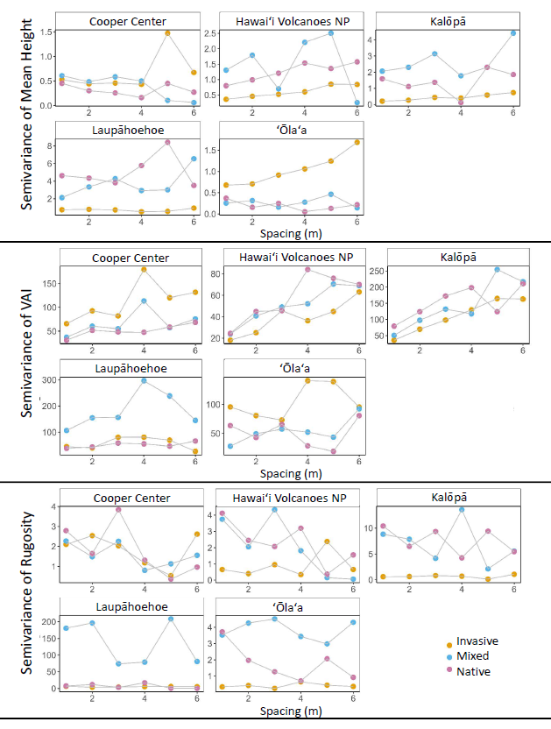
Figure S 2
Figure S2. Variograms plotting the semivariance of mean height, vegetation area index (VAI), and rugosity against the spacing between point cloud samples. The Y-axis range varies by plot to enable internal comparisons between invasive (gold), mixed (blue), and native (pink) transects within each site.
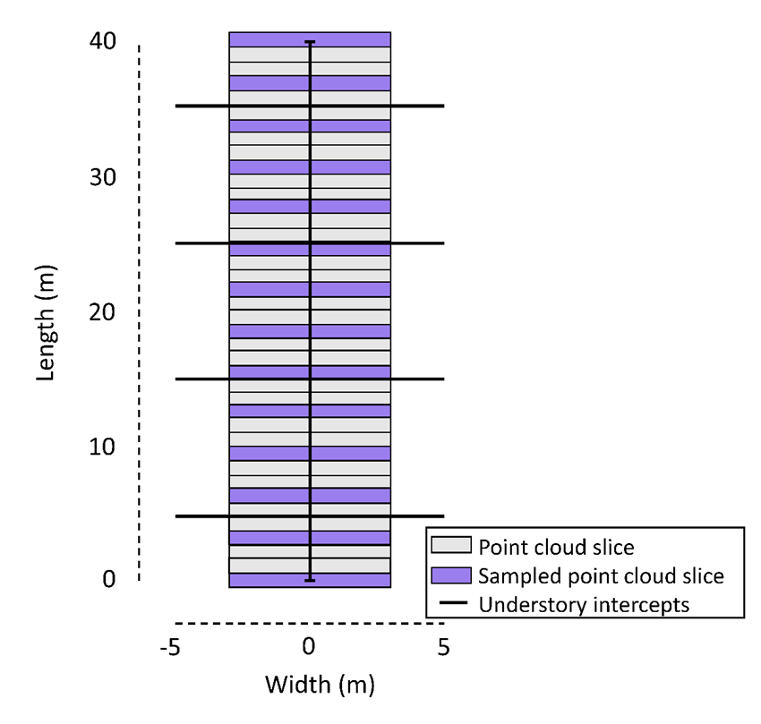
Figure S 3
Figure S3. Sampling scheme of point cloud slices taken from TLS data at each transect.

S7. Statistics
To quantify differences in canopy structure (response variable) across a gradient of invasion (dependent variable), we evaluated three linear mixed effects models, computed with the R package nlme, for each metric of canopy structure (Pinheiro and Bates 2006; Pinheiro and others 2023; Table S2). We included the random effects of transect nested in site and compared three alternative specifications of the random effects: random intercepts, random slopes, and both random intercepts and random slopes (Table S2). The null model, which included the fixed effect defined by the intercept only, was a benchmark for assessing the informative value of the other models (Bumham and Anderson 2002).We implemented an information theoretic approach: Instead of hypothesis testing, an information theoretic approach compares multiple models for their ability to explain the data but avoid overfitting (Bumham and Anderson 2002). To compare models, we ranked them using Akaike information criterion (an information-theoretic approach) with correction for small sample size (AICc) using the R package MuMIn (Akaike 1974; Bartoń 2023). The model with the lowest AICc value was considered the best fit model if it had an AICc value less the AICc value of the next best model, or ΔAICc, greater than or equal to two. For each of the lowest AICc models, we reported the ΔAICc, the slope and intercept of the regression, the marginal and conditional r², and the next lowest AICc model. The r² values indicate how much variation is explained by the model. The marginal r² represents the variance of the fixed effects, and the conditional r² represents the variance of both fixed and random effects (Nakagawa and Schielzeth 2013). A greater marginal r²:conditional r² ratio indicates the fixed effect (the invasion importance value in this case) explains a greater amount of model variation. The slope of the regression indicates the magnitude and direction of the fixed effect of invasion importance value.

Table S2. Three statistical models compared for each structural metric. Model.intercept has a fixed slope and random intercept; Model.slope has a fixed intercept and random slope; Model.both has a random intercept and a random slope.
Table S 2
Model | Response Variable | Explanatory Variable | Random Effect
Model.null | Structural metric | 1 | ~ 1|site
Model.intercept | Structural metric | Invasive abundance | ~ 1|site
Model.slope | Structural metric | 0 + Invasive abundance | ~ 0 + gradient|site
Model.both | Structural metric | Invasive abundance | ~ 1 + gradient|site

Table S3. Statistical results for each structural metric (response variable) as a function of invasion importance value (explanatory variable). The normality of model residuals was assessed; a natural log transformation was applied when necessary to improve residual normality.
Table S 3
Structural metric | Transfor-mation | Best fit model | ΔAICc | r²m | r²c | Gradient | Intercept | 2nd lowest AICc model
Total VAI | none | intercept | 3.34 | 0.29 | 0.89 | 9.12 | 25.63 | both
Leaf height | none | both | 18.51 | 0.20 | 0.98 | -2.98 | 8.26 | intercept
Rugosity | Log | intercept | 3.75 | 0.66 | 0.93 | -1.24 | 2.10 | both
Gini coefficient | none | both | 22.78 | 0.22 | 0.94 | -0.12 | 0.68 | intercept

S8. Biophysical model
The multilayer biophysical model we used enables comparisons in evapotranspiration between sites driven by climate differences and structural differences, which can be parameterized in detail for each model simulation (Bonan 2019). The multilayer calculates fluxes for sunlit and shaded leaves separately. Plant physiological parameters were estimated for both sunlit and shaded conditions, accordingly.

S8.1 Model parameterization
Model parameters are broadly categorized as canopy, soil, or climate attributes. Model variables were parameterized with data from the present study, data from publicly available repositories, or estimates when data was unavailable. Parameter defaults written into the model were used for model variables unless specified (Bonan 2023).

A) Canopy
a) Vegetation area index
Vegetation Area Index (VAI) was derived from terrestrial LiDAR measurements. VAI is the density of LiDAR returns for each 1-m³ voxel, which we assumed to be proportional to canopy LAI. To scale the VAI measurements to reasonable LAI estimates, we scaled VAI by a factor of 0.25 to better fit the expected LAI magnitude. We ensured LAI estimates were reasonable based on comparisons to published LAI values for wet and mesic forest on the Island of Hawai’i (Asner and others 2008).
b) Stomatal conductance
Stomatal conductance was projected separately for sunlit and shaded leaves. Within each category, stomatal conductance was approximated for each canopy layer according to an assumed gradient in which stomatal conductance is highest in the upper canopy and exponential decreases to its lowest value in the understory. Stomatal conductance approximations were based on data for Metrosideros polymorpha from the TRY leaf database (Baruch and Goldstein 1999; Wright and others 2004; Cornwell and others 2007; Hoof and others 2008; Kattge and others 2011; Maire and others 2015).
c) Leaf net radiation
Leaf net radiation was projected separately for sunlit and shaded leaves for each daytime hour. Within each category at each time, net radiation was approximated by canopy layer according to an assumed gradient in which net radiation is highest in the top layer of the canopy, fluctuates somewhat in the upper canopy, and steadily decreases through the mid-canopy and understory layers. Diurnally, net radiation peaks at 13:00 and reaches its minimum at night, when it’s typically a negative value. Net radiation was adjusted and scaled to conserve the assumed temperature gradient from the soil through the canopy, using calibration data collected in the field.

B) Soil
a) Soil temperature
Soil temperature was estimated from an adjusted surface temperature measurement from remote sensing data (Giambelluca and others 2014). The adjustment was calibrated by comparing field-based soil temperature measurements to remote sensing surface temperature measurements for a subset of locations on the Island of Hawai’i (Figure S4). Mesic and wet sites were adjusted separately.

C) Climate
a) Atmospheric pressure
Atmospheric pressure was calculated from site elevation using the Hypsometric formula.
b) Air temperature, wind speed, solar radiation, and relative humidity
Air temperature, wind speed, solar radiation, and relative humidity were derived from remote sensing data and parameterized as the monthly mean for each hour for the month of December (Giambelluca and others 2014). Study sites were assumed to receive the same proportion of estimated solar radiation; further model refinement incorporating slope and azimuth would be needed to integrate topographically driven differences in energy exchange between sites.

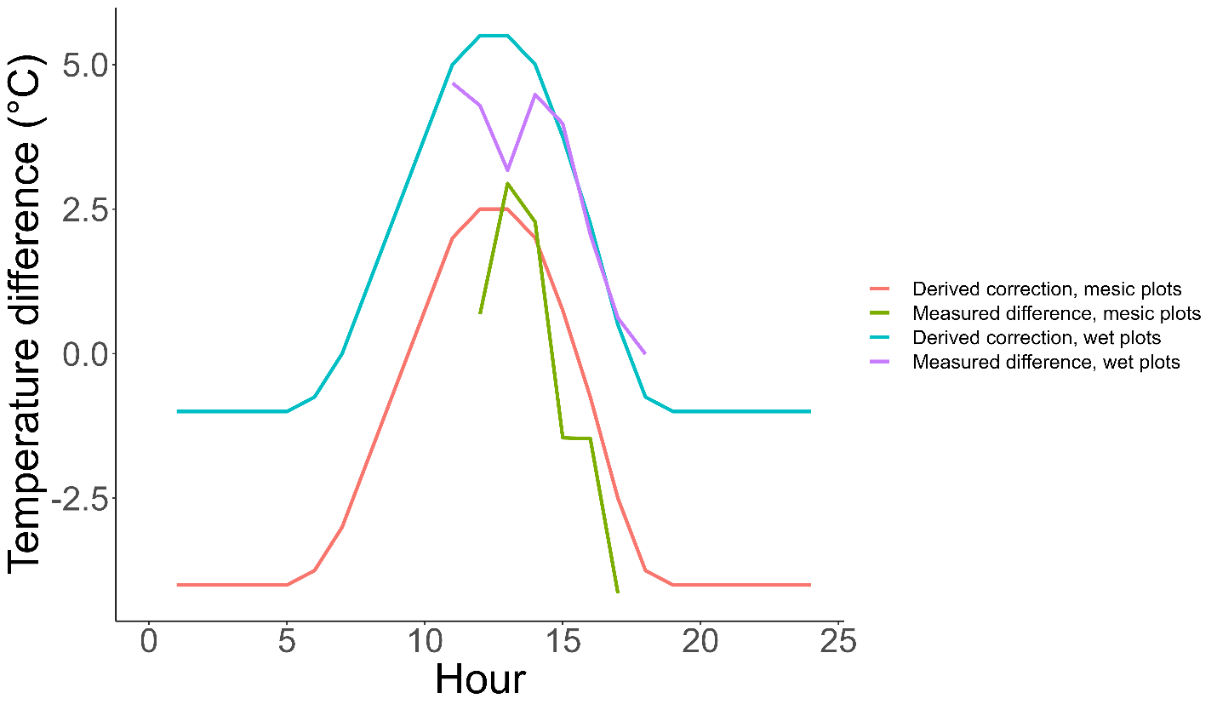
Figure S 4
Figure S4. Temperature differences between field-based measurements of soil temperature and remote sensing measurements of surface temperature for mesic (green) and wet (purple) sites on the Island of Hawai’i informed the temporally dependent derived correction used to estimate soil temperature from surface temperate for mesic (red) and wet (blue) sites.

S9. R packages
Several R packages were integral in the data processing and analysis component of this study. R packages, key functions, and citations are listed in Table S5.

Table S5. Essential data processing and analytical functions and their corresponding R packages.
Table S 5
Function | R package | Citation
Point cloud thinning; normalization | LidR | (Roussel and others 2020; Roussel and Auty 2023)
Extract canopy metrics | ForestR | (Atkins and others 2018)
AICc calculation, model selection | MuMln | (Bartoń 2023)
Statistical analysis of model | nlme | (Pinheiro and Bates 2006; Pinheiro and others 2023)

S10. Disclaimer
Any use of trade, firm, or product names is for descriptive purposes only and does not imply endorsement by the U.S. Government.

References
Akaike H. 1974. A new look at the statistical model identification. IEEE Transactions on Automatic Control 19:716–23.
Anon. 2018. Global Mapper. https://www.bluemarblegeo.com/global-mapper/
Anon. 2021. ReCap Pro. https://www.autodesk.com/products/recap/free-trial
Asner GP, Jones MO, Martin RE, Knapp DE, Hughes RF. 2008. Remote sensing of native and invasive species in Hawaiian forests. Remote Sensing of Environment 112:1912–26.
Atkins JW, Bohrer G, Fahey RT, Hardiman BS, Morin TH, Stovall AEL, Zimmerman N, Gough CM. 2018. Quantifying vegetation and canopy structural complexity from terrestrial LiDAR data using the forestr r package. Methods in Ecology and Evolution 9:2057–66.
Bartoń K. 2023. MuMIn: Multi-Model Inference. https://CRAN.R-project.org/package=MuMIn
Baruch Z, Goldstein G. 1999. Leaf construction cost, nutrient concentration, and net CO2 assimilation of native and invasive species in Hawaii. Oecologia 121:183–92.
Becker P, Nichols T. 2011. Effects of Basal Area Factor and Plot Size on Precision and Accuracy of Forest Inventory Estimates. Northern Journal of Applied Forestry 28:152–6.
Bonan G. 2019. Climate Change and Terrestrial Ecosystem Modeling. Cambridge University Press https://www.cambridge.org/core/books/climate-change-and-terrestrial-ecosystem-modeling/scalar-canopy-profiles/3494C1999FF1BCEA960D6279F892856D. Last accessed 03/01/2023
Bonan G. 2023. Matlab code for Climate Change and Terrestrial Ecosystem Modeling. https://github.com/gbonan/bonanmodeling. Last accessed 11/10/2022
Bonham CD. 2013. Measurements for Terrestrial Vegetation. John Wiley & Sons
Bumham KP, Anderson DR. 2002. Model selection and multimodel inference: a practical information-theoretic approach. New York, New York: Spnnger-Veflag https://cir.nii.ac.jp/crid/1572543026243620608. Last accessed 21/02/2025
Cogbill CV, Thurman AL, Williams JW, Zhu J, Mladenoff DJ, Goring SJ. 2018. A retrospective on the accuracy and precision of plotless forest density estimators in ecological studies. Ecosphere 9:e02187.
Cornwell WK, Bhaskar R, Sack L, Cordell S, Lunch CK. 2007. Adjustment of Structure and Function of Hawaiian Metrosideros polymorpha at High vs. Low Precipitation. Functional Ecology 21:1063–71.
Giambelluca TW, Shuai X, Barnes ML, Alliss RJ, Longman RJ, Miura T, Chen Q, Frazier AG, Mudd RG, Cuo L, Businger AD. 2014. Evapotranspiration of Hawai‘i Final Report. U.S. Army Corps of Engineers - Honolulu District and Commission on Water Resource Management, State of Hawaiʻi
Hoof J, Sack L, Webb DT, Nilsen ET. 2008. Contrasting Structure and Function of Pubescent and Glabrous Varieties of Hawaiian Metrosideros polymorpha (Myrtaceae) at High Elevation. Biotropica 40:113–8.
Kattge J, Díaz S, Lavorel S, Prentice IC, Leadley P, Bönisch G, Garnier E, Westoby M, Reich PB, Wright IJ, Cornelissen JHC, Violle C, Harrison SP, Van BODEGOM PM, Reichstein M, Enquist BJ, Soudzilovskaia NA, Ackerly DD, Anand M, Atkin O, Bahn M, Baker TR, Baldocchi D, Bekker R, Blanco CC, Blonder B, Bond WJ, Bradstock R, Bunker DE, Casanoves F, Cavender-Bares J, Chambers JQ, Chapin Iii FS, Chave J, Coomes D, Cornwell WK, Craine JM, Dobrin BH, Duarte L, Durka W, Elser J, Esser G, Estiarte M, Fagan WF, Fang J, Fernández-Méndez F, Fidelis A, Finegan B, Flores O, Ford H, Frank D, Freschet GT, Fyllas NM, Gallagher RV, Green WA, Gutierrez AG, Hickler T, Higgins SI, Hodgson JG, Jalili A, Jansen S, Joly CA, Kerkhoff AJ, Kirkup D, Kitajima K, Kleyer M, Klotz S, Knops JMH, Kramer K, Kühn I, Kurokawa H, Laughlin D, Lee TD, Leishman M, Lens F, Lenz T, Lewis SL, Lloyd J, Llusià J, Louault F, Ma S, Mahecha MD, Manning P, Massad T, Medlyn BE, Messier J, Moles AT, Müller SC, Nadrowski K, Naeem S, Niinemets Ü, Nöllert S, Nüske A, Ogaya R, Oleksyn J, Onipchenko VG, Onoda Y, Ordoñez J, et al. 2011. TRY – a global database of plant traits. Global Change Biology 17:2905–35.
Maire V, Wright IJ, Prentice IC, Batjes NH, Bhaskar R, van Bodegom PM, Cornwell WK, Ellsworth D, Niinemets Ü, Ordonez A, Reich PB, Santiago LS. 2015. Global effects of soil and climate on leaf photosynthetic traits and rates. Global Ecology and Biogeography 24:706–17.
Morisita M. 1957. A new method for the estimation of density by spacing method applicable to nonrandomly distributed populations. Seiri Seitai [Physiology and Ecology - Kyoto]:134–44.
Nakagawa S, Schielzeth H. 2013. A general and simple method for obtaining R2 from generalized linear mixed-effects models. Methods in Ecology and Evolution 4:133–42.
Pinheiro J, Bates D. 2006. Mixed-Effects Models in S and S-PLUS. Springer Science & Business Media
Pinheiro J, Bates D, R Core Team. 2023. nlme: Linear and Nonlinear Mixed Effects Models. https://CRAN.R-project.org/package=nlme
Roussel J-R, Auty D. 2023. Airborne LiDAR Data Manipulation and Visualization for Forestry Applications. https://cran.r-project.org/package=lidR
Roussel J-R, Auty D, Coops NC, Tompalski P, Goodbody TRH, Meador AS, Bourdon J-F, de Boissieu F, Achim A. 2020. lidR: An R package for analysis of Airborne Laser Scanning (ALS) data. Remote Sensing of Environment 251:112061.
USDA. 2024. Forest Inventory and Analysis Data Mart. https://apps.fs.usda.gov/fia/datamart/datamart.html
Wensel LC, Levitan J, Barber K. 1980. Selection of Basal Area Factor in Point Sampling. Journal of Forestry 78:83–4.
Wright IJ, Reich PB, Westoby M, Ackerly DD, Baruch Z, Bongers F, Cavender-Bares J, Chapin T, Cornelissen JHC, Diemer M, Flexas J, Garnier E, Groom PK, Gulias J, Hikosaka K, Lamont BB, Lee T, Lee W, Lusk C, Midgley JJ, Navas M-L, Niinemets Ü, Oleksyn J, Osada N, Poorter H, Poot P, Prior L, Pyankov VI, Roumet C, Thomas SC, Tjoelker MG, Veneklaas EJ, Villar R. 2004. The worldwide leaf economics spectrum. Nature 428:821–7.

