Supplementary Material – Ecosystems
Benthopelagic Deep-Sea Food Webs Along a Latitudinal Gradient in the Scotia Sea (Southern Ocean)

José P. Queirós^{1,2,8*}, Mark Belchier², José Abreu^{1,2}, Paco Bustamante³, Martin A. Collins², Ana M. M. Gonçalves^{4,5}, Irene Bermúdez-Gutiérrez¹, Gabriele Stowasser², Diana Vaz⁷, Philip R. Hollyman^{2,7}, José C. Xavier^{1,2,5}

¹University of Coimbra, MARE – Marine and Environmental Sciences Centre/ARNET – Aquatic Research Network, Department of Life Sciences, 3000-456 Coimbra, Portugal
²British Antarctic Survey, Natural Environment Research Council, High Cross, Madingley Road, Cambridge, CB3 0ET United Kingdom
³Littoral Environnement et Sociétés (LIENSs), UMR 7266 CNRS – La Rochelle Université, 2 rue Olympe de Gouges, 17000 La Rochelle, France
⁴Department of Biology and CESAM – Centre for Environmental and Marine Studies, University of Aveiro, Campus Universitário de Santiago, 3810-193 Aveiro, Portugal
⁵CFE – Centre for Functional Ecology: Science for People & Planet, Department of Life Sciences, University of Coimbra, 3000-456 Coimbra, Portugal
⁶Department of Physics, University of Aveiro, Campus Universitário de Santiago, 3810-193 Aveiro, Portugal
⁷School of Ocean Sciences, Bangor University, Askew Street, Menai Bridge, LL59 5AB, United Kingdom
8Present Address: CIIMAR/CIMAR LA, Interdisciplinary Centre of Marine and Environmental Research, University of Porto, Terminal de Cruzeiros Do Porto de Leixões, 4450-208 Matosinhos, Portugal

*Corresponding author: José P. Queirós (jqueiros@student.uc.pt)

Table A1. Fatty acid concentration (mg.g⁻¹ dry weight) for the different species at the three study areas.
South Georgia
Species | n | C15:0 | C16:0 | C17:0 | C18:0 | C20:0 | C22:0 | ΣSFA | C16:1ω7 | C18:1ω9 | C20:1ω9 | C22:1ω9 | ΣMUFA | C18:2ω6 | ΣPUFA | C20:4ω3 | C20:5ω3 | C22:6ω3 | ΣHUFA | ΣFA
Fish
Amblyraja sp. | 3 | 0.16 ± 0.03 | 36.78 ± 2.61 | 0.28 ± 0.06 | 9.05 ± 0.89 | 0.15 ± 0.01 | 0.00 ± 0.00 | 46.41 ± 3.34 | 3.13 ± 0.77 | 28.09 ± 6.51 | 3.59 ± 1.13 | 0.94 ± 0.14 | 35.75 ± 8.45 | 1.62 ± 0.11 | 1.62 ± 0.11 | 10.44 ± 1.10 | 16.42 ± 1.80 | 93.84 ± 10.15 | 120.70 ± 9.50 | 204.48 ±20.03
A. pharao | 0
A. rostrata | 3 | 0.12 ± 0.02 | 25.87 ± 4.08 | 0.10 ± 0.02 | 3.95 ± 0.64 | 0.14 ± 0.01 | 0.00 ± 0.00 | 30.18 ± 4.76 | 2.47 ± 0.68 | 13.92 ± 3.35 | 3.57 ± 1.00 | 0.70 ± 0.02 | 20.66 ± 4.97 | 0.53 ± 0.12 | 0.53 ± 0.12 | 2.17 ± 0.91 | 17.03 ± 6.71 | 84.05 ± 23.51 | 103.25 ± 29.31 | 154.62 ± 38.61
Artedridaco sp. | 0
Bathydraco sp. | 4 | 0.21 ± 0.06 | 28.69 ± 5.87 | 0.15 ± 0.03 | 6.93 ± 1.55 | 0.17 ± 0.01 | 0.00 ± 0.00 | 36.16 ± 7.18 | 7.86 ± 4.67 | 26.63 ± 7.47 | 3.81 ± 1.59 | 1.38 ± 0.53 | 39.69 ± 13.32 | 1.39 ± 0.43 | 1.39 ± 0.43 | 5.50 ± 2.00 | 48.41 ± 8.69 | 75.17 ± 22.06 | 129.08 ± 28.75 | 206.31 ± 44.77
Bathylagus sp. | 0
Channichthyidae | 0
C. armatus | 0
D. eleginoides | 3 | 1.32 ± 0.31 | 126.97 ± 28.58 | 0.55 ± 0.19 | 36.97 ± 14.12 | 0.91 ± 0.40 | 0.41 ± 0.37 | 167.12 ± 42.91 | 111.33 ± 22.31 | 426.62 ± 81.25 | 84.62 ± 38.04 | 26.90 ± 17.98 | 649.47 ± 89.31 | 8.26 ± 2.23 | 8.26 ± 2.23 | 8.35 ± 1.53 | 54.33 ± 13.92 | 95.59 ± 8.42 | 158.27 ± 19.93 | 983.12 ±135.96
D. mawsoni | 0
Lepidonotothen sp. | 3 | 0.17 ± 0.07 | 19.99 ± 8.70 | 0.14 ± 0.06 | 1.32 ± 2.29 | 0.15 ± 0.02 | 0.06 ± 0.11 | 21.84 ± 9.31 | 2.36 ± 1.10 | 8.80 ± 3.97 | 1.95 ± 0.70 | 0.79 ± 0.31 | 13.90 ± 5.67 | 1.03 ± 0.53 | 1.03 ± 0.53 | 3.50 ± 2.22 | 28.19 ± 12.08 | 58.35 ± 24.21 | 90.03 ± 37.99 | 126.80 ±52.88
M. caml | 3 | 0.28 ± 0.09 | 42.35 ± 10.13 | 0.17 ± 0.03 | 7.44 ± 1.36 | 0.14 ± 0.02 | 0.05 ± 0.09 | 50.43 ± 11.61 | 5.83 ± 2.76 | 18.97 ± 4.39 | 5.28 ± 2.17 | 1.18 ± 0.26 | 31.25 ± 9.05 | 1.08 ± 0.51 | 1.08 ± 0.51 | 7.87 ± 3.98 | 53.01 ± 34.84 | 61.30 ± 18.27 | 122.18 ± 57.06 | 204.94 ± 77.95
M. carinatus | 3 | 0.19 ± 0.05 | 25.19 ± 2.59 | 0.15 ± 0.06 | 5.12 ± 1.51 | 0.13 ± 0.01 | 0.00 ± 0.00 | 30.78 ± 3.71 | 2.65 ± 0.80 | 14.26 ± 4.32 | 2.03 ± 0.53 | 0.81 ± 0.29 | 19.75 ± 5.89 | 0.56 ± 0.24 | 0.56 ± 0.24 | 4.13 ± 3.17 | 15.25 ± 11.97 | 52.81 ± 33.76 | 72.19 ± 48.54 | 123.28 ± 55.28
M. holotrachys | 3 | 0.18 ± 0.04 | 26.39 ± 4.64 | 0.14 ± 0.00 | 5.44 ± 0.71 | 0.15 ± 0.00 | 0.05 ± 0.09 | 32.35 ± 5.11 | 4.46 ± 3.21 | 20.93 ± 10.97 | 3.49 ± 2.42 | 1.30 ± 0.08 | 30.17 ± 16.38 | 0.67 ± 0.36 | 0.67 ± 0.36 | 6.24 ± 0.49 | 19.65 ± 4.49 | 59.11 ± 16.59 | 85.00 ± 21.34 | 148.19 ± 39.10
M. whitsoni | 3 | 0.27 ± 0.08 | 41.16 ± 7.50 | 0.18 ± 0.05 | 6.72 ± 2.01 | 0.15 ± 0.02 | 0.10 ± 0.09 | 48.59 ± 9.72 | 4.57 ± 0.94 | 24.24 ± 7.12 | 3.26 ± 1.70 | 1.22 ± 0.60 | 33.30 ± 9.95 | 0.75 ± 0.17 | 0.75 ± 0.17 | 5.80 ± 2.03 | 38.75 ± 11.02 | 116.31 ± 18.97 | 160.85 ± 29.01 | 243.49 ± 47.65
Muraenolepis sp. | 4 | 0.29 ± 0.17 | 30.12 ± 16.59 | 0.24 ± 0.12 | 6.79 ± 4.35 | 0.24 ± 0.04 | 0.05 ± 0.11 | 37.72 ± 21.23 | 5.09 ± 3.03 | 28.66 ± 13.30 | 3.73 ± 2.78 | 0.96 ± 0.66 | 38.45 ± 19.60 | 0.62 ± 0.29 | 0.62 ± 0.29 | 2.13 ± 1.94 | 26.22 ± 15.49 | 72.51 ± 45.62 | 100.86 ± 62.80 | 177.65 ± 98.25
Paraliparis sp. | 1 | 0.22 | 24.09 | 0.24 | 4.93 | 0.22 | 0.00 | 29.70 | 8.64 | 67.78 | 9.02 | 0.57 | 86.01 | 1.99 | 1.99 | 1.96 | 29.05 | 62.38 | 93.39 | 211.09
Cephalopoda
B. abyssicola | 1 | 0.52 | 66.90 | 1.88 | 42.85 | 0.72 | 0.52 | 113.38 | 6.55 | 41.67 | 47.16 | 40.05 | 135.43 | 1.24 | 1.24 | 12.16 | 152.35 | 318.09 | 482.59 | 732.64
C. veranyi | 1 | 0.95 | 87.79 | 2.00 | 19.54 | 0.65 | 0.47 | 111.40 | 7.12 | 31.09 | 24.49 | 5.11 | 67.81 | 0.65 | 0.65 | 5.81 | 102.77 | 209.16 | 317.73 | 497.61
F. knipovitchi | 2 | 0.43 ± 0.28 | 68.18 ± 63.56 | 0.62 ± 0.42 | 7.93 ± 5.72 | 0.25 ± 0.03 | 0.24 ± 0.06 | 77.65 ± 69.88 | 2.51 ± 0.19 | 16.08 ± 10.72 | 29.77 ± 26.13 | 3.49 ± 1.30 | 51.86 ± 38.34 | 0.44 ± 0.04 | 0.44 ± 0.04 | 1.64 ± 0.88 | 108.39 ± 72.56 | 243.43 ± 200.89 | 353.46 ± 274.33 | 483.41 ±382.60
G. glacialis | 0
M. hamiltoni | 0
M. longimana | 3 | 0.50 ± 0.19 | 50.35 ± 15.27 | 0.63 ± 0.26 | 6.60 ± 3.34 | 0.31 ± 0.06 | 0.21 ± 0.18 | 58.61 ± 18.47 | 2.61 ± 0.57 | 16.10 ± 1.69 | 15.85 ± 5.60 | 3.42 ± 2.57 | 37.99 ± 9.48 | 0.50 ± 0.12 | 0.50 ± 0.12 | 3.31 ± 1.19 | 55.98 ± 23.87 | 113.07 ±30.72 | 172.36 ± 53.95 | 269.45 ±78.86
P. turqueti | 2 | 0.33 ± 0.06 | 37.41 ± 10.41 | 0.84 ± 0.07 | 11.27 ± 1.05 | 0.21 ± 0.03 | 0.17 ± 0.00 | 50.23 ± 9.34 | 0.82 ± 0.42 | 6.35 ± 2.97 | 14.69 ± 1.57 | 8.99 ± 1.59 | 30.85 ± 0.23 | 0.19 ± 0.06 | 0.19 ± 0.06 | 4.48 ± 1.97 | 38.29 ± 1.95 | 70.64 ± 36.48 | 113.41 ± 40.40 | 194.69 ±31.34
P. glacialis | 0
S. circumantarctica | 4 | 1.75 ± 1.59 | 95.87 ± 46.02 | 1.07 ± 0.41 | 9.78 ± 5.13 | 0.38 ± 0.12 | 0.41 ± 0.23 | 109.26 ± 49.62 | 13.84 ± 8.45 | 76.00 ± 42.47 | 28.04 ± 7.77 | 6.86 ± 5.84 | 124.73 ± 60.57 | 1.25 ± 0.47 | 1.25 ± 0.47 | 1.78 ± 1.66 | 122.92 ± 81.01 | 427.36 ± 479.67 | 552.06 ± 541.87 | 787.30 ± 556.07
S. gilchristi | 3 | 0.28 ± 0.16 | 29.97 ± 10.04 | 1.28 ± 0.07 | 24.69 ± 6.19 | 0.22 ± 0.03 | 0.17 ± 0.02 | 56.61 ± 6.29 | 4.16 ± 1.87 | 22.92 ± 11.68 | 24.17 ± 13.98 | 12.02 ± 2.29 | 63.28 ± 20.69 | 0.69 ± 0.26 | 0.69 ± 0.26 | 5.21 ± 1.31 | 46.59 ± 3.81 | 101.30 ± 15.61 | 153.09 ± 16.29 | 273.66 ± 38.08
T. notalia | 1 | 0.89 | 94.51 | 1.47 | 20.32 | 0.44 | 0.00 | 117.63 | 8.42 | 37.28 | 48.25 | 6.13 | 100.08 | 0.76 | 0.76 | 8.61 | 144.81 | 219.06 | 372.48 | 590.95
Crustacea
Euphausiidae | 1 | 0.23 | 26.79 | 0.16 | 1.85 | 0.23 | 0.28 | 29.53 | 3.77 | 38.56 | 1.34 | 0.76 | 44.43 | 0.91 | 0.91 | 1.51 | 49.97 | 63.54 | 115.03 | 189.90
Gnatophausiidae | 1 | 0.51 | 41.87 | 0.20 | 5.61 | 0.21 | 0.17 | 48.58 | 45.01 | 97.71 | 1.61 | 0.86 | 145.19 | 0.45 | 0.45 | 1.87 | 43.28 | 57.51 | 102.67 | 296.89
Nematocarcinus sp. | 3 | 0.42 ± 0.06 | 36.17 ± 7.00 | 0.16 ± 0.01 | 7.47 ± 1.61 | 0.21 ± 0.02 | 0.20 ± 0.03 | 44.63 ± 8.54 | 15.17 ± 5.65 | 72.93 ± 15.30 | 5.14 ± 4.99 | 2.14 ± 0.88 | 95.38 ± 26.36 | 0.61 ± 0.28 | 0.61 | 2.84 ± 0.74 | 74.33 ± 17.37 | 99.62 ± 29.02 | 176.78 ± 45.34 | 317.40 ±51.55
Paralomis sp. | 3 | 0.84 ± 0.24 | 40.47 ± 7.12 | 0.79 ± 0.14 | 7.34 ± 0.62 | 1.53 ± 1.93 | 0.60 ± 0.62 | 51.56 ± 4.10 | 8.58 ± 5.53 | 65.68 ± 8.82 | 13.40 ± 7.69 | 3.45 ± 2.78 | 91.11 ± 14.85 | 1.19 ± 0.13 | 1.19 ± 0.13 | 34.72 ± 35.62 | 207.10 ± 82.35 | 169.77 ± 122.30 | 411.59 ± 115.72 | 555.45 ± 98.47
Pasiphae sp. | 3 | 0.50 ± 0.54 | 36.31 ± 26.50 | 0.36 ± 0.33 | 4.67 ± 3.18 | 0.28 ± 0.19 | 0.32 ± 0.20 | 42.44 ± 30.38 | 13.22 ± 13.22 | 59.65 ± 40.20 | 3.53 ± 0.12 | 1.56 ± 0.21 | 77.96 ± 51.45 | 1.51 ± 1.18 | 1.51 ± 1.18 | 3.47 ± 0.77 | 79.47 ± 26.91 | 83.66 ± 19.90 | 166.60 ± 45.97 | 288.50 ± 128.39
Thymops sp. | 3 | 0.51 ± 0.47 | 37.29 ± 5.05 | 0.32 ± 0.12 | 4.16 ± 1.62 | 0.18 ± 0.05 | 0.20 ± 0.02 | 42.66 ±r 3.58 | 10.16 ± 2.54 | 66.08 ± 9.80 | 5.94 ± 5.74 | 1.95 ± 1.05 | 84.13 ± 6.57 | 1.82 ± 0.95 | 1.82 ± 0.95 | 4.45 ± 1.29 | 86.42 ± 14.70 | 81.09 ± 12.60 | 171.96 ± 27.48 | 300.56 ± 37.38
Other
Asteroidea | 1 | 0.02 | 0.19 | 0.03 | 0.47 | 0.04 | 0.04 | 0.79 | 0.06 | 0.18 | 0.21 | 0.07 | 0.52 | 0.02 | 0.02 | 1.65 | 0.29 | 0.08 | 2.02 | 3.35
Antipatharia | 1 | 0.45 | 28.59 | 1.83 | 6.72 | 1.03 | 67.62 | 106.24 | 6.06 | 46.13 | 199.91 | 134.42 | 386.53 | 2.14 | 2.14 | 36.57 | 182.52 | 11.65 | 230.74 | 725.64
Holothuria | 1 | 0.00 | 0.00 | 0.02 | 0.03 | 0.04 | 0.00 | 0.08 | 0.00 | 0.07 | 0.00 | 0.00 | 0.07 | 0.00 | 0.00 | 0.03 | 0.00 | 0.04 | 0.07 | 0.23
P. antarctica | 0

South Sandwich Islands - North
Species | n | C15:0 | C16:0 | C17:0 | C18:0 | C20:0 | C22:0 | ΣSFA | C16:1ω7 | C18:1ω9 | C20:1ω9 | C22:1ω9 | ΣMUFA | C18:2ω6 | ΣPUFA | C20:4ω3 | C20:5ω4 | C22:6ω3 | ΣHUFA | ΣFA
Fish
Amblyraja sp. | 0
A. pharao | 0
A. rostrata | 1 | 0.18 | 31.56 | 0.11 | 0.00 | 0.15 | 0.00 | 31.99 | 4.23 | 19.49 | 3.30 | 0.93 | 27.95 | 0.95 | 0.95 | 1.68 | 26.30 | 65.68 | 93.66 | 154.54
Artedridaco sp. | 0
Bathydraco sp. | 0
Bathylagus sp. | 1 | 0.81 | 72.26 | 0.22 | 16.10 | 1.31 | 1.12 | 91.81 | 28.90 | 160.06 | 116.44 | 19.23 | 324.63 | 5.41 | 5.41 | 3.64 | 52.12 | 140.18 | 195.93 | 617.78
Channichthyidae | 1 | 0.28 | 34.39 | 0.16 | 5.68 | 0.15 | 0.14 | 40.81 | 12.31 | 34.79 | 4.85 | 1.28 | 53.23 | 2.85 | 2.85 | 4.43 | 70.35 | 80.96 | 155.74 | 252.64
C. armatus | 0
D. eleginoides | 3 | 0.95 ± 0.22 | 88.74 ± 27.68 | 0.44 ± 0.11 | 22.82 ± 9.15 | 0.62 ± 0.08 | 0.51 ± 0.05 | 114.07 ± 36.80 | 81.99 ± 17.92 | 311.00 ± 92.59 | 43.00 ± 11.96 | 9.81 ± 2.61 | 445.80 ± 121.03 | 7.10 ± 2.10 | 7.10 ± 2.10 | 7.08 ± 3.26 | 62.35 ± 28.27 | 96.73 ± 43.15 | 166.17 ± 74.54 | 733.14 ± 229.06
D. mawsoni | 3 | 2.12 ± 0.23 | 100.83 ± 5.96 | 0.67 ± 0.19 | 17.68 ± 2.98 | 0.75 ± 0.06 | 0.62 ± 0.01 | 122.67 ± 9.41 | 128.86 ± 10.12 | 317.92 ± 29.22 | 77.57 ± 18.61 | 28.23 ± 8.50 | 552.58 ± 10.93 | 24.14 ± 1.85 | 24.14 ± 1.85 | 4.90 ± 0.09 | 49.56 ± 14.87 | 52.35 ± 11.93 | 106.81 ± 26.83 | 806.20 ± 41.34
Lepidonotothen sp. | 0
M. caml | 3 | 0.19 ± 0.04 | 30.63 ± 9.77 | 0.12 ± 0.02 | 6.01 ± 1.78 | 0.14 ± 0.00 | 0.05 ± 0.08 | 37.14 ± 11.51 | 3.63 ± 1.19 | 17.14 ± 5.31 | 1.99 ± 0.16 | 0.88 ± 0.11 | 23.64 ± 6.50 | 0.86 ± 0.30 | 0.86 ± 0.30 | 3.77 ± 1.04 | 31.31 ± 12.27 | 80.70 ± 20.94 | 115.78 ± 33.96 | 177.42 ± 51.64
M. carinatus | 0
M. holotrachys | 0
M. whitsoni | 3 | 0.21 ± 0.01 | 41.37 ± 8.45 | 0.14 ± 0.03 | 8.42 ± 1.79 | 0.15 ± 0.00 | 0.00 ± 0.00 | 50.28 ± 10.15 | 6.45 ± 1.30 | 33.93 ± 2.53 | 3.88 ± 1.99 | 1.04 ± 0.30 | 45.29 ± 5.91 | 1.25 ± 0.17 | 1.25 ± 0.17 | 4.56 ± 0.68 | 39.03 ± 5.48 | 114.78 ± 33.35 | 158.37 ± 39.49 | 255.19 ± 47.16
Muraenolepis sp. | 3 | 0.19 ± 0.10 | 25.83 ± 14.82 | 0.12 ± 0.01 | 4.63 ± 3.09 | 0.18 ± 0.02 | 0.05 ± 0.08 | 30.99 ± 18.09 | 6.68 ± 6.97 | 31.62 ± 30.24 | 2.42 ± 2.78 | 0.99 ± 1.10 | 41.71 ± 41.09 | 1.00 ± 0.75 | 1.00 ± 0.75 | 2.52 ± 1.66 | 30.49 ± 24.30 | 69.57 ± 46.74 | 102.58 ± 72.53 | 176.28 ± 132.36
Paraliparis sp. | 0
Cephalopoda
B. abyssicola | 0
C. veranyi | 0
F. knipovitchi | 1 | 0.34 | 35.00 | 0.73 | 8.04 | 0.33 | 0.31 | 44.74 | 2.71 | 14.37 | 28.34 | 3.35 | 48.77 | 0.45 | 0.45 | 2.16 | 65.92 | 119.86 | 187.94 | 281.90
G. glacialis | 0
M. hamiltoni | 0
M. longimana | 2 | 0.30 ± 0.05 | 27.94 ±1.76 | 0.29 ± 0.02 | 2.87 ± 0.02 | 0.22 ± 0.09 | 0.00 ± 0.00 | 31.61 ± 1.62 | 1.14 ± 0.04 | 7.47 ± 0.47 | 12.30 ± 3.95 | 1.89 ± 0.36 | 22.81 ± 4.74 | 0.27 ± 0.01 | 0.27 ± 0.01 | 3.59 ± 0.59 | 45.62 ± 22.16 | 107.93 ± 30.18 | 157.14 ± 52.93 | 211.83 ± 56.04
P. turqueti | 0
P. glacialis | 0
S. circumantarctica | 0
S. gilchristi | 0
T. notalia | 0
Crustacea
Euphausiidae | 1 | 0.69 | 59.17 | 0.41 | 3.63 | 0.33 | 0.38 | 64.61 | 12.97 | 46.95 | 1.16 | 1.38 | 62.45 | 7.06 | 7.06 | 3.73 | 121.26 | 125.98 | 250.97 | 385.09
Gnatophausiidae | 0
Nematocarcinus sp. | 0
Paralomis sp. | 0
Pasiphae sp. | 0
Thymops sp. | 0
Other
Asteroidea | 0
Antipatharia | 0
Holothuria | 0
P. antarctica | 0

South Sandwich Islands - South
Species | n | C15:0 | C16:0 | C17:0 | C18:0 | C20:0 | C22:0 | ΣSFA | C16:1ω7 | C18:1ω9 | C20:1ω9 | C22:1ω9 | ΣMUFA | C18:2ω6 | ΣPUFA | C20:4ω3 | C20:5ω4 | C22:6ω3 | ΣHUFA | ΣFA
Fish
Amblyraja sp. | 2 | 0.19 ± 0.08 | 41.05 ± 11.49 | 0.21 ± 0.03 | 8.02 ± 0.84 | 0.15 ± 0.01 | 0.00 ± 0.00 | 49.62 ± 12.45 | 6.80 ± 3.83 | 47.01 ± 10.30 | 5.55 ± 1.76 | 1.33 ± 0.20 | 60.69 ± 16.09 | 3.13 ± 1.26 | 3.13 ± 1.26 | 8.67 ± 0.99 | 19.21 ± 10.34 | 101.59 ± 9.88 | 129.47 ± 21.21 | 242.91 ± 51.01
A. pharao | 1 | 0.35 | 36.19 | 0.11 | 5.07 | 0.18 | 0.00 | 41.90 | 11.82 | 56.98 | 4.27 | 0.75 | 73.83 | 2.86 | 2.86 | 3.78 | 47.05 | 119.54 | 170.36 | 288.96
A. rostrata | 3 | 0.15 ± 0.04 | 28.87 ± 7.03 | 0.09 ± 0.01 | 1.17 ± 2.03 | 0.15 ± 0.01 | 0.00 ± 0.00 | 30.43 ± 7.80 | 3.74 ± 1.92 | 18.63 ± 8.47 | 3.75 ± 2.02 | 0.81 ± 0.23 | 26.93 ± 12.57 | 0.91 ± 0.24 | 0.91 ± 0.24 | 1.93 ± 0.59 | 20.46 ± 5.37 | 75.69 ± 15.05 | 98.08 ± 20.98 | 156.35 ± 40.52
Artedridaco sp. | 1 | 0.29 | 33.36 | 0.13 | 5.01 | 0.13 | 0.00 | 38.91 | 9.97 | 35.23 | 2.36 | 1.00 | 48.55 | 1.01 | 1.01 | 3.08 | 30.88 | 101.25 | 135.21 | 223.69
Bathydraco sp. | 0
Bathylagus sp. | 0
Channichthyidae | 1 | 0.68 | 61.06 | 0.25 | 9.68 | 0.61 | 0.24 | 72.53 | 62.01 | 152.71 | 18.75 | 4.22 | 237.70 | 6.55 | 6.55 | 6.31 | 72.75 | 94.53 | 173.59 | 490.36
C. armatus | 3 | 0.16 ± 0.04 | 26.27 ± 8.74 | 0.12 ± 0.03 | 6.70 ± 2.90 | 0.14 ± 0.02 | 0.00 ± 0.00 | 33.39 ± 11.67 | 2.43 ± 0.74 | 18.35 ±- 8.61 | 2.91 ± 2.20 | 1.16 ± 0.34 | 24.85 ± 11.79 | 1.06 ± 0.35 | 1.06 ± 0.35 | 3.56 ± 1.38 | 19.27 ± 4.34 | 94.27 ± 30.55 | 117.09 ± 35.20 | 176.39 ± 58.94
D. eleginoides | 1 | 0.49 | 50.94 | 0.26 | 12.68 | 0.43 | 0.00 | 64.80 | 22.22 | 102.95 | 10.34 | 2.48 | 137.98 | 1.78 | 1.78 | 7.55 | 42.89 | 89.03 | 139.47 | 344.03
D. mawsoni | 3 | 1.36 ± 0.27 | 67.50 ± 17.89 | 0.42 ± 0.03 | 11.65 ± 2.37 | 0.59 ± 0.04 | 0.55 ± 0.02 | 82.07 ± 20.39 | 95.54 ± 7.18 | 257.82 ± 21.21 | 59.35 ± 16.44 | 22.92 ± 7.64 | 435.64 ± 30.49 | 15.34 ± 2.61 | 15.34 ± 2.61 | 3.57 ± 0.45 | 24.76 ± 7.43 | 35.43 ± 14.15 | 63.76 ± 21.60 | 596.81 ± 71.00
Lepidonotothen sp. | 1 | 0.19 | 18.99 | 0.26 | 0.00 | 0.14 | 0.00 | 19.58 | 4.40 | 12.81 | 1.43 | 0.39 | 19.04 | 0.67 | 0.67 | 7.69 | 27.96 | 38.01 | 73.66 | 112.95
M. caml | 3 | 0.33 ± 0.15 | 40.83 ± 9.52 | 0.21 ± 0.07 | 9.40 ± 2.05 | 0.16 ± 0.03 | 0.00 ± 0.00 | 50.94 ± 11.75 | 7.67 ± 3.46 | 39.68 ± 16.52 | 6.82 ± 4.01 | 1.57 ± 0.97 | 55.74 ± 24.94 | 1.84 ± 0.54 | 1.84 ± 0.54 | 7.22 ± 5.04 | 43.99 ± 15.99 | 111.01 ± 23.21 | 162.21 ± 44.05 | 270.73 ± 81.06
M. carinatus | 0
M. holotrachys | 0
M. whitsoni | 3 | 0.21 ± 0.05 | 41.03 ± 11.33 | 0.13 ± 0.03 | 8.07 ± 2.20 | 0.15 ± 0.01 | 0.06 ± 0.10 | 49.65 ± 13.55 | 5.45 ± 1.45 | 30.34 ± 4.87 | 2.87 ± 0.67 | 1.03 ± 0.06 | 39.68 ± 5.89 | 1.25 ± 0.03 | 1.25 ± 0.03 | 4.59 ± 1.14 | 37.59 ± 14.66 | 114.96 ± 28.54 | 157.14 ± 44.06 | 247.72 ± 62.96
Muraenolepis sp. | 3 | 0.31 ± 0.06 | 33.89 ± 5.95 | 0.17 ± 0.03 | 8.25 ± 1.77 | 0.23 ± 0.03 | 0.09 ± 0.15 | 42.94 ± 7.96 | 26.35 ± 15.23 | 87.77 ± 31.94 | 7.90 ± 1.94 | 1.16 ± 0.22 | 123.18 ± 45.39 | 2.36 ± 0.85 | 2.36 ± 0.85 | 3.47 ± 0.21 | 32.85 ± 12.65 | 105.30 ± 22.81 | 141.62 ± 35.33 | 310.10 ± 65.86
Paraliparis sp. | 0
Cephalopoda
B. abyssicola | 0
C. veranyi | 0
F. knipovitchi | 3 | 0.56 ± 0.34 | 88.61 ± 84.34 | 0.59 ± 0.36 | 8.53 ± 6.85 | 0.26 ± 0.03 | 0.28 ± 0.01 | 98.84 ± 91.80 | 5.22 ± 2.72 | 26.80 ± 19.16 | 18.91 ±5.22 | 4.27 ± 3.00 | 55.19 ± 30.01 | 0.79 ± 0.59 | 0.79 ± 0.59 | 2.24 ± 1.31 | 120.53 ± 98.09 | 236.80 ± 207.55 | 359.57 ± 305.13 | 514.40 ± 426.73
G. glacialis | 3 | 0.59 ± 0.05 | 58.09 ± 7.40 | 0.51 ± 0.27 | 11.10 ± 10.38 | 0.40 ± 0.17 | 0.00 ± 0.00 | 70.70 ± 17.83 | 14.00 ± 10.45 | 39.94 ± 22.33 | 30.50 ± 15.66 | 7.27 ± 4.94 | 91.71 ± 53.13 | 1.16 ± 0.66 | 1.16 ± 0.66 | 5.14 ± 1.26 | 80.81 ± 14.55 | 106.28 ± 19.09 | 192.23 ± 17.98 | 355.80 ± 74.55
M. hamiltoni | 3 | 0.58 ± 0.19 | 49.79 ± 22.58 | 0.83 ± 0.16 | 12.40 ± 0.58 | 0.27 ± 0.09 | 0.00 ± 0.00 | 63.87 ± 22.46 | 7.79 ± 5.10 | 24.22 ± 14.58 | 33.20 ± 0.85 | 3.38 ± 1.21 | 68.58 ± 20.32 | 0.79 ± 0.92 | 0.79 ± 0.92 | 3.42 ± 1.46 | 83.75 ± 19.99 | 139.17 ± 62.43 | 226.34 ± 81.13 | 359.59 ± 124.23
M. longimana | 4 | 0.44 ± 0.13 | 44.96 ± 11.26 | 0.57 ± 0.07 | 7.89 ± 3.67 | 0.28 ± 0.04 | 0.12 ± 0.15 | 54.26 ± 11.31 | 2.84 ± 1.05 | 14.24 ± 7.45 | 26.93 ± 10.23 | 3.94 ± 1.74 | 47.96 ± 14.63 | 0.38 ± 0.20 | 0.38 ± 0.20 | 8.80 ± 4.42 | 55.22 ± 16.22 | 131.28 ± 50.40 | 195.30 ± 69.75 | 297.90 ± 85.30
P. turqueti | 0
P. glacialis | 1 | 0.46 | 51.37 | 0.34 | 5.72 | 0.30 | 0.00 | 58.19 | 6.13 | 22.96 | 20.92 | 4.68 | 54.70 | 0.61 | 0.61 | 5.11 | 71.15 | 109.64 | 185.90 | 299.40
S. circumantarctica
S. gilchristi | 0
T. notalia | 0
Crustacea
Euphausiidae | 3 | 0.33 ± 0.12 | 35.91 ± 20.49 | 0.16 ± 0.08 | 2.13 ± 1.39 | 0.58 ± 0.67 | 0.67 ± 0.67 | 39.79 ± 20.31 | 12.04 ± 9.89 | 67.75 ± 74.42 | 9.95 ± 9.32 | 3.62 ± 1.77 | 93.36 ± 93.60 | 5.58 ± 1.90 | 5.58 ± 1.90 | 3.24 ± 1.34 | 139.66 ± 1.63 | 242.30 ± 129.03 | 385.20 ± 129.05 | 523.92 ± 158.74
Gnatophausiidae | 0
Nematocarcinus sp. | 4 | 0.44 ± 0.30 | 25.57 ± 17.62 | 0.25 ± 0.18 | 8.51 ± 8.45 | 0.26 ± 0.06 | 0.17 ± 0.11 | 35.20 ± 23.53 | 29.83 ± 16.63 | 145.57 ± 121.46 | 5.66 ± 4.39 | 2.50 ± 1.25 | 183.56 ± 143.32 | 1.79 ± 1.42 | 1.79 ± 1.42 | 2.66 ± 1.49 | 82.19 ± 43.69 | 109.32 ± 55.97 | 194.17 ± 100.85 | 414.72 ± 257.60
Paralomis sp. | 0
Pasiphae sp. | 2 | 0.47 ± 0.26 | 23.49 ± 7.88 | 0.13 ± 0.02 | 2.90 ± 1.26 | 0.20 ± 0.02 | 0.18 ± 0.04 | 27.36 ± 9.36 | 10.75 ± 0.25 | 70.05 ± 53.80 | 11.87 ± 13.48 | 2.23 ± 1.84 | 94.90 ± 68.86 | 2.66 ± 2.77 | 2.66 ± 2.77 | 2.96 ± 3.04 | 52.02 ± 55.74 | 80.69 ± 90.18 | 135.67 ± 148.97 | 260.60 ± 211.24
Thymops sp. | 0
Other
Asteroidea | 4 | 0.05 ± 0.03 | 0.88 ± 0.62 | 0.05 ± 0.03 | 0.99 ± 0.39 | 0.08 ± 0.04 | 0.02 ± 0.02 | 2.08 ± 0.83 | 0.32 ± 0.17 | 1.21 ± 0.67 | 0.31 ± 0.17 | 0.38 ± 0.16 | 2.22 ± 1.15 | 0.07 ± 0.02 | 0.07 ± 0.02 | 1.21 ± 1.54 | 2.42 ± 1.36 | 0.55 ± 0.35 | 4.18 ± 2.70 | 8.54 ± 2.62
Antipatharia | 0
Holothuria | 3 | 0.12 ± 0.13 | 8.49 ± 11.18 | 0.15 ± 0.09 | 2.76 ± 2.49 | 0.24 ± 0.15 | 0.21 ± 0.18 | 11.97 ± 14.22 | 4.92 ± 6.28 | 17.23 ± 22.55 | 1.98 ± 2.41 | 1.18 ± 0.65 | 25.31 ± 31.86 | 0.48 ± 0.55 | 0.48 ± 0.55 | 8.79 ± 6.70 | 9.50 ± 9.19 | 6.49 ± 7.76 | 24.78 ± 23.56 | 62.55 ± 70.14
P. antarctica | 1 | 0.33 | 37.94 | 0.14 | 40.03 | 0.56 | 0.57 | 79.58 | 6.60 | 76.96 | 2.76 | 0.90 | 87.22 | 5.21 | 5.21 | 3.17 | 12.22 | 4.85 | 20.24 | 192.24

Table A2. Maximum size of species in the South Georgia and the South Sandwich Islands’ bathyal benthopelagic food webs. n: number of individuals analysed; δ¹⁵N values: range of values analysed in individuals across the three food webs; Trophic position: range of estimated trophic position for the species across the three studied food webs; Total length, Mantle length and Carapace length represent the maximum length reported in previous studies for the species; Reference species: species from the genus/family present in the study region and were used as reference for the lengths. Values in δ¹⁵N values and Trophic position represent the minimum – maximum; Values in Total length, Mantle length, and Carapace length represent the maximum size recorded for the smallest species - largest species used as reference.
Species |  | n | δ¹⁵N values (‰) | Trophic position | Total length (cm) | Mantle length (cm) | Carapace length (cm) | Reference speciesª | Source^{b}
Fish
Amblyraja sp. |  | 13 | 11.14 – 13.42 | 4.2 – 4.9 | 115 |  |  |  | (Main and Collins 2011)
Anotopterus pharao |  | 1 | 9.77 | 3.8 | 105 |  |  |  | (Gon and Heemstra 1990)
Antimora rostrata |  | 20 | 10.30 – 12.51 | 4.0 – 4.6 | 75 |  |  |  | (Gon and Heemstra 1990)
Artedidraco sp. |  | 1 | 11.45 | 4.3 | 125 |  |  | A. mirus | (Gon and Heemstra 1990)
Bathydraco sp. |  | 13 | 8.69 – 12.70 | 3.5 – 4.7 | 17 - 24 |  |  | B. antarcticus, B. joannae, B. marri, B. scotiae | (Gon and Heemstra 1990; Queirós and others 2024)
Bathylagus sp. |  | 1 | 11.53 | 4.4 | 19 - 22 |  |  | B. antarcticus, B. gracilis | (Gon and Heemstra 1990; Froese and Pauly 2021)
Champsocephalus gunnari |  | 2 | 10.21 – 10.22 | 4.0 – 4.0 | 66 |  |  |  | (Gon and Heemstra 1990)
Channichthyidae |  | 1 | 11.89 | 4.5 | 52 - 66 |  |  | Chaenocephalus aceratus, Champsocephalus gunnari, Chionodraco rastrospinosus, Pseudochaenichthys georgianus | (Gon and Heemstra 1990; Clarke and others 2008; Queirós and others 2024)
Chionodraco rastrospinosus |  | 1 | 10.11 | 3.9 | 52 |  |  |  | (Gon and Heemstra 1990)
Coryphaenoides armatus |  | 10 | 12.11 – 12.89 | 4.5 – 4.8 | 102 |  |  |  | (King and Priede 2008; Froese and Pauly 2021)
Dissostichus eleginoides |  | 22 | 12.30 – 15.90 | 4.6 – 5.6 | 253 |  |  |  | (Soeffker and others 2022)
Dissostichus mawsoni |  | 19 | 12.68 – 15.47 | 4.7 – 5.5 | 198^{c} |  |  |  | (Soeffker and others 2022)
Gymnoscopelus sp. |  | 3 | 10.47 – 11.31 | 4.0 – 4.3 | 13 - 28 |  |  | G. bolini, G. braueri, G. nicholsi, G. opisthopterus | (Gon and Heemstra 1990)
Idiacanthus atlanticus |  | 2 | 11.55 – 11.81 | 4.4 – 4.4 | 53 |  |  |  | (Froese and Pauly 2021)
Lepidonotothen sp. |  | 6 | 9.42 – 10.41 | 3.7 – 4. | 22 – 60 |  |  | L. larseni, L. nudifrons, L. squamifrons | (Gon and Heemstra 1990; Blasina and others 2017; Maschette and others 2024)
Lycenchelys antarctica |  | 1 | 11.38 | 4.3 | 26 |  |  |  | (Gon and Heemstra 1990)
Macrourus caml |  | 31 | 11.14 – 13.29 | 4.2 – 4.9 | 90^{d} |  |  |  | (Abreu, unpublished data)
Macrourus carinatus |  | 11 | 12.24 – 14.84 | 4.6 – 5.3 | 103 |  |  |  | (unpublished data)
Macrourus holotrachys |  | 8 | 14.18 – 15.55 | 5.1 – 5.5 | 98 |  |  |  | (unpublished data)
Macrourus whitsoni |  | 29 | 10.98 – 13.82 | 4.2 – 5.0 | 78 |  |  |  | (unpublished data; Moore and others 2022b)
Melanostigma sp. |  | 1 | 12.97 | 4.8 | 29 |  |  | M. gelatinosum | (Gon and Heemstra 1990)
Muraenolepis sp. |  | 34 | 10.75 – 14.45 | 4.1 – 5.2 | 60e |  |  |  | (Fitzcharles and others 2021)
Paraliparis sp. |  | 1 | 8.76 | 3.5 | 11 - 20 |  |  | P. diploprora, P. gracilis, P. kreffti, P. stehmanni, P. tetrapteryx | (Gon and Heemstra 1990)
Pogonophryne sp. |  | 1 | 12.01 | 4.5 | 21 |  |  | P. marmorata | (Gon and Heemstra 1990; Queirós and others 2024)
Stomiidae |  | 2 | 11.62 – 12.66 | 4.4 – 4.7 | 29 |  |  | Stomias gracilis | (Gon and Heemstra 1990; Queirós and others 2024)
Cephalopoda
Batoteuthis abyssicola |  | 1 | 10.63 | 4.1 |  | 8 |  |  | (Cherel 2020)
Chiroteuthis veranyi |  | 3 | 10.51 – 13.25 | 4.1 – 4.9 |  | 30 |  |  | (Cherel 2020)
Filippovia knipovitchi |  | 8 | 8.33 – 10.92 | 3.4 – 4.2 |  | 45 |  |  | (Cherel 2020)
Galiteuthis glacialis |  | 4 | 8.71 – 10.21 | 3.5 – 4.0 |  | 68 |  |  | (Cherel 2020)
Mesonychoteuthis hamiltoni |  | 4 | 10.48 – 11.97 | 4.1 – 4.5 | 600 | 250^{f} |  |  | (Rosa and others 2017; Cherel 2020)
Moroteuthopsis longimana |  | 20 | 6.33 – 12.16 | 2.8 – 4.5 | 225 | 110^{g} |  |  | (Lynnes and Rodhouse 2002; Cherel 2020)
Pareledone turqueti |  | 4 | 10.75 – 11.61 | 4.1 – 4.4 |  | 10 |  |  | (Matias and others 2019; Queirós and others 2021)
Psychroteuthis glacialis |  | 2 | 9.56 – 11.08 | 3.8 – 4.2 |  | 44 |  |  | (Cherel 2020)
Slozarczykovia circumantarctica |  | 7 | 7.81 – 12.72 | 3.3 – 4.7 |  | 18 |  |  | (Cherel 2020)
Stauroteuthis gilchristi |  | 6 | 7.88 – 12.11 | 3.3 – 4.5 | 60 | 7 |  |  | (Collins and Henriques 2000)
Taonius sp. B (Voss) |  | 1 | 8.32 | 3.4 |  | 46 |  |  | (Cherel 2020)
Crustacea
Euphausiid |  | 10 | 4.42 – 9.12 | 2.3 – 3.7 | 2 – 7 |  |  | Euphausia frigida, E. superba, E. triacantha, Thysanoessa vicina, T. macrura | (Cuzin-Roudy and others 2014)
Gammaridae |  | 3 | 8.26 – 10.30 | 3.4 – 4.0 | 8 |  |  | Eurythenes obesus^{g} | (Xavier and others 2020)
Gnathophausiidae |  | 1 | 10.11 | 3.9 | 16 – 35^{i} |  |  | Neognathophausia gigas, N. ingens | (Pequegnat 1965; Xavier and others 2020)
Isopod |  | 3 | 9.61 – 11.75 | 3.8 – 4.4 | 2 – 10 |  |  | Glyptonotus antarcticus, Ceratoserolis trilobitoides, Septemserolis septemcarinata, Cassidinopis emarginata | (Xavier and others 2020)
Nematocarcinus sp. |  | 17 | 8.16 – 11.53 | 3.4 – 4.4 | 16 |  | 3 | N. lanceopes | (Arntz and Gorny 1991; Dambach and others 2012; Basher and Costello 2016)
Paralomis sp. |  | 5 | 12.04 – 13.36 | 4.5 – 4.9 |  |  | 7 - 13 | P. anemarae, P. birsteini, P. formosa, P. spinosissima | (Belchier and others 2012; Griffiths and others 2013; Smith and others 2017)
Pasiphae sp. |  | 8 | 8.92 – 11.43 | 3.6 – 4.3 | 9^{j} |  |  | P. scotiae | (Lorentsen and others 1998)
Thymops sp. |  | 3 | 9.41 – 10.18 | 3.7 – 4.0 | 25 |  | 14 | T. birsteini | (Laptikhovsky and Reyes 2009; Palomares and Pauly 2025)
ªSpecies of reference for taxa identified to genus (or family) were chosen according to their known distribution in South Georgia and the South Sandwich Islands. When more than one species can be found in the region we presented the range from the smallest to the largest species. ^{b}Sources were used for species distribution and maximum size; for fish, we started by checking in Gon and Heemstra (1990) and searched in other literature for updates or if information on maximum total length was not available; ^{c}Total length for Dissostichus mawsoni in the study region, the species can reach larger sizes in other areas, e.g. Ross Sea region up to 210 cm (Hanchet and others 2015); ^{d}Total length recorded for the South Georgia and the South Sandwich Islands area; species can reach larger sizes in other areas, e.g. Ross Sea region up to 97 cm (Moore and others 2022a); ^{e}The maximum length presented here refers to fisheries data in South Georgia and the South Sandwich Islands with individuals identified as Muraenolepis sp.. ^{f}Maximum mantle length confirmed though possible growing up to 400 cm (Cherel 2020); ^{g}Potentially growing up to 200 cm of mantle length (Cherel 2020).^{h}Eurythenes obesus was chosen as a reference species as it was the largest species found in the diet of predators in the study region (JPQ unpublished data); ^{j}The largest individual of Neognathophausia ingens was recorded in the Pacific Ocean but it was a unique specimen with further expeditions in the deep-sea capturing the largest individuals with total length of 16 cm ; ^{i}Largest individuals recorded from the diet of Antarctic petrels Thalassoica antarctica.

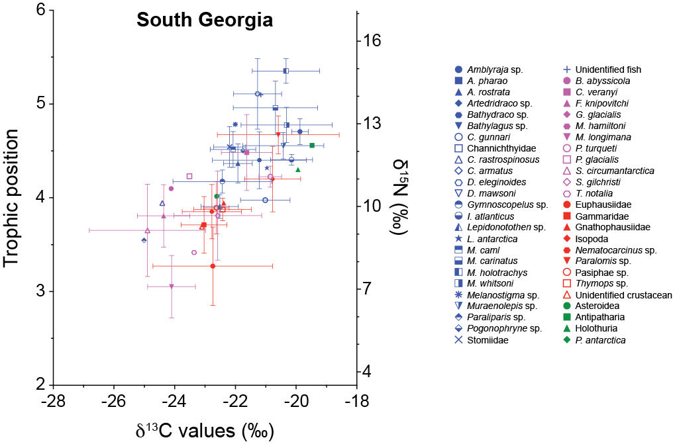
Figure A1. Trophic position and δ¹³C values for each study area. Colours define the taxonomic groups: blue – fish; pink – cephalopods; red – crustaceans; green – others. Values are mean ± standard deviation.
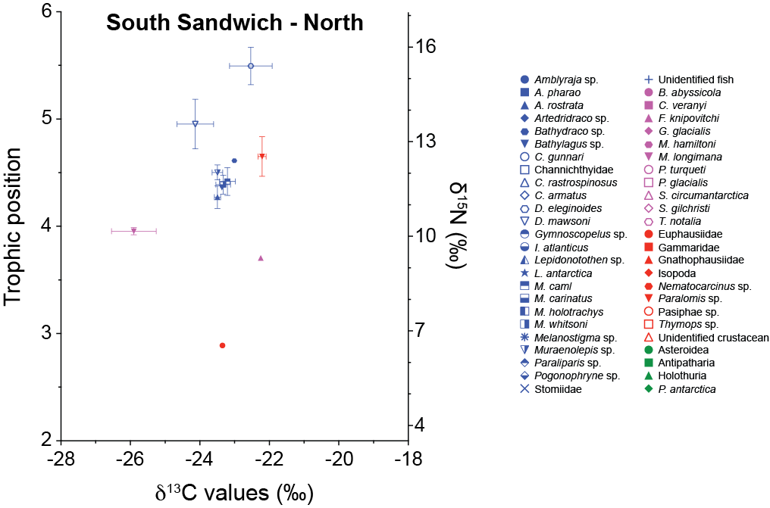

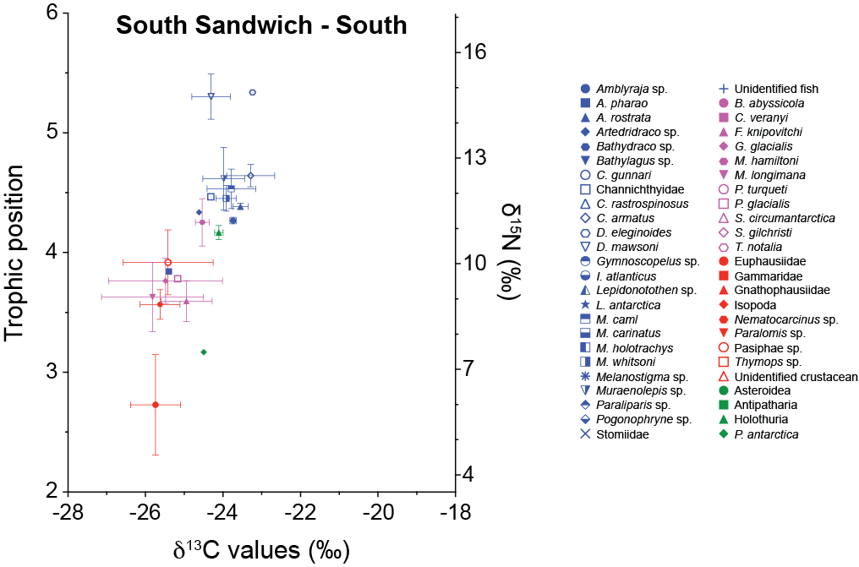

Figure A2. Heatmaps with the % of the different fatty acids in the muscle (except Asteroidea, Antipatharia and Holothurian) for each study areas. Colours in the name define the taxonomic groups: blue – fish; pink – cephalopods; red – crustaceans; green – others. Grey columns mean no sample of the species was analysed.

