Supporting information
Herbivory-induced Nardus stricta dominance enriches plant silicon relative to phosphorus enforcing alternative ecosystem stable states in an alpine environment.
Furey G. N.₁, Austrheim, G. ₂, Strand, L. T. ₁, Mulder, J.₁, Speed J. D. M. ₂, and Martinsen, V.₁
1 Faculty of Environmental Sciences and Natural Resource Management
Norwegian University of Life Sciences, Ås, Norway
2 Department of Natural History, NTNU University Museum, Norwegian University of Science and Technology, Trondheim, Norway.

Supplemental Methods

Leaf sampling
In the approximately 15 meters surrounding each quadrat, at least five leaves were taken from at least five individuals and collected in paper bags. Upright leaves representing this year’s growth were sampled for the grasses. For Solidago virgaurea, some plants were just rosettes and others had stem tissue and leaf sampling occurred on both rosettes and those growing latterly on stem tissue. For the grasses, three samples were taken at all sites. For S. virgaurea three samples were only taken on each of the islands. As it was too rare on the mainland, only one sample was taken inside the fence and where possible outside the fence, but it was not found in two grazed plots. The composite samples for each species in each area were then bulked for analyses at the site by fenced level to obtain a representative sample.

Plant chemical analyses
The plant samples represent 45 whole samples from 0.25m² clipped quadrats and 43 composite leaf samples at the species level. The samples were analyzed for total C and N by the dry combustion method (LECO CHN628, USA). For other elements, the samples were digested twice: once with HNO₃ and again using HNO₃ + HF (for Si only). 0.25 g of plant sample was digested using 2 ml of Milli-Q H₂O and 5 ml of HNO₃ (additionally with 1 ml of HF) at 260 C for 60 minutes using microwave digestion (Ultraclave, Milestone, Italy) and analyzed using Inductively Coupled Plasma Optical Emission Spectrometer (ICP-OES) (5110 VDV, Agilent, USA). As S. virgaurea had low leaf mass outside the fence, three M-G samples had insufficient mass for the second HF digest and are reported as missing values for Si.

Soil stocks
The stock for each core was calculated using equation 1 summing from 1 to n core sections (2–4) based on each section i where S_{core} is the total stock per core in grams per meter squared, C is the concentration of P_{AL} on the fine earth fraction in milligrams per kilogram, ρ is bulk density measured as the mass of fine earth divided by the total volume in grams per centimeter cubed, L is the length in centimeters of the core. The mean total depth was 31 cm (n = 45).
$S_{core}=\sum_{i=1}^{n}{\left(C_{i}ρ_{i}L_{i}*0.01\right)}$ (1)

Data inclusion
Out of the experiment’s ten original sites, we report the five that were sampled in June of 2023. The focus of this manuscript is on the plant community and the concentration of elements within leaves and biomass. Given the complexity of the soil in this study system, a more thorough description of the soils will be presented in a forthcoming manuscript. Background characteristics are presented in the methods. For this manuscript, soil ammonium lactate P, soil oxalate extractable P, and soil texture, are presented to help explain the patterns we discovered in aboveground plant P.

Pre-planned and post-hoc analyses
Prior to data collection, we established a priori hypotheses that Si would be highest in Nardus stricta due to its herbivory resistance and that plant Si should increase under herbivory (Grant and others 1985; Massey and others 2007; Soininen and others 2013; Petit Bon and others 2022). We further expected that S. virgaurea should be the lowest in Si and highest in other essential elements and that Avenella flexuosa should be lower in Si than N. stricta as it is grazing preferred (Evju and others 2006; Petit Bon and others 2022). We expected that calcium (Ca) would be the element with the greatest increase on the islands with decreased graminoid dominance given phylogenetic differences comparing grasses e.g. N. stricta and forbs e.g. S. virgaurea (Bradshaw and others 1958; Schaller and others 2016, 2017; Mládková and others 2018; White and others 2018; Furey and Tilman 2023) and their response to herbivory—particularly that of congener Solidago rigida, which is high in Ca and preferred by white-tailed deer (Furey and Tilman 2023, 2024). While there were interesting patterns in the ratio of Si to Ca, following data exploration, we found that it was the concentration of P, not Ca, that had the largest increase in plant biomass on the islands and report it as a post-hoc discovery. We further discovered very low levels of soil phosphorus coinciding with the low levels of P in plant biomass. To reduce false positives, we report only multiple comparisons in leaves for Si and P for the three species and report formal analyses for the concentration and stock of Si and P in aboveground biomass. The means and standard deviation for other elements are presented below.

Statistical Analyses
The relative abundance of two grass species: N. stricta and A. flexuosa were analyzed. A generalized linear mixed effects model was tested using a binomial family with site included as a random intercept using package lme4 (Bates and others 2015). Pairwise comparisons were conducted among the three means using emmeans (Lenth 2020) with a Tukey post-hoc correction on the log odds scale using asymptotic degrees of freedom.
The Berger-Parker Dominance Index was calculated based on the measured plant abundances (Berger and Parker 1970). The index was tested for differences based on Grazing status using a generalized linear mixed effect model with site as a random intercept using the beta distribution with package glmmTMB (Brooks and others 2017). Differences were tested as previously described for community abundance.
The concentration of Si and P in the leaves of the three species were tested for both interspecific differences, intraspecific differences and Grazing status differences. Both Grazing status (the three grazing statuses) and Species (the three species) were considered factors. A linear mixed effects model tested each factor and their interaction along with a random intercept for site using a Gaussian distribution. Si was natural log transformed. Pairwise comparisons were tested using a Tukey post-hoc correction using Kenward-Roger degrees of freedom using emmeans.
Aboveground plant biomass, the concentration of Si and P within aboveground biomass and the stock of those elements within aboveground biomass were analyzed based on Grazing status. A linear mixed effects model was first tested with the effect of Grazing status and a random intercept for plot nested within site using a Gaussian distribution. A site-level random intercept for the mainland sites was over specified explaining negligible variance and we therefore treated site by Grazing status as a crossed random effect. For the model for aboveground biomass and for the concentration and stocks of Si and the stocks of P, the response variable was transformed using the natural log. Pairwise comparisons were conducted in the previously describe two-step process using twelve degrees of freedom.
Soil P_{AL} was analyzed using three different response variables to capture variation in the soil. One using the concentration of P_{AL} in the O-horizon, one using the concentration of P_{AL} in the top 10 cm of the mineral soil (excluding histosols) and one using the total stock of P_{AL} per core (n = 45; n = 32; n = 45). Neither a crossed nor a nested site-level random effect was supported as it explained negligible variance. Ordinary least squares (OLS) regression was therefore used for all soil variables. For the model of the stock of P_{AL}, a binary variable of organic soil or not was included to control for the effect of Histosols. The total stock of P_{AL} was natural log transformed. Pairwise tests were conducted as previously described but averaged across the Histosol variable for the stock of P_{AL} with degrees of freedom constrained to the number of sites and not subplots. For all soil variables, we report differences p<0.1 as marginal given the high heterogeneity to present uncertainty and reduce false negatives.
For the deepest mineral fraction of each core that was not a Histosol (n = 22), indices of oxalate extractable P (P_{ox}), P_{ox} sorption capacity (PSC) and the degree of P saturation (DPS) were similarly tested for their dependency on Grazing status using OLS regression.
The ratio of Si to P in both aboveground biomass and leaves was calculated using the concentration of both elements. For aboveground biomass, a linear mixed effect model tested the dependency of the natural log of Si:P on Grazing status with a random intercept for site using a Gaussian distribution. For leaves, the dependency of the natural log of Si:P was tested on Species, Grazing status and their interaction as previously described for leaf Si and P. Pairwise comparisons and model assumptions were tested as previously described.

Supplemental tables
Supplemental Table 1: Background soil characteristics in both the O-horizon¹ and mineral soil from 0–10 cm where present. I-NG, M-G and M-NG represent the three grazing statuses Sheep grazed (M-G), Sheep excluded (M-NG) and Sheep-free islands (I-NG). Each value represents the mean ± 1 standard error. Natural bulk density is the mass of soil divided by the total volume (g cm⁻³); Total Soil carbon and nitrogen is the total amount measured by dry combustion (%). Soil pH² is the soil pH on dry soil².
Variable | Horizon | I-NG | M-G | M-NG
Natural Bulk Density | Org1 | 0.22 ± 0.02 | 0.19 ± 0.01 | 0.17 ± 0.02
Natural Bulk Density | Min1 | 1.05 ± 0.03 | 0.94 ± 0.08 | 0.99 ± 0.05
Total Soil Carbon | Org1 | 39.90 ± 2.61 | 37.05 ± 2.58 | 38.90 ± 2.33
Total Soil Carbon | Min1 | 2.79 ± 0.21 | 4.47 ± 0.66 | 3.19 ± 0.22
Total Soil Nitrogen | Org1 | 2.69 ± 0.17 | 2.72 ± 0.21 | 2.55 ± 0.17
Total Soil Nitrogen | Min1 | 0.16 ± 0.02 | 0.26 ± 0.05 | 0.18 ± 0.02
Soil pH | Org1 | 4.15 ± 0.07 | 4.53 ± 0.10 | 4.56 ± 0.08
Soil pH | Min1 | 4.32 ± 0.04 | 4.45 ± 0.07 | 4.51 ± 0.07
1 The O-horizon of soils with mineral soil present combined with the top 10 cm of Histosols.
2 Measured in a 1:2.5 volume of water to volume of dry soil

Supplemental Table 2: Soil texture measured on one sample representing the deepest, longest, mineral core with the smallest coarse fraction per mainland site or island. Clay, Silt and Sand are expressed as percent of the total. Texture classes were assigned using the United States Department of Agricultural system with cutoffs for < 2 µm for clay, ≤ 2 µm x ≤ 50 µm for silt and 50 < x < 2000 µm for sand using R package soiltexture. The sample code is I for island or M for mainland, G for grazed and NG for ungrazed, the plot and the core section as the 3rd of three ten centimeter sections.
Sample | Island or Mainland | Site | Grazing status | Clay (%) | Silt (%) | Sand (%) | Texture Class
I1-NG-1-Min3 | I | I1 | I-NG | 1.34 | 15.2 | 83.4 | Loamy Sand
I3-NG-1-Min3 | I | I3 | I-NG | 3.53 | 25.9 | 70.6 | Sandy Loam
I4-NG-1-Min3 | I | I4 | I-NG | 1.35 | 17.6 | 81.0 | Loamy Sand
I5-NG-1-Min3 | I | I5 | I-NG | 2.15 | 23.0 | 74.9 | Loamy Sand
M1-G-1-Min3 | M | M1 | M-G | 0.92 | 7.87 | 91.2 | Sand
M2-G-1-Min3 | M | M2 | M-G | 1.40 | 10.7 | 87.9 | Sand
M3-G-2-Min3 | M | M3 | M-G | 1.68 | 16.5 | 81.9 | Loamy Sand
M4-G-2-Min3 | M | M4 | M-G | 2.47 | 24.0 | 73.5 | Loamy Sand
M8-G-3-Min3 | M | M8 | M-G | 0.75 | 11.1 | 88.1 | Sand

Supplemental Figures
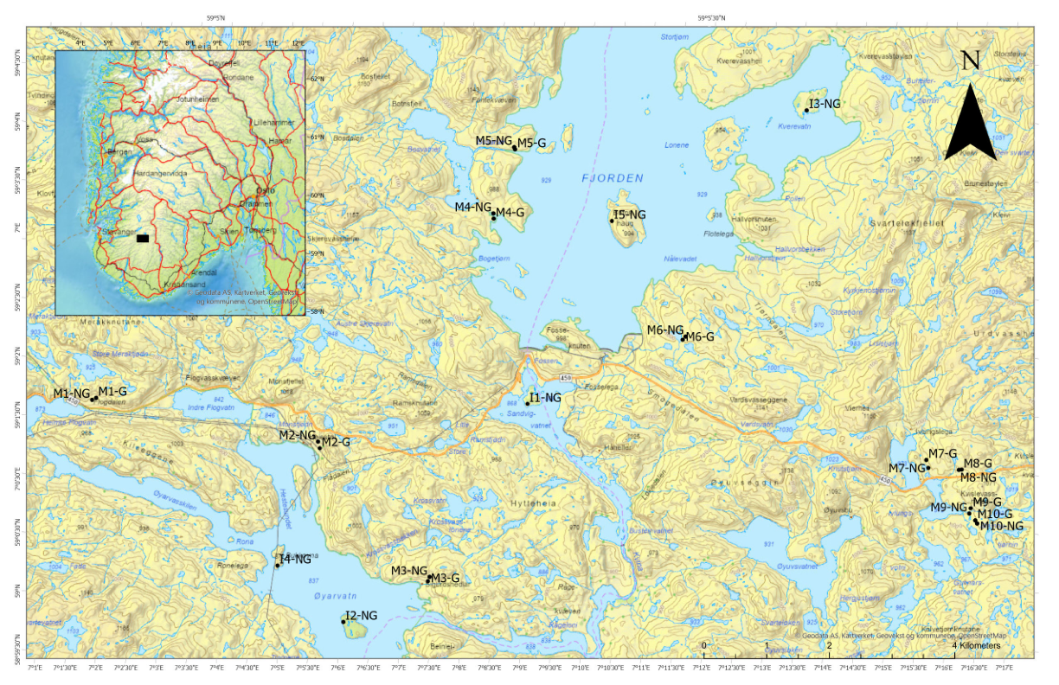
Supplemental Figure 1: Map of the experimental area in Setesdal Vesthei. Each site is denoted with the prefix M and its number from M1–M10. The paired exclosure (NG) and grazed plots (G) are shown for each site at their approximate location. Each of the five islands is shown from I1–I5. In the present study, all islands were sampled. Sites M1, M2, M3, M4 and M8 were sampled.

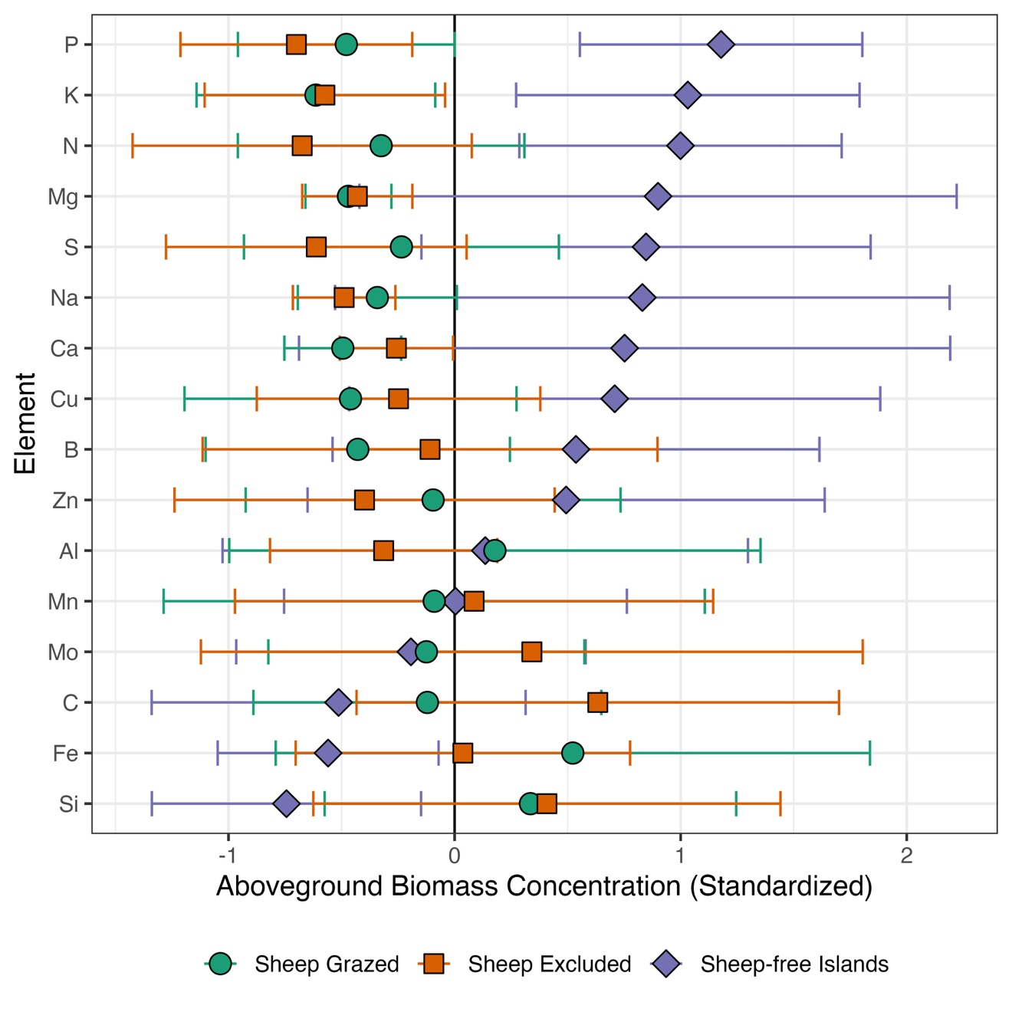
Supplemental Figure 2: Standardized concentration of elements in aboveground biomass. Each point represents the standardized mean, and the error bars represent one standard deviation: Sheep grazed (green circles) (M-G), Sheep excluded (orange squares) (M-NG) and Sheep-free islands (purple diamonds) (I-NG). The means are sorted based on the difference between the islands and the mainland.

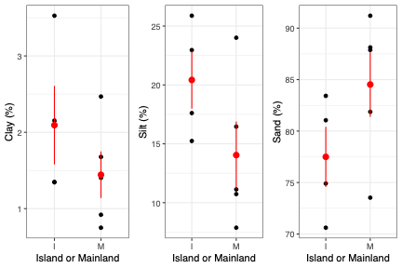
Supplemental Figure 3: Soil particle size fractions using the United States Department of Agricultural system with cutoffs for x < 2 µm for clay, ≤ 2 µm x ≤ 50 µm for silt and 50 < x < 2000 µm for sand. (a) % Clay compared across island (I) and mainland plots (M). Each black point is an observation, and the red point is the mean ± 1 standard error. (b) % Silt (c) % Sand.

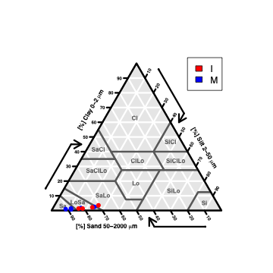
Supplemental Figure 4: Soil Texture Triangle based on the United States Department of Agriculture. Each point represents one measurement for Island (I, red) and Mainland (M, blue). Generated using R package soiltexture.

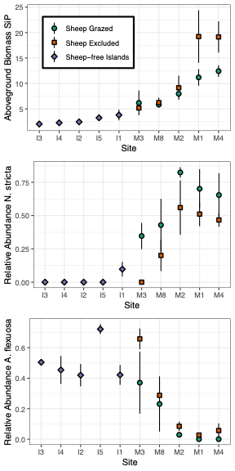
Supplemental Figure 5: (a) The ratio of Si:P in aboveground plant biomass. Each point represents the mean ± 1 standard error (SE) across sheep grazed (green circles) (M-G), sheep excluded (orange squares) (M-NG) and sheep-free islands (purple diamonds) (I-NG). (b) The relative abundance of N. stricta. (c) The relative abundance of A. flexuosa. I prefix indicates island and M indicates mainland followed by the site number.

Supplemental References

Bradshaw AD, Lodge RW, Jowett D, Chadwick MJ. 1958. Experimental Investigations into the Mineral Nutrition of Several Grass Species: Part I. Calcium Level. J Ecol 46:749.
Evju M, Mysterud A, Austrheim G, økland RH. 2006. Selecting herb species and traits as indicators of sheep grazing pressure in a Norwegian alpine habitat. Écoscience 13:459–68.
Furey GN, Tilman D. 2023. Plant chemical traits define functional and phylogenetic axes of plant biodiversity. Ecol Lett 26:1394–406.
Furey GN, Tilman D. 2024. Trade-offs between deer herbivory and nitrogen competition alter grassland forb composition. Oecologia 204:47–58.
Grant SA, Suckling DE, Smith HK, Torvell L, Forbes TDA, Hodgson J. 1985. Comparative Studies of Diet Selection by Sheep and Cattle: The Hill Grasslands. J Ecol 73:987.
Massey FP, Ennos AR, Hartley SE. 2007. Grasses and the resource availability hypothesis: the importance of silica-based defences. J Ecol 95:414–24.
Mládková P, Mládek J, Hejduk S, Hejcman M, Pakeman RJ. 2018. Calcium plus magnesium indicates digestibility: the significance of the second major axis of plant chemical variation for ecological processes. Ecol Lett 21:885–95.
Petit Bon M, Inga KG, Utsi TA, Jónsdóttir IS, Bråthen KA. 2022. Forage quality in tundra grasslands under herbivory: Silicon-based defences, nutrients and their ratios in grasses. J Ecol 110:129–43.
Schaller J, Hodson MJ, Struyf E. 2017. Is relative Si/Ca availability crucial to the performance of grassland ecosystems? Ecosphere 8:e01726.
Schaller J, Roscher C, Hillebrand H, Weigelt A, Oelmann Y, Wilcke W, Ebeling A, Weisser WW. 2016. Plant diversity and functional groups affect Si and Ca pools in aboveground biomass of grassland systems. Oecologia 182:277–86.
Soininen EM, Bråthen KA, Jusdado JGH, Reidinger S, Hartley SE. 2013. More than herbivory: levels of silica‐based defences in grasses vary with plant species, genotype and location. Oikos 122:30–41.
White PJ, Broadley MR, El-Serehy HA, George TS, Neugebauer K. 2018. Linear relationships between shoot magnesium and calcium concentrations among angiosperm species are associated with cell wall chemistry. Ann Bot 122:221–6.

