SI tables
Table S1: Full model results for model in main text table 1.
 | Soil inorganic N  Random effects: Soil depth, plot |  |  |  | Volumetric water content  Random effects: Soil depth, plot
 | Estimate | SE | p>Z | Estimate |  | SE | p>Z
(Intercept) | 0.96 | 0.17 | <0.0001 | -1.35 |  | 0.032 | <0.0001
Irrigation - summer | 0.48 | 0.21 | 0.024 | 0.0039 |  | 0.045 | 0.93
Irrigation – winter | 0.26 | 0.21 | 0.22 | 0.0072 |  | 0.045 | 0.87
Vegetation – native shrub-steppe | 0.15 | 0.15 | 0.32 | -0.028 |  | 0.038 | 0.47
Irrigation – summer: Vegetation – native shrub-steppe | -0.023 | 0.21 | 0.91 | 0.0086 |  | 0.054 | 0.87
Irrigation – winter: Vegetation – native shrub-steppe | 0.53 | 0.21 | 0.011 | 0.045 |  | 0.054 | 0.40
Irrigation – summer:Date - 6/30/20 | 0.27 | 0.24 | 0.26 | -0.120 |  | 0.034 | 0.0005
Irrigation – winter:Date - 6/30/20 | 0.17 | 0.24 | 0.47 | -0.038 |  | 0.034 | 0.27
Irrigation – summer:Date - 7/15/20 | -0.11 | 0.24 | 0.66 | -0.023 |  | 0.034 | 0.50
Irrigation – winter:Date - 7/15/20 | -0.31 | 0.24 | 0.20 | -0.042 |  | 0.034 | 0.22
Irrigation – summer:Date - 8/5/20 | 0.13 | 0.24 | 0.59 | -0.065 |  | 0.034 | 0.058
Irrigation – winter:Date - 8/5/20 | 0.10 | 0.24 | 0.69 | -0.088 |  | 0.034 | 0.0099
Irrigation – summer:Date - 6/22/21 | -0.022 | 0.24 | 0.93 | -0.044 |  | 0.034 | 0.20
Irrigation – winter:Date - 6/22/21 | -0.19 | 0.24 | 0.41 | -0.057 |  | 0.034 | 0.097
Irrigation – summer:Date - 8/12/21 | -0.12 | 0.24 | 0.63 | -0.036 |  | 0.035 | 0.31
Irrigation – winter:Date - 8/12/21 | -0.18 | 0.24 | 0.45 | -0.029 |  | 0.034 | 0.39
Date - 6/30/20 | 0.23 | 0.17 | 0.18 | -0.482 |  | 0.024 | <0.0001
Date - 7/15/20 | -0.28 | 0.17 | 0.095 | -0.610 |  | 0.024 | <0.0001
Date - 8/5/20 | -0.28 | 0.17 | 0.099 | -0.785 |  | 0.024 | <0.0001
Date - 6/22/21 | 0.22 | 0.17 | 0.20 | -0.746 |  | 0.024 | <0.0001
Date - 8/12/21 | -1.23 | 0.17 | <0.0001 | -0.688 |  | 0.024 | <0.0001

Table S2: Soil N effect sizes according to planted community and hydroclimate. The response data are values in µg N/g soil, i.e. they are un-transformed values derived from the model presented in Tables 1, S1.
Hydroclimate | Planted vegetation | response | SE | Lower CI | Upper CI
Ambient | Crested wheatgrass | 2.10 | 0.26 | 1.64 | 2.69
Ambient | Native shrub-steppe | 2.41 | 0.31 | 1.87 | 3.10
Summer-wet | Crested wheatgrass | 3.46 | 0.43 | 2.70 | 4.42
Summer-wet | Native shrub-steppe | 3.93 | 0.50 | 3.07 | 5.05
Winter wet | Crested wheatgrass | 2.54 | 0.32 | 1.98 | 3.25
Winter wet | Native shrub-steppe | 4.97 | 0.62 | 3.89 | 6.35

Table S3: Generalized linear mixed effects model results for a model of soil inorganic nitrogen as a function of each plant functional type of interest in this study. The model controlled for total canopy cover as a fixed effect with random intercepts for year, plot ID and all combinations of the experimental irrigation, vegetation and soil depth treatments. The model used a gaussian distribution.
Independent variables | Model functional plant type
Independent variables | Nitrogen fixing forbs |  |  | Shrubs |  |  | Perennial grasses
 | Estimate | SE | p<z | Estimate | SE | p<z | Estimate | SE | p<z
Intercept | 1.51 | 0.14 | <0.0001 | 1.52 | 0.14 | <0.0001 | 1.08 | 0.18 | <0.0001
Functional plant type cover (see headers) | 1.69 | 0.51 | 0.0008 | 1.65 | 0.61 | 0.0071 | 0.95 | 0.26 | 0.0003
Date (July 15, 2020) | -0.76 | 0.05 | <0.0001 | -0.77 | 0.049 | <0.0001 | 0.076 | 0.17 | 0.66
Date (August 5, 2020) | -0.45 | 0.05 | <0.0001 | -0.47 | 0.049 | <0.0001 | 0.04 | 0.17 | 0.84
Date (April 20, 2021) | -0.25 | 0.05 | <0.0001 | -0.28 | 0.049 | <0.0001 | 0.08 | 0.18 | 0.65
Date (June 22, 2021) | -0.072 | 0.05 | 0.16 | -0.08 | 0.049 | 0.1 | 0.54 | 0.17 | 0.00020
Date (August 12, 2021) | -1.52 | 0.05 | <0.0001 | -1.53 | 0.049 | <0.0001 | -1.2 | 0.18 | <0.0001
Total canopy cover | -0.0011 | 0.14 | 0.99 | 0.0016 | 0.15 | 0.99 | 0.022 | 0.13 | 0.86
Functional plant type: July 15, 2020 | -1.37 | 0.67 | 0.042 | -1.17 | 0.82 | 0.15 | -1.79 | 0.35 | <0.0001
Functional plant type: August 5, 2020 | -1.79 | 0.67 | 0.008 | -1.68 | 0.82 | 0.04 | -1.1 | 0.35 | 0.0015
Functional plant type: April 20, 2021 | -2.58 | 0.68 | 0.0001 | -2.08 | 0.82 | 0.011 | -0.81 | 0.35 | 0.019
Functional plant type: June 22, 2021 | -2.07 | 0.68 | 0.0021 | -2.41 | 0.82 | 0.0032 | -1.37 | 0.35 | <0.0001
Functional plant type: August 12, 2021 | -1.76 | 0.68 | 0.0099 | -2.13 | 0.82 | 0.0096 | -0.76 | 0.36 | 0.034

Table S4: Model results for individual regressions within the SEM
Response | Predictor | Estimate | SE | P.Value
Resistance  Random effects  Year, Plot, Vegetation:Soil | Pre-fire N-fixer cover | -0.46 | 0.046 | <0.0001
Resistance  Random effects  Year, Plot, Vegetation:Soil | Pre-fire shrub cover | -0.26 | 0.56 | <0.0001
Resistance  Random effects  Year, Plot, Vegetation:Soil | Pre-fire perennial grass cover | 0.32 | 0.068 | <0.0001
Resistance  Random effects  Year, Plot, Vegetation:Soil | Pre-fire crested wheatgrass cover | 0.022 | 0.040 | 0.58
Resistance  Random effects  Year, Plot, Vegetation:Soil | Soil inorganic N | 0.026 | 0.026 | 0.27
Resistance  Random effects  Year, Plot, Vegetation:Soil | Post-fire interspace area | -0.039 | 0.044 | 0.37
Resistance  Random effects  Year, Plot, Vegetation:Soil | Leaf N % | 0.054 | 0.030 | 0.075
 | Total plant cover | -0.087 | 0.093 | 0.35
 | Hydroclimate |  |  | <0.0001
 | Winter | -0.067 | 0.010 | 0.50
 | Ambient | 0.29 | 0.11 | 0.0075
 | Summer | -0.24 | 0.091 | 0.0085
Soil inorganic N  Random effects Year, Date, Plot, Vegetation:Soil | Pre-fire N-fixers | 0.16 | 0.096 | 0.082
 | Pre-fire shrub cover | 0.20 | 0.10 | 0.051
 | Pre-fire perennial grass cover | -0.092 | 0.12 | 0.45
 | Post-fire interspace area | 0.25 | 0.081 | 0.0020
 | Total plant cover | -0.025 | 0.16 | 0.88
 | Hydroclimate |  |  | 0.0008
 | Winter | -0.16 | 0.23 | 0.47
 | Ambient | -0.085 | 0.24 | 0.73
 | Summer | 0.26 | 0.22 | 0.25
Post-fire interspace area | Pre-fire N-fixers | -0.36 | 0.061 | <0.0001
Random effects  Hydroclimate:Vegetation:Soil | Pre-fire shrub cover | 0.43 | 0.066 | <0.0001
Random effects  Hydroclimate:Vegetation:Soil | Pre-fire perennial grass cover | -0.59 | 0.075 | <0.0001
 | Total plant cover | -0.30 | 0.12 | 0.013
 | Hydroclimate |  |  | 0.0006
 | Winter | 0.27 | 0.13 | 0.044
 | Ambient | -0.27 | 0.14 | 0.065
 | Summer | 0.0052 | 0.12 | 0.97
Leaf N  Random effects  Hydroclimate:Vegetation:Soil | Pre-fire shrub cover | -0.016 | 0.10 | -0.89
Leaf N  Random effects  Hydroclimate:Vegetation:Soil | Pre-fire perennial grass cover | 0.26 | 0.095 | 0.0055
Leaf N  Random effects  Hydroclimate:Vegetation:Soil | Pre-fire crested wheatgrass cover | -0.38 | 0.072 | <0.0001
 | Post-fire interspace area | 0.35 | 0.073 | <0.0001
 | Total plant cover | -0.26 | 0.15 | 0.096
 | Hydroclimate |  |  | <0.0001
 | Winter | 0.18 | 0.39 | 0.65
 | Ambient | -0.48 | 0.39 | 0.22
 | Summer | 0.32 | 0.38 | 0.39

Table S5: Conditional model results for generalized mixed effects model of resistance with random effects of the experimental treatments (i.e. hydroclimate, planted vegetation, soil depth and plot ID). Bold text is used to highlight values that gain significance or underline to highlight values toat lose significance after the model structure was changed to produce the consecutive panels on the right.
Full model |  |  |  | Model without N-fixers |  |  |  | Model without N-fixers or shrubs |  |  |  | Model without N-fixers, shrubs or soil N
 | Estimate | SE | p<z |  | Estimate | SE | p<z |  | Estimate | SE | p<z |  | Estimate | SE | p<z
Intercept | -0.21 | 0.013 | <0.0001 |  | -0.21 | 0.02 | <0.0001 |  | -0.21 | 0.022 | <0.0001 |  | -0.21 | 0.034 | <0.0001
Pre-fire N-fixers | -0.13 | 0.014 | <0.0001 |  | -- | -- | -- |  | -- | -- | -- |  | -- | -- | --
2021 | -0.026 | 0.008 | 0.0015 |  | -0.026 | 0.008 | 0.002 |  | -0.026 | 0.009 | 0.004 |  | -0.026 | 0.0098 | 0.0087
2022 | 0.0023 | 0.008 | 0.78 |  | 0.002 | 0.008 | 0.78 |  | 0.0023 | 0.009 | 0.08 |  | 0.0023 | 0.0098 | 0.82
Soil N | -0.020 | 0.017 | 0.24 |  | -0.074 | 0.026 | 0.0042 |  | -0.11 | 0.022 | <0.0001 |  | -- | -- | --
Pre-Fire shrub cover | -0.034 | 0.017 | 0.043 |  | -0.057 | 0.027 | 0.039 |  | -- | -- | -- |  | -- | -- | --
Pre-fire perennial grass cover | 0.0088 | 0.012 | 0.48 |  | 0.033 | 0.02 | 0.097 |  | 0.042 | 0.021 | 0.044 |  | 0.037 | 0.027 | 0.16
Pre-fire N-Fixers: 2021 | -0.024 | 0.01 | 0.018 |  | -- | -- | -- |  | -- | -- | -- |  | -- | -- | --
Pre-fire N-Fixers: 2022 | -0.016 | 0.01 | 0.11 |  | -- | -- | -- |  | -- | -- | -- |  | -- | -- | --
Soil N:2021 | 0.012 | 0.012 | 0.35 |  | -0.001 | 0.011 | 0.93 |  | -0.032 | 0.009 | 0.00034 |  | -- | -- | --
Soil N:2022 | 0.03 | 0.012 | 0.014 |  | 0.022 | 0.011 | 0.056 |  | 0.008 | 0.009 | 0.38 |  | -- | -- | --
Pre-fire shrub cover: 2021 | -0.044 | 0.011 | <0.0001 |  | -0.046 | 0.011 | <0.0001 |  | -- | -- | -- |  | -- | -- | --
Pre-fire shrub cover: 2022 | -0.019 | 0.011 | 0.092 |  | -0.02 | 0.011 | 0.074 |  | -- | -- | -- |  | -- | -- | --
Pre-fire perennial grass cover:2021 | -0.001 | 0.0087 | 0.91 |  | 0.004 | 0.0087 | 0.62 |  | 0.014 | 0.009 | 0.13 |  | 0.0092 | 0.0098 | 0.35
Pre-fire perennial grass cover:2022 | 0.0061 | 0.0087 | 0.49 |  | 0.01 | 0.0087 | 0.26 |  | 0.014 | 0.009 | 0.12 |  | 0.015 | 0.0098 | 0.13

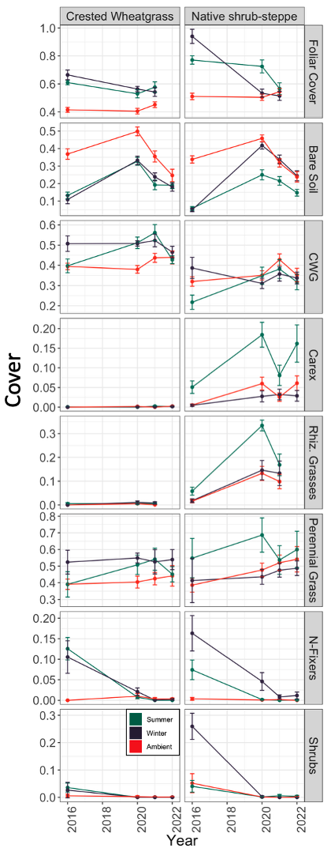
Figure S1: Total foliar cover and cover of key plant functional groups pre-fire (2016) and post-fire (2020-2022). A cover value of 1.0 indicates that all line point intercept ‘hits’ contained a plant, i.e. 100% foliar cover.
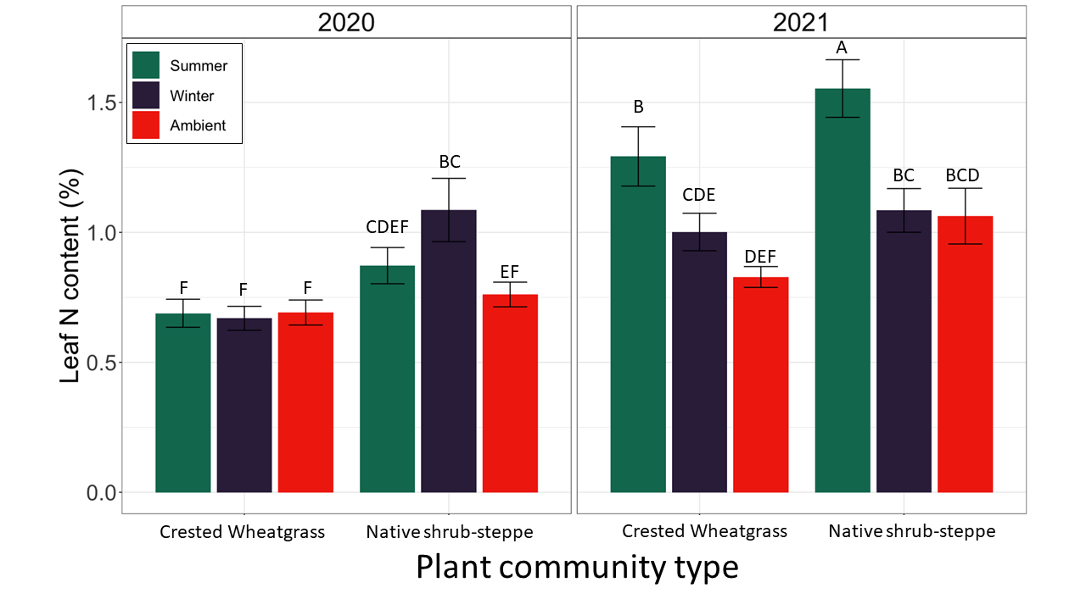Figure S2: Crested wheatgrass leaf N content in crested wheatgrass and native shrub-steppe plant community types (x-axis groups) in summer, winter, and ambient hydroclimate plots (green, purple, red, respectively).

