Ecosystem synchrony among small shallow lakes is driven differently by their biotic and abiotic similarities

Short title: Drivers of ecosystem synchrony among shallow lakes

Authors:
Chloé VAGNON^{1,2} (corresponding author) /chloe.vagnon@gmail.com
Mathieu CHEVALIER³ / mathieu.chevalier38@gmail.com
Stéphanie BOULÊTREAU¹ / stephanie.bouletreau@utoulouse.fr
Flavien GARCIA¹ / flavien.garcia.pro@gmail.com
Julian D. OLDEN⁴ / olden@uw.edu
Julien CUCHEROUSSET¹ / julien.cucherousset@cnrs.fr
¹ Centre de Recherche sur la Biodiversité et l'Environnement (CRBE), Université de Toulouse, CNRS, IRD, Toulouse INP, Université Toulouse 3 – Paul Sabatier (UT3), Toulouse, France
² FRB — CESAB, Montpellier, France
³IFREMER-DYNECO-LEBCO, Centre de Bretagne, CS 10070, France
⁴School of Aquatic and Fishery Sciences, University of Washington, Seattle, WA 98105, United States

Table S1: Location and abiotic characteristics of the studied lakes.
 | Location |  | Morphometry |  |  |  |  | Water transparency |  | Water quality
Lake | Latitude | Longitude | Depth max (m) | Surface  (m²) | Perimeter (m) | Hydromorphology index (MIdx) | Shoreline index (SIdx) | Secchi  (SecD, m) | Turbidity  (Turb, NTU) | Conductivity  (Cond, μs.cm⁻¹) | Total phosphorus  (P_{tot}, μg.L⁻¹) | Dissolved organic carbon  (DOC, mg .L⁻¹)
BID | 43.52557 | 1.285494 | 2.9 | 151836 | 2583 | 0.74 | 1.87 | 0.37 | 22.15 | 263.34 | 48.41 | 3.95
BIR | 43.53033 | 1.289764 | 2.6 | 203628 | 2634 | 0.58 | 1.65 | 1.70 | 2.32 | 201.18 | 22.01 | 100.07
CAB | 43.21567 | 1.616650 | 8.9 | 121964 | 1526 | 2.55 | 1.23 | 3.22 | 2.31 | 244.02 | 23.28 | 5.56
FDL | 43.43998 | 1.302606 | 2.0 | 187706 | 3922 | 0.46 | 2.55 | 0.73 | 9.65 | 354.67 | 26.65 | 29.26
GNN | 43.22763 | 1.611648 | 6.0 | 114500 | 1350 | 1.77 | 1.13 | 2.01 | 3.06 | 312.29 | 20.20 | 3.22
GNS | 43.22104 | 1.612649 | 8.0 | 110000 | 1533 | 2.41 | 1.30 | 3.38 | 1.58 | 227.71 | 24.56 | 6.42
LAM | 43.50626 | 1.337336 | 3.0 | 213016 | 4139 | 0.65 | 2.53 | 0.81 | 7.55 | 635.16 | 50.25 | 10.02
LAV | 43.38639 | 1.265891 | 3.7 | 182103 | 2485 | 0.87 | 1.64 | 1.84 | 2.96 | 421.19 | 21.38 | 4.76
POU | 43.37193 | 1.258473 | 4.4 | 103909 | 2199 | 1.36 | 1.92 | 1.47 | 3.52 | 429.19 | 17.72 | 3.63
ROY | 43.19194 | 1.622482 | 12.0 | 118831 | 1561 | 3.48 | 1.28 | 2.34 | 2.56 | 378.55 | 13.89 | 2.18
SAB | 43.36462 | 1.251335 | 5.1 | 162864 | 2113 | 1.26 | 1.48 | 1.85 | 3.33 | 415.20 | 22.78 | 2.98
SOA | 43.20562 | 1.040017 | 5.9 | 87037 | 1220 | 1.99 | 1.17 | 3.07 | 1.07 | 305.90 | 21.77 | 2.94
SOB | 43.20763 | 1.046572 | 5.9 | 210002 | 2070 | 1.51 | 1.27 | 3.02 | 1.29 | 285.53 | 19.92 | 2.61
SOC | 43.20892 | 1.038937 | 7.0 | 145985 | 1679 | 1.83 | 1.24 | 2.45 | 1.40 | 349.82 | 31.58 | 3.28
SOD | 43.21076 | 1.044337 | 5.0 | 132781 | 1495 | 1.37 | 1.16 | 2.65 | 9.01 | 279.53 | 22.91 | 3.77
TAB | 43.55135 | 1.259427 | 4.3 | 28600 | 815 | 2.54 | 1.36 | 0.99 | 5.80 | 450.07 | 0.99 | 5.80

Table S2: Biotic characteristics of the studied lakes.
 | Community composition |  |  |  | Trophic characteristics |  |  | Functional characteristics
Lake | Fish biomass (FBiom, BPUE) | Crayfish biomass (CBiom, BPUE) | Total chlorophyll-a (TChl, µg.L⁻¹) | Non-native fish biomass  (NN, %) | Autochthonous reliance  (ARel) | Chore isotopic niche of consumers (SEAc) | Food chain length  (FCL) | Functional richness (FRic)
BID | 177.86 | 0.00 | 17.11 | 23.60 | 0.15 | 9.22 | 3.70 | 0.50
BIR | 7.40 | 299.11 | 6.23 | 27.99 | 0.60 | 12.43 | 3.54 | 0.33
CAB | 72.92 | 0.00 | 14 | 0.00 | 0.19 | 9.41 | 3.06 | 0.55
FDL | 179.50 | 16.21 | 12.19 | 68.66 | 0.26 | 7.29 | 3.79 | 0.46
GNN | 98.83 | 0.72 | 12.38 | 5.18 | 0.12 | 5.86 | 3.30 | 0.81
GNS | 20.09 | 0.00 | 8.3 | 0.00 | 0.42 | 9.16 | 3.61 | 0.44
LAM | 326.77 | 0.00 | 65.35 | 84.70 | 0.25 | 9.79 | 5.41 | 0.39
LAV | 397.68 | 67.19 | 3.15 | 78.77 | 0.20 | 12.09 | 3.85 | 0.41
POU | 99.94 | 0.00 | 1.17 | 52.66 | 0.52 | 9.54 | 3.44 | 0.004
ROY | 182.46 | 0.00 | 3.65 | 81.34 | 0.37 | 12.77 | 3.94 | 0.23
SAB | 274.28 | 11.94 | 6.1 | 54.09 | 0.44 | 7.34 | 3.48 | 0.04
SOA | 92.71 | 44.90 | 6.929 | 0.72 | 0.45 | 8.49 | 4.09 | 0.34
SOB | 444.66 | 38.72 | 1.47 | 0.00 | 0.46 | 11.12 | 3.81 | 0.30
SOC | 317.29 | 50.88 | 6.24 | 89.51 | 0.30 | 9.88 | 3.80 | 0.07
SOD | 76.49 | 27.54 | 3.05 | 0.00 | 0.02 | 5.72 | 3.01 | 0.36
TAB | 695.49 | 0.00 | 31.17 | 95.16 | 0.14 | 5.96 | 3.45 | 0.02

Table S3: Summary statistics of dissolved oxygen (DO) saturation (%) for each lake. The coefficient of variation of DO saturation was computed as the standard deviation of DO saturation / mean of DO saturation based on the two-year time series.
Lake | Mean DO saturation (%) | Minimum DO saturation (%) | Maximum DO saturation (%) | Range of DO saturation (%) | Coefficient of variation of DO saturation (unitless)
BID | 93.94 | 13.37 | 127.54 | 114.17 | 13.45
BIR | 101.70 | 54.67 | 145.26 | 90.60 | 12.49
CAB | 102.38 | 49.59 | 145.79 | 96.20 | 15.96
FDL | 104.80 | 57.22 | 212.18 | 154.96 | 20.12
GNN | 96.69 | 70.38 | 156.30 | 85.92 | 16.17
GNS | 100.38 | 43.04 | 153.81 | 110.77 | 21.99
LAM | 89.73 | 29.44 | 229.32 | 199.89 | 39.53
LAV | 92.03 | 58.48 | 134.40 | 75.92 | 12.38
POU | 95.31 | 73.13 | 175.24 | 102.10 | 14.54
ROY | 99.41 | 83.85 | 124.43 | 40.59 | 7.07
SAB | 96.37 | 72.50 | 150.41 | 77.91 | 12.04
SOA | 102.01 | 73.51 | 144.22 | 70.71 | 15.52
SOB | 101.16 | 79.04 | 141.54 | 62.49 | 10.49
SOC | 108.21 | 65.30 | 167.57 | 102.27 | 17.62
SOD | 100.63 | 71.49 | 135.25 | 63.76 | 11.55
TAB | 87.71 | 25.16 | 184.87 | 159.70 | 24.99
minimum value / maximum value

Table S4: Functional trait used to construct the functional space based on which we computed functional richness
Function | Morphological traits | Description
Food acquisition + locomotion | Mass | Volume, muscle mass
Food acquisition | Oral gape surface | Maximum prey size or ability to filter water
Food acquisition | Oral gape shape | Prey shape and food acquisition
Food acquisition | Oral gape position | Position of prey in the water
Food acquisition | Eye diameter | Prey detection
Food acquisition | Gill raker length | Filtration capacity or gill protection
Food acquisition | Gut length | Digestibility of food
Locomotion | Eye position | Position in the water column
Locomotion | Body section shape | Position in the water column and hydrodynamism
Locomotion | Body section area | Mass distribution along the body and hydrodynamism
Locomotion | Pectoral fin position | Manoeuvrability and position in the water column
Locomotion | Pectoral fin shape | Propulsion and/or manoeuvrability
Locomotion | Caudal peduncle throttling | Swimming endurance
Locomotion | Caudal fin shape | Endurance, acceleration and/or manoeuvrability
Locomotion | Ratio of fins’ area | Swimming type (pectoral or caudal fin propulsion)
Locomotion | Fins’ area | Endurance, acceleration and/or manoeuvrability
From Zhao T, Villéger S, Cucherousset J. 2019. Accounting for intraspecific diversity when examining relationships between non-native species and functional diversity. Oecologia 189:171–83. http://link.springer.com/10.1007/s00442-018-4311-3. Last accessed 19/05/2025

Table S5: Summary statistics of ecosystem synchrony for each lake during the cold period and the warm periods.
 | COLD PERIOD |  |  |  | WARM PERIOD
Lake | mean | sd | mode |  | mean | sd | mode
BID | 0.87 | 0.11 | 0.92 |  | 0.74 | 0.11 | 0.75
BIR | 0.83 | 0.17 | 0.90 |  | 0.71 | 0.10 | 0.71
CAB | 0.88 | 0.15 | 0.94 |  | 0.76 | 0.11 | 0.80
FDL | 0.85 | 0.15 | 0.90 |  | 0.58 | 0.08 | 0.59
GNN | 0.86 | 0.10 | 0.92 |  | 0.77 | 0.11 | 0.76
GNS | 0.85 | 0.10 | 0.90 |  | 0.65 | 0.10 | 0.68
LAM | 0.60 | 0.17 | 0.66 |  | 0.40 | 0.13 | 0.43
LAV | 0.88 | 0.13 | 0.93 |  | 0.70 | 0.12 | 0.77
POU | 0.90 | 0.11 | 0.96 |  | 0.75 | 0.13 | 0.82
ROY | 0.88 | 0.25 | 0.94 |  | 0.69 | 0.17 | 0.78
SAB | 0.88 | 0.11 | 0.94 |  | 0.77 | 0.13 | 0.84
SOA | 0.89 | 0.12 | 0.95 |  | 0.75 | 0.13 | 0.83
SOB | 0.82 | 0.20 | 0.90 |  | 0.70 | 0.16 | 0.79
SOC | 0.70 | 0.22 | 0.79 |  | 0.62 | 0.17 | 0.69
SOD | 0.89 | 0.12 | 0.94 |  | 0.73 | 0.16 | 0.81
TAB | 0.65 | 0.29 | 0.90 |  | 0.69 | 0.10 | 0.71
minimum value / maximum value

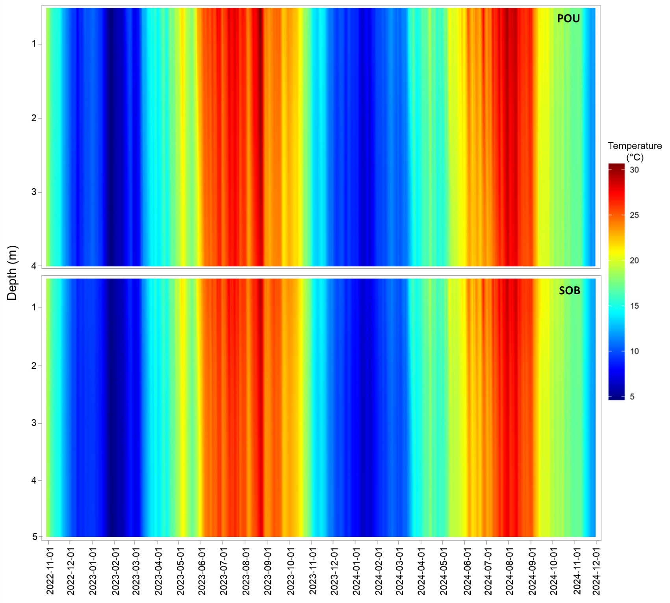
Figure S1: Daily average temperature in the water column measured using automatic temperature loggers (HOBO UA-001-64; Onset, USA) in the lake POU and SOB from November 2022 to November 2024. Loggers were located at the deepest point of the lakes and attached to a stainless-steel cable at 0.5 m below the water surface and then every 1m.

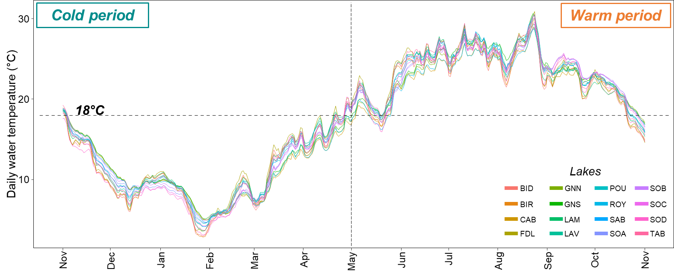
Figure S2: Daily average water temperature measured in the 16 gravel pit lakes. The horizontal dashed line represents the temperature of 18°C above which primary productivity is expected to significantly increase. The vertical dashed line represents the date after which daily water temperature remained above 18°C during several consecutive days and thus delimiting the cold period from the warm period in analyses. The temperature was obtained by daily averaging the temperature measured using miniDot® loggers (PME, California, USA) located at 70 cm below the water surface.

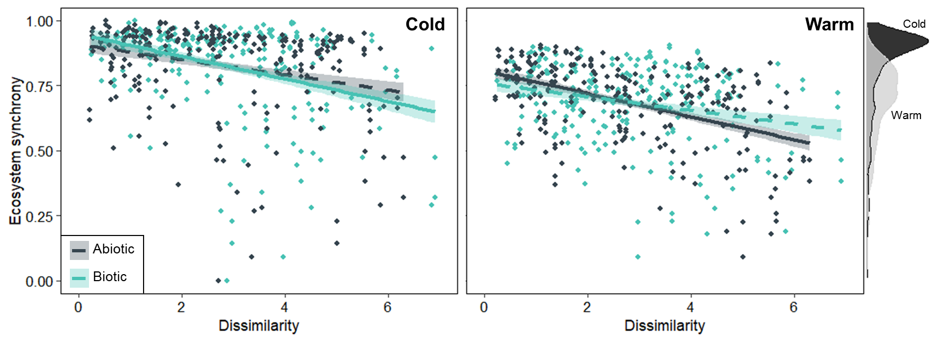
Figure S3: Relationships between ecosystem synchrony and biotic and abiotic dissimilarities during the cold (A) and warm (B) periods. Each point represents a pair of lakes. The lines represent the fitted relationships and the ribbons represent the associated standard errors, dashed lines represent insignificant relationships. The density curves represent the distributions of ecosystem synchrony values computed between lakes during cold periods (dark grey) and warm periods (light grey) from 2022-2023 and 2023-2024.

