Supplementary Figures (Fig1-3):
Fig1 – Literature search threads used for Embase and Medline.
Medline
1. hernia, abdominal/ or hernia, inguinal/ or exp hernia, ventral/ or incisional hernia/
2. ((abdominal or incisional or Ventral or inguinal or postoperative or parastomal or umbilical) adj3 hernia*).tw.
3. 1 or 2
4. Surgical Mesh/
5. mesh*.tw.
6. 4 or 5
7. Materials Testing/
8. test*.tw.
9. assess*.tw.
10. compar*.tw.
11. measur*.tw.
12. or/7-11
13. 3 and 6 and 12
14. limit 13 to animals
15. limit 14 to (english language and yr="2009 -Current")

Embase
1. abdominal wall hernia/ or inguinal hernia/ or parastomal hernia/ or spigelian hernia/ or umbilical hernia/
2. incisional hernia/
3. ((abdominal or incisional or ventral or inguinal or postoperative or post-operative or parastomal or umbilical) adj3 hernia*).tw.
4. 1 or 2 or 3
5. surgical mesh/ or mesh plug/ or nonabsorbable mesh/ or titanium mesh/ or transabdominal mesh/
6. mesh*.tw.
7. 5 or 6
8. materials testing/
9. test*.tw.
10. assess*.tw.
11. compar*.tw.
12. measur*.tw.
13. 8 or 9 or 10 or 11 or 12
14. 4 and 7 and 13
15. limit 14 to animals
16. limit 15 to (english language and yr="2009 -Current")

Fig 2: PRISMA flow diagram representing article screening process.

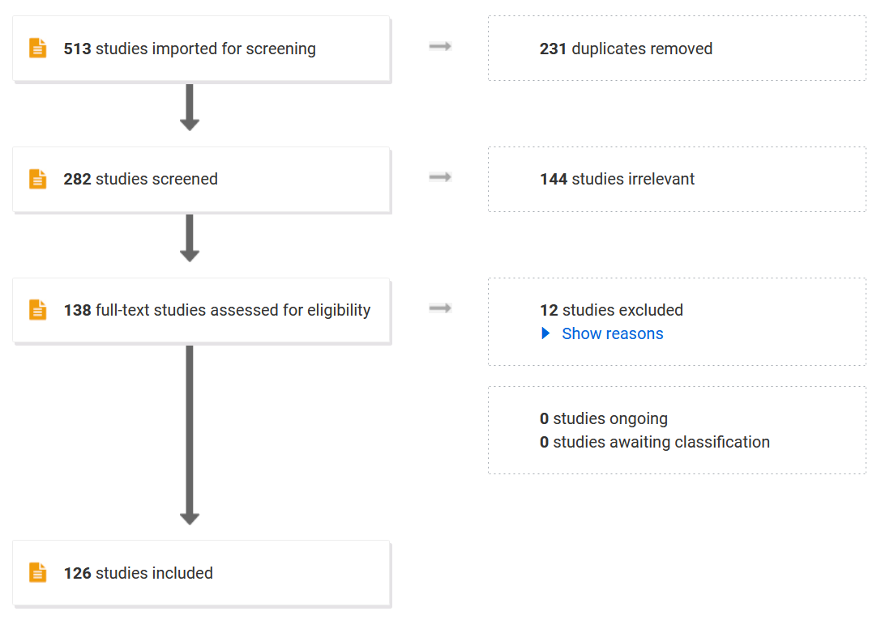

Fig 3: A graph assessing the mesh/tissue overlap in studies where a defect was made. Blue bars represent opposed repairs where orange bars represent bridged repairs.

Fig 4: Pictorial representations of mesh/tissue testing strips and how they are described.

Mesh/Tissue interface
Tissue/Tissue Interface with mesh
Tissue/Mesh/Tissue (generally for bridged defects)

