Supplemental material

S1 Forest plots of outcomes included in the analysis: SSIH and length of follow-up
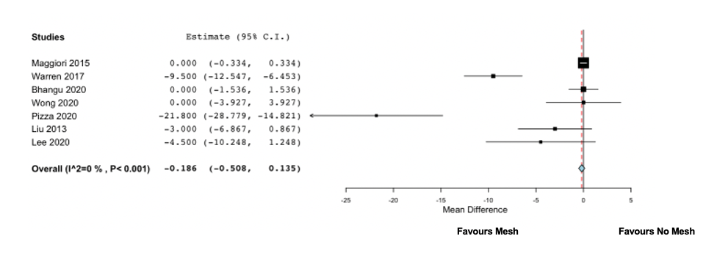

S2 Forest plots of outcomes included in the analysis: SSI (surgical site infection)
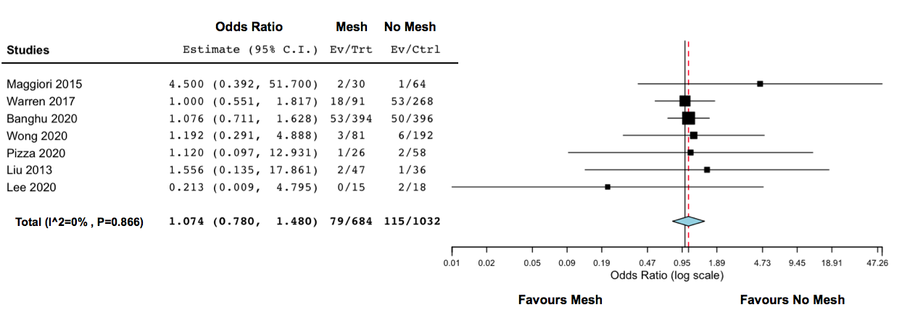

S3 Forest plots of outcomes included in the analysis: Need for second operation
