Supplementary Information
Cowan B. et al. Risk factors for inguinal hernia repair among US adults
Supplementary Table 1. Risk factors associated with inguinal hernia repair incidence in Kaiser Permanente RPGEH women
Supplementary Table 2. Risk factors associated with inguinal hernia repair incidence in Kaiser Permanente RPGEH men
Supplementary Fig. 1. Kaplan–Meier inguinal hernia repair-specific survival probabilities by age
Supplementary Fig. 2. Kaplan–Meier inguinal hernia repair-specific survival probabilities by sex
Supplementary Fig. 3. Kaplan–Meier inguinal hernia repair-specific survival probabilities by race/ethnicity
Supplementary Fig. 4. Kaplan–Meier inguinal hernia repair-specific survival probabilities by BMI categories
Supplementary Fig. 5. Kaplan–Meier inguinal hernia repair-specific survival probabilities by alcohol use
Supplementary Fig. 6. Kaplan–Meier inguinal hernia repair-specific survival probabilities by cigarette smoking
Supplementary Fig. 7. Kaplan–Meier inguinal hernia repair-specific survival probabilities by physical activity
Supplementary Fig. 8. Hazard models of predictors of inguinal hernia repair (Women only)
Supplementary Fig. 9. Hazard models of predictors of inguinal hernia repair (Men only)

Supplementary Table 1. Risk factors associated with inguinal hernia repair incidence in Kaiser Permanente RPGEH women
 |  | Univariate models |  | Multivariate model
Factors |  | Hazard Ratio (95%CI) | P Value | Hazard Ratio (95%CI) | P Value
Age at survey group |  | Reference |  | Reference
18-<30
30-<40 |  | 2.02 (0.97, 4.2) | 0.062 | 2.14 (1.02, 4.48) | 0.044
40-<50 |  | 2.80 (1.40, 5.6) | <0.001 | 2.88 (1.44, 5.75) | <0.001
50-<60 |  | 4.07 (2.08, 8.0) | <0.001 | 4.13 (2.11, 8.10) | <0.001
60-<70 |  | 7.53 (3.88, 14.6) | <0.001 | 7.34 (3.79, 14.35) | <0.001
70-<80 |  | 14.80 (7.64, 28.7) | <0.001 | 14.17 (7.30, 27.52) | <0.001
80+ |  | 15.13 (7.71, 29.7) | <0.001 | 14.07 (7.15, 27.71) | <0.001
Race/ethnicity | Non-Hispanic White | Reference |  | Reference
Race/ethnicity | Asian | 0.20 (0.14, 0.28) | <0.001 | 0.25 (0.17, 0.36) | <0.001
Race/ethnicity | Hispanic/Latino | 0.78 (0.63, 0.96) | 0.021 | 1.14 (0.92, 1.42) | 0.231
Race/ethnicity | African American | 0.58 (0.41, 0.82) | <0.001 | 0.81 (0.57, 1.16) | 0.250
Race/ethnicity | Other | 1.74 (0.93, 3.25) | 0.081 | 2.03 (1.09, 3.79) | 0.026
BMI | Normal Weight | Reference |  | Reference
BMI | Underweight | 0.75 (0.47, 1.20) | 0.227 | 0.75 (0.47, 1.22) | 0.253
BMI | Overweight | 0.80 (0.70, 0.91) | 0.001 | 0.69 (0.60, 0.79) | <0.001
BMI | Obese | 0.48 (0.40, 0.57) | <0.001 | 0.45 (0.38, 0.54) | <0.001
Alcohol Consumption | Non-Drinker | Reference |  | Reference
Alcohol Consumption | Drinker | 1.25(1.1, 1.4) | <0.001 | 1.05 (0.93, 1.19) | 0.435
Smoking initiation | Never smokers | Reference |  | Reference
Smoking initiation | Ever smokers | 1.58 (1.4, 1.8) | <0.001 | 1.23 (1.09, 1.40) | <0.001
Total MET | Q1 | Reference |  | Reference
Total MET | Q2 | 1.20 (1.01, 1.4) | 0.038 | 1.21 (1.02, 1.45) | 0.029
Total MET | Q3 | 1.20 (1.01, 1.4) | 0.034 | 1.19 (1.00, 1.43) | 0.049
Total MET | Q4 | 1.18 (0.99, 1.4) | 0.058 | 1.22 (1.02, 1.47) | 0.030
Abbreviations: CI confidence interval; MET metabolic equivalent of task; Q1, Q2, Q3, Q4 1st quartile, 2nd quartile, etc.

Supplementary Table 2. Risk factors associated with inguinal hernia repair incidence in Kaiser Permanente RPGEH men

 |  | Univariate models |  | Multivariate model
Factors |  | Hazard Ratio (95%CI) | P Value | Hazard Ratio (95%CI) | P Value
Age at survey group
18-<30 |  | Reference |  | Reference
30-<40 |  | 2.36 (1.6, 3.4) | <0.001 | 2.63 (1.82, 3.81) | <0.001
40-<50 |  | 4.30 (3.1, 6.1) | <0.001 | 4.75 (3.36, 6.71) | <0.001
50-<60 |  | 6.78 (4.9, 9.5) | <0.001 | 7.62 (5.43, 10.73) | <0.001
60-<70 |  | 9.01 (6.4, 12.6) | <0.001 | 9.96 (7.09, 14.00) | <0.001
70-<80 |  | 11.04 (7.9, 15.4) | <0.001 | 11.66 (8.29, 16.40) | <0.001
80+ |  | 9.62 (6.8, 13.5) | <0.001 | 9.37 (6.62, 13.28) | <0.001
Race/ethnicity | Non-Hispanic White |  |  | Reference
Race/ethnicity | Asian | 0.359 (0.32, 0.40) | <0.001 | 0.363 (0.32, 0.41) | <0.001
Race/ethnicity | Hispanic/Latino | 0.610 (0.55, 0.68) | <0.001 | 0.782 (0.70, 0.87) | <0.001
Race/ethnicity | African American | 0.554 (0.47, 0.65) | <0.001 | 0.663 (0.57, 0.78) | <0.001
Race/ethnicity | Other | 0.897 (0.65, 1.24) | 0.511 | 0.893 (0.64, 1.25) | 0.513
BMI | Normal Weight |  |  | Reference
BMI | Underweight | 0.758 (0.57, 1.01) | 0.055 | 0.799 (0.60, 1.07) | 0.130
BMI | Overweight | 0.787 (0.75, 0.83) | <0.001 | 0.704 (0.67, 0.74) | <0.001
BMI | Obese | 0.341 (0.31, 0.37) | <0.001 | 0.313 (0.29, 0.34) | <0.001
Alcohol Consumption | Non-Drinker |  |  | Reference
Alcohol Consumption | Drinker | 1.23 (1.2, 1.3) | <0.001 | 1.05 (1.00, 1.11) | 0.053
Smoking initiation | Never smokers |  |  | Reference
Smoking initiation | Ever smokers | 1.16 (1.1, 1.2) | <0.001 | 0.963 (0.91, 1.02) | 0.168
Total MET | Q1 |  |  | Reference
Total MET | Q2 | 1.13 (1.0, 1.2) | 0.002 | 1.10 (1.01, 1.19) | 0.022
Total MET | Q3 | 1.23 (1.1, 1.3) | <0.001 | 1.17 (1.09 1.27) | <0.001
Total MET | Q4 | 1.32 (1.2, 1.4) | <0.001 | 1.24 (1.15, 1.34) | <0.001

Abbreviations: CI confidence interval; MET metabolic equivalent of task; Q1, Q2, Q3, Q4 1st quartile, 2nd quartile, etc.

Supplementary Fig. 1. Kaplan–Meier inguinal hernia repair-specific survival probabilities by age
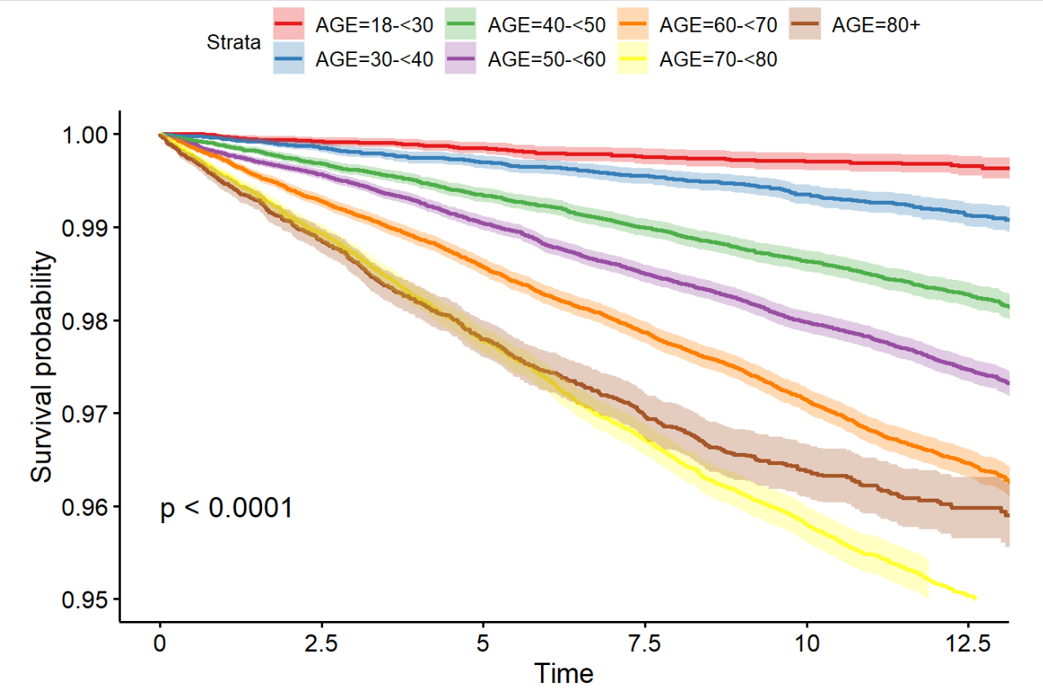

Supplementary Fig. 2. Kaplan–Meier inguinal hernia repair-specific survival probabilities by sex
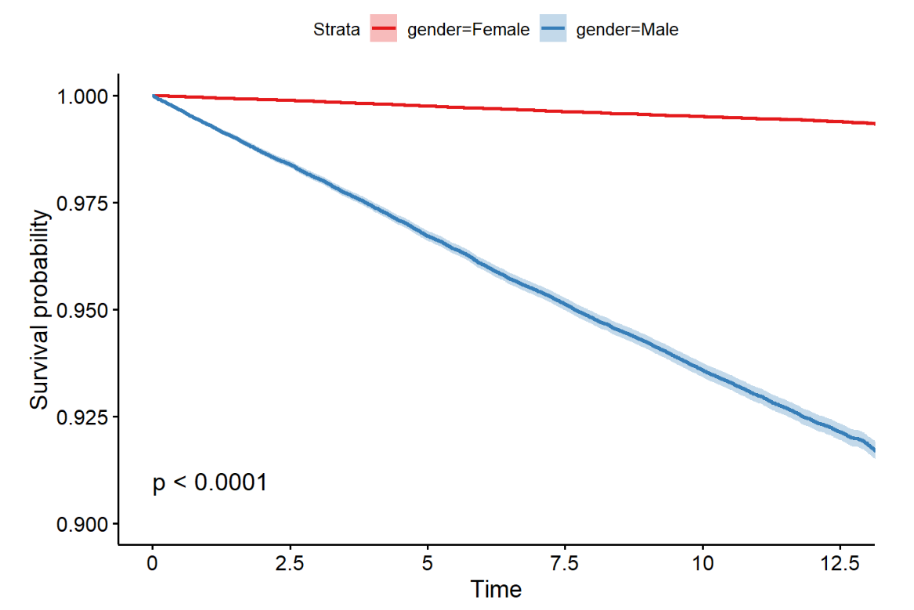

Supplementary Fig. 3. Kaplan–Meier inguinal hernia repair-specific survival probabilities by race/ethnicity
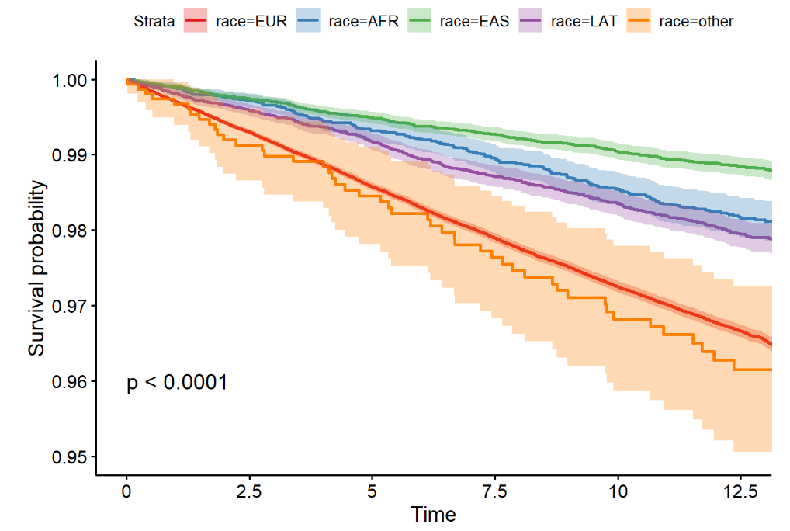

Supplementary Fig. 4. Kaplan–Meier inguinal hernia repair-specific survival probabilities by BMI categories
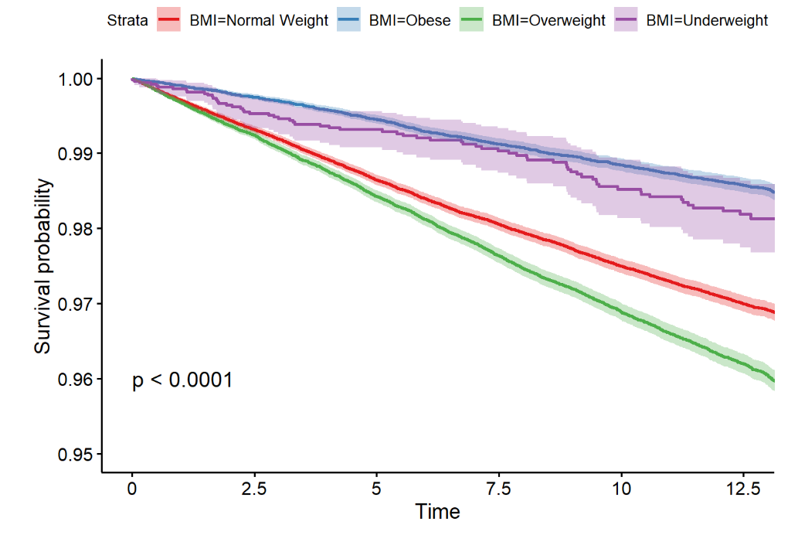

Supplementary Fig. 5. Kaplan–Meier inguinal hernia repair-specific survival probabilities by alcohol use
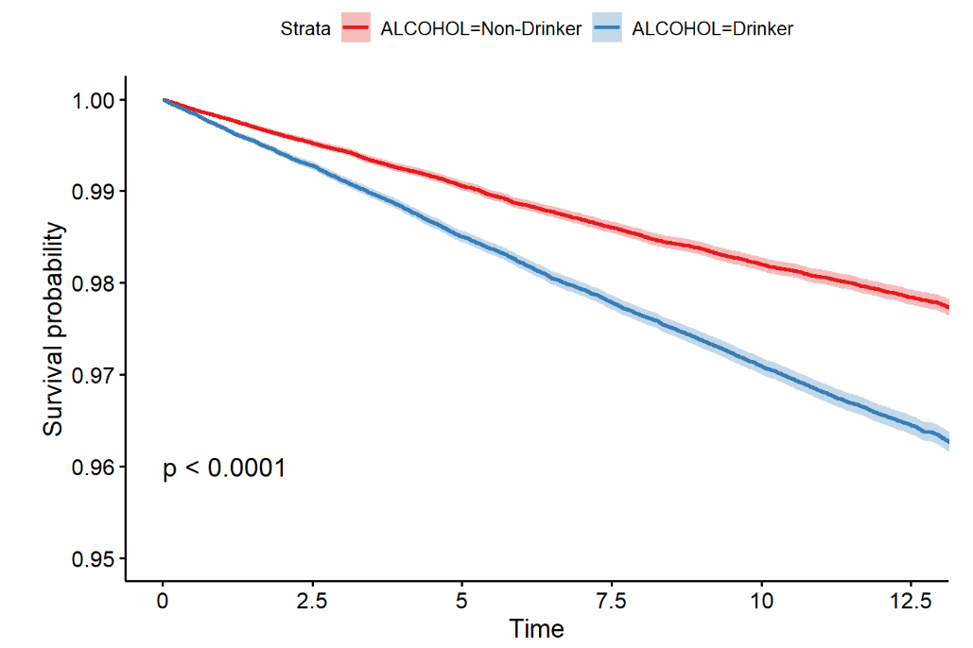

Supplementary Fig. 6. Kaplan–Meier inguinal hernia repair-specific survival probabilities by cigarette smoking
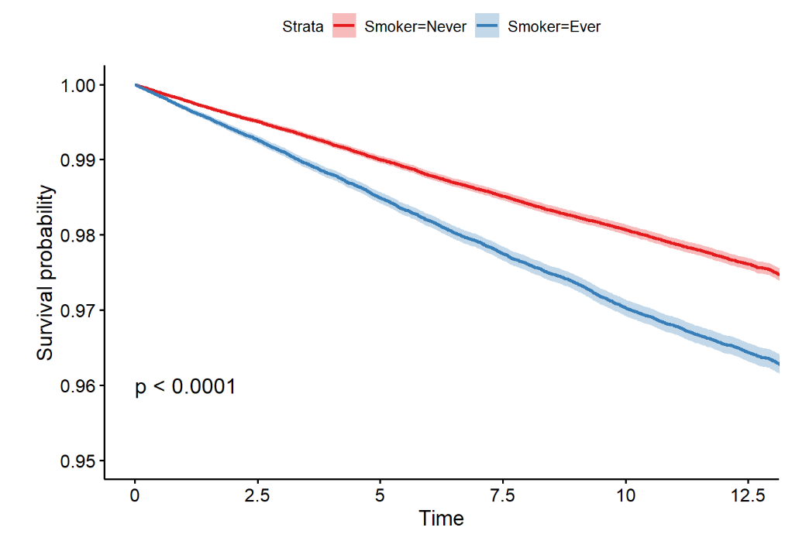

Supplementary Fig. 7. Kaplan–Meier inguinal hernia repair-specific survival probabilities by physical activity
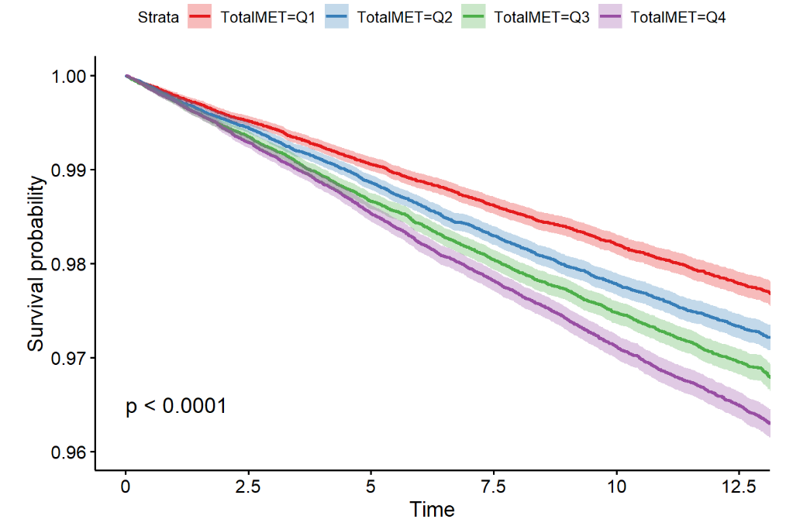
Supplementary Fig. 8. Hazard models of predictors of inguinal hernia repair (Women only)

Supplementary Fig. 9. Hazard models of predictors of inguinal hernia repair (Men only)

