Supplement 4. Direct and indirect evidence

Type of mesh and incisional hernia.

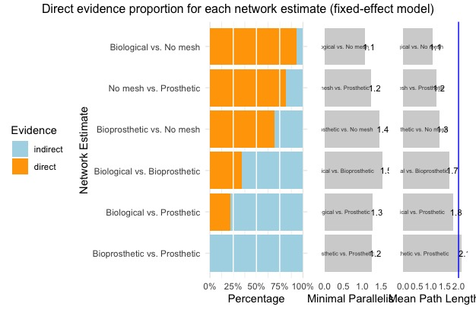

Type of mesh and surgical site infection

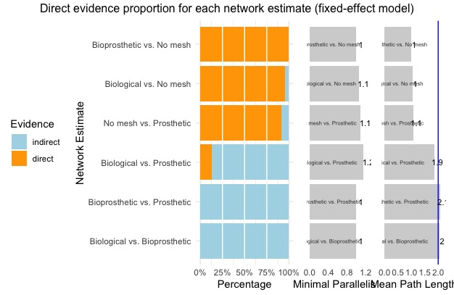

Wall plane for the mesh and incisional hernia

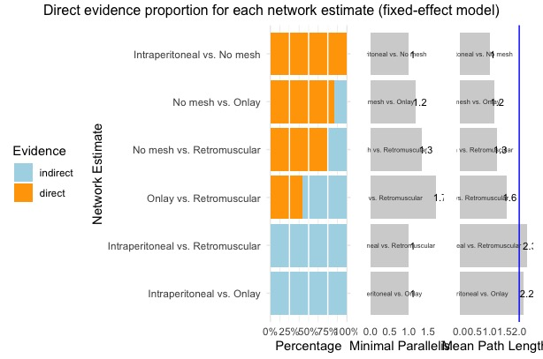

Wall plane for the mesh and surgical site infection

