Hydrogeology Journal – Electronic Supplementary Material
Groundwater connectivity of a sheared gneiss aquifer in the Cauvery River Basin, India
Sarah Collins^{1*}, Sian Loveless², Sekhar Muddu^{3,4}, Sriramulu Buvaneshwari^{3,4}, Romesh Palamakumbura¹, Maarten Krabbendam¹, Dan Lapworth², Christopher Jackson⁵, Daren Gooddy², Siva Naga Venkat Nara³, Somsubhra Chattopadhyay⁶, Alan M MacDonald¹
1 British Geological Survey, The Lyell Centre, Edinburgh, EH14 4AP, United Kingdom. Tel.: +44 131 650 0224 Email: sarcol@bgs.ac.uk
2 British Geological Survey, Maclean Building, Crowmarsh Gifford, Wallingford, OX10 8BB, United Kingdom
3 Department of Civil Engineering, Indian Institute of Science, Bangalore, Karnataka 560012, India
4 Indo-French Cell for Water Sciences, Indian Institute of Science, CNRS, IRD, INRA, UPS, Bangalore, India
5 British Geological Survey, Environmental Science Centre, Keyworth, NG12 5GG, United Kingdom
6 Ashoka Trust for Research in Ecology and the Environment, Bangalore, Karnataka 560064, India
*corresponding author

S1 – Methods

S1.1 Geological observations
Field campaigns of 2−3 weeks were undertaken in November 2018 and March 2019 to assess the nature of fracture networks and weathering profiles across the catchment. Assessment of the fracture networks was in two parts: first, a qualitative study from field observations, and, second, more focused work on representative outcrops to quantify fracture network spatial variability. During field work, road-side outcrop and quarries from across the catchment were studied to understand the local and regional trends of fracture patterns and regolith thickness. During fieldwork, photographs, with accurate scales, were taken of representative fracture networks from across the catchment. From these photographs, fracture networks were digitised in ArcGIS to create a scaled vector file representation of the fractures. These vector files were used to calculate key parameters such as average length, orientation, density and spacing.
S1.2 Groundwater levels
The elevations of groundwater levels measured in boreholes were derived using surface altitude extracted from a digital surface model with an accuracy of +/− 5 m (JAXA, 2018). Incomplete or anomalous borehole records (e.g. due to drying up of boreholes or water level measured during pumping) were removed from the dataset before calculating the mean and range of water level depth and elevation.

S1.3 Salt dilution tests
Salinity−depth profiles were obtained using an Aqua TROLL 200 temperature, pressure and salinity probe measuring at intervals of 2 s (equivalent to ~20 cm). Depth to water level was measured at the start of the test and a background salinity profile obtained. A hosepipe was inserted into the borehole and filled – up to the water level in the borehole – with a salt solution (1 kg L⁻¹). The hosepipe was then removed as quickly as possible to raise salinity uniformly along the length of the borehole. The probe was equilibrated at the top of the water column and initially four to six profiles were collected in quick succession in order to catch any rapid dilutions. The timings of subsequent profiles were determined according to the rate of dilution, and obtained periodically until the salt had completely diluted, as indicated by a background salinity along the length of the borehole. The duration of monitoring varied from four hours to over four months.
The dilution test results were modelled by solving the 1D advection–dispersion with a finite differences model written in Python (Collins and Bianchi 2019):
$\frac{∂}{∂z}\left(D_{0}\frac{∂C}{∂z}- Cv\right)+\frac{q_{in}C_{0}-q_{out}C}{A}=\frac{∂C}{∂t}$ (S1)
where $z$ is depth (m), C (kg m⁻³) is the solute concentration in the borehole, D₀ (m² s⁻¹) is the dispersion coefficient, v (m s⁻¹) is the velocity of water longitudinal to the borehole, C₀ (kg m⁻³) is the background solute concentration, A (m²) is the area of the borehole, and q_{in} and q_{out} (m² s⁻¹) are inflows and outflows at the fractures. Fluid electrical conductivity was converted to salinity (in kg m⁻³) and corrected for temperature according to Doughty and Tsang (2005). To ensure numerical stability a spatial discretisation of 10 or 20 cm was used, thus keeping the Peclet number (Δz × Q/D₀; where Q is volumetric flow longitudinal to the borehole) lower than two. The numerical integrator odeint (Scipy package) was used to solve the set of ordinary differential equations for the exact observation times. Manual calibration of the model was found to be appropriate because of the subjectivity in assessing model fit (as also found by Mathias et al. 2007). For borehole NB128, constant source/sink flows and locations as well as a dispersion coefficient were calibrated; however, for boreholes BH86 and NB112N, which took much longer to dilute, flow velocity was found to change over time and the inflow/outflow strengths had to be adjusted proportionately. The amount of dispersion/diffusion appeared to decrease over time, most likely because the act of moving the electrical conductivity probe up and down the borehole increases dispersion/diffusion (also observed by Doughty and Tsang 2005). The dispersion/diffusion coefficient was, therefore, reduced for boreholes BH86 and NB112N after the initial, frequent observations on the first day (from 0.03 to 0.002 m² d⁻¹).

S1.4 Numerical model structure and calibration
The flow path for the transect model was based on groundwater contours generated using observed groundwater levels from a wider groundwater monitoring campaign, which included boreholes outside the catchment (Fig. 2, main article). Localised depressions in groundwater level are an inevitable consequence of intensive abstraction; however, when the groundwater contours are smoothed, there is a clear gradient from west to east. As these wider data were not available monthly and missing data could lead to large changes in contours from month to month, for all comparisons of observed against simulated groundwater levels, the raw groundwater level data were used. These data were mapped to transect nodes 500 m apart. Uncertainty in the groundwater level observations has two components: +/− 5 m due to uncertainty in DSM elevation (JAXA, 2018); and the error in averaging observed groundwater levels to transect nodes. Where two or more observations could be mapped to the same node, an average was taken and the range added to the uncertainty.
An east−west rainfall gradient is observed in the Berambadi. Mean annual precipitation between 2010 and 2018 was 982 mm within the catchment and 659 mm to the east of the catchment (gauges 1 and 2 in Fig. 2, main article). The observed difference in rainfall was reflected in the model by applying a linear decrease to the observed rainfall at gauge 1 in an easterly direction based on the mean difference between the two gauges (0.024 mm/m/year). Additional recharge was not applied underneath the tanks, as no evidence was found of significant recharge from the tanks in the stable isotope samples.
The Chamarajnagar District report (CGWB 2008) estimates groundwater abstraction for the Gundlupete Taluk at 70.8 mm/year. This figure is in close agreement with that of Siebert et al. (2010), who estimated abstraction at 70.3 mm/year. In order to account for the uncertainty in these estimates mean abstraction was sampled within +/− 20% of 70.8 mm/year. The farm typologies in the Berambadi, described by Robert et al. (2017), show a trend from predominantly rainfed agriculture in the west of the catchment to predominantly irrigated agriculture in the east. The percentage of farms in the west (19%), mid-west (40%), mid-east (59%) and east (72%) that use irrigation is displayed in Fig. 1b (main article). The differences in abstraction among these four regions are likely less striking, as farmers with higher yielding wells tend to grow more water intensive crops. Abstraction was, therefore, represented in the model with a calibrated linear gradient between the four regions:
${Abs}_{regional}=region × ∆_{Abs}+C$ (S2)
where Abs_{regional} (mm/year) is the abstraction in a region whereby the regions are assigned values 1, 2, 3, 4 for the west, mid-west, mid-east and east, respectively, ∆_{Abs} is the abstraction gradient (mm/year/region), and C (mm/year) was a constant adjusted to ensure that the mean abstraction was equal to the reported value. The model inputs are summarised in Table S1.4.
Table S1.4 Numerical model inputs
Model input | Source
Rainfall | Maddur rain gauge (1, Fig. 2, main article). Rainfall gradient calculated based on comparison with Gundlupete rain gauge (2, Fig. 2, main article)
Recharge coefficient | Calibrated for each steady-state model
Abstraction | Chamarajnagar District report (CGWB 2008). Subject to sensitivity analysis within +/− 20% of reported value
Abstraction gradient | Calibrated based on median transmissivity profile
Transmissivity | Specific capacity data (see section ‘Geological and hydrogeological investigations’, main article)
Specific yield | Subject to sensitivity analysis

Five transmissivity profiles were derived from the transformation of specific capacity data (at the 10th, 25th, 50th, 75th and 90th percentiles) into transmissivity (see section ‘Geological and hydrogeological investigations’, main article). An exponential curve was fitted to each profile for input into the model. To estimate the abstraction gradient, a steady-state model using mean rainfall (mm/year) was run with the median transmissivity profile and 10 different mean abstraction rates, sampled at equal intervals between 56.6 and 85.0 mm/year. A single recharge coefficient (R₀) for each steady-state model was also calibrated:
$R=R_{0} ×(Mean rainfall -0.024× X_{1})$ (S3)
where X₁ (m) is the distance between the transect point and rain gauge 1 (Fig. 2, main article) in an easterly direction, 0.024 (mm/m/year) is the rainfall gradient and R is recharge (mm/year). The recharge coefficient and abstraction gradient were calibrated by minimising the difference between observed and simulated average groundwater levels (April 2010–December 2018) using the sequential least squares programming algorithm (Kraft, 1988) (within Python Scipy package). The abstraction gradient calibrated with the 10 models varied between 4.6 and 5.1 with a mean of 4.9 (mm/year/region), which is equivalent to a difference of ~20 mm/year between the west and east regions for a mean annual abstraction of 70.8 mm/year. The models were then re-run with the abstraction gradient fixed to the mean. To test the sensitivity of the model to transmissivity, the steady-state model was run a further 40 times: with the four remaining transmissivity profiles (at the 10th, 25th, 75th and 90th percentiles) and 10 different abstraction rates.

Only those steady-state simulations that produced average groundwater levels within the uncertainty limits of 80% of the observations were run as transient simulations. Steady-state groundwater levels were used as initial groundwater levels in the transient model runs. The transient model was run on a daily time step with monthly stress periods. Annual abstraction was converted to monthly abstraction based on growing season and the availability of electricity, which is provided free to farmers for irrigation. In the kharif and rabi seasons, electricity is available for 3–4 h/day and for 2–3 h/day, respectively (Robert et al. 2017). It was assumed that 10% of annual abstraction occurs in the summer for household use, and therefore the fraction of annual abstraction in kharif is 52.5% and in rabi 37.5%. Abstraction was assumed uniform in the summer, as very little irrigation is carried out, and therefore:
${Abs}_{summer} = {Abs}_{mean} ×0.1$ (S4)
where Abs_{summer} (mm/year) is the total abstraction over the 4 months of summer and Abs_{mean} (mm/year) is the annual mean abstraction. In kharif and rabi, when abstraction is predominantly for irrigation, the abstraction gradient was taken into account, that is:
${Abs}_{growing} =\left({Abs}_{regional}- {Abs}_{summer} \right)×season$ (S5)
where Abs_{growing} (mm/year) is the total abstraction over the 4 months of either rabi or kharif and season is equal to 0.58 in kharif and 0.42 in rabi to reflect electricity availability in the different seasons.
Specific yield was calibrated during the transient simulations. For each combination of abstraction and transmissivity, the model was run 20 times with specific yield sampled logarithmically between 0.05% and 5%, which is consistent with the range of values quoted in the literature for Indian basement aquifers (e.g. Dewandel et al. 2006, 2010). Additionally, the theory of decreasing storage with depth, hypothesised from geological observations, was explored. An exponentially decreasing specific yield (S_{y}) was applied in the model to reflect the decrease in transmissivity:
$S_{y} \left(z\right)=S_{y,min} + C × e^{- D ×{depth}_{gw}}$ (S6)
where depth_{gw} is depth to groundwater and C and D are parameters. A minimum specific yield, S_{y,min}, of 0.05% for fresh bedrock was added to prevent storage from becoming exceptionally low, which leads to model instability. C was sampled logarithmically between 0.1% and 5% and D logarithmically between 0.001 and 0.1. These ranges produce profiles with a maximum S_{y} of 0.15−5% at the surface and a decrease with depth ranging from linear to sharp exponential.

In order to explore the consequences of reduced abstraction, the boundary condition at the eastern edge of the transect – i.e. time-variant fixed head – had to be changed. We experimented with several different boundary conditions and found that the boundary had an influence up to 2.5 km into the transect. We therefore extended the transect by 2.5 km and implemented the same time-variant fixed-head condition as implemented in the original model. The rainfall gradient was continued into the final 2.5 km of the new transect and abstraction was set equal to that at the end of the original transect (fourth region). Steady-state and transient simulations were run with the new, extended model for mean abstraction (70.8 mm/year), no abstraction and abstraction reduced to 25% (17.7 mm/year) and 50% (35.4 mm/year) of the mean. The extended model was able to model groundwater levels with the same accuracy as the original model (root mean square error 5.7−7.5 m).

S2 – Results

S2.1 Geological observations
The Berambadi catchment comprises both massive and sheared gneisses. Both massive and sheared gneisses consist of mainly felsic grey gneiss (mainly qtz + plag + biot) with locally mafic, amphibolite (likely to be of intrusive origin) enclaves or layers. However, sheared gneisses may also include supracrustals units of the Dharwar Schists. Foliation (‘gneissosity’) in the massive gneisses is moderately developed with a typically wispy layering of felsic/intermediate composition and locally more distinct mafic layers (Fig. S1) whereas the sheared gneisses possess a strongly to very strongly developed gneissosity. This gneissosity is defined by: (i) alternation of felsic/intermediate layers, (ii) migmatitic and pegmatite layers; (ii) biotite foliation planes continuous for several metres, (iv) sheared out, thin (<10–100 cm) amphibolite layers; and (v) mineral foliation (e.g. by amphiboles in amphibolite and biotite in felsic gneiss). In places, the foliation is so strong that the rocks should arguably be termed gneissose schists rather than gneisses. In most outcrops, the gneissic foliation was steep to subvertical, although it is locally inclined. In the Berambadi catchment, sheared gneisses occupy 40–70% of the rock. In the Berambadi catchment the foliation swings from an east−west trend in the south towards a more north-east to south-west or north−south trend north of Gundlupet, consistent with the mapping of shear fabrics by Chardon et al. (2008) (Fig. S2). The features used to derive structural orientation can be found in Table S1.
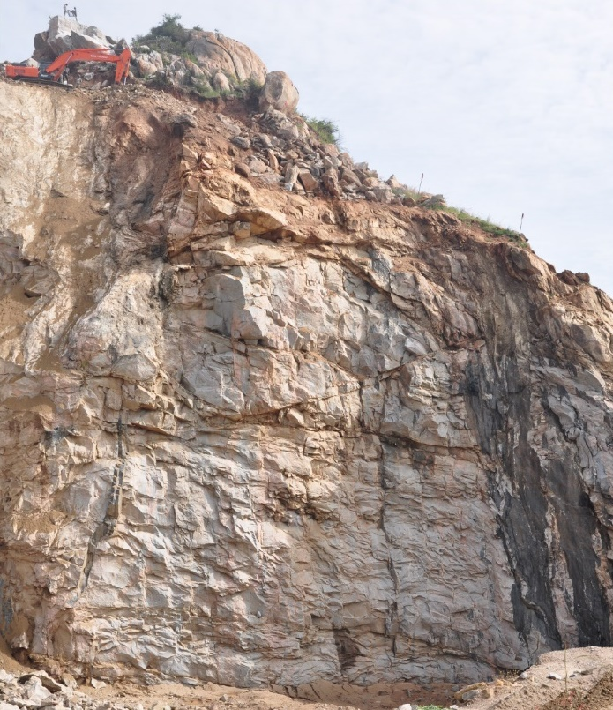
Fig. S1 Massive gneiss with vertical sheared amphibolite layers (black streaks to the right), at the eastern edge of the Berambadi catchment.
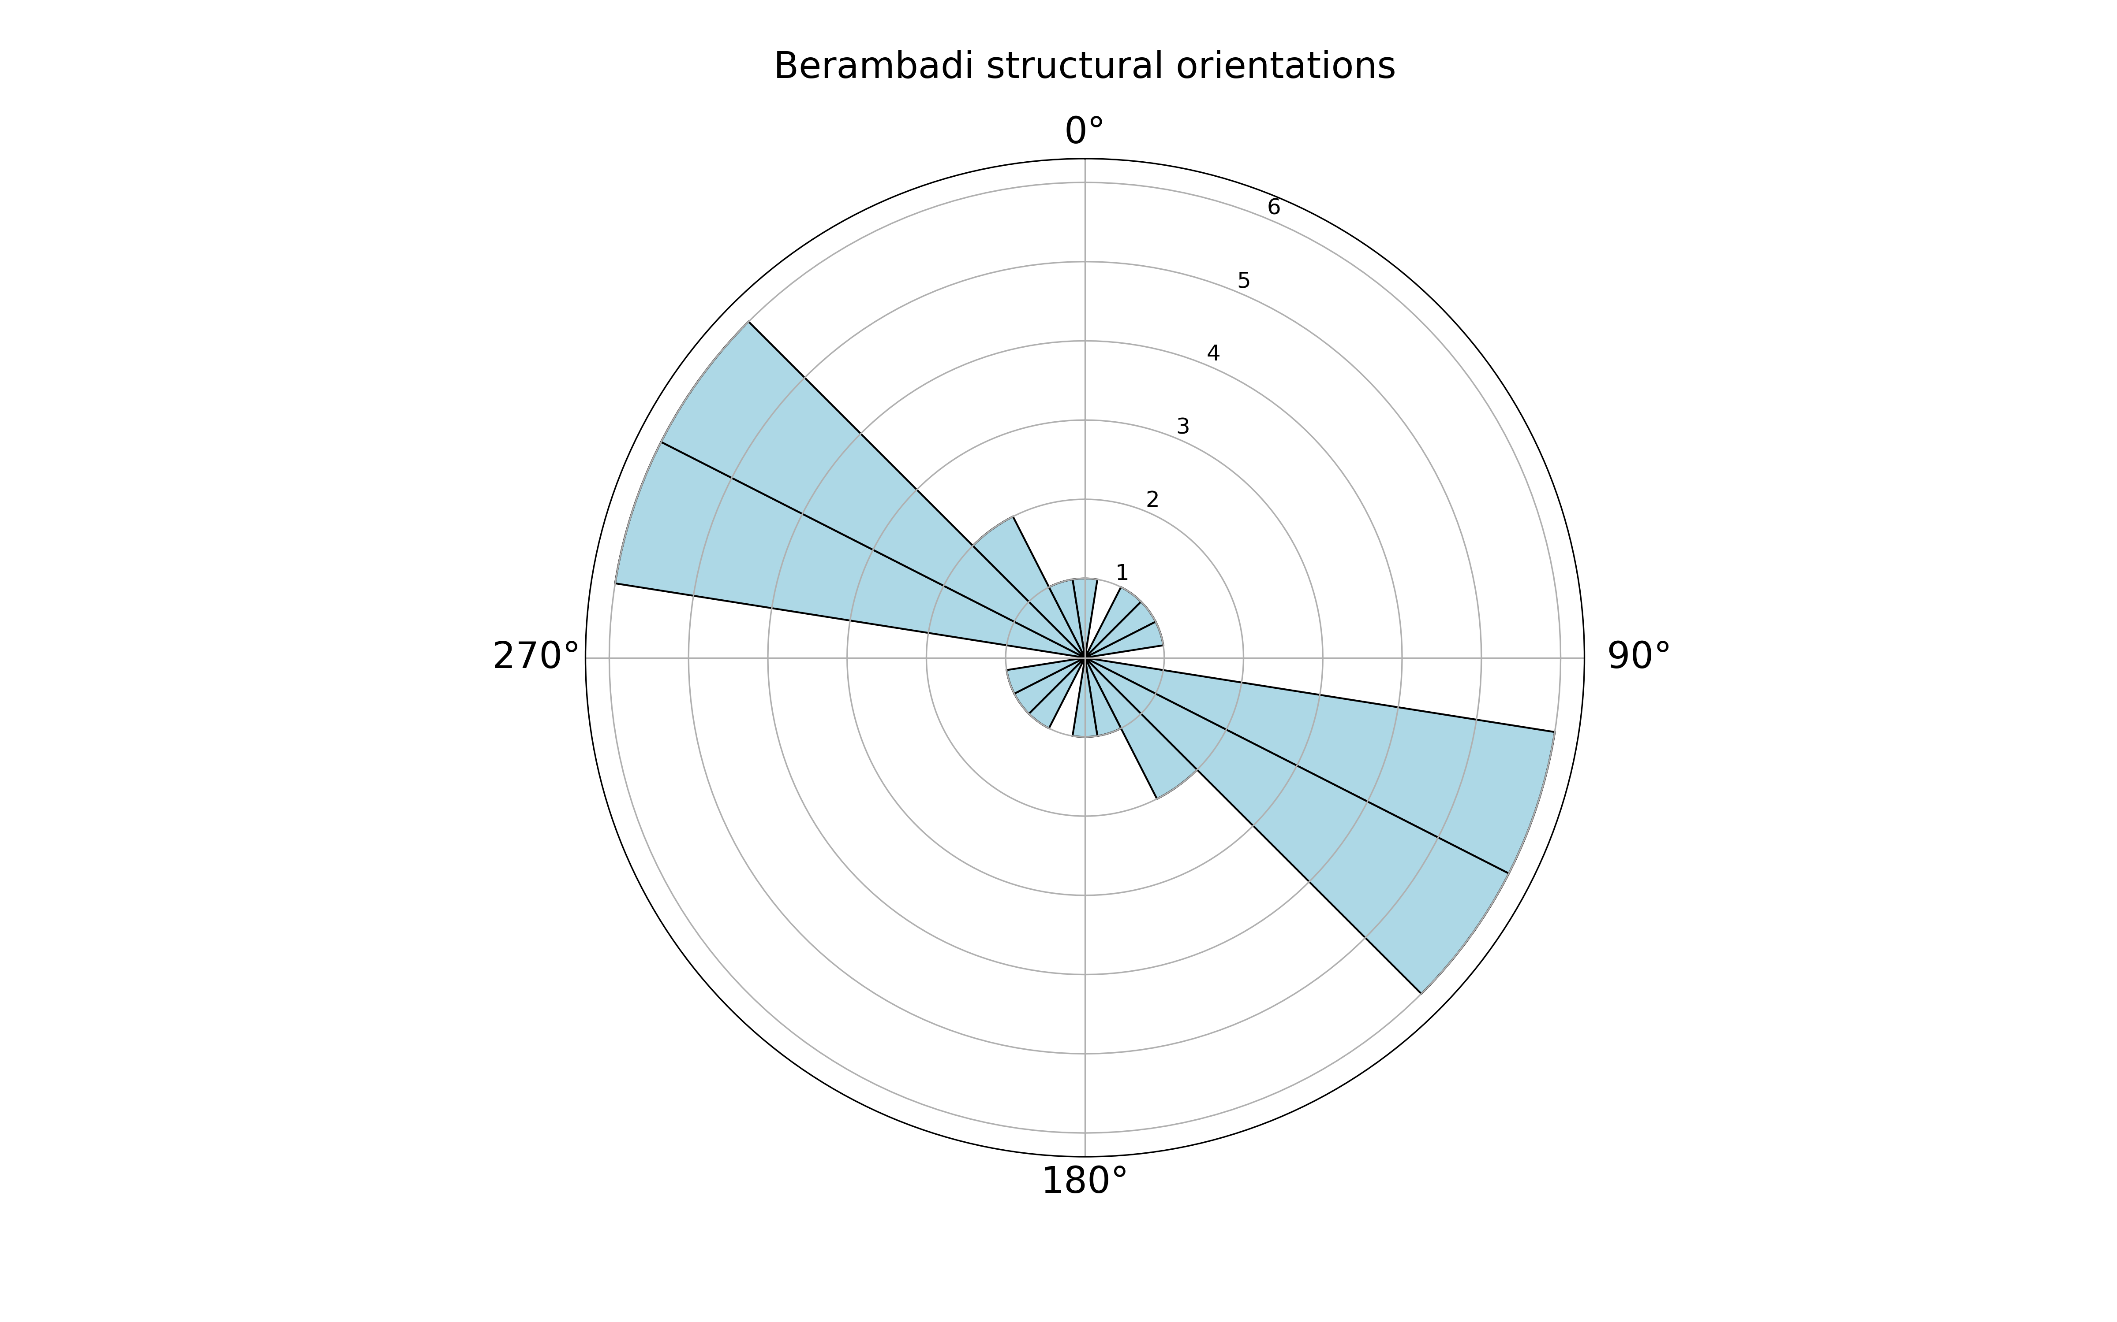
Fig. S2 Rose plot showing orientation of key structural features in Berambadi.
Table S1 Measurement of key structural features from the Peninsula Gneiss in the Berambadi catchment. The data are plotted on a rose plot in Fig. S2
X (˚) | Y (˚) | Feature | Azimuth (˚) | Dip (˚)
77.35 | 12.92 | Joint | 140 | 90
77.84 | 12.47 | Joint | 115 | 60
77.16 | 12.26 | Foliation | 252 | 60
76.66 | 11.77 | Foliation | 165 | 85
76.55 | 11.78 | Foliation | 160 | 80
76.65 | 11.8 | Foliation | 115 | 85
76.65 | 11.8 | Joint | 115 | 85
76.65 | 11.8 | Foliation | 110 | 80
76.66 | 11.8 | Foliation | 110 | 85
76.54 | 11.93 | Foliation | 290 | 82
76.66 | 11.8 | Foliation | 310 | 80
76.66 | 11.8 | Foliation | 180 | 70
76.65 | 11.78 | Foliation | 140 | 85
76.65 | 11.78 | Foliation | 160 | 85
76.81 | 11.78 | Foliation | 130 | 80
76.81 | 11.78 | Lineation | 42 | 42
76.81 | 11.78 | Foliation | 129 | 80
76.82 | 11.78 | Foliation | 127 | 70
76.82 | 11.78 | Lineation | 64 | 50

Supracrustals include mainly schistose amphibolite, garnet-mica schist and psammite (metasandstone), with thinner or rarer units of quartzite and metalimestone (marble). Supracrustals commonly form the spine of hills, which appears somewhat counterintuitive, as they are considerably more friable and softer than the gneisses, but is likely explained by their slower weathering rate (more quartz, less feldspar than the gneisses). Typically, the supracrustals have a strong fabric, a composite between (sheared) bedding and strong schistose foliation planes. The overall foliation is broadly parallel to that in the sheared gneisses, and all conform broadly to the mapped shear fabrics of Chardon et al. (2008). We note that, due to the strong foliation development, sheared gneisses can appear very similar to supracrustal rocks, and some of the mapped supracrustal units may in fact comprise strongly sheared gneiss.
Outcrop observations indicate well-developed sub-horizontal sheet joints broadly parallel to the ground surface within the massive gneisses, which increase in abundance close to the surface (with spacing of 1–2 m) (Fig. 3a, main article). These fractures may have an anastomosing pattern, potentially providing a well-connected fracture network in the top 5−10 m. Below this upper fractured zone, the ‘background jointing’ comprises both vertical fractures and horizontal fractures in a broadly orthogonal system, with an overall fracture spacing of 1–3 m and a density of ca. 0.5–2 m⁻¹. The horizontal fractures in this upper zone can be several metres in length, whereas the vertical connecting fractures tend to be centimetres in length.
In the sheared gneiss and supracrustal rocks fracturing is much more intense (fracture spacing of <10 cm). Foliation-parallel fractures, usually steeply dipping, are particularly common, particularly along relatively weaker continuous biotite-foliation planes (Fig. 3b, main article). Where the spacing of the vertical fractures is less than 10–50 cm, fractures normal to foliation appear to link the foliation-parallel fractures (‘ladder fractures’). The fractures have broadly the same spacing as the foliation-parallel set, creating a dense orthogonal fracture network with approximately cubic blocks. It is possible that these latter ladder fractures become more abundant closer to the surface (like sheeting joints) but this could not be confirmed, as no sufficiently deep outcrop (<25 m below ground) was available for comparison. Broadly speaking, the more intense the gneissic layering, the more dense the fracture network is. Within well-fractured, sheared gneiss, however, continuous horizontal sheet joints have not been observed, presumably because the surface-parallel stresses required for sheet jointing cannot build up (Jahns 1943, Martel 2017). In general, the sheared fracture zones are parallel to the north−east to south−west foliation; however, this may vary somewhat at a site scale. The fracture zones are dominated by lots of relatively short fractures of <10 cm up to 4 m in length. The fracture density within the fracture zones is significantly higher than in the background gneiss but also highly variable within and between fracture zones (0.7–18 m⁻¹), reflecting their heterogeneous nature.

S2.2 Groundwater levels
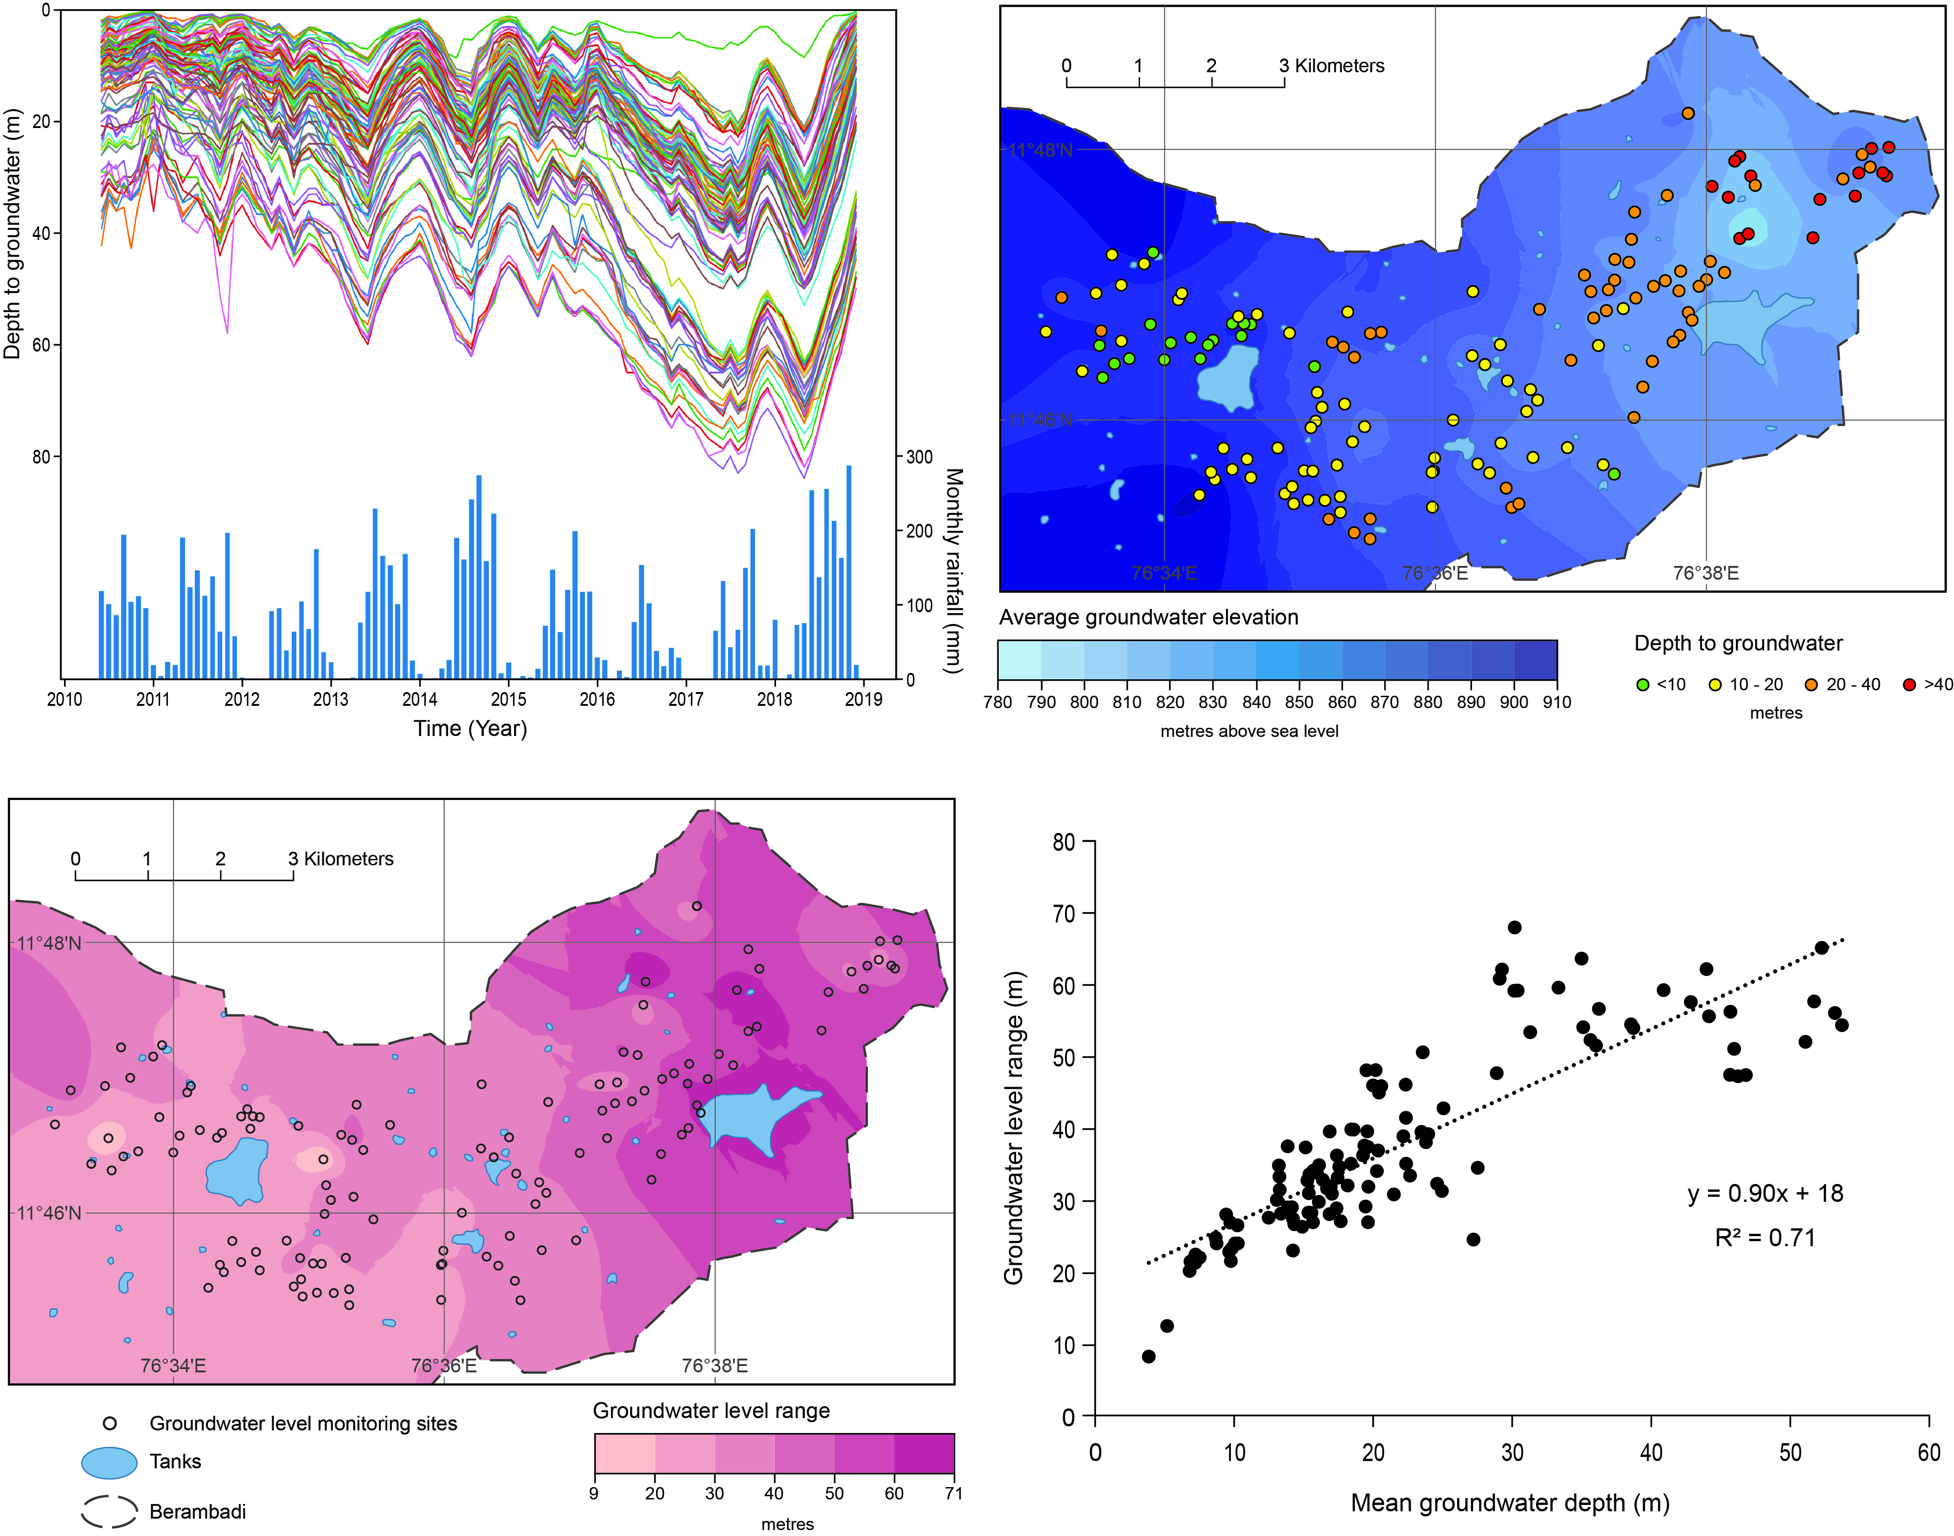
Fig. S3 Groundwater level range (2010−2018).
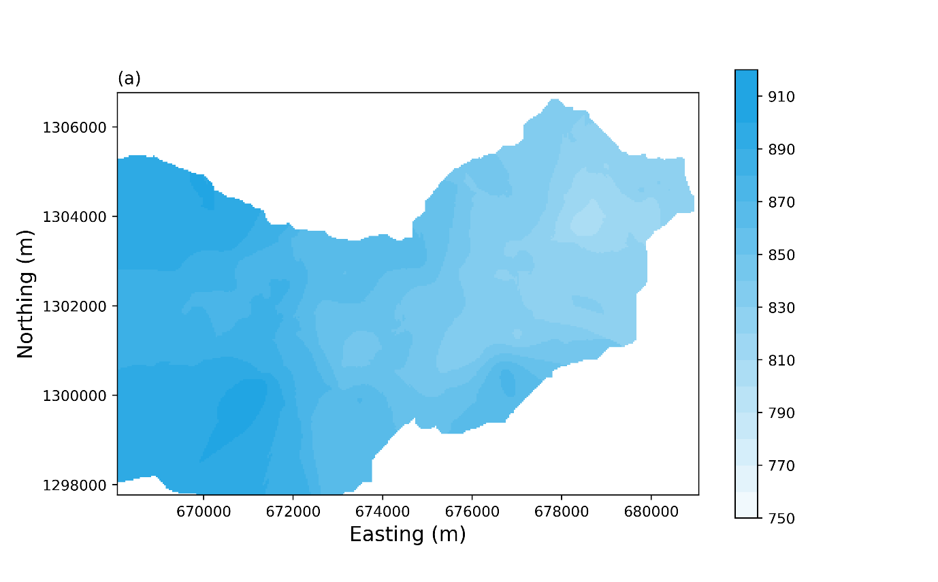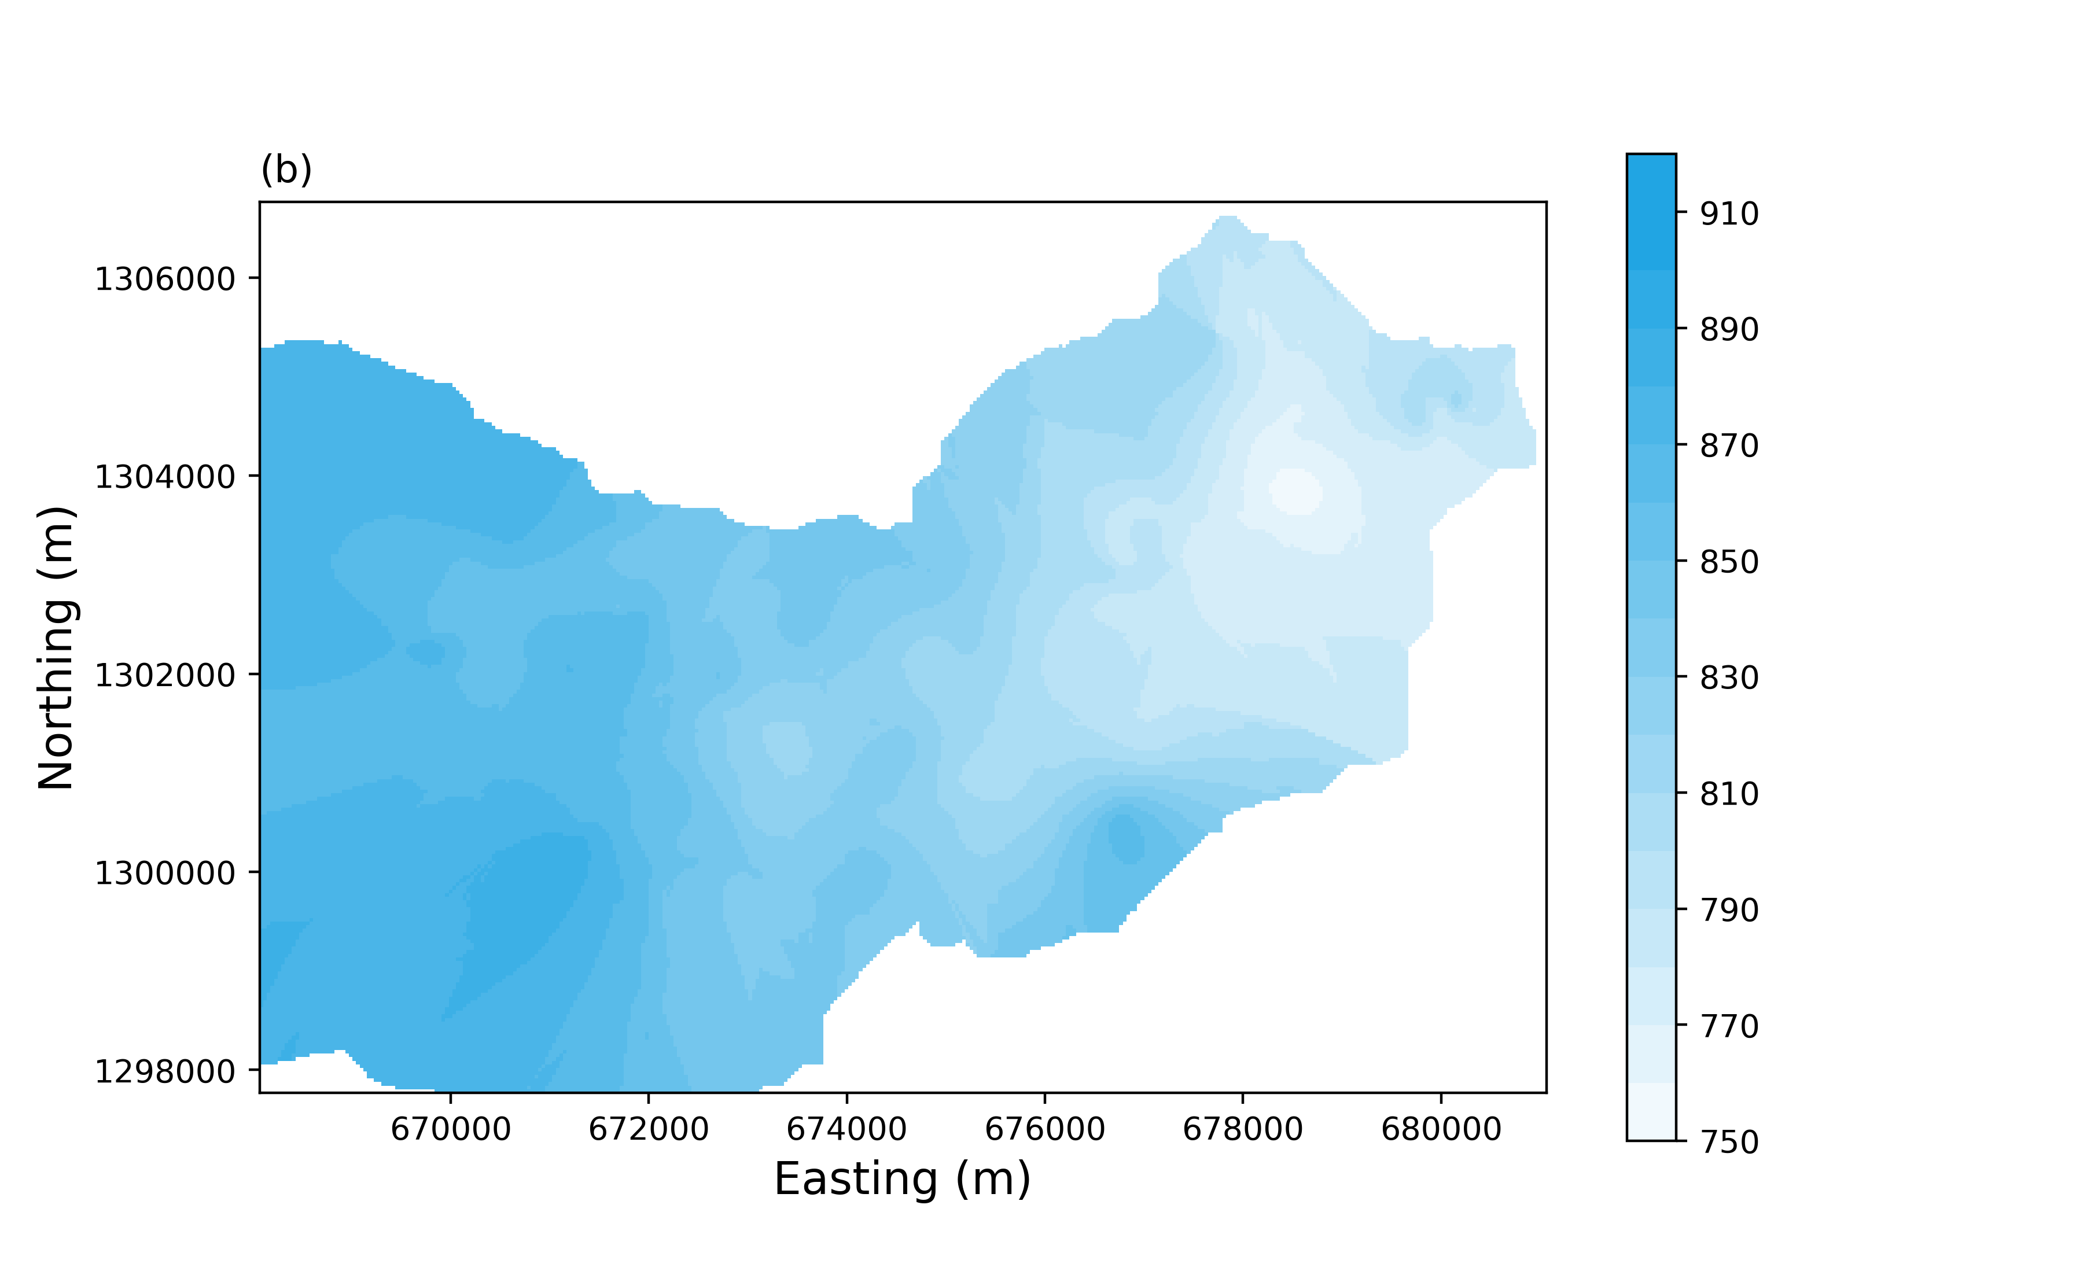
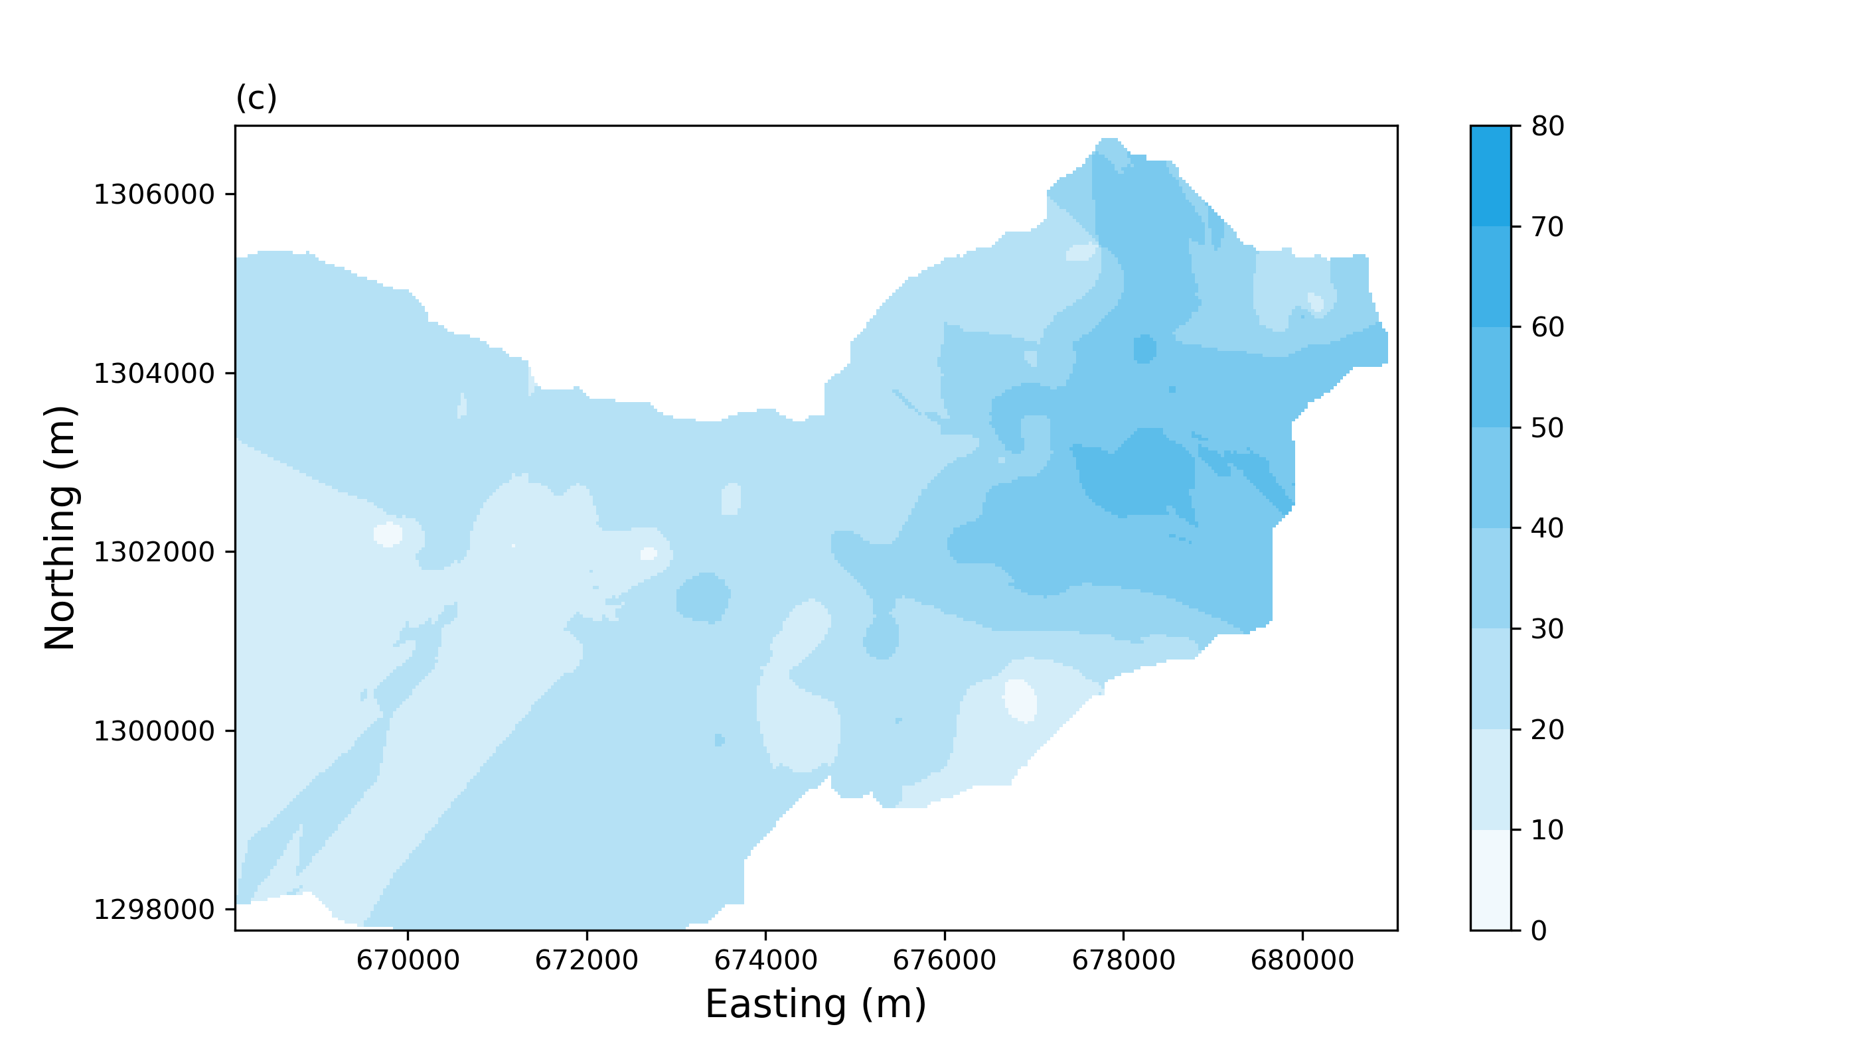
Fig. S4 Pre-monsoon groundwater levels (above sea level) in (a) 2010 and (b) 2017. (c) The difference (m) between pre-monsoon groundwater levels in 2010 and 2017. Coordinates are WGS 1984 UTM Zone 43N.

S2.3 Salt dilution tests
Borehole dilution-test salinity profiles are presented below, and described in the main article. Some profiles have been removed for clarity.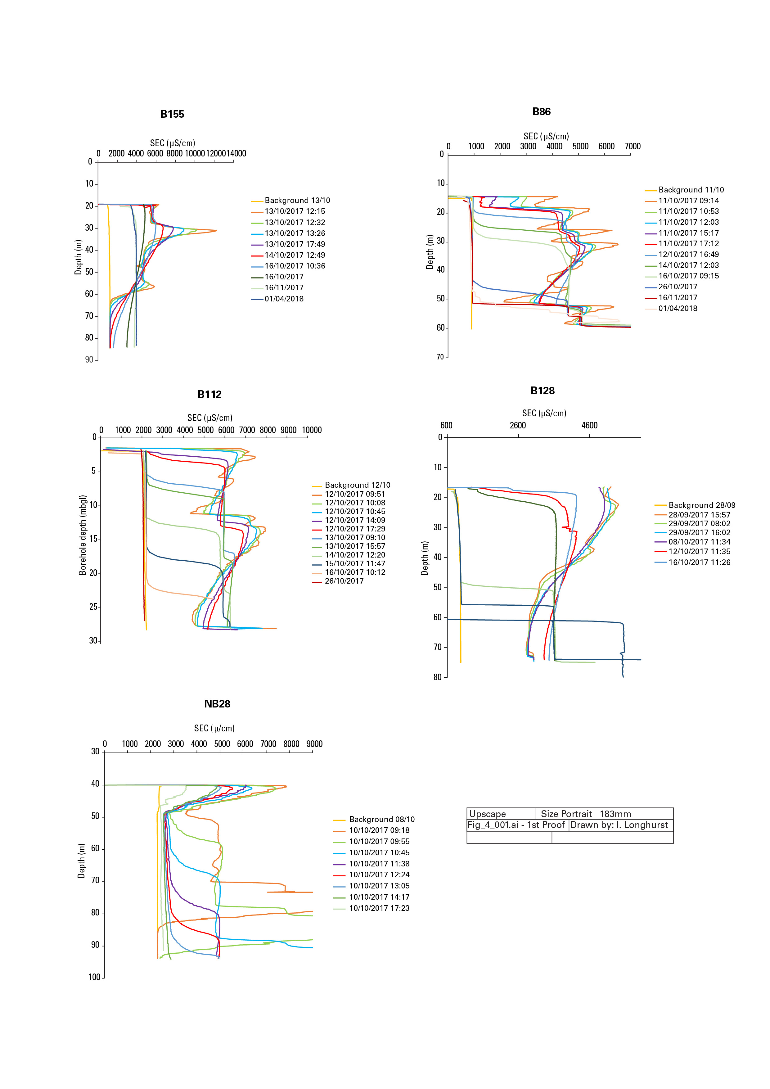
Fig. S5 Single borehole dilution test profiles. Some profiles have been removed for clarity.

S2.4 Salt dilution test modelling
Observed against simulated salinity profiles are presented below, and described in the main article. The resulting inflow and outflow locations and strengths can be found in Table S2.
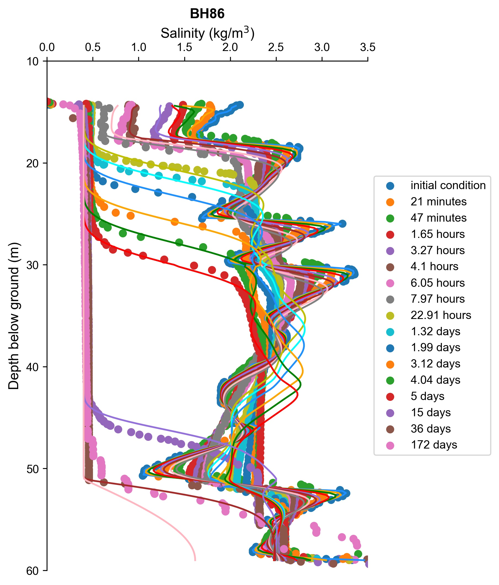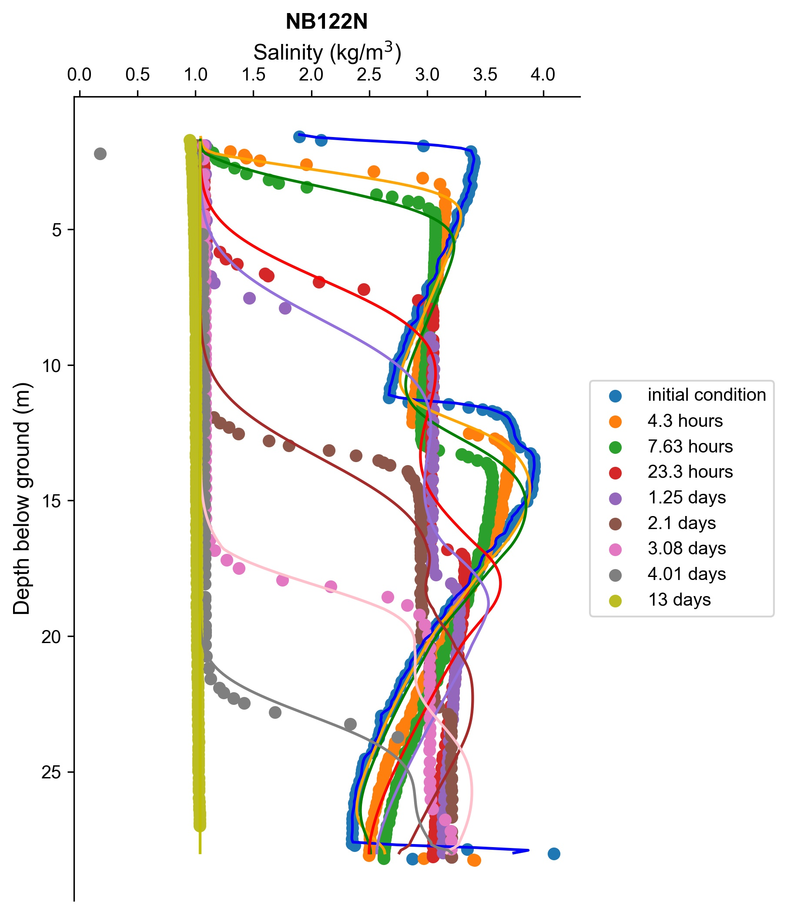
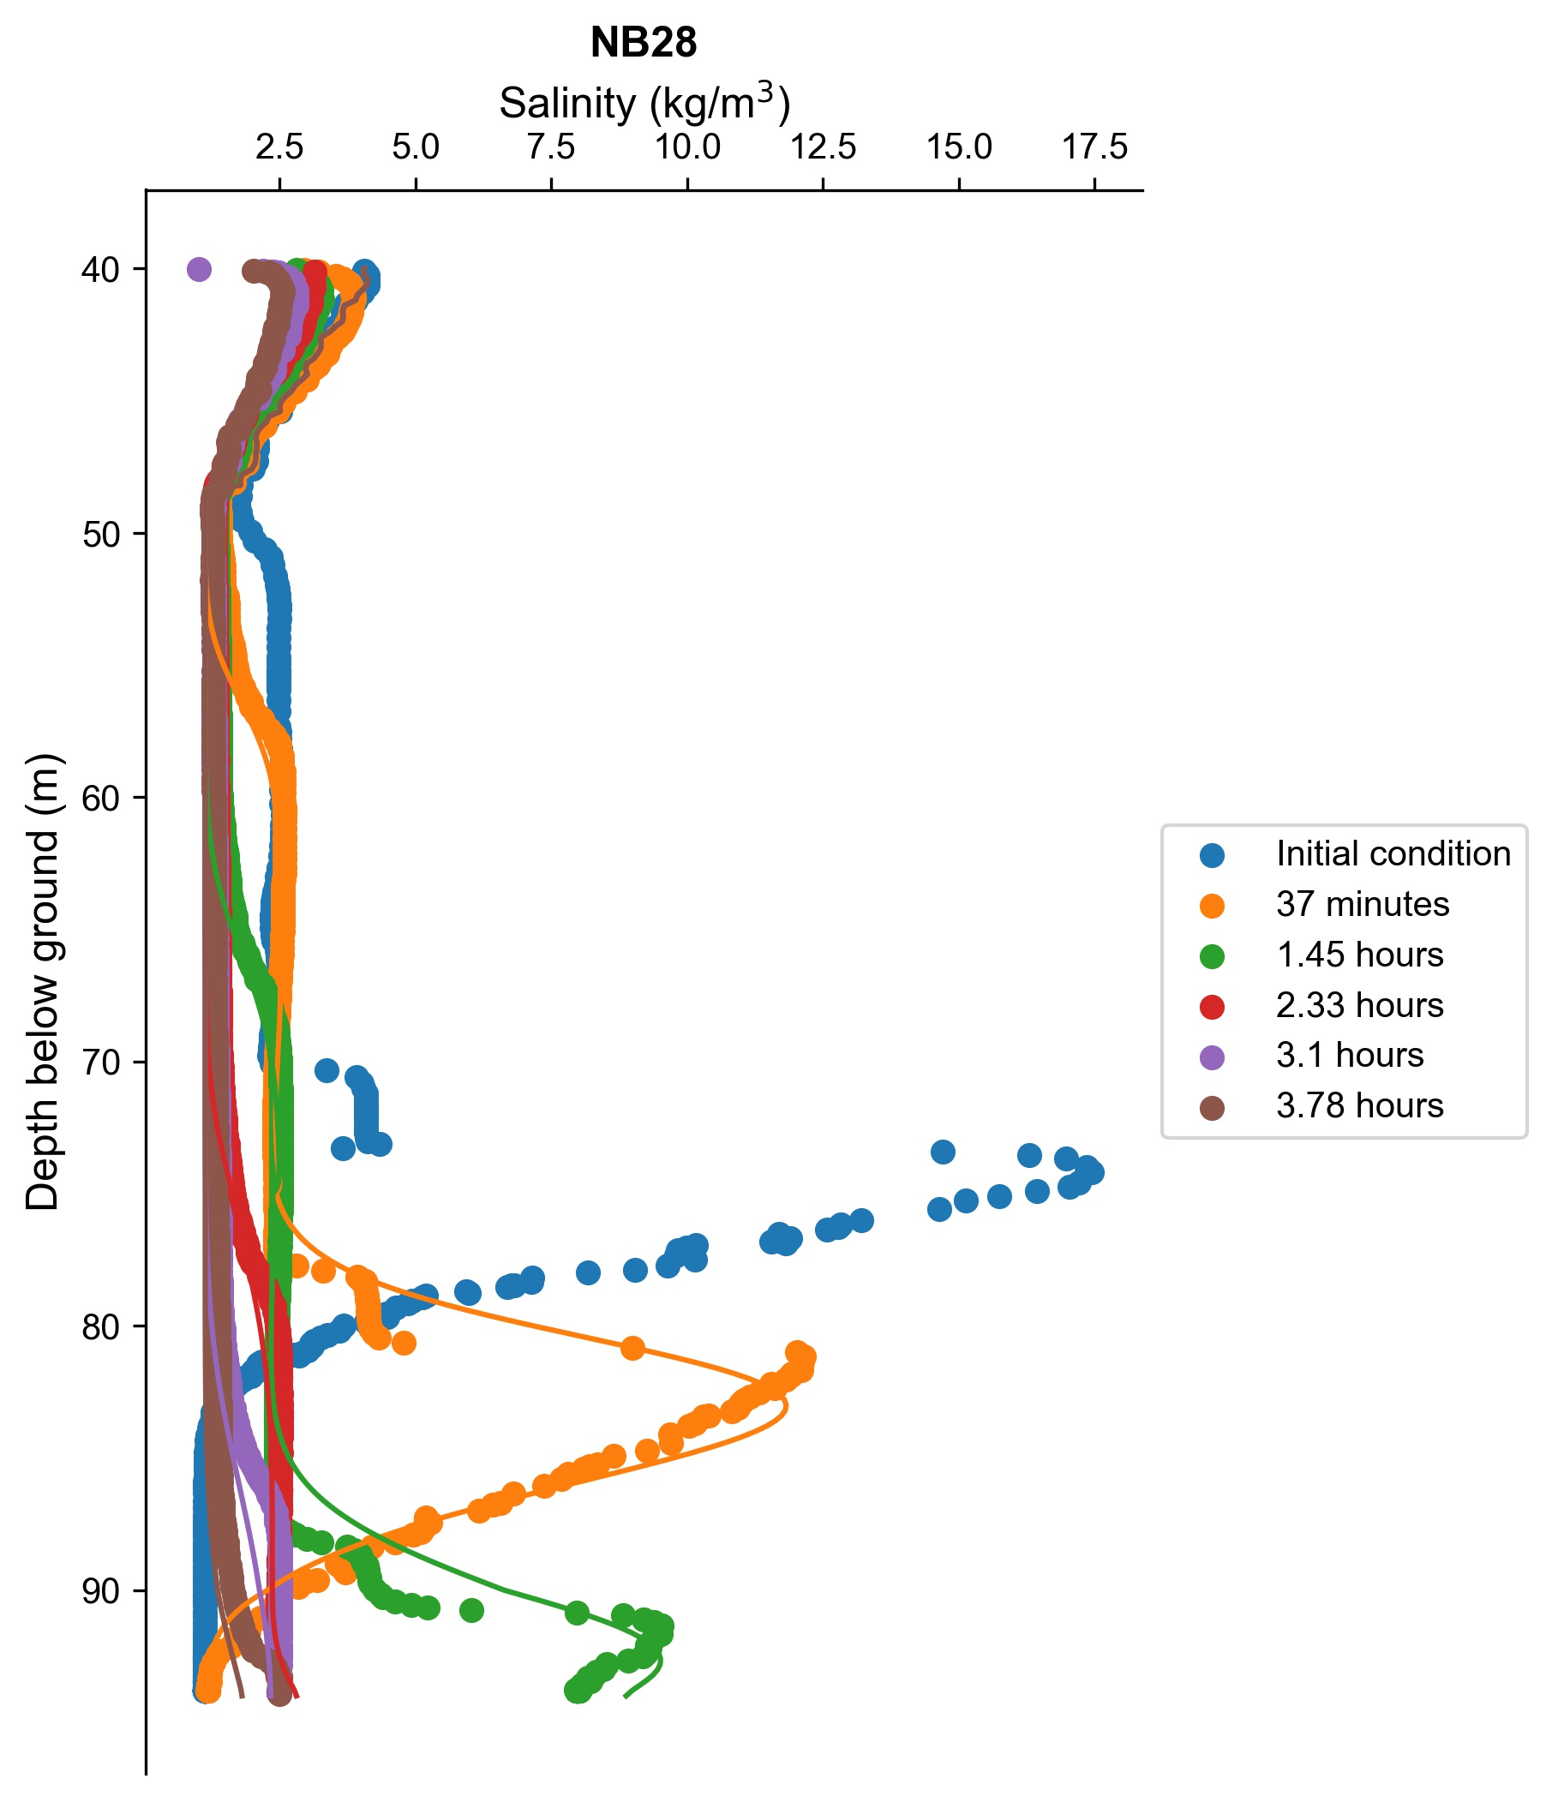
Fig. S6 Borehole dilution-test modelling results. Solid lines, modelled profiles; scatter points, observations.

Table S2 Fracture depth, total groundwater flow within the boreholes, and flows into and out of the boreholes identified through salt dilution test modelling. Locations of boreholes can be found in Fig. 1 (main article)
Borehole | Total flow (m³/d) | Fracture depth (m) | Fracture inflow (% of total inflow) | Fracture outflow (% of total outflow)
B155 | 0 | None identified | N/A | N/A
NB128 | Not known | 18 m | N/A | N/A
NB128 | Not known | 55 m + (profile does not fully dilute) | N/A | N/A
BH86 | 0.19–0.83 | 14.4–17.6 | 99.7 | 83.5
BH86 | 0.19–0.83 | 30.2 | 0.3
BH86 | 0.19–0.83 | 40.3–40.5, 41.2–41.4, 42.2 |  | 9.7
BH86 | 0.19–0.83 | 51.2 |  | 6.8
NB28 | 5.5 | 48.6–50.4 | 91.3
NB28 | 5.5 | 75 | 8.7
NB28 | 5.5 | 90 |  | 25
NB28 | 5.5 | 93.8 |  | 75
NB112 | 0.94−2.1 | 1.5–2.3 | 97.9
NB112 | 0.94−2.1 | 2.4–3.1 | 1.8
NB112 | 0.94−2.1 | 1.5–2.3 |  | 81.3
NB112 | 0.94−2.1 | 16.4 |  | 8.2
NB112 | 0.94−2.1 | 18.9–20.2 | 0.3
NB112 | 0.94−2.1 | 27.4 |  | 10.5

S2.5 Hydrochemistry data
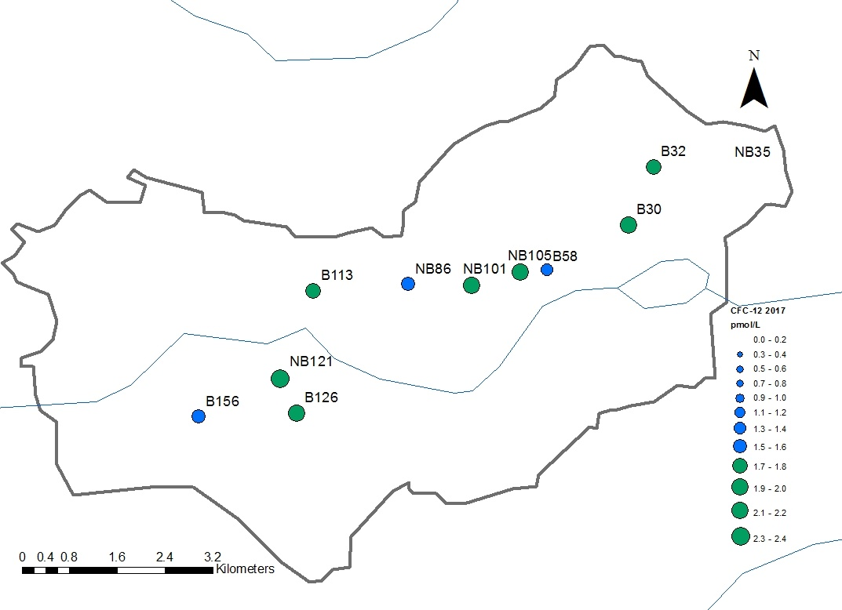
Fig. S7 Spatial distribution of CFC-12 values obtained in 2017 along the sampling transect.

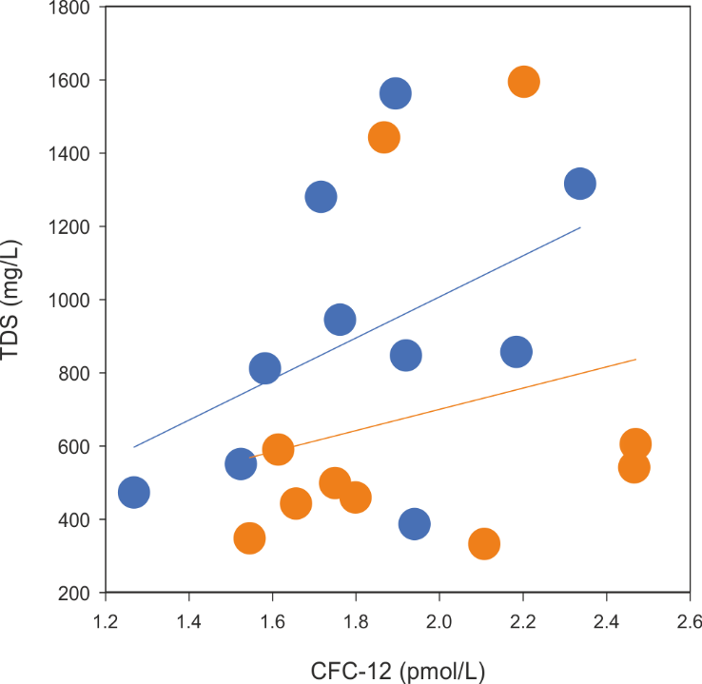
Fig. S8 Groundwater TDS vs CFC-12, blue symbols show post-monsoon values in 2018, orange symbols show pre monsoon data in 2017 with respective regression lines.
Hydrochemistry data, including inorganic, trace elements and residence time tracers, are included in a separate hydrochem.XLS file in the electronic supplementary material.

S2.6 Numerical transect model
S2.6.1 Steady state calibration
The transmissivity profiles at the 10th and 25th percentiles failed to meet the calibration criterion of producing simulated groundwater heads within the uncertainty limits of 80% of the observations. At these lower transmissivities, groundwater levels were too high in the west and too low in the east. The calibrated recharge coefficients for the 30 successful steady-state models ranged between 5% and 9%.

S2.6.2 Sensitivity analysis of specific yield
Fig. S9 shows the results of the sensitivity analysis performed on specific yield – as a single value, independent of depth – for the median transmissivity profile. The optimum for all transmissivity profiles and abstraction rates was consistently between ~0.2% and ~0.4%. This is in line with magnetic resonance sounding carried out in a neighbouring catchment, which showed an effective porosity of 1% in the regolith/saprolite and an effective porosity below detection limit in the fractured rock (< 0.5%) (Legchenko et al. 2006), but is an order of magnitude higher than was found during hydraulic testing in a single boreholes to the north of the catchment (Maréchal et al 2010). Fig. S10 shows the results of introducing an exponential decrease in specific yield with depth. In this analysis, incorporating a decrease in specific yield with depth failed to improve the simulation results. Moreover, the best results were achieved with parameters that produce an average specific yield value close to the optimum depth-independent value. For example, for C = 0.001−0.007 and D = 0.0024 (see Equation S6), the average specific yield is 0.1−0.7% between depths of 10 and 60 m below ground (Fig. S10).
Fig. S9 (a) Root mean square error (m) and (b) Nash Sutcliffe efficiency of transient model with median transmissivity profile for ranges of abstraction and specific yield.
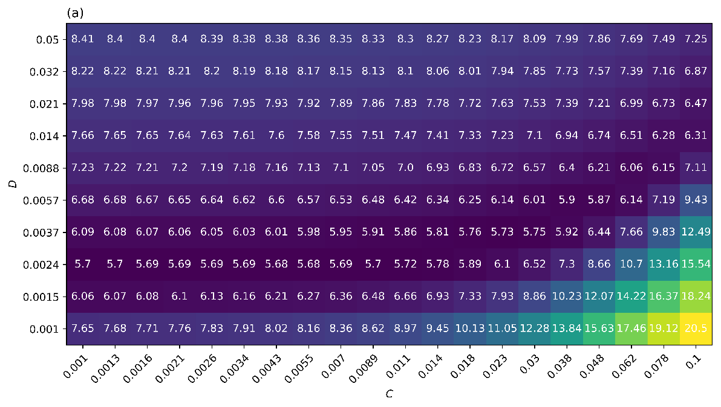
Fig. S10 (a) Root mean square error and (b) Nash Sutcliffe efficiency of transient model with median transmissivity profile for parameters C and D in Equation S6.

ESM References
CGWB (Central Ground Water Board) (2008) Groundwater information booklet: Chamarajnagar District, Karnataka. Ministry of Water Resources, Government of India
Chardon D, Jayananda M, Chetty TR, Peucat JJ (2008) Precambrian continental strain and shear zone patterns: South Indian case, J. Geophys. Res.-Sol. Ea. 113: B08402, doi:10.1029/2007JB005299
Collins S, Bianchi, M (2020) DISOLV: A Python package for the interpretation of borehole dilution tests. Groundwater. doi: 10.1002/GWAT.12992
Dewandel B, Lachassagne P, Wyns R, Maréchal JC, Krishnamurthy NS (2006) A generalized 3-D geological and hydrogeological conceptual model of granite aquifers controlled by single or multiphase weathering, J Hydrol 330(1–2): 260−284
Dewandel B, Perrin J, Ahmed S, Aulong S, Hrkal Z, Lachassagne P, Samad M, Massuel S (2010) Development of a tool for managing groundwater resources in semi‐arid hard rock regions: application to a rural watershed in South India, Hydrol. Process., 24: 2784−2797. doi:10.1002/hyp.7696
Doughty C, Tsang C-F (2005) Signatures in flowing fluid electric conductivity logs, J. Hydrol. 310(1−4): 157−180
Kraft D (1988) A software package for sequential quadratic programming. Forschungsbericht- Deutsche Forschungs- und Versuchsanstalt fur Luft- und Raumfahrt.
Jahns RH (1943) Sheet structure in granites: its origin and use as a measure of glacial erosion in New England, J. Geol. 51: 71−98
JAXA (Japan Aerospace Exploration Agency) (2018) ALOS World 3D – 30m (AW3D30) Version 2.1. Updated April 2018
Legchenko A, Descloitres M, Bost A, Ruiz L, Reddy M, Girard JF, Sekhar M, Mohan Kumar M, Braun JJ (2006) Resolution of MRS applied to the characterization of hard‐rock aquifers, Groundwater 44(4): 547−554
Mathias S, Butler A, Peach D, Williams A (2007) Recovering tracer test input functions from fluid electrical conductivity logging in fractured porous rocks, Water Resour. Res. 43, no. 7
Maréchal J-C, Vouillamoz J-M, Mohan Kumar MS, Dewandel B (2010) Estimating aquifer thickness using multiple pumping tests, Hydrogeol. J. 18(8): 1787−1796
Martel SJ (2017) Progress in understanding sheeting joints over the past two centuries. J. Struct. Geol. 94: 68−86
Robert M, Thomas A, Sekhar M, Badiger S, Ruiz L, Willaume M, Leenhardt D, Bergez JE (2017) Farm typology in the Berambadi watershed (India): farming systems are determined by farm size and access to groundwater. Water 9
Siebert S, Burke J, Faures JM, Frenken K, Hoogeveen J, Döll P, Portmann FT (2010) Groundwater use for irrigation – a global inventory, Hydrol. Earth Syst. Sci. 14: 1863–1880. https://doi.org/10.5194/hess-14-1863-2010, 2010

