639
640
641

642
643

644
645
646
647

648
649

650

651

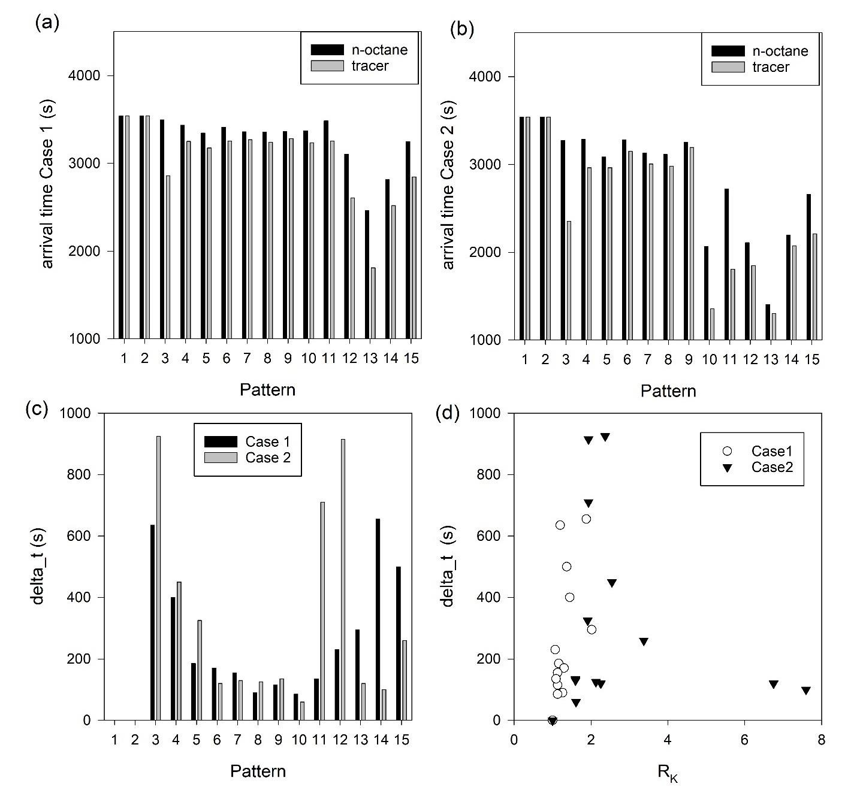Appendix

652
653
654
655

656

657

658
659
660

661
Figure S1. Plot of (a) the n-octane arrival time and the tracer arrival time in Case 1, (b) the n- octane arrival time and the tracer arrival time in Case 2, (c) the difference in arrival time for n- octane and tracer for all the patterns in both cases, and (d) the difference in arrival time for n-octane and tracer versus the ratio of RK.

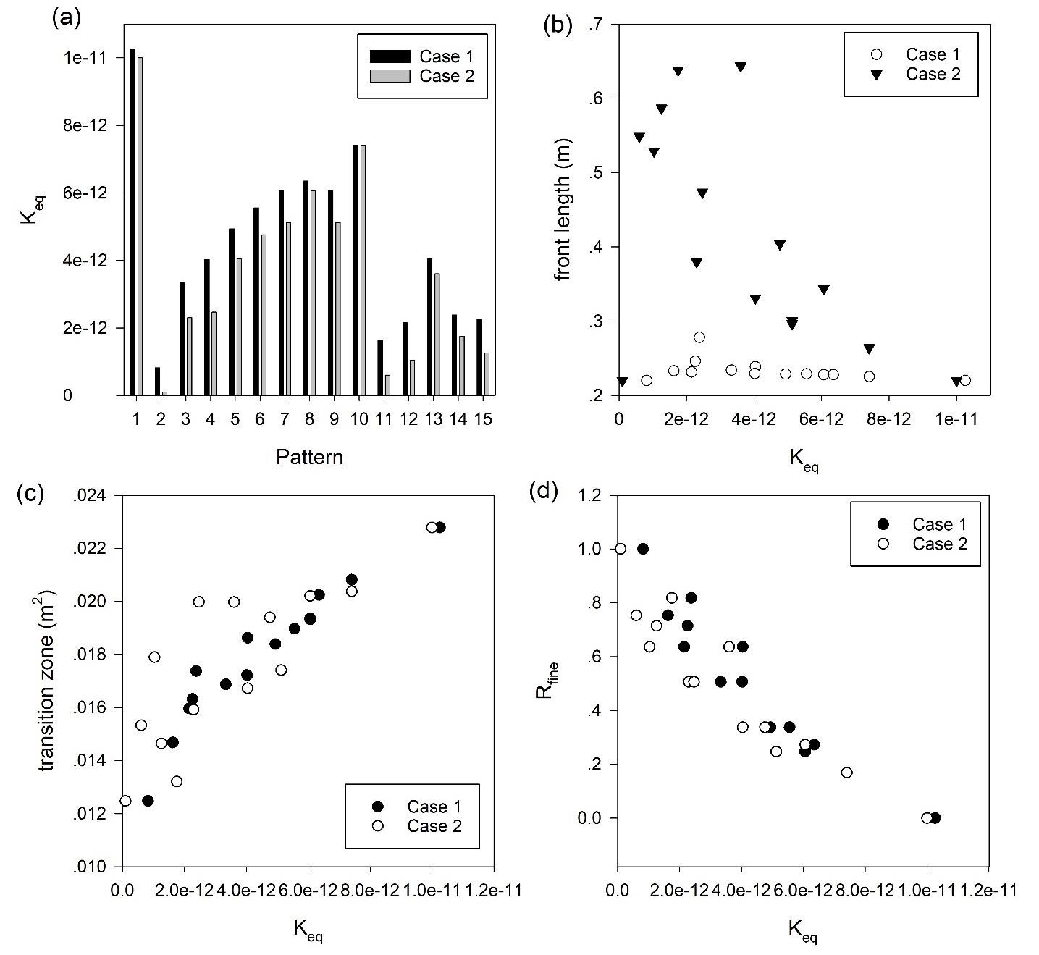

Figure S2. Plot of (a) the equivalent permeability for all heterogeneity patterns in both cases, (b) the front length versus the equivalent permeability, (c) the transition zone size versus the equivalent permeability, and (d) Rfine versus the equivalent permeability.

