Supp. figure 1: Sanger sequencing of the index patient and his three children showing the A) SLC20A2 (c.1523+1G>T) and B) PSEN1 (c.235G>A) variants.
A.
Exon 8
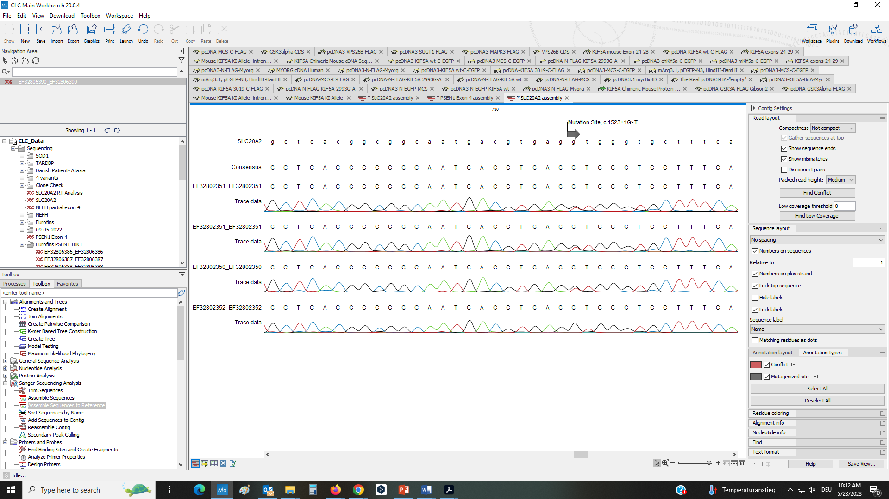
Reference

Index patient
Child 1

Child 2

Child 3

B.
Exon 4
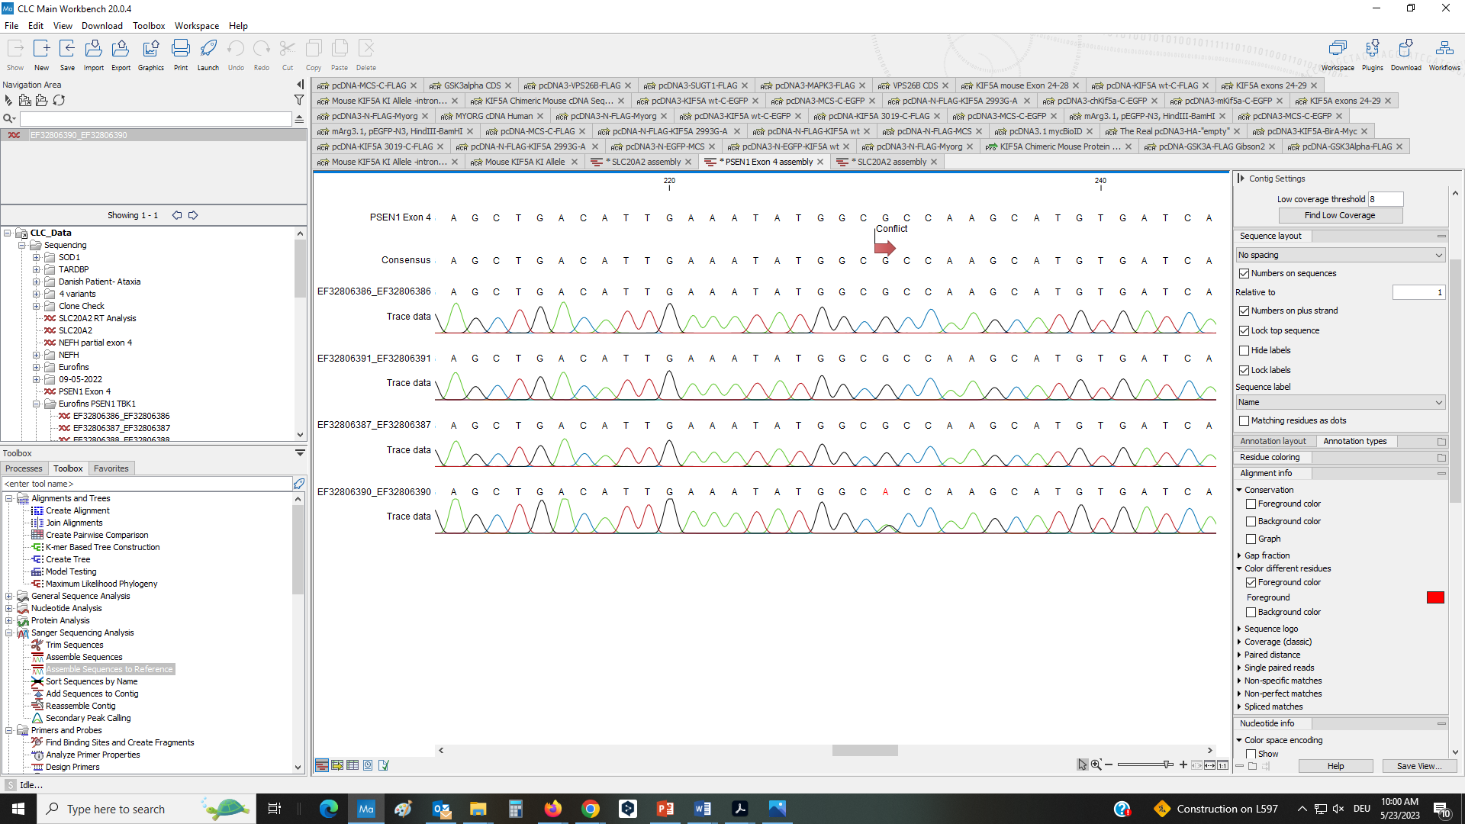
Reference

Child 3
Child 2
Child 1
Index patient

