Supplementary Information

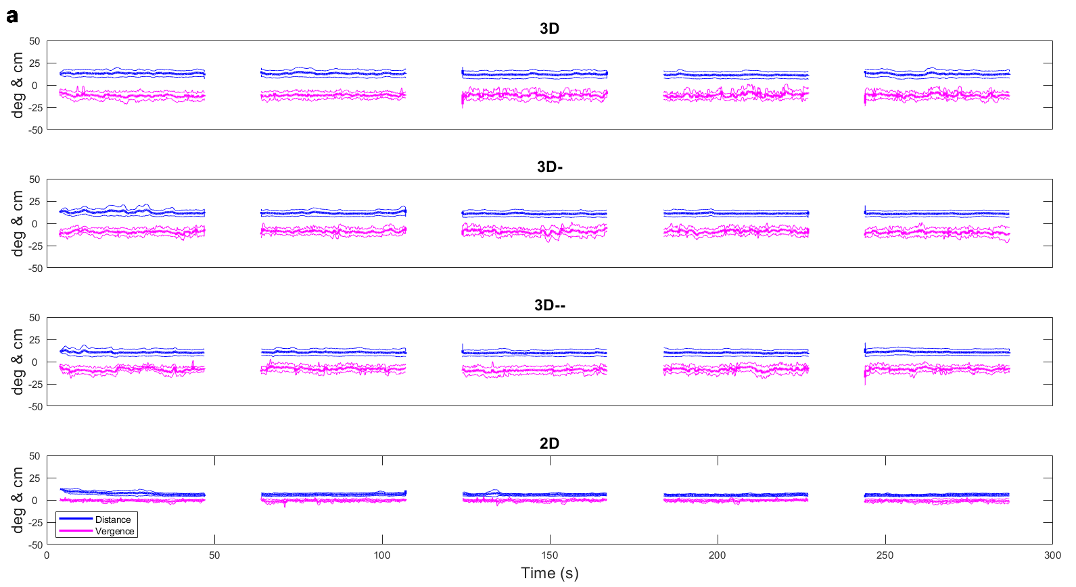
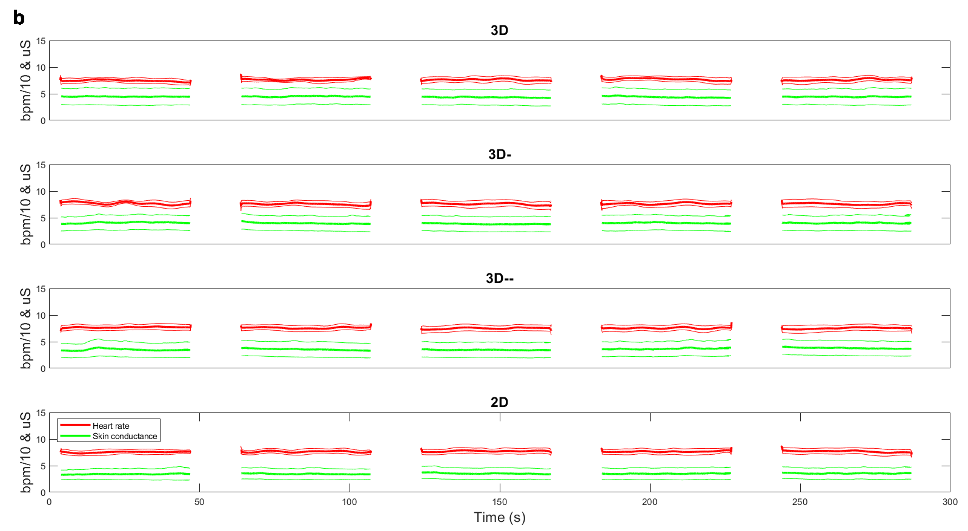
Figure 1S. Average (thick traces) and point-wise 95% confidence band (delimited by thin traces) of vergence and distance (a, top panels) and skin conductance and heart rate (b, bottom panels) recordings in the four viewing conditions (from top to bottom: 3D, 3D-, 3D--, 2D) and five repetitions (from left to right). Same conventions as in Fig. 9.

