Additional file 1:

Pictures A to G displayed the VR wearing devices, CAVE VR physical set up and cognitive motor VR activities.
Picture A. VR headset (3D stereoscopic eyewear) |  | 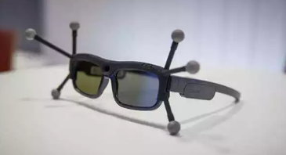
Picture B. CAVE VR Room Design  Specifications:  Room size: 2meter x 2meter  4 overhead projectors |  | 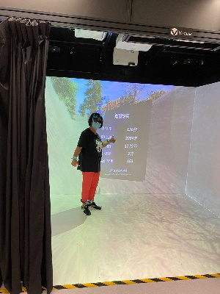
Picture C. sensors attached to 4 limbs. |  | 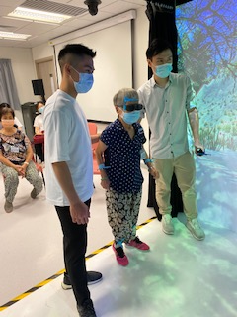
Picture D: Physical VR exercise (soccer) | 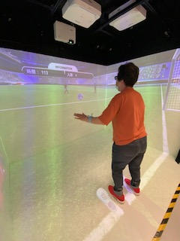
Picture E: Physical VR exercise (jogging) | 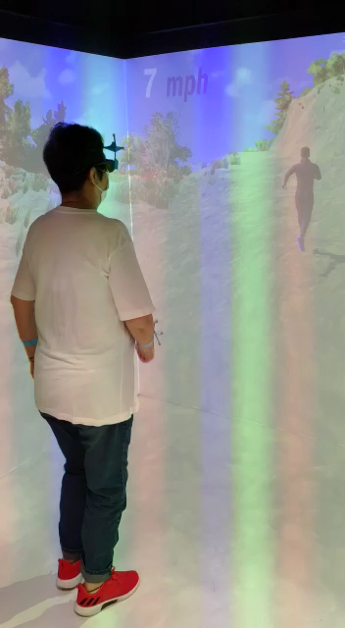
Picture F. Cognitive motor VR game  (IADL-community shopping) | 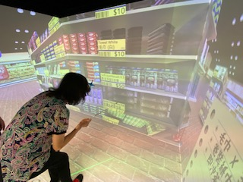
Picture G. Executive function VR game (emergency handling) | 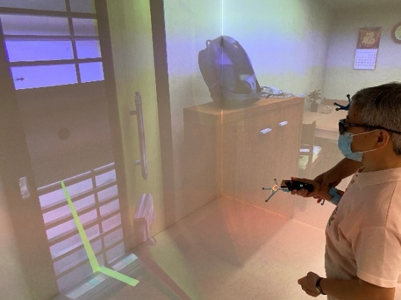

Additional file 2: VirCube VR Game Training Program (2021 version)

VR Game 1: Jogging exercise
Purpose: Physical balance and safe walking training
Grading: 3 levels (Level 1-by hand trackers; Level 2- by hand trackers & obstacle; Level 3- by hand/foot trackers & obstacles)
Device: 3D stereoscopic eyewear, hand, and foot trackers

VR game- Jogging exercise
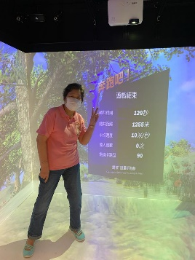  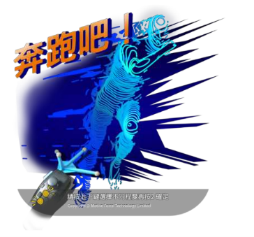  Jogging in the park | Sequencing & Grading:  1. Participant uses hand trackers & selects a level of activity  2. Participant runs with arms movement and keeps on a running path (upper limb balance)  3. Participant runs with upper and lower limbs trackers and follows a running path (whole body balance & physical training)  4. Participant runs and avoids hitting any obstacle on a running path (advanced physical balance and coordination skill)  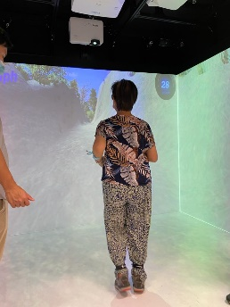  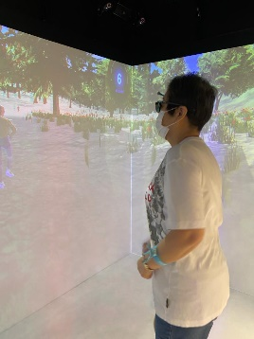  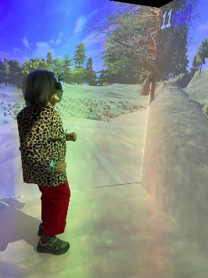  5. Participant runs faster and overcomes more obstacles (physical and cognitive training)  VR demon (see video clip)

VR Game 2: Fire Drill
Purpose: Cognitive training - executive function (Problem-solving skill)
Grading: N/A
Device: 3D stereoscopic eyewear, hand controller, hand trackers

VR game – File drill
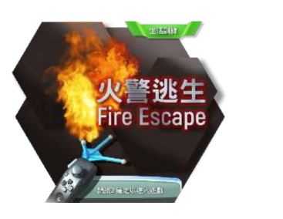  Fire drill exercise | Sequencing:  1. When fire alarm on, participant moves tracker to point out and touch three important things (key, mobile & wet towel) for evacuation.  2. Participant walks to the front door and uses tracker to unlock the door (balance and hand-eye coordination)  3. Participant uses tracker to select different escape routes (judgement)  4. Participant chooses either route 1(lift) or route 2(up/downstairs) to get out of fire scene safely (decision making)  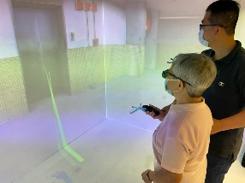  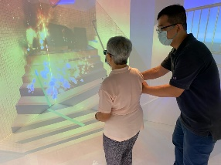  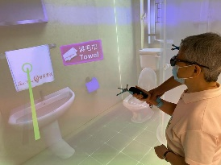

VR Game 3: Community Living Skill Practice
Purpose: Cognitive training – executive function (classification & calculation)
Grading: 3 levels (Level 1- free choice; Level 2: shopping items- 2-3; Level 3: shopping items- 3-5)
Device: 3D stereoscopic eyewear, hand controller

VR game- community living skill
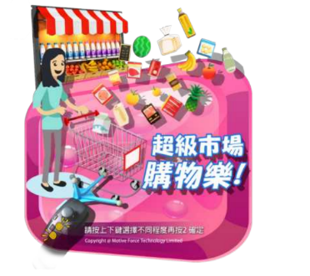  Shopping orientation | Sequencing & Grading:  1. Participant uses hand controller & selects a level of activity  2. Participant remembers a shopping list (memory skill)  3. Participant goes to the selected shopping regions (making decision)  4. Participant chooses and picks up the correct no. of items (classification & counting)  5. Participant checks and goes to cashier for payment (calculation)  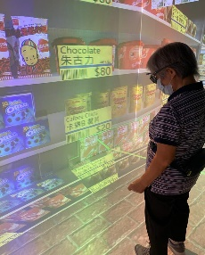  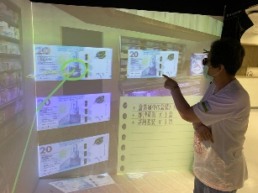

VR Game 4: Balance & sport exercises
Purpose: Cognitive-motor training and advanced balance exercise
Grading: 4 levels:
Level 1- defender (keeping); Level 2-attacker (attacking); Level 3- penalty kick (attacking);
Level 4- penalty kick (goalkeeping)-
Device: 3D stereoscopic eyewear, hand controller, hand, and foot trackers

VR game- balance & sport exercise
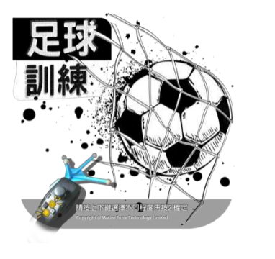  Soccer exercise | Sequencing & Grading:  1. Participant uses hand controller & selects a level of activity  2. Participant wears hand and foot trackers, practices passing a soccer to other player (balance & stability)  3. Participant runs and kicks a soccer ball to different position (balancing & weight shifting training)  4. Participant kicks a soccer ball to goalkeeper repeatedly (balancing, stability, weight-shift training to prevent falling)  5. Participant as a goalkeeper uses hand and foot trackers to defend the attacker (advanced limbs balancing and coordination, ball tracking exercise, spatial orientation & higher executive function skill)  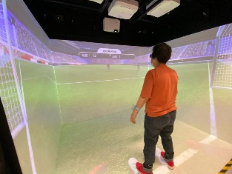  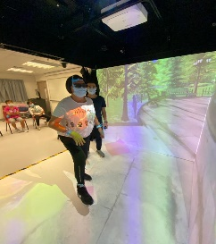  VR demon (see video clips)

Additional file 3:
Baduanjin Exercise Group

Part A: Traditional Chinese Qigong - Baduanjin
Photo A: English version
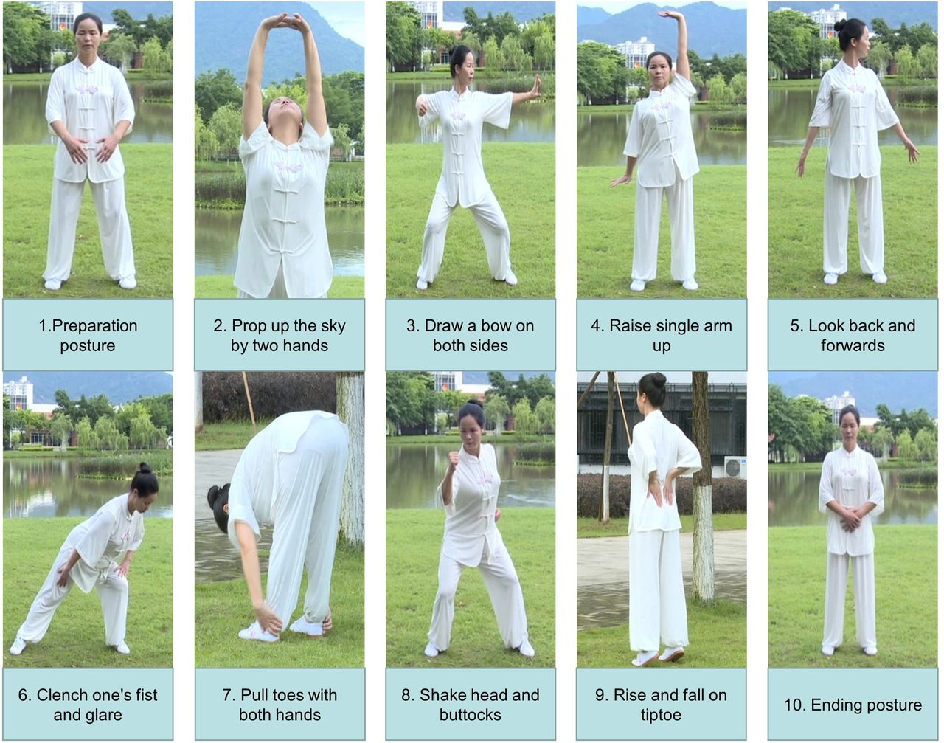

Picture B: Chinese version
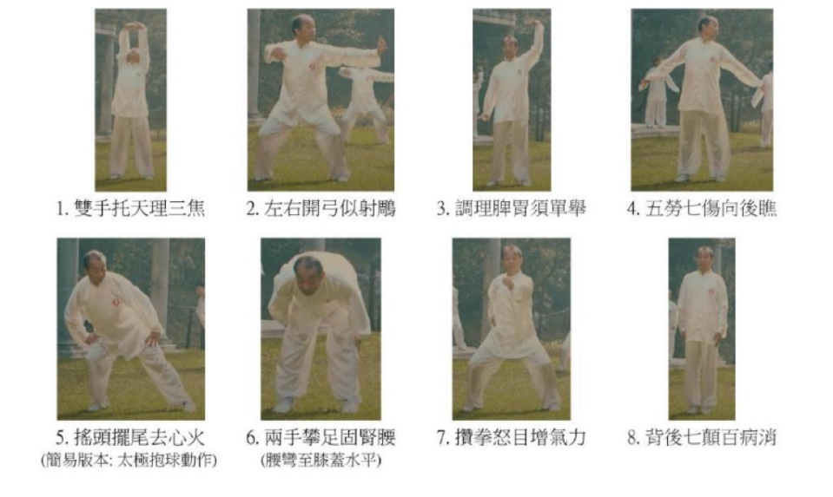

Photo C: Practice session 1

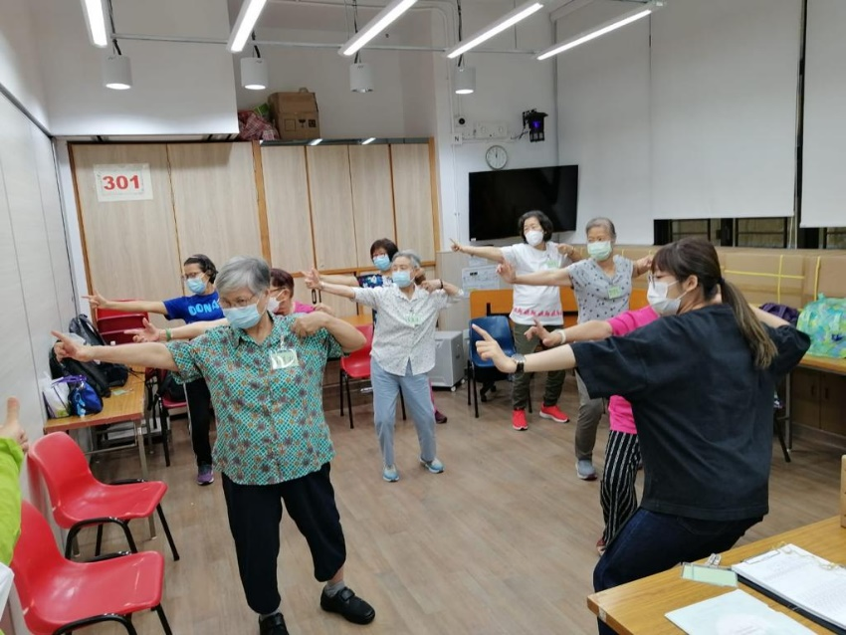

Photo D: Practice session 2
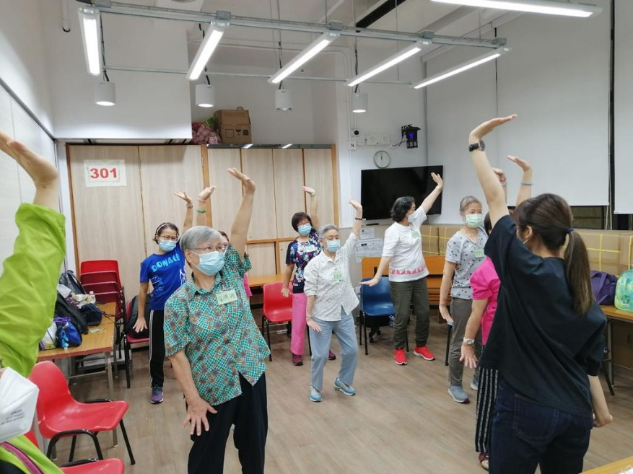

Part B: Fall prevention strategies.

Photo E: Practice tips for preventing falls

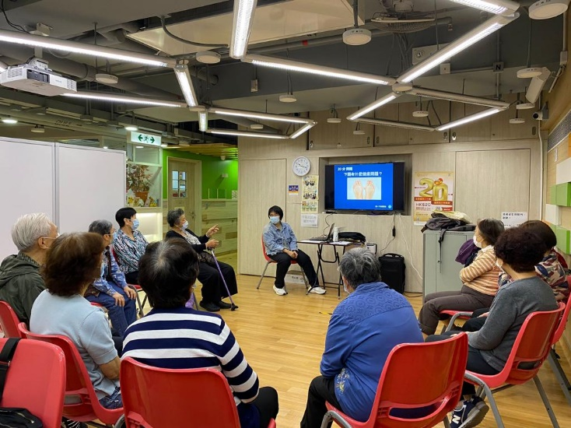

Photo F: Group sharing

