Online Resource 2 – Additional information on Control Group Comparisons

Contents
Studies reporting effects between MR VET group and control group 2
Additional information on meta-analysis in chapter 4.2 5
All outcomes meta-analysis 5
Behavioral outcomes meta-analysis 10
Cognitive Outcomes meta-analysis 12
Affective outcomes meta-analysis 15

Studies reporting effects between MR VET group and control group

Study | Search | country | publication | N | % female | Age | group | sector | ROB | MR type | Part of analysis
Adami et al. (2021 & 2022) | Initial | USA | Journal | 50 | 4% | 39,68 | Employees | Construction | low | VR | Affective, Behavioral, Cognitive
Amirian et al. (2014) | Initial | USA | Journal | 19 |  |  | College Students | Healthcare & Social Work | high | VR | Behavioral
Andretta et al. (2010) | Initial | USA | Conference / Proceedings | 15 |  |  | Employees | Healthcare & Social Work | high | VR | Cognitive
Barré et al. (2019) | Initial | France | Journal | 10 | 40% | 30,2 | Employees | Healthcare & Social Work | medium | VR | Affective
Birrenbach et al. (2021) | Updated | Switzerland | Journal | 29 | 62.07% | 22,75 | College Students | Healthcare & Social Work | low | VR | Behavioral
Birt, Moore & Cowling (2017) | Initial | Australia | Journal | 137 | 58% |  | Vocational Students | Healthcare & Social Work | medium | AR | Behavioral
Borgen, Ropp & Weldon (2021) | Initial | USA | Journal | 36 |  |  | College Students | Manufacturing | medium | VR | Behavioral
Borsci et al. (2016) | Initial | United Kingdom | Journal | 60 | 60% | 35,77 | Employees | Trade | medium | VR | Behavioral, Cognitive
Calandra et al. (2023) | Updated | Italy | Journal | 45 | 8.88% | 30,33 | Employees | Other | medium | VR | Behavioral, Cognitive
Clark et al. (2019) | Initial | USA | Journal | 49 | 79.59% | 27,5 | Mixed | Hospitality | medium | AR | Behavioral
Elhakim et al. (2023) | Updated | Egypt | Conference / Proceedings | 24 |  |  | College Students | Construction | high | VR | Cognitive
Figols Pedrosa et al. (2023) | Updated | Spain | Journal | 131 | 84,74% | 38,82 | Employees | Healthcare & Social Work | medium | VR | Cognitive
Fogarty, McCormick and El-Tawil (2018) | Initial | USA | Journal | 76 |  |  | College Students | Construction | high | VR | Cognitive
Gavish et al. (2015) | Initial | Israel | Journal | 40 | 3% | 33,2 | Employees | Manufacturing | medium | AR | Behavioral
Hooper et al. (2019) | Initial | USA | Journal | 14 | 36% | 28,3 | Employees | Healthcare & Social Work | medium | VR | Behavioral, Cognitive
Huang, Hwang & Jong (2022) | Updated | Taiwan | Journal | 66 |  | 25,15 | Employees | Healthcare & Social Work | medium | VR | Affective, Behavioral, Cognitive
Hwang, Chang & Chien (2022) | Updated | Taiwan | Journal | 70 |  |  | Employees | Healthcare & Social Work | medium | VR | Affective, Cognitive
Kalkan, Karabulut & Höke (2021) - S1 | Initial | Turkey | Journal | 56 | 9% | 33 | Employees | Manufacturing | low | VR | Behavioral
Kalkan, Karabulut & Höke (2021) - S2 | Initial | Turkey | Journal | 56 | 0% | 30 | Employees | Manufacturing | low | VR | Behavioral
Khundam, Sukkriang & Noël (2021) | Initial | Thailand | Journal | 45 |  |  | College Students | Healthcare & Social Work | medium | VR | Behavioral, Cognitive
Koutitas, Smith & Lawrence (2021) | Initial | USA | Journal | 30 |  |  | Apprentices | Healthcare & Social Work | high | both | Behavioral
Lee (2020) | Initial | Taiwan | Journal | 29 |  | 19,17 | Apprentices | Manufacturing | high | VR | Cognitive
Lin et al. (2022) | Updated | Taiwan | Journal | 76 |  |  | Employees | Healthcare & Social Work | medium | VR | Behavioral, Cognitive
Makransky & Klingenberg (2022) - S1 | Initial | Denmark | Journal | 86 | 21% | 22 | Mixed | Other | medium | VR | Affective, Behavioral
Makransky & Klingenberg (2022) - S2 | Initial | Denmark | Journal | 28 | 0% | 35 | Employees | Other | medium | VR | Affective, Behavioral
McCoy-Fischer et al. (2019) - S1 | Initial | USA | other | 70 |  |  | Employees | Military | high | VR | Behavioral
McCoy-Fischer et al. (2019) - S2 | Initial | USA | other | 91 |  |  | Employees | Military | high | VR | Behavioral
Nykänen et al. (2020) | Initial | Finland | Journal | 119 | 3% | 41,2 | Employees | Construction | low | VR | Affective, Behavioral, Cognitive
Osti et al. (2021) | Initial | Italy | Journal | 20 | 40% | 24 | College Students | Construction | high | VR | Behavioral
Poshdar et al. (2021) | Initial | New Zealand | Conference / Proceedings | 10 | 0% | 34 | Employees | Construction | medium | VR | Behavioral, Cognitive
Rey-Becerra et al. (2023) | Updated | Germany | Journal | 102 | 3.9% | 35,7 | Employees | Construction | low | VR | Affective, Behavioral, Cognitive
Rojas-Munoz et al. (2020) | Initial | USA | Journal | 20 | 35% | 28,5 | Employees | Healthcare & Social Work | medium | AR | Affective
Sacks, Perlman & Barak (2013) | Initial | Israel | Journal | 66 |  |  | Mixed | Construction | high | VR | Cognitive
Schwarz et al. (2020) | Initial | Austria | Conference / Proceedings | 30 | 3% | 30,8 | Employees | Manufacturing | medium | VR | Behavioral
Sirakaya & Kilic Cakmak (2018) | Initial | Turkey | Journal | 46 | 39% |  | College Students | Information & Communication | high | AR | Affective, Cognitive
Webster (2014) | Initial | USA | Conference / Proceedings | 140 | 3% | 29,64 | Employees | Other | medium | VR | Cognitive
Weng et al. (2021) | Initial | Taiwan | Journal | 194 |  |  | Vocational Students | Construction | medium | AR | Cognitive
Werrlich et al. (2018) | Initial | Germany | Conference / Proceedings | 30 | 10% | 18,44 | Apprentices | Manufacturing | medium | AR | Behavioral
Werrlich, Nguyen & Notni (2018) | Initial | Germany | Conference / Proceedings | 30 | 20% | 24,635 | Employees | Manufacturing | medium | AR | Behavioral
Wismer et al. (2021) | Initial | Denmark | Journal | 69 | 16% |  | Apprentices | Manufacturing | medium | VR | Affective, Behavioral, Cognitive
Yang et al. (2022) | Initial | China | Journal | 80 | 23% |  | College Students | Manufacturing | high | VR | Behavioral
Yong et al. (2023) | Updated | China | Journal | 127 | 23.62% | 19,04 | College Students | Other | medium | both | Cognitive

Additional information on meta-analysis in chapter 4.2

All outcomes meta-analysis
Model Results:
Pooled d = 0.5604 (95%CI: 0.2525-0.8682)
Standard error = 0.1571
Variance Components:
τ²_{Level 2} = 0.8832
τ²_{Level 3} = 0.1579
Test for Heterogeneity:
Q(df = 142) = 868.1224, p < 0.0001
Attribution of Heterogeneity:
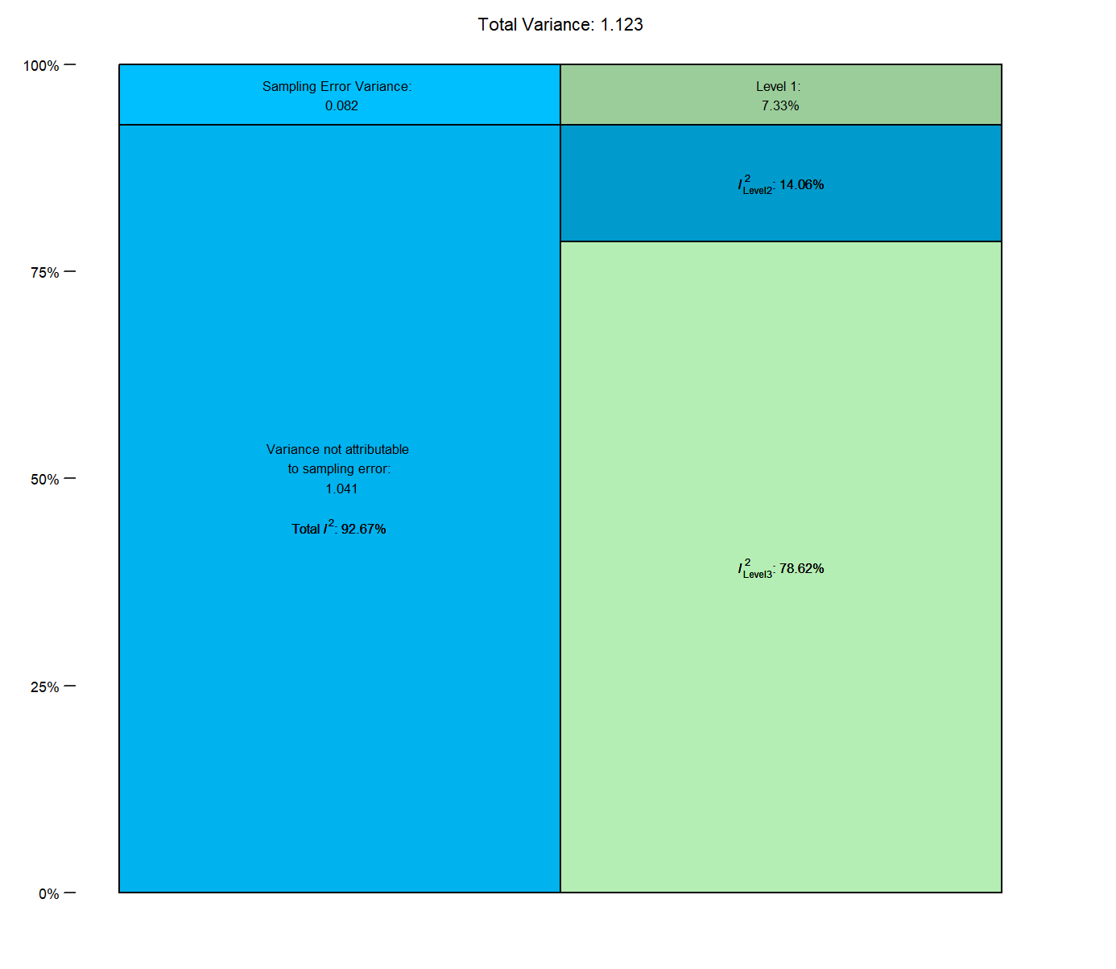
Check of overparameterization:
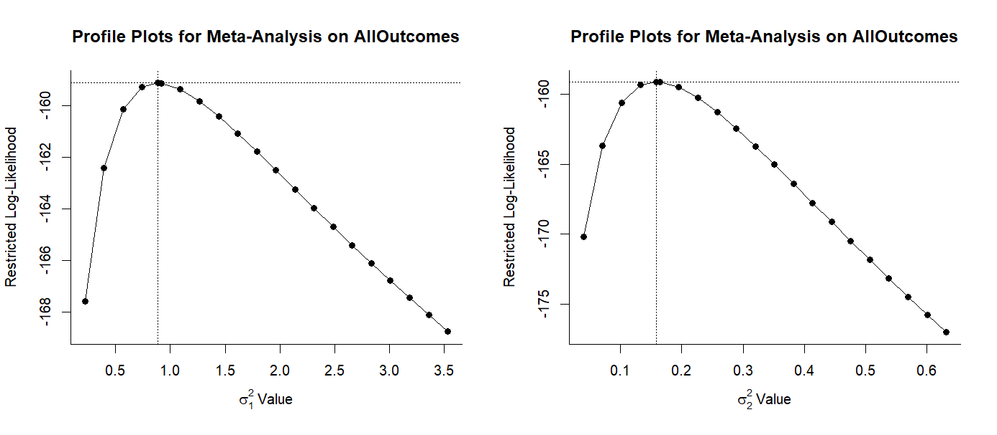
Intraclass Correlation of the true effects
ICC = 0.848

Comparison to 2-level model
χ2= 51.121; p < 0.001
Full: AIC = 324.2146, BIC = 333.0820
Reduced AIC = 373.3354, BIC = 379.2471

Contour-enhanced funnel plot

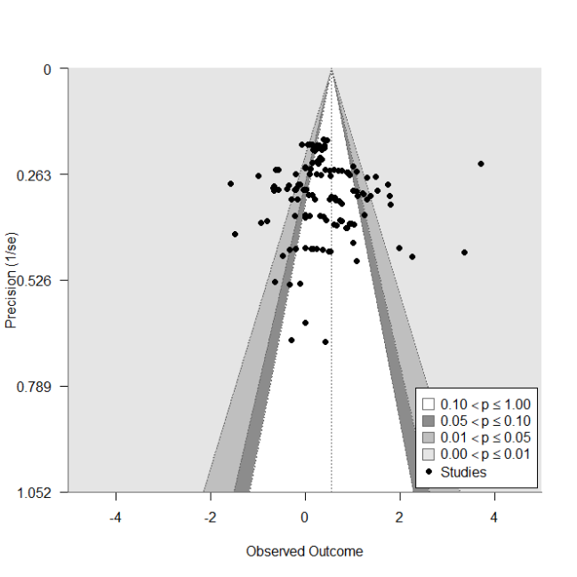

Forest Plot all Control group comparisons
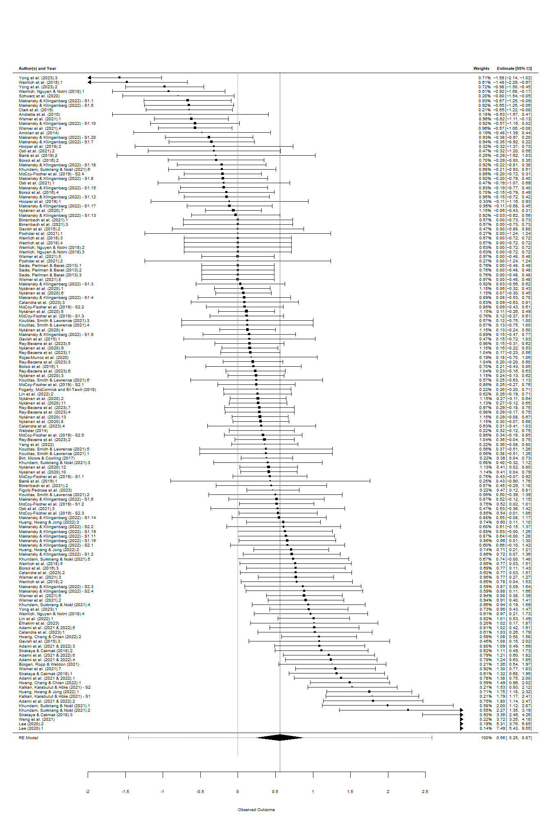

Sensitivity Analysis
Model Results after excluding high ROB studies:
(k = 113 in s = 30)
d = 0.502, z = 3.5428, p = 0.0004, 95%CI = 0.2245-0.7803

Model Results after excluding studies, where control group did not receive comparable treatment (i.e. no or unequal learning contents or delivery):
(k = 97 in s = 32)
d = 0.538, z = 3.019, p = 0.0025, 95%CI = 0.189-0.887

Moderator analyses across all outcomes

Moderator | d | SE | t | p | 95%CI (low) |  | 95%CI (up) | F(df)
Technology
AR | 0.389 | 0.301 | 1.292 | 0.204 | -0.220 |  | 0.997 | F(2, 140) = 0.894, p = 0.411
both | 0.899 | 0.389 | 1.311 | 0.192 | -0.259 |  | 1.280
VR | 0.597 | 0.326 | 0.639 | 0.524 | -0.436 |  | 0.852
Interaction Modality |  |  |  |  |  |  |  | F(7, 34) = 1.754, p = 0.129
Controllers | 0.727 | 0.216 | 3.360 | 0.002 | 0.287 |  | 1.166
Gaze | 1.000 | 1.034 | 0.265 | 0.793 | -1.827 |  | 2.374
Genuine Objects | 0.216 | 0.637 | -0.802 | 0.428 | -1.804 |  | 0.784
Gestures | 0.238 | 0.295 | -1.655 | 0.100 | -1.073 |  | 0.095
Insufficient description | 0.361 | 0.674 | -0.543 | 0.591 | -1.735 |  | 1.004
Multiple | 0.038 | 0.299 | -2.301 | 0.023 | -1.281 |  | -0.097
No interaction described | 0.207 | 0.588 | -0.884 | 0.383 | -1.715 |  | 0.675
Touch | 1.917 | 0.639 | 1.863 | 0.071 | -0.108 |  | 2.489
Visualization |  |  |  |  |  |  |  | F(4,37) = 6.993, p = 0.0003
CAVE | -0.189 | 0.477 | -0.396 | 0.694 | -1.154 |  | 0.776
HHD | 1.901 | 0.713 | 2.931 | 0.006 | 0.648 |  | 3.533
HMD | 0.519 | 0.502 | 1.411 | 0.166 | -0.307 |  | 1.722
Sector |  |  |  |  |  |  |  | F(7,34) = 0.797, p = 0.595
Construction | 0.720 | 0.352 | 2.044 | 0.049 | 0.004 |  | 1.435
Healthcare & Social workd | 0.356 | 0.462 | -0.788 | 0.436 | -1.304 |  | 0.575
Hospitality | -0.650 | 1.160 | -1.180 | 0.246 | -3.728 |  | 0.989
Information & Communication | 1.776 | 1.095 | 0.964 | 0.342 | -1.170 |  | 3.282
Manufacturing | 0.972 | 0.491 | 0.514 | 0.611 | -0.746 |  | 1.251
Military | 0.276 | 0.802 | -0.553 | 0.584 | -2.074 |  | 1.186
Other | 0.216 | 0.581 | -0.867 | 0.392 | -1.684 |  | 0.676
Trade | 0.130 | 1.082 | -0.546 | 0.589 | -2.788 |  | 1.608
Employment status |  |  |  |  |  |  |  | F(4, 37) = 2.202, p = 0.088
Apprentices | 1.293 | 0.484 | 2.673 | 0.011 | 0.313 |  | 2.274
College Students | 0.479 | 0.577 | -1.413 | 0.166 | -1.983 |  | 0.354
Employees | 0.442 | 0.525 | -1.621 | 0.114 | -1.915 |  | 0.213
Mixed | -0.183 | 0.733 | -2.016 | 0.051 | -2.961 |  | 0.008
Vocational students | 2.030 | 0.859 | 0.857 | 0.397 | -1.004 |  | 2.477
Task |  |  |  |  |  |  |  | F(2, 39) = 1.564, p = 0.222
Intellectual | 0.814 | 0.232 | 3.513 | 0.001 | 0.345 |  | 1.282
Physical | 0.391 | 0.316 | -1.335 | 0.190 | -1.062 |  | 0.217
Social | -0.650 | 1.080 | -1.355 | 0.183 | -3.648 |  | 0.721
Duration |  |  |  |  |  |  |  | F(4, 37) = 0.776, p = 0.548
< 1h | 0.321 | 0.235 | 1.363 | 0.181 | -0.156 |  | 0.797
< 2h | 0.456 | 0.136 | 0.477 | 37.000 | 0.777 |  | -0.831
< 4h | 0.887 | 0.566 | 0.567 | 37.000 | 0.325 |  | -0.583
> 4h | 0.743 | 0.423 | 0.652 | 37.000 | 0.521 |  | -0.899
not available | 1.019 | 0.699 | 0.441 | 37.000 | 0.122 |  | -0.195
VR-Augmentation |  |  |  |  |  |  |  | F(2, 32) = 1.697, p = 0.199
augmented | 0.716 | 0.194 | 3.694 | 0.001 | 0.321 |  | 1.111
non-augmented | 0.054 | 0.360 | -1.837 | 0.069 | -1.375 |  | 0.051
unclear | 0.466 | 1.111 | -0.225 | 0.823 | -2.513 |  | 2.013
Control group |  |  |  |  |  |  |  | F(3, 139) = 2.226, p = 0.088
Equal treatment | 0.462 | 0.171 | 2.709 | 0.010 | 0.117 | 0.808
No treatment | 0.349 | 0.278 | 1.257 | 0.211 | -0.200 | 0.897
Unequal treatment | 0.413 | 0.184 | 2.248 | 0.026 | 0.050 | 0.777
Unequal treatment (reverse) | 0.074 | 0.275 | 0.268 | 0.789 | -0.470 | 0.617
Unequal treatment (reverse), i.e. where the control group received more intensive training

Behavioral outcomes meta-analysis

Test for Heterogeneity:
Q(df = 73) = 239.9821, p-val < .0001
Check of overparameterization and outliers (Cook’s d <0.5):
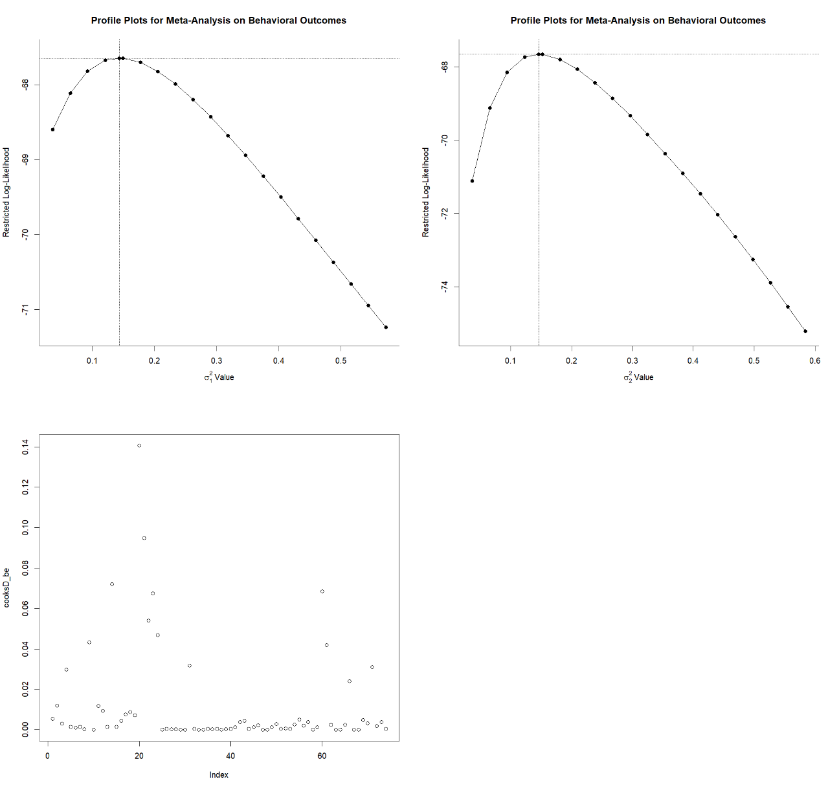
Comparison to 2-level model
χ2= 3.9656; p < 0.05
Full: AIC = 141.2901, BIC = 148.162
Reduced AIC = 143.256, BIC = 147.836
Though BIC is lower for reduced model, we retain full model due to other indicators and intraclass correlation.
Contour-enhanced funnel plot

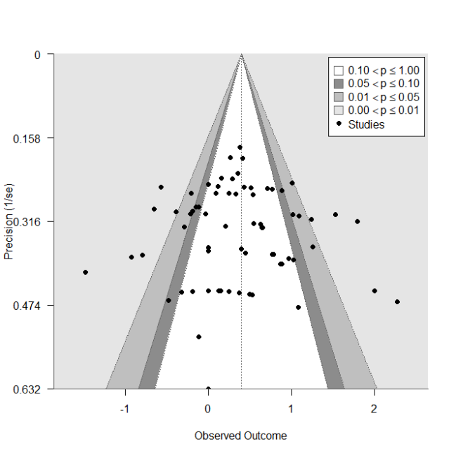
Test for Funnel Plot Asymmetry: z = 0.043, p = 0.965
Rank Correlation Test for Funnel Plot Asymmetry: Kendall's tau = 0.037, p = 0.641

Sensitivity Analysis
Model Results after excluding high ROB studies:
(k = 55 in s = 23)
d = 0.463, z = 3.755, p = 0.0002, 95%CI = 0.2225-0.705

Model Results after excluding studies, where control group did not receive comparable treatment (i.e. no or unequal learning contents or delivery):
(k = 46 in s = 22)
d = 0.397, z = 3.291, p = 0.001, 95%CI = 0.160-0.633

Moderator analysis with different levels of comparable treatments:
F(3,70) = 0.5442, p = 0.654
 | d | SE | t | p | 95%CI lower bound | 95%CI upper bound
Equal Treatment | 0.339 | 0.122 | 2.777 | 0.010 | 0.088 | 0.590
No treatment | 0.633 | 0.255 | 1.153 | 0.253 | -0.215 | 0.804
Unequal treatment | 0.462 | 0.219 | 0.559 | 0.578 | -0.315 | 0.560
Unequal treatment (reverse) | 0.295 | 0.327 | -0.133 | 0.895 | -0.695 | 0.608
Unequal treatment (reverse), i.e. where the control group received more intensive training

Cognitive Outcomes meta-analysis

Sensitivity Analysis – Gain scores
Gain scores (i.e. the score difference of learners in both groups between pre- and post-intervention) are often used as an alternative to raw post-score comparisons. In the main analysis reported in the paper, raw post-scores were used to calculate d, because a) a majority of included studies did not report data to calculate gain scores, b) d for affective and behavioral outcomes is also calculated from raw post-scores, and c) we report separate meta-analyses for pre-post comparisons of the variables. However, gain scores were calculated where possible to conduct the following sensitivity analysis, showing a negligible difference in the pooled effect size:
(k = 33 in s = 22)
d = 0.834, z = 2.570, p = 0.010, 95%CI = 0.198-1.469

To explore the effect of using gain scores instead of post-score comparisons to calculate d on the pooled effect, we conducted a moderator analysis:

F(1,31) = 0.085, p = 0.773

 | d | SE | t | p | 95%CI lower bound | 95%CI upper bound
Gain scores | 0.940 | 0.491 | 1.915 | 0.070 | -0.084 | 1.965
Post scores | 0.753 | 0.642 | -0.292 | 0.773 | -1.495 | 1.121

Test for Heterogeneity:
Q(df = 32) = 453.554, p < .0001

Check of overparameterization and outliers (Cook’s d <0.5):
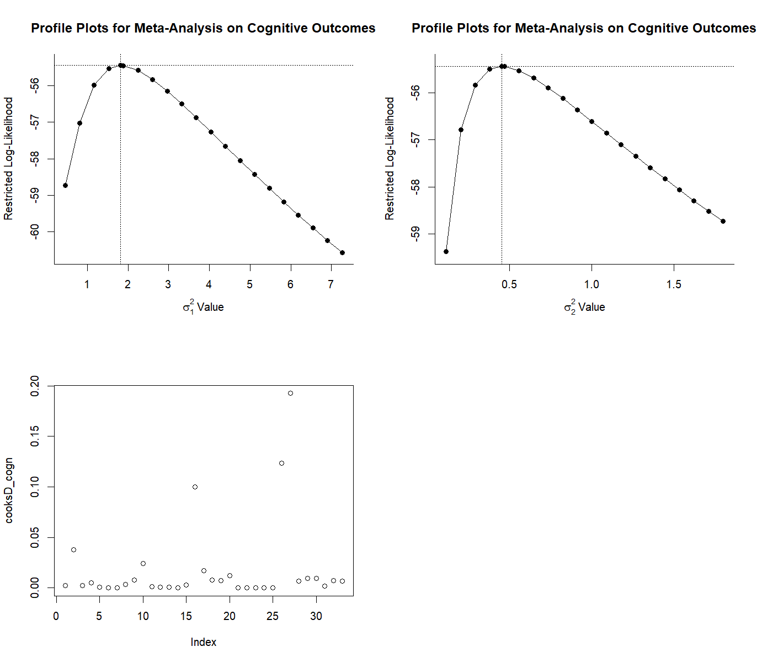
Comparison to 2-level model
χ2= 11.205; p < 0.001
Full: AIC = 116.876, BIC = 121.273
Reduced AIC = 126.081, BIC = 129.012

Contour-enhanced funnel plot
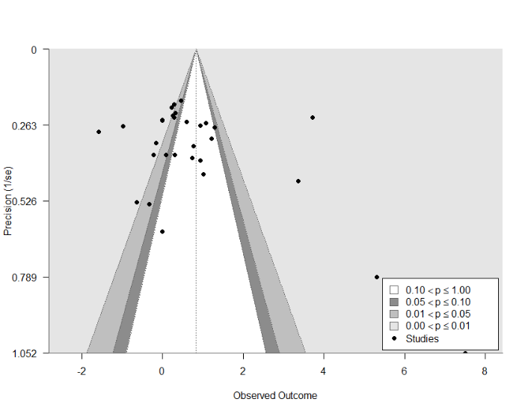
Test for Funnel Plot Asymmetry: z = 4.133, p < 0.001
Rank Correlation Test for Funnel Plot Asymmetry: Kendall's tau = 0.181, p = 0.141

Sensitivity Analysis
Model Results after excluding high ROB studies:
(k = 26 in s = 16)
d = 0.471, z = 2.240, p = 0.025, 95%CI = 0.059-0.883

Model Results after excluding studies, where control group did not receive comparable treatment (i.e. no or unequal learning contents or delivery):
(k = 27 in s = 20)
d = 0.683, z = 2.089, p = 0.037, 95%CI = 0.042-1.323

Moderator analysis with different levels of comparable treatments:
F(3,70) = 2.414, p = 0.107
 | d | SE | t | p | 95%CI lower bound | 95%CI upper bound
Equal Treatment | 0.689 | 0.316 | 2.183 | 0.042 | 0.028 | 1.350
No treatment | 0.985 | 0.588 | 0.5034 | 0.618 | -0.904 | 1.496
Unequal treatment | 2.371 | 0.781 | 2.154 | 0.039 | 0.088 | 3.2766

Affective outcomes meta-analysis

Q(df = 73) = 239.9821, p-val < .0001
Check of overparameterization and outliers (Cook’s d <0.5):
Comparison to 2-level model
χ2= 3.9656; p < 0.05
Full: AIC = 141.2901, BIC = 148.162
Reduced AIC = 143.256, BIC = 147.836
Though BIC is lower for reduced model, we retain full model due to other indicators and intraclass correlation.

Contour-enhanced funnel plot
Test for Funnel Plot Asymmetry: z = 0.043, p = 0.965
Rank Correlation Test for Funnel Plot Asymmetry: Kendall's tau = 0.037, p = 0.641

Sensitivity Analysis
Model Results after excluding high ROB studies:
(k = 34 in s = 10)
d = 0.594, z = 2.648, p = 0.008, 95%CI = 0.154-1.034

Model Results after excluding studies, where control group did not receive comparable treatment (i.e. no or unequal learning contents or delivery):
(k = 24 in s = 8)
d = 0.705, z = 2.274, p = 0.023, 95%CI = 0.097-1.313

Moderator analysis with different levels of comparable treatments:
F(3,7) = 0.423, p = 0.743
 | d | SE | t | p | 95%CI lower bound | 95%CI upper bound
Equal Treatment | 0.720 | 0.243 | 2.959 | 0.021 | 0.145 | 1.296
No treatment | 0.123 | 0.638 | -0.936 | 0.380 | -2.105 | 0.911
Unequal treatment | 0.851 | 0.230 | 0.569 | 0.574 | -0.338 | 0.599
Unequal treatment (reverse) | 0.768 | 0.298 | 0.162 | 0.873 | -0.559 | 0.655
Unequal treatment (reverse), i.e. where the control group received more intensive training

