Supplementary Materials
Shaping negative attitudes toward Mafias through immersive virtual reality

Methods

Participants
We performed an a-priori power analysis using G.power software (Faul et al., 2007; 2009) for a t-test study design based on a medium effect size (d = .50) from previous studies (Peck et al., 2013; Banakou et al., 2018; Banakou et al., 2020), with a statistical power β = .80 and significance level α = .05 that suggested recruiting 50 participants for each of the 2 groups.
Since normality assumption was violated, we performed non-parametric Mann-Whitney tests to check that groups did not differ for age (U=1194, p=.70; M_{exp}=25.58, SD_{exp}=4.14; M_{con}=25.54, SD_{contr}=4.15) and income (U=1231, p=.43; M_{exp}=3.09, SD_{exp}=1.21; M_{con}=3.29, SD_{con}=1.25). Twelve participants from the experimental and 9 from the control condition came from target regions (Campania, Apulia, Calabria, Basilicata, Sicily). 34 experimental and 29 control condition participants came from non-target regions, respectively. 3 and 2 participants omitted to provide this information.

Materials
Illustrative videos can be found in the OSF repository
(https://osf.io/n8h37/?view_only=729e95c2c65e4130a2574601cbfd00bd)
https://www.youtube.com/watch?v=QbVC7UWuaj0
Experimental condition (mafia scenario): the two men seen from the back uttered a speech from which was clear they had come to collect "pizzo" (i.e., a “tax” that mafia-like organizations collect periodically from businesses). The bartender attempted to delay the payment, explaining he couldn't pay due to unexpected family expenses. The situation escalated when the men threatened him, brandishing a gun and demanding all the money on hand. The intimidated bartender reluctantly complied, retrieving bills from under the counter and handing them over. The men then left the bar.
Control condition (non-specific criminal scenario): the two men approached the bartender and ordered drinks. They claimed they couldn't pay and insisted the bartender cover the cost. He tried to explain he couldn't provide them for free, but they persisted. The situation escalated as the men intimidated the bartender, brandishing a gun and demanding the drinks. Frightened, the bartender reluctantly agreed, taking the beers from under the counter and handing them over. The men then left the bar.

Script. Dialogue:
Experimental condition (mafia scenario)
Top of the scene: the bartender (B) is working behind the bar counter. There are no other customers in the bar. After a few moments, two men (M1 and M2) enter, and the dialogue begins:
M2: “Allora Salvo, sai che giorno è oggi?”
(“Well then, Salvo, do you know what day it is today?")
B: “Si, ma… non posso pagare ragazzi. Non è stato un buon periodo. Ho avuto pochi clienti e… Sono
saliti i prezzi delle merci. Un casino.”
(“Yes, but ... I can't pay guys. It hasn't been a good period. I've had few customers and... Prices of goods have gone up. Just a mess.”)
M1: “Eh… Questo non è un nostro problema. Abbiamo fatto un patto tra amici. E tu lo devi rispettare!”
(“This is not our problem. We made a deal between friends. And you have to keep your end!”)
B: “Si, lo so ragazzi. Ma davvero, non so come fare. Mia suocera è stata male, la abbiamo dovuta portare da uno specialista e abbiamo speso un sacco di soldi…”
(“Yes, I know guys. But seriously, I don't know how to pay you. My mother-in-law was sick, we had to take her to a specialist doctorand we spent a lot of money…”)
M2: “Ascoltaci bene! O ci dai tutti i soldi, o finisce molto male.”
(“Listen well! Give us all the money, or it will end very badly.”)
B: “Si! Ma io non so come fare ragazzi. Sono tantissimi soldi. Non… Non so proprio come fare…”
(“Yes! But I don't know how to pay guys. It's so much money. I don't -- I just don't know how to do it.”)
M1: “Ora, Salvo… mi sembra che ci siamo sempre comportati bene con te. I patti sono patti! E lo sai cosa succede se non li si rispetta. Quindi fai il bravo e tira fuori sti soldi, così ce ne andiamo e tu continui la tua giornata, okay?”
(“Now, Salvo… I feel like we've always been on good terms with you. A deal is a deal! And you know what happens if you don't honor it. So, be nice and get that money out so we can leave, and you can continue your day, okay?”)
B: “Per favore… vi ridarò la metà dei soldi…”
(“Please... I will give you half the money…”)
M1: “Ma per favore cosa?! O ora tu ci ridai questi soldi, o tu dalla tua famiglia non torni. Mi hai capito bene?!”
(“ ”Please” what?! You either return our money immediately or you don't return back to your family. Do you understand me well?!”)
B: “Per favore… un paio di giorni. Solo un paio di giorni…”
(“Please ... a couple of days. Just a couple of days...")
M1: “Ora ascoltaci bene. Ora tu ci dai quello che hai in questo momento. La settimana prossima noi ripassiamo e, oltre a quello che ci devi, ci aggiungi anche un bel 20%, okay?!”
(“Now listen carefully. You give us all the money you have at this time. Next week we will come back and, in addition to what you owe us, you will add 20%, okay?!”)
B: “ Okay, okay. Stai calmo però… Tieni.”
(“Okay, okay. Keep calm... Here.”)
M1: “Ecco, bravo. Salutami tua suocera.”
(“There we go, that's it. Give my regards to your mother-in-law.”)

Control condition (non-specific criminal scenario)
Top of the scene: the bartender (B) is working behind the bar counter. There are no other customers in the bar. After a few moments, two men (M1 and M2) enter, and the dialogue begins:
B: “Signori? Che cos’altro posso fare per voi?”
(“Gentlemen? What else may I do for you?")
M1: “Facci altre due birre a me e al mio compare qua, dai.”
(“Two more beers for me and my buddy here.”)
B: “Va bene, signori. Però prima della consumazione dovete pagare qui. Sono 12 euro.”
(“All right, gentlemen. But before the consummation you have to pay here. It is 12 euros”)
M1: “Arrivano eh…Aspetta. Dio, ma ho finito i soldi. Eh, offri te!”
(“Here coming eh...Wait. God, I'm out of cash. It's on you!”)
M2: “Eh ma neanche io ce li ho. Li abbiamo spesi tutti durante la serata.”
(“I don't have it either. We spent all the money during the evening...”)
B: “Allora, ragazzi. Come vogliamo fare? Se non mi pagate non posso darvi da bere.”
(“So, guys, how would you like to handle this? If you don't pay, I can't give you drinks.”)
M1: “Dai, offrile te ste due birre, su. Pure due amari. Dai, facci pure due amari.”
(“Come on, you buy these two beers. And two shots. Come on, also two shots.”)
B: “Signori, finché non mi pagate, io non posso fare nulla… Mi dispiace, ma…”
(“Gentlemen, till you pay me, I can't bring you anything... I'm sorry, but...")
M2: “Oh! Sono solo due birre, eh! Non ti ho mica chiesto il mondo. Dai! Muoviti! Le voglio vedere sul bancone. Adesso.”
(“Only two beers, huh! It's not like I asked you the world. Come on! Hurry up! I want to see them on the counter. Now.")
B: “Signori. Mi dispiace, ma io non posso fare altrimenti.”
(“Gentlemen. I am sorry, but I cannot do otherwise.”)
M1: “Facci le due birre… Dai! Non fare storie. Che ti ci vuole?!”
(“Bring us the two beers, come on! Don't make a fuss. What is it going to take for you?”)
B: “Stiamo calmi ragazzi. Purtroppo, non posso farci nulla…”
(“Keep calm, guys. Unfortunately, I can't help it...")
M1: “ah…non puoi farci nulla, eh? E adesso?! Che cosa fai? Ce le fai queste due birre o vuoi una pallottola?”
(“You can't help it, can you? Now what?! What are you doing? Are you going to bring these two beers, or do you want a bullet?”)
B: “Sì sì, ragazzi. Ve le preparo subito le vostre birre. Ma stiamo calmi. Ecco qua.”
(“Yes yes, guys. I'll get your beers ready for you now. But keep calm. Here.”)

The virtual scenario and avatars were designed using 3DS Max 2019 2017 (Autodesk, Inc.) and Iclone 7 (Reallusion, Inc.), respectively, implemented in Unity Game engine software (Unity Technology, version 2018.3) and presented through the head-mounted display Meta Quest 2 (HMD; www.meta.com/it/quest/), having 110◦ field-of-view (diagonal FOV) with a resolution of 2160 × 1200.
In order to realize naturalistic movements, we recorded the kinematics of three professional actors by means of an Optitrack System (https://optitrack.com/) composed by 24 Flex 13 camera (1280 × 1024, 120 Hz). All actors wore a mocap suite with 41 markers placed by following a standard configuration reported in Supplemental Fig. S1 and S2 (see also https://docs.optitrack.com/markersets/full-body/baseline-41 for a complete guide).
The actors were instructed to personate the bar counter and the two men and to recite the scripts reported in Supplementary Materials
Ambient audio and voices were recorded by means of two Studio Condenser Microphone (Behringer C-1) placed close to the actors and connected to the Focusrite Scarlett (18i8 2nd gen) audio card. Audio tracks were then mixed by Pro Tools Studio.
The actors’ kinematics, the facial expressions and the lip-synch were transferred on the virtual avatar by means of Motion Builder 2019 and Crazy Talk 7 (Reallusion, Inc.), respectively, and rendered in Unity by means of a MSI Pc Gaming Mpg (with a graphic card NVIDIA Ge Force RTX 2070 SUPER).

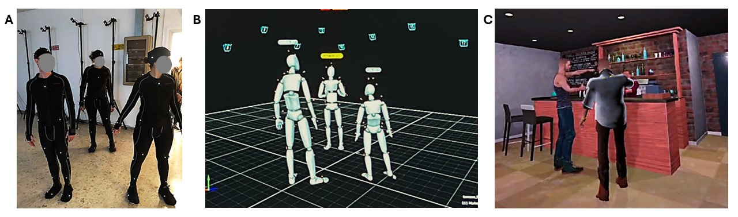
Fig S1 | Example of Mocap recording and virtual scene creator. A| Picture of the three actors wearing the Mocap suits inside the mocap arena. B| Rendering of real-time mocap recording. C| Example of the final result where mocap data were then transferred on the avatars.

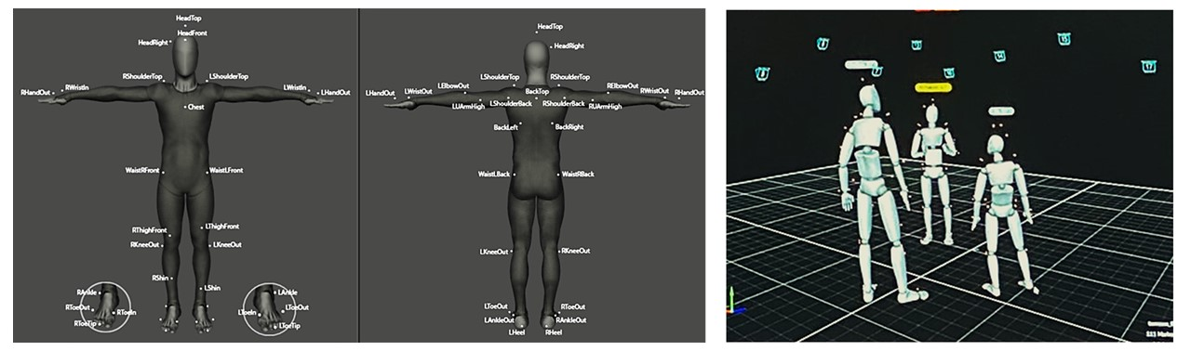
Fig S1. Configuration of 41 markers placed on the actor’s full body suite. The configuration is fully inspired by guidelines suggested by Optitrack reported in https://docs.optitrack.com/markersets/full-body/baseline-41.

Measures
SC-IAT
We built an ad-hoc Single Category Implicit Association Test (SC-IAT 36, through the online experiment builder Psytoolkit 37,38. For the target category “Mafia” we used 7 items (‘Ndrangheta, Camorra, Cosa Nostra, Pizzo, Extortion, Boss, Omertà) that we previously selected in a pilot study. We also used 7 items for the attribute category “Positive” (Joy, Love, Peace, Pleasure, Happiness, Fun, Laughter,) and 7 items for the attribute category “Negative" (Sadness, Sorrow, Evil, War, Hate, Failure, Cruelty). The total number of trials was 144 + 48 practice trials divided into four blocks. Following Karpinski and Steinman 36, each trial stayed on the screen for 1500 ms maximum and was separated by 350 ms inter-trial interval. We counterbalanced the temporal order of the two combined tasks and the sides (top left, top right) initially assigned to the mafia category.

Pilot study: selection of Mafia-related items
The 7 items related to the mafia category (e.g., "'Ndrangheta," "Camorra," "Cosa Nostra," "Pizzo," "Extortion," "Boss," "Omertà") were chosen through a pilot study in which we asked respondents (N=54, female=31, males=21, NA=2, M_{Age}= 33.15, SD_{Age}=13.23) to answer on a 10-point Likert (from 1 “Not representative” to 11 “Highly Representative”) scale how representative 18 mafia-related words were. We selected the 7 items judged to be on average most representative (Tab.S1 and Fig. S2).

Mafia items | Score | Mafia items | score
Ndrangheta | 10.7037 | Padrino | 8.796296
Camorra | 10.7037 | Clan | 8.611111
Cosa Nostra | 10.38889 | Racket | 8.574074
Pizzo | 9.962963 | Cosca | 8.185185
Estorsione | 9.37037 | Uomo d'onore | 8.185185
Boss | 9.351852 | Pizzino | 8.111111
Omertà | 8.981481 | Faida | 7.796296
41bis | 8.888889 | Picciotto | 7.740741
Intimidazione | 8.833333 | Lupara | 7.037037
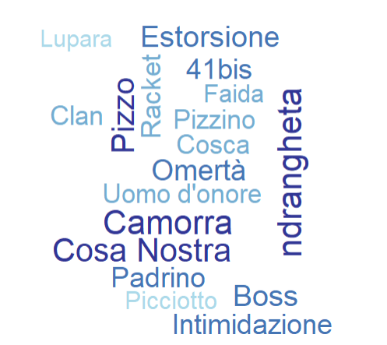
Tab. S1 | Mafia-related words and representativeness score.
Fig. S2 | Mafia-related words: word-cloud plot.

Procedure
Both the Implicit Association Test (SC-IAT) and the questionnaire (AIMS) were administered one week prior to the IVR exposure and immediately after the IVR session. This design was chosen to reduce the likelihood that participants would recall their previous responses, which helps minimize response bias and social desirability effects in the post-exposure questionnaire. By separating the sessions, participants are more likely to respond spontaneously based on their actual experience during the IVR intervention. Additionally, spreading the assessments over two sessions helps prevent fatigue or cognitive overload that could occur if all measures were completed in one sitting, thereby supporting the quality of the data collected. Finally, administering the SC-IAT at two different time points also helps to minimize practice effects, ensuring that changes observed in implicit attitudes are more likely to reflect genuine shifts rather than familiarity with the test.

Analyses and Results
Expanded sections of the main text: AIMS, SC-IAT frequentist analyses; AIMS, SC-IAT Bayesian analyses in detail, Behavioral intentions analyses, where we reported response frequencies.
Finally, we reported SC-IAT pre- and post-exposure data distribution in the Discussion section of the main text. We analyzed ceiling and floor effects and plotted histograms to clearly observe implicit attitudes of our participants before and after our experimental manipulation.

AIMS
To control for gender effects, we performed a two-way ANOVA with Condition and Gender as the independent variables, resulting in the same main effect of Condition [F(1,91)=5.85, p=.02].
As purely exploratory analysis, we also performed a two-way ANOVA with Condition and Target_Region as the independent variables. We found the same main effect of Condition [F(1,91)= 5.66 p=.02], and no other effects [all F_{s}<.16, all p_{s}>.69]. However, since the two conditions were very unbalanced (N_{target} =21 vs. N_{non-target} = 74), we used a boot-strap procedure with 1000 iterations to randomly select 21 people from the non-target regions and run the same analysis, which resulted in a probability of less than 0.5% to obtain a significant difference.

SC-IAT
To check for gender effects, we performed a two-way ANOVA with Condition and Gender as the independent variables. Again, we found no effect of Condition even after controlling for participants’ gender [F_{s}<2.14 and all p_{s}>.15].
As for the AIMS, we performed a two-way ANOVA with Condition and Target_Region as the independent variables. We found no effects [all F_{s}<3.00 and all p_{s}>.09]. The same boot-strap procedure resulted in a probability of less than 5.8% of finding a significant difference between the two conditions.

Bayesian analyses
To test the robustness of our findings, we performed the same analyses within a Bayesian framework. We ran two Bayesian independent samples t-tests on AIMSΔ and SC-IATΔ scores as the dependent variables and Condition (experimental vs. control) as the independent variable.
Since we had very specific hypotheses regarding the direction of the effect, both tests were one-tailed, for which the alternative hypothesis specifies higher negative Δ scores for the experimental condition (i.e., stronger negative attitudes towards mafias).
As for priors specification, we followed an empirical Bayesian approach based on what Dienes defines as the “room-to-move” heuristic (42). According to this heuristic, when evaluating the expected difference between two means one should consider the maximum difference that might be obtained, which is dependent on the extreme values of the dependent variable. Dienes suggests then using the mean score of the group that offers the least room to move, that is, the mean that is closer to one of the extremes, or in other words, the "base" and the "apex" of a scale. In doing so, one could detect any potential ceiling or floor effects. Since the AIMSΔ scores can go towards both positive and negative directions, the base value for AIMSΔ is 0, i.e., if no difference between the two means is detected, while the apex values could range between -6 and 6 (maximum anti-mafia score is 1 and the minimum 7, so the extreme scores by calculating Δ are 1-7=-6 or 7-1=6). The mean AIMSΔ score for the control condition was M=0.04, SD=0.31, while that for the experimental condition was M=-0.11, SD=0.31. The mean closer to the extreme, and thus with the least room to move, was that of the control condition, which was close to 0. Thus, we used this value and divided by 7 following Dienes’ recommendations for a Cauchy distribution, obtaining a prior value of 0.006.
In line with the results obtained with the frequentist approach, this analysis revealed moderate evidence in favor of the alternative hypothesis -i.e., more negative AIMSΔ score for the experimental condition- with a BF=3.52. More importantly, the evidence remains moderate even when wider priors are used, as shown by the Bayes Factor robustness check (Fig. 3A in the main text).
As for the SC-IAT analysis, the SC-IATΔ could range between -4 and 4 (maximum anti-mafia score is -2 and the minimum 2, so the extreme scores by calculating Δ are -2-2=-4 or +2+2=4) (57), or assume the value of 0 if no difference between the two means is detected. The mean SC-IATΔ score for the control condition was M=0.03, SD=0.37, while that for the experimental condition was M=0.10, SD=0.36. The mean closer to the extreme, and thus with the least room to move, was that of the control condition, which was close to 0. Thus, we used this value and divided by 7 following Dienes’ recommendations for a Cauchy distribution, obtaining a prior value of 0.003.
In line with what we observed for the AIMS, this analysis confirmed the results of the frequentist approach, providing inconclusive evidence at best with a BF=0.96. In fact, the Bayes Factor robustness check indicated more likely evidence for the null hypothesis both with narrower and wider priors (see Fig. 3B in the main text).
The results of AIMS and SC-IAT are provided in the OSF repository
(https://osf.io/n8h37/?view_only=729e95c2c65e4130a2574601cbfd00bd)

Behavioral intentions
(Q1) Would you report what you just saw to the police?
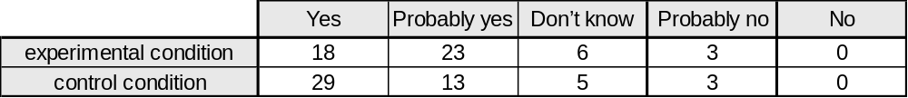

(Q2) Would you testify in a trial against those two people?
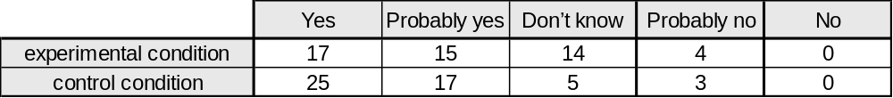

(Q3) If you could have, would you have intervened to interrupt the argument?
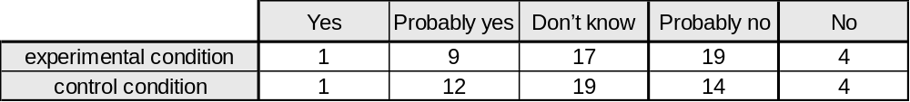

(Q4) Have you ever witnessed such an event in the past?
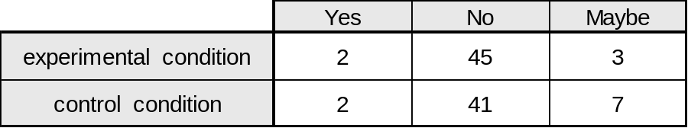

SC-IAT data distribution
Ceiling and floor effect analysis for the pre-exposure SC-IAT (baseline).
(LEV= lowest extreme values; HEV= highest extreme values)
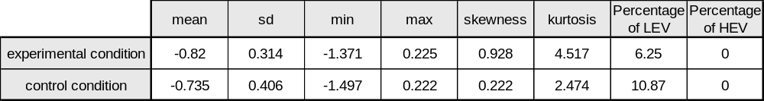

Ceiling and floor effect analysis for the post exposure SC-IAT.
(LEV= lowest extreme values; HEV= highest extreme values)
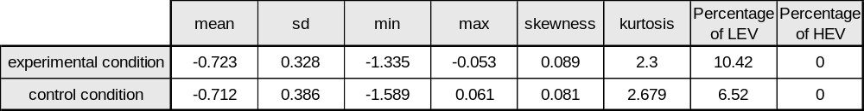

Histograms of SC-IAT scores before and after the experimental and control conditions are represented in Fig. S3.

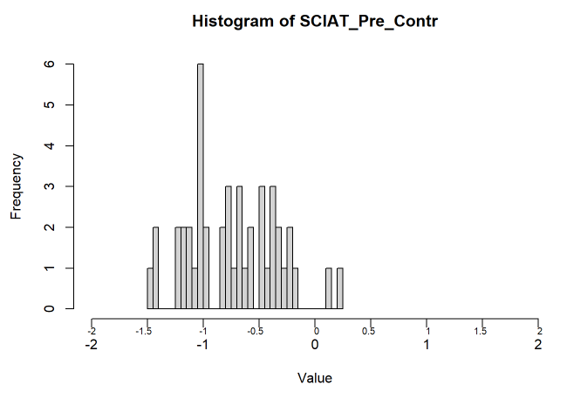
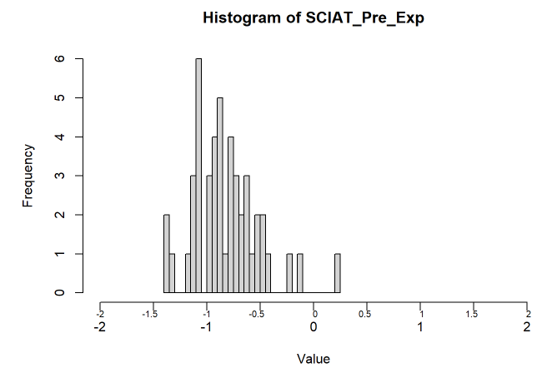
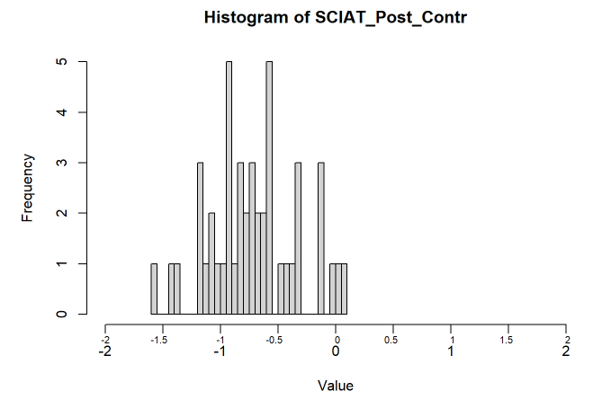
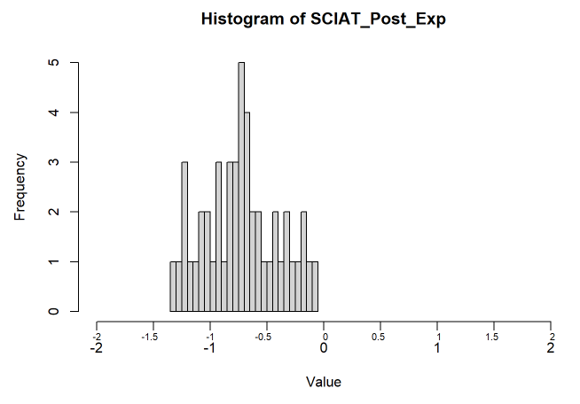

Fig. S3 | SC-IAT data distribution. Negative scores (from -0.01 to -2) indicate a strong association between Mafia target category and Negative attribute category. Upper left panel: Distribution of SC-IAT data before exposure to the experimental scenario. Upper right panel: Distribution of SC-IAT data before exposure to the control scenario. Lower left panel: Distribution of SC-IAT data after exposure to the experimental scenario. Lower right panel: Distribution of SC-IAT data after exposure to the control scenario.

