Pictographic instruments

Inclusion of Other in the Self scale (IOS; Aron et al., 1992).
Instructions: Which image best represents your relationship with the people who will participate (or have participated) in the experience? (1: do not overlap; 2: overlap slightly; 3: overlap somewhat; 4: overlap moderately; 5: overlap considerably; 6: overlap a lot; 7: mostly overlap).
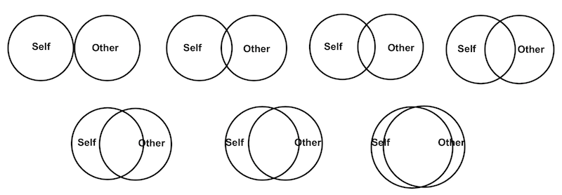

Perceived Body Boundaries Scale (Dambrun, 2016).
Instructions: Please indicate the image that best describes your experience in the virtual reality environment. To what extent did you feel that the boundaries of your body were altered?


Spatial Frame of Reference Continuum (SFoRC; Hanley & Garland, 2019).
Instructions: To what extent has your perception of yourself extended in the virtual reality experience? Using the letters and the following image, indicate how far you believe your "self" extends beyond your physical body. The letter "A" represents that your "self" stops at your physical body (A head, B chest, C abdomen). Starting from D, it indicates that your "self" extends to a space beyond your physical body. The rings are symbolic and do not represent actual distances.
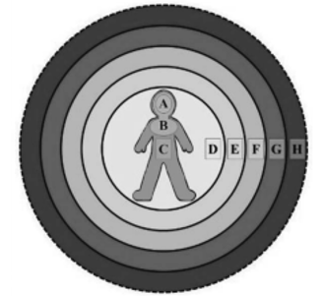

Fusion (Ad Hoc).
Instructions: Please indicate the image that best describes your experience in the virtual reality environment. To what extent did you feel that you fused with your partner during the experience?

Small self (Ad Hoc).
Instructions: Please indicate the image that best describes your experience in the virtual reality environment. To what extent did you feel that your sense of self diminished?


Self-referentiality (Ad Hoc).
Instructions:
Item 1 (intensity): Please indicate the image that best describes your experience in the virtual reality environment. To what extent did sensations, images, thoughts, and/or memories from your life (self-referential) appear?

Item 2 (percentage of time): During the virtual reality experience, what percentage of the time did you have sensations, images, thoughts, and/or memories of your life?
100% | 90% | 80% | 70% | 60% | 50% | 40% | 30% | 20% | 10% | 0%

Figure S1

Percentage of the maximum score for the MEQ-30 subscales.
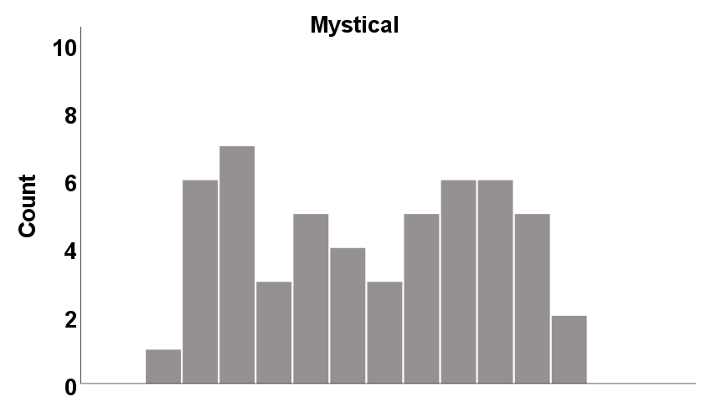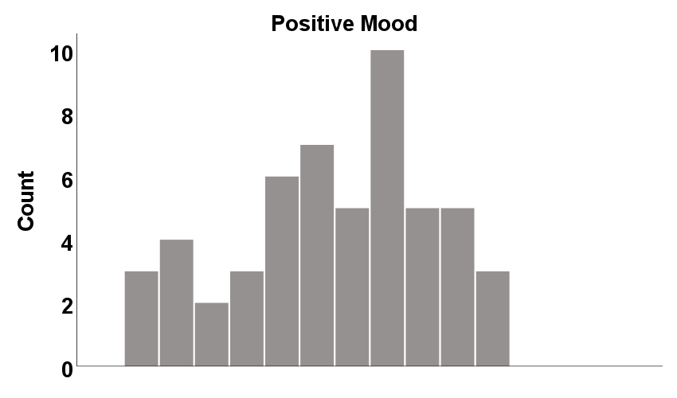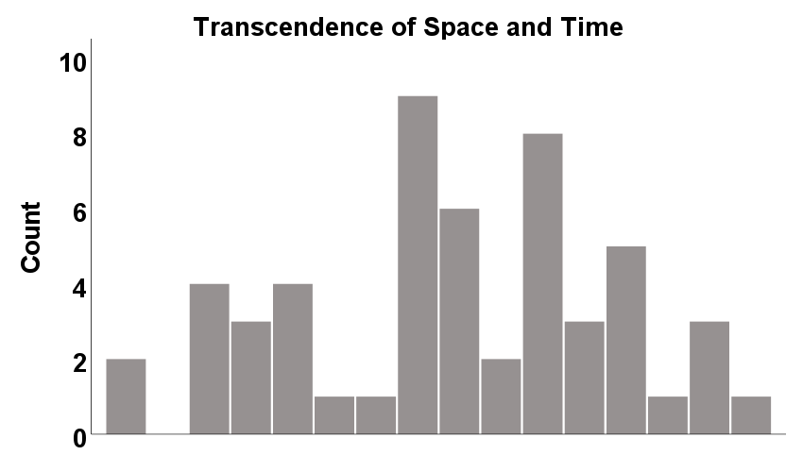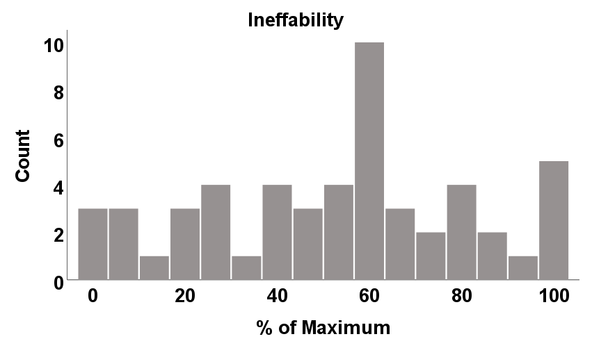

Table S1

Means (M), standard deviations (SD), and minimum (Min) and maximum (Max) scores on Satisfaction scale items.
Item | N | M | SD | Min | Max
I think this type of experience is useful to improve my knowledge about myself. | 48 | 7.23 | 1,92 | 3.00 | 10.00
In case you meditate: I think this type of experience is useful to improve my knowledge about my meditative practice. | 48 | 7.27 | 2,62 | 1.00 | 10.00
I believe this type of experience is useful in improving my knowledge of non-ordinary states of consciousness. | 48 | 7.92 | 2,19 | 2.00 | 10.00
If possible, I would like to participate in this type of experiences soon. | 48 | 7.85 | 2,51 | 2.00 | 10.00
I believe that participating in this type of experience can provide therapeutic knowledge to people. | 48 | 8.38 | 1.72 | 2.00 | 10.00
I forgot how time passed while participating in this experience. | 48 | 7.52 | 2.44 | 2.00 | 10.00
After this experience I want to learn much more about meditation. | 48 | 6.56 | 2.66 | 1.00 | 10.00

Table S2

Means (M), standard deviations (SD), and minimum (Min) and maximum (Max) scores on Adverse effects scale items.
Item | N | M | SD | Min | Max
I have boycotted the experience. | 47 | 2.13 | 1.48 | 1.00 | 6.00
I have felt fear or resistance to the experience at times. | 47 | 2.09 | 1.48 | 1.00 | 7.00
I have had unpleasant feelings about my body representation. | 47 | 1.47 | 1.17 | 1.00 | 7.00
I have had unpleasant feelings about merging bodies. | 47 | 1.36 | 1.07 | 1.00 | 7.00
I felt anxious. | 47 | 1.91 | 1.26 | 1.00 | 5.00
I experienced repeated and disturbing memories, thoughts, or images of a stressful experience from the past. | 47 | 1.40 | 1.21 | 1.00 | 7.00
I had trouble thinking clearly and/or making decisions. | 47 | 1.66 | 1.04 | 1.00 | 5.00
Anything bothered me. | 47 | 1.47 | 0.85 | 1.00 | 5.00
I felt distant or isolated from other people. | 47 | 1.57 | 0.97 | 1.00 | 5.00
I experienced headaches and/or body aches. | 47 | 2.87 | 2.06 | 1.00 | 7.00
My hearing has become very sensitive. | 47 | 1.17 | 0.38 | 1.00 | 2.00
I felt disconnected from the experience. | 47 | 2.23 | 1.49 | 1.00 | 7.00
I have felt lost with the instructions. | 47 | 2.98 | 1.66 | 1.00 | 7.00

Straussian Grounded Theory Analysis of Participant Interviews Following Ripple

Semi-structured Interview
In addition to the quantitative data, a semi-structured interview was conducted to obtain a more in-depth understanding of participants' experiences with the Ripple experience. These interviews were carried out with only seven participants, as they were not included in the initial study protocol. Their purpose was to explore in greater depth the nature of the elicited state, including its nuances and complexities. All interviews were audio-recorded and subsequently transcribed verbatim for analysis.
Semi-structured Interview Analysis
Seven semi-structured interviews were analyzed using Straussian Grounded Theory, following the three classic stages of analysis: open coding, axial coding, and selective coding (Glaser & Strauss, 1967; Corbin & Strauss, 2014). Two researchers independently coded the transcripts line-by-line, identifying significant concepts and comparing them using the constant comparative method. After reaching consensus, a unified coding framework was developed. In axial coding, codes were grouped into broader themes, which were further refined and integrated in the final stage of selective coding to identify a central phenomenon. The analysis was conducted using Atlas.Ti 9.
Results
The analysis revealed two main categories and five interrelated themes. The core variable identified was: Ripple virtual reality temporarily dissolves self-identity, enabling deep emotional resonance and connection.
Transformation of Self-Identity
Participants consistently reported a profound alteration in their sense of self. This category encompasses the erosion of bodily and personal boundaries, the blurring of self–other distinctions, and the emergence of a unified, expansive consciousness.
Blurring of Body Boundaries. All participants (N=7) described experiences in which the limits of their body became vague or disappeared altogether. There was a marked sensation of bodily lightness or the absence of physical boundaries.
“I could not perceive the boundaries of my body. I felt that everything was one, that I was one with everything.” (S3)
“I didn’t feel my body; it was pure experience, pure awareness, a warm space... There was no density.” (S4)
Loss of Egoic Reference. Some participants (N=3) reported temporarily forgetting who they were – their social identity or even the existence of a “self.” This was perceived not as confusion, but as a liberating truth.
“I didn’t know who I was. There was no sense of self or other… it was the truth, and I could rest in it.” (S6)
“Those boundaries… disappeared, and there was no one left. And I was part of that no one.” (S2)
Transpersonal Connection. A strong theme (N=5) was the perception of being connected not just to others, but to an impersonal energy or universal consciousness, often described as loving or warm. This was not merely conceptual, but described as an immediate and unquestionable insight.
“I felt a sense of connection with the group and the other person as energy - impersonal.” (S1)
“I had the certainty that we are one, all one – endless, timeless. A certainty… not reasoning, but certainty.” (S7)
Intensified Affective States
The experience of selflessness was accompanied by intense emotional states and existential realizations, often difficult to express in words but deeply meaningful.
Emotional Overwhelm and Awe. Several participants (N=5) reported being overwhelmed by beauty, wonder, or emotion. These responses were often described as spontaneous and difficult to articulate, and they sometimes triggered a deep emotional release, including uncontrollable crying.
“I couldn’t stop crying from the intensity, but I didn’t feel the tears.” (S4)
“It moved me deeply – it left me inspired.” (S5)
States of Peace and Serenity. Most participants (N=6) reported feelings of deep calm, tranquility, or a cessation of internal noise.
“A feeling of serenity and wholeness (...) without internal noise.” (S1)
“I felt very peaceful and calm.” (S3)

