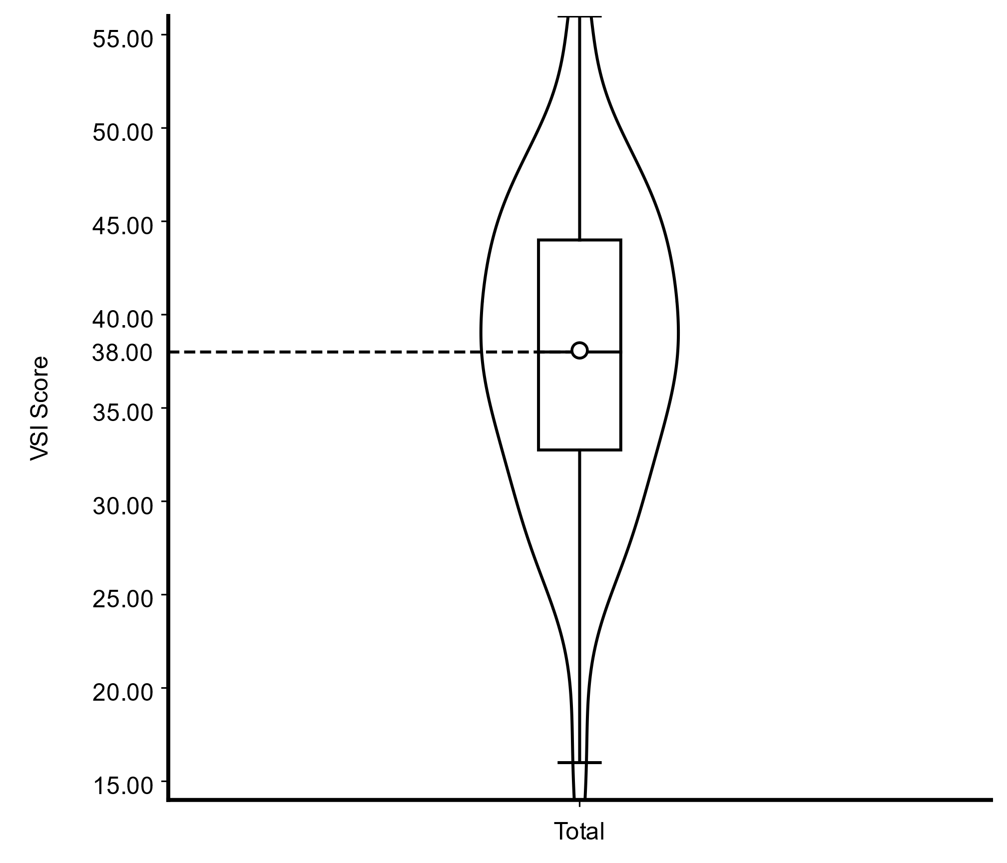
Figure A1 Violin plot showing the overall distribution of VSI scores. The overall sample median was 38, indicated by the dashed line.

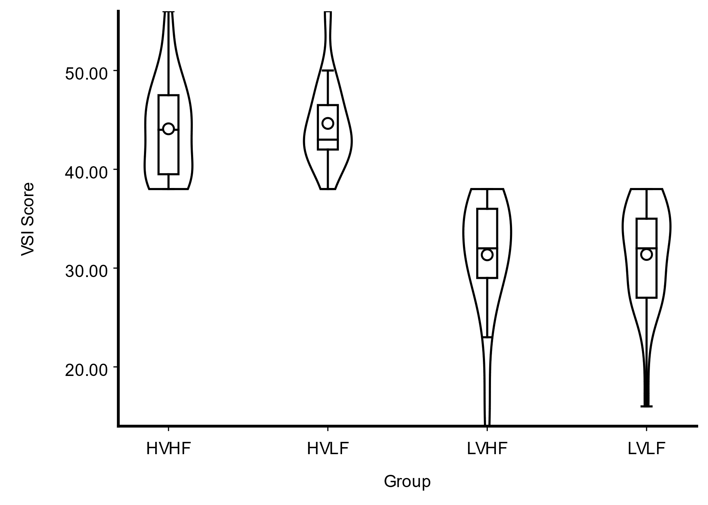
Figure A2 Violin plots of VSI scores across the four experimental groups, indicating higher VSI levels in the high-ability groups (HVHF and HVLF) compared to the low-ability groups (LVHF and LVLF).

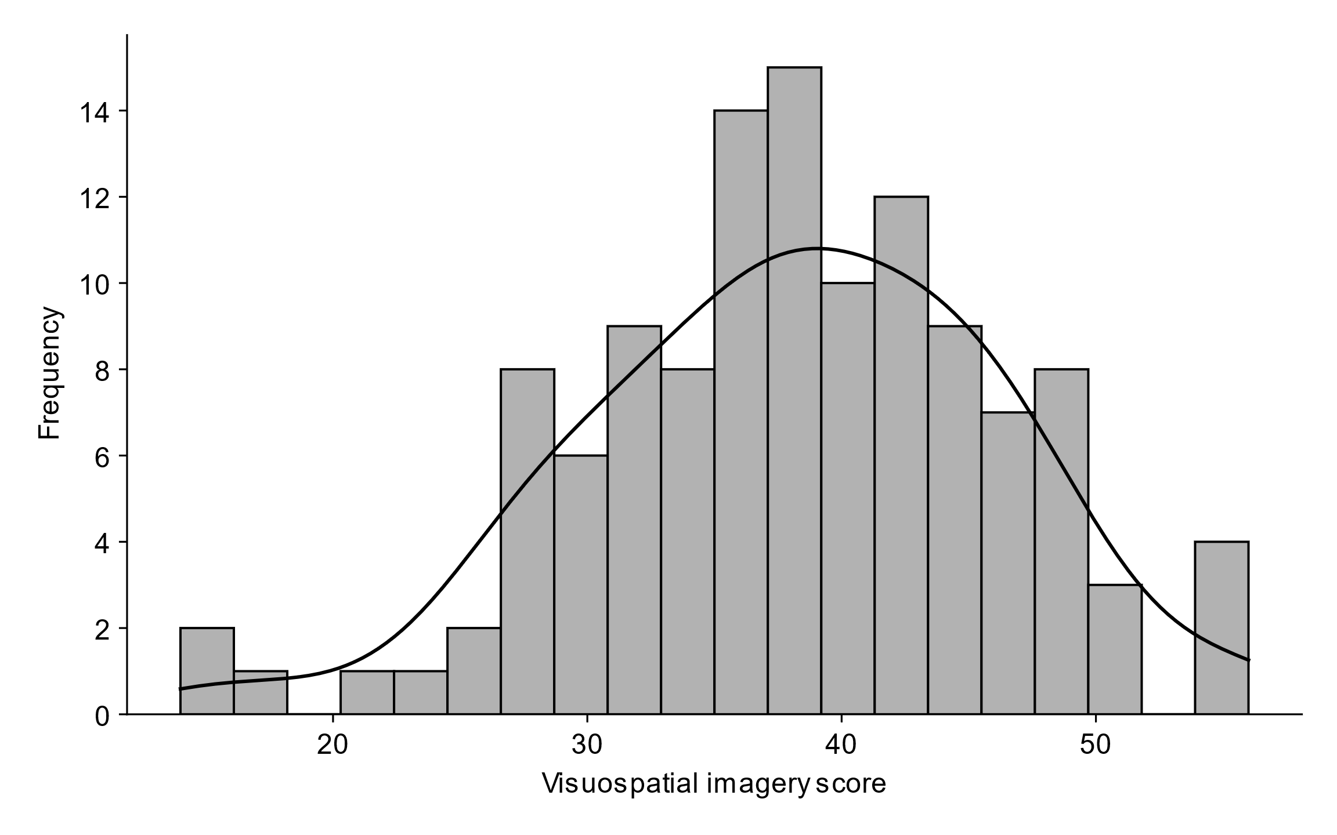
Figure A3 Distribution of visuospatial imagery scores with fitted normal curve

Table A1 Descriptive statistics of the VSI scale
Measures | M | SD | Median | Max | Min
High_VSI | 44.37 | 20.63 | 43.50 | 56.00 | 38.00
Low_VSI | 31.36 | 29.99 | 32.00 | 38.00 | 14.00
High_fidelity | 37.93 | 69.39 | 38.00 | 56.00 | 14.00
Low_fidelity | 38.23 | 66.83 | 39.00 | 56.00 | 16.00
HVHF | 44.10 | 23.62 | 44.00 | 56.00 | 38.00
HVLF | 44.65 | 18.17 | 43.00 | 56.00 | 38.00
LVHF | 31.34 | 33.88 | 32.00 | 38.00 | 14.00
LVLF | 31.38 | 27.17 | 32.00 | 38.00 | 16.00
Total | 38.08 | 67.56 | 38.00 | 56.00 | 14.00

Table A2 Confirmatory factor analysis (CFA) model fit indices for the learning performance test
Test | χ²/df | p | CFI | TLI | IFI | RMSEA (90%CI)
Learning performance | 1.054 | 0.285 | 0.925 | 0.915 | 0.936 | 0.021  (0.000, 0.045)

Note. χ²/df is the ratio of Chi-square degrees of freedom, values below 3 indicate great model fit. CFI = comparative fit index, TLI = Tucker-Lewis index, and IFI = Value-added fit index. For CFI, TLI, and IFI values equal to or greater than 0.95 indicate excellent model fit, while values greater than 0.90 are considered acceptable. RMSEA = Root mean square error of approximation; CI = Confidence interval. RMSEA values below 0.05 indicate excellent model fit. Based on the learning performance test structure with two dimensions, "Retention" and "Transfer," a two-factor CFA model was constructed. Initial model fit indices indicated potential correlations between certain items, and specified some correlations between items based on modification indices to improve the model fit of the test.

Table A3 Correlation analysis between VSI and performance
 | Research variable | VSI | Knowledge posttest
All Participants | VSI
All Participants | r | 1 | —
All Participants | P value | — | —
All Participants | Knowledge posttest
All Participants | r | .205* | 1
All Participants | P value | .025 | —
High Fidelity | VSI
High Fidelity | r | 1 | —
High Fidelity | P value | — | —
High Fidelity | Knowledge posttest
High Fidelity | r | -.035 | 1
High Fidelity | P value | .793 | —
Low Fidelity | VSI
Low Fidelity | r | 1 | —
Low Fidelity | P value | — | —
Low Fidelity | Knowledge posttest
Low Fidelity | r | .454** | 1
Low Fidelity | P value | <.001 | —
—: Not applicable

Table A3 The results of hypothesis testing
Hypothesis | Dimension | Description | Evidence | Upheld
H1a | retention | LV (HF > LF) | LV (HF > LF) | √
H1b | transfer | LV (HF > LF) | no effects | ×
H1c | retention | HV (HF < LF) | no effects | ×
H1d | transfer | HV (HF < LF) | no effects | ×
Additional evidence: LF (HV > LV); interaction effects on retention; VSI positively correlated with performance
H2a | cognitive load | LV (HF > LF) | intrinsic: no effects; extraneous: no effects | ×
H2b | cognitive load | HV (HF > LF) | intrinsic: no effects; extraneous: HV (HF > LF) | O
Additional evidence: interaction effect
H3a | attention | LV (HF > LF) | no effects | ×
H3b | attention | HV (HF > LF) | no effects | ×
Additional evidence: LF (HV > LV); HVLF > LVHF; HVHF > LVLF; main effects (VSI)
H4a | motivation | LV (HF > LF) | no effects | ×
H4b | motivation | HV (HF < LF) | fear of failure (reverse): HV (LF < HF) | O
Additional evidence:
- interest: LF (HV > LV)
- fear of failure (reverse): HV (LF < HF); HVLF < LVHF; LF (HV < LV)
- challenge: LF (HV > LV)
H5a | learning experience | LV (HF > LF) | perceived ease of use: LV (HF > LF) | O
H5b | learning experience | HV (HF < LF) | perceived usefulness: HV (HF < LF); perceived ease of use: HV (HF < LF); satisfaction: HV (HF < LF) | √
Additional evidence:
- perceived usefulness: HVLF > LVHF; HVLF > LVLF
- perceived ease of use: HVLF > LVHF; LF (HV > LV)
- satisfaction: HV (HF < LF); LF (HV > LV)
- main effects (VSI)
- interaction effects on perceived ease of use and satisfaction
H6a | positive emotions | LV (HF > LF) | LV (HF > LF) | √
H6b | negative emotions | LV (HF < LF) | LV (HF < LF) | √
H6c | positive emotions | HV (HF < LF) | no effects | ×
H6d | negative emotions | HV (HF > LF) | HV (HF > LF) | √
Additional evidence:
- positive emotions: LF (HV > LV); HVHF > LVLF
- negative emotions: LF (HV < LV)
- main effects (VSI)
- interactions effects
Note: √ (supported, statistically significant results in the predicted direction); × (not supported, no significant effects or effects in the opposite direction); O (partially supported: overall differences observed, but no significant pairwise effects or only limited evidence).

