Supplementary Information

Supplementary Materials:
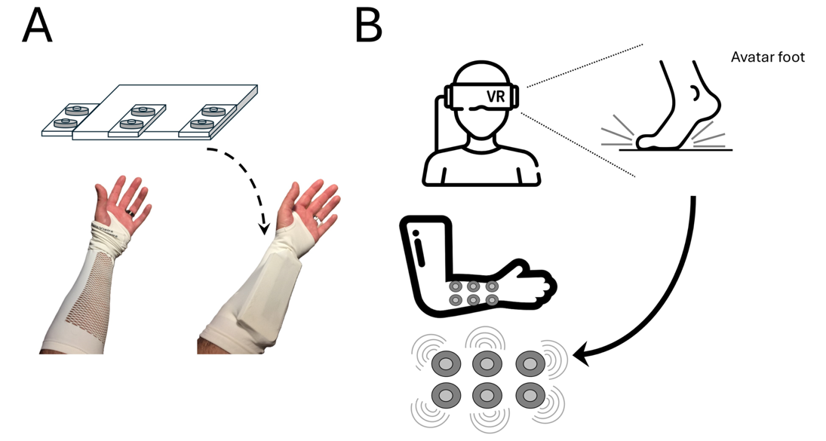
Supplementary Figure 1 - Tactile sleeve mapping. Panel A shows the tactile sleeve used to deliver vibrotactile stimulation, including the actuator module and its placement on the participant’s forearm. Panel B illustrates the mapping between virtual foot‑ground contact events and forearm stimulation: when the avatar’s foot contacts the ground in VR, the corresponding tactile signal is delivered through the forearm actuators.

Supplementary Table S1 - Sensitivity analyses using corrected embodiment scores and weighted SSQ scoring
Two complementary sensitivity analyses were conducted. First, the sensory-condition analyses were repeated after excluding the poorly performing reverse-scored Self-location item and recalculating the Self-location and global embodiment scores. Second, analyses involving cybersickness were repeated using the weighted SSQ score together with the corrected embodiment scores. The primary sensory-condition conclusion was preserved. Cybersickness-related associations remained directionally consistent, although some adjusted and exploratory effects were attenuated.
Panel A. Sensitivity of sensory-condition effects to corrected Self-location and global embodiment scoring
Analysis | Main manuscript: original scoring | Corrected SoE/SoL scoring | Interpretation
Effect of sensory condition on global embodiment | F(2, 48) = 0.58, p = .563 | F(2, 48) = 0.851, p = .433 | No significant condition effect under either scoring approach
Effect of sensory condition on Self-location | Non-significant, p > .41 | F(2, 48) = 0.430, p = .653 | Conclusion unchanged
Bayesian ANCOVA for global embodiment | BFincl = .229 | BFincl = .275 | Evidence continued to favour models excluding the sensory-condition effect

Panel B. Combined sensitivity analyses using weighted SSQ and corrected embodiment scores
Analysis | Main manuscript: raw SSQ + original SoE/SoL | Sensitivity analysis: weighted SSQ + corrected SoE/SoL | Interpretation
Correlation between SSQ and global embodiment | r = -.45, p < .001 | r = -.411, p = .002 | Significant negative association preserved
Hierarchical regression predicting SoE: Step 2 | β = -.379, p = .024 | β = -.316, p = .057 | Direction preserved; effect attenuated to marginal significance
Hierarchical regression predicting SoE: final model | β = -.37, p = .033 | β = -.295, p = .085 | Direction preserved; independent contribution no longer statistically significant
Indirect association: HADS-A → SSQ → SoE | Effect = -.39, 95% CI [-.87, -.11] | B = -.326, 95% CI [-.692, -.085] | Indirect association remained supported because the confidence interval excluded zero
Exploratory personality model: SSQ predicting SoE | β = -.35, p = .036 | β = -.320, p = .057 | Negative association preserved but attenuated to marginal significance; personality traits remained non-significant
Regression predicting BMI performance | SSQ and embodiment components were non-significant | SSQ: β = -.243, p = .170; corrected SoL: β = -.134, p = .443 | Conclusion unchanged
Exploratory SSQ × SoL moderation: unadjusted | β = -.33, p = .039 | β = -.247, p = .099 | Direction preserved; interaction attenuated and no longer statistically significant
Exploratory SSQ × SoL moderation: adjusted for age and sex | β = -.31, p = .059 | β = -.212, p = .165 | Interaction further attenuated and remained non-significant
Note. SoE = global sense of embodiment; SoL = Self-location; SSQ = Simulator Sickness Questionnaire; HADS-A = Hospital Anxiety and Depression Scale–Anxiety subscale; BMI = brain–machine interface. Corrected SoE and SoL scores were calculated after excluding the poorly performing reverse-scored Self-location item. The weighted SSQ score was calculated according to Kennedy et al. (1993). Regression coefficients are standardized values unless otherwise indicated. Indirect effects are interpreted primarily from their bootstrapped 95% confidence intervals.

Supplementary Table S2 - Offline and online decoding accuracy

Global Sample:
Metric | N valid | N missing | Mean (%) | SD (%) | Min (%) | Max (%)
Offline accuracy / Experimental ACQ (%) | 48 | 5 | 78.10 | 5.55 | 66.37 | 89.79
Online accuracy / Experimental BMI (%) | 49 | 4 | 58.84 | 11.50 | 40.00 | 80.00
Online − offline (percentage points) | 46 | 7 | -19.02 | 10.58 | -40.77 | 3.58

Visual (V):
Metric | N valid | N missing | Mean (%) | SD (%) | Min (%) | Max (%)
Offline accuracy / Experimental ACQ (%) | 15 | 2 | 79.55 | 6.10 | 68.88 | 89.79
Online accuracy / Experimental BMI (%) | 16 | 1 | 58.34 | 10.83 | 40.00 | 75.00
Online − offline (percentage points) | 14 | 3 | -19.80 | 11.12 | -40.77 | -3.87

Audiovisual (VA):
Metric | N valid | N missing | Mean (%) | SD (%) | Min (%) | Max (%)
Offline accuracy / Experimental ACQ (%) | 15 | 1 | 78.28 | 3.69 | 73.26 | 85.61
Online accuracy / Experimental BMI (%) | 15 | 1 | 61.83 | 13.31 | 42.50 | 80.00
Online − offline (percentage points) | 15 | 1 | -16.45 | 13.09 | -38.62 | 3.58

Audiovisual + tactile (VAT)
Metric | N valid | N missing | Mean (%) | SD (%) | Min (%) | Max (%)
Offline accuracy / Experimental ACQ (%) | 18 | 2 | 76.75 | 6.28 | 66.37 | 88.67
Online accuracy / Experimental BMI (%) | 18 | 2 | 56.81 | 10.57 | 40.00 | 80.00
Online − offline (percentage points) | 17 | 3 | -20.65 | 7.41 | -32.35 | -5.61

Participant | Feedback condition | Offline accuracy / Experimental ACQ (%) | Online accuracy / Experimental BMI (%) | Online − offline (%)
P2 | VAT | 77.29 | 55.00 | -22.29
P3 | VA | 81.12 | 42.50 | -38.62
P4 | V | NA | 42.50 | NA
P5 | V | 78.87 | 75.00 | -3.87
P6 | VA | 78.42 | 45.00 | -33.42
P7 | VA | NA | NA | NA
P8 | V | 75.71 | 58.36 | -17.35
P9 | VAT | 70.81 | 40.00 | -30.81
P10 | VA | 79.74 | 55.00 | -24.74
P11 | VAT | 66.37 | 40.00 | -26.37
P12 | V | 75.25 | 50.00 | -25.25
P13 | VA | 83.16 | 80.00 | -3.16
P14 | VAT | 82.04 | 62.50 | -19.54
P15 | VA | 85.61 | 62.50 | -23.11
P16 | VAT | 75.81 | 52.50 | -23.31
P17 | VA | 75.92 | 47.50 | -28.42
P18 | V | NA | 60.00 | NA
P19 | VAT | 74.18 | 60.00 | -14.18
P20 | V | 80.77 | 40.00 | -40.77
P21 | VAT | 83.11 | 77.50 | -5.61
P22 | V | 89.79 | 57.50 | -32.29
P23 | V | 68.88 | 55.00 | -13.88
P24 | VA | 79.13 | 60.00 | -19.13
P25 | VAT | 84.29 | 55.00 | -29.29
P26 | VAT | 79.69 | 55.00 | -24.69
P27 | VAT | 81.79 | 65.00 | -16.79
P28 | VAT | NA | NA | NA
P29 | VAT | 72.00 | 55.00 | -17.00
P30 | VAT | 73.00 | NA | NA
P31 | VA | 80.51 | 70.00 | -10.51
P32 | V | 73.21 | 60.00 | -13.21
P33 | VAT | 66.94 | 52.50 | -14.44
P34 | VAT | 82.35 | 50.00 | -32.35
P35 | VAT | NA | 65.00 | NA
P36 | VA | 77.35 | 75.00 | -2.35
P37 | V | 81.33 | 62.50 | -18.83
P38 | VAT | 88.67 | 80.00 | -8.67
P39 | VAT | 75.51 | 50.00 | -25.51
P40 | VAT | 78.11 | 57.50 | -20.61
P41 | VAT | 69.59 | 50.00 | -19.59
P42 | VA | 74.28 | 47.50 | -26.78
P43 | V | 85.10 | NA | NA
P44 | V | 81.02 | 75.00 | -6.02
P45 | VA | 75.05 | 70.00 | -5.05
P46 | VA | 73.26 | 50.00 | -23.26
P47 | VA | 75.20 | 65.00 | -10.20
P48 | VA | 81.58 | 80.00 | -1.58
P49 | VA | 73.92 | 77.50 | 3.58
P50 | V | 83.21 | 55.00 | -28.21
P51 | V | 76.58 | 67.50 | -9.08
P52 | V | 87.90 | 75.00 | -12.90
P53 | V | 84.59 | 50.00 | -34.59
P54 | V | 71.02 | 50.00 | -21.02
Note. ACQ = acquisition/classifier-training phase; BMI = brain–machine interface; Offline accuracy refers to Experimental ACQ %. Online accuracy refers to Experimental BMI %. Feedback condition: V = visual; VA = audiovisual; VAT = audiovisual + tactile. NA indicates missing or invalid performance data due to technical or protocol-related irregularities affecting BMI task logs, classifier-output files, or acquisition/classifier-training files.

