SUPPLEMENTARY MATERIAL
SUPPLEMENTARY FIGURES
Supplementary figure 1. Flow chart of variant selection
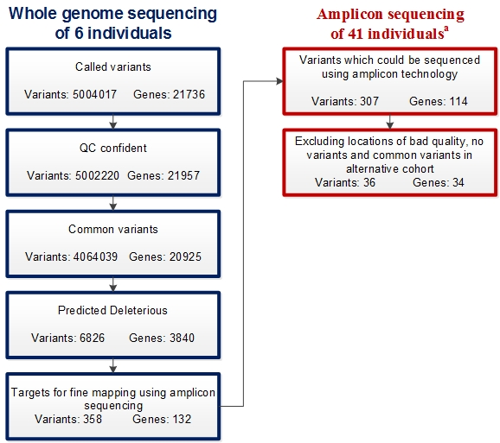
ª The 6 whole genome sequenced individuals are included in the 41individuals who were amplicon sequenced.

