Clinical Rheumatology

Online Resource

Efficacy and safety of tofacitinib by background methotrexate dose in psoriatic arthritis: post hoc exploratory analysis from two phase III trials

Alan J. Kivitz,¹ Oliver FitzGerald,² Peter Nash,³ Shirley Pang,⁴ Valderilio F. Azevedo,⁵ Cunshan Wang,⁶ Liza Takiya⁷
¹Department of Rheumatology, Altoona Center for Clinical Research, Duncansville, Pennsylvania, USA; ²Department of Rheumatology, Conway Institute for Biomolecular Research, University College, Dublin, Ireland; ³Department of Medicine, University of Queensland, St Lucia, Brisbane, Australia; ⁴St Joseph Heritage Healthcare, Fullerton, California, USA; ⁵Universidade Federal do Paraná, Curitiba, Brazil; ⁶Pfizer Inc, Groton, Connecticut, USA; ⁷Pfizer Inc, Collegeville, Pennsylvania, USA
Corresponding author: Dr. Liza Takiya, Liza.Takiya@pfizer.com

Supplementary Table 1 Least squares mean (SE) changes from baseline (Δ) by treatment group and background MTX dose (month 3)
 | Tofacitinib  5 mg BID |  | Tofacitinib  10 mg BID |  | Placebo
 | MTX dose  ≤ 15 mg/week  (N = 116)ª | MTX dose  > 15 mg/week  (N = 70)ª | MTX dose  ≤ 15 mg/week  (N = 122)ª | MTX dose  > 15 mg/week  (N = 56)ª | MTX dose  ≤ 15 mg/week  (N = 133)ª | MTX dose  > 15 mg/week  (N = 59)ª
ΔHAQ-DI (SE) [n]^{b} | –0.35 (0.05)  [112] | –0.39 (0.06)  [67] | –0.46 (0.04)  [118] | –0.28 (0.07)  [52] | –0.17 (0.04)  [123] | –0.18 (0.06)  [58]
ΔPGA-PsA-VAS, mm (SE) [n]^{b} | –24.90 (1.96) [110] | –30.90 (2.54)  [66] | –32.70 (1.91) [117] | –30.36 (2.85)  [52] | –16.85 (1.89) [122] | –21.39 (2.69)  [58]
ΔPGJS-VAS, mm (SE) [n]^{b} | –26.36 (2.14) [111] | –29.44 (2.76)  [67] | –33.14 (2.08) [118] | –26.63 (3.12)  [52] | –13.08 (2.06) [123] | –14.16 (2.95)  [58]
ΔLEI (SE)  [n]^{b,c} | –0.92 (0.20)  [73] | –1.47 (0.26)  [43] | –1.47 (0.20)  [74] | –1.93 (0.28)  [36] | –0.52 (0.19)  [81] | –0.64 (0.28)  [37]
ΔDSS (SE)  [n]^{b,d} | –4.66 (0.74)  [67] | –5.25 (1.07)  [30] | –6.44 (0.71)  [69] | –4.27 (1.13)  [27] | –2.31 (0.74)  [69] | –3.77 (1.18)  [25]
Baseline values are presented in Table 1. This analysis included all patients who received MTX as background therapy only on day 1 in the FAS. Eight patients who used both MTX and other csDMARDs on day 1 were excluded, as were two patients who exceeded the protocol-defined maximum dose of MTX for the analysis (20 mg/week), and one patient without dosing frequency to calculate the dose. Each endpoint was analyzed using a mixed model for repeated measures without imputation for missing values. The model included the fixed effects of treatment, visit, treatment-by-visit interaction, geographic location, study, and baseline value, as well as fixed effects of MTX dose and its two-way and three-way interactions with treatment and visit; an unstructured covariance matrix was used
ªN is the number of patients who received MTX as background therapy only on day 1 in the FAS. ^{b}[n] is the number of patients evaluable for change from baseline in the endpoint at month 3. ^{c}Only patients with a baseline value of LEI or DSS > 0 were included in this analysis. ^{d}For patients with baseline DSS > 0
BID, twice daily; csDMARD, conventional synthetic disease-modifying antirheumatic drug; DSS, Dactylitis Severity Score; FAS, full analysis set; HAQ-DI, Health Assessment Questionnaire-Disability Index; LEI, Leeds Enthesitis Index; MTX, methotrexate or methotrexate sodium; PGA-PsA-VAS, physician’s global assessment in psoriatic arthritis-visual analog scale; PGJS-VAS, patient’s global joint and skin assessment-visual analog scale; SE, standard error; Δ, change from baseline

Supplementary Fig. 1 Mean (SE) ΔALT and ΔAST by treatment group and background MTX dose
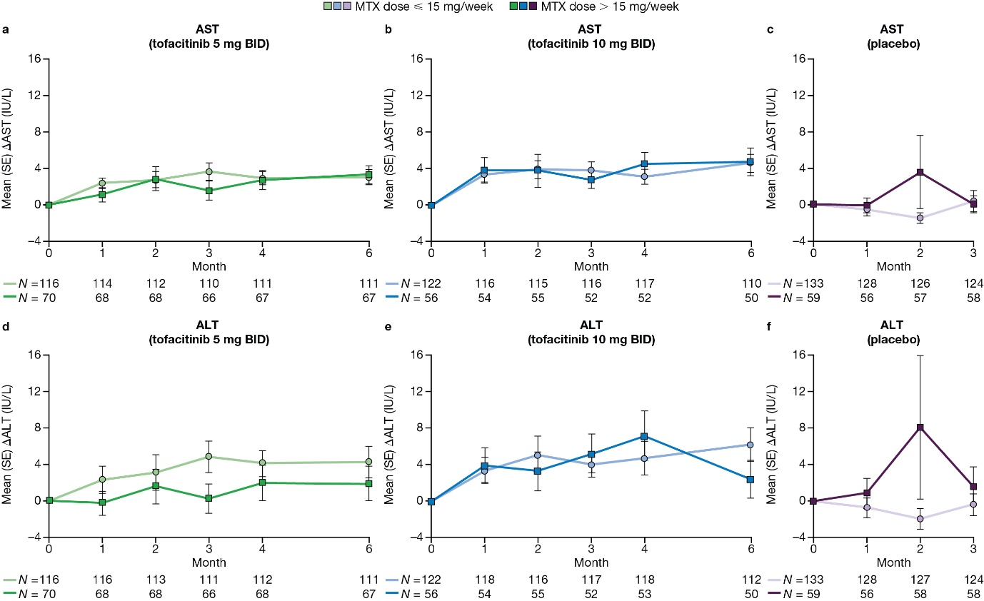
(a) ALT (tofacitinib 5 mg BID), (b) ALT (tofacitinib 10 mg BID), (c) ALT (placebo), (d) AST (tofacitinib 5 mg BID), (e) AST (tofacitinib 10 mg BID), and (f) AST (placebo) at month 1 through month 6 (tofacitinib) and month 1 through month 3 (placebo). The analysis included all patients who received MTX as background therapy on day 1 in the safety analysis set. Eight patients who used both MTX and other csDMARDs on day 1 were excluded, as were two patients who exceeded the protocol-defined maximum dose of MTX for the analysis (20 mg/week), and one patient without dosing frequency to calculate the dose. ALT, alanine aminotransferase; AST, aspartate aminotransferase; BID, twice daily; csDMARD, conventional synthetic disease-modifying antirheumatic drug; MTX, methotrexate or methotrexate sodium; N, number of patients evaluable for changes from baseline in ALT or AST at each visit; SE, standard error; Δ, change from baseline

Supplementary Fig. 2 Proportion of patients with ALT and AST ≥ 1, ≥ 2, ≥ 3, ≥ 5, and ≥ 10× ULN by month 6, by treatment group and background MTX dose

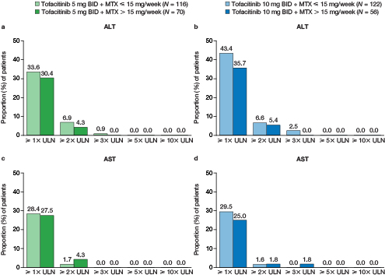
(a) ALT (tofacitinib 5 mg BID), (b) ALT (tofacitinib 10 mg BID), (c) AST (tofacitinib 5 mg BID), and (d) AST (tofacitinib 10 mg BID) by month 6. The analysis included all patients who received MTX as background therapy on day 1 in the safety analysis set. Eight patients who used both MTX and other csDMARDs on day 1 were excluded, as were two patients who exceeded the protocol-defined maximum dose of MTX for the analysis (20 mg/week), and one patient without dosing frequency to calculate the dose. ALT, alanine aminotransferase; AST, aspartate aminotransferase; BID, twice daily; csDMARD, conventional synthetic disease-modifying antirheumatic drug; MTX, methotrexate or methotrexate sodium; N, number of patients evaluable for changes from baseline in ALT or AST at each visit; ULN, upper limit of normal

Supplementary Fig. 3 Lipid values mean (SE) percent change from baseline (Δ) by background MTX dose (months 1 and 3)
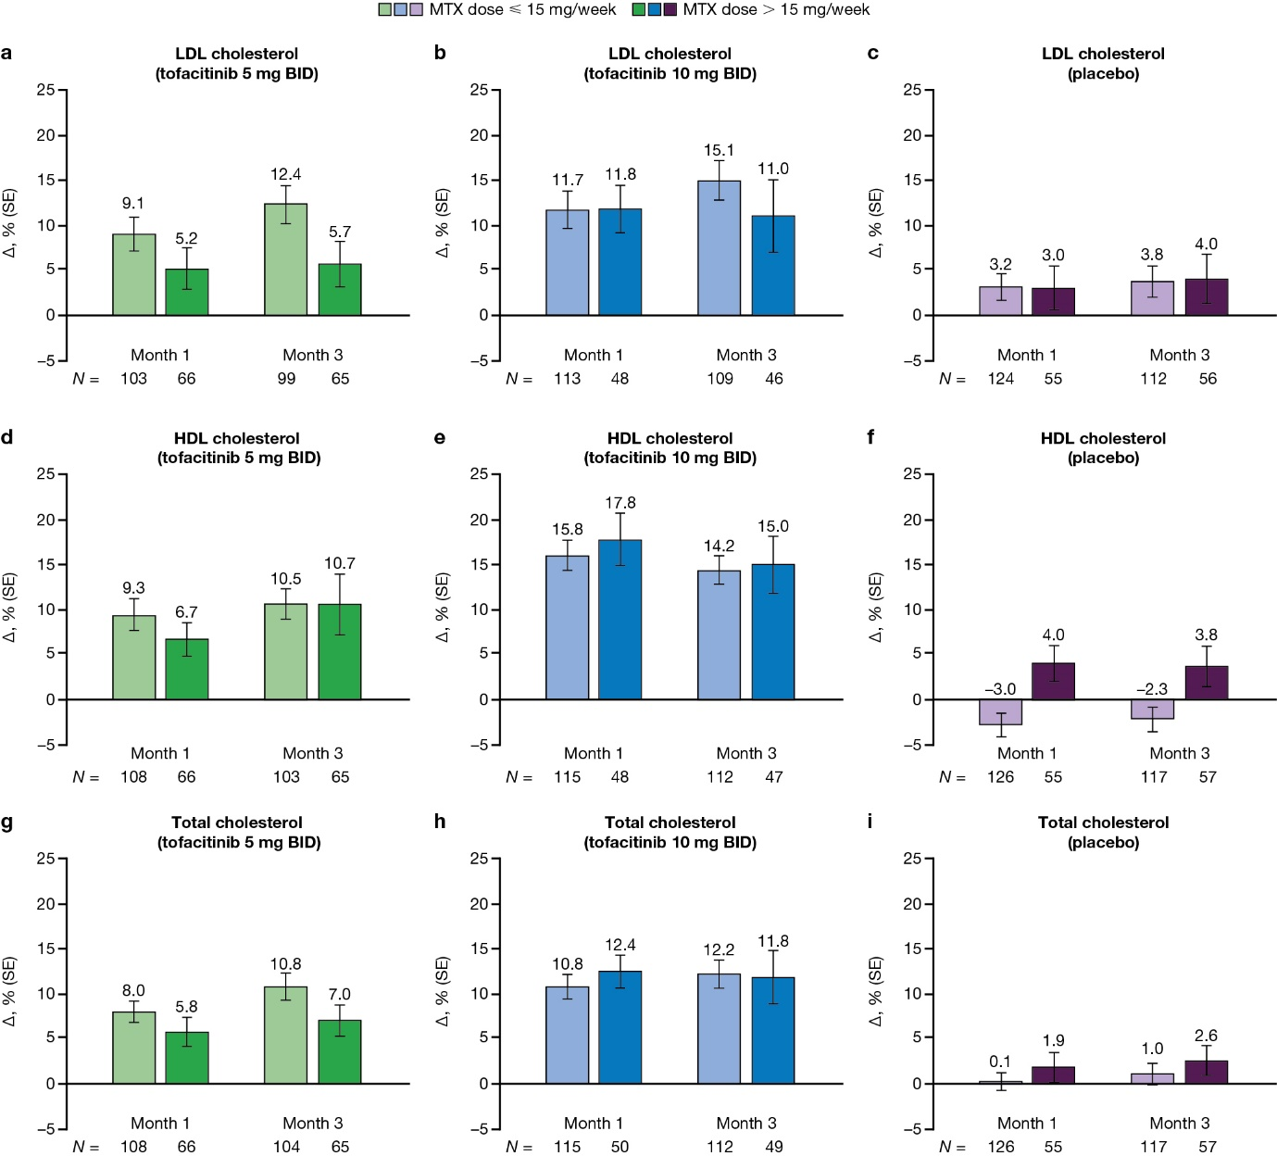
(a) LDL cholesterol (tofacitinib 5 mg BID), (b) LDL cholesterol (tofacitinib 10 mg BID), (c) LDL cholesterol (placebo), (d) HDL cholesterol (tofacitinib 5 mg BID), (e) HDL cholesterol (tofacitinib 10 mg BID), (f) HDL cholesterol (placebo), (g) total cholesterol (tofacitinib 5 mg BID), (h) total cholesterol (tofacitinib 10 mg BID), and (i) total cholesterol (placebo), at months 1 and 3. The analysis included all patients who received MTX as background therapy on day 1 in the safety analysis set. Eight patients who used both MTX and other csDMARDs on day 1 were excluded, as were two patients who exceeded the protocol-defined maximum dose of MTX for the analysis (20 mg/week), and one patient without dosing frequency to calculate the dose. BID, twice daily; csDMARD, conventional synthetic disease-modifying antirheumatic drug; HDL, high-density lipoprotein; LDL, low-density lipoprotein; MTX, methotrexate or methotrexate sodium; N, number of patients evaluable for change from baseline in the endpoint at each visit; SE, standard error; Δ, change from baseline
Supplementary Fig. 4 Mean (SE) change from baseline (Δ) in hematology values by background MTX dose
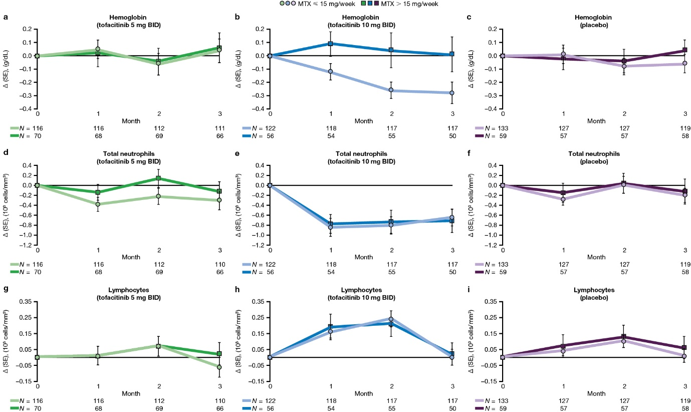
(a) Hemoglobin (tofacitinib 5 mg BID), (b) hemoglobin (tofacitinib 10 mg BID), (c) hemoglobin (placebo), (d) neutrophils (tofacitinib 5 mg BID), (e) neutrophils (tofacitinib 10 mg BID), (f) neutrophils (placebo), (g) lymphocytes (tofacitinib 5 mg BID), (h) lymphocytes (tofacitinib 10 mg BID), and (i) lymphocytes (placebo), at months 1, 2, and 3. The analysis included all patients who received MTX as background therapy on day 1 in the safety analysis set. Eight patients who used both MTX and other csDMARDs on day 1 were excluded, as were two patients who exceeded the protocol-defined maximum dose of MTX for the analysis (20 mg/week), and one patient without dosing frequency to calculate the dose. BID, twice daily; csDMARD, conventional synthetic disease-modifying antirheumatic drug; MTX, methotrexate or methotrexate sodium; N, number of patients evaluable for change from baseline in the endpoint at each visit; SE, standard error; Δ, change from baseline

