Appendix A.
WALK - WARM UP
In preparation for walk: Walk at a medium pace 3-5 mins, then move through some range of motion drills and stretches for major walking muscle groups.

- Trunk and upper limbs  Relaxed arm swings around trunk with trunk rotations.  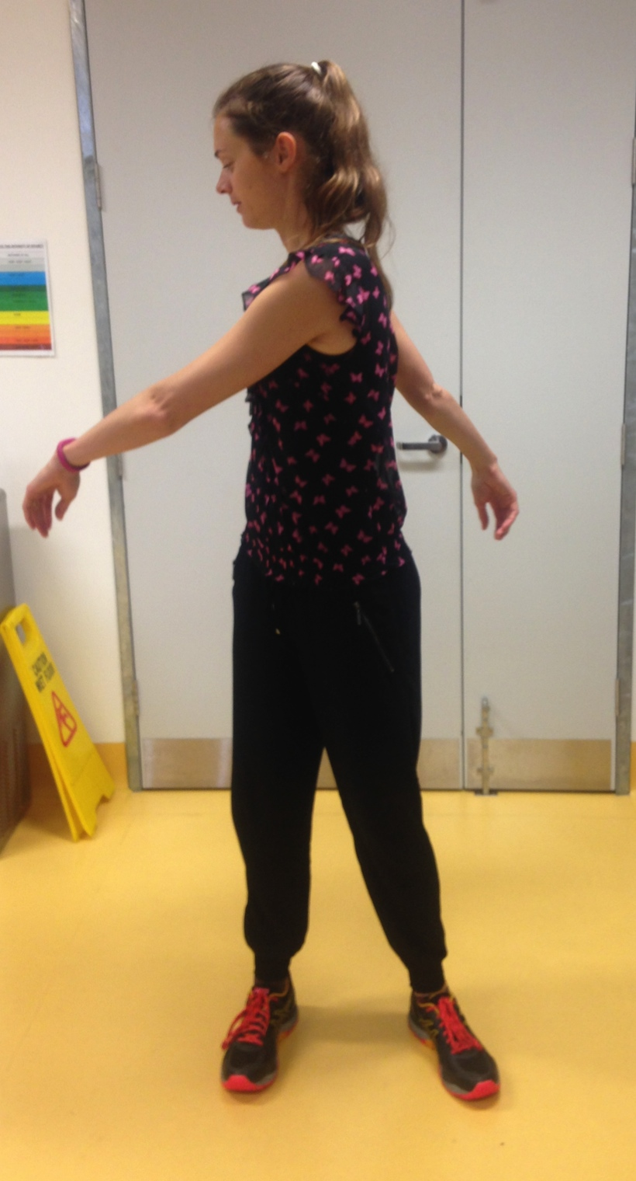 | - Hip Adductors  Feet wide, facing forward, moving between side lunge left and right. Finish with 1-2 short 5-10 sec holds on each side.  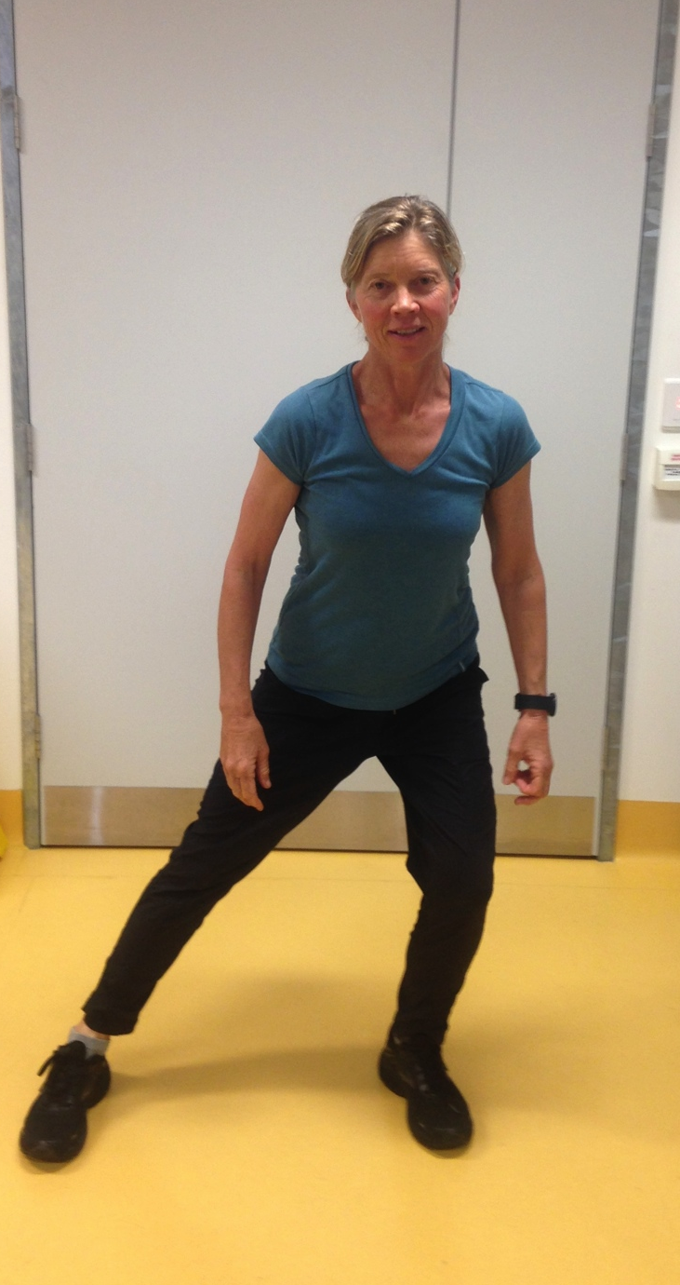 | - Quadriceps/ Hamstring and Calf  Long stride stance. Transfer weight from back leg to front leg. Finish with holds 5-10 sec, repeat other side.  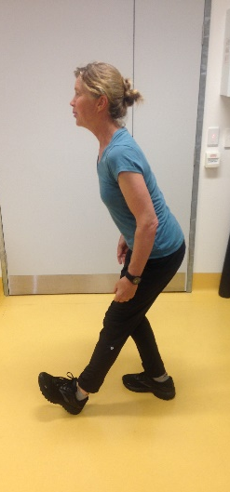 ↔ 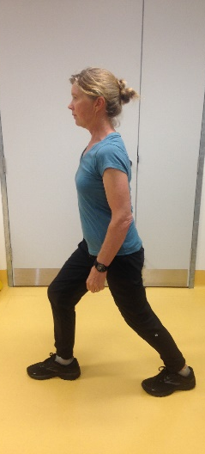
- Hip flexor  Upright stride stance with anterior pelvic tilt 5—10 sec hold.  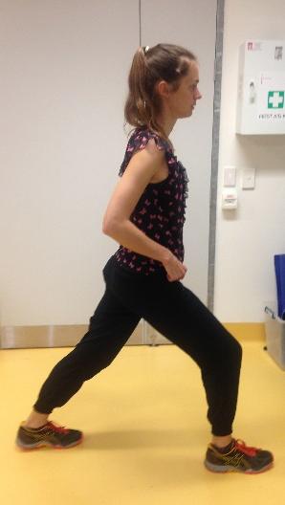 | - Ankle pumps  - each leg- with support if needed  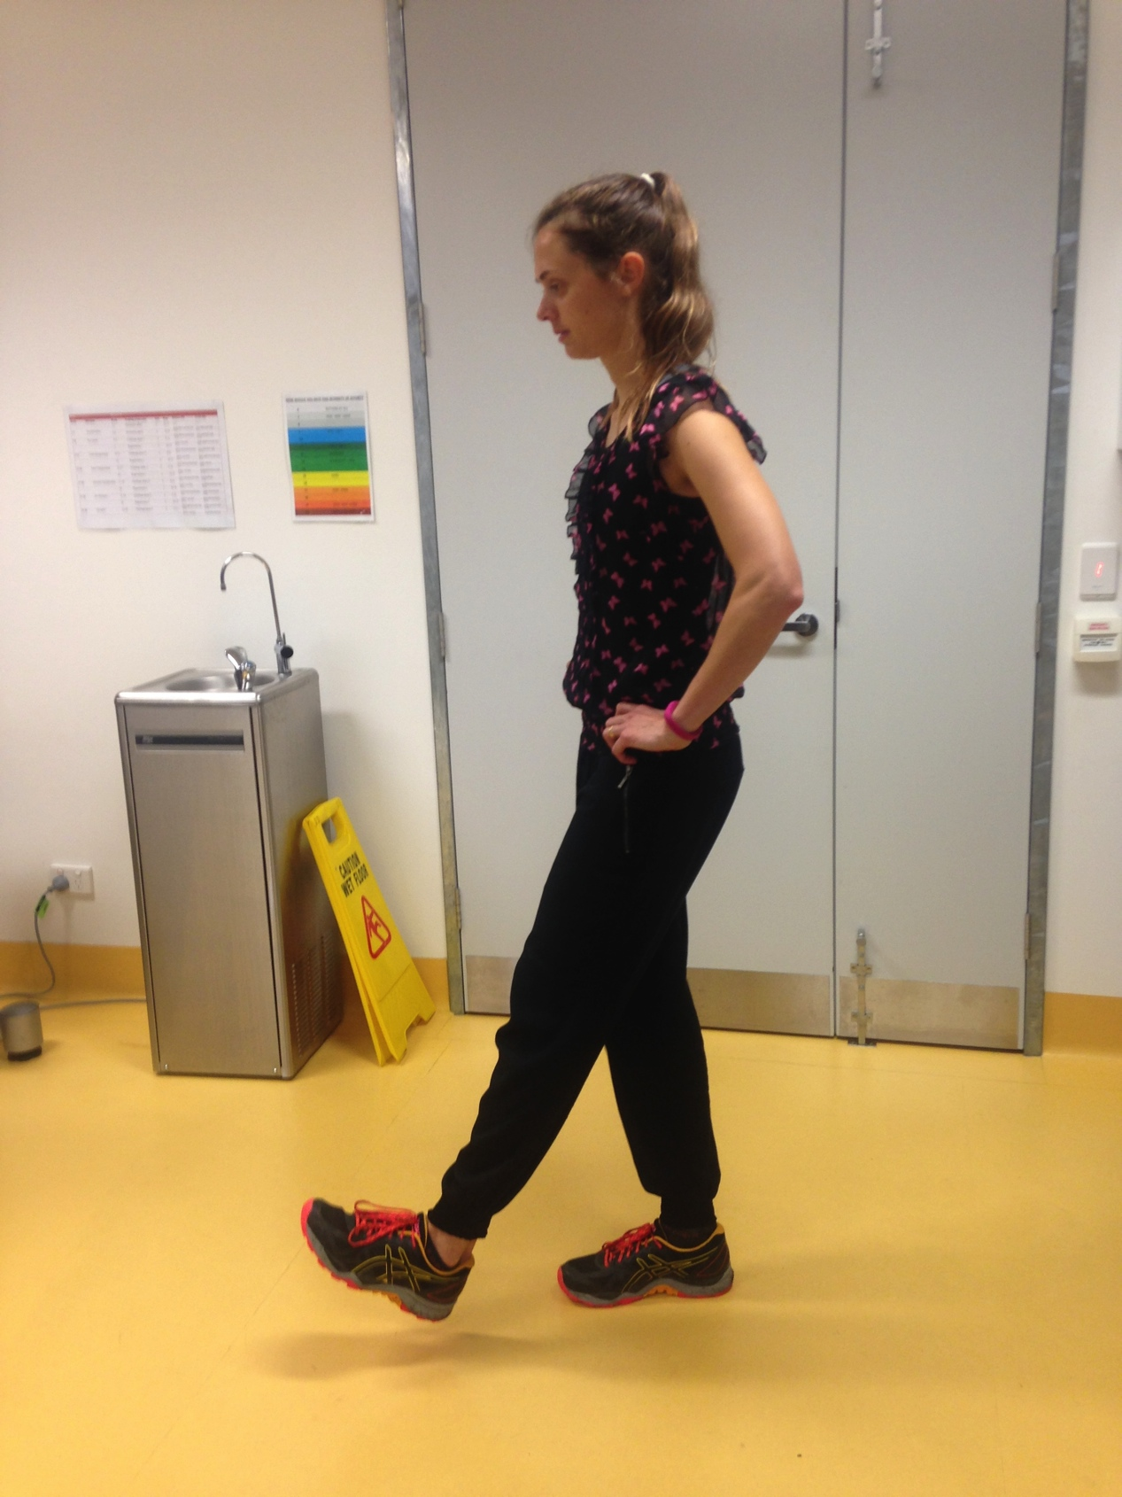 | - Arm circles
COOL DOWN / STRETCH

Whole body cool down with sustained stretches – hold up to 30 seconds for each.

- Diagonal whole body stretch – reaching above head  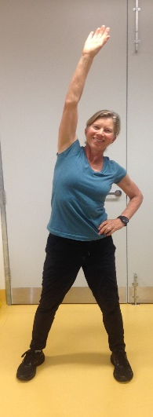 | - Stand tall/Pectorals and upper limb lengthening – hands behind back  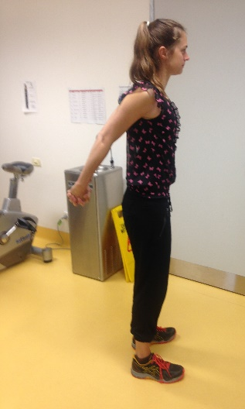 | - Upper trunk / upper limb  Rounding upper trunk and arms- ‘hug a tree’  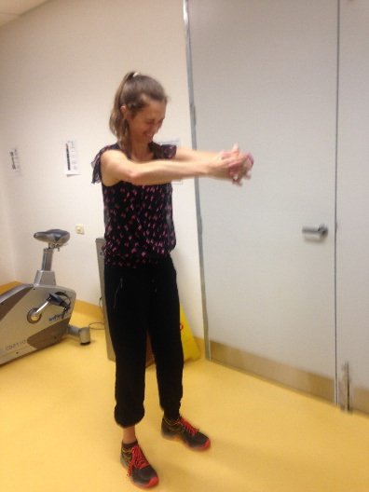 | - Adductor stretch in wide stance  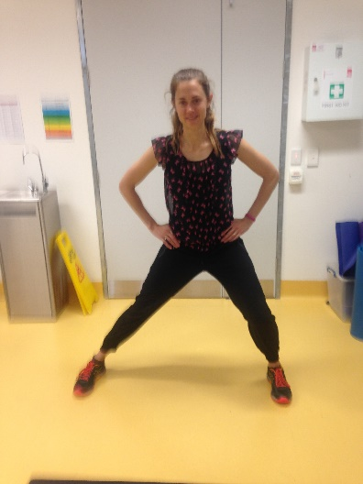
- Supported stretch for Quadriceps  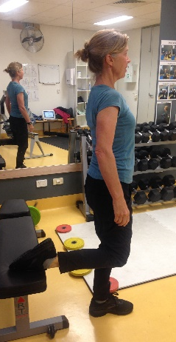 OR 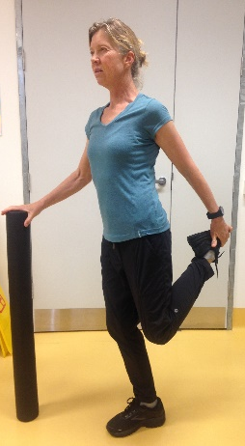 | - Supported stretch for Hamstrings  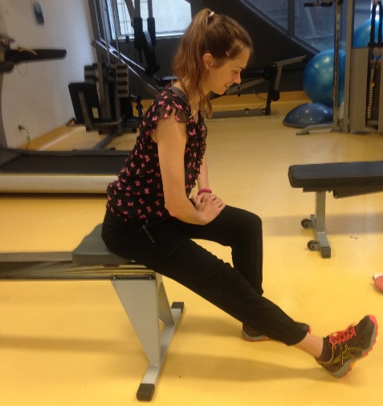 | - Calf stretch- Gastrocnemius  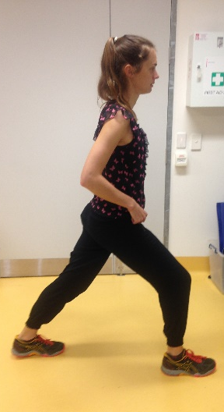 | - Calf stretch- Soleus  